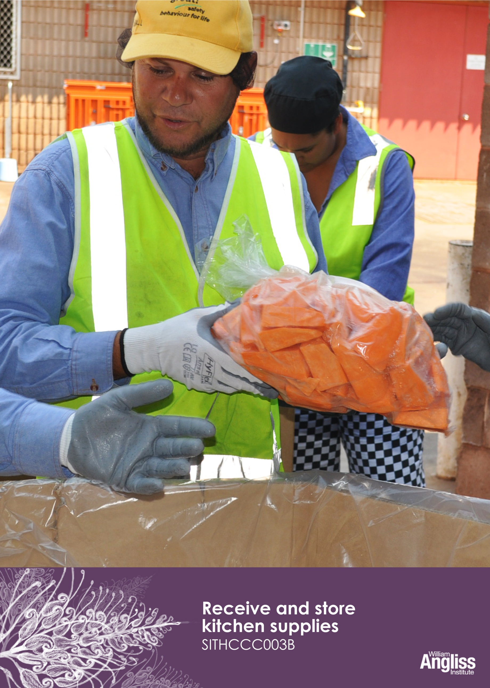
Workbook

© Commonwealth of Australia. 2012

CC BY-NC-SA
This work is copyright. Except where otherwise indicated, and save for the Commonwealth Coat of Arms, the Department has applied the Creative Commons Attribution-Noncommercial-Share Alike 3.0 Australia Licence to this work.
The Department of Education, Employment and Workplace Relations must be attributed as the author of the Department’s copyright material.
As far as practicable, material for which the copyright is owned by a third party has been clearly labelled. The Department has made all reasonable efforts to ensure that this material has been reproduced in this resource with the full consent of the copyright owners.
Requests and enquiries concerning the Department’s copyright material should be addressed to:
The Copyright Officer
Department of Education, Employment and Workplace Relations
Location code C148CW2
GPO Box 9880 Canberra ACT 2601

Or emailed to copyright@deewr.gov.au
Funded under the Workplace English Language and Literacy (WELL) Program by the Australian Government Department of Education, Employment and Workplace Relations.
The views expressed in this publication do not necessarily represent the view of the Minister for Education or the Australian Government. The Australian Government does not give any warranty nor accept any liability in relation to the contents of this work.

ISBN 978-1-922108-06-7

Development Team
Content | William Angliss Institute  Macsmith and Associates
Photography & graphics | Benjamin B Photography

Acknowledgments
We would like to acknowledge the generous support of the following organisations and the Indigenous learners and employees in those venues for giving their permission for photography:
Ayers Rock Resort, Yulara, NT
Charcoal Lane Restaurant, Fitzroy, VIC
Lux Foundry Café, Brunswick, VIC
Peninsula Palms (Compass Group Australia), Dampier, WA
Permissions
We would like to acknowledge the following organisations who have granted permission for their copyright materials to be incorporated in this resource.
Better Health Channel, Department of Health, VIC
Cultural Warning
People of Aboriginal or Torres Strait Islander descent should be aware that this publication contains images of people who may be deceased.
Disclaimer
Every effort has been made sure that this booklet is free from error or omissions. However, you should conduct your own enquiries and seek professional advice before relying on any fact, statement or matter contained in this book. William Angliss Institute of TAFE is not responsible for any injury, loss or damage as a result of material included or omitted from this course.

Contents
Welcome vi
Icons vi
What you will learn vii
1 The laws about storing food 1

2 Supplies and storage areas 3
Supplies 3
Suppliers 8
Storage areas 9
Maintain storage areas 15
Section summary 17
3 Receiving supplies 18
Prepare for the delivery 18
Check documentation 20
Do temperature checks 27
Check freshness of food 29
Check quality of food 30
Check for damage or defects 32
Deal with delivery problems 33
Section summary 36
4 Storing supplies 37
Safe manual handling 37
Unpack the goods 42
Put the goods away 43
Storage guidelines 44
Section summary 51

5 Managing supplies 52
Rotate stock 52
Record stock levels 52
Manage excess stock 53
Dispose of spoilt or damaged supplies 53
Section summary 56
Key words 57

Welcome

Icons
These signs tell you what type an activity is:
 | Do this activity in a big group.
 | Do this activity in a small group.
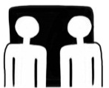 | Do this activity in pairs.
 | Do this activity by yourself.
Do this activity using the internet.
If you are not connected to the internet, your trainer will provide you with another activity.
Do this activity in your workplace.
If you are not in a workplace, your trainer will provide you with another activity.

What you will learn
A lot of different supplies are received and stored in a hospitality business. These supplies can be:
- food – fresh, frozen or dry
- non-food e.g. paper goods, drinks, kitchen equipment or cleaning materials.

It is important to receive and store these supplies properly so that:
- food stays safe for customers to eat
- goods are not damaged, spoiled and wasted.
In this workbook, you will learn how to:
- check that a delivery of supplies matches the order
- check that supplies received are in good condition
- store supplies so that they stay in good condition
- rotate (move around) supplies so that older stock is used before newer stock
- maintain storage areas in a clean and safe condition
- work safely so you don’t get injured
- dispose correctly of spoiled or damaged stock
- follow the laws relating to this work.

1 The laws about storing food
There are laws that set standards for receiving and storing food so that the food remains safe to eat.
The Food Act
This law sets minimum (lowest level) standards for food storage, and hygienic (clean) food handling practices. Each state has its own Food Act, but they all require food businesses to make sure that the food they sell is safe to eat.
Australia New Zealand Food Standards Code (ANZFSC)
This code contains detailed regulations for a food business to operate safely, including receiving and storing food. The Food Act in each state is based on this code.
Further information can be found at:
Food Standards Australia and New Zealand (FSANZ) <www.foodstandards.gov.au>
Food Safety Program (FSP)
Food businesses must have a food safety program, which shows their food safety and hygiene practices and procedures. In most states this program must be written, but in some states the business must notify the government department of their food safety activities.
The program usually requires businesses to record information such as food delivery times, food storage temperatures and cleaning schedules.
Your employer will train you in how to follow the food safety program.
Environmental Health Officers
Environmental Health Officers usually work for local councils. They check that food businesses in their area are following the food safety laws. They make sure food sold to people is safe to eat and that the kitchens and storage areas are clean and well maintained.
It is an offence to:
- store food at unsafe temperatures
- have unclean food storage areas
- not keep the required records.
If the officers are not happy with the food safety and hygiene of a business, they can fine the owners and even close the business.

Who can you report food safety issues to?
You can report a food safety issue to your manager, supervisor, chef, owner or purchasing officer. Each workplace will have its own procedure (way of doing things).

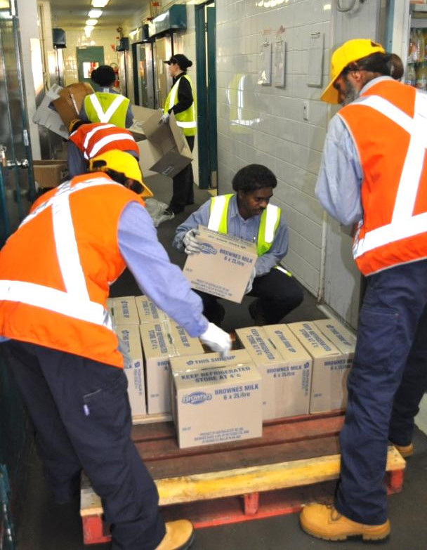

2 Supplies and storage areas

Supplies
Many goods come into a hospitality business to provide a service to customers. These are all called supplies. These supplies cost the business money and must be treated properly so that they are not damaged, spoiled or lost.
There are four types of supplies, which must be handled differently. They are:
- frozen food
- perishable and semi-perishable food
- non-perishable food
- non-food supplies.

1. Frozen food
Some foods arrive frozen, for example:
- chicken, meat, fish and seafood
- ice-cream and deserts
- fruit and vegetables.
Frozen food must be kept between –15ºC and –18ºC so it stays frozen until ready to use. If frozen food starts to thaw, germs can grow in it and make the food unsafe to eat.
It must be moved from a refrigerated truck directly into a freezer.

2. Perishable food
Perishable food can go bad quickly if left at room temperature. Perishable food includes:
- fresh fruit and vegetables
- fresh meat and fish
- dairy products e.g. milk, yoghurt and cream
- freshly cooked food.
Perishable food should be stored in the refrigerator between 0ºC and 5ºC. Some fresh fruit and vegetables can be stored in a coolroom rather than a refrigerator.
The most perishable foods are fresh, moist and have high protein. They include meat and fish. Even when stored in a fridge, these only last between two and four days.

3. Semi-perishable food
Semi-perishable food can go bad within a few days at room temperature. These foods should be stored in a coolroom at a low temperature and can usually last for a week or longer, depending on the type of food.
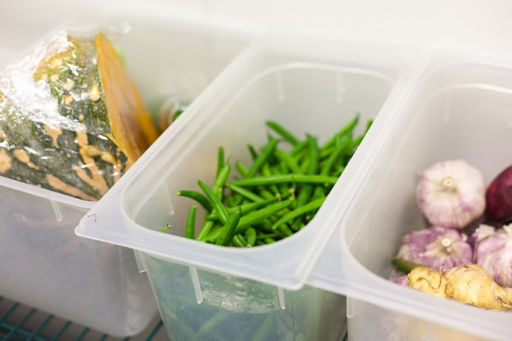
Semi-perishable food includes:
- eggs
- cheese
- unsliced smallgoods e.g. salami
- fruit and vegetables
- nuts
- butter
- cooking oil.

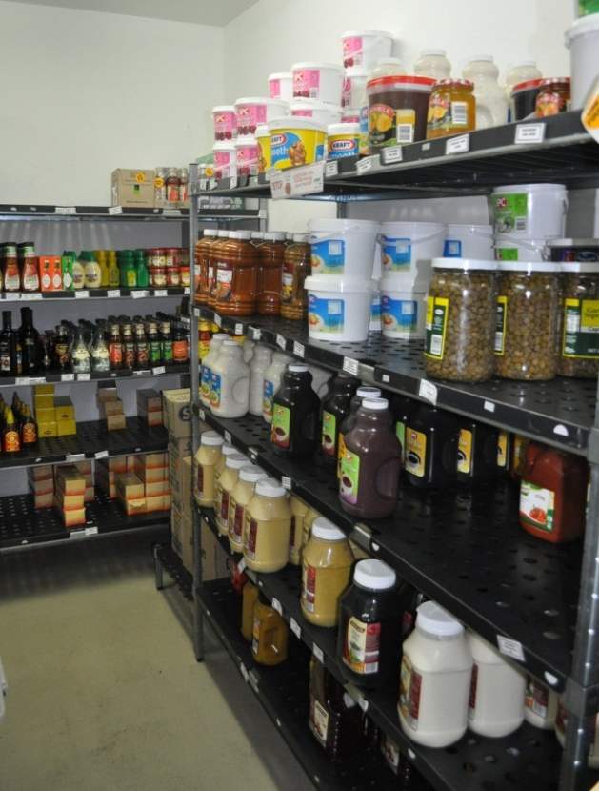
4. Non-perishable food
Non-perishable food does not go bad quickly, even if kept at room temperature. These foods are also called dry goods. They include things like:
- flour
- sugar
- uncooked rice
- dried beans
- uncooked pasta
- bottled and tinned food
- dried food.

5. Non-food supplies
A lot of non-food supplies are also used in
hospitality workplaces.
Most non-food supplies can be stored in a dry storage area, stored separately to food. They should be on shelves and labelled appropriately.
Cleaning materials and other chemicals must be stored in a separate place away from food.

Activity 1
Non-food supplies
The Sunrise Café is open from 8 am until 4 pm, serving morning tea and lunch. It does takeaways too. What non-food supplies might the owner need to order sometimes?
 | SUNRISE CAFÉ
Non-food supplies |  | Examples
Beverages (drinks)
Supplies for food preparation
Linen
Stationery and paper products
Cleaning materials and equipment

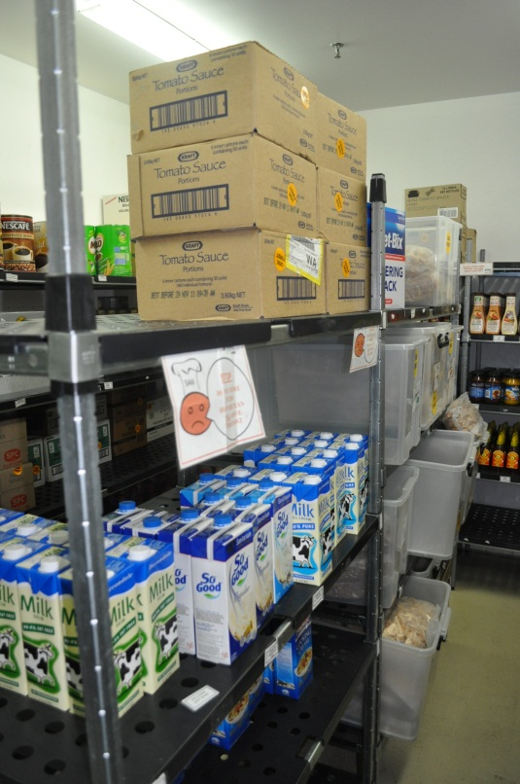

Activity 2
Supplies in your workplace
What supplies are used in your workplace?
Write some down in the correct columns. Later, compare with other learners to see how workplaces can be different.

Frozen food | Perishable food | Semi-perishable food | Non-perishable food | Other supplies  (not food)

Suppliers
Suppliers are the people or organisations that supply the goods. They could be supermarket chains, local farmers, catering supply companies, soft drink companies, butchers and bakeries.
Under the Food Standards Code, hospitality businesses need to be sure that supplies they receive are safe to use. Businesses choose a supplier, try them out and if they are happy with them, they order from the same people each time. These are the approved suppliers for the business.
The hospitality business keeps a list with each supplier’s contact details and the food they supply. If there is a problem with the food, the business knows where it came from.
Here is part of an approved supplier list for the Sunrise Café.
Sunrise Café
APPROVED SUPPLIER LIST
Supplier |  | Contact details | Goods supplied | Special instructions
Di Matteo Coffee Supplies |  | 23 Main Road  Parkland  Tel: 08 987 65543 | Coffee beans | Beans must be freshly roasted  Supply on demand
Artikas Bakery |  | 340 Side Road  Parkland  Tel: 08 987 4589 | Bread  Rolls  Pastries | Deliver by 8 am each day  Goods must be baked on day of supply
Fresh Dairy Co |  | 53 Crossover Lane  Parkland  Tel: 08 987 5390 | Milk  Cream | Delivery by 8 am each day  Refrigerated truck

Specifications
These are the instructions you give to the suppliers about the type, quality and amount of the goods you need. The chef will often give details about the food they order. For example, if the chef orders apples, they will have to specify (say exactly) things like:
- the type – Pink Lady
- the quality – First Grade
- the quantity – 3 cases.
The specifications might include:
- delivery time – by 2 pm
- method of transport or arrival temperature – Frozen meat must be transported in a refrigerated truck and be below –15ºC when it arrives.

Storage areas
When supplies arrive, they should be put into the correct storage areas quickly so that they stay in good condition. There is generally a storage area for the different types of supplies. These storage areas include:
- refrigerator (fridge)
- coolroom
- freezer
- dry goods storeroom
- chemical store.
Storage areas should have:
- shelves that can be reached easily and are adjustable
- enough room so that nothing is stored on the floor
- walls, ceiling and floor in good condition, with no cracks where pests or dust can get in
- equipment for moving supplies such as:
- ladders and steps so that top shelves can be reached
- scales for weighing stores as they are received
- trolleys for moving heavy items.

Safe food temperatures
Different foods need to be kept at different temperatures so they stay safe for people to eat.
Hot food  Must be kept at 60°C or hotter | 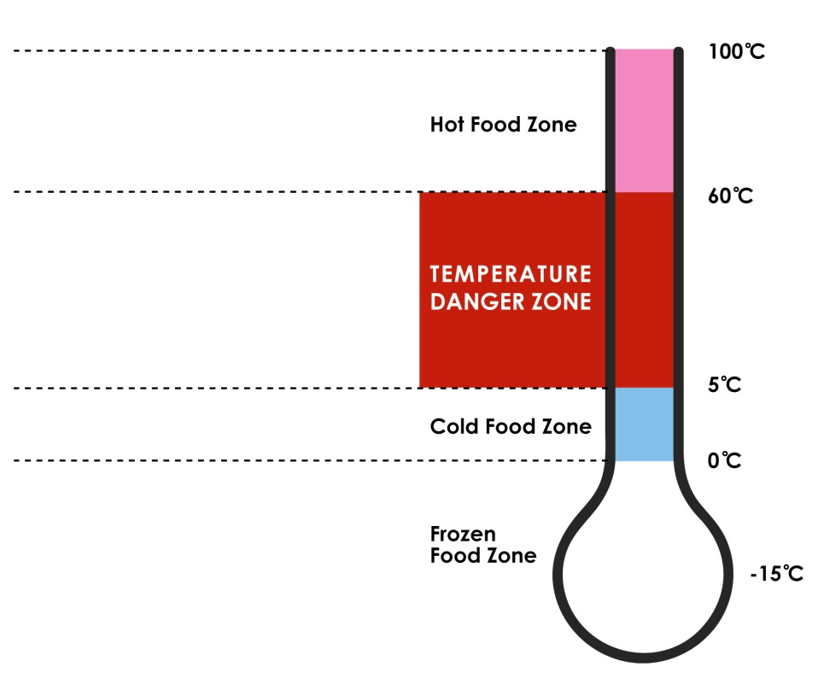
Danger zone
Food between 5°C and 60°C is in the danger zone – germs will grow easily and quickly on food in this temperature range
Cold food
Must be kept between 0°C and 5°C
0°C to –15°C
Frozen food
Must be –15°C or colder (this figure may differ between states and territories).
Fridge
This is usually a freestanding unit. It should operate between 0ºC and 5ºC.
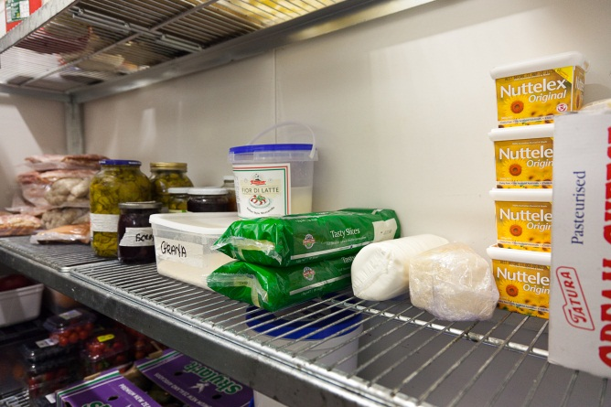
A large business may have several fridges for different types of food.
The fridge temperature should be checked at least twice a day and recorded on a chart or temperature log. This is part of the kitchen’s food safety program. The first check should be at the beginning of the day when the temperature will be at its lowest because the door has not been opened overnight.
Each workplace will have its own procedures and you will be shown how to do this check.

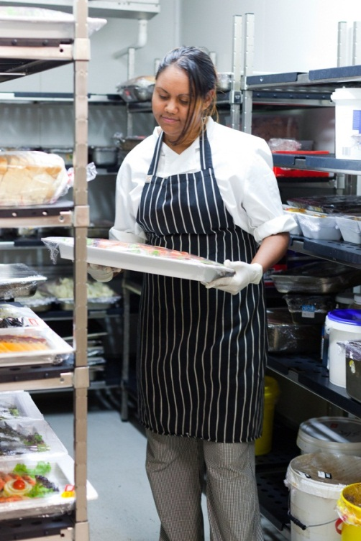
Coolroom
This is usually a walk-in cold storage area.

The coolroom should also operate between 0ºC and 5ºC. The temperature should be checked and regularly recorded.

There is usually a thermostat outside the door so you can read the temperature without opening the door.

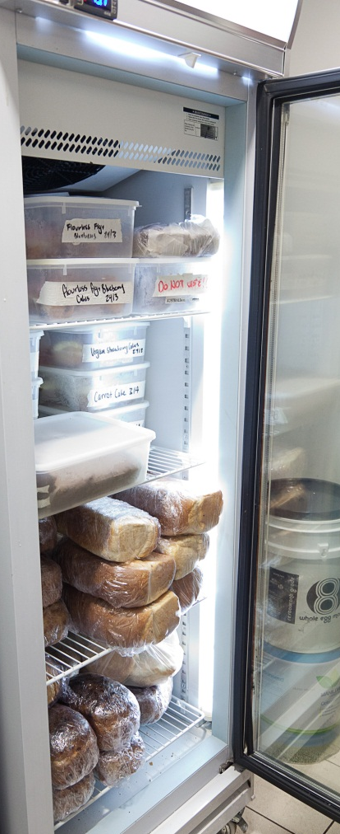

Freezer
The freezer is used to freeze food and to store frozen supplies.
The freezer should be between –15ºC and –18ºC.

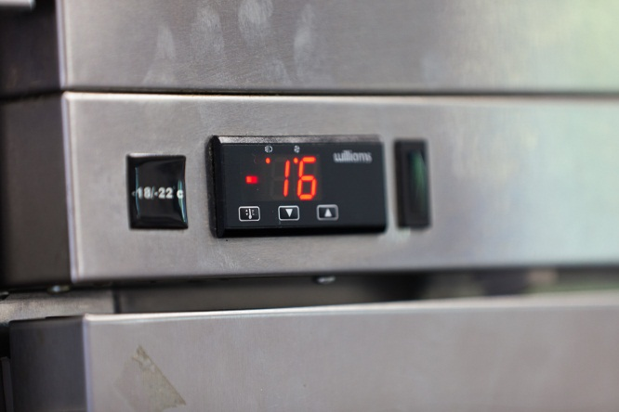

Dry goods store
Non-perishable food and other supplies (except cleaning products and chemicals) are stored in a dry goods store. This area is not refrigerated. The dry goods store should be cool, at around 15ºC to 21ºC.
It should have no direct sunlight coming in through windows. It should be well-ventilated (fresh air can come in) so that smells go away and things don’t get damp.
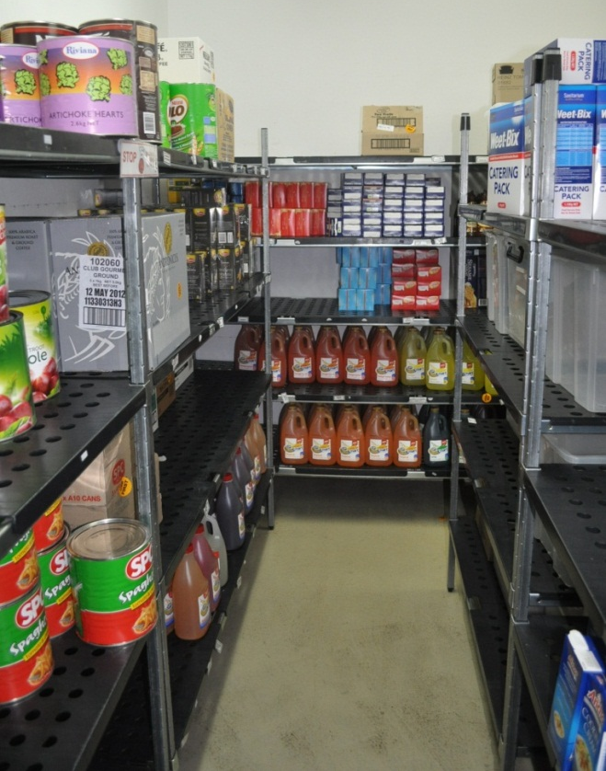

Chemical store
All chemicals, such as cleaning products, must be stored away from food.
The chemical storage area must be secure and have clear signs.
It should be well-ventilated and have good light so you can read the labels easily.

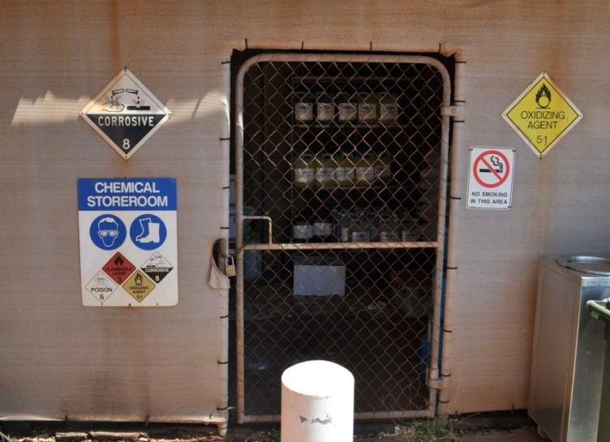

Temperature log
It may be your job to regularly check and record temperatures of the fridge, coolroom and freezer.
Here is the temperature log for one day at Sunrise Café.
 | Sunrise Café  TEMPERATURE LOG |  |  |  |  |  |  |  | Week starting: 3 Jan 2012
Area | Time | Temperature (ºC) |  |  |  |  |  |  | Corrective action | Initials
 |  | M | T | W | T | F | S | S
Refrigerator | 9.00 am | 2ºC | 2ºC | 2ºC | 2ºC | 2ºC | 2ºC | 2ºC |  | BJ
 | 4.00 pm | 4ºC | 5ºC | 4ºC | 3ºC | 3ºC | 4ºC | 4ºC |  | BJ
Coolroom | 9.00 am | 2ºC | 2ºC | 2ºC | 2ºC | 2ºC | 3ºC | 3ºC |  | BJ
 | 4.00 pm | 5ºC | 4ºC | 3ºC | 4ºC | 5ºC | 5ºC | 8ºC | 9/1/12 Call maintenance to check thermostat | BJ
Freezer | 9.00 am | –20ºC | –20ºC | –20ºC | –20ºC | –20ºC | –20ºC | –20ºC |  | BJ
 | 4.00 pm | –18ºC | –17ºC | –17ºC | –17ºC | –18ºC | –18ºC | –18ºC |  | BJ

Activity 3
Temperature and food

1. Why did BJ ask maintenance to check the coolroom thermostat on 9 January?

2. What are some possible problems if these foods are not stored at the correct temperature?
Food | Possible problems
Frozen chicken
Butter
Oysters and sushi prepared this morning for tonight’s meals
Cake
Carrots and celery
Bananas

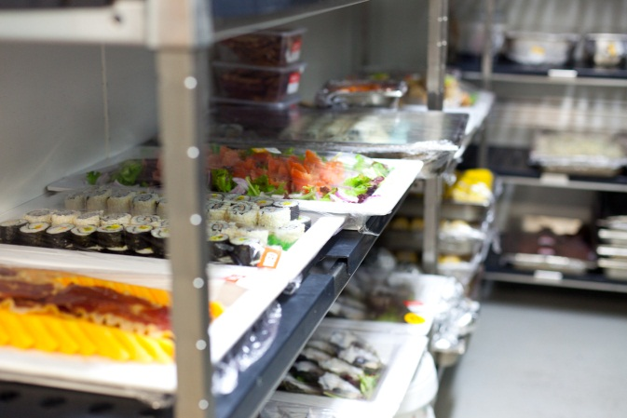

Maintain storage areas
All storage areas must be kept clean, at the right temperature and free from pests such as insects and rats.
The storage area needs to be … | How will I do this?
Clean | - Sweep and clean floor after each delivery.  - Remove trip hazards e.g. clear up empty boxes and packing material after a delivery and put in recycling bins.  - Make sure nothing is stored on the floor.  - Make sure nothing blocks exits or walkways.  - Keep shelves tidy and orderly so supplies are easily located.  - Check for defects or damage and report it e.g. loose or rusty shelving, broken locks, blown light globes or damaged containers.  - Clean up any spills promptly.
At the right temperature | - Check the temperature of cool areas regularly.  - Keep seals around doors clean and report any damage.  - Keep shelves uncluttered so air can circulate well.
Free from pests | - Check for and report cracks in walls, ceilings or floors where insects might breed or get in it.  - Report any sign of pests e.g. mouse droppings, cobwebs, grubs or chewed containers.  - Clean up any food spills promptly.  - Report any damage to flyscreens or door seals.  - Check lids on containers are tight.

Activity 4
Your workplace storage areas
- What storage areas are there in your workplace?
- What is stored in each area?
- Put a tick () in the last 3 columns to show whether the area is clean, at the right temperature and free from pests.
CL – Is the area clean?
RT – Is the area at the right temperature?
FFP – Is the area free from pests?
- Later, compare notes with other learners to see how workplaces can be different.
Storage area | What is stored there | CL | RT | FFP

Activity 5
Where will I put it?
Your trainer will organise you in groups to do an activity about storing supplies in the correct storage area.

Section summary
Now you have completed this section you should have developed the following skills and knowledge.
Tick each box if you are satisfied that you have those skills and knowledge.

Describe what supplies come into a hospitality workplace.
Know where supplies are kept.
Identify safe temperatures for different kinds of foods.
Maintain storage areas properly.
Notes

3 Receiving supplies
Receiving supplies is an important task in a hospitality workplace. You have to check that the right goods have been sent and that they are in good condition. Once the goods have been accepted, they have to be paid for.
Every workplace will have its own procedure for receiving supplies. The basic stages are:
1. Prepare for the delivery.
2. Check documentation:
- check and record supplier details
- check delivery docket against order form
- check actual delivery against delivery docket.
3. Do temperature checks.
4. Check quality of goods.
5. Deal with any problems.
6. Sign off on delivery (maybe you, or someone else with the authority).

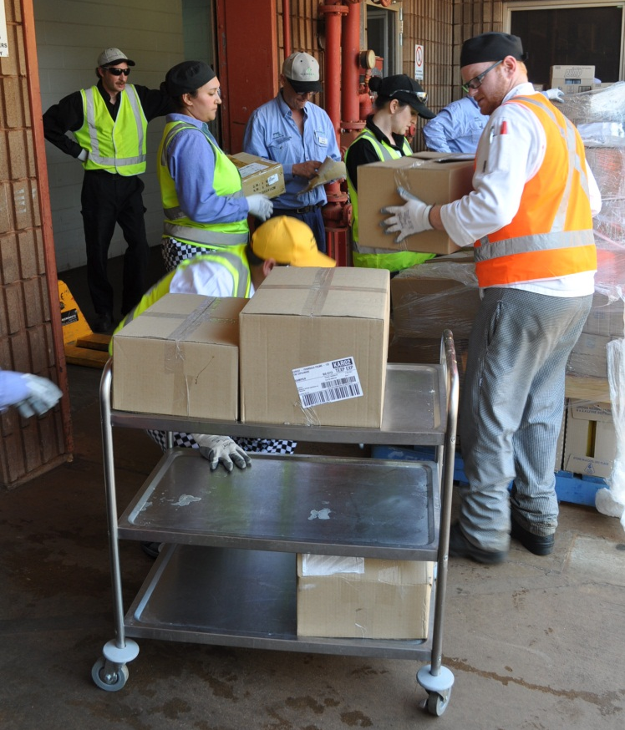
Prepare for the delivery
Often deliveries arrive at an arranged time, so everything will go more quickly and smoothly if you plan ahead and have everything you need ready.
If you rush or are not careful when you receive supplies, you might make mistakes when you are checking documentation or quality.

Activity 6
Prepare for a delivery
When you are preparing for a delivery, why do you need to do each thing?
Fill in the gaps in the Why? column.
Do this … | Why?
- Plan your own workload. | So that you have enough time to check and store the supplies properly.
- Have a copy of the order forms and any other documents ready.
- Make sure the receiving area is clear.
- Have any equipment ready such as:  - forklifts and trolleys  - thermometers  - hand-held scanners  - box-cutters  - scales. | - For moving heavy things  - To check food temperatures  - If you receive supplies electronically  - To remove packaging  - For checking weights
- Have the personal protective equipment (PPE) ready, including strong gloves and boots.

NOTE
Delivery drivers may be very busy.
They might try to pressure you to accept the supplies without checking them.
Make sure you check everything before the delivery driver leaves.
If there is a problem, let your supervisor know immediately.

Check documentation
Orders and deliveries have to be recorded and checked. Filling in the wrong form or filling in a form incorrectly can cost the business time and money, so it is important to know what each form is for and what you should do with them.
There are 3 main types of forms you might have to deal with:

Form | What is on this? | What do you do with it?
Order form (purchase order) | Your workplace uses this form to order stock from suppliers. | Check the supplier and the items on the delivery docket match this.
Delivery docket | The supplier sends this with their delivery. It lists all the items in the delivery. | Check the items on the delivery docket match the order form.
Invoice | This is a bill. It lists each item, the prices and the total amount to be paid by your workplace. Sometimes the supplier sends this form with the delivery and sometimes they send it separately. | If the invoice comes with the delivery, give it to your supervisor or the person responsible for paying the bills.

Before you accept a delivery, you need to check that what has been delivered is exactly what your business ordered. You do this in 2 ways:

1. Check delivery docket against order form
- Take the delivery docket from the driver.
- Check that supplier details are exactly the same as on the order form.
- Then check that the goods listed on the delivery docket are exactly the same as those listed on the order form.

2. Check actual delivery against delivery docket
- As goods are unloaded, note the quantity (number, size or weight) and brand of each item.
- If the item matches the delivery docket, tick the item off.
- If something is incorrect, note it on the delivery docket.

Order form
The order form lists the things that your workplace has ordered, with descriptions, brands, quantities, weights and anything else that makes it clear what is wanted.
An order might be:
- filled out by hand – there should be a carbon copy or photocopy to use for checking when the goods arrive
- filled in on a computer – you can print out a copy to check goods received
- made on the telephone – an order form must still be filled in so the business has accurate records and the delivery can be checked against the order.
Here is an order form from the Sunrise Café.
 | Sunrise Café  PURCHASE ORDER No. SC3467 |  |  | 32 Main Road  Parkland 8333  Phone: 08 987 3456
To: Artikas Bakery
340 Side Road, Parkland 8333
Tel: 08 987 4589
Order to be delivered: 4th January
Quantity |  | Unit | Description
10 |  | Loaf | White bread, sliced, fresh home baked
10 |  | Loaf | Wholemeal bread, sliced, fresh home baked
2 |  | Dozen | Croissants , plain, fresh home baked
2 |  | Dozen | Mixed pastries, fruit, fresh home baked
5 |  | Dozen | Rolls, mixed – white, wholemeal, multigrain, fresh home baked
2 |  | Box of 10 | Jam tarts, fresh home baked
Delivery instructions
Delivery before 7 am. Come to kitchen back door to get receiving staff, entrance in lane behind café.
Authorised by: J Brown Date: 3rd January

Delivery docket
A delivery docket is the supplier’s list of the goods they are delivering. The delivery docket should come with the delivery. It should show:
- the number of items
- a brief description of them.
The delivery docket is signed by someone in the receiving business after they have checked that the items are of the correct quantity, size, weight and quality.
Here is a delivery docket from Artikas Bakery for a delivery of bread and other bakery items to the Sunrise Café.
Artikas Bakery  DELIVERY DOCKET Delivery No. 12-34567 |  |  |  | 340 Side Road  Parkland 8333  Tel: 08 987 4589
Delivery for:  Sunrise Café  32 Main Road  Parkland 8333  Tel: 08 987 3456 |  |  | Order No: SC3467  Date: 4th January
Delivery instructions:
Before 7 am. Come to kitchen back door to get receiving staff, entrance in lane behind café.
Quantity | Unit | Specifications
10 | Loaf | White bread, sliced, fresh home baked
5 | Loaf | Wholegrain bread, fresh home baked
2 | Dozen | Croissants , ½ plain ½ chocolate, fresh home baked
2 | Dozen | Mixed pastries, fresh home baked
5 | Dozen | Rolls, mixed – white, wholemeal, fresh home baked
2 | Box of 10 | Jam tarts, fresh home baked
Signature of supplier: B Artikas
Signature of recipient: ____________________________

Activity 7
Check documentation (1)
Check the order form from the Sunrise Café against the delivery docket from Artikas Bakery.

Did the Sunrise Café get exactly what it ordered?

Mark any differences you find on both documents.
Invoice
An invoice is the bill to be paid for the goods delivered. It shows the cost of the goods and any other costs such as delivery costs and taxes. Frequent suppliers sometimes send a monthly invoice instead of sending one every time goods are delivered.
Someone in your workplace, such as the accounts department or manager, will be responsible for checking prices and paying these bills.
If the invoice comes with the goods, you should take it and give it to that person or your supervisor.
Look out for this sign on a box:
INVOICE ENCLOSED
If you see this sign on a box, you must look for the invoice. It is often sealed in a plastic bag and attached to the outside of the box.
Sometimes the invoice and delivery docket are combined into one document.

Incoming Goods Record
Some workplaces enter details of deliveries on an Incoming Goods Record.
Here is the Incoming Goods Record for Sunrise Café.
Sunrise Café
INCOMING GOODS RECORD
Date | Time |  | Supplier | Temp ºC | Product | Visual check | Accepted/ rejected | Designated storage area | Corrective action | Checked by
3/12 | 8 am |  | Fresh Dairy | 4º | Milk, cream |  |  | Fridge | None | AK
3/12 | 11 am |  | Di Matteo Coffee Supplies | n/a | Coffee beans |  | with adjustments | Dry goods store | Wrong quantity delivered, adjust invoice | AK
3/12 | 11.15 am |  | The Fruit Shed | n/a | Tomatoes  Lettuce | × | × | Coolroom | Lettuce returned to supplier. Not fresh. Delivery was late.  Talk to manager – find another supplier? | AK
3/12 | 11.30 am |  | Bison Butcher | 3º | Raw beef |  |  | Fridge | None | AK

Activity 8
Incoming goods record
Fill in the details of the delivery from the Artikas Bakery in the previous incoming goods record.

Activity 9
Check documentation (2)
Your trainer will give you another order form or delivery docket for Sunrise Café.
Some mistakes have been made in the delivery. The delivery docket shows some differences between what was ordered and what was delivered.
Mark the things that are wrong on the delivery docket. One has been done for you.

Check delivery items against delivery docket
Once you have checked the paperwork, you need to physically check the supplies against the delivery docket. You must check the following:
Check this |  | How?
Quantity (number) | Number | Count boxes or other goods.
 | Weight | Check the weight on packaged goods.  Weigh loose goods.  Get to know the weight of food containers.
 | Size | Check size specifications e.g. if the delivery is 400 gm tins tomatoes instead of 800 gm.
Quality | Brand | Check you receive the brands that were ordered.
 | Temperature | Use a thermometer.
 | Freshness | Look, smell, feel and check use-by dates.
 | Signs of pests, damage to product or containers | Do a visual inspection.

As you count, weigh and check size and brands, mark items off on the delivery docket.
If the wrong number, weight, size or brand has been sent, make a note on the delivery docket. Report it to your supervisor later.
In some workplaces, goods are checked using a hand-held scanner to scan the bar code on the product. If you have to use a scanner you will be shown how to use it correctly.
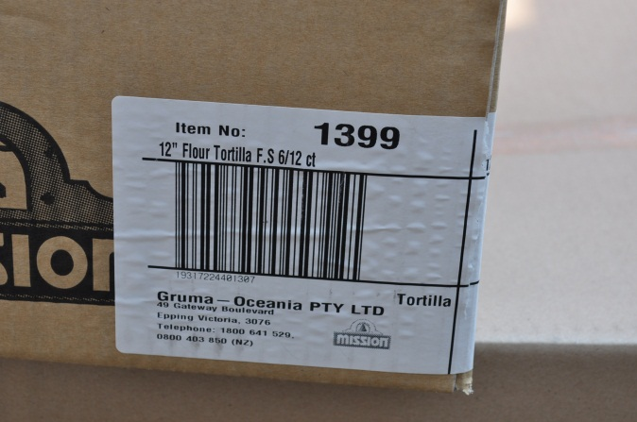

Do temperature checks
Under the Food Safety Code, food businesses must have an accurate (correct) thermometer to measure the temperature of high risk foods.

Frozen food
Must remain frozen, not be partly thawed. It should be at
–15ºC or lower when it is delivered. It should be checked and stored first so that it stays frozen.
- Feel it – it should feel hard, not slightly thawing (melting).
- Check that there are no juices or drips around the food.
- Put the thermometer between frozen goods – don’t stick it into them.
- Check for ‘freezer burn’. This shows as a change in colour. The food has not been correctly packaged and has dried out.

Cold food
Must be at 5ºC or below when it arrives. High risk cold food includes:
- meat
- poultry
- fish and other seafood
- dairy products
- cooked rice and pasta
- smallgoods
- any food containing these items.

Hot food
Hot food includes food that has been cooked ready for serving.
This food must be at 60ºC or above when delivered and must be kept above 60ºC.

Using a thermometer
- Make sure the thermometer is clean and dry.
- Clean and sanitise the thermometer after each use.
- Put the thermometer in the food and wait until the temperature reading has become steady before reading the temperature.
- Measure different parts of the food, as the temperature may not be the same. Don’t just check the middle.
- You may have to stir some foods to get an accurate reading.
- Don’t pierce the packaging of any vacuum-packed or frozen food. Instead, put the thermometer between two packages.
- If you’re taking the temperature of both hot and cold foods, wait for the thermometer to return to room temperature before using it.
- For large deliveries, test a sample of items from different parts of the delivery truck.

The temperature of goods should be entered on the incoming goods record.
Have a look at the previous incoming goods record for Sunrise Café. Which goods have been checked for temperature?

Check freshness of food
You can check the freshness of food through these methods:
- visual inspection – see if something looks wrong
- pick up some items and handle them to see if they feel right
- smell items to see if they smell right and smell fresh
- move cartons to check that there is no damage to the contents (things inside).

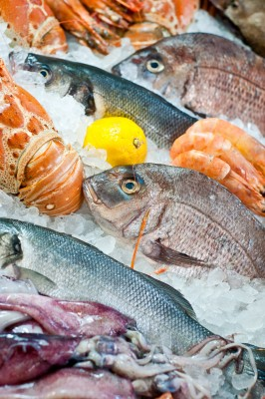
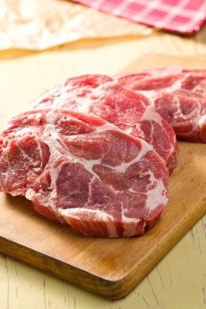

Check quality of food
Checking the quality of fresh food is important. Here are some of the things to look for.
Meat poultry and seafood
Beef | A bright red colour  Firm to touch  Creamy/white fat  Does not smell strongly or feel slimy
Lamb | Rose pink flesh  Creamy/white and waxy fat
Pork | Light pink flesh  Creamy/white and soft fat
Poultry  (includes chicken and turkey) | Should not:  - smell strongly  - feel sticky  - have any bruises or dark colours on the skin.
Fish | Should have:  - round, bright, shiny eyes  - firm and springy flesh if you touch it  - bright red gills  - shiny skin and scales  - a fresh sea smell.
Other seafood (includes things like prawns, oysters and crayfish) | - Should not have much smell, just a fresh seaweed smell.  - Shellfish such as mussels and clams should be closed when delivered.  - If there is a lot of water around fish or seafood, it might have been frozen then thawed.

Dairy food
Check the use-by date on milk, cream, yoghurt and other dairy food.
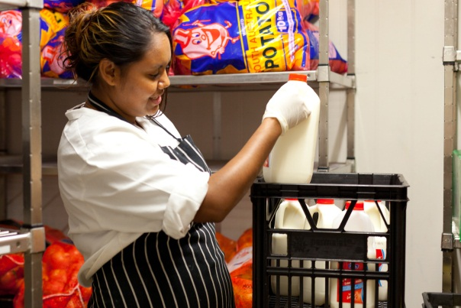

Fruit, vegetables and herbs
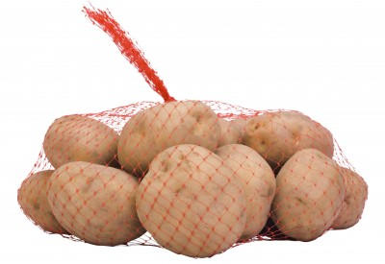
- They should be firm and bright in colour, with no wilting.
- Skin should not be broken or bruised.
- They should smell fresh.
- Potatoes must not have any green skin or sprouting.

The quality of goods can be entered on the incoming goods record.
Have a look at the incoming goods record for Sunrise Café. Which goods have been passed as good quality? Which ones have a quality problem?

Check for damage or defects
Here are some extra checks you should make. Watch out for:
- damaged packaging e.g. dented cans or torn plastic bags of vegetables
- broken containers e.g. glass bottles or jars (listen for broken glass when you are moving a carton of jars or bottles)
- damaged or broken food e.g. eggs or bruised fruit
- cartons that have been opened and resealed (something may have been taken out or damaged)
- evidence of pests e.g. bags chewed by mice or insects
- food not delivered in clean, covered containers
- dirty delivery vehicles.

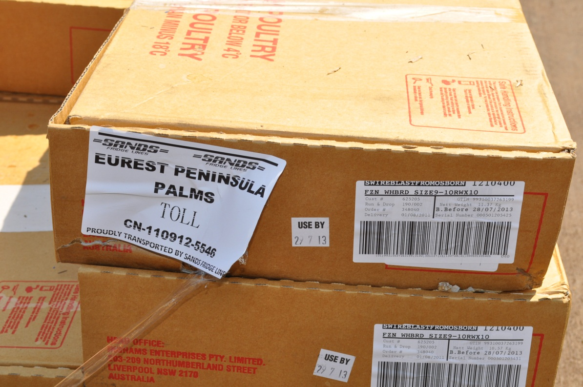

Deal with delivery problems
Problems can include:
- contaminated food
- food at the wrong temperature
- wrong supplies e.g. incorrect weights, quantities or brands
- poor quality produce
- damaged packaging.
These problems must be dealt with quickly and calmly. Depending on the procedures in your workplace, you, or the person responsible, can:

a. Return goods to the supplier and:
- ask the supplier to send the correct item
- accept a credit note (which means you can buy something else of the same value at another time)
- cross the product and its price off the invoice and change the total to pay.

OR

b. Accept the product because it is incorrect but not unsafe to use or eat.
The problem and its solution should be recorded on the purchase order, delivery docket and tax invoice if possible. The receiver and supplier should both sign for any changes to an order and delivery.
If suppliers often make mistakes, your manager or chef might decide to change suppliers.

Activity 10
Dealing with delivery problems
Here are some examples of things that can go wrong when you are receiving supplies. Talk together about some things you can do if these problems happen. Also talk about why you will take this action.
Delivery problem | What will you do? | Why?
- Vegetables came on an open truck so they are dusty.
- Fresh meat arrived at 7ºC.
- The top layer of frozen chicken breasts has thawed a bit.
- A carton of potato chips has been crushed in the truck.
- You get three deliveries at the same time – bakery, fruit and veg, and dairy.
- A carton falls off the forklift and some tins of baked beans are dented.
- The rice is in small packets so the total price is higher.
- Not enough milk has been delivered.
- The wrong brand of juice has been delivered.
- The use-by date on cream is in two days.
- Some eggs are cracked – you only discover this after the truck has gone.

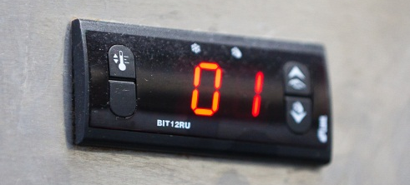
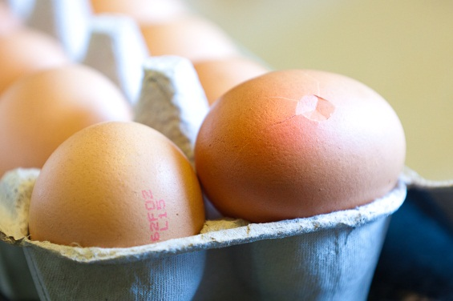

Section summary
Now you have completed this section you should have developed the following skills and knowledge.
Tick each box if you are satisfied that you have those skills and knowledge.
Take delivery of supplies.
Carry out the required checks on deliveries.
Record information about supplies received.
Take correct action if something goes wrong with the delivery of supplies.
Notes

4 Storing supplies
When the supplies arrive, they have to be put away quickly in the right place so food stays safe to eat and goods don’t get damaged or stolen. It is very important to do this safely.

Safe manual handling
When you unpack goods, move them to storage and stack them on shelves, it involves lifting, pushing, pulling, carrying or holding goods. This is called manual handling.
Your workplace should train you in correct manual lifting and carrying techniques. This is an occupational health and safety (OHS) requirement under law. Each workplace will also have its own OHS procedures for you to follow.

Common manual handling injuries
These are some common injuries from lifting and carrying heavy things or twisting your body while carrying something. You might:
- strain your back, neck, shoulders or arms
- tear your muscles or tendons
- lose your balance and fall over
- slip or trip over something
- drop something on your foot or on someone else
- cut your hands on containers.

NOTE
One in three injuries to Australian workers is caused by manual handling.
Inexperienced workers are at greatest risk.
Source: <http://www.betterhealth.vic.gov.au>

Activity 11
PPE for manual handling
Look at the photos in this workbook.
What PPE are people wearing when they are unpacking deliveries?
Reduce the risk
It is better to reduce (cut down) or eliminate (get rid of) the risk of an injury by changing things to make the task safer. You can:
Change the task | Does this task need to be done this way? Can we think of other ways to do it that reduce the risk of injury?
Change the load | Repack a heavy load into smaller units.
Change the workspace | Are benches and shelves at the right height to reduce bending or stretching? Can ramps, walkways, doorways or lighting be improved?
Use mechanical aids | Use trolleys or forklifts.
Follow your training | Wear correct PPE.  Perform lifting and carrying tasks according to your workplace training and procedures.
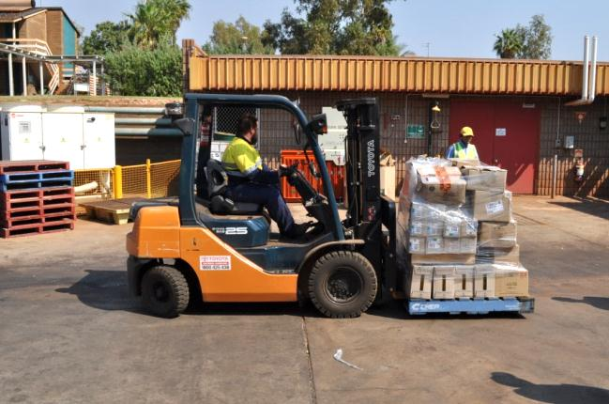

Safe lifting and carrying
Here are some general guidelines for safe lifting and carrying.
STEP | EXPLAIN
- Look at the load carefully | What size and shape is the load?  Do you know its weight? Does it look like it will be heavy?  Are there any sharp edges?  Do you need help to lift and carry it?
- Plan your route | Where are you going to carry the goods to?  Is there anything in the way that you could trip over? Any steps or other obstacles?
- Bend your knees | Keep your feet apart and in a comfortable position.  Bend your knees into a semi squat.  Don’t bend your lower back if possible.  Get a good grip on the load.
- Raise the load with your legs | Straighten your legs.  Lift smoothly without jerking your body.  Bend your back as little as possible.
- Hold the load as close to your body as possible | A load strains your back and arms more if you hold it away from your body.
- Turn your feet in the direction you want to move in | Change directions by turning your feet, not your back. Don’t twist your body.  Look straight ahead as you are carrying the load. If you can’t see over it, don’t carry it.
- Put the load down | Bend your knees again, not your back. Squat down and keep your head up. Let your legs do the work.

What load is too heavy?
There is no maximum weight limit for lifting goods. It depends on the size and strength of the person. WorkSafe authorities recommend that one person should not lift a load over 16 kg.
If the load is too heavy for you, you must not lift it.

Do a trial lift
If you are not sure about the weight of a load, do a trial lift first to get an idea of how heavy it is.
Try to pick up the load a little bit OR push the load a short distance with your foot.
If it feels too heavy, don’t lift it.

Use mechanical aids
Mechanical aids such as forklifts and trolleys can save your back. Forklift trucks can only be driven by people with a forklift licence. Be careful around forklift trucks. Don’t walk in front of them or under the load.
Here are some guidelines for using a trolley safely.
- Don’t overload the trolley. Make two trips rather than overload a single trip.
- Put the heaviest items on the bottom. This will help stop the trolley turning over and it means heavy things won’t fall off onto someone’s foot.
- Always push the trolley, don’t pull it. Walking forward places less strain on your body and you can see where you are going.
- Never use a damaged trolley e.g. if the wheels don’t go straight.
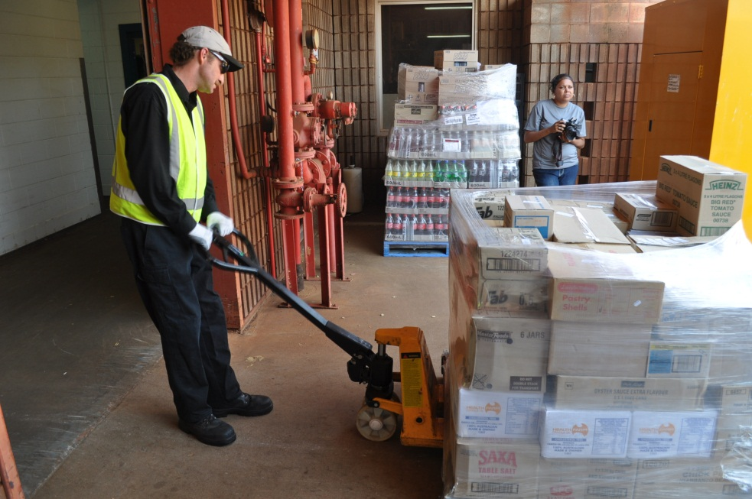

Do a team lift
You can ask someone else to help you lift and carry goods. This is called a team lift. Here are some guidelines to make team lifting safe for both people.
- If possible, you should both be about the same size and build.
- One person should give the directions, so decide who that will be. Make sure the instructions are clear so you are both doing the same thing.
- Follow safe lifting and carrying procedures. Bend from the knees, not the back, and keep your back as straight as possible.
- Make sure you both have a good grip on the goods.

Activity 12
What are they doing wrong?
Here is a picture of some people lifting. But they are not doing it safely.
How could they hurt themselves?
Give these people some advice about how to lift safely.
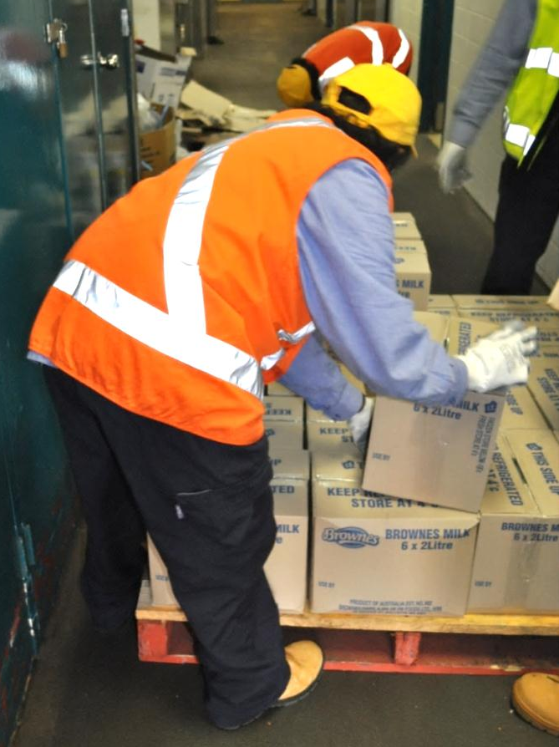

Unpack the goods
Unpack goods carefully.
Some goods can stay in their packaging to be moved to the storeroom, such as cartons of tinned food. Other goods need to be unpacked where they arrive and you might have to cut wires or plastic covering. Be careful with the equipment and try not to damage the goods inside.
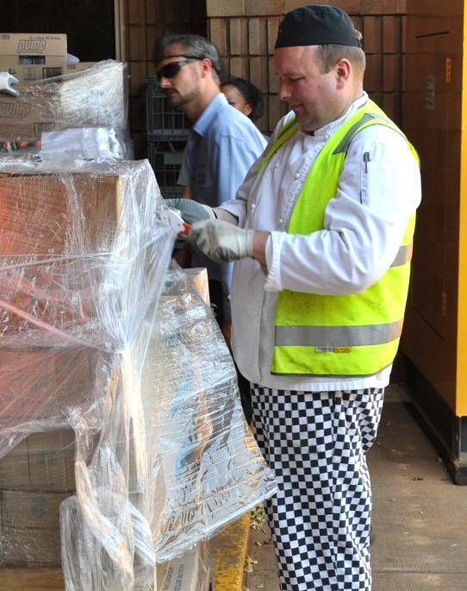
Remove packing material quickly so people can’t trip or slip on it. In the following picture, cardboard boxes have been flattened and stacked in a bin that will be taken away for recycling.
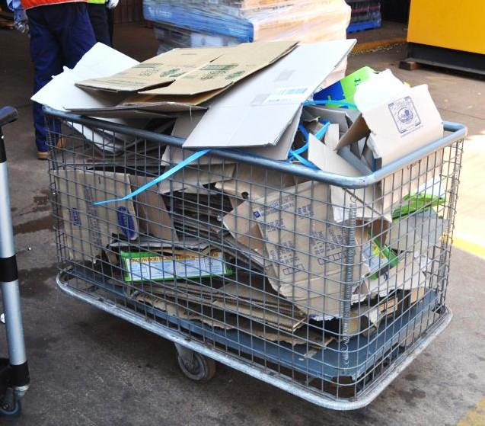
Check the area as you work and remove packing material such as nails, staples and metal strapping that could injure someone.

Put the goods away

Goods must be put away quickly. Otherwise:
- frozen food might thaw
- high risk food might wait too long before storage and rise in temperature
- there is a chance of contamination e.g. from dust, pests, animals or contact with chemicals such as flysprays or cleaning chemicals
- goods can start to block up the delivery area
- hazards develop e.g. boxes that people can trip over
- there is a chance of theft
- entrances to storage areas might be blocked so that kitchen staff can’t get to them.

Put things away in this order:
- Frozen food
- Perishable and hot food
- Semi-perishable food
- Non-perishable food
- Non-food items

Protect food from contamination
To prevent contamination of goods while they are waiting to be stored, make sure:
- the food is covered
- the food is moved and stored quickly in the correct order
- the food is never left unattended
- the food is not transported with chemicals
- staff have clean clothes and hands, and long hair is tied back from the face.

Storage guidelines
First In, First Out (FIFO)
Follow the First In, First Out (FIFO) process for all food so that older stock is used before new supplies. You should:
- move old stock forward and put the new supplies behind it
- lift existing stock up and put new supplies under it
- create a new storage area or stack for the new stock and clearly label it
- read the use-by or ‘best before’ dates on stock to decide which items to place in front
- label stock with delivery date, use-by date or ‘use first’ labels on older stock.
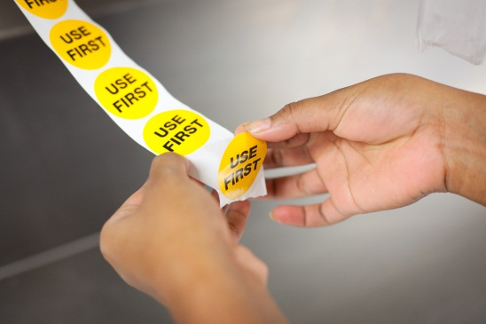

NOTE
Use-by date – food past this date can’t be used and must be thrown out.
Best before date – food past this date may be used but check that it is not damaged, deteriorated or perished.

Label supplies
Many frozen, perishable and semi-perishable supplies are already labelled with the delivery date and use-by date. But not all goods are labelled, so your workplace will have a labelling system. For example, with a large fresh meat delivery, the meat may be divided into smaller portions to be refrigerated or frozen, so you will need to label it.
Labels may contain:
- name of product and a description e.g. what is contained in cooked items
- date of delivery
- use-by date
- directions to staff, such as ‘Old bananas – save for cake’ or ‘This is for the party on Saturday’.
Labels should not come into direct contact with the goods.
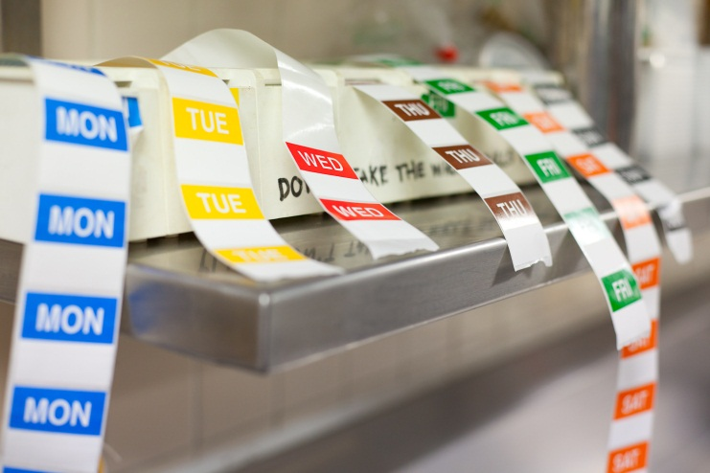

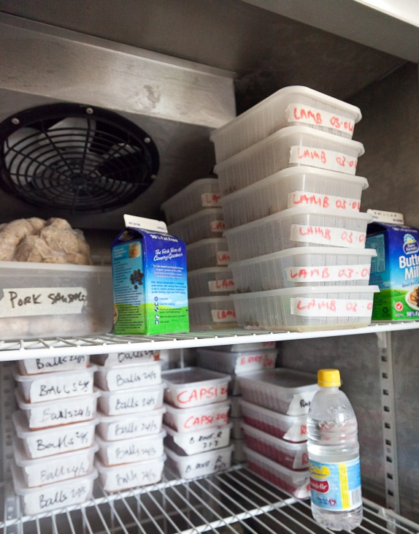
Frozen food
Frozen food goes into the freezer. You should:
- pack loosely to allow for air to circulate
- double wrap to prevent freezer burn
- label and date food.
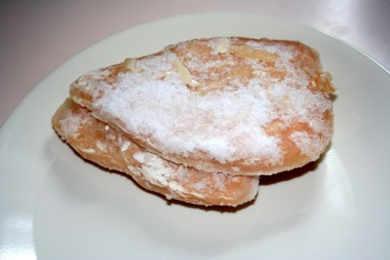

Perishable and semi-perishable food
Perishable and semi-perishable foods go into the fridge or coolroom.
You should:
- cover the food so it does not spoil and to prevent the transfer of smells
- label and date the food so you know what to use first
- keep food away from the coolroom floor and walls to allow air to circulate
- never store raw and cooked meat on the same tray
- store different types of meat separately
- store raw meat on bottom shelves and cooked meat on upper shelves to prevent the risk of cross-contamination by blood and juices dripping
- place meat and poultry in single layers on trays with the fat side up; cover the trays
- store fish in the coolest part of the coolroom.
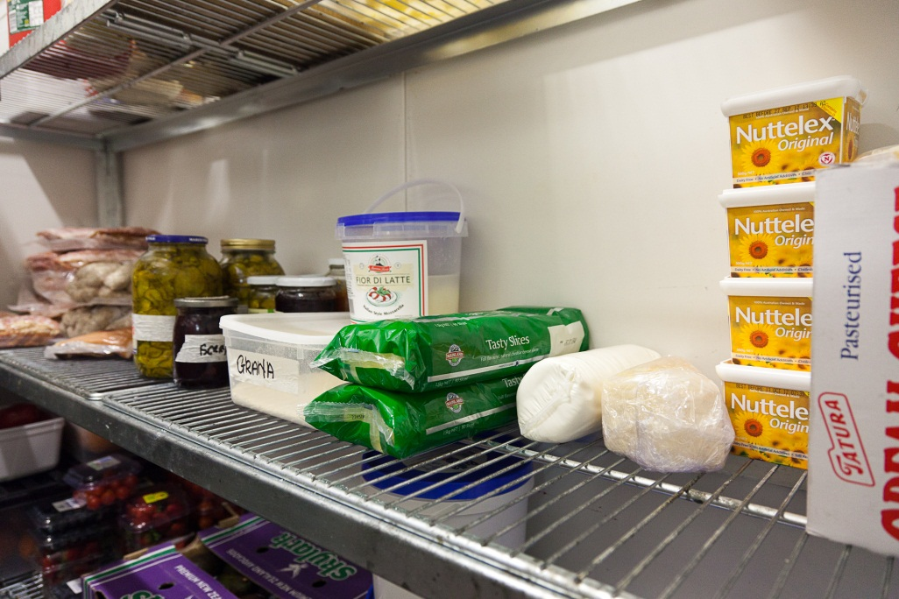

Non-perishable food
Non-perishable food goes into the dry goods store.
- Store goods in their correct place in the storeroom so they can be found easily.
- Put commonly used items where they are easy to reach.
- Some bulk goods might have to be put into bulk bins e.g. flour, sugar and rice.
Don’t add new food on top of the old food.
They must be cleaned before re-filling.
Bins should be airtight with tight fitting lids.
- Don’t store things on the floor.
This reduces the risk of pests, makes it easier to sweep and allows air to circulate.
- Put heavier items on the middle shelves to reduce strain on backs.
- Don’t stack things on top of each other or things can fall off.
- Don’t reach up above your head to put something on a high shelf. Use steps instead.
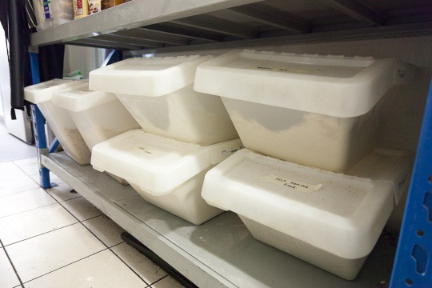
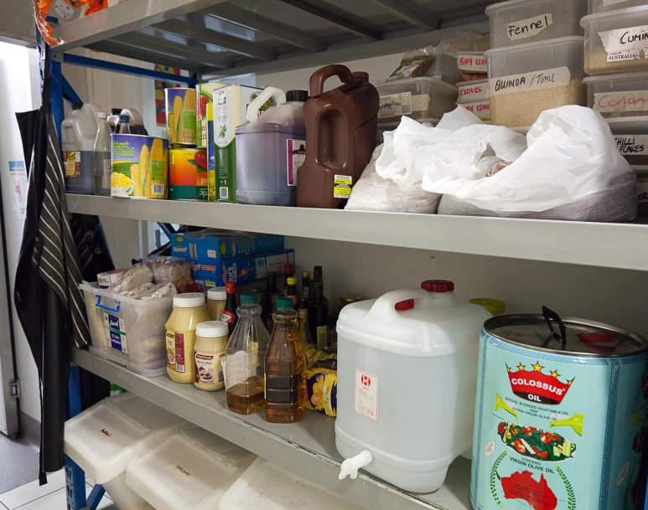

Non-food
Sometimes non-food items are stored in the dry goods store e.g. disposable items such as plastic knives and forks, single use chopsticks, takeaway containers, paper serviettes, foil and plastic wrap, and drinking straws.
Make sure they are in a different section to non-perishable food and labelled so they are easy to find.

Chemicals
Chemicals must never be stored in the same place as food. They must be kept secure at all times.
Each workplace will have its own procedures and training for safe chemical handling.
Always wear correct PPE and follow your workplace procedures.

Activity 13
Which order?
Three deliveries arrive at the same time from different suppliers.
List the order you would put these goods away in.
Delivery 1 | Bread and cakes
 | Tinned goods
 | Flour, sugar and rice
Delivery 2 | Fresh vegetables – lettuce, cucumbers, tomatoes and potatoes
 | Fresh fruit – raspberries, strawberries, apples, bananas and mangoes
 | Dairy – milk, cream, yoghurt and butter
Delivery 3 | Frozen chicken and frozen lamb fillets
 | Fresh beef and fresh pork

Activity 14
Storing supplies in your workplace
How are kitchen supplies received and stored in your workplace?

1. Where are deliveries received?
2. Who does the unpacking and storing?
3. Who decides which supplies are put away first?
4. How is food kept safe from contamination while it is being unpacked?
5. Have you seen staff use:
- a trolley? YES / NO
- a forklift? YES / NO
- a team lift? YES / NO
- a thermometer? YES / NO
6. Have you had training in safe manual handling? YES / NO
7. Have you had training in using a thermometer? YES / NO

Section summary
Now you have completed this section you should have developed the following skills and knowledge.
Tick each box if you are satisfied that you have those skills and knowledge.
Lift and carry goods safely.
Know what order to put goods away in.
Follow the FIFO process and label food.
Know how and where to store supplies correctly.
Notes

5 Managing supplies

Rotate stock
Stock rotation (turning) means moving older stock to the front of shelves so it is used before newer stock. This is so older stock is used up before it becomes out of date, stale or unsafe to eat and has to be thrown out.
Always follow the FIFO process when you are storing new supplies so that older stock gets finished up before new supplies are used.
Check for ageing or deteriorating stock
When rotating stock you will be physically handling many items, so it is a good opportunity to also make these checks:
- check the use-by dates on existing stock
- check for signs of pest and rodent (rat and mouse) attack or infestation
- check the quality of the product to see if it is deteriorating (losing quality) in storage or has been damaged in storage.

Advise the kitchen about stock approaching its expiry date
Whenever you identify items that are approaching their expiry date, or the end of their usable life, you must tell the chef or your supervisor.

Record stock levels
Your workplace will have a procedure to record how much stock they have, so they don’t run out or order too much.
Some workplaces record stock by hand on special cards near where the stock is kept (bin cards). Others do it electronically.
If you are involved in recording and controlling stock at work, you will be shown how the system operates in your workplace. You must record information accurately, as mistakes can mean over-ordering or the kitchen running out of something.

Manage excess stock
Excess stock means that there is more stock than the kitchen can use in a reasonable period of time. It can be caused by over-ordering, goods not selling as well as expected or poor stock rotation.
This can cost the workplace money because:
- some stock goes stale or bad before it can be used and must be disposed of
- there may be storage problems and not enough space for other supplies.
Workplaces try to prevent excess stock. They keep track of what they have in storage and are careful not to order too much.
But if there is excess stock, your workplace may:
- return it to the supplier
- organise in-house specials, such as putting on a special menu item at a lower price
- freeze food if possible, to be used later
- dispose of food that is un-useable.

Dispose of spoilt or damaged supplies
When you are rotating stock and checking stock levels, you may find spoilt food, food that is out of date, food in damaged containers and hazardous substances. These unwanted goods must be disposed of in a way that does least harm to the environment.
The Food Safety Code requires workplaces to keep food that is to be disposed of separate from other food. It must be labelled until it can be:
- destroyed or disposed of so it can’t be eaten by humans
- returned to the supplier
- further processed to make sure it is safe to eat e.g. immediately cooking food that has thawed.
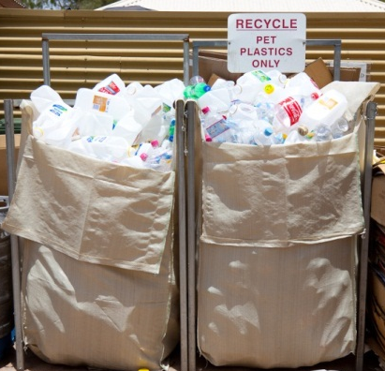
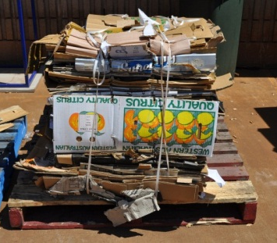
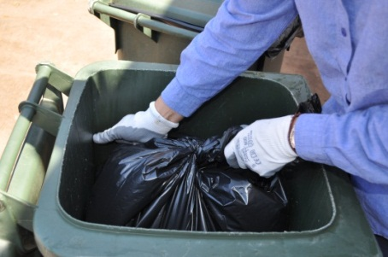

How to dispose of supplies correctly
If food and other goods in your workplace are being thrown away, proper and safe waste disposal methods must be used. Every workplace will have its own procedures, but here are some guidelines.
Item | Guideline | Why?
1. Waste bins | Must have tight fitting lids. | Keep out vermin and pests, keep smells in.
2. Vegetables and fruit | Put in a composting bin or into general waste bins. | Less waste to the tip if they are composted.
3. Meat, chicken and seafood | Must be placed in a separate bag and put in the general rubbish bin. | Stop smells and keep the bin hygienic.
4. Food waste | Can be stored in refrigerated cool room before putting it out for collection. | Control problems with pests and smells.
5. Food contaminated by insects and other pests | - Seal food in a container  - Clearly mark it ‘DO NOT USE’  - Report it to your supervisor. | Stop the problem spreading to other stock.  Follow up with pest control strategies.
6. Hazardous waste such as some cleaning products and their containers | Should be collected by a licensed disposal agency.  DO NOT:  - empty the products down the stormwater drain  - re-use chemical containers  - throw chemical containers in the general rubbish. | Stop chemicals from getting into the environment, such as waterways.
7. Plastic, aluminium, glass and cardboard | Place in workplace recycle bins. | Less waste in landfill, less energy used in manufacturing new products.

Activity 15
What will we do with it?
What should you do in these situations?
Problem | Disposal method
- Friday is fish day in the restaurant. At the end of the day there are a lot of fish scraps to throw out.
- Your workplace has changed to cleaning products that are better for the environment. You notice that there are some old cleaning chemicals in the storeroom that will never be used now.
- A brand of orange juice has been recalled by the manufacturer because there was a problem with some of the containers.
- You find half a tray of sandwiches on a shelf in the coolroom. The use-by date is two days ago.
- The oldest carrots and celery in the coolroom have gone soft and limp. A new delivery is coming tomorrow.
- Three tins of tomatoes fell off the shelf and are dented.
- When you are cleaning out the storeroom you notice that there are some cobwebs in the rice bin.

Section summary
Now you have completed this section you should have developed the following skills and knowledge.
Tick each box if you are satisfied that you have those skills and knowledge.
Rotate stock.
Manage excess stock.
Dispose of spoiled stock in ways that do least harm to the environment.
Notes

Key words
Word | Meaning
authorise | Approved or allowed to do something
bar code | A black and white striped sticker on a product. It tells the product, number and location when it is read by a laser scanner
contamination (of food) | When there is something in food that should not be there, which could make someone sick or injure them
cross-contamination | When germs from food, on food surfaces, hands or equipment, pass to other food
defect | A fault, something that is wrong
delivery docket | A list and description of goods delivered
documentation | Forms and other papers
electronically | Not done by hand, usually by computer
excess | More than the business needs
FIFO | First In, First Out. This process makes sure old supplies are used before new supplies.
goods | Supplies or stock
hygiene | Being clean
invoice | The bill to be paid for the goods delivered
order form | List of things ordered or sent to the supplier; also called a purchase order
perishable | Can go bad quickly
pests | Unwanted creatures in food premises e.g. mice, flies, ants and cockroaches
PPE | Personal protective equipment or safety equipment and clothing e.g. gloves, aprons and non-slip shoes
premises | A place of business such as a restaurant or hotel
procedures | A list of steps telling you how to do a work task
recycling | Using something again, usually after processing e.g. bottles and paper
rotate | Move things around or turn around
specifications | Details given to a supplier about the type, quality and characteristics of the goods ordered
specify | Say exactly what
smallgoods | Cured meats e.g. ham, bacon and salami
stock | Supplies or goods
suppliers | Businesses that sell goods, such as food or equipment, to a hospitality business
supplies | Any goods that are used in the workplace, including food, cooking equipment, linen and cleaning materials
unsafe (food) | Food that can cause harm if it is eaten
waste | Something that is thrown away because it is not needed or can’t be used

