Workbook

© Commonwealth of Australia. 2012

CC BY-NC-SA
This work is copyright. Except where otherwise indicated, and save for the Commonwealth Coat of Arms, the Department has applied the Creative Commons Attribution-Noncommercial-Share Alike 3.0 Australia Licence to this work.
The Department of Education, Employment and Workplace Relations must be attributed as the author of the Department’s copyright material.
As far as practicable, material for which the copyright is owned by a third party has been clearly labelled. The Department has made all reasonable efforts to ensure that this material has been reproduced in this resource with the full consent of the copyright owners.
Requests and enquiries concerning the Department’s copyright material should be addressed to:

The Copyright Officer
Department of Education, Employment and Workplace Relations
Location code C148CW2
GPO Box 9880 Canberra ACT 2601

Or emailed to copyright@deewr.gov.au
Funded under the Workplace English Language and Literacy (WELL) Program by the Australian Government Department of Education, Employment and Workplace Relations.
The views expressed in this publication do not necessarily represent the view of the Minister for Education or the Australian Government. The Australian Government does not give any warranty nor accept any liability in relation to the contents of this work.

ISBN 978-1-922108-03-6

Development Team
Content | William Angliss Institute  Macsmith and Associates
Photography & graphics | Benjamin B Photography
Acknowledgments
We would like to acknowledge the generous support of the following organisations and the Indigenous learners and employees in those venues for giving their permission for photography:
Ayers Rock Resort, Yulara, NT
Charcoal Lane Restaurant, Fitzroy, Vic
Lux Foundry Café, Brunswick, Vic
Peninsula Palms (Compass Group Australia), Dampier, WA
Permissions
We would like to acknowledge the following organisations who have granted permission for their copyright materials to be incorporated in this resource:
Ecolab
Worksafe Victoria
Cultural Warning
People of Aboriginal or Torres Strait Islander descent should be aware that this publication contains images of people who may be deceased
Disclaimer
Every effort has been made sure that this booklet is free from error or omissions. However, you should conduct your own enquiries and seek professional advice before relying on any fact, statement or matter contained in this book. William Angliss Institute of TAFE is not responsible for any injury, loss or damage as a result of material included or omitted from this course.

Contents
Welcome vi
Icons vi
What you will learn vii
1 Why is a clean kitchen important? 1

2 The cleaning process 3
Four steps for cleaning 4
Storing 7
Section summary 9
3 Cleaning equipment 10
Use cleaning equipment safely 13
Check before you start work 16
Care of cleaning equipment 17
Cleaning electrical equipment 18
Report damaged equipment 21
Section summary 23
4 Cleaning products 24
Types of cleaning products 25
Use cleaning products safely 28
What is an MSDS? 30
Diluting chemicals – the maths 32
Section summary 37
5 Cleaning safely 38
How to prevent problems 38
Cleaning hazards 39
Make sure you know what to do 41
What to do if there is an accident 42
Section summary 44

6 The cleaning schedule 45
Following a cleaning schedule 48
Daily cleaning worksheet 52
Follow safe work procedures (SWPs) 53
Section summary 56
7 Cleaning procedures 57
Washing dishes and utensils 58
Cleaning kitchen equipment 61
Cleaning surfaces 64
Cleaning storage areas 70
Cleaning waste bins 74
Section summary 77
8 Sorting linen 78
What is linen? 78
Why is washing linen important? 78
Where is linen washed? 79
Why is linen sorted? 79
Section summary 82
9 Safe disposal waste 83
Disposal of hazardous waste 83
Recycling 85
Section summary 87
Key words 88

Welcome

Icons
These signs tell you what type an activity is:
 | Do this activity in a big group.
 | Do this activity in a small group.
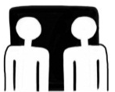 | Do this activity in pairs.
 | Do this activity by yourself.
Do this activity using the internet.
If you are not connected to the internet, your trainer will provide you with another activity.
Do this activity in your workplace.
If you are not in a workplace, your trainer will provide you with another activity.

What you will learn
In this unit, you will learn how to keep the kitchen area clean so the food that is cooked and served is safe to eat.
You will learn how to:
- clean the kitchen and food storage areas
- clean and store the equipment used for food preparation, serving and storage
- get rid of waste safely
- clean in ways that are less harmful to the environment.

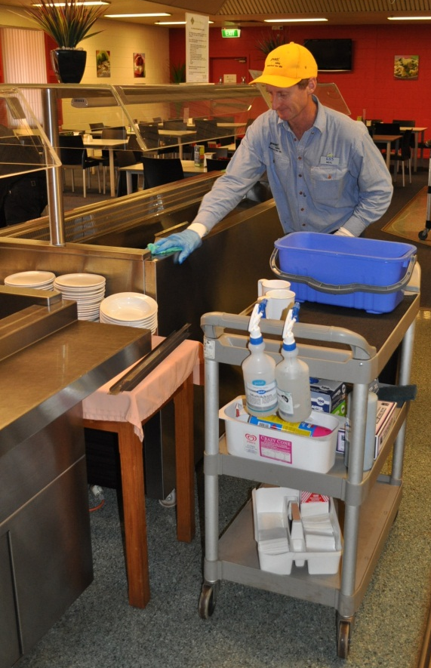

1 Why is a clean kitchen important?
In the hospitality industry, it is important to keep food safe to eat so that people don’t get sick. The main way to do this is to keep everything clean. This includes:
- all areas where food is received, prepared, stored and served
- all the equipment used to prepare and serve food.
The kitchen and equipment quickly get dirty through normal use. Germs in a dirty kitchen will spread and the food won’t be safe to eat.
Also, first impressions are very important in the hospitality industry. If things are not clean, guests will see this straight away and not want to stay or recommend the business to other people.
The government has laws that businesses and people handling food must follow. One law is called the Food Act. It sets minimum (lowest level) standards for cleanliness of food storage, preparation and service areas, and for hygienic (clean) food handling practices.
Activity 1
Would you eat here?
Read this newspaper article and talk about the questions together.

Cockroach café
3 February 2010
A café has been fined $20,000 after a health inspector found its kitchen in a terrible condition.  The inspector found cockroaches, rat droppings and a lot of grease, dirt and food waste. There was rubbish under the fridges and on kitchen benches. There was rotting food in the bottom of the refrigerator and the bins were overflowing.  Also there was no equipment or procedures to sanitise surfaces and utensils. | The inspector found that the staff were not trained in safe food handling. The inspector found 30 breaches of the Food Act law.  The café was inspected after a complaint from customers and the inspector closed it for a month.  The owners had to spend quite a bit of time and money to fix up the problems, but the café is now a safe and clean business.

Questions

1. Think about people who recently ate at this café. How would they feel?

2. What were some of the problems found by the inspector?

3. How could this make the food unsafe to eat?

4. What costs did the café have?

5. What costs were there to the staff?

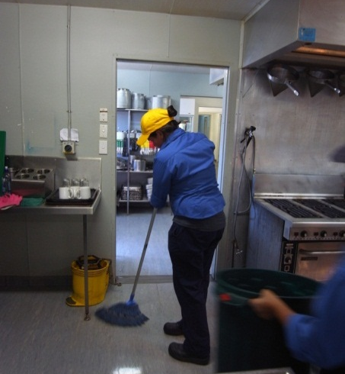

2 The cleaning process
Two basic processes are used to clean a kitchen and kitchen equipment.
1. Clean | - Get rid of anything that you can see on the surface e.g. grease, food scraps, dust and spills.  - Do this by sweeping, scrubbing, vacuuming, mopping or wiping.

Remember that there could still be germs on the surface that you can’t see, so you may need to take another step, called sanitising.

2. Sanitise | - Reduces the number of invisible germs to safe levels on food-contact surfaces, but doesn’t kill them all.  - Very important for areas where food is prepared.  - 2 methods:  - Spray, rinse or wipe the surface or item with a food-grade chemical sanitiser  - Use heat, steam or boiling water to kill germs.  When you are using heat, steam or boiling water, be careful not to burn or scald yourself.

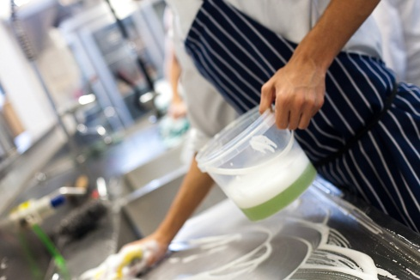

Don’t waste water
- Don’t leave taps running when you are not using them.
- Rinse by filling up another container with clean water rather than rinsing under running water.
- If any taps are dripping, let your supervisor know so they can be fixed.
- Only use as much water as you need. If you only need to wash a few things, don’t fill the sink full. Use cold water rather than hot if possible as this will save electricity.
Four steps for cleaning
Each cleaning task is different, and uses different products and equipment. But for most cleaning tasks in the kitchen, whether it is washing dishes or cleaning the floor, you will follow these 4 steps.

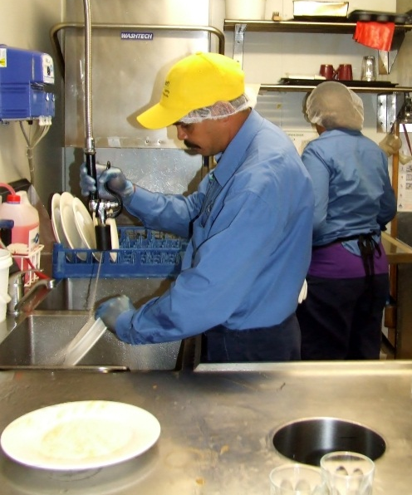
1 Pre-clean
Get rid of loose dirt from the item or surface to make the cleaning easier. For example:
- sweep dirt from the floor before you wash
- dust cobwebs from shelves before you wipe
- rinse plates with high pressure water before you stack them in the dishwasher
- scrape food from cooking utensils before you put them in the dishwasher.
Treat any stains or something that is really dirty with a special cleaner. For anything really difficult, ask your supervisor for advice.

2 Wash and rinse
Wash the rest of the dirt and grease from the item or surface. Use the correct cleaning product, equipment, water temperature and cleaning methods e.g. scrubbing, wiping, scouring or dishwasher.
Usually you need to rinse off the cleaning product, so there is not even a small amount left to be in contact with food. Use clean hot water. Be careful not to waste water.
If you are not sure what to use, ask your supervisor. If you are using the dishwasher, make sure you have been trained in how to use it and follow the instructions.

3 Sanitise
This reduces germs that make food unsafe to eat. You must sanitise all surfaces and equipment used in food preparation. You can sanitise using chemicals or heat.
Chemicals
This is practical for larger areas e.g. benches.
Some sanitisers need to be rinsed off but others can be left on. Read the instructions or ask your supervisor.
Heat
The main way is to use a commercial dishwasher. Hot water from the tap is not hot enough. Things will be very hot after they come out of a dishwasher, so be careful handling them.
Some kitchens have special sanitising equipment using steam or ultra violet (UV) light.

4 Dry
It is best to let things air dry. Drying with a cloth or tea towel can spread germs and put lint on items.
If dishes are washed in a dishwasher, the drying cycle will dry them well.

Environmentally friendly sanitisers
Environmentally friendly sanitisers may be labelled ‘biodegradable’, ‘non-toxic’, ‘phosphate-free’ or ‘green’.

Storing
Once you have washed and sanitised items, don’t touch them with dirty hands or a dirty cloth.
Store clean, dry kitchen equipment properly. Every workplace will have its own procedures, but here are some general guidelines.
Guideline | Why this is important
- Make sure items are completely dry before you store them.
- Don’t store things on the ground or near doorways.
- Store cutting boards vertically in a rack.
- Store bowl-shaped items upside down on a clean shelf.
- Store knives in a knife block or on a magnetic strip rather than loose in a drawer.
- Wrap the cord around electrical equipment before you store it.
- Keep storage areas clean, dry and orderly.
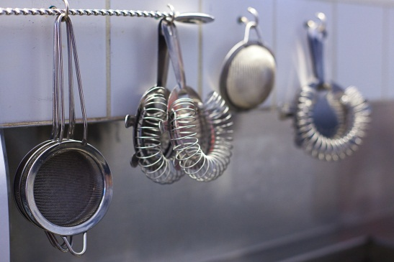
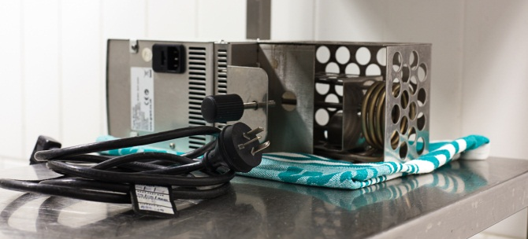

Activity 2
Storing cleaning items
1. Look at each guideline in the previous table. Talk about it with others in your group.
Why is it important to do this? What problems does it prevent?
After you have discussed it together, write some brief notes in the ‘Why this is important?’ column.

2. Look at the following photo of a storeroom. Is everything done correctly?
What suggestions can you make to improve this storeroom?

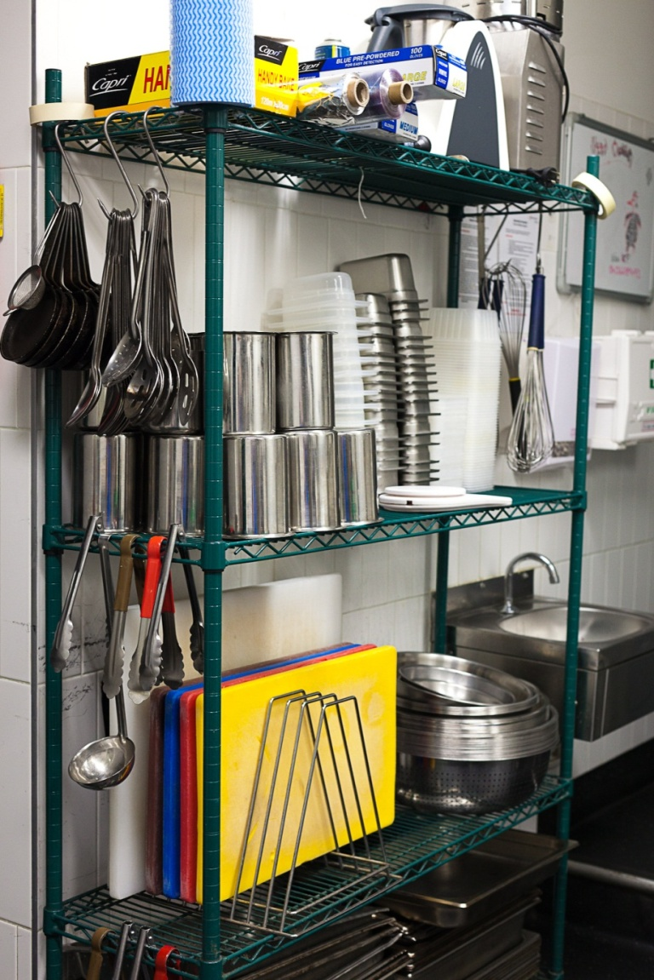

Section summary
Now you have completed this section you should have developed the following skills and knowledge.
Tick each box if you are satisfied that you have those skills and knowledge.
Clean and sanitise.
Know the steps in the cleaning process.
Store clean items.
Notes

3 Cleaning equipment
There are many different types of cleaning equipment used to clean a kitchen and each piece of equipment has a special purpose.
Smaller businesses may only have domestic cleaning equipment (what you use at home) kept in a cupboard. Bigger businesses have commercial or industrial equipment because it is more powerful and is built for constant use. They may also have a purpose-built cleaning storeroom where equipment, cleaning products and protective clothing is kept.
Here is a list of cleaning equipment commonly used to clean kitchens.
Manual cleaning equipment | Purpose
Broom | Used for sweeping dirt and other rubbish off floors and other surfaces.
Dustpan and brush | Used for sweeping up small spills and collecting dust and dirt swept into a pile.
Mop and bucket | Used for washing smooth floors such as tiles or vinyl with water after sweeping or vacuuming.  Mop buckets often have rollers to remove excess water from the mop head.
Cleaning cloths (may be microfibre) and sponge | Used for wiping and polishing wet or dry hard surfaces such as benches, furniture and sinks.
Scourer and scraper | Used for cleaning saucepans, stove tops and hard to remove dirt.
Scrubbing brush | Used to clean areas that are very dirty, such as a floor where something has been spilt.
Window squeegee | Used for cleaning windows, including windows which are high up.
Dusters (including cobwebber) | Cleaning surfaces where there is dust, light dirt or cobwebs.
Disposable gloves | Wear to protect your hands when cleaning and also when handling chemicals.
Cleaning safety signs | Used to warn people that cleaning is in progress or there is a cleaning hazard, such as wet floors.
Rubbish bin bags | For putting food and other waste in before it is collected.
Cleaner’s sink | A low sink used to fill and empty buckets and wash mops.
The cleaning equipment you use depends on what parts of the kitchen you are cleaning and what they are made of. For example:
- a tiled floor in a kitchen wet area – mop, bucket or scrubbing brush
- a storeroom with shelves and a lino floor – broom, dustpan, cleaning cloth or cobwebber.

Electrical cleaning equipment | Purpose
Dishwasher | Washes dishes, cutlery, crockery and pots and pans.  Also washes parts of kitchen equipment such as the blades from the meat slicer.
Pressurised steam and water cleaner  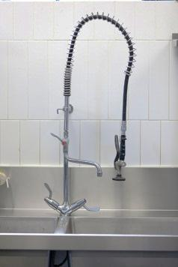 | Uses a high powered stream of water to rinse stains and marks off cooking equipment.  Useful when hand scrubbing does not work, you can’t reach the problem area or it takes too long.
Floor scrubber  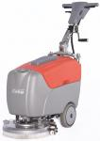 | Washes large areas of hard floors. The dirty cleaning solution is sucked up under the machine. The floor is left clean and almost dry.
Vacuum cleaner | Removes dust and dirt from large floor surfaces.  There are different types of vacuum cleaners:  - wet and dry types  - backpack, upright and floor types.

Activity 3
Use the correct eqiupment for the job
1. Would you use a vacuum cleaner to pick food up from the floor of the kitchen?
Why/why not?

2. Would you use a cleaner’s sink to wash dishes?
Why/why not?

3. Would you scrub a sticky spill from a floor, then use the same scrubbing brush to scrub potatoes?
Why/why not?

Use cleaning equipment safely
If you are not sure how to use a piece of equipment, ask a workmate or your supervisor before you begin the task. If you forget, ask again.
If you don’t know how to use equipment properly, you might:
- injure yourself
- injure other people
- damage the equipment and whatever you are cleaning.

Guidelines for using cleaning equipment safely | Important because?
- Never use equipment if you are not sure how to use it.
- Always follow the manufacturers’ instructions.
- Always check equipment before you use it – make sure it is clean and safe to use.
- Don’t lift heavy equipment. Ask for help or use ramps or lifts.
- Don’t leave equipment lying around.
- If equipment is not working properly or is damaged, don’t use it. Tell your supervisor.
- Don’t let electric cords trail behind you.
- Unplug electrical equipment when it is not being used.
- Don’t use electrical equipment near water.
- Put equipment away in its correct place after you have finished using it.

Activity 4
Use equipment safely
Talk about each guideline in the previous table.
Why is it important? What could go wrong if you did not follow the guidelines?
Make brief notes in the right hand column.

Activity 5
Ask for help or advice
Your trainer will organise this activity for you.
You are not sure how to use a piece of equipment and you need help. Here are some suggestions about what you could say. Or you can use your own words.

I’m not sure how this works. Would you mind showing me again please?

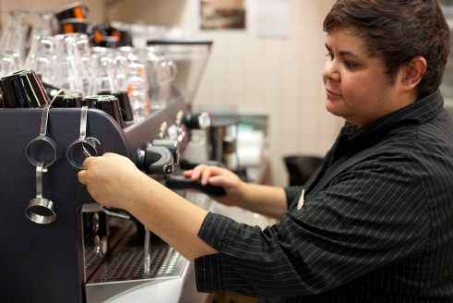

I think I’ve got the hang of it. But can you watch to make sure I’m doing everything right?

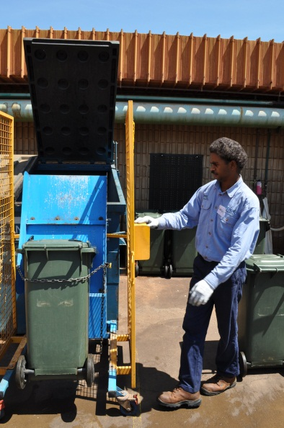

I’m still a bit uncomfortable with this. Could you show me again please?

Adapted from Safety tips for young workers, © Worksafe Victoria,
The publication quoted above is not an official publication of DEEWR.
This and other related publications are available free of charge
by contacting WorkSafe Victoria on 1800 136 089 or by visiting <http://www.worksafe.vic.gov.au/>

Cleaning equipment and the environment
You can help look after the environment by using and maintaining cleaning equipment properly.
- Report electrical equipment that is not working properly as it could use more electricity.
- Clean equipment after you have used it e.g. empty the vacuum cleaner and clean the brushes. This means the equipment will work more efficiently and use less energy next time.
- Turn off equipment when it is not being used so it does not use electricity.
- Use microfibre cleaning, dry mopping and sweeping rather than wet cleaning to save water.
- Do not use the dishwasher until it is full.

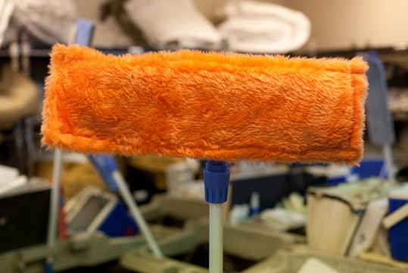

Check before you start work
Before you start work, check the equipment and other items. Make sure that:
- there are no jagged parts or sharp edges on equipment
- equipment looks clean and presentable
- buckets don’t have leaks, are not smelly and have secure handles
- you have enough cleaning cloths, disposable gloves and other supplies so you don’t run out before your shift ends
- you have the right tools and attachments for your tasks – you will waste time and effort if you have to go back to the storeroom
- the electrical equipment does not have frayed cords or exposed wires
- any battery-operated equipment is fully charged.

Care of cleaning equipment
Take care of cleaning equipment and keep it clean, so the equipment stays in good working order.
Equipment should be cleaned after every use so that dirt from a previous task is not transferred (moved) on to another surface.
Every workplace will have its own procedures, but here are some general guidelines.
Equipment | Care
Brooms and brushes | Shake bristles clean.  Sometimes wash them in hot soapy water and leave to air dry.
Mops | Wash in hot soapy water, rinse thoroughly, sanitise, squeeze dry, then hang up to air dry.
Dusters and cloths | Shake thoroughly outside.  Wash in hot soapy water and hang up to air dry OR follow the manufacturer’s instructions.
Buckets | Wash thoroughly with hot soapy water and leave to air dry.  Clean around the rollers on mop buckets to remove mop fibres and other dirt.
Vacuum cleaner | Empty the dust bag or replace it at the end of the shift or as necessary.  If you are using a wet/dry vacuum cleaner you will need to empty the liquid, dirt and debris.  Wipe the outside of the machine and its attachments with a damp soft cloth.  Tidy the electrical cord to avoid kinks.  Replace filters regularly – follow the manufacturer's instructions.
Dishwasher | Clean out food or other waste from the drain in the dishwasher every time you empty it. Be careful of broken glass or anything else that could cut you.  Wipe around the edges of the door and the inside of the dishwasher regularly with hot water and a detergent.  Clean any baskets with a brush.  Wipe down the outside.
Other electrical equipment | After each use, wipe the outside clean.  Store the power cord correctly.  Clean the inside and all attachments regularly – follow the manufacturer's instructions.
Cleaning electrical equipment
You may need to clean electrical equipment such as a floor scrubber. You might need to take the equipment apart before you wash it and then put it back together again.
Before you clean any electrical equipment, someone must show you how to do it. Always follow the instructions.

If you forget how to do it, ask again.
Here are some guidelines.
- Make sure electrical items are turned off and unplugged before you start.
- Be careful with sharp edges such as blades.
- Wear correct personal protective equipment (PPE) such as gloves, rubber apron and safety goggles.
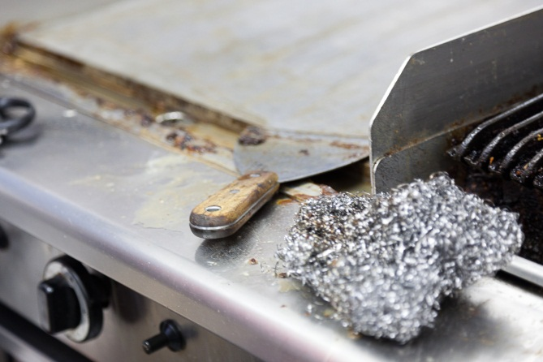

Activity 6
Care of cleaning eqiupment
What might happen if cleaning equipment is left dirty or poorly maintained?

- A dishwasher slowly gets a clogged drain.

- A mop that was used to clean up a grease spill is not thoroughly washed before it is put away.

- Cloths that are used for wiping down food preparation benches are not cleaned and sanitised after each use.

- The handles of the bucket are loose.

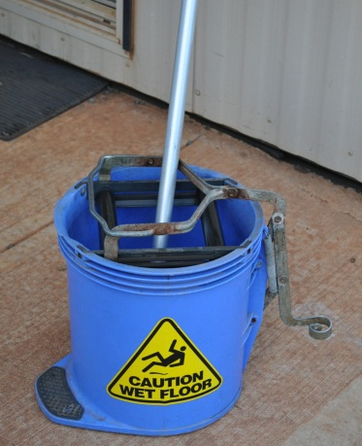
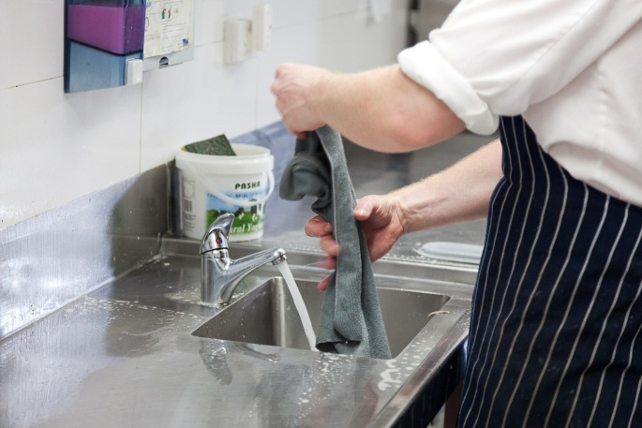

Activity 7
Kitchen cleaning equipment
1. Where is the kitchen cleaning equipment kept in your workplace?
2. Look for these items of cleaning equipment. Tick each item as you find it. There might be other pieces of equipment too. Write them in the empty spaces.
Broom, dustpan and brush
Mop and bucket
Cleaning cloths (may be microfibre) and sponge
Scourer and scraper
Scrubbing brush
Window squeegee
Dusters including cobwebber
Disposable gloves
Cleaning safety sign
Rubbish bin bags
Cleaner’s sink
3. Does the equipment look clean and in good condition? Can you make any suggestions to improve it?
4. Are there any energy markings on electrical equipment to show energy efficiency, such as star ratings? What do they mean? Your trainer or supervisor can help you.
Report damaged equipment
If you notice something wrong, don’t use the equipment. Report it to your supervisor immediately.
Some examples of things you might notice are:
- frayed electrical cord
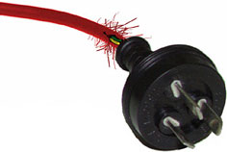
- broken switch
- cracked hose on the vacuum cleaner
- screws coming loose or missing
- rattles or strange noises in the equipment
- smells, smoke or sparks coming from the equipment
- warning light or temperature gauge not working
- broken accessories
- broken handles
- lack of power in an electric machine.
You may need to fill in a workplace report form. Or you might have to tell your supervisor about the problem, and they will fill out the form.
Activity 8
Report damaged eqiupment
Discuss together:
The floor scrubber has a frayed cord but you need to finish cleaning the kitchen floor before the next shift starts. So you decide to report it after you have finished.
Is this the right decision? Why/why not?

Activity 9
Fill in a Maintenance Request tag
You were using an electric floor scrubber in the kitchen when you noticed that it was making a rattling noise and there was a burning smell coming from the machine.
Fill in the Maintenance Request tag on the next page.
Say what the problem is and what you did when it happened. Use today’s date and your workplace location.

MAINTENANCE REQUEST 254875
ITEM _________________________________
______________________________________
REPORTED BY ________________________
DATE ________________________________
LOCATION ____________________________
PROBLEM _____________________________
______________________________________
______________________________________
______________________________________
______________________________________

ASSIGNED TO _________________________
DATE COMPLETED _____________________
COMPLETED BY _______________________
REMARKS ____________________________
______________________________________
______________________________________
______________________________________

Section summary
Now you have completed this section you should have developed the following skills and knowledge.
Tick each box if you are satisfied that you have those skills and knowledge.
Know what to use different cleaning equipment for.
Choose the right equipment for the task.
Use cleaning equipment safely.
Understand the importance of maintaining cleaning equipment.
Clean the equipment after use.
Identify and report faults.
Notes

4 Cleaning products
Many different types of cleaning products are used to clean and sanitise the kitchen. Different products are used for different purposes.
Your workplace supervisor will tell you which cleaning products to use for each cleaning task and how to use the products properly and safely.
Cleaning products can be dangerous chemicals.
They must be handled carefully and kept away from food.
They should be stored in a separate area such as a locked cupboard or storeroom.
A lot of chemicals are coloured so you can identify (tell what it is) the different chemicals by their colour. There are also symbols (pictures) and words on the bottle, so if you are colour blind you can still identify what they are.
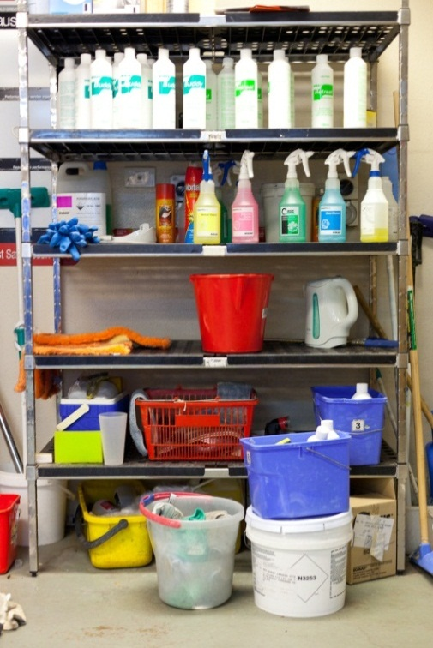

Types of cleaning products
Here are the main types of cleaning products you will find in a hospitality business.
They may be called by different brand names.
Type of cleaner | Use
Abrasive cleaners | Used for scouring and cleaning ceramic or enamel surfaces e.g. the cleaner’s sink. Don’t use on surfaces that scratch easily.  They can be hard to rinse away, so wipe and rinse as soon as possible after you use them.
Detergents | Come in different strengths, so always follow dilution instructions on the label.  Some detergents are for heavy-duty cleaning e.g. fat, grease and oil on steel, most plastics, glass, ceramics and concrete. They are often used in dish and glass washing machines.
Chlorine or bleach | Used to disinfect, bleach and deodorise.  They can attack rubber, plastic and aluminium.  They should never be mixed with other cleaning products as they may give off toxic fumes.
Sanitisers | Used to reduce germs on a surface. Use them on food preparation surfaces.
Disinfectants | Used to kill germs. They should be used in rubbish bins and other non-food preparation areas.  Because they sometimes have a strong scent, they are not suitable for use in a kitchen or food area.
Specialist cleaning agents | Used for a specific cleaning task e.g. to remove difficult stains from small areas, clean windows and glass, clean stainless steel or clean rubbish bins.
Polishes | Used to protect surfaces from spills. Floors can be slippery after they have been polished.

Activity 10
Different surfaces
What different materials could these areas of the workplace and equipment be made of?
Area | Could be made of:
Kitchen floors
Walls
Skirting boards
Kitchen benches
Kitchen sinks
Stove tops and ovens
Body of cooking appliances e.g. juicer or blender
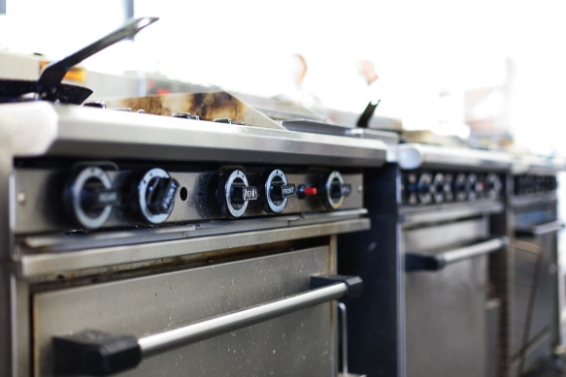
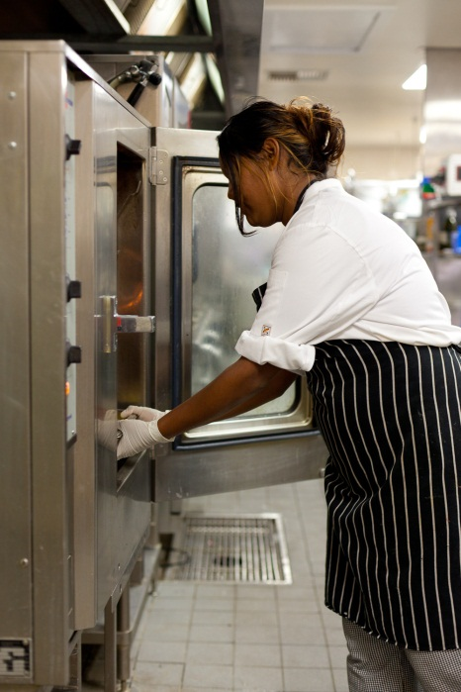
Activity 11
Use the right equipment and products
Which equipment and products would you use for the 5 cleaning tasks below?
Cleaning task | Equipment | Products
Clean an oven
Clean a food preparation bench
Clean a kitchen floor that has had cooking oil spilt
on it
Clean an electric juicer
Wash a greasy cooking pot

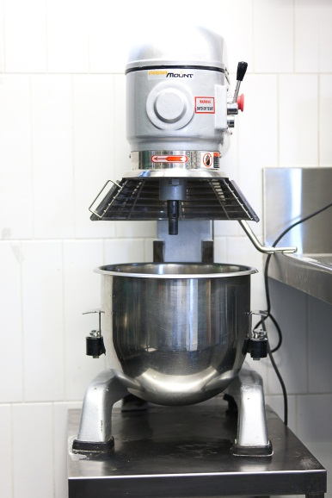
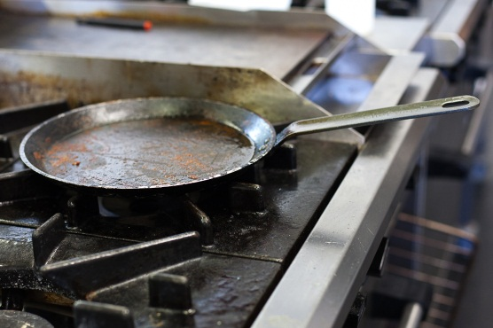

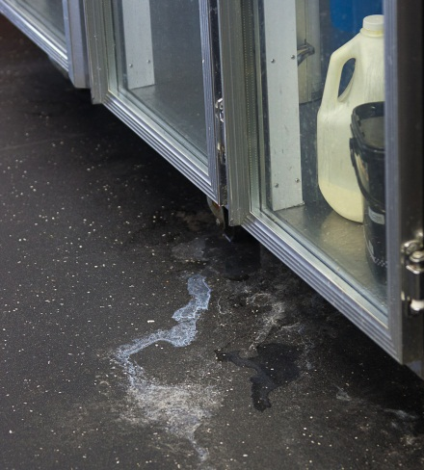

Use cleaning products safely
Your workplace will have procedures that tell you what products to use for each task and how to use them safely.
Some cleaning products are toxic (poisonous) if you breathe the fumes (gas), touch them or they get into food.
If you use a product wrongly you could:
- harm yourself or people you work with e.g. splash chemicals into your face or eyes or mix the wrong chemicals together and cause toxic fumes
- damage surfaces by using the wrong chemical on them
- poison food so it is unsafe to eat.

If you are not sure what to use and how to use it, ask a workmate or your supervisor.
Guidelines for using cleaning products safely
- Store all cleaning products in a locked storeroom or secure place.
- Use the correct PPE to protect yourself from splashes or spills.
- Put all cleaning products back where they belong after you have finished using them.
- Don’t use cleaning chemicals near food.
- Never store chemicals in food containers.
- Never light a cigarette or a match near chemicals or chemical storage areas.
- Never smell a chemical as you might burn inside your nose or faint.
- Follow the manufacturer’s instructions exactly when using and diluting chemicals (mixing them with water).
- Always read warning signs or labels about cleaning products.
- If you don’t know what a chemical is, don’t use it.
- Always put the chemical into water rather than water into the chemical, so there is no splashing.
- Know where the MSDSs (Material Safety Data Sheets) are kept and how to read and use them.
- Use the correct lifting method for heavy containers of chemicals. Bend from your knees, not from your back. Or ask someone to help you.

Activity 12
Use chemicals safely
Discuss each guideline in the previous table.
1. Why is it important?
2. What could happen if you did not follow the guideline?

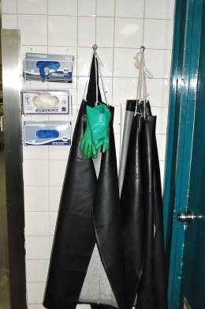
Personal protective equipment (PPE)
Personal protective equipment (PPE) is clothing and equipment that you wear or use to make sure you are safe in the workplace, such as when you are using cleaning products. It includes:
- non-slip shoes or waterproof boots
- thick rubber gloves
- goggles
- face masks
- overalls
- rubber aprons.

What is an MSDS?
MSDS stands for Material Safety Data (information) Sheet. An MSDS is the manufacturer’s information about each chemical. These sheets tell you:
- what a chemical is made from
- if it is hazardous
- how to handle it safely
- first aid instructions if you are exposed to it (get it on you).

Activity 13
Use the correct PPE
Look at the following pictures. Label the PPE the people are wearing.
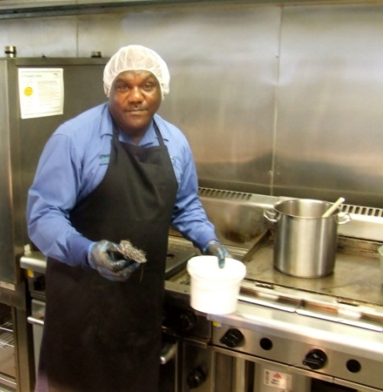 | 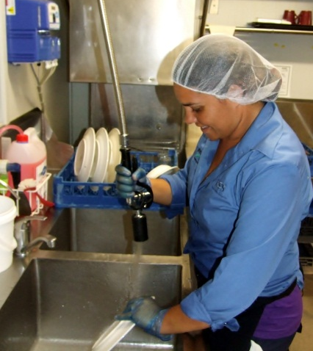

Activity 14
Reading an MSDS
Here is part of an MSDS for a cleaning product used for cleaning stove tops.
This section of the MSDS gives information about what to do in an emergency.
Material Safety Data Sheet
The Grease Cutter Stove Top cleaner
SECTION 4 – EMERGENCY FIRST AID PROCEDURES
For advice, contact the Poisons Information Centre (phone 123 456) or a doctor.
Swallowed | Rinse mouth with plenty of water and give water to drink. Seek medical aid.
Eye | Hold eyes open and flush with water for at least 15 minutes. Seek medical attention promptly.
Skin | Remove contaminated clothing and wash affected skin area thoroughly with soap and water. Wash clothing before re-use.
Inhaled | Unlikely due to physical form of product. Take patient to fresh air and put in a comfortable position until fully recovered.
1. A workmate has eaten food prepared on a bench next to the stove before the area was rinsed clean. They may have accidentally swallowed a little bit of Grease Cutter. What will you do?
2. A workmate has splashed some Grease Cutter into their eyes. What will you do?

3. You were mixing Grease Cutter with water and splashed some mixture on your shirtsleeves and wrists. What will you do?
Diluting chemicals – the maths

Here are the instructions on the label for diluting Shyne Floor Cleaner with water.
Shyne
Floor Cleaner
Mix 10 ml in 1 litre
of warm water

ml = millilitres

Your bucket holds 10 litres.
- Multiply the amount of warm water (1litre) by 10 to fill your bucket.
- Also multiply the amount of floor polish chemical by 10 to match the water.

The water and the chemical must stay in the same ratio or balance with each other.

WATER | CHEMICAL | RATIO
1 litre | 10 ml | 1:10
x 10 | x 10
= 10 litres | = 100 ml | 10:100  = 1:10

- ALWAYS measure chemicals. NEVER guess how much to use.
- ALWAYS follow the manufacturer’s instructions.
- ALWAYS put the chemical into the water so there is no splashing.
NEVER pour water into the chemical.

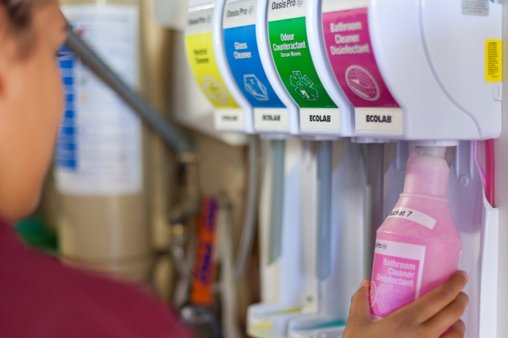

A lot of chemicals are pre-mixed so you don’t need to dilute them yourself.

Activity 15
Diluting chemicals
You have to mix up the floor washing detergent in a 10 litre bucket.
On the label it says 20 ml per litre of water.
- How much detergent will you put in?
WATER | CHEMICAL
1 litre | ml
x 10 | x 10
= 10 litres | = ml
- The detergent cap is also a measuring cup. It holds 20 ml. How many caps of detergent will you put in the bucket?

Chemicals and the environment
Chemicals are often toxic and bad for the environment. When we empty our buckets down the sink, the poison can get into the water. Here are 3 ways you can reduce the amount of cleaning chemicals put into the land, water and air.
- Use microfibre cloths for cleaning. These are made of a special material that removes dirt, grease and dust without chemicals.
- Choose bio-degradable cleaning products, which are less harmful to the environment.
- When you dilute chemicals with water, only use the exact amount on the label. Using more won’t clean any better and puts extra chemicals into the environment.

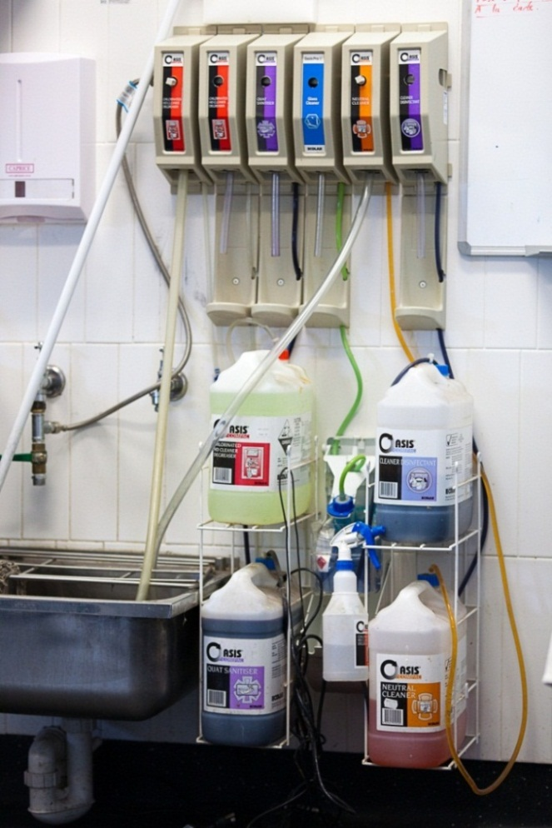

Activity 16
Cleaning products in your workplace

1. Where are the cleaning products kept in your workplace?

2. What signs are on the door of the storage area?

3. Where is the PPE kept?

4. Where are the MSDSs kept?

5. Are there any chemicals that need to be diluted? Or are most of them pre-mixed?

6. Choose 4 cleaning products and fill in the table below. If you can’t find the information, ask your trainer or supervisor to help you.
Name of product | What is it used for? | Warnings on label | Safe for environ’t?
7. Choose one of the products in question 6 and tell someone else about it.

Section summary
Now you have completed this section you should have developed the following skills and knowledge.
Tick each box if you are satisfied that you have those skills and knowledge.
Know what the different cleaning products are used for.
Choose the right product for the task.
Dilute cleaning products.
Use and store cleaning products safely.
Know how to clean in ways that reduce harm to the environment.
Notes

5 Cleaning safely
Cleaning can be dangerous if it is not done properly.
You have learnt how to handle cleaning equipment and cleaning products safely.
But there are other hazards when you are cleaning kitchens.

How to prevent problems
You can prevent many problems by following these guidelines.
1. Be trained and follow the training
Make sure you have been shown how to use equipment and chemicals, and how to do the cleaning tasks. This might happen during your training or during the induction to your workplace. Follow all workplace procedures.
2. Follow safety signs and information
Follow all safety signs and instructions. They might be labels on the equipment or products, or notices on the wall. Use them to help you remember what to do.
3. Be clean
Clean, sanitise and dry equipment and materials after you have finished so you don’t spread germs while you are cleaning.
4. Use correct PPE
If you have been trained, you should know the correct PPE for each product, piece of equipment and cleaning task. There is no choice – you must use it.
5. Do correct manual handling
Know how to lift heavy items so you don’t hurt yourself. Ask for help or use trolleys or lifts.
6. Know what to do in an accident
Know your emergency procedures, where the emergency numbers are and how to contact the first aid person.

Cleaning hazards
Activity 17
Workplace hazards for cleaners
In the following table are some other potential (possible) hazards when you are cleaning in a kitchen.
For each hazard talk about:
- the injuries or damage that it could cause to you or others
- what you should do to reduce the risk or eliminate (get rid of) the hazard.
You could use the information you learned in other units. Some ideas have been written in for the first hazard.

Once your group has discussed a hazard, you could write some short notes in each space.

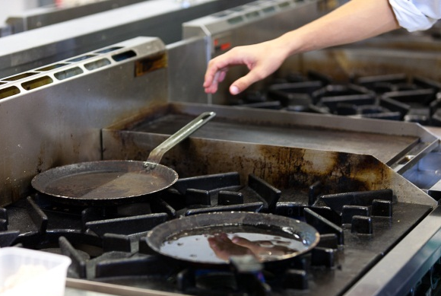
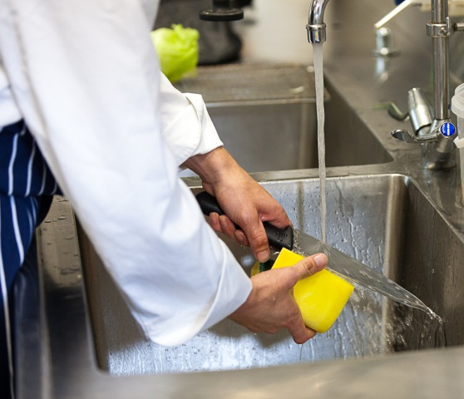
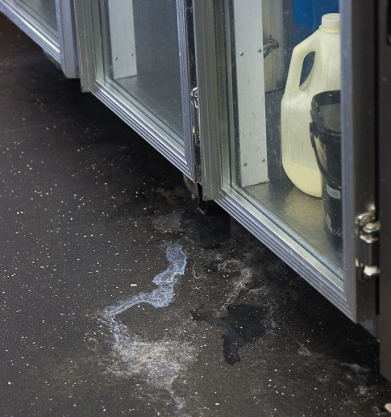

Workplace hazards for cleaners
Possible hazard | Injury or damage it could cause | What you should do to prevent injury or damage
- Cleaning up liquids spilt on the floor e.g. water, oil or cleaning products | Slips, trips or falls – you or others.  Chemicals on skin or food. | Clean up and mop area as soon as possible.  Handle chemicals safely, use PPE.  Put up ‘Wet Floor’ signs.
- Using heavy equipment e.g. floor scrubbers
- Not rinsing and sanitising cleaning cloths after use
- Taking apart kitchen appliances to wash them
- Contact with sharp things e.g. knives, broken glass or food scraps such as bones
- Working near hot surfaces

Make sure you know what to do
The most important part of working safely is knowing what to do.
- How do you know what equipment and chemicals to use for each cleaning task?
- How do you find out what to do?
- How do you know what to do if there is a problem?
WATCH AND LISTEN | You should be shown how to do your cleaning tasks in your induction training or on the job.
ASK | If you are still not sure, ask someone, even if you have been told before. There are a lot of things to remember when you start work in a new workplace!  If someone is explaining to you and you don’t understand them, ask them to explain again or show you. Sometimes people forget that you are new to the work and they go too fast.  If you have a problem on the job, ask for advice or help.
READ | - Instructions on equipment or products.  - Notices on the wall.  - Workplace procedures.  - Labels on chemical containers.  - Safety signs.
MAKE NOTES | Write down things that are hard to remember in a small notebook or draw pictures to help you remember next time.

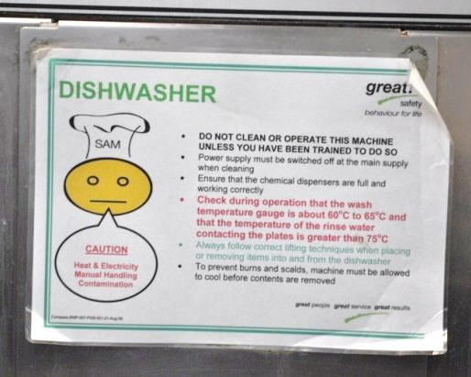 | 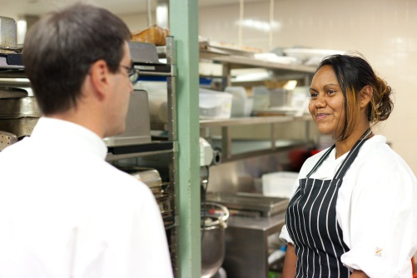

What to do if there is an accident
Your workplace induction should include emergency procedures. Each workplace will be a little bit different, but here are some typical guidelines.
Emergency telephone numbers | They should be posted on the wall in your workplace e.g. ambulance, fire brigade, poisons information and police.
First aid kit | You should know where it is and who the first aider is.
Chemicals near food | If you have an accident with chemicals while you are cleaning near food or in a food preparation area, tell your supervisor immediately. The food must be destroyed so no-one can accidentally eat it. All surfaces and cooking equipment around the spill must be cleaned and sanitised so the chemicals can’t get into the food.
Fire extinguishers | You should know where the fire extinguishers are.  BUT don’t use a fire extinguisher unless you have been trained which one to use and how to use it. A fire involving chemicals requires the right kind of fire extinguisher. If you use the wrong fire extinguisher it could make the fire worse.

Activity 18
Emergency procedures
Find your workplace emergency procedure.

1. Where are the emergency phone numbers?
2. Where is the nearest phone?

3. Who do you contact first in an emergency?
4. How do you contact them?
5. Where is the first aid kit? Who is allowed to use it?
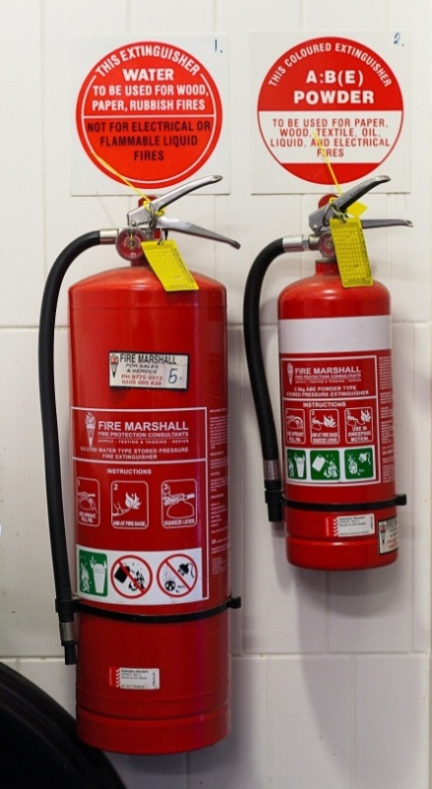
- Where are the fire extinguishers?
- What kinds of fire extinguishers are they?
8. Who can use the fire extinguishers?

Section summary
Now you have completed this section you should have developed the following skills and knowledge.
Tick each box if you are satisfied that you have those skills and knowledge.
Check for common hazards when cleaning.
Know how to deal with hazards.
Understand guidelines for preventing problems.
Know what to do if there is an accident or emergency
Notes
6 The cleaning schedule
All parts of the premises where food is prepared, served and stored must be kept clean to make sure the food is safe to eat. They all need to be cleaned regularly.
This includes:
- walls
- floors
- benches
- shelves
- storerooms and cupboards
- fridges, freezes and coolrooms
- ovens, stoves and cooking equipment such as fryers
- extraction fans.

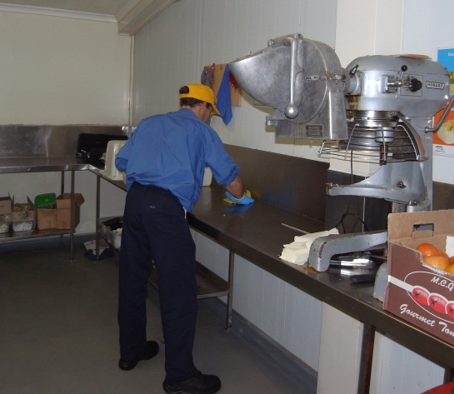

All the things used to prepare, serve and store food also need cleaning. This equipment includes:
- crockery and glassware e.g. plates, cups and glasses
- cutlery e.g. knives, forks and spoons
- utensils used to cook and serve food with e.g. knives, spatulas and rolling pins
- cooking containers e.g. saucepans, frying pans and baking trays
- electric equipment such as mixers, meat slicers and graters
- cutting boards
- containers to store food before or after it has been cooked
- garbage bins.

Here is the kitchen at the Wattle Café.

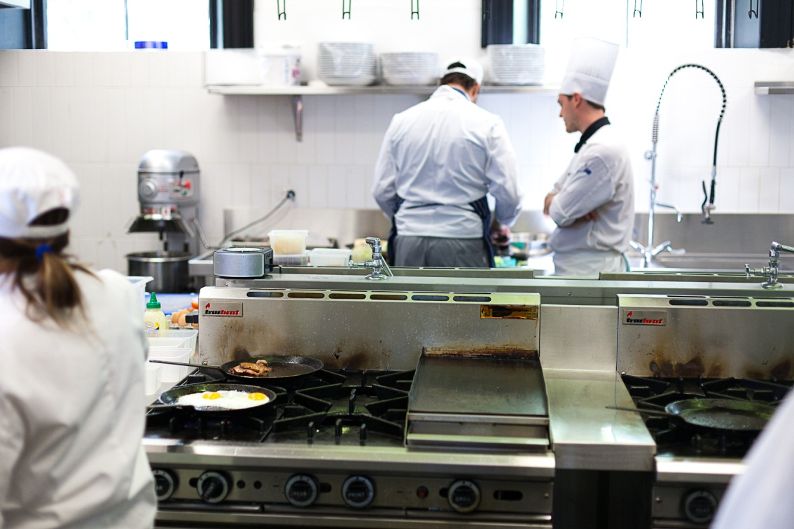

Activity 19
The kitchen at the Wattle Café
1. List 6 things in the kitchen at the Wattle Café that need to be cleaned. Put them in the following table.
2. How often do you think each thing should be cleaned?
 | - As needed during every day  - Once a day  - Once a week | - Once a month  - Other
Thing to be cleaned |  |  | How often

Activity 20
Equipment in your workplace kitchen
1. What kitchen equipment is in your workplace kitchen? If you don’t know the name of something, ask your trainer or supervisor.

2. How often should each piece of equipment be cleaned?
3. If you work in different kitchens, compare lists, so you can see what different kitchens have.
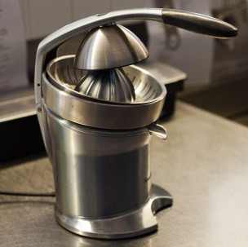
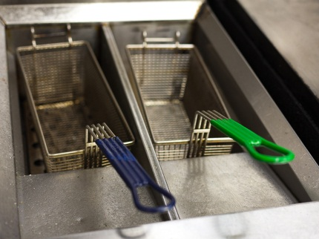

Following a cleaning schedule
Cleaning is part of the regular routine in a kitchen. It is not something that happens when people feel like it. A well organised kitchen has a schedule (timetable).
The cleaning schedule tells you:
what to clean
when to clean it
how to clean it
who cleans it.
Without the schedule, things might not get cleaned often enough. As well as the schedule there will probably also be:
- a daily cleaning worksheet so the cleaner knows what they need to do each day
- cleaning instructions for particular pieces of equipment that explain exactly how to clean them.
Your manager or supervisor writes the cleaning schedule. It is often in a place where everyone can see it easily, e.g. next to the roster.
Cleaning tasks are timed to cause the least amount of upset for staff working in the kitchen. For example, you wouldn’t scrub the floor when the chefs are busy unless you have to clean up a spill.

 |  | Wattle Café Cleaning Schedule
What | How often |  | When | How | Products | Who
Benches | Twice daily and between raw and cooked foods |  | Morning and afternoon | Wash with hot soapy water and a scourer sponge.  Sanitise and wipe with a soft cloth. | XY detergent  AB sanitiser | Joe
Utensils | After use and between raw and cooked foods |  | As required | Wash, sanitise and dry in the dishwasher. | XY detergent  AB sanitiser | Joe
Meat slicer | After use and between raw and cooked foods |  | As required | Take apart before washing. Follow the instructions on the slicer.  Wash, sanitise and dry in the dishwasher. | XY detergent  AB sanitiser | Joe
Bain marie | Daily and as required |  | Before close | Make sure it is turned off. Read the instructions next to the bain marie.  Wash with hot soapy water and a soft cloth.  Sanitise and wipe with a soft cloth. | XY detergent  AB sanitiser | Joe
Floors | Daily and as required |  | Before close | Sweep.  Mop with hot soapy water that has a sanitiser in it. | XY detergent  FJ spray sanitiser | Susan
Walls | Weekly |  | Monday morning | Wash with a wall mop and mild detergent. | MN detergent | Susan
Refrigerator | Daily and as required |  | Morning | Wipe down with hot soapy water and a soft sponge.  Sanitise and wipe with a soft cloth. | CD detergent  AB sanitiser | Amon
Storeroom | Weekly |  | Friday afternoon | Check for any evidence of pests.  Sweep and mop the floor using hot soapy water.  Dust the shelves, then wash with hot soapy water and a scourer if required. | XY detergent | Amon
Sinks | Twice daily and as required |  | Morning and afternoon | Wash with abrasive cleanser and a scourer.  Sanitise and wipe with a soft cloth. | PT cleanser  AB sanitiser | Susan
Inside and outside bins and outside garbage area | Daily and as required |  | Before close | Wash inside and outside the bins with hot soapy water.  Sanitise and leave to air dry.  Hose down the outside area. Use the trigger nozzle. | XY detergent  AB sanitiser | Amon
Coolroom | Fortnightly |  | Every second Monday morning | Follow instructions for entry into the coolroom on the wall outside.  Mop the floor with hot soapy water.  Wash the shelves with hot soapy water and a scourer sponge. | CD detergent | Amon

Activity 21
Wattle Café’s cleaning schedule
Circle one of the names below.

I am Sean / Susan / Amon.
Read Wattle Café’s cleaning schedule. Tell the other people in your group what you have to clean and the order you will clean them in.
For example:

I’m Sean.
First I will clean the ….
Then I will do the ….
After that I will clean the ….
Finally I will …

Activity 22
Your workplace cleaning schedule
Look at a cleaning schedule from your workplace kitchen.
1. Choose 5 things that need to be cleaned. Write down what has to be cleaned and when it is cleaned.
Item to be cleaned | When it is cleaned

2. When do you think is a good time to clean each of these kitchen areas? What is a time that would cause the least inconvenience to staff and guests?
Area to be cleaned | Best time to clean
Storeroom
Refrigerator
Benches
Sink
Floors
Walls and ceiling
Dishwasher
Daily cleaning worksheet
A workplace may have a daily worksheet so people know what they need to do each day.
Activity 23
Prepare a daily cleaning worksheet
Look back at the cleaning schedule for the Wattle Café.
Using this information, complete this Cleaning Worksheet for Monday, so that Joe, Susan and Amon know what they have to do that day.
Think about what should be done in the morning and what should be done in the afternoon. Pick the best times to do the tasks.
Here is some information to help you pick the best times for the tasks.
- Wattle Café only serves lunch.
- Work starts at 9 am but the café doesn’t open to customers until 11 am.
- The café closes at 4 pm and the staff go home at 5.30 pm.
- The coolroom was not cleaned last week.
 |  | Wattle Café Cleaning Worksheet
Day: Mondays
Time | Items to be cleaned |  | Who
8.50 am | Staff arrive
9.00 am
11.00 am
5.30 pm | Staff close up and leave |  | All
Follow safe work procedures (SWPs)
Your workplace may also have safe work procedures (SWPs) for some pieces of equipment. They explain exactly how to clean the equipment. Never clean a piece of equipment unless you have been trained to do it.
Equipment such as meat slicers have sharp blades and must be taken apart, so they can be dangerous to clean.
Here is an example of a safe work procedure for a meat slicer.
WATTLE CAFÉ
Safe Work Procedure for Cleaning Meat Slicer
How often | Every day after use.  Between slicing different food types.
Safety | Do not clean this machine unless you have been trained.  Unplug the machine from the wall.  Use correct PPE – rubber gloves, safety glasses, rubber apron.  Be careful with sharp blades; wipe them from the centre out.
Cleaning products | AB detergent diluted following manufacturer’s instructions.  Sanitiser: use XY bleach – 2 ml per 5 litres of water; wear rubber gloves.
Equipment | Dry brush, bucket or sink, cleaning cloth, spray bottle.  Blade guard and food guide plate can also be cleaned in the dishwasher.
Procedure | 1. PREPARE  Set the slice thickness to zero, so the blade is level with the machine.  Remove the blade guard.  Remove the crumb tray.  Remove the food guide plate.  Remove the centre panel from the blade.
2. CLEAN
Use a dry brush to remove loose crumbs from the machine and parts.
Clean parts in warm water and detergent, then rinse.
Wipe machine with warm water and detergent, then rinse.
3. SANITISE
Soak parts in boiling water (not tap hot water) for 30 seconds. Be careful as the parts will be hot to touch.
Spray machine with solution of sanitiser.
Rinse machine and parts in clean water.
4. REASSEMBLE
Put the machine back together so it is ready to use.
Activity 24
Cleaning the meat slicer
Look at the instructions for cleaning the meat slicer at Wattle Café.
1. Underline any parts of the procedure where you could hurt yourself.
2. What should you do so you don’t get hurt?

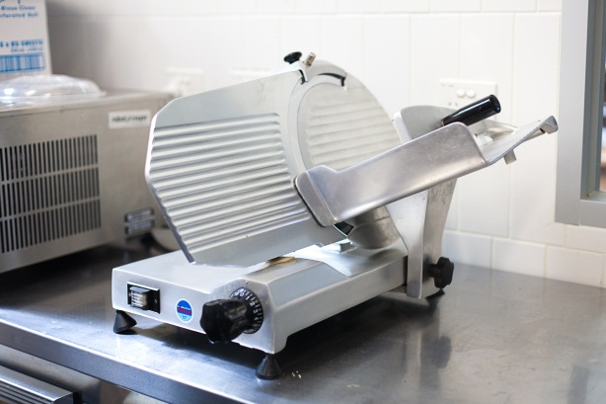 | 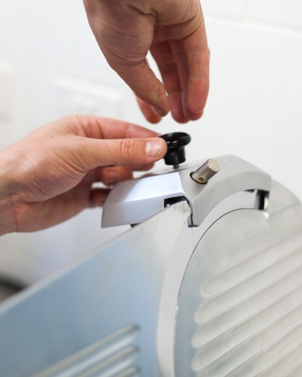
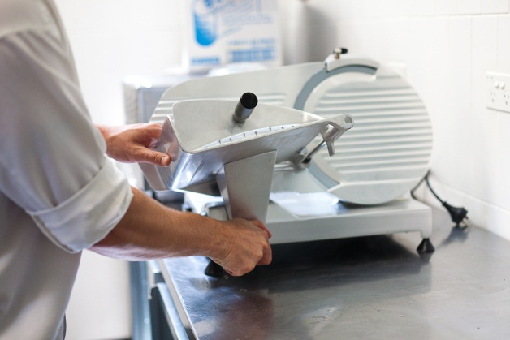 | 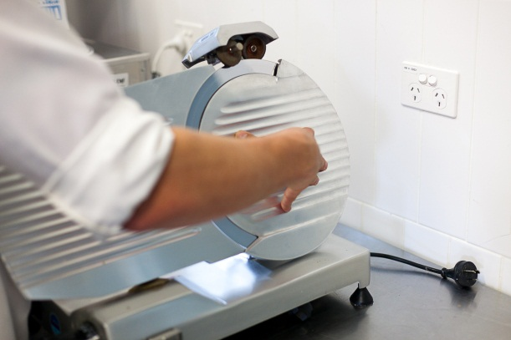
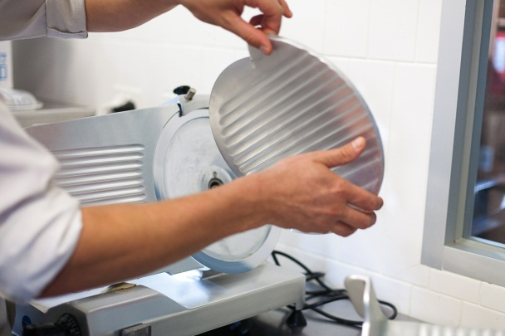 | 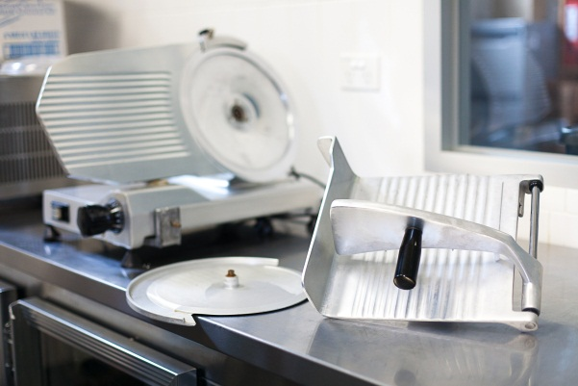

Section summary
Now you have completed this section you should have developed the following skills and knowledge.
Tick each box if you are satisfied that you have those skills and knowledge.
Know what needs to be cleaned in kitchens.
Understand a cleaning schedule.
Carry out cleaning tasks to cause least problems to customers and staff.
Clean kitchen equipment safely.
Notes
7 Cleaning procedures
Your workplace will train you in its own ways of doing things. These are often called standard operating procedures (SOPs). If you don’t know what to do, ask!
Here are some guidelines for the main cleaning tasks in a kitchen. But each workplace kitchen will be a bit different.
Remember the four steps for cleaning:

Washing dishes and utensils
Dishes and cooking utensils can be washed and sanitised by hand or by machine.

Using a dishwashing machine
You only have to do Step 1. Pre-clean the items by using a high pressure hose to clean off loose dirt. The dishwashing machine does Steps 2, 3 and 4 for you.

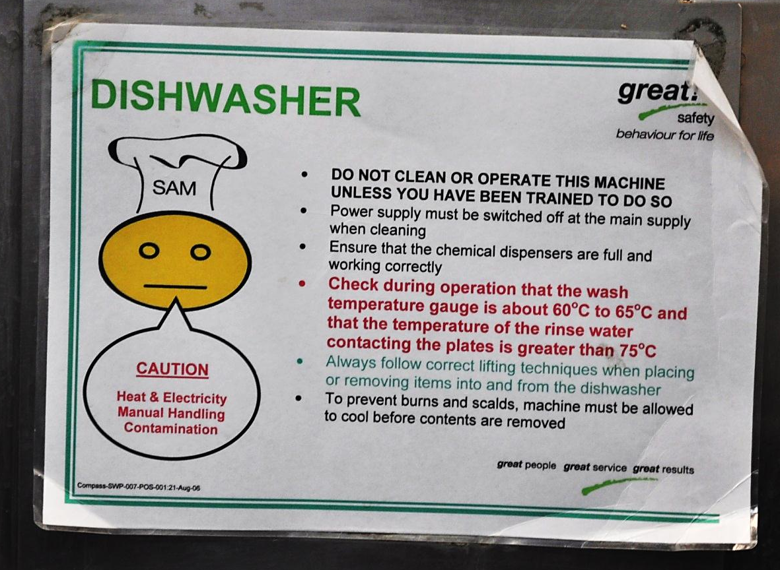

Don’t use the dishwasher until you have been shown how to use it. This includes:
- how to open and close the door
- how to stack the dishes correctly
- which detergent to use and how much
- how to choose the right washing cycle
- how to turn it on and off
- how to take out the dishes
- how to clean it after use.

Washing by hand
Every workplace will have its own procedures for washing and sanitising kitchen equipment by hand. Here are some guidelines.
- Pre-clean | - Use correct PPE – rubber gloves and a rubber apron.  - Scrape food and other scraps off.  - Use a pressure hose to rinse off any remaining dirt.  - Soak really dirty cooking pans. Fill the pan with hot water and put in a small amount of detergent.  - Stack dishes neatly so you can reach them easily.  - Make sure the sink is clean.  - Fill the sink with hot water and add the correct amount of detergent.
- Wash and rinse | - Wash wooden items quickly e.g. rolling pins or wooden bowls. Don’t leave them to soak and dry them quickly.  - Only wash one sharp knife at a time. Never put them in frothy water because they are hard to see.  - Change the water often.  - Rinse with clean hot water.
- Sanitise | - Mix food-grade chemical sanitiser into a sink of warm water.  - Soak utensils and equipment in it according to the manufacturer’s instructions. It does not need to be rinsed off.
- Dry | - Place the items in a rack to air dry.
Clean up | - Remove any food scraps from the plug hole.  - Clean the sink and area around it.  - Clean and sanitise the cleaning equipment e.g. brush, scourer or cloth. Leave them to dry.
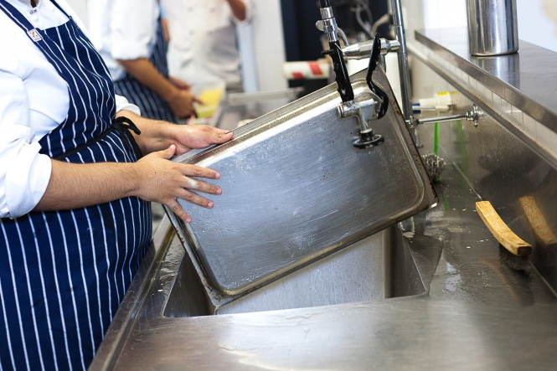
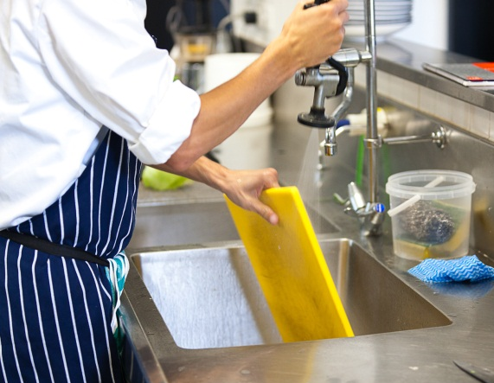

Don’t waste water
- Don’t leave taps running when you are not using them.
- Rinse by filling up another sink with clean water rather than rinsing under running water.
- If any taps are dripping, let your supervisor know so they can be fixed.
- Only use as much water as you need. If you only need to wash a few things, don’t fill a big sink right up.

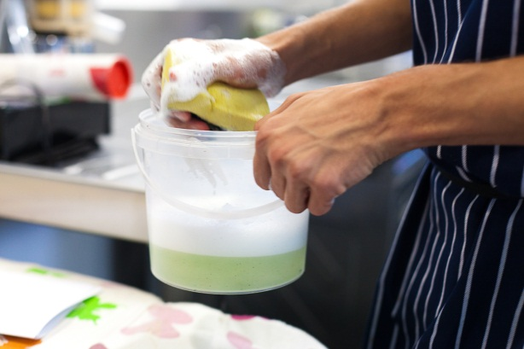

Cleaning kitchen equipment
You may need to wash kitchen equipment used for food preparation, storage and display. This includes stoves and ovens, toasters, microwaves, salamanders, mixers, exhaust fans, pie warmers, deep fryers and bain maries.
You might need to take the equipment apart before you wash it and then put it back together again.

Before you wash any equipment, you must be shown how to do it.
You must follow the instructions so you don’t hurt yourself or damage the equipment.

If you forget how to do it, ask someone.

Every workplace will have its own equipment and procedures. Here are some general guidelines.
- Turn off and unplug electrical equipment before you clean it.
- Be careful with anything that has sharp edges or blades.
- Always wear correct PPE e.g. gloves, rubber apron, glasses and face mask.
- Stoves and ovens may need the use of strong chemicals. Rinse an oven properly to get all the chemicals out of it or it will smell next time it is turned on.
- Sanitise the equipment according to workplace procedures.
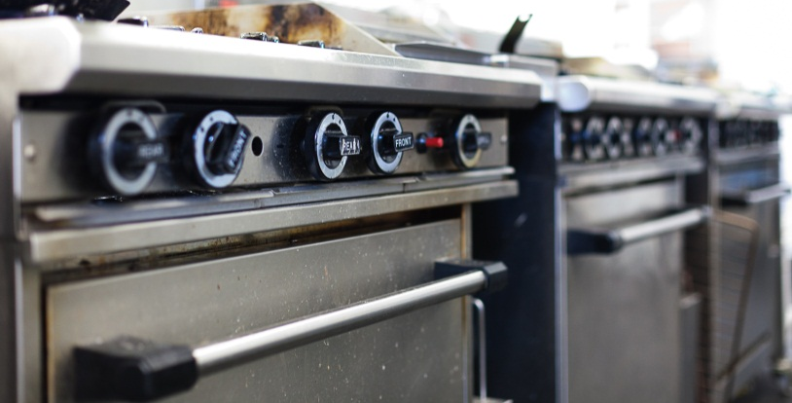
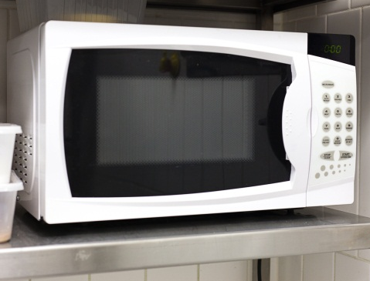

Wattle Café Standard Operating Procedure
Clean kitchen equipment
EQUIPMENT |  |  | HOW TO CLEAN
DAILY | Toasted sandwich maker |  | Clean as required during trade and at the end of each day.  - Heat the sandwich maker.  - Wipe away loose dirt with a clean cloth.  - Spot-clean or scrape difficult areas.  - Wash with detergent and hot water, rinse and sanitise.  - Rinse and allow to air dry.
 | 5 ring burner |  | Clean under the rings as required during trade and at the end of each day.  - Scrape difficult areas with a scraper.  - Wipe to remove debris.  - Wash with detergent and hot water, rinse and sanitise.  - Rinse and allow to air dry.
 | Microwave |  | Clean the microwave as required during trade and at the end of each day.  - Wipe away loose debris and dirt with a clean cloth.  - Spot-clean or scrape problem or difficult areas.  - Wash with detergent and hot water, rinse and sanitise.  - Rinse and allow to air dry.
WEEKLY | Exhaust canopy and filters |  | Clean at the end of each week.  - Wipe the canopy with a cloth to remove surface grease.  - Wash the canopy with detergent and hot water, rinse and sanitise.  - Rinse and allow to air dry.  - Soak filters in a solution of degreaser and hot water for 30 minutes, agitate (move around) and hose down or rinse.  - Allow to air dry.

Activity 25
Cleaning kitchen equipment
Have a look at the previous Standard Operating Procedure for cleaning parts of the kitchen at Wattle Café. Find the answers to these questions.
1. What pieces of equipment do you have to clean?

2. What has to be sanitised?
3. Underline the actions where you are handling chemicals.
What should you do to protect yourself and food from contact with them?
4. Look at the time for each cleaning job. Why do you think that is the best time to do it?
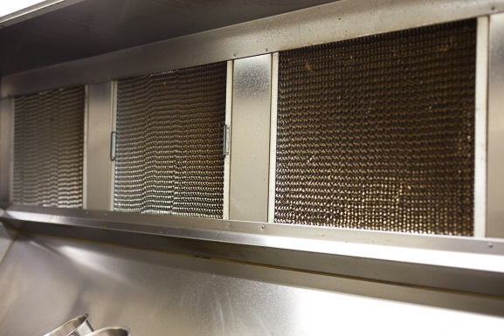
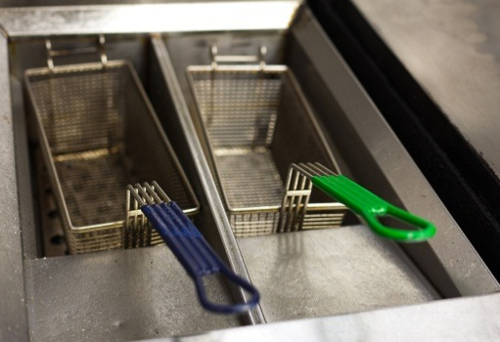

Activity 26
Cleaning a piece of equipment
Your trainer will show you how to:
- take apart a piece of equipment
- clean it
- put it back together again.
When you are confident, take the piece of equipment apart and clean it, using the correct equipment and products. Then put the equipment together again.
As you do this activity, explain to the trainer or your supervisor what you are doing and why.
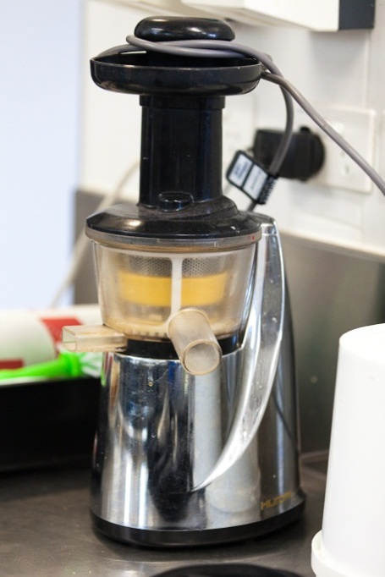
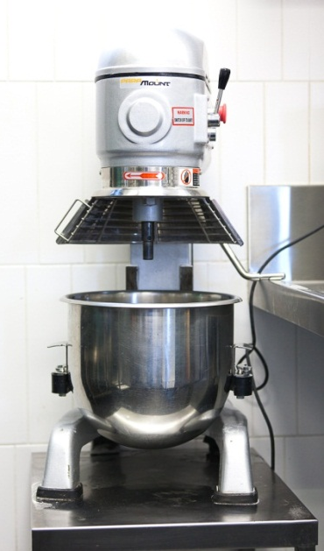

Cleaning surfaces
The surfaces in a kitchen include floors, benches, walls and the ceiling.

Floors
Kitchen floors get dirty very quickly. They can get slippery and dangerous. They must be swept, washed and sanitised at least at the end of the day or shift. They may need to be cleaned at other times of the day too e.g. when food is spilt.
Don’t fill or empty the bucket in the same sink that dishes are washed in. Always use the waste sink.

Here are some guidelines for cleaning floors.
1. Pre-clean | - Put up a ‘Wet Floor’ warning sign.  - Sweep to get rid of visible dirt. Collect the dirt in a dustpan and put it in the bin.
2. Wash | - Fill a mop bucket with hot water and add detergent.  - Clean the floor with a rag mop using a ‘figure 8’ movement.  - Change the water as needed.
3. Sanitise | - Get a fresh bucket of warm water and add sanitiser.  - Mop the floor again.
4. Dry | - Leave floor to dry.
Clean up | - Remove the ‘Wet Floor’ sign after the floor is dry.  - Wash mops in hot soapy water and a sanitiser, then leave them to air dry.
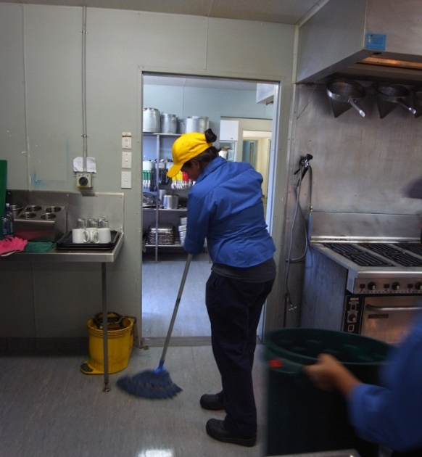

Benches
Benches are where the food is prepared, so they need to be cleaned all through the day. The chef or someone in the kitchen may tell you when to clean the benches.
At the end of the day or after each shift, the benches should be thoroughly cleaned and sanitised.
Stainless steel benches can scratch easily. Don’t use scourers on them.

Here are some guidelines for cleaning benches.
1. Pre-clean | - Take food off the bench and store it away from the cleaning area.  - Sweep off any crumbs or other food scraps and put them in the bin.
2. Wash | - Wipe down with warm water and a detergent, using a cloth or sponge.
3. Sanitise | - Spray with a food-grade sanitiser.  - Leave for the time specified by the manufacturer, then wipe off.
4. Dry | - Leave to dry.
Clean up | - Wash cloths and sponges in hot soapy water and a sanitiser, then leave them to air dry.
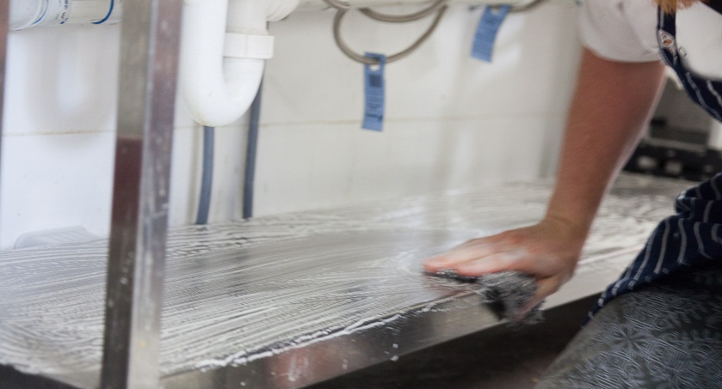

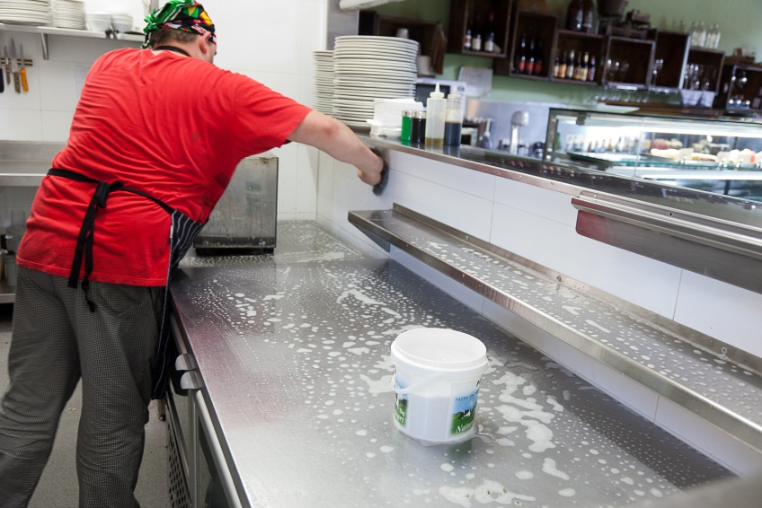

Walls and ceilings
Walls and ceilings are often washed each month, depending on how dirty they get at each workplace. Every workplace will have its own procedures.

Here are some guidelines.
- Put up a ‘Wet Floor’ warning sign. Water may drip onto the floor and make it slippery.
- You might need to use a special cleanser and scourer on the greasy walls behind the stoves. Be careful not to damage the paint or the wall.
- Wash other parts of the wall and the ceiling using a detergent or all-purpose cleaner and a wall mop. You can then sanitise walls with a spray-on sanitiser.
- Clean the walls from bottom to top. The bottom of a wall is usually dirtier than the top, so if you work this way the water does not run through the dirt and cause streaking.

Wattle Café Standard Operating Procedure
Cleaning walls, floors, ceilings, windows
JOB |  |  | DESCRIPTION
DAILY | Floors (lino and tiles) |  | Clean as required during trade and at the end of each day’s trade.  - Sweep and spot-clean difficult areas such as food spills.  - Mop with detergent and hot water, rinse and sanitise.  - Allow to air dry.
MONTHLY | Walls |  | Clean as required and at the end of each month.  - Remove visible dirt by spot-cleaning.  - Wash using a wall mop, detergent and warm water.  - Rinse and sanitise.  - Rinse and allow to air dry.
 | Windows |  | Clean as required and at the end of each month.  - Remove fly screens (where fitted) and remove visible dirt by spot-cleaning.  - Wash windows inside and out using spray-on glass cleaner, warm water and a squeegee.  - Rinse and polish with a soft lint-free cloth.
 | Ceilings and light fittings |  | Clean as required and at the end of each month.  - Remove visible dirt by spot-cleaning.  - Wash ceilings using detergent and hot water. Wipe light fittings with a damp cloth and detergent.  - Rinse and sanitise.  - Rinse and allow to air dry.

Activity 27
Cleaning surfaces
Have a look at the previous Standard Operating Procedure for cleaning walls, floors and other parts of the kitchen at Wattle Café. Find the answers to these questions.
1. List the equipment and products you need to do each cleaning task.
Floors
Windows
Walls
Rubbish bins
Ceilings and
light fittings

2. Highlight the actions in the SOP where you may be lifting heavy items, stretching high or working low.
3. What should you do to avoid back or shoulder injury?

4. Underline the actions in the SOP where you are handling chemicals.
5. What should you do to protect yourself from contact with them?

6. After you have cleaned the bins, can you go straight inside to clean the benches?
YES/NO Why/why not?

7. What safety actions should you take when cleaning light fittings?

Cleaning storage areas

Fridge
Empty the shelves and wipe them down daily, using a food-grade cleaning product. Sanitise with a food-grade sanitiser.
Limit the time that any food spends out of refrigeration to no more than 30 minutes.
Let your supervisor know if you see any food that is out of date or stale.

Coolroom
1. Pre-clean | - Move food from the coolroom to other refrigeration if possible.  - Remove any food matter or debris on the floor, walls or shelving.
2. Wash | - Wash the interior (including shelving and seals) and exterior walls with a food-grade detergent and hot water.
3. Sanitise | - Rinse and sanitise with a food-grade sanitiser.
4. Dry | - Rinse and allow to air dry.
Clean up | - Replace food if you have moved it.

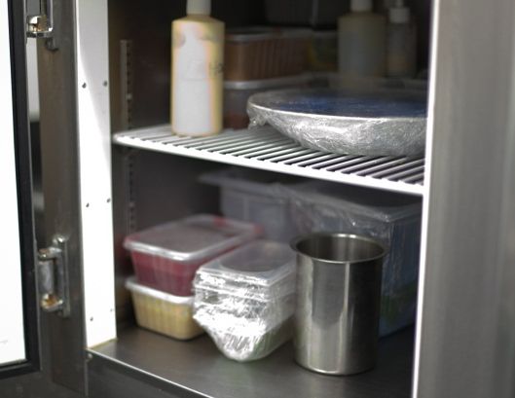
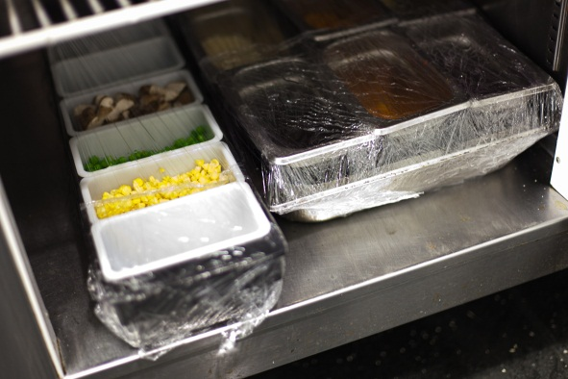

Freezer

Empty the freezer, then defrost, clean and sanitise with a food-grade sanitiser.
Defrost the fridge and freezer
If fridges and freezers are defrosted regularly they will work better and use less electricity.

Dry storerooms and cupboards
Storerooms and cupboards need to be cleaned regularly. Sweep and wash the floor at least weekly. Dust, clean and sanitise the shelves regularly, and clean any spills when they happen.
While you are cleaning, check for these things:
- anything that is out of date or is in the wrong place
- anything that has spilled or broken, or come out of its packet
- signs of pests such as mice, rats, cockroaches or other insects:
- mouse droppings
- chew marks on containers
- moths flying around
- grubs or moths in containers
- spots on walls and surfaces
- eggs and cocoons
- spider webs.
Pests can spread diseases. If you see any of signs of pests, tell your supervisor immediately.

Activity 28
Cleaning storage areas
1. How long should it take you to empty a fridge, clean the shelves and return the food?
2. What equipment and products would you need to clean a coolroom?
3. You are cleaning the coolroom and you see a tray of sandwiches with a use-by date of 2 days ago. What should you do?

4. You are sweeping the dry goods storeroom and you see some mouse droppings. What should you do?

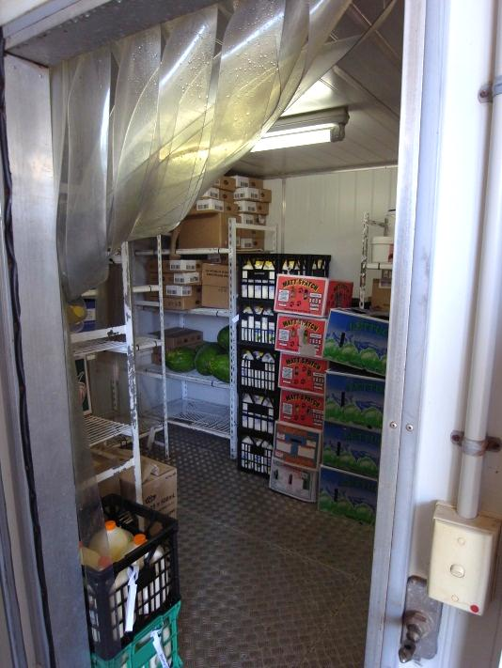
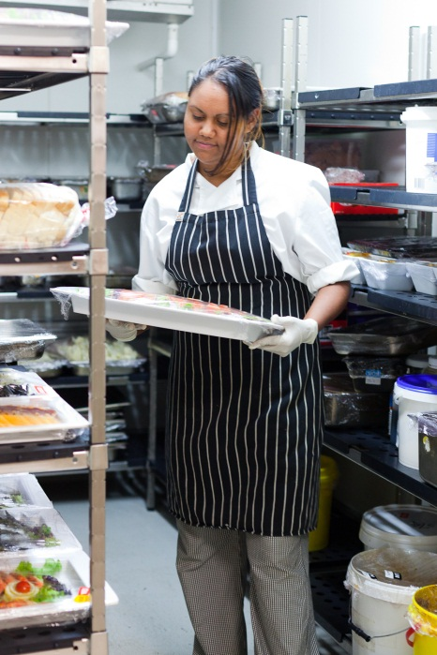

Activity 29
Your workplace cleaning procedures
Choose something that needs to be cleaned in your workplace kitchen.
Find out how it is cleaned. You can:
- read the instructions
- ask your supervisor or workmates
- watch people do the task (ask if there are any ‘tricks’ to make it easier or safer).
Write down the information in the following table.

In your workplace:
What is to be cleaned
How often
PPE
Safety
Cleaning products used
Equipment used
Procedure

Cleaning waste bins
Food waste can attract pests and contaminate food. Rubbish areas must be kept clean so that the kitchen stays safe.
Every workplace has its own procedures for handling waste, but here are some general guidelines.
Guideline | Why is this important?
- Line all rubbish bins.
- Take rubbish out of the kitchen regularly. Don’t let bins overfill.
- Tie the top of the bin liner before you dispose of rubbish.
- Carry rubbish bins away from your body and clothes.
- Use correct PPE.
- Wash your hands after handling bins.
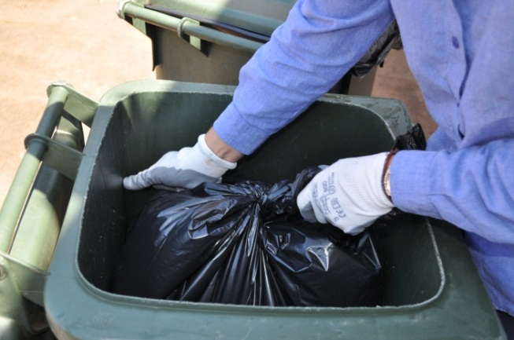

Activity 30
Cleaning waste bins
Talk about each guideline in the previous table. Why is it important?
Make brief notes in the column.

Procedure for cleaning bins
1. Pre-clean | - Clean up anything that has fallen out of bins onto the floor.  - Remove the bin liner, with rubbish, from the bin. Tie the top and dispose of the rubbish correctly.  - Wipe away loose dirt from outside and inside the bin with a cloth.
2. Wash | - Scrub the outside and inside of the bin and lid with detergent and hot water.  - Wash the area around the bin, such as floors and walls.
3. Sanitise | - Rinse the kitchen bins with hot water and disinfect them.  - Hose out commercial bins with cold water and disinfect them. Use a nozzle spray to save water.
4. Dry | - Rinse, allow to air dry and fit with a new bin liner.
Clean up | - Wash your hands thoroughly after you have finished.

Activity 31
Waste at your workplace
How is kitchen waste dealt with at your workplace?
1. Are the rubbish bins in the kitchen covered and lined?
2. How often are they emptied?
3. How often are they washed?
4. Whose job is it to empty and wash the bins?
5. How is the outside bin area kept clean?

Section summary
Now you have completed this section you should have developed the following skills and knowledge.
Tick each box if you are satisfied that you have those skills and knowledge.
Wash dishes and kitchen equipment.
Clean surfaces.
Clean storage areas.
Clean waste bins.
Notes

8 Sorting linen
In the hospitality industry, a lot of linen is used.

What is linen?
Items called ‘linen’ are usually made from linen, cotton, polyester or other fabrics.
Linen includes:
- tea towels
- aprons
- tablecloths and napkins
- uniforms
- oven mitts
- cleaning cloths
- serving cloths.

Why is washing linen important?
Germs from linen can be passed to hands or equipment and then to food, so linen must be washed and stored properly.
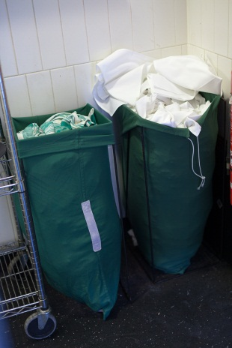
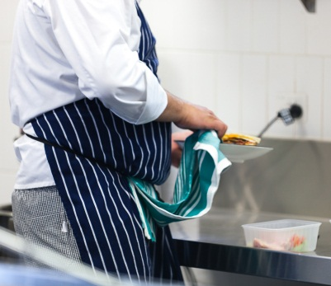

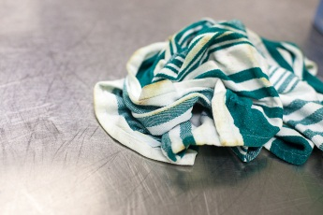

Where is linen washed?
Every workplace has its own arrangements for washing linen. Washing may be:
- sent out to an external laundry using industrial washing and drying machines that wash and dry at a high temperature
- done in the workplace laundry using industrial washing machines
- done in the workplace laundry using domestic washing machines.

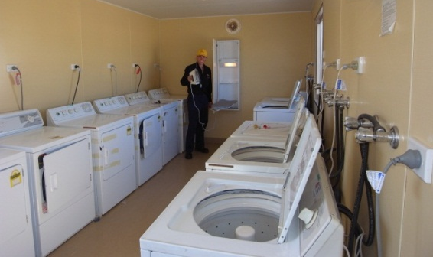

Why is linen sorted?
Different types of linen may be washed differently or should be separated to prevent cross-contamination (passing germs from one surface to another).
You may need to sort linen and put different types into separate bags ready for washing. It is generally sorted by:
- quantity
- size
- type or use
- colour.
Every workplace has its own procedures but here are some general guidelines.

Guidelines for sorting linen
- Separate the linen according to how it is washed, for example:
- anything that will come in contact with food must be washed and sanitised separately e.g. tea towels must be washed separately
- separate cleaning cloths as these must be washed separately
- white linen is washed separately from coloured linen
- large items (e.g. tablecloths) may be washed separately from small items (e.g. napkins).
- Remove loose dirt from the linen e.g. crumbs.
- Separate damaged items e.g. torn tablecloths and burnt tea towels.
- Separate items with stains that may need special treatment e.g. grease, red wine or blood.
- Put soiled linen in the laundry bags and label them clearly.
- Count the linen after you have sorted it to make sure the correct amount is sent back from an external laundry.
- Always wash your hands after handling soiled linen.
- Sort soiled linen in an area where there is no food or food equipment present.
- When removing soiled linen from the kitchen area, keep it in a closed container. Take a route that avoids food areas and areas where there are guests.

! | WARNING – Handling contaminated linen
If linen is stained by blood, vomit or other similar substances, put it in a red labelled biohazard waste bag so it does not contaminate other surfaces or people.
Use disposable gloves and a disposable apron when you are handling contaminated linen.

Activity 32
Handling linen at your workplace
1. Is linen sent out to an external laundry or washed ‘in house’?
2. Whose job is it to sort linen?
3. What PPE do they wear?
4. Where is the sorting done?
5. What happens to badly stained linen?
6. How is soiled linen moved to the laundry or a laundry pick-up point?

Re-usable not disposable
Disposable items, such as paper serviettes and tablecloths, can save time. But it is better for the environment to wash and re-use linen rather than throwing paper items away after one use.

Section summary
Now you have completed this section you should have developed the following skills and knowledge.
Tick each box if you are satisfied that you have those skills and knowledge.
Sort linen.
Notes

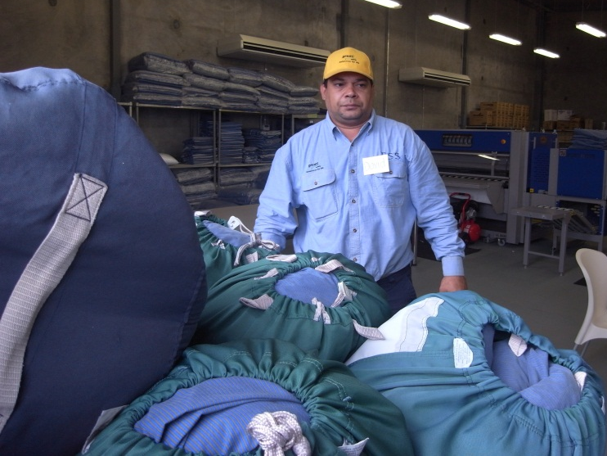
9 Safe disposal waste

Disposal of hazardous waste
Some things used in kitchens must be disposed of properly or they can pollute (poison) the environment (the land, sea, water and air).
Some examples of hazardous waste are:
- cleaning chemicals
- corrosive products such as oven and drain cleaners
- used cooking oils
- aerosol containers
- insecticides and pesticides such as mouse bait
- flammable products (it is against the law to have methylated spirits in the workplace any more).
They must be disposed of (got rid of) in a way that protects the environment.

These substances must never be poured down a sink or a gully trap, put into storm water drains or thrown out with normal rubbish.
Hazardous waste | How to dispose of it
Unwanted concentrated chemicals, aerosol sprays and empty chemical containers | Your workplace should have them collected by a licenced industrial waste company who will dispose of them safely.
Diluted chemicals e.g. used cleaning water | Pour it down a cleaner’s sink with a chemical waste trap that feeds into the sewer system, not the storm water.
Used cooking oil and grease | Your workplace should have it collected in a special kitchen grease trap and use a licensed company to take it away.

There are federal, state and local laws about the environmentally safe disposal of chemicals and used cooking oil. Any business that does not follow these laws can be fined and get bad publicity.
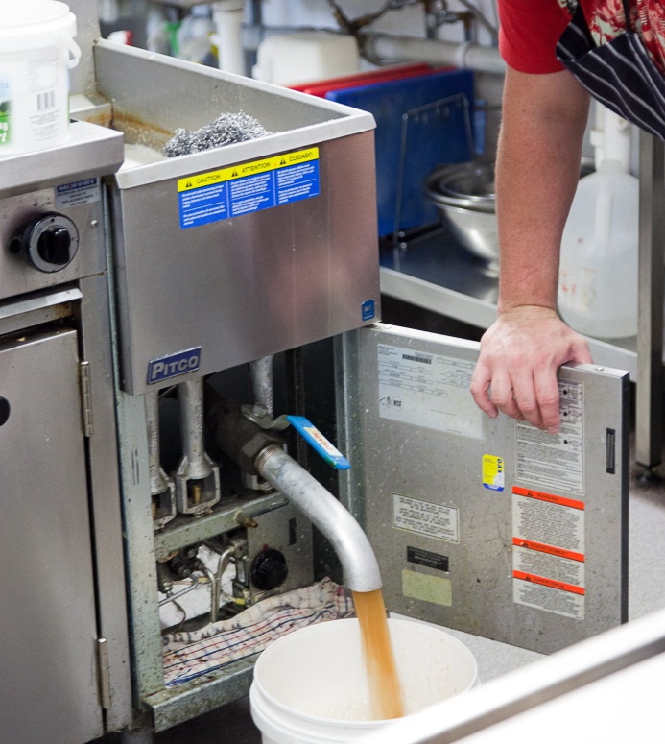

Your workplace will have a procedure for disposing of hazardous waste. If you notice that this waste is being disposed of wrongly, tell your supervisor.

Reduce use of chemicals
Hazardous waste can’t be put into normal rubbish bins or tipped down drains. It must be disposed of safely in a way that follows the law.
Your workplace could also try to produce less hazardous waste by:
- buying spray bottles rather than aerosol sprays
- buying cleaning products that are not harmful to the environment
- using microfibre cleaning products that don’t need chemicals
- using environmentally friendly methods to remove pests, such as mice traps instead of bait and insect screens on windows.

Recycling

Recycling
Recycling means re-using something.
Your workplace probably has recycling rubbish bins where you put bottles and cans into one bin and food scraps in another. There may also be a separate bin for paper and cardboard. Things like paper, glass and plastic can be used again; food can be turned into compost and used on garden beds.
It is good for the environment because it reduces the number of new things that must be manufactured and there is less rubbish sent to the tip.

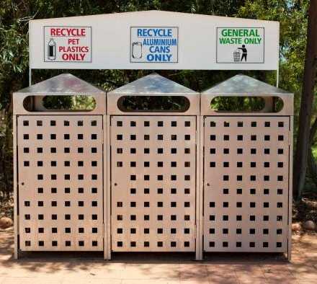

Activity 33
Is your workplace enivronmentally friendly?
In this workbook, you have found out about ways to clean that help protect the environment.
Which ones are used in your workplace?
Tick the YES or NO box for each question.
At your workplace … | YES | NO
- Are any of the cleaning products you use biodegradable and non-toxic?
- Are spray bottles used instead of aerosol cans?
- Are cloth napkins used instead of paper serviettes?
- Is the electrical cleaning equipment energy efficient e.g. a dishwasher with a high star rating?
- Are you encouraged to save water, e.g. by turning off taps when you are not using them; not rinsing under running water?
- Are you encouraged to save energy e.g. by turning off lights and equipment when they are not being used?
- Are recycling bins used?
- Are chemicals disposed of properly?
- Is used cooking oil disposed of properly?
- Do you use microfibre cleaning products?
- When you dilute chemicals with water, do you only use the amount on the label?
- Do you let your supervisor know if you find a dripping tap?

Section summary
Now you have completed this section you should have developed the following skills and knowledge.
Tick each box if you are satisfied that you have those skills and knowledge.
Understand the environmental effects of cleaning.
Know about a range of environmentally sound cleaning practices that use less energy, water and chemicals.
Know how to dispose of waste and chemicals in an environmentally sound way.
Notes

Key words
Word | Meaning
biodegradable | Breaks down naturally so causes less pollution
biohazard | Something infectious, such as a virus or germ, that could make people sick
cross-contamination | When germs pass from one place (e.g. food, benches, hands or equipment) to a piece of food
data | Information
detergent | Used to remove grease and dirt
disposable | Something that can be thrown away after it has been used once e.g. paper serviettes and cups
eliminate | Get rid of
fumes | Smells or gas from chemicals, which can harm you if you sniff them
hazard | A risk of danger
induction | Training when you first start work so you know what to do
linen | Things made of fabric e.g. tea towels, chef’s cloths, aprons, tablecloths, napkins
lint, lint-free | Small bits of fluff that come off fabric. Some cleaning cloths don’t do this – they are lint-free
MSDS | Material Safety Data Sheet – it contains the manufacturer’s information about a chemical product to help people use the chemical safely
non-toxic | Not poisonous, safe
pests | Creatures which can contaminate food e.g. mice, flies, ants and cockroaches
PPE | Personal protective equipment. Equipment and clothing to protect you from hazards. It includes gloves, aprons, masks, safety glasses, ear plugs and safety shoes.
premises | A place of business such as a restaurant or hotel
procedures | A list of steps telling you how to do tasks at work
recycling | Using something again, e.g. glass or paper, usually after it has been processed
repel | Drive pests away
re-usable | Something that can be used again, usually after washing, such as cloth napkins and tablecloths
salamander | Portable stove or burner
sanitise | Use a chemical or heat to reduce the number of germs on a surface
scald | Burn with hot liquid or steam
schedule | Timetable
utensils | Tools used in the kitchen e.g. knives, mixers and serving spoons
waste | Rubbish; something that has to be thrown away e.g. leftover food

