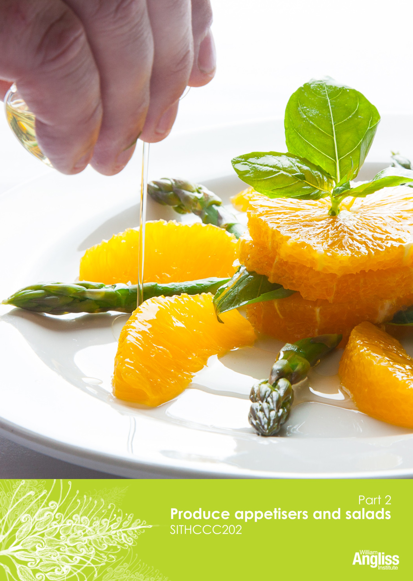

© Commonwealth of Australia 2013

CC BY-NC-SA

This work is copyright. Except where otherwise indicated, and save for the Commonwealth Coat of Arms, the Department has applied the Creative Commons Attribution-Noncommercial-Share Alike 3.0 Australia Licence to this work.

The Department of Industry, Innovation, Climate Change, Science, Research and Tertiary Education must be attributed as the author of the Department’s copyright material.

As far as practicable, material for which the copyright is owned by a third party has been clearly labelled. The Department has made all reasonable efforts to ensure that this material has been reproduced on this website with the full consent of the copyright owners.

Requests and enquiries concerning the Department’s copyright material should be addressed to:

The Legal Branch
Department of Industry, Innovation, Climate Change, Science, Research and Tertiary Education
GPO Box 9839 Canberra ACT 2601

Or emailed to legalservices@innovation.gov.au

Funded under the Workplace English Language and Literacy (WELL) Program by the Australian Government Department of Industry, Innovation, Climate Change, Science, Research and Tertiary Education

The views expressed in this publication do not necessarily represent the view of the
Minister for Tertiary Education, Skills, Science and Research or the Australian
Government. The Australian Government does not give any warranty nor accept any liability in relation to the contents of this work

ISBN 978-1-922108-14-2

Development Team
Content | William Angliss Institute of TAFE
 | Macsmith and Associates
Photography & graphics | Benjamin B Photographer
Acknowledgments
We would like to acknowledge the generous support of the following organisations and the learners and employees in those venues, both Indigenous and non-Indigenous, for giving their permission for photography:
William Angliss Institute Coffee Academy, Melbourne, VIC
Voyages Ayers Rock Resort, Yulara, NT
Cultural Warning
People of Aboriginal or Torres Strait Islander descent should be aware that this publication contains images of people who may be deceased
Disclaimer
Every effort has been made to ensure that this booklet is free from error or omissions. However, you should conduct your own enquiries and seek professional advice before relying on any fact, statement or matter contained in this book. William Angliss Institute of TAFE and Macsmith and Associates are not responsible for any injury, loss or damage as a result of material included or omitted from this course.

Contents
Welcome vi
Icons vi
What you will learn vii
5 Produce salads 1
Types of salads 1
Salad ingredients 4
Salad dressings and sauces 11
Dressing a salad 23
Words for taste and texture 25
Construct salads 27
Store prepared salads 29
Present salads 30
Section summary 33
6 Produce appetisers 34
What are appetisers? 34
Types of appetisers 35
Canapés 35
Put canapés together 39
Chef makes canapés 39
Savouries 44
Make savouries 45
Appetisers from other countries 47
Present appetisers 50
Store appetisers before service 52
Use leftovers and trimmings 52
Section summary 53
The Gums Recipe Book 54
Salads 54
Dressings and sauces 60
Appetisers 63
Key words 67
Welcome

Icons
These signs tell you what type an activity is:
Do this activity in a big group.
Do this activity in a small group.
Do this activity in pairs.
Do this activity by yourself.
Do this activity using the internet.
If you are not connected to the internet, your trainer will provide you with another activity.
Do this activity in your workplace.
If you are not in a workplace, your trainer will provide you with another activity.

What you will learn
Appetisers and salads are important parts of the menu of a café or restaurant.
They must be fresh, tasty and good to look at.
In this unit you will learn how to:
- select the ingredients for appetisers and salads
- select, prepare and use equipment safely and correctly
- follow food safety guidelines
- portion and prepare the ingredients
- perform some basic cooking techniques
- produce and present appetisers and salads
- store the appetisers and salads.
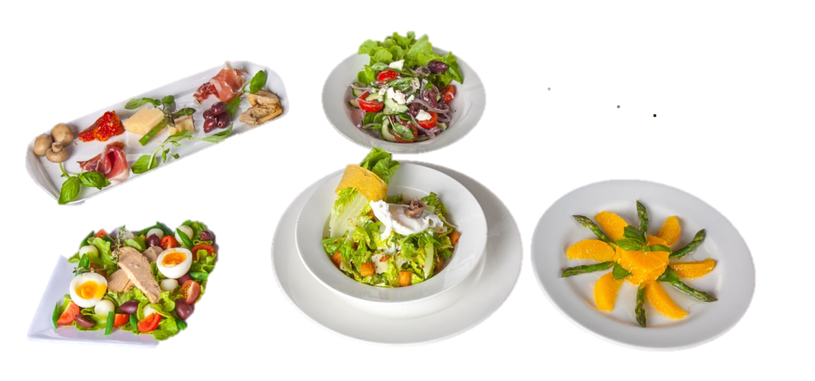

5 Produce salads
Types of salads
Salads are popular in Australia’s warm climate, and as people change to lighter, healthier food.
A salad can be served in many different ways:
- warm or cold
- raw ingredients , cooked or a combination
- as a starter, main course, meal accompaniment or in a buffet table.
Here are some types of salads.
Simple salads:  One ingredient is the main feature, usually a vegetable, e.g. lettuce or tomato salad.  Usually has a dressing (a liquid sauce) added, e.g. vinaigrette dressing. | 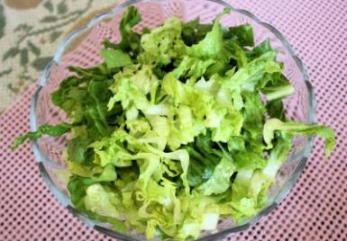
Mixed or compound salads:  Two or more main ingredients  The dressing binds the ingredients, e.g. Coleslaw salad with mayonnaise. | 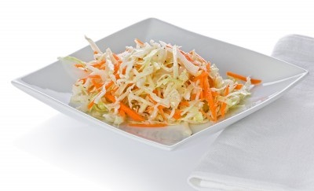
Composed salads:  The ingredients are arranged on the plate rather than mixed or tossed.  The dressing is often poured over the salad or served as an accompaniment,  e.g. Salad niçoise. | 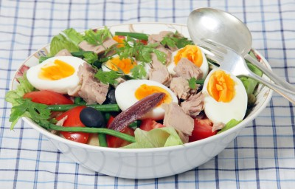
Classical salads:  Follow recipes which have been around for a long time.  They may be simple, compound or composed, e.g. Waldorf salad. | 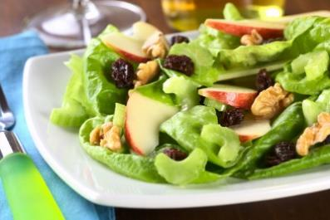
Contemporary (modern) salads:  May combine flavours, ingredients and techniques from different cuisines (style or method of cooking).  e.g. Couscous and roast vegetable salad from Middle Eastern cuisine. | 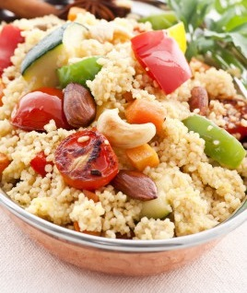
Warm salads:  A warm or cooked item is the main focus, e.g. meat, poultry or seafood.  Usually arranged on a base of salad leaves, e.g. Warm lamb salad with yoghurt dressing. | 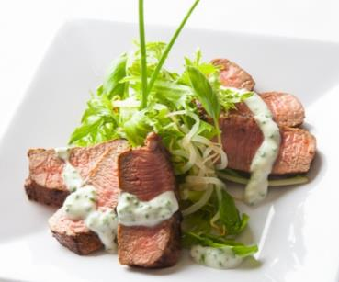

Activity 23
What salad is that?
1 Choose 5 salads from the Recipe Book.
Which types of salads are they? You might tick more than one box for a salad.
One has been done for you.
Salad | Simple | Mixed | Composed | Classical | Contemporary | Warm
Coleslaw salad
2 In your workplace, what salads have you made yourself, or seen made?
3 If they are different to the 4 above, add them to the table.

Salad ingredients
Salads can be made from a variety of ingredients. With the influence of many cultures in Australia, the range of ingredients has increased, and continues to increase.
Here are some common ingredients for making salads and dressings

Salad greens
‘Leafy green’ or ‘salad green’ includes leafy lettuce and other green vegetables that are used in salads, such as baby spinach and cabbage.
Here are some common ‘leafy greens’ in Australia.
Iceberg lettuce  - the most familiar salad green  - firm, compact head  - light green leaves, paler colour on the inside. |  |  |  | 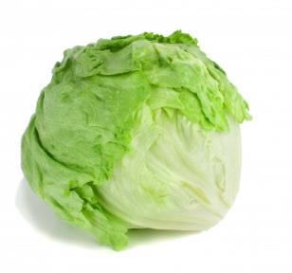
Radicchio  - deep red leaves with a white contrasting rib  - bitter and spicy taste. |  |  |  | 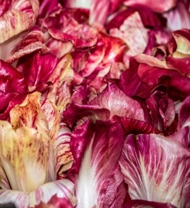
 |  | Curly endive  - thin, twisted leaves, curly at the outer edges  - dark green outside to pale yellow or white in the centre  - slightly bitter taste. |  | 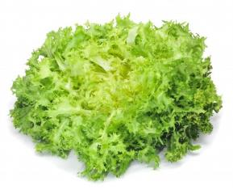
 |  | Cos lettuce  - a long shape with loose green leaves  - stays crisp. |  |  | 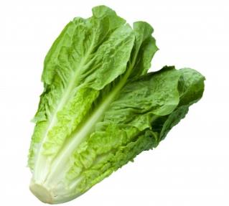
 |  | Butter lettuce  - loose, yellow to pale green leaf  - soft, not crisp  - delicate flavour. | 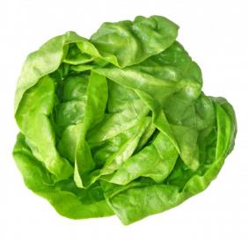
 |  | Oakleaf lettuce  - base is pale green and the tip is red  - soft loose-leaf lettuce. | 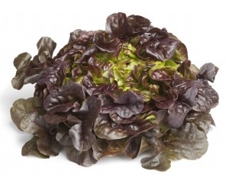
 | Rocket (roquette)  - small separate leaves  - peppery, spicy flavour. |  | 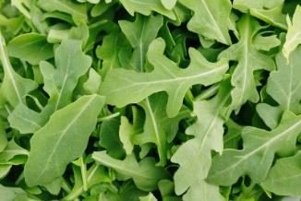
 |  | Baby spinach  - small separate dark green leaves  - adds variety of colour and shape to mixed leaf salad. | 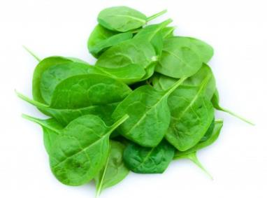
 |  | Cabbage  - usually pale green, but can also be red  - leaves are firm and densely packed. | 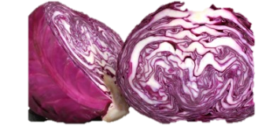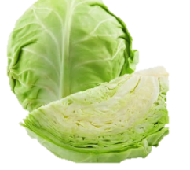
 |  | Mixed baby leaves  A prepared and pre-washed salad mix made up of several types of leaves. | 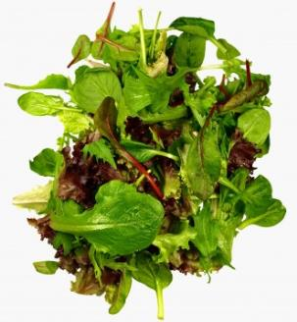

Sprouts
Some sprouts can be used in salads. These provide flavour, texture and a visual appeal. Some examples are:
- snowpea sprouts
- alfalfa spouts
- bean shoots.
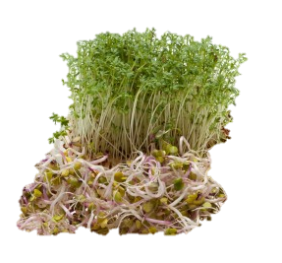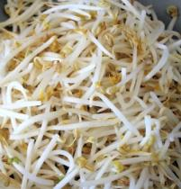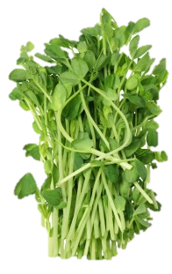

Salad herbs
Herbs are used in salads to provide flavour, aroma (smell) and texture (feel). If you put in too much, it may take over the taste of the main ingredients of the salad.
Here are some popular herbs used in salads.
Chives | 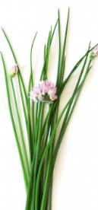 | Curley leaf parsley | 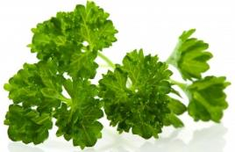
Coriander | 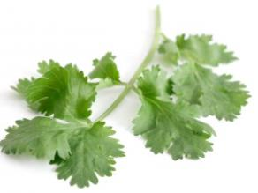 | Vietnamese mint | 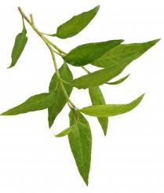
Basil | 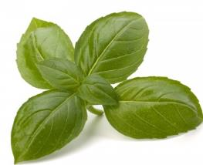 | Mint | 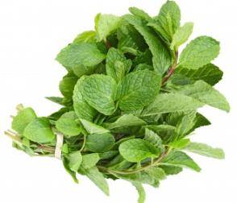
Italian parsley | 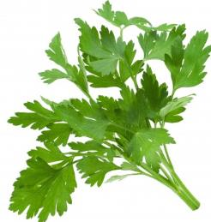 | Dill | 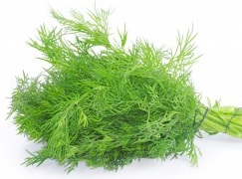
Other herbs may include:
- thyme | - marjoram | - oregano
- rosemary | - fennel | - spearmint
- tarragon

Fruit and vegetables
Fruits and vegetables can also be used in salads, including:
- carrots | - capsicum | - beans
- cucumber | - pears | - apples
- oranges | - avocado | - mangoes.
They add different flavours, crunch, texture and colour.
Also, simple fruit salad can be served during a meal or as a sweet after a meal. You can use a range of fruit in season.

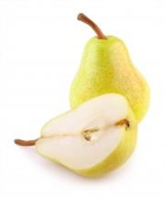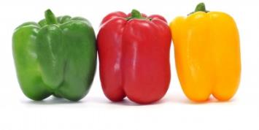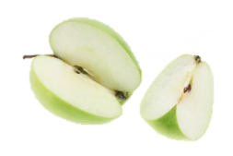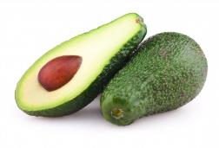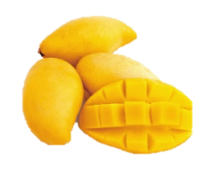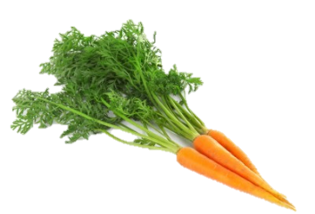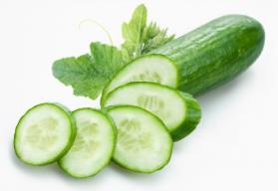

Other ingredients
You can use a range of other ingredients in salads, including:
- meat | - fish | - seafood
- nuts | - cheese | - olives
- eggs | - pasta | - rice.

Activity 24
What ingredients?

Recipe | Salad green | Herbs or sprouts | Fruit or vegetables | Other ingredients
Caesar salad | cos lettuce | parsley |  | bread bacon  parmesan anchovies
Nicoise salad
Warm lamb salad with yoghurt dressing
Couscous and Roast Vegetable Salad

Activity 25
Salads in your workplace
Choose 2 salads that are served in your workplace.
1 When are the salads served?
For example, before a meal, with a meal, as a meal in itself, as part of a buffet.
2 List the main ingredients of the salad.
Salad and when served | Main ingredients

Salad dressings and sauces
‘Dressing’ a salad doesn’t mean we are putting clothes on it.It means we are putting a liquid or sauce into the salad.
Salad dressings or sauces are usually added to salads, for a variety of reasons. These include to:
- add flavour
- add colour
- bind (join) the ingredients together
- moisten the salad
- aid digestion (make it easier for the stomach to break down the food)
- make the salad look more attractive.
There are many types of dressings and sauces that can be used for salads. Before choosing the best dressing for the particular salad, you should ask these questions.

What is the dressing for? Is it only to add flavour or also to bind the ingredients?
Will the dressing be served in the salad or next to the salad?
Does the dressing go with the flavour of the salad?

There are several different types of dressings, but many are based on the standard recipes for vinaigrette and mayonnaise.

Vinaigrette
This is a mix of oil and vinegar seasoned with salt and pepper.
It is also called a French dressing. A vinaigrette can accentuate (make more intense) the flavour of the salad, and gives moisture to the salad.
The usual ratio is 1 part vinegar and 3 parts oil.
So, for 1 cup of oil, you only need 1/3 cup vinegar.
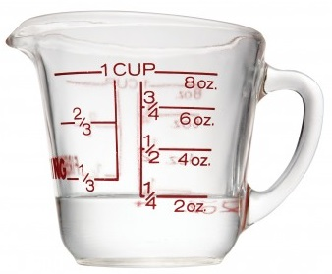
1/3 cup vinegar
1 cup oil

Activity 26
How much vinegar or oil?
You have been asked to make a vinaigrette dressing.
The chef only tells you one quantity. Work out the missing quantities.
The first one is done for you.
One part is … | 1 part vinegar | and | 3 parts oil
1/3 cup | 1/3 cup | and | 1 cup
100 ml | 100 ml | and
 |  | and | 3/4 cup
1 tbspn | 1 tbspn | and

Did you know?
The word, vinegar, comes from the French “vin aigre” meaning “sour wine”.
Other ingredients which add flavours to a dressing are:
- herbs
- garlic
- mustard
- lemon juice.
Oil and vinegar do not emulsify (bind together), so they will separate (come apart) quite quickly. You must whisk or shake the dressing well before it is served to mix the ingredients again.
Adding mustard to vinaigrette helps to emulsify the ingredients so that they stay together.
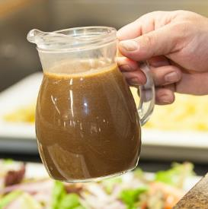
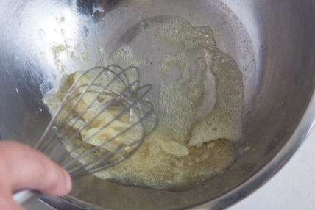

Mayonnaise
Mayonnaise is a mix of egg yolks, vinegar and oil whisked together. They form a thick sauce which does not split (separate into its parts) if you let it sit. It is flavoured with mustard. It is not cooked. Other ingredients may be added to a basic mayonnaise to form other types of dressings. Some examples are:
Name | Flavoured with
- Tartare sauce | - Lemon juice, capers, gherkin and chopped herbs
- Sauce verte (Green sauce) | - Chopped or pureed green vegetables and herbs  They give it a green colour
- Caesar salad dressing | - Anchovies
- Aioli | - Crushed garlic
- Cocktail sauce | - Tomato sauce, Worcestershire sauce and lemon juice

Chef makes mayonnaise
Find the recipe for Mayonnaise in your Recipe Book, and follow what the chef is doing. Notice the different preparation and cooking methods he is using.
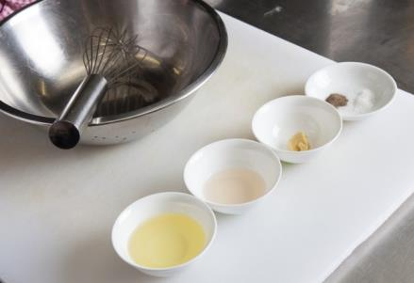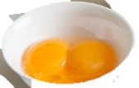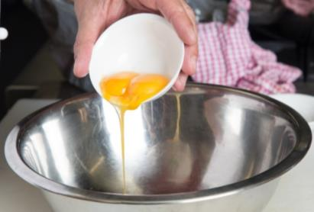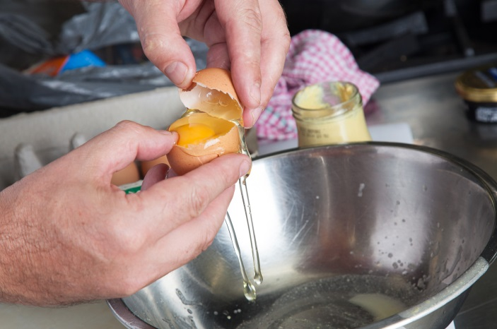
1. Gather your ingredients.
2. Separate egg yolks.
3. Put egg yolks into mixing bowl.

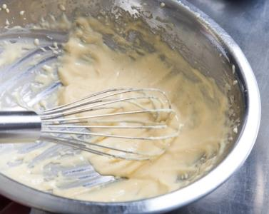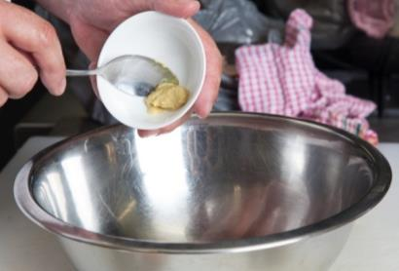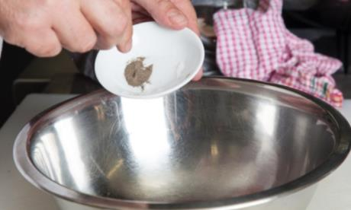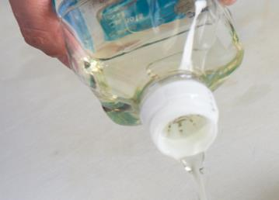
4. Add pinch of salt and pepper.
7. Add the oil gradually to prevent the mixture from splitting.

5. Add mustard.
6. Whisk vigorously.

Chef’s tip
If your mayonnaise splits, don’t throw it out. You can try one of these ways to fix it:
- Start with a fresh egg yolk, then add the split mixture gradually
- Add some boiling water to the side of the mayonnaise and stir with a whisk
- Place the mixture into a blender on high speed.

Dairy based dressings
Some dressings use dairy products, for example:
- sour cream | - cottage cheese | - ricotta cheese
- yoghurt | - blue cheese | - goat’s cheese.
If you use dairy products in a dressing, you must also use some sort of acid, such as vinegar or lemon juice. This cuts through the fattiness of the dairy product so that you can taste the salad better. It also helps you digest the food better.
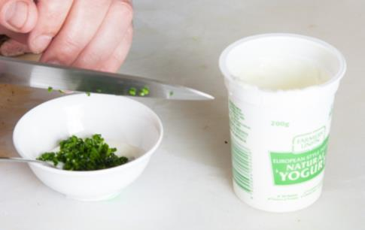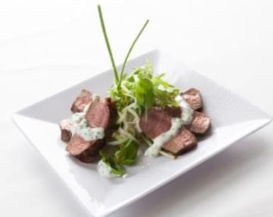

Activity 27
Using a dairy based dressing
Look at the recipe for Warm lamb salad in the Recipe Book.
Fill in the missing information in this table.
Dairy product used?
Acid used?
Other ingredients to
flavour the dressing?
How do you make the dressing?

Activity 28
Dressings at The Gums Resort
Choose 5 salads from the Recipe Book.
Is the dressing based on a vinaigrette or mayonnaise?
Has anything extra been added?
Salad | Vinaigrette or Mayonnaise? | Anything added?
Potato salad | M | Chopped herbs

Types of oils
You can use oils with different flavours in salad dressings.
Some oils have a light flavour and aroma (smell), e.g. sunflower oil and canola oil.
Others have a stronger flavour and aroma, e.g. olive oil, sesame oil and walnut oil.
Oils may be flavoured by adding spices, herbs and things such as peppercorns, garlic or chilli.
Choose the oil to suit the salad. If the flavour of the oil is too strong, it can dominate (take over) the flavour of the salad.

Types of vinegars
Vinegar is an acidic (sharp or tart tasting) liquid made from wine, cider, sherry and other similar ingredients.
The sourness of the vinegar brings out the flavour of the ingredients used in salads. The acid cuts through the fattiness of the oil or dairy product, so the salad can be tasted more clearly.
The acid can also help you digest the salad.
There are many different types of vinegars available. Some vinegars are flavoured, e.g. with herbs.
You can also use other acidic liquids in a dressing instead of vinegar , e.g. verjuice (unfermented grape juice), or lemon, lime or orange juices.

Storing dressings and ingredients
Store oils and vinegars in the dry store. However flavoured oils should be kept in the refrigerator.
Eggs and dairy products must be stored in the refrigerator.
To store prepared dressings:
Vinaigrette | - No need to keep it in the fridge, as the ingredients do not spoil easily. The high acid content in the vinegar stops it going bad.  - If oils are stored in the fridge, many of them will solidify (go hard).
Mayonnaise | - Must keep it in the fridge because it contains egg yolks, which grow germs very easily.  - Also, it does not have enough vinegar in it to stop it going bad.  - Should be kept in the dairy section of the fridge, at 1-4ºC  - Can be kept there for up to 3 weeks. However, because there is oil in it, it may solidify.

Chef’s tip
Canola oil does not solidify (go solid or hard) when cold. So salad dressings made with this can be kept in the fridge without solidifying Start with a fresh egg yolk, then add the split mixture gradually.

Activity 29
Food storage at your workplace
Where are things stored in your workplace?
Oils
Vinegars
Eggs
Sour cream, yoghurt
Garlic, parsley
Completed dressings

Calculating portions of dressings
I’ve had to learn some work maths.
I need to work out how much of a dressing or sauce to make for a service.
- Sometimes dressings and sauces are made on a per person basis as needed.
- But the kitchen makes some common dressings and sauces on a daily or weekly basis. They make a large quantity and store it in the fridge.

The general rule | You need 25 ml of dressing or sauce for one person.  We call this a serve or a portion.
The standard recipe | The standard recipe for mayonnaise makes 500 ml.
How many serves in the standard recipe?
The total amount divided by |  | The amount in one serve equals |  | The number of serves
500 ÷ |  | 25 = |  | 20
Use your calculator to check |  |  | 500 ÷ 25 = 20

Look at the measuring jug

500 ml  250 ml  250 ml | 1 25 ml  2 25 ml  3 25 ml  4 25 ml  5 25 ml  6 25 ml  7 25 ml  8 25 ml  9 25 ml  10 25 ml  250 ml
500 divided into half equals 250  500 ÷ 2 – 250  2 lots of 250 adds up to 500  2 x 250 = 500 | 250 divided into 10 equal parts – each part is 25  250 ÷ 10 = 25  10 lots of 25 adds up to 250  10 x 25 = 250

Activity 30
How many portions?
1 You have 40 people booked for lunch. How much mayonnaise do you need to make?
2 Look at the recipe for Italian dressing in the Recipe Book.
a. How much in total does the recipe make?

b. How many portions will you get from the recipe? Follow the general rule for portion size.
c. You need to make enough Italian dressing for 30 people. How much should you make?
Dressing a salad
After you have dressed a salad, use a clean spoon or fork and taste it to check the seasoning.
Dress salads just before serving. Add just enough dressing to moisten the salad.
Take care so you do not damage or ‘drown’ the salad ingredients.
There are different ways to put on the salad dressing. Read about them on the next page.
Activity 31
Dressing salads
Look at the salad recipes in the Recipe Book.
What method of dressing a salad is used for each one?
Salad | Method of dressing
Nicoise Salad
Grilled asparagus and blood orange salad
Coleslaw salad
Potato salad
Caesar salad
Nicoise Salad
Greek salad
Waldorf salad
Warm lamb salad with yoghurt dressing
Couscous and Roast Vegetable Salad

Method | Salads | How to do it
Toss  Mix lightly with  your hands | For light salads using a vinaigrette dressing, e.g. a simple green salad. | - Wash your hands  - Pour the dressing over the ingredients  - With your fingers spread, gently lift and mix the dressing through the ingredients. Don’t damage the leaves.  - Coat all the ingredients with the dressing  - Put the salad into the serving dish.
Fold  Turn over with a spatula | For salads that have a mayonnaise dressing, e.g. coleslaw. | - Spoon the dressing carefully onto the salad.  - Mix gently with a spatula or tongs. Turn the ingredients over.  - Coat all the ingredients with the mayonnaise  - Put the salad into the serving dish.
Drizzle  Pour a very fine stream over the top | Good for constructed salads, e.g. Niçoise salad. It does not disturb the look of the salad | - Put the salad into the serving dish.  - Pour a small stream of dressing all over the salad, not just in one spot.
Steep  Pour dressing over the salad and let it stand | Use with cooked vegetable salads, where the ingredients have already been softened by cooking, e.g. potato salad. Do not use with salad greens, as they will go soft. | - Pour the dressing onto the salad ingredients.  - Fold the dressing gently through.  - Let the salad sit a while so the flavour of the dressing soaks into the ingredients.  - Put the salad into the serving dish.
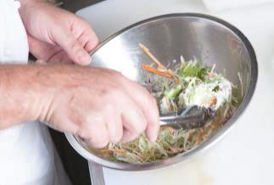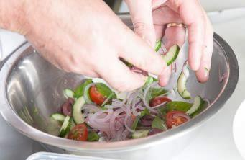

No dressing
Most salads in a buffet are not dressed. If dressed salad is left for a period of time, it will wilt (go soft and floppy) and will not taste or look good.
Put the dressing separately in a small jug or bowl with a spoon at the side. The guest can then serve themselves.
Words for taste and texture
You should check your salad by tasting it. You will also be looking for the correct texture, how it feels in your mouth. You need to know some words so you can talk about tastes and textures with your kitchen colleagues.

Words for tastes
- bitter | - salty | - umami (a Japanese word - it means a pleasant savoury taste)
- sweet | - sour
Words for textures
- clean | - creamy | - crisp
- crunchy | - fibrous | - moist
- velvety | - rich | - slippery
- smooth | - mousse (light and fluffy)
Salads aim to have a harmonious (when different things go together well) mix of tastes and textures.
For example, Caesar salad:
- Tastes: A umami taste. Some saltiness in the parmesan. A bit sour from the lemon in the dressing.
- Textures: The cos lettuce is crisp, the croutons and fried crisp bacon are crunchy, the mayonnaise dressing is smooth and rich-feeling.

Activity 32
Taste and texture
Your trainer will organise this activity.
What words would you use to describe each ingredient?
Ingredient | Taste and texture
celery
vinaigrette
soy sauce
carrot sticks
olives
mayonnaise
fried bacon
croutons
Construct salads
When you construct a salad (put the salad together), it normally has 4 parts.
4. Garnish | Adds colour, flavour and texture to the salad.
3. Dressing | Blends the ingredients together and adds flavour.
2. Body | The main ingredients of the salad.
1. Base | This is usually salad greens.
Here is how Warm lamb salad with yoghurt dressing is constructed.
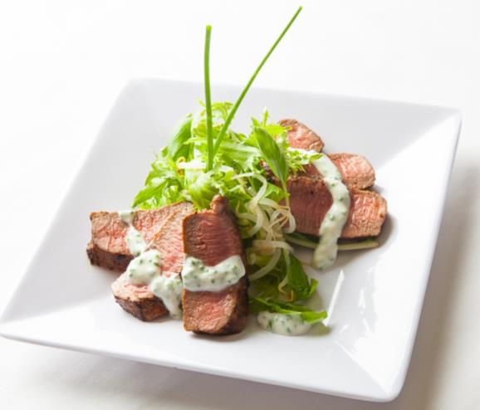
Base – lettuce
Body – lamb
Garnish – chives
Dressing – yoghurt

Guidelines for constructing salads
These things are important when you are constructing a salad.
Colours | There should be contrast (differences),  e.g. red roasted capsicum with green baby spinach and yellow cous cous.
Textures | There should be contrast,  e.g. creamy avocado with crisp salad greens.
Flavours | They should be balanced (not too much of one thing).  They should complement each other (go well together),  e.g. blander tomato and bocconcini cheese with pungent shreds of basil and a sharp vinaigrette dressing.
Shape | Give the salad height, rather than leaving it flat  e.g. heap up a Caesar salad and layer garnishes on top.
Cutting | All ingredients should be identifiable and cut precisely, unless they are torn.
Order | Add the firmest ingredients first.  Leave softer ingredients until last.
Dressing | Add just enough dressing to moisten the salad.  Too much dressing will spoil it.

Activity 33
Constructing a salad
Look at the recipes for these salads.
What is used for the base, body, dressing and garnish?
 | Caesar salad | Niçoise salad
4. Garnish
3. Dressing
2. Body
1. Base
Store prepared salads
Salads should be made as close as possible to the time of service.
Most salad ingredients are not cooked so it is important to store them properly until service. Kitchens and serving areas can be humid, hot and stuffy, and this can make salads spoil more quickly.
Salads should be stored:
- in containers covered with plastic wrap, on in containers with a fitted lid
- at 1ºC-5ºC
- away from raw or cooked meat or seafood.
- This stops germs growing and stops the salad drying out on top.

Present salads
Salads can be served plated up in single portions, or they can be prepared and served in bulk amounts to provide multiple serves, e.g. at a buffet.
You can use a range of different bowls or other containers to serve salads. Glass bowls are attractive because you can see the ingredients.
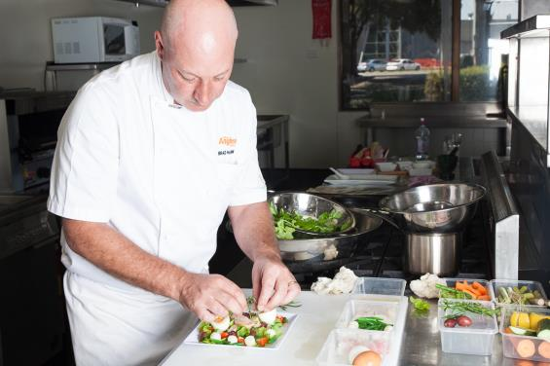
When you present the salad, check these quality points.

Salad checklist
The salad is at the right temperature.
The plate is at the right temperature.
Contrast in colours and textures is appropriate and attractive.
The garnishes suit the salad.
There is not too much dressing.
The portion size is correct.
There are no drips or spills on the serving plate.

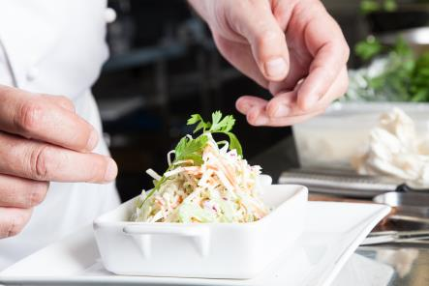
You may have to make some adjustments, such as:
- change the garnish so the balance, colour and contrast look right
- change the serviceware or the way it is plated so it looks more attractive or is easier to eat.

Activity 34
Make a salad
Now make a salad from the Recipe Book.
Tick off each step as you do it. Your salad may not need all these steps.
Steps in salad construction | Done
I’ve read the recipe.
I’ve worked out what quantities I need of each ingredient.
I’ve assembled my ingredients.
I’ve assembled my equipment.
I’ve set out my ingredients and equipment in a good work flow.
I’ve prepared all the ingredients for the salad using the techniques in the recipe, including cutting and cooking.
I’ve made the dressing.
I’ve stored correctly any prepared ingredients that I’m not using immediately.
I’ve constructed the salad.
I’ve dressed the salad using the method in the recipe.
I’ve tasted the salad and adjusted it if needed.
I’ve presented the salad attractively.
I’ve gone through the Salad checklist.
I’ve stored correctly any leftovers or the final salad if it is not being served immediately.
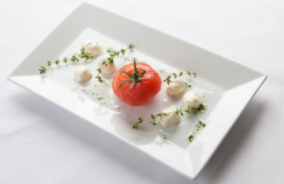

Section summary
Now you have completed this section you should have developed the following skills and knowledge.
Tick the box if you are satisfied that you have those skills and knowledge.
Understand the different types of salads.
Know different salad ingredient that can be used.
Know how to make a salad dressing, and how to dress a salad.
Describe different tastes and textures.
Construct salads.
Store prepared salads.
Present salads attractively and know when to adjust salads for presentation.
Notes

6 Produce appetisers
What are appetisers?
Appetisers are small portions of food designed to stimulate (excite) the appetite before a meal. They are tasty, attractive and small so they don’t fill you up.
Appetisers should look attractive as well as taste good.
The colours, flavours and textures should be interesting, and tempt guests to try them.
Appetisers can be:
- served before a meal with a knife and fork, because the guests are sitting down
- served at cocktail parties or other functions where people are standing up so food is picked up in the fingers.
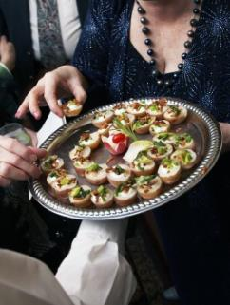

Did you know?
Other names for appetisers are:
- finger food – because they may be eaten in the fingers
- hors d’ouevres - French word meaning “outside of the main meal”
- bite-sized - because you can eat them in just one bite.
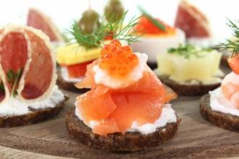
Types of appetisers
There are many types of appetisers. They range from traditional appetisers such as smoked salmon, to more complex appetisers using a range of ingredients and influenced by other countries, such as rice paper rolls.
You will learn about:
- canapés
- savouries
- appetisers from other countries.

Activity 35
Appetisers at your workplace
What appetisers are made at your workplace?
Canapés
Canapés are savoury, bite-sized finger food. The word is pronounced kah/nah/pay. Canapés are usually served:
- with pre-dinner drinks, at cocktail functions, formal parties and wedding receptions.
- cold and offered around on a platter by wait staff.
- attractively arranged on a platter
- with a mixture of different canapés for guests to choose from so that everyone can find something they like.
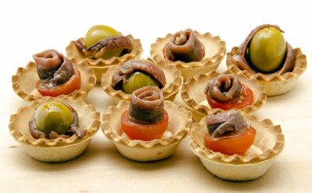

Parts of a canapé
Canapés are usually made up of a base, the body and a garnish (decoration).
The flavours and colours of the three parts must complement each other (go together).
Look at the ingredients of these 4 canapés. Would you like to eat them?
 |  | Canape 1 | Canape 2 | Canape 3 | Canape 4
Garnish | Adds colour and flavour.  Can also be used to moisten the body, e.g. sour cream.  The size or amount of garnish should not dominate. | Parsley | Asparagus tip | Quince paste | A slice of gherkin
Body | The main ingredient, often a meat, fish or cheese. | A prawn | Pate | Brie cheese | Rare roast beef
Base | Must be solid enough to support the toppings and so the guest can pick it up in their fingers.  Can be different shapes, e.g. squares, triangles or circles.  May be covered with a spread to stop the toppings making it soggy. This also helps the body stick to the base. | Piece of crisp toast spread with herbed cream cheese | Round of pastry | Firm savoury biscuit | Square of rye bread spread with mustard

Parts of a canapé
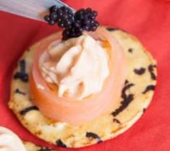
Garnish – caviar
Body – smoked salmon and cream cheese
Base – seaweed rice cracker

Activity 36
What are these canapés made from?
Look at the canapés in this picture.
What do you think they are they made from?
Put the ingredients into the columns in the table. One has been done for you.
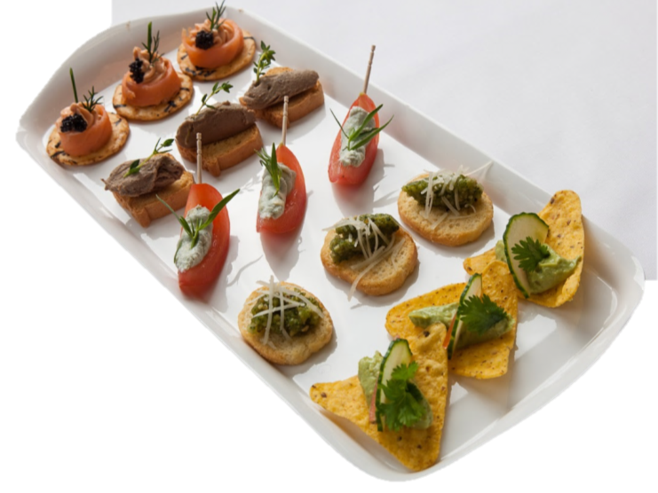
1 2 3 4 5

Canapé | Base | Body | Garnish
1 | seaweed rice cracker | smoked salmon mousse | caviar
2
3
4
5

Activity 37
Designing canapés
Go to the recipe for Canapés in the Recipe Book.
This lists a number of different bases, toppings and garnishes.
You can mix and match these ingredients to make different canapés.
Design six different canapés you would like to eat and which would look nice together on a platter.
Write them in this table.
Base | Body | Garnish
1
2
3
4
5
6

Put canapés together
You construct (build or put together) canapés. Follow these steps.
- Do your mise en place. Gather all the ingredients and equipment you need.
- Prepare all the bases, spreads, body ingredients and garnishes in separate containers.
- Clean your work area.
- Lay out the bases for one type of canapé.
- Put spread onto each base (if you are using it).
- Add the body ingredient onto each base.
- Add the garnish to each canapé.
- Clean the work area again, then start on another type of canapé. This prevents cross-contamination and mixing of ingredients and flavours.
- Arrange the canapés attractively on the platter or tray.
Chef makes canapés
I’m making some canapés for a cocktail party tonight. I’ve chosen a mix of shapes, colours, textures and flavours.

Step 1: Prepare the bases
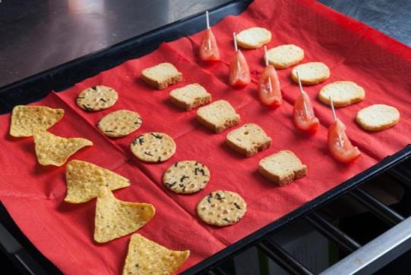  Trim the tomatoes | 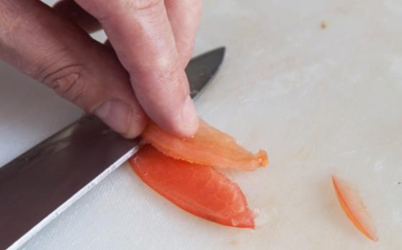

Step 2: Add the body
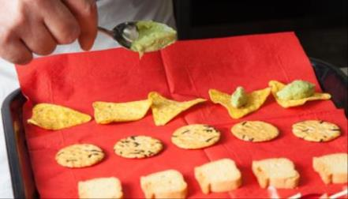 | Spoon on avocado puree
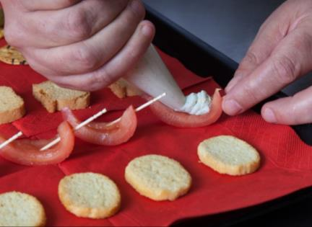 | Pipe creamy blue cheese
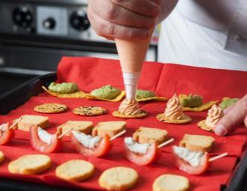 | Pipe smoked salmon mousse
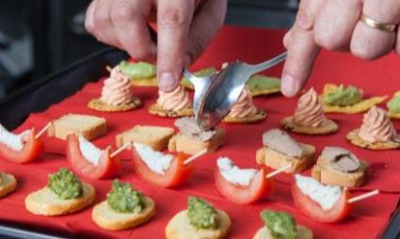 | Spoon (quenelle) chicken paté

Step 3: Add the garnish
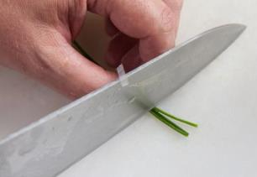  Trim chives | 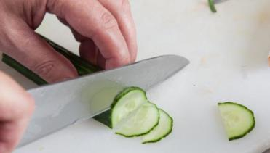  Slice cucumber thinly
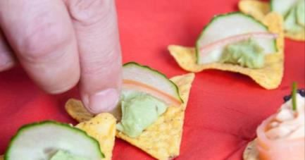 | Arrange on body
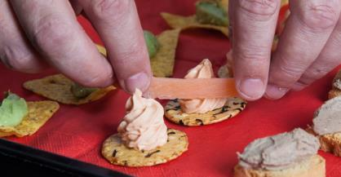 | Wrap slivers of smoked salmon around
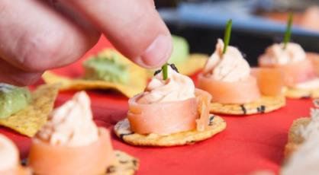 | Garnish with thyme leaves

Step 4: Plate the canapés
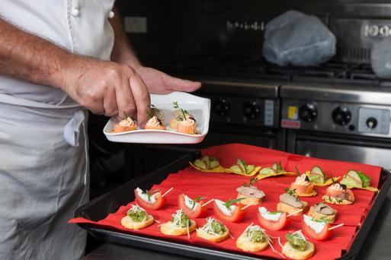 | Carefully arrange on platter

Canapé checklist |  | Go through the Canapé checklist
The canapés are at the right temperature.
The plate is at the right temperature.
Contrast in colours and textures is appropriate and attractive.
There is not too much garnish.
They are not too crowded on the serving plate.
There are no drips or smears on the serving plate.

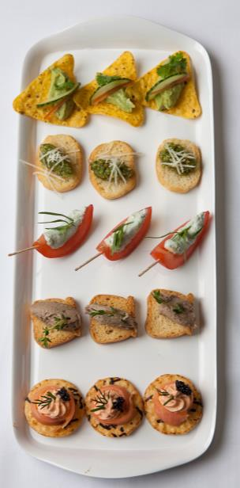 | Ready to share
Activity 38
Make some canapés
Choose 3 canapé recipes.
Tick off each step as you do it.
Steps in salad construction | Done
- I’ve chosen a good mixture of recipes.
- I’ve worked out what quantities I need of each ingredient.
- I’ve assembled my ingredients.
- I’ve assembled my equipment.
- I’ve set out my ingredients and equipment in a good work flow.
- I’ve prepared all the ingredients for the canapés using the techniques in the recipe, including cutting and cooking.
- I’ve stored correctly any prepared ingredients that I’m not using immediately.
- I’ve constructed the canapés.
- I’ve plated a mixture of canapés and presented them attractively.
- I’ve gone through the Canapé checklist.
- I’ve stored correctly any leftovers or the final canapés if they are not being served immediately.
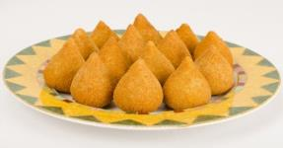
Savouries
Savouries are small portions of hot or cold food which can be served at stand up functions or at the table.
They are generally more filling than a canapé, so use them at a function that goes for longer than a cocktail party.
Some examples of savouries are:
- mini quiches | - satays
- small meatballs | - mini spring rolls
- wontons | - spinach and fetta triangles
- shot glasses filled with soup | - mini dim sim
- samosas | - crumbed and fried pieces of fish
- curry puffs | - tempura (batter fried vegetables or seafood)
Savouries are sometimes served with a dipping sauce, such as peanut sauce, sweet chilli sauce or plum sauce.
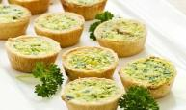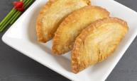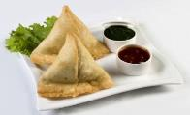

Activity 39
Make some canapés
Look in the Recipe Book. What savouries would you choose to serve at a 21st birthday party where people are having some drinks and standing up to eat?

Make savouries
Use the preparation and cooking techniques you have learnt to make savouries.

Activity 40
Make some savouries
Choose 2 savouries from the Recipe Book to make. Write their names at the top of the columns. Tick off each step as you do it.
Questions | Savoury 1: | Savoury 2:
Put the tasks you have to do in order.
List the ingredients you need.
Types of cuts used
Cooking methods used

Appetisers from other countries
The way we eat in Australia has been influenced by migration from other countries. This has given us a much broader range of appetisers.
Antipasto  - Means ‘before the meal’ in Italian  - Includes cured meats (e.g. salami, ham), char-grilled vegetables, frittata (cold savoury omelette), olives, pickled vegetables and cheeses.  - Generally served on a platter at the table, not as a finger food. | 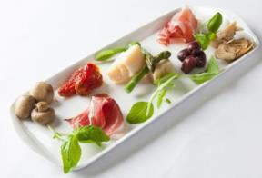
Tapas  - From Spain, where they are eaten as finger food in bars.  - Includes spicy chorizo sausage, marinated mushrooms, ham, stuffed olives, fried sardines, and mini omelettes. | 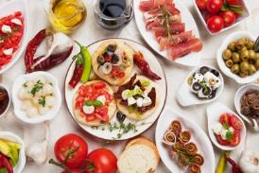
Mezze  - A Turkish word, but mezze are eaten throughout the Middle East and Eastern Europe.  - Includes dips (e.g. hummus, tzatziki and baba ganoush), marinated feta cheese, kebabs, dolmades and small salads.  - Served with bread such as Turkish bread. | 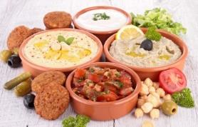

Asian appetisers
Many countries in Asia serve small snacks as street food. These have become popular as appetisers in Australia.
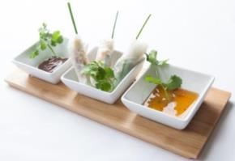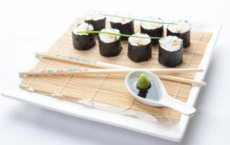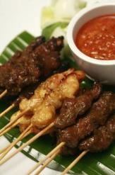Some examples are:
- sushi and nori rolls from Japan
- dumplings from China
- fish cakes from Thailand
- samosas from India
- satays from Malaysia
- rice paper rolls from Vietnam.

Activity 41
Appetisers from other countries
1 Choose one appetiser from another country.
2 Write the information you need in the following table for the appetiser.
3 Then follow the steps and make it.

Appetiser from another country:
- Ingredients and quantities
- Equipment
- Preparation and cooking methods
- Order you will do the tasks in
- How will you store prepared ingredients?
- How will you construct the appetisers?
- Serviceware
- How will you arrange the appetisers?
Present appetisers
Present appetisers in an attractive manner.
Before you put the appetisers onto the platter, plan where you will put them. If you change your mind, you can make a mess.

Serviceware
Serviceware can be made of glass, stainless steel, silver, wood or china, and in different shapes. Choose plates and bowls that complement the food and display it attractively. Be creative. Think of these things:
- contrast of colours
- the country the appetiser comes from, e.g. dumplings in a bamboo steamer, satays on a banana leaf
- unusual containers, e.g.shot glasses, cocktail glasses, espresso cups, Asian spoons
- decorations for the platter, e.g. paper doily, salad leaves or herbs.
- Check the serviceware is at the correct temperature – cold for cold appetisers, warm for warm appetisers.
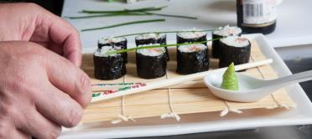

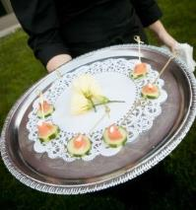
Arrangement
Appetisers can be served on large platters for people to help themselves.
They need to be spaced out so they look attractive and are easy to identify and pick up.

How many?
- For appetisers served before a meal: allow 3-4 pieces for each person, so guests don’t fill up before the meal.
- For appetisers at a cocktail party: allow 12-15 pieces per person.

Final quality check
Appetisers checklist
The appetisers are at the right temperature.
The plate is at the right temperature.
Contrast in colours and textures is appropriate and attractive.
There is not too much garnish.
They are not too crowded on the serving plate.
There are no drips or smears on the serving plate.

You may need to:
- change accompaniments and garnishes so that it looks better
- change to a different plate
- remove any appetisers that have been damaged or have deteriorated
- wipe drips or spills.
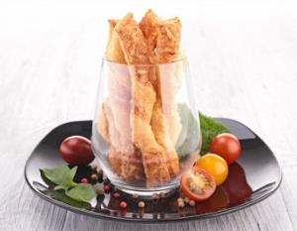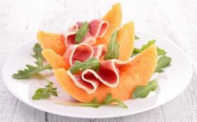

Store appetisers before service
If the finished appetisers need to be stored before serving, cover them well with plastic wrap. Place them in the fridge or coolroom.
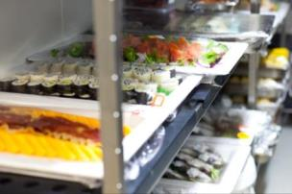

Use leftovers and trimmings
When you are preparing appetisers, there may be some trimmings from the ingredients. These can often be used in other dishes, reducing waste.
Here are some examples:
Left over bread | can be used to make | breadcrumbs and stuffings.
Trimmings from vegetables or herbs | can be used to make | a dip or a stock.
Offcuts of meat | can be used to make | make small meatballs.
Leftover roast beef or chicken | can be used to make | filling for canapés.

Section summary
Now you have completed this section you should have developed the following skills and knowledge.
Tick each box if you are satisfied that you have those skills and knowledge.
Know the different types of appetisers and when they are used.
Prepare and construct canapés.
Prepare and construct savouries.
Present appetisers.
Store appetisers before services.
Use leftovers and trimmings to prevent waste.
Notes

The Gums Recipe Book
Salads

Simple salads
Tomato, bocconcini and basil salad (1 portion)
Ingredients  1 fresh vine tomato  2 bocconcini balls, small  15 basil leaves  20 ml vinaigrette dressing | Method  - Blanche and refresh tomato then remove skin.  - Cut tomato into 1 cm slices.  - Place leaves at base of salad plate and top with tomato slices and torn pieces of bocconcini.  - Drizzle with vinaigrette dressing.

Grilled asparagus and blood orange salad (1 portion)
Ingredients  6 asparagus spears  1 blood orange  roquette leaves  20 ml vinaigrette dressing | Method  - Peel and blanche asparagus.  - Lightly oil grill bars and grill asparagus – allow to cool.  - Segment the blood orange and squeeze remaining juices into vinaigrette. Mix well.  - Place roquette onto plate then layer orange segments on top.  - Top this with grilled asparagus and drizzle with vinaigrette dressing.

Compound salads
Coleslaw salad (2 portions)
Ingredients  40 gm carrots, fine julienne  40 gm cabbage, fine chiffonnade  1 celery stalk, finely sliced  20 gm onions, finely sliced  40 gm apples, fine julienne  1 tbsp parsley, chopped  30 ml mayonnaise | Method  - Combine all ingredients in a suitably sized bowl.  - Fold through mayonnaise to bind.  - Cover and refrigerate until required.

Potato salad (2 portions)
Ingredients  160 gm potatoes, floury  30 ml mayonnaise  1 tbsp either chopped parsley, mint, thyme or tarragon | Method  - Steam the potatoes in their skins until just tender.  - Allow potatoes to cool, then remove skin and cut into 2 cm cubes.  - Fold through mayonnaise and choice of herb.  - Cover and refrigerate until required.

Composed salads
Caesar salad (2 portions)
Ingredients  Dressing:  2 egg yolks  1 clove garlic crushed  5 gm Dijon mustard  60 ml salad oil  5 ml Worcestershire sauce  1 anchovy crushed  10 ml lemon juice  Grated parmesan cheese  1 tsp chopped parsley | Method  - Whisk yolks, mustard vinegar, anchovy together.  - Add oil as for mayonnaise.  - Season with remaining ingredients.
Salad  1 baby cos lettuce  30 gm bacon julienne (fried crisp)  40 bread croutons fried lightly (1cm x 1cm)  15 gr shaved parmesan | - Wash and dry cos leaves and lightly toss through the dressing.  - On a salad plate, alternate layers of leaves, bacon, croutons and parmesan.

Niçoise Salad (2 portions)
Ingredients  4 leaves iceberg lettuce –cut into chiffonnade  40 gm green beans, blanched and cut 1 cm diamonds  40 gm black olives, pitted and torn  4 small new potatoes, cooked and torn  tomato concassee raw (1 tomato)  2 soft boiled eggs  2 pieces fresh tuna, seared  60 ml olive oil  20 ml lemon juice | Method  - Place lettuce on plate as base.  - Place ingredients around the plate to look as attractive as possible.  - Garnish with the seared tuna.  - Prepare a vinaigrette from the olive oil and lemon juice.  - Drizzle salad with lemon vinaigrette dressing.

Classical salads
Greek salad (2 portions)
Ingredients  60 gm feta cheese cut 1cm cubes  60 gm cucumber, peeled, seeded cut 1 cm cubes  12 cherry tomatoes halved  12 kalamata olives, pitted and halved  40 gm red onion, finely sliced  60 ml vinaigrette  2 basil leaves chopped  2 oregano leaves chopped  1 basil leaf whole, garnish | Method  - Mix herbs with vinaigrette.  - Mix together prepared vegetables and cheese.  - Place neatly into a salad bowl and drizzle with vinaigrette dressing.  - Garnish with basil leaf.

Waldorf salad (2 portions)
Ingredients  50 gm celery julienne  20 gm walnuts, chopped  50 gm grapes green, peeled  50 gm apple, julienne  50 ml mayonnaise | Method  - Combine all ingredients in a bowl.  - Add mayonnaise and fold through to bind the salad.  - Portion and plate or refrigerate until required.

Contemporary salads
Warm lamb salad with yoghurt dressing (2 portions)
Ingredients  1 tablespoon olive oil  200 gm lamb fillet or back strap  ¼ teaspoon each paprika, black pepper, salt  100 ml yoghurt, natural unsweetened  1 teaspoon chopped parsley  1 clove crushed garlic  ¼ teaspoon lemon juice  Pinch each salt and white pepper  40 rocket leaves  60 gr bean shoot sprouts  14 basil leaves | Method  - Season lamb with salt, pepper and paprika.  - Heat oil in pan and seal the lamb, continue cooking until medium rare, remove from heat and allow to rest.  - Mix together the yoghurt, parsley, garlic, lemon and seasonings to make a dressing.  - Mix the rocket, sprouts and basil leaves and place in centre of plate.  - Thinly slice the warm lamb and place neatly on top of the salad leaves.  - Drizzle salad with yoghurt dressing.

Couscous and Roast Vegetable Salad (2 portions)
Ingredients  100 gm couscous  100 ml water, boiling hot  4 spring onions  8 slices zucchini  8 asparagus  ½ red capsicum  bunch coriander  1 sprig basil  Olive oil  Lemon juice  Salt and freshly ground black pepper | Method  - Pour boiling water over the couscous, cover and leave to soften.  - Cut spring onions to 5 cm lengths and wash well. Remove and discard the tough woody end of the asparagus and cut the remaining piece in half.  - Heat a char grill and grill the spring onions and asparagus to partly soften and lightly colour.  - Roast the red capsicum, peel and cut into diamond shape pieces about 4cm long.  - Clean the coriander and basil and roughly chop.  - Season the couscous and add sufficient olive oil and lemon juice to flavour and moisten the couscous.  - Gently fold the spring onions, asparagus, red capsicum, zucchini, basil and coriander through the couscous.  - Place the salad on a plate, piling it up high, garnish and serve.

Dressings and sauces

Dressings – vinaigrette based
Vinaigrette dressing (150 ml)
Ingredients  150 ml vegetable oil  50 ml white vinegar  5 gm Dijon mustard  Pinch salt  Pinch white pepper | Method  - Place all ingredients in a suitable sized bowl and whisk together.  - Cover and refrigerate until required.  - The dressing will separate over time so, again whisk thoroughly before use.

Italian dressing (150 ml)
Ingredients  1 tsp chopped oregano  1 tsp chopped basil  1 tsp chopped continental parsley  10 ml lemon juice  ½ tsp crushed garlic  150 ml vinaigrette dressing | Method  - Whisk all ingredients together.  - Cover and refrigerate until required.

Dressings – mayonnaise based
Mayonnaise (500 ml)
Ingredients  4 large egg yolks  ½ tsp Dijon mustard  10 ml white vinegar  Pinch salt  Pinch white pepper  500 ml salad oil  Few drops boiling water | Method  - Place yolks, mustard, vinegar, salt and pepper in a large bowl and whisk thoroughly.  - Slowly add the oil a little at a time while whisking continuously.  - Add a few drops of boiling water at the end. This will help to stabilise (stop it splitting) the sauce.  - Cover and refrigerate until required.

Tartare sauce (500 ml)
Ingredients  500 ml mayonnaise  25 gm chopped capers  50 gm chopped gherkin  1 tbsp fine chopped herbs | Method  - In a suitably sized bowl, combine all ingredients.  - Cover and refrigerate until required.

Sauce verte (500 ml)
Ingredients  25 gm water cress  50 gm spinach leaves  10 gm parsley  10 gm tarragon  10 gm chives  500 ml mayonnaise | Method  - Blanche, squeeze and puree watercress and spinach.  - Chop herbs finely.  - Mix herbs and puree through mayonnaise.  - Cover and refrigerate until required.

Other dressings and sauces
Sour cream dressing (100 gm)
Ingredients  100 gm sour cream  1 teaspoon lemon juice  Pinch salt  Pinch white pepper  1 tspn parsley, finely chopped | Method  - Place all ingredients in a suitable size bowl and stir through to combine.  - Cover and refrigerate until required.

Sweet Chilli Lemon Sauce (2 portions)
Ingredients  1 birds eye chilli (chopped)  2 garlic cloves (minced)  2 tbsp coriander (chopped)  1 lemon (juice)  3 tbsp palm sugar  6 tbsp hot water  2 tbsp roasted peanuts (chopped) | Method  - Combine palm sugar and hot water in a saucepan.  - Bring to the boil and turn heat off and cool.  - Mix in chilly, coriander, garlic and then lemon juice.  - Add peanuts.

Appetisers

Canapés
Choose a base, topping and garnish for each canapé.

Base
Corn chip | Crispbread | Croutons
Melba toast | Mini toast | Parmesan biscuit
Puff pastry round | Pumpernickel bread | Rice crackers
Savoury biscuits | Short pastry cups or boats | Slices of firm vegetables or fruit
Topping
Blue cheese mixed with ricotta | Cheese | Chicken liver pate
Fruit – melon, strawberry | Guacamole | Hard boiled eggs
Salami, ham | Sardines | Seafood – prawns, lobster
Smoked oysters | Smoked salmon | Smoked trout
Vegetables – avocado, tomato
Garnish
Asparagus tip | Capers | Cheese
Chervil sprig | Coriander leaf | Dill
Fish roe | Fruit | Gherkins
Olives | Parsley | Pea sprouts
Smoked salmon

Savouries
Vegetable spring rolls ( 4 pieces)
Ingredients  1 tablespoon vegetable oil  3-4 drops sesame oil  30 gm spring onions, finely sliced  30 gm cabbage, fine chiffonnade  30 gm carrots, fine julienne  30 gm mushrooms, finely chopped  30 gm bean shoots  ¼ teaspoon crushed ginger  ¼ teaspoon crushed garlic  ½ teaspoon soy sauce  Spring roll wrappers  Egg white | Method  - Heat oils in pan.  - Add ginger and garlic and cook briefly.  - Add remaining vegetables and allow to sweat until just tender.  - Stir through soy sauce. Remove from heat and allow to cool.  - Lay wrappers with points facing north/south.  - Brush edges with a little egg white.  - Place a portion of cold vegetable mixture onto wrapper, fold over twice then fold sides to the centre then continue rolling forward into a neat firm cylinder.  - Cover and refrigerate until required.  - To cook, deep fry rolls at 180°C until golden brown.

Rice paper rolls (8 pieces)
Ingredients  8 rice paper wrappers  80 g rice vermicelli , softened in water  80 g bbq pork  80 g bean shoots  8 large basil leaves  8 mint leaves  6 small chives  60 g cashew nuts, chopped | Method  - Soften rice paper wrappers in warm water briefly and drain well and cover.  - Place 1 piece of rice paper flat on the bench.  - Place equal amounts of vermicelli, bean shoots, mint leaf, basil leaf, cashew nuts, BBQ pork.  - Fold the rice paper over & place a garlic chive on rice paper and roll up firmly.  - Keep rolls covered to avoid drying out.  - Serve with nam prik sauce.
Antipasto plate (1 plate)
Ingredients  40 gm parma ham  8 kalamata olives  8 sun dried tomatoes  8 grilled artichoke hearts  shaved parmesan  10 basil leaves  Olive oil | Method  - Place ham and vegetables neatly onto a suitable plate  - Garnish with basil leaves and parmesan  - Drizzle with a little olive oil

Chicken Satay (1 portion)
Ingredients  80 gm chicken breast  20 ml soy sauce  10 ml Chinese rice wine  Satay sauce  10 gm onion, fine dice  ½ clove garlic  10 ml peanut oil  100 gm peanuts, fried & crushed  100 ml coconut milk  1 red chilli, finely chopped  ¼ lemon juiced  15 gm brown sugar | Method  - Cut chicken into strips or dice. Place in a bowl and add soy and rice wine, leave to marinate for 10 minutes.  - Sweat onion, garlic and chilli in oil.  - Add peanuts and cook for 2 minutes.  - Add brown sugar and lemon juice. Take of the heat.  - Add coconut milk and blend until semi smooth.  - To serve, heat but do not boil.  - Thread the chicken pieces onto a toothpick. Cook on the griddle plate; serve hot with the satay sauce.

Spinach and Feta Cheese Triangles (6 pieces – serves 2)
Ingredients  300 gm spinach  20 gm feta cheese  15 gm bacon  15 gm onion  pinch nutmeg  1 sheet filo pastry  20 ml clarified butter | Method  - Remove stalks, wash and roughly chop the spinach.  - Wilt the spinach in a hot sauté pan and cool.  - Squeeze out the excess moisture.  - Finely dice the onion and chop bacon finely.  - Sweat the onion and bacon, leave to cool.  - Mix spinach, feta, onion, and bacon together in a bowl, add seasoning and nutmeg.  - Brush the filo sheet with clarified butter.  - Cut the sheet across into 6 equal strips.  - Fold the triangle parcels as shown in the demo & brush with a little clarified butter.  - Place on a baking tray & bake in a hot oven until golden brown.

Key words
Word | Meaning
accentuate | Make a flavour seem stronger, more intense
accompaniment | Food item served alongside a meal, e.g. soy sauce, lemon segments
accompany | Go with
acid | In cooking, a liquid such as vinegar or lemon juice
acidic | Sharp or tart tasting
adjust | Change slightly, such as final seasoning
aroma | Smell
assemble | Gather together
balanced | Not too much of one thing
bind | Coat and mix food items with sauce to stick ingredients together
combine | Mix ingredients together
complement each other | Go well together
compost bin | Bin for food scraps
contemporary | Modern
contrast | Differences
crevice | Deep crack
cuisine | Style of cooking in a particular culture
deadline | When you need to have your tasks finished by
disassemble | Take apart equipment
discard | Throw away
dominate | Take over
emulsify | Combine two liquids which normally don't mix together easily (such as oil and water) so they become a smooth mixture
estimate | Judge times or quantities based on experience
foreign objects | Things that shouldn’t be in food, e.g. band aid, insect
garnish | Decoration
harmonious | When different things go together well
inedible parts | Parts of food that you are unpleasant to eat
irregular | Not all the same shape and size
lengthwise | Down the length
mise en place | Have everything organised and in place before you start
mousse | Light and fluffy
nutrients | Things in food that are good for you, e.g. vitamins
platter | A large flat dish or plate, typically oval or circular in shape, used for serving food.
pod | Outer casing of vegetables such as peas and beans
portion | How much you need for one person
pungent | Spicy tasting or smelling
quantities | Measured amounts of ingredients
select | Choose
separate | Come apart
serviceware | Plates, bowls, platters and other items for serving food
solidify | Go solid or hard
special dietary requirements | Things some people can’t eat (e.g. gluten) or choose not to eat (e.g. meat)
split | Separate into its parts
spoil | When food goes ‘bad’ - mouldy, stale or rotting
stabilise | Stop a sauce ‘splitting’
stimulate | Excite
texture | Feel of food in the mouth
thoroughly | Completely
umami | A pleasant savoury taste (Japanese word)
utensil | Kitchen tool
verjuice | Unfermented grape juice
wilt, wilting | Go floppy or soft due to losing water

