**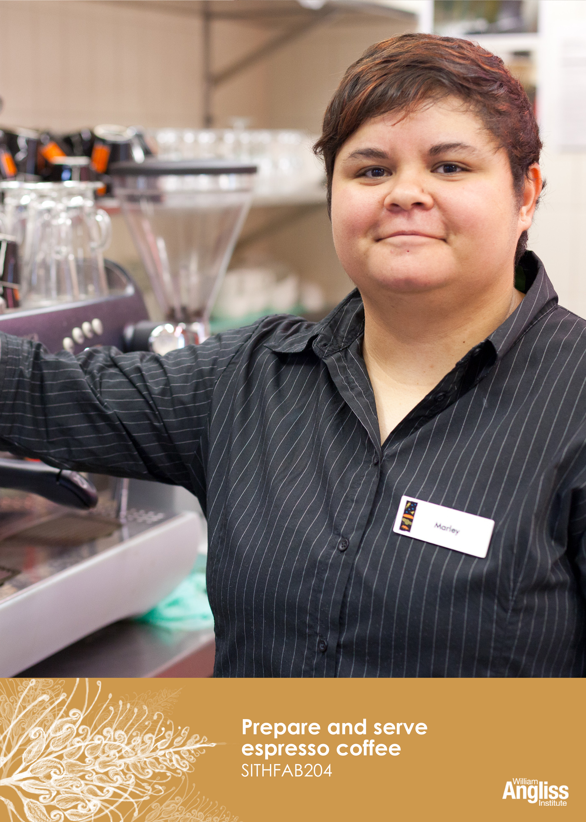**

© Commonwealth of Australia 2013



**CC BY-NC-SA**

This work is copyright. Except where otherwise indicated, and save for the Commonwealth Coat of Arms, the Department has applied the [Creative Commons Attribution-Noncommercial-Share Alike 3.0 Australia Licence](http://creativecommons.org/licenses/by-nc/3.0/au) to this work.

The Department of Industry, Innovation, Climate Change, Science, Research and Tertiary Education must be attributed as the author of the Department’s copyright material.

As far as practicable, material for which the copyright is owned by a third party has been clearly labelled. The Department has made all reasonable efforts to ensure that this material has been reproduced on this website with the full consent of the copyright owners.

Requests and enquiries concerning the Department’s copyright material should be addressed to:

The Legal Branch

Department of Industry, Innovation, Climate Change, Science, Research and Tertiary Education

GPO Box 9839 Canberra ACT 2601

Or emaile[d to legalservices@innovation.gov.au](mailto:legalservices@innovation.gov.au)

Funded under the Workplace English Language and Literacy (WELL) Program by the Australian Government Department of Industry, Innovation, Climate Change, Science, Research and Tertiary Education

The views expressed in this publication do not necessarily represent the view of the

Minister for Tertiary Education, Skills, Science and Research or the Australian

Government. The Australian Government does not give any warranty nor accept any liability in relation to the contents of this work

ISBN 978-1-922108-13-5

|  |  |
| --- | --- |
| Development Team | |
| Content | William Angliss Institute |
|  | Macsmith and Associates |
| Photography & graphics | Benjamin B Photographer |
|  |  |
| Acknowledgments | |
| We would like to acknowledge the generous support of the following organisations and the learners and employees in those venues, both Indigenous and non-Indigenous, for giving their permission for photography: | |
| The Coffee Academy, William Angliss Institute, Melbourne, VIC | |
| Voyages Ayers Rock Resort, Yulara, NT | |
|  | |
| Permissions | |
| We would like to acknowledge the following organisations who have granted permission for their copyright materials to be incorporated in this resource: | |
| Cafetto Coffee Machine Cleaning Products | |
| Lion (Pura Milk) | |
| Vitasoy Australia Products | |
|  | |
| Cultural Warning | |
| People of Aboriginal or Torres Strait Islander descent should be aware that this publication contains images of people who may be deceased | |
|  | |
| Disclaimer | |
| Every effort has been made to ensure that this booklet is free from error or omissions. However, you should conduct your own enquiries and seek professional advice before relying on any fact, statement or matter contained in this book. William Angliss Institute of TAFE and Macsmith and Associates are not responsible for any injury, loss or damage as a result of material included or omitted from this course. | |

Contents

[Welcome vii](#_Toc361825212)

[Icons vii](#_Toc361825213)

[What you will learn ix](#_Toc361825214)

[1 Some coffee facts 1](#_Toc361825215)

[How coffee is grown and processed 2](#_Toc361825216)

[Varieties of coffee 3](#_Toc361825217)

[Espresso coffee 5](#_Toc361825218)

[The barista 12](#_Toc361825219)

[Section summary 13](#_Toc361825220)

[2 The equipment 14](#_Toc361825221)

[The espresso machine 14](#_Toc361825222)

[The coffee grinder 16](#_Toc361825223)

[Tamper 17](#_Toc361825224)

[Knock out tube 17](#_Toc361825225)

[Thermometer 18](#_Toc361825226)

[Milk jugs 19](#_Toc361825227)

[Weighing and measuring equipment 19](#_Toc361825228)

[Cleaning equipment and products 19](#_Toc361825229)

[Section summary 21](#_Toc361825230)

[3 Prepare for service 22](#_Toc361825231)

[Check serviceware 22](#_Toc361825232)

[Check supplies 23](#_Toc361825233)

[Check work area 24](#_Toc361825234)

[Section summary 26](#_Toc361825235)

[4 Work safely 27](#_Toc361825236)

[Personal safety 27](#_Toc361825237)

[What temperature is safe? 28](#_Toc361825238)

[Food safety 30](#_Toc361825239)

[Environmental safety 33](#_Toc361825240)

[Section summary 35](#_Toc361825241)

[5 Grind coffee 36](#_Toc361825242)

[What is grinding? 36](#_Toc361825243)

[Check the grinder 36](#_Toc361825244)

[Grind on demand 37](#_Toc361825245)

[Monitor the grind 37](#_Toc361825246)

[Dose the coffee 38](#_Toc361825247)

[Section summary 40](#_Toc361825248)

[6 Extract coffee 41](#_Toc361825249)

[Check the espresso machine 41](#_Toc361825250)

[Clear the steam wand 41](#_Toc361825251)

[Do test extractions 42](#_Toc361825252)

[Extract the coffee 43](#_Toc361825253)

[Liquid measurements 46](#_Toc361825254)

[Monitor the extraction 49](#_Toc361825255)

[What can go wrong? 51](#_Toc361825256)

[Section summary 53](#_Toc361825257)

[7 Texture milk 54](#_Toc361825258)

[About milk 54](#_Toc361825259)

[Heat the milk 55](#_Toc361825260)

[Stretch and texture milk 56](#_Toc361825261)

[Pour milk 60](#_Toc361825262)

[What can go wrong? 62](#_Toc361825263)

[Section summary 63](#_Toc361825264)

[8 Serve coffee 64](#_Toc361825265)

[Take customer orders 64](#_Toc361825266)

[Serve coffee 66](#_Toc361825267)

[Coffee art 69](#_Toc361825268)

[Section summary 70](#_Toc361825269)

[9 Clean and maintain the equipment 71](#_Toc361825270)

[Safety 71](#_Toc361825271)

[Cleaning equipment and products 72](#_Toc361825272)

[Clean the espresso machine 73](#_Toc361825273)

[Clean the grinder 78](#_Toc361825274)

[Maintenance 79](#_Toc361825275)

[Section summary 81](#_Toc361825276)

[Key words 82](#_Toc361825277)

Welcome

Icons

These signs tell you what type an activity is:

|  |  |
| --- | --- |
| C:\Users\Alan\Desktop\IMG_1094.jpg | Do this activity in a big group. |
| C:\Users\Alan\Desktop\IMG_1079.jpg | Do this activity in a small group. |
| C:\Users\Alan\Desktop\IMG_1081.jpg | Do this activity in pairs. |
| C:\Users\Alan\Desktop\IMG_1080.jpg | Do this activity by yourself. |
| C:\Users\Alan\Desktop\IMG_1086.jpg | Do this activity using the internet. If you are not connected to the internet, your trainer will provide you with another activity. |
| C:\Users\Alan\Desktop\IMG_1087.jpg | Do this activity in your workplace. If you are not in a workplace, your trainer will provide you with another activity. |

This page has been left blank intentionally.

What you will learn

Drinking coffee is part of our way of life. People enjoy the taste of coffee and the social part of meeting friends for coffee and a chat. A good cup of coffee makes this a very pleasant experience. A bad cup of coffee leaves people thinking badly about the café.

In this unit you will learn how to operate an espresso machine so that you always produce an excellent cup of coffee for your customers.

You will learn how to:

* select and grind coffee
* extract coffee using the espresso machine
* texture milk
* serve and present espresso coffee and other coffee drinks
* clean and maintain the coffee making equipment
* provide advice to customers
* maintain a well-organised work area.

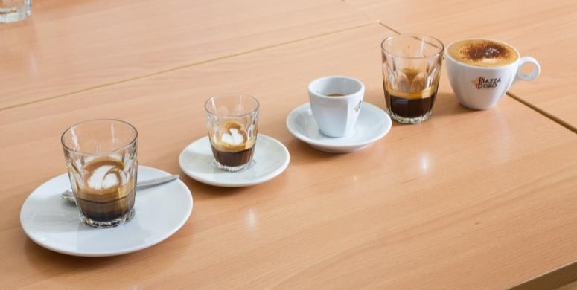

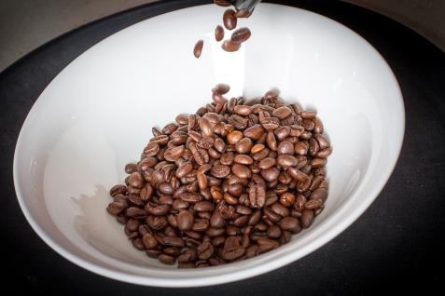1 Some coffee facts

Coffee is one of the world’s most widely traded products. It is grown in over 60 countries. The top 5 producers are Brazil, Vietnam, Colombia, Indonesia and [Ethiopia](http://en.wikipedia.org/wiki/Coffee_production_in_Ethiopia)

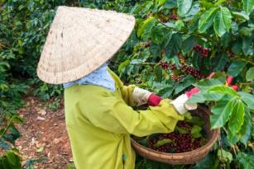

Small farmers produce most of the world’s coffee. Coffee provides an income for over 125 million people around the world.



Coffee is a very popular drink. More than two billion cups are drunk worldwide every day.

**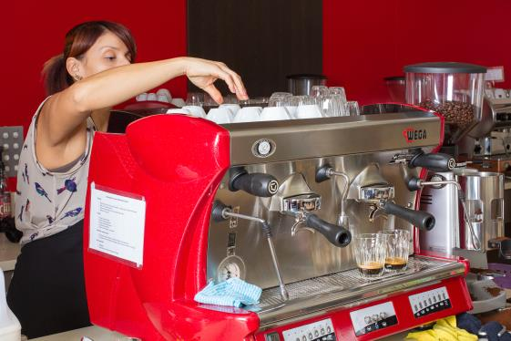**

The *aroma* (smell) of brewed coffee gives pleasure, and it also protects the body’s cells from damage caused by stress.

*Source: International Coffee Organization, <http://www.ico.org/index.asp*>

How coffee is grown and processed

Growing

Coffee grows on coffee bushes and trees and is a really a fruit, called a ‘coffee cherry’. When it turns a bright, deep red it is ready to be picked. It looks a lot like the cherries we eat. Inside the cherry are two coffee beans, covered by a *husk* (outside covering).

Processing

After the coffee cherries have been picked, they are dried and the outside covering is removed to leave the coffee beans. There are two methods of processing the coffee cherry to remove the husk, each producing a different taste in the coffee.

* **Wet processing.** The coffee is washed and soaked before the cherry skins are removed. Then the coffee beans are dried.
* **Dry processing.** The cherries are taken directly from the tree then dried, making it easy to remove the skin.

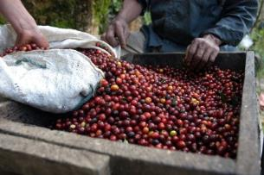

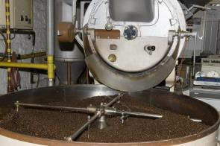Roasting

The beans are then roasted until they become *aromatic* (scented) and brown. Different levels of roast affect the flavour of the coffee. A darker roast is preferred for espresso coffee, but not too dark or the coffee will taste bitter.

Grinding

The roasted beans are ready to be *ground* (crushed into very small pieces) and *brewed* (soaked in very hot water) into coffee.

|  |  |
| --- | --- |
| **The language of coffee** | |
| *Can* ***you grind*** *the coffee?* | To crush the coffee beans into small pieces. |
| ***I have ground*** *it.* | After you finish grinding. |
| *I will adjust* ***the grind.*** | The size of the pieces. |
| *Put* ***the grounds*** *into the dosing chamber.* | The small pieces of crushed coffee. |

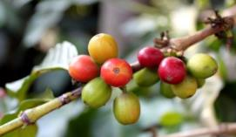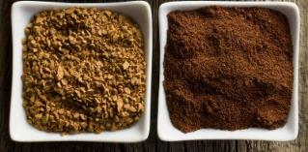

*Coffee cherries Green beans Roasted beans Ground beans Ground coffee*

Varieties of coffee

There are many different *varieties* (types) of coffee, with different flavours and smells.Also the same type of coffee beans can taste different when they grow in different places.

The two main varieties of coffee are Robusta and Arabica.

Robusta

This coffee is higher in *caffeine* (the chemical in coffee that makes your brain and body more active) and has a stronger taste than other varieties. However, it can have a bitter taste. You are unlikely to see pure Robusta coffee as it is too strong to be enjoyable.

Arabica

Most of the world’s coffee production is Arabica. The roasted beans have a sweet smell and are thought to have a better flavour than other varieties. It is also lower in caffeine. It is considered to be a higher quality than the Robusta bean.

Blended coffees

Most coffee used in cafés is a blend of different varieties of coffee. The main blend a café uses is often called the house blend. Different coffees are blended to produce different flavours.

Specialty coffee

Some cafés serve specialty coffees to provide a range of flavours to their customers.

**Fairtrade certified coffee**

Coffee is mainly grown in developing countries. Coffee with the FAIRTRADE mark has been checked to make sure that the growers get fair pay for their work and that children are not being used as labour.

Fairtrade coffee can come from East Timor, Papua New Guinea and many other countries. An example is Trade Winds Organic East Timor Coffee.

**Single origin coffee**

The flavour of coffee is strongly influenced by where it is grown, for example how high above sea level, how shady, the soil and the climate. Single origin coffee means it is not a blend and that we know the country it comes from, such as Ethiopia or Peru. Sometimes we may even know the particular region or farm it comes from.

Some examples are Jamaica Blue Mountain, Hawaiian Kona, Sumatran Blue Batakand El Conquistador Costa Rica.

**Decaffeinated coffee**

Some people want the flavour of coffee but not the caffeine. Coffee beans can be treated so that the caffeine is removed, although it often loses some if its flavor.

|  |
| --- |
| ***Did you know?***  Kopi luwak, from Indonesia, is the most expensive coffee in the world. It is made from coffee berries that have been eaten and excreted by the Asian palm civet (a small animal). |

|  |  |
| --- | --- |
| C:\Users\Alan\Desktop\IMG_1087.jpg | Activity 1  Your workplace coffee beans |

In your workplace:

1 What type of coffee is used at your workplace?  
Where does it come from?  
Is it a blend?

|  |
| --- |
|  |
|  |

2 Are specialty coffees also available? If so, which ones?

|  |
| --- |
|  |
|  |

Espresso coffee

There are many ways of making coffee from ground beans e.g. by boiling (Turkish and Greek coffee) or by using a percolator, plunger or dripolator. In this unit you are learning to make espresso coffee with an espresso machine.

|  |
| --- |
| ***Did you know?***  The term *espresso* comes from the Italian word for express, because espresso was made and served immediately to the customer.  *Source:* Coffee Research Organization, <*www.coffeeresearch.org>* |

Espresso coffee is a small *shot* (measure) of coffee, made by forcing very hot water (but not boiling) at high pressure through finely ground coffee beans. This process *extracts* (removes) and *emulsifies* (blends together) the oils in the ground coffee, producing a rich, thick liquid.

*Extraction* refers to the flow of the coffee from the espresso machine.

Espresso coffee can be drunk as it is, and it is also the base for many other coffee drinks such as cappuccino or café latte.

Crema

The *crema* (pronounced ‘cremma’) is the creamy layer on top of a freshly made espresso. It is rich and golden in colour.

Crema is made when air bubbles combine with oils from the finely ground coffee. It is a fine foam without big bubbles.

If sugar is sprinkled on top, it should sit there for a few seconds.

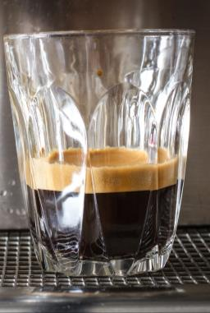

Describing coffee flavours

People tasting coffee use some of these words to describe its special flavour and smell.

|  |  |
| --- | --- |
| **The language of coffee** | |
| **acidity**  **acid** | The sharp and pleasing taste that is left in the mouth after tasting the coffee. Low acidity gives a smooth flavour. High acidity gives a stronger tasting coffee. A coffee with no acidity is not considered good and is called ‘flat’. |
| **sweetness**  **sweet** | A smooth and mild flavour, may taste fruity. Not harsh.  You taste sweetness on the tip of your tongue. |
| **bitterness**  **bitter** | A harsh, unpleasant taste.  May happen if the coffee is over roasted. |
| **sourness** | A sharp, biting and unpleasant flavour. |
| **body** | The feel of the coffee in your mouth. It can feel thick or thin. |
| **aroma** | Smell – coffee can smell burnt, caramel, chocolate, nutty. |

Many other words are used to describe the flavour of coffee, such as spicy, floral, woody, and earthy.

You will learn to recognise different coffee tastes.

What makes a good espresso?

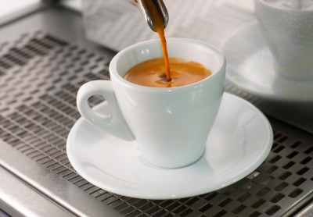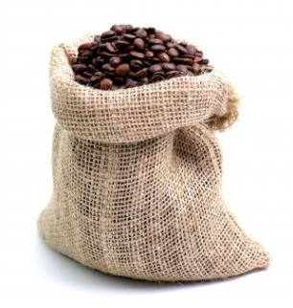

1. The quality and freshness of the coffee beans

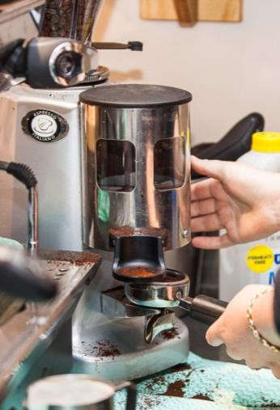

2. Correct grinding of the coffee

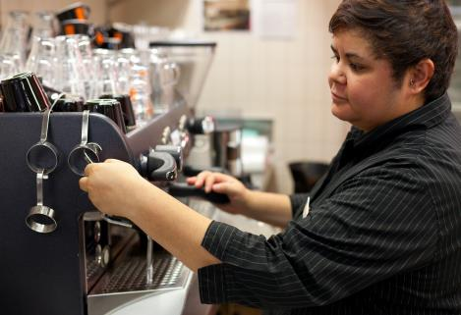

4. The skill of the person making the coffee

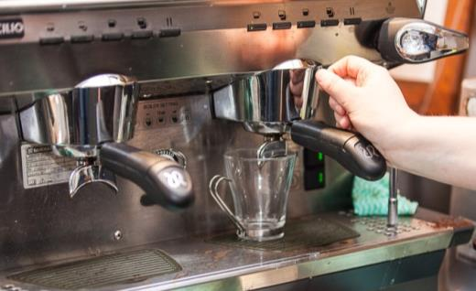

3. Correct use of the espresso machine

Other coffee-based drinks

Your customers will ask for different styles of coffee, all based on an espresso shot. Here are the main styles, although sometimes they are called by different names.

| ***Style of coffee*** | |
| --- | --- |
| **Espresso (short black)**  The basis of all other coffee styles. It is a *single shot* (30 ml) of coffee.  It has a full, dark colour and a strong coffee aroma.  On top is the crema.  People may also ask for   * ristretto – short espresso * doppio – double espresso. | C:\Users\Alan\Documents\Carol\Consulting\24. WELL_Hospitality _resources\Photos\Coffee\Coffee_small\CoffeeServingSmall-8818.jpg |
| **Long black**  Starts with 2/3 cup hot water, topped with a *double shot* (60 ml) of coffee.  Sometimes called ‘Americano’. | C:\Users\Alan\Documents\Carol\Consulting\24. WELL_Hospitality _resources\Photos\Coffee\Coffee_small\CoffeeServingSmall-8799.jpg |
| **Cappuccino**  An espresso topped with milk that has been steamed to form a creamy foam.  It consists of 1/3 espresso, 1/3 steamed milk and 1/3 foamed milk resting on top.  It can be sprinkled with chocolate powder. | C:\Users\Alan\Documents\Carol\Consulting\24. WELL_Hospitality _resources\Photos\Coffee\Coffee_small\CoffeeServingSmall-8920.jpg |
| **Flat white**  An espresso topped with steamed milk. It has a small amount of foam. | C:\Users\Alan\Documents\Carol\Consulting\24. WELL_Hospitality _resources\Photos\Coffee\Coffee_small\CoffeeServingSmall-8896.jpg |
| **Café latte**  An espresso topped with steamed milk, with about 1 cm of dense foam.  Usually served in a glass.  People often just call this a latte.  You can also get a piccolo latte – a small latte. | C:\Users\Alan\Documents\Carol\Consulting\24. WELL_Hospitality _resources\Photos\Coffee\Coffee_small\CoffeeServingSmall-8873.jpg |
| **Macchiato**  An espresso stained with a dash of milk. There are different ways to make a macchiato:   * Macchiato caldo – an espresso with a dash of hot milk placed in the centre of the crema * Macchiato freddo – a dash of cold milk is used * Long macchiato – two shots of espresso. | C:\Users\Alan\Documents\Carol\Consulting\24. WELL_Hospitality _resources\Photos\Coffee\Coffee_small\CoffeeServingSmall-8832.jpg |
| **Mocha**  A mixture of espresso and milk that has been steamed with chocolate powder.  Can be served in a latte glass and dusted with chocolate. | C:\Users\Alan\Documents\Carol\Consulting\24. WELL_Hospitality _resources\Photos\Coffee\Coffee_small\CoffeeServingSmall-8911.jpg |
| **Others**  There are many other types of coffee served using espresso as a base. They include:   * affogatto – espresso and vanilla ice-cream * iced coffee * coffee with liqueurs or syrups (add syrup before the espresso to release the flavour). | C:\Users\Alan\Documents\Carol\Consulting\24. WELL_Hospitality _resources\Photos\Coffee\Coffee_small\CoffeeServingSmall-8954.jpg |

|  |  |
| --- | --- |
| C:\Users\Alan\Desktop\IMG_1087.jpg | Activity 2  Your coffee menu |

1 Find a menu from your workplace.  
What different types of coffee are offered?

|  |
| --- |
|  |
|  |

2 Are they called the same as the coffee in the previous table?  
Or are they called by a different name?

|  |
| --- |
|  |
|  |

|  |
| --- |
| ***Did you know?***  ‘Latte’ is the Italian word for milk. So a café latte is just a milk coffee. |

The barista

|  |
| --- |
| ***Did you know?***  In Italian, a ‘barista’ is a bartender who works behind a counter or bar serving both hot and cold *beverages* (drinks), not only making coffee.  Among coffee enthusiasts, the term is used for a highly skilled coffee-making professional with a wide knowledge of coffee varieties, blends, quality, roasting, espresso equipment and maintenance. |

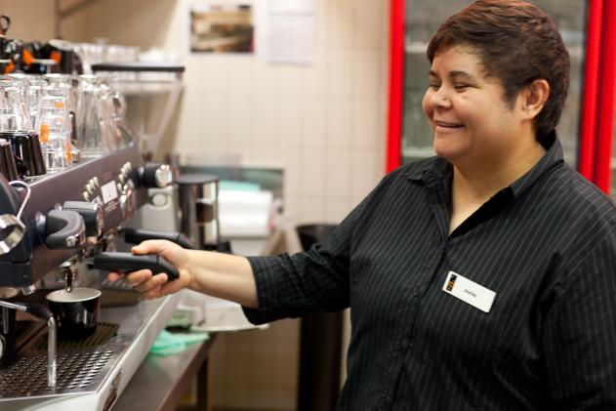

*If I have an order with different types of coffee, I make the latte first, then the espresso because it gets cold more easily.*

*I make them in the order so they can all be served at the right temperature.*

*I set up my work area before I start, so I can work efficiently and produce the coffee quickly.*

*People often ask me about different coffee drinks, so I need to know what they all are.*

*I also must be able to tell them about different coffee types and blends.*

*I keep the equipment and my work area clean throughout the day.*

Section summary

Now you have completed this section you should have developed the following skills and knowledge.

Tick each box if you are satisfied that you have those skills and knowledge.

|  |  |
| --- | --- |
|  | Know how coffee is grown and processed. |
|  | Know about different varieties of coffee. |
|  | Understand different types of coffee drinks based on espresso. |
|  | Know the role of the barista. |

Notes

|  |
| --- |
|  |
|  |
|  |
|  |
|  |

2 The equipment

The main pieces of equipment you use to make coffee are:

* espresso machine
* coffee grinder
* tamper and tamp mat
* filters
* knockout tube (or knock box)
* milk jugs
* thermometer
* weighing and measuring equipment
* cleaning equipment and products e.g. cleaning brushes.

The espresso machine

The espresso machine forces steam and water under pressure through ground coffee, resulting in a rich, dark liquid. There are many different sizes, brands and types of espresso machines. You will be taught how to operate the machine at your workplace.

Here are the parts on a typical espresso machine.

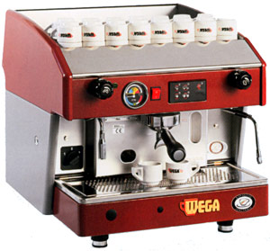

On/off switch

Steam control

Manual switch

Steam wand

Cup warming tray

Pressure gauge

Group handle

Group head

Drip tray

Hot water control

Hot water outlet

Automatic controls

Group handle and filters

The group handle is the part of the espresso machine that holds the ground coffee in a filter basket. It is also called a portafilter or filter holder. The water goes through a filter inside the holder.

You use different size filters depending on what you are doing:

* making a single shot of espresso – use a single filter
* making a double shot of espresso – use a double filter
* cleaning the machine – use a blind filter with no holes.

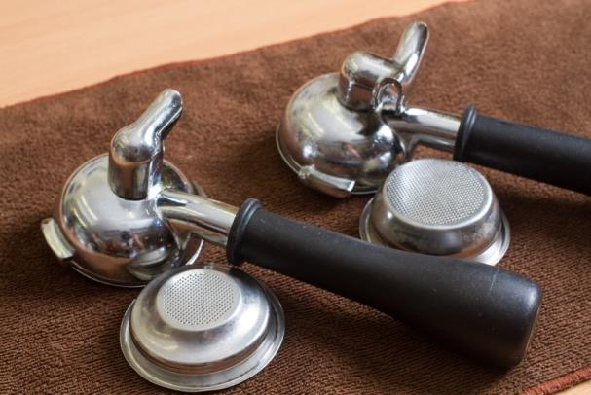

*Blind filter for cleaning*

*Single filter for single shot*

*Double filter for double shot*

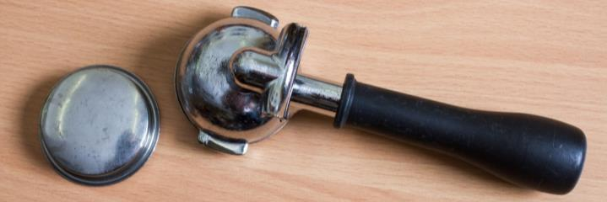

Always leave the group handles locked in the group head to keep them warm. If you take them off and they get cold, they will cool the hot water when extracting the coffee. This will result in poor quality coffee.

The coffee grinder

There are different brands and types of grinders.

* **Blade grinders**: The blades chop the coffee beans. They are not suitable for use with espresso machines, as the grind is not even.
* **Burr grinders:** These grind the coffee beans between two rotating parts. This crushes the beans into grounds that are the same size, so it is suitable for use with espresso machines. There are many different brands.

The two main parts of the coffee grinder are:

* hopper – you put the beans in the hopper ready for grinding
* dosage chamber (doser) – the ground coffee is transferred to the dosage chamber when it is needed.

Here are the parts on a typical grinder.

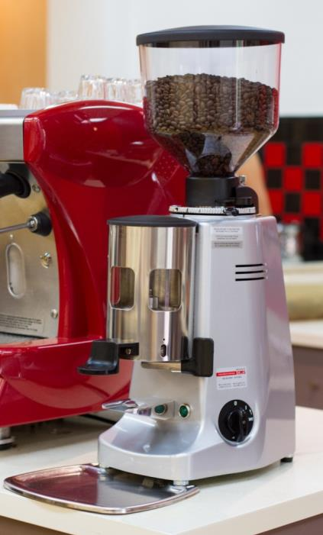

Hopper

Adjustment collar

Dosage chamber

Lever for grinder doser

Blades (inside)

On/off switch

Coffee waste tray

Tamper

The tamper is used to pack the ground coffee tightly into the filter basket. This means the water goes more slowly through the coffee grounds, allowing time for the flavour to be extracted from the coffee.

The tamped coffee is called a *puck* or *cake*.

Some cafes use a rubber mat to protect the tamper, the bench and the bottom of the group handle.

*If you tamp the coffee correctly, the puck should stay in the filter basket when you turn the group handle upside down.*

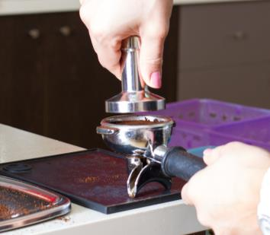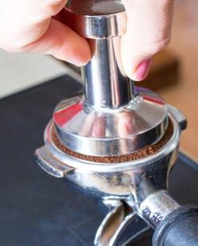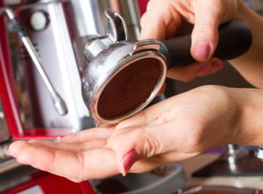

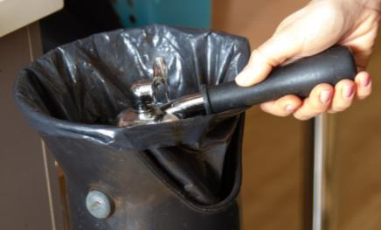Knock out tube

Used coffee grounds are emptied into a knock out tube (or knock box). Tap the group handle on the bar so that the used grounds fall out.

Thermometer

Milk thermometers are used to make sure the milk is at the correct temperature. Milk should be no more than 65°C.

An experienced barista can often tell just by the heat through the jug, without having to use a thermometer.

You also will learn to *estimate* the temperature. This means judging how hot the milk is by looking at it and by feeling the hot jug on your hand, without actually measuring it with a thermometer. You learn this through experience.

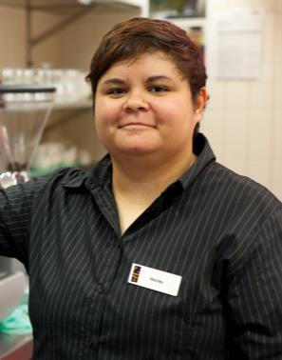

*Keep the thermometer clean.   
But don’t put it in the dishwasher.*

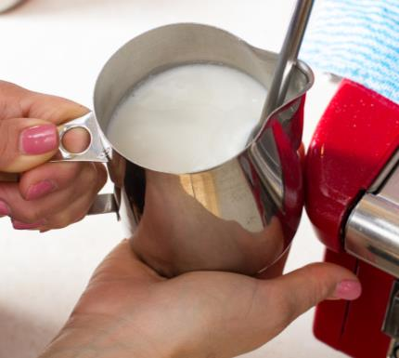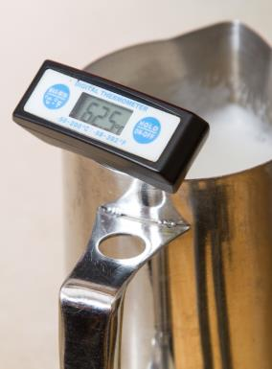

Milk jugs

Use different sizes of jugs to heat the milk, depending on the amount of milk. Milk will *expand* (get bigger) when textured, to double its size.

Jugs are made of stainless steel because it:

* lasts well
* is easy to clean
* is easier to control the temperature of the milk.

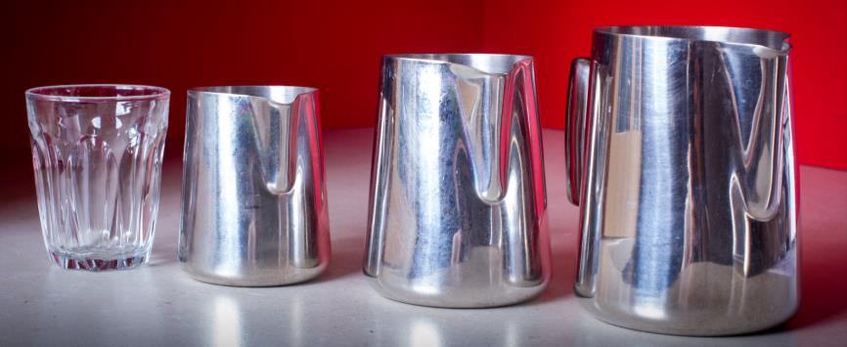

**2 cups**

**3 cups**

**1 cup**

Weighing and measuring equipment

Electronic scales can be used to weigh coffee after is has been ground to get the correct *dose* (amount) of coffee. You can also use coffee scoops to measure a correct dose.

An experienced person can do it by sight.

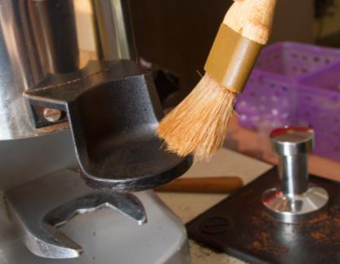Cleaning equipment and products

You need the right cleaning equipment and products to keep the equipment clean, for example:

* brushes to clean the group head and grinder
* cleaning cloths – use different coloured cloths for different purposes, to prevent cross contamination
* cleaning detergent
* sanitising products.

|  |  |
| --- | --- |
| C:\Users\Alan\Desktop\IMG_1087.jpg | Activity 3  Your workplace equipment |

1 Look at an espresso machine in your workplace. What brand is it?

|  |
| --- |
|  |

2 Point out and name the different parts of the machine.

|  |
| --- |
|  |

3 Look at the grinder. Point out and name the different parts of the machine.

|  |
| --- |
|  |

4 What other equipment can you see?

|  |
| --- |
|  |

Section summary

Now you have completed this section you should have developed the following skills and knowledge.

Tick the box if you are satisfied that you have those skills and knowledge.

|  |  |
| --- | --- |
|  | Recognise the main pieces of equipment you use to make coffee. |

Notes

|  |
| --- |
|  |
|  |
|  |
|  |
|  |

3 Prepare for service

In a busy café it is important to be well organised and efficient, so you can make and serve coffee quickly for customers.

Before you start making coffee, you must do your *mise en place* in your workstation, making sure you have everything you need and that it is in its right place.

You should check:

* the serviceware – cups, glasses, saucers and spoons
* the supplies – coffee, milk, sugar, chocolate dusting powder, syrups, accompaniments, paper serviettes and takeaway stirrers.

|  |
| --- |
| ***Did you know?***  The French term *mise en place* translates as ‘put in place’. It means making sure that everything is in its place before you start work e.g. equipment and supplies. It is pronounced *‘meez on pluss’.* |

Check serviceware

Cups and glasses

Coffee is served in different types of cups and glasses. Some styles of coffee have a particular type of glass or cup associated with them.

Store the cups and glasses upside down on top of the espresso machine. This keeps them warm and makes sure nothing can fall into them.

Have the saucers where they are easy to reach.

Check for chips in cups, glasses or saucers. Throw out any damaged serviceware as germs can grow in the cracks.

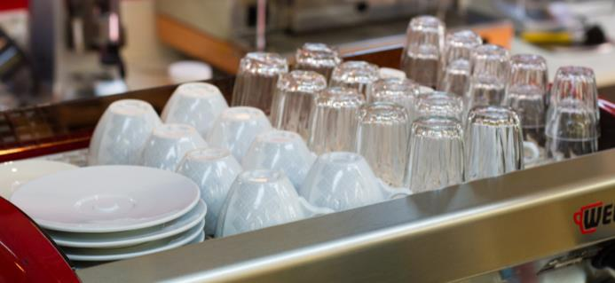

Cafés that offer takeaway coffee will have different sizes of takeaway cups, and other disposable items such as cardboard trays and plastic spoons.

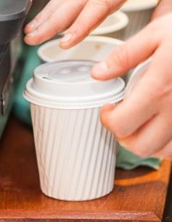Spoons

Teaspoons should be easy for you to reach. Store them in a container with the handles pointing up so you only touch the handle, not the bowl of the spoon.

Milk jugs

Make sure you have a supply of small milk jugs for people who want their milk served on the side.

Other serviceware

If you also serve food, make sure you have enough plates within easy reach.

If you use trays to take the coffee orders to tables, check they are clean.

Check supplies

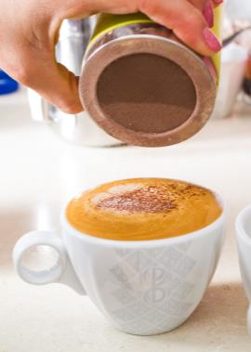Check at the start of shift that you have all the supplies you need:

* coffee beans, fresh milk, sugar and sugar substitutes
* dry goods e.g. serviettes, takeaway cups, stirrers, straws and paper doilies to put under glasses
* flavoured syrups, chocolate powder, cinnamon and *accompaniments* such as small biscuits.

Check powder shakers for chocolate or cinnamon are filled and clean.

Check the sugar containers are clean and refilled.

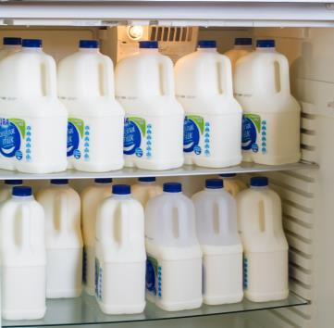Stock rotation

Always use up older *stock* (supplies) first.

This is the FIFO principle – First In, First Out.

Don’t put new milk in front of the older milk in the fridge. Put the new milk at the back and use up the older milk first. This is *stock* *rotation* (moving supplies around so you use the oldest first).

You should let your supervisor know if things are starting to run out so they can order more.

Check work area

Check that:

* cleaning equipment such as spray bottles, wipes and sponges is easy to reach, so you can clean as you work
* the other equipment you use is easy to reach and clean e.g. milk jugs, tamper and thermometer
* the areas around the espresso machine, such as the counter and display areas, are clean and look attractive.

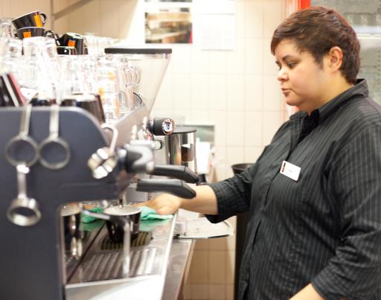

*In our café, customers can see me making coffee. So I keep the espresso machine and my work area clean and tidy.*

Workplace procedures

Follow any procedures in your particular workplace for *mise en place*. For example, there may be a notice on the wall listing the steps to follow.

|  |  |
| --- | --- |
| C:\Users\Alan\Desktop\IMG_1087.jpg | Activity 4  Mise en place in your workplace |

1 What cups and glasses are used in your workplace?  
Are they the same as the ones in the pictures in this workbook? Are there any different ones?

|  |
| --- |
|  |
|  |

2 List the other supplies used in your workplace, such as syrups.

|  |
| --- |
|  |
|  |

3 What is the *mise en place* procedure in your workplace? Write a short list.

|  |
| --- |
|  |
|  |

Section summary

Now you have completed this section you should have developed the following skills and knowledge.

Tick each box if you are satisfied that you have those skills and knowledge.

|  |  |
| --- | --- |
|  | Know the equipment and supplies needed for making coffee. |
|  | Organise the coffee workstation so that there is a safe and efficient work flow. |

Notes

|  |
| --- |
|  |
|  |
|  |
|  |
|  |

4 Work safely

Personal safety

Making coffee can be dangerous! You are:

* using hot water and steam
* working quickly at busy times
* using electrical equipment
* standing and bending.

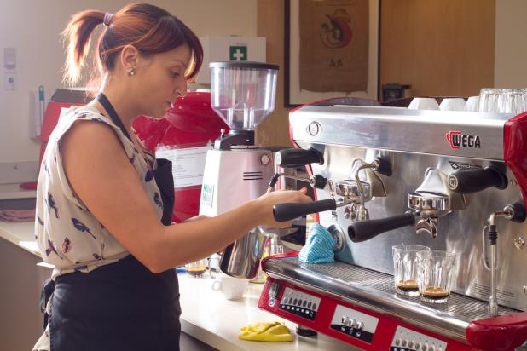

You must follow workplace safety guidelines so that you and others are not injured.

|  |
| --- |
| ***Did you know?***  At 60ºC, it takes one second for hot water to cause third-degree burns. This means there is damage to the two layers of skin plus the tissues underneath.  Steam is at about 100°C so it will burn even faster.  Burns larger than a 20 cent coin can be serious. Always report any burn immediately to your supervisor.  *Source*: Better Health Channel, <http://www.betterhealth.vic.gov.au/> |

What temperature is safe?

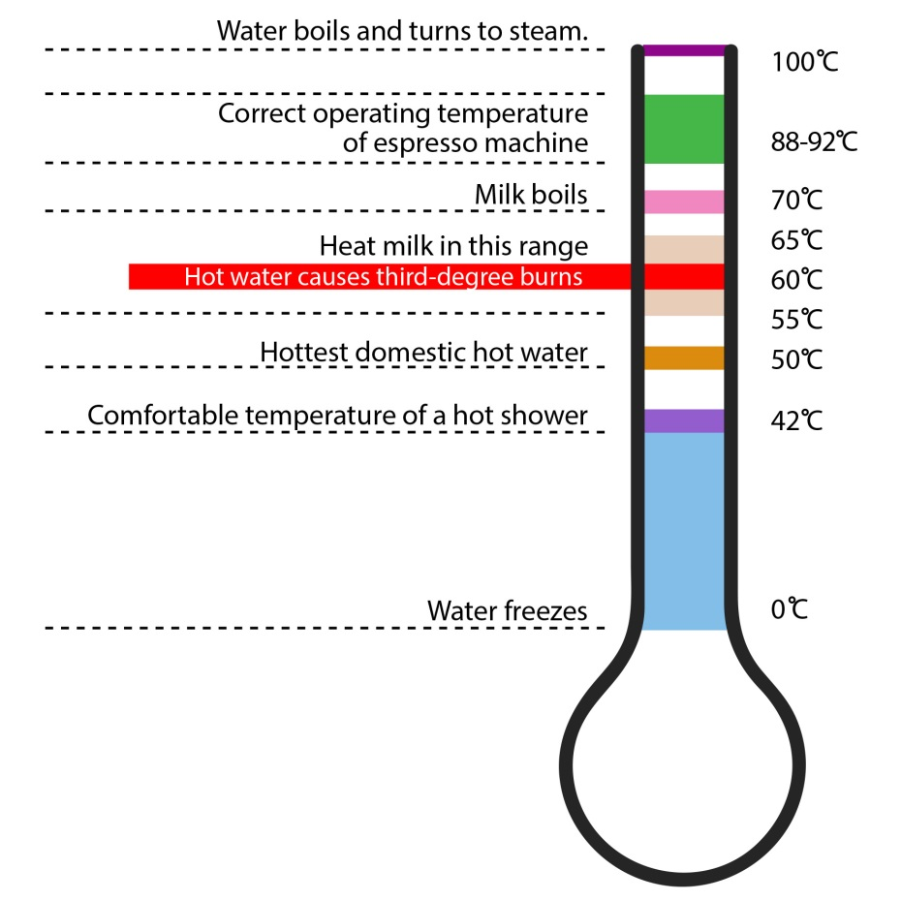

|  |  |
| --- | --- |
| C:\Users\Alan\Desktop\IMG_1094.jpg | Activity 5  Personal safety |

1 Discuss together.   
What safety procedures must you follow in your workplace when making and serving coffee?

2 The following table lists some hazards of coffee making.

* What are some possible injuries?
* What should you do to prevent you or others getting injured?

|  |  |  |
| --- | --- | --- |
| Hazards of coffee making | Possible injuries | What should you do to prevent injury? |
| 1. Working in a small space |  |  |
| 1. Using hot water, steam and hot machine |  |  |
| 1. Using electrical equipment |  |  |
| 1. Spills on the floor |  |  |
| 1. Working fast to serve customers quickly |  |  |
| 1. Standing for long periods, bending over the workbench |  |  |
| 1. Using chemicals to clean the equipment |  |  |

Food safety

Food safety is important when making and serving coffee. An unclean work area or equipment can grow germs, and people can get sick from   
germs in coffee, the same as in food.

Contamination

*Contamination* means something gets into the coffee that should not be there and can make people sick or injure them.   
*Cross-contamination* happens when germs from one place pass to another place.

**X**

**✓**

Use cloth to wipe the bench

Use same cloth to wipe steam wand

Use a special cloth only for the steam wand

**X**

Germs from bench are now in the milk

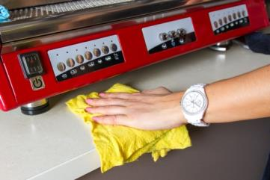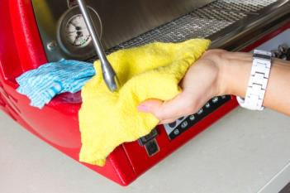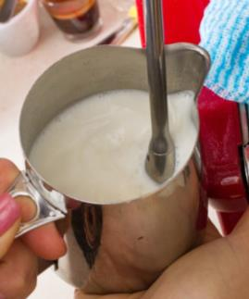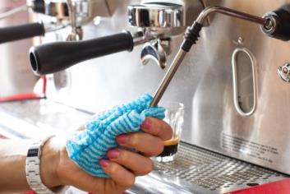

**Three types of contamination**

|  |  |  |
| --- | --- | --- |
| Type of contamination | Examples when making coffee | What you can do to prevent contamination |
| **Microbiological contamination**  Germs such as bacteria, viruses or mould get into the coffee.  You mainly can’t see these. | Milk has ‘gone off’.  Barista doesn’t wash their hands after coughing, going to the toilet …  Barista has dirty clothes or hands.  *Crockery* (cups and saucers) is chipped or cracked so germs can grow.  Equipment is dirty, e.g. steam wand is not clean between uses | Check the ‘Use by’ date.  Check the fridge is at the right temperature.  Put the milk back in the fridge when it is not being used.  Make sure equipment is clean before using it.  Throw out chipped or cracked crockery. |
| **Physical contamination**  An object gets into the coffee.  You can usually see this. | Things fall into the milk jug or coffee, such as hair or a band aid.  Insects and *vermin* (rats, mice) are attracted to food crumbs, syrups and spills.  Raw food such as meat is put above the milk in the refrigerator where it can drip down. |  |
| **Chemical contamination**  C:\Users\Alan\Documents\Carol\Consulting\12. IEP WELL Resource\Photos\ARR reduced\111130_9847_hospitality_uluru.jpgChemicals get into the coffee.  You can’t see these. | Cleaning chemicals used to clean the equipment are not washed off thoroughly. |  |

|  |  |
| --- | --- |
| C:\Users\Alan\Desktop\IMG_1079.jpg | Activity 6  Food handling when making coffee |

Look at the previous table about the three types of contamination.

1 Can you think of any other ways coffee can be contaminated?

|  |
| --- |
|  |

2 Remember what you learnt about food safety.   
What suggestions do you have for preventing contamination?  
Discuss together and add your ideas in the right hand column.

Storing coffee

Ground coffee goes stale quickly. The oils inside the coffee beans are exposed to the air and they begin to taste bad.

Air, moisture, heat and direct sunlight can all *affect* (change) coffee, both beans and grounds.

* Store unopened bags of coffee beans in a dry, cool, dark place.
* Once a coffee bag is opened, store the beans in a clean, dry, airtight container in the same cool, dark place. Put unused beans from the hopper back into this container at the end of the day.
* Don’t store opened coffee in the fridge or freezer. It can *absorb* (soak up) smells from food. The moisture can also affect the coffee.
* Don’t leave the coffee beans or grounds in warm places e.g. make sure the grinder is not next to a window where sunshine comes in.

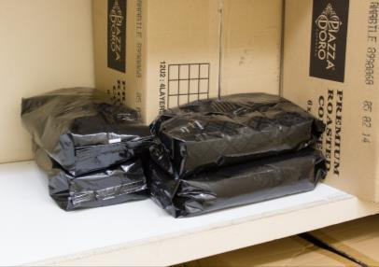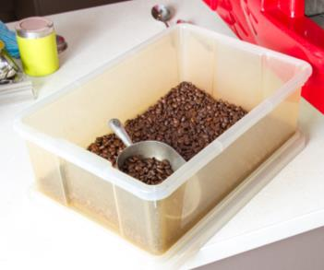

You can use leftover ground coffee from the dosing chamber to *season the machine* at the start of the next shift, so put it in a labelled airtight container. Don’t use it to make coffee the next day – it will be stale. *Season the machine* by making at least 3 espressos using each group head and throwing them away.

Storing milk

Milk and cream should be refrigerated at 0ºC–5ºC. It can go bad quickly if it is left out of the fridge or if the fridge is not cold enough.

If milk goes bad, you must throw it out. This is wasteful and will cost the workplace money.

To check if milk is fresh:

* read the ‘use-by’ date
* smell the milk before you use it.

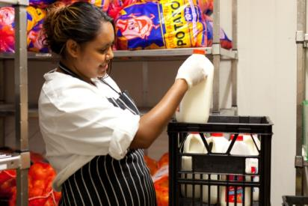

Storing other supplies

Sugar and sweeteners may be bought in bulk and put into sugar bowls or pre-packaged in small packets.

Store sugar in a sealed container to keep out insects or dirt.

Keep the lids tightly on syrups and wipe spills and drips off the bottles.

Keep biscuits in an airtight container to keep them fresh.

Environmental safety

How can you protect the environment in your work? The main ways are by using less of these things:

* water
* electricity
* cleaning chemicals
* packaging.

You will learn some ways of doing these things in the green boxes in this workbook.

When you do these things to protect the environment, you are also *minimising* (making the smallest amount) waste, which will help your workplace save money.

|  |  |
| --- | --- |
|  | **Use less packaging** |
| Packaging such as plastic wrapping, boxes and bottles can fill up rubbish tips, blow around the land and injure creatures in the sea.  Your workplace can help the environment by:  buying goods with little or no packaging  recycling cardboard boxes, plastic or glass jars and bottles  putting coffee grounds and other food scraps into a compost bin to fertilise gardens. | |

|  |  |
| --- | --- |
| C:\Users\Alan\Desktop\IMG_1087.jpg | Activity 7  Storage in your workplace |

1 Where is the coffee stored beforeit is opened?

|  |
| --- |
|  |

2 Where is the coffee stored after it has been opened?

|  |
| --- |
|  |

3 What is the temperature of the fridge?

|  |
| --- |
|  |

4 What packaging gets thrown away in your workplace? Is any packaging recycled? If so, how is it recycled?’

|  |
| --- |
|  |
|  |

Section summary

Now you have completed this section you should have developed the following skills and knowledge.

Tick each box if you are satisfied that you have those skills and knowledge.

|  |  |
| --- | --- |
|  | Know how to work safely when making and serving coffee. |
|  | Know how food safety guidelines apply to making and serving coffee. |
|  | Know some ways to protect the environment when making coffee. |

Notes

|  |
| --- |
|  |
|  |
|  |
|  |
|  |

5 Grind coffee

What is grinding?

Grinding is crushing the coffee beans so that the hot water can *extract* (get out) the coffee.

Coffee can be ground to different *grades* (sizes). The grade of the grind affects the time the water takes to move through the coffee and how much flavour it can get out. If the grind is too *coarse* (big) or too *fine* (small), it affects the flavour and quality of the coffee.

|  |  |
| --- | --- |
| **Size of grind** | **Description** |
| **Coarse** | Very distinct particles of coffee, like heavy grained, chunky salt |
| **Medium** | Gritty, like coarse sand |
| **Fine** | Smoother to the touch, a little finer than granular sugar or table salt |
| **Extra fine** | Finer than sugar but not quite powdered. Grains should still be noticeable to the touch |
| **Turkish** | Powdered, like flour |

To make good espresso coffee, you need an extra fine grind.

Check the grinder

Prepare the grinder for service each day.

* If it has been taken apart for cleaning, you may need to *reassemble* it (put it back together).
* Switch it on.
* Do a test grind to check it is produces the right size grind.

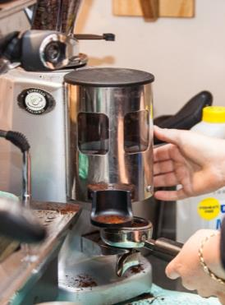

Grind on demand

Ground coffee goes stale quickly, so you should grind *on demand* – that is, grind it just when a customer orders a coffee. Coffee made from stale grounds won’t taste good.

Put the beans in the hopper of the grinder, ready for grinding.

After grinding, ground coffee automatically goes into the doser, ready to be used.

Only grind the amount of coffee you need. If you have to throw coffee away, this is wasteful and can affect the profit of the establishment.

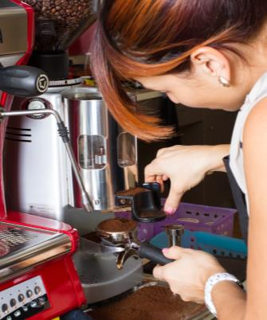

*To get the best flavour, grind the coffee freshly for each coffee order. Ground coffee loses its flavour and aroma quickly.*

Monitor the grind

The grinder doesn’t always produce the same size of grind. Coffee can be affected by *humidity* (moisture in the air). Coffee *absorbs* (takes in) moisture and the coffee grounds may *expand* (increase in size). This makes extraction slower and changes the flavour of the coffee.

You need to *monitor* (check) the grind during the day, to make sure the coffee grounds are still the right size. You might need to make the grind coarser or finer.

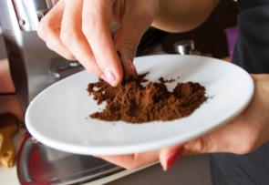To monitor the grind, use your senses:

* **look at** the grind to see how fine or coarse it is
* **taste** the coffee:
* if the coffee has little flavour or a *sour* flavour, the grind is too coarse and the water flows through too quickly (under extraction)
* if the coffee has a *bitter* flavour, the grind is too fine and the water takes too long to flow through the coffee (over extraction).
* **touch** the grind with your fingers – it should feel powdery with a gritty finish.

If you notice that the grind needs to be adjusted, tell your supervisor. Once you are more experienced, you may learn how to *adjust* (change) the grind.

Dose the coffee

The *dose* of coffee means the amount of coffee you use to make a shot.

This is between 7-9 grams per cup for a single shot, depending on the grind and your café’s standards. A double shot needs double the amount.

Flick the doser lever until you have a mound of coffee in the group handle basket. You will learn how many clicks of the doser lever to use to get the correct amount.

Level it with your finger, moving it gently back and forwards across the basket.

**Don’t overfill the basket:**

This wastes more coffee when you level off the basket

If you tamp the coffee in too tightly, it stops the water flowing through the coffee. This produces a poor-tasting coffee.

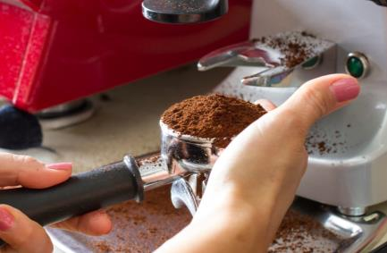

|  |  |
| --- | --- |
| C:\Users\Alan\Desktop\IMG_1087.jpg | Activity 8  Grinding coffee at your workplace |

1 Where is the grinder located at your workplace?

|  |
| --- |
|  |

2 Who is responsible for adjusting the grind?

|  |
| --- |
|  |

Section summary

Now you have completed this section you should have developed the following skills and knowledge.

Tick each box if you are satisfied that you have those skills and knowledge.

|  |  |
| --- | --- |
|  | Understand the importance of grinding on demand. |
|  | Know when to check and adjust the coffee grind. |

Notes

|  |
| --- |
|  |
|  |
|  |
|  |
|  |

6 Extract coffee

Check the espresso machine

Before you start work, check that the espresso machine is ready to use.

Turn it on as soon as you arrive – it may take 15–20 minutes or longer to warm up. While it is warming up, do these checks.

1. Check the machine is clean on the outside.
2. Check the machine is put together properly.
3. Check the pump pressure, the boiler pressure and the temperature.   
   You will be shown how to do this on your workplace machine.
4. Check the machine is clean inside.   
   Lock in group handles and run about 60 ml of hot water through each one. This flushes out water that has been sitting in the pipes overnight and heats up the group handles.

The water coming through each group head should flow in a single spiral and runs clear. If not, the machine is not clean.

1. Freshen up the boiler water.  
   Turn on the water outlet and release about 1 litre.
2. Clear the steam wand.   
   Open up the steam wand and release steam for about 30 seconds.

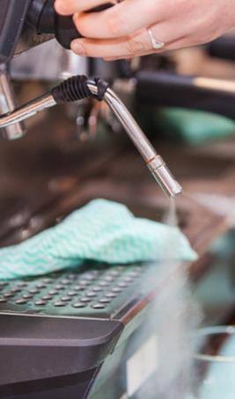Clear the steam wand

The steam wand needs to be completely clean and unblocked.   
Each machine is different, but these are guidelines for a check.

1. Check that the steam wand is clean on the outside, with no signs of dried milk.
2. Check that the holes in the steamer nozzle are not blocked.   
   You could use something like a toothpick to clear the holes.   
   Make sure the wand is not on when you do this.
3. Position the nozzle over the drip tray and gently turn on the steamer tap to *expel* (push out) any water in the nozzle. Otherwise water will get into the milk.
4. Bring the nozzle out from over the drip tray and turn on the steam tap until the steam pressure does not increase any further.
5. Check that there is an even pattern of steam coming from the holes.

If everything is working properly, turn off the steam tap until you are ready to use it.

Do test extractions

*Season* the group heads and filter folders by making at least 3 espressos and throwing them away. Use yesterday’s leftover grounds to save new coffee and money.

This makes sure all cleaning chemicals are rinsed away. You can also check the quality of the coffee before you make one for a customer.

Check:

* Is the grind *consistent* (the same every time)?
* Is the extraction consistent?
* Is the equipment working correctly?

Then make one more espresso for yourself.   
Does the coffee taste good? Do you need to adjust the grind?

|  |  |
| --- | --- |
| C:\Users\Alan\Desktop\IMG_1087.jpg | Activity 9  Your workplace preparation |

What procedures do you follow when preparing the equipment at your workplace?

1 Are there written procedures or have you been told the procedures verbally?

|  |
| --- |
|  |

2 Are there any checklists or notes beside the espresso machine to remind you what to do?   
If so, what do they tell you to do?

|  |
| --- |
|  |
|  |
|  |

Extract the coffee

|  |  |
| --- | --- |
| **Step 1: Grind the coffee** | C:\Users\ELIZABETH\Desktop\Carol's work part 2\SITHFAB012B Prepare and serve espresso coffee\Coffee_Uluru2012_SmallSize\Hospitality2012Uluru-0731.jpg |
| C:\Users\Alan\Documents\Carol\Consulting\24. WELL_Hospitality _resources\Photos\Coffee\Coffee_small\CoffeeServingSmall-9056.jpg**Step 2: Check the filter basket**  Make sure the filter basket is dry and clean,  and in the group handle.  Use a cloth or brush. |  |
| **Step 3: Dose the coffee**  Fill the filter basket with the correct dose from the grinder. It should be slightly heaped. | C:\Users\ELIZABETH\Desktop\Carol's work part 2\SITHFAB012B Prepare and serve espresso coffee\Coffee_Uluru2012_SmallSize\Hospitality2012Uluru-0733.jpg |
| **Step 4: Level the coffee**  Level the grounds in the filter basket.  Tamp the grounds with the tamper.  Gently tap the side of the group handle with the tamper. | C:\Users\Alan\Documents\Carol\Consulting\24. WELL_Hospitality _resources\Photos\Coffee\Coffee_small\CoffeeServingSmall-8744.jpg |
| **Step 5: Tamp the coffee**  Tamp again to level the coffee in the filter basket.  Brush any loose coffee off the rim.  *Polish* (smooth) the surface by turning the tamper while pressing it down.  Use enough pressure so that you can turn it upside down without the puck falling out. | C:\Users\ELIZABETH\Desktop\Carol's work part 2\SITHFAB012B Prepare and serve espresso coffee\Coffee_Uluru2012_SmallSize\Hospitality2012Uluru-0722.jpg |
| **Step 6: Purge water**  *Purge* (push out) water from the group head for 2 seconds, to remove any old coffee and to get the right temperature. | C:\Users\Alan\Documents\Carol\Consulting\24. WELL_Hospitality _resources\Photos\Coffee\Coffee_small\CoffeeServingSmall-9023.jpg |
| **Step 7: Lock in the group handle**  Insert the group handle into the machine and *rotate* (turn) it firmly until it locks into position. | C:\Users\ELIZABETH\Desktop\Carol's work part 2\SITHFAB012B Prepare and serve espresso coffee\Coffee_Uluru2012_SmallSize\Hospitality2012Uluru-0749.jpg |
| **Step 8: Place cup or glass**  Put the warm cup or glass in position under the group head. | C:\Users\ELIZABETH\Desktop\Carol's work part 2\SITHFAB012B Prepare and serve espresso coffee\Coffee_Uluru2012_SmallSize\Hospitality2012Uluru-0754.jpg |
| **Step 9: Extract the coffee**  Begin the extraction, following the operating instructions of your espresso machine. There should be a 4–5 second delay before the coffee comes through.  The machine should produce 30 – 35 ml of espresso in 25–30 seconds.  The espresso should be thick and flow down in a heavy stream. You should see the crema forming.  Stop the flow after it begins to turn slightly lighter in colour. | C:\Users\Alan\Documents\Carol\Consulting\24. WELL_Hospitality _resources\Photos\Coffee\Coffee_small\CoffeeServingSmall-8812.jpg |
| **Step 10: Empty used grounds**  Empty used grounds into the knockout tube by knocking the group head on the bar.  What comes out is called the *puck*, coffee biscuit or cake. | C:\Users\ELIZABETH\Desktop\Carol's work part 2\SITHFAB012B Prepare and serve espresso coffee\Coffee_Uluru2012_SmallSize\Hospitality2012Uluru-0784.jpg |

|  |  |
| --- | --- |
| C:\Users\Alan\Desktop\IMG_1087.jpg | Activity 10  Extracting coffee at your workplace |

How do you extract coffee in your workplace?

Is it the same as described in the previous section? Are there any differences?

|  |
| --- |
|  |
|  | |
|  | |
|  | |

Liquid measurements

You have to measure liquids when you are making coffee – the espresso, the milk, the hot water.

Get familiar with what these amounts look like in the containers you use.   
Then you won’t have to measure, which is slow. You can *estimate* by looking, which is quicker. *Estimating* is when you judge from your experience.

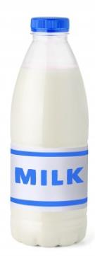

1,000 mls

500 mls

250 mls

60 mls

30 mls

|  |
| --- |
| UNITS OF MEASUREMENT  **ml, mls** = millilitres  **L** = litre  **1 litre** = 1,000 mls  1 standard cup = 250 mls  1 litre = 4 cups |

200 mls

100 mls

60 mls

30 mls

A 30 ml shot of espresso in  
a 200 ml café latte glass

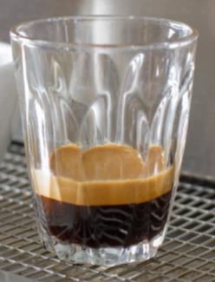

|  |  |
| --- | --- |
| **A café latte glass** | = 200 mls (approx.) |
| **An espresso cup** | = 100 mls (approx.) |
| **A single shot** | = 30 mls |
| **A double shot** | = 60 mls |
| **¼ cup** | = 60 mls (approx.) |

*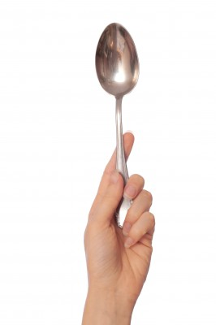*

|  |  |
| --- | --- |
| **1 tablespoon** | = 20 mls |

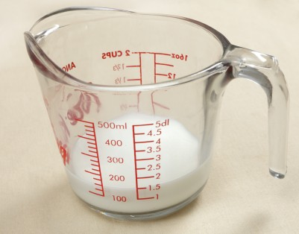

*300 ml = milk for 2 cappuccinos*

Use a jug with measurements on the side to get experience.

|  |
| --- |
| **FRACTIONS**  **1/3 = one third**  **1/3**  **1/3**  **1/3**  *When heating milk, only put milk into 1/3 of the jug.*  1/3 jug + 1/3 jug + 1/3 jug = 1 whole jug |

¼

¼

¼

¼



|  |
| --- |
| **FRACTIONS**  **1/4 = one quarter**  1/4 cup + 1/4 cup + 1/4 cup + 1/4 cup = 1 whole cup |

|  |  |
| --- | --- |
| C:\Users\Alan\Desktop\IMG_1079.jpg | Activity 11  Measuring and estimating liquids |

Your trainer will organise an activity to practise measuring and estimating liquids.

Monitor the extraction

Check the extraction rate

The *extraction rate* is the amount of time it takes for the coffee to flow from the machine to make an espresso.

As you are making the coffee, *monitor* (watch) the extraction rate to make sure the right amount of water flows through the coffee in the right amount of time.

|  |
| --- |
| ***The correct extraction rate***  There should be a 4–5 second *delay* (wait) before coffee comes through.  Then the machine should produce 30 – 35 ml of espresso in 25–30 seconds. |

If the extraction rate is not correct, you may have to adjust the grind or the amount of coffee in the filter.

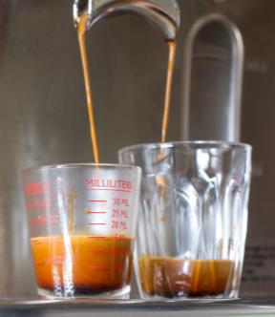How long is a second?

To judge how long a second is, you could:

* use a watch, stop watch, or timer in a mobile phones.
* count under your breath e.g. say these words slowly:
* one cat and dog, two cat and dog, three cat and dog, four cat and dog …
* one thousand and one, one thousand and two, one thousand and three, one thousand and four ….

|  |  |
| --- | --- |
| C:\Users\Alan\Desktop\IMG_1081.jpg | Activity 12  Checking the extraction rate |

Your trainer will organise this activity to help you practise timing the extraction rate.

Check the crema

The *crema* is the rich, creamy, golden coloured layer that forms on top of freshly extracted espresso.

If the crema is thin, too dark or too pale, it shows that there is something wrong. It could be that:

* the coffee is too coarse
* the coffee is stale
* the espresso machine is not clean
* the espresso machine was not warmed up properly.

Check the puck

The *puck* is the coffee grounds left in the filter basket after extraction. Check the puck after you have knocked it out.

You should be able to pick it up without it crumbling. It should be firm and crisp when it breaks.

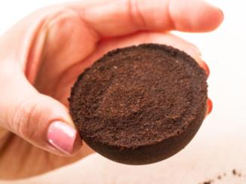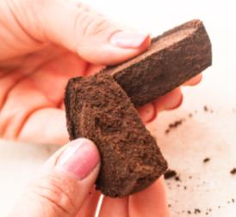

If the puck is sloppy and there is water left in the filter cup, you may need to:

* adjust the dosage
* adjust the grind
* tamp the coffee grounds harder.

Check the water temperature

Water temperature should always be between 90ºC and 95ºC.

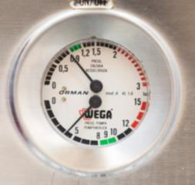Check the water and pump pressure

Most machines have a pressure gauge that tells you the pressure of the water as it is forced through the coffee. Correct pressure makes sure you get a good crema.

You will be shown how to check the water pressure on your workplace espresso machine.

If the water pressure is incorrect, you may need to call a technician.

|  |  |
| --- | --- |
|  | **Use less electricity** |
| You can protect the environment by using less electricity.  Turn electrical equipment off overnight.  Turn lights off when you leave a room.  Only open the fridge door when necessary.  Tell your supervisor if the fridge door doesn’t close properly. | |

What can go wrong?

Sometimes the coffee does not turn out right. In the next table, there are some typical problems you might have.

|  |  |
| --- | --- |
| C:\Users\Alan\Desktop\IMG_1094.jpg | Activity 13  What could go wrong? |

Look at the problems in the next table.

What solutions can you think of?

Write them in the empty column in the table.

|  |  |  |
| --- | --- | --- |
| Problem | Possible cause | Possible solution |
| Extraction is too fast so that:   * water rushes through the coffee * the crema is thin and pale * the taste is watery. | Not enough coffee  Tamp too soft  Temperature too cold  Grind too coarse |  |
| Extraction is too slow so that:   * water has trouble getting through the coffee * the crema is very dark brown * the coffee tastes bitter. | Too much coffee  Tamp too hard  Temperature too hot  Grind too fine |  |
| Coffee grounds in the cup | Grind too fine  Worn grinder blades  Worn filter holders  Group head dirty  Coffee on the edge of the filter holder  Water not hot enough |  |
| Coffee tastes burnt | Machine dirty  Coffee old  Hopper in grinder needs cleaning |  |

Section summary

Now you have completed this section you should have developed the following skills and knowledge.

Tick each box if you are satisfied that you have those skills and knowledge.

|  |  |
| --- | --- |
|  | Understand the steps for extracting coffee. |
|  | Recognise possible problems when extracting coffee and know what action to take to solve them. |

Notes

|  |
| --- |
|  |
|  |
|  |
|  |
|  |

7 Texture milk

Milk is added to espresso to make a range of other coffee drinks such as cappuccino, café latte, macchiato and flat white.

About milk

Different types of milk can behave differently. Some types of milk you might use are:

* regular milk (full fat)
* skim milk (lower in fat)
* soy milk (made from soy beans).

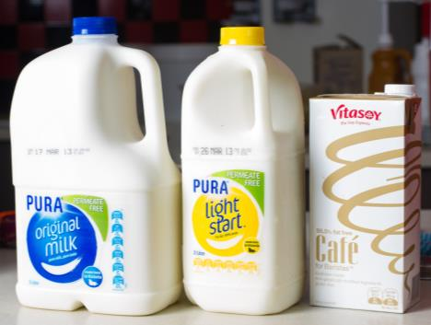

Some cafés also use café milk, which is high in protein and is produced specially for coffee making. It is the protein content in milk that gives it the body when it is steamed.

It is important to practise with different types of milk.

* ***Skim milk*** froths more easily. But the froth also disappears more quickly because there is less fat and less weight in the milk.
* ***Soy milk*** curdles more often than regular milk when it is added to the coffee.

|  |
| --- |
| ***Did you know?***  Milk can be affected by the time of year because the cows eat different plants. So the same milk might behave differently at different times of the year. Spring and early summer milk is usually the best. |

Heat the milk

You heat the milk with the steam wand on the espresso machine.

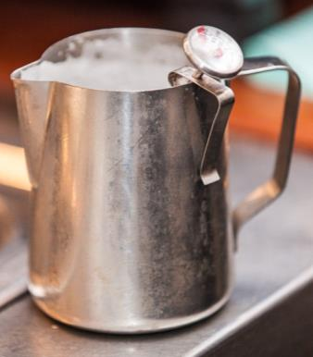Guidelines for heating milk

* Only use cold, fresh milk.
* Use a jug big enough for the milk to double in size.
* Only put as much milk in the jug as you need, to prevent wasting milk.
* Heat milk to between 55ºC and 65ºC.
* Milk boils at 70ºC. If you accidentally boil the milk, throw it out as it will never get a creamy texture.
* After you have finished pouring, throw away any leftover milk. Don’t reheat milk. It goes watery and the coffee tastes bad.

Use a thermometer to check the temperature, particularly when you are learning.

Understanding temperatures



Stretch and texture milk

There are two steps in making the milk ready for the coffee.

1. **Stretching**   
   Use steam to put air bubbles into the milk, so the milk increases in *volume* (amount).
2. **Texturing**  
   Mix the air bubbles through the milk until you have the *texture* (feel) you want. The milk should be thicker and creamy. You don’t need lots of foam.

Stretching and texturing milk takes a lot of practice before you get it right.

Here are some guidelines.

|  |  |
| --- | --- |
| **How to stretch and texture milk** | |
| *Release* (let out) a small amount of steam through the steam wand to remove any moisture from cooled steam. | C:\Users\ELIZABETH\Desktop\Carol's work part 2\SITHFAB012B Prepare and serve espresso coffee\Coffee_Uluru2012_SmallSize\Hospitality2012Uluru-0767.jpg |
| C:\Users\ELIZABETH\Desktop\Carol's work part 2\SITHFAB012B Prepare and serve espresso coffee\Coffee_Uluru2012_SmallSize\Hospitality2012Uluru-0761.jpg | Choose a clean stainless steel jug large enough to hold the milk you need. The jug should be about 1/3 full. |
| Pour in the amount of cold fresh milk you need. | **C:\Users\ELIZABETH\Desktop\Carol's work part 2\SITHFAB012B Prepare and serve espresso coffee\Coffee photos\CoffeeServing-8900.jpg** |
| **C:\Users\ELIZABETH\Desktop\Carol's work part 2\uluru 2012 photos smaller size for word pages\Hospitality2012Uluru-0771.jpg** | Place the steam wand into the jug just below the top of the milk. Tilt the jug at an angle. |
| Turn on the steam – open the steam valve fully. | C:\Users\Alan\Documents\Carol\Consulting\24. WELL_Hospitality _resources\Photos\Coffee\Coffee_small\CoffeeServingSmall-8783.jpg |
| C:\Users\Alan\Documents\Carol\Consulting\24. WELL_Hospitality _resources\Photos\Coffee\Coffee_small\CoffeeServingSmall-8885.jpg | The position of the steam wand in the milk will create different effects.  Cappuccino needs a thick foam. Keep the wand just under the milk surface so you hear a gentle, hissing sound.  Café latte needs a thinner texture. Start with the wand just below the milk surface. When the milk heats to 40ºC, move the wand deeper into the milk. |
| Listen for the hiss of the steam. It should be a soft hiss, not too loud.  Watch that the milk is spinning like a whirlpool and slowly rising.  When the milk is at the right temperature, turn off the steam valve and carefully remove the jug. | C:\Users\Alan\Documents\Carol\Consulting\24. WELL_Hospitality _resources\Photos\Coffee\Coffee_small\CoffeeServingSmall-9064.jpg |
| C:\Users\Alan\Documents\Carol\Consulting\24. WELL_Hospitality _resources\Photos\Coffee\Coffee_small\CoffeeServingSmall-8780.jpg | Wipe the steam wand immediately with a clean, damp cloth to remove any milk *residue* (leftovers). |
| *Purge* the steam wand to blow any milk out. | C:\Users\Alan\Documents\Carol\Consulting\24. WELL_Hospitality _resources\Photos\Coffee\Coffee_small\CoffeeServingSmall-8781.jpg |
| C:\Users\ELIZABETH\Desktop\Carol's work part 2\SITHFAB012B Prepare and serve espresso coffee\Coffee_Uluru2012_SmallSize\Hospitality2012Uluru-0773.jpg | *Swirl* (move around in a circle) heated milk and foam in the jug for 5–10 seconds so the mixture is smooth and foamy.  This also spreads the heat evenly through the milk. |

The correct amount of milk

Two cappuccinos need 300 ml of milk. Fill a 1 litre jug between a third and a half full.

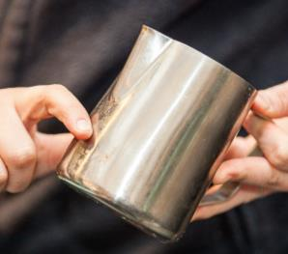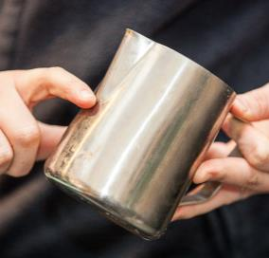

*A third*

*A half*

Pour milk

Pour the milk in immediately, before the foam separates. Throw out any unused milk

The way you pour the milk into the cup depends on the type of coffee being made. Here are some guidelines.

* *Cappuccino* - Requires more foam. Pour quickly, with the jug low, so the foam goes into the cup. Don’t spoon the foam in.
* *Café latte* - Pour a little slower to control the amount of foam going into the cup.
* *Flat white coffee* - Pour last, as it does not need any foam.

If making several cappuccinos, half fill each cup with milk, working from first to last.   
Then fill each cup, working from last to first.   
This makes sure there is an equal amount of foam and textured milk in each cup.

*Pouring a cappuccino*

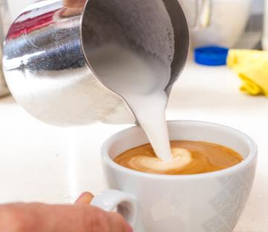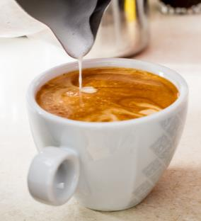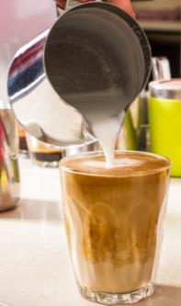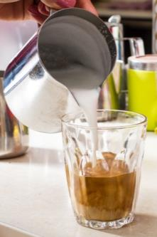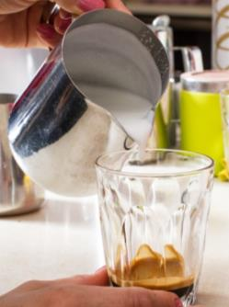

*Pouring a café latte*

|  |  |
| --- | --- |
| C:\Users\Alan\Desktop\IMG_1087.jpg | Activity 14  Stretching and texturing milk |

1 What types of milk are used at your workplace?

|  |
| --- |
|  |
|  |

2 Watch someone stretching and texturing milk at your workplace.

* Did they follow the steps in the previous section?
* Did they do anything differently?

|  |
| --- |
|  |
|  |

|  |
| --- |
| ***Barista Tip***  Soy milk has a lower “sweet spot temperature” than other milks and should be heated to between 50-55°C to produce good foam. Full fat and reduced fat milks are best heated to between 55-65°C. |

|  |  |
| --- | --- |
| C:\Users\Alan\Desktop\IMG_1079.jpg | Activity 15  What can go wrong when texturing milk? |

Look at the problems you can have when texturing milk in the following table.

What solutions can you and your group think of?

Write them in the empty column in the table.

What can go wrong?

Here are some typical problems that can happen when you are texturing milk.

|  |  |  |
| --- | --- | --- |
| Problem | Possible cause of problem | Possible solution |
| 1. Too much foam | Too much air has entered the milk, making big bubbles |  |
| 1. Milk does not foam | Steam wand held too far under the milk  Milk and jug not cold enough Milk not fresh or wrong type  Too much milk in the jug Steam temperature and pressure not high enough Wrong technique used |  |
| 1. Steam wand is blocked | Wand not wiped and purged after each use |  |
| 1. Milk has boiled | Did not check temperature during heating |  |
| 1. Milk has *curdled* (separated into different parts) | Milk may be old or ‘off’ |  |
| 1. Milk smells bad | Left out of the fridge  Past its ‘use-by’ date  Fridge temperature not correct |  |

Section summary

Now you have completed this section you should have developed the following skills and knowledge.

Tick each box if you are satisfied that you have those skills and knowledge.

|  |  |
| --- | --- |
|  | Know about different types of milk. |
|  | Understand the steps for heating, stretching and texturing milk. |
|  | Know how to keep milk safe to drink. |
|  | Recognise possible problems when using milk in coffee and know what action to take. |

Notes

|  |
| --- |
|  |
|  |
|  |
|  |
|  |

8 Serve coffee

You may not only make the coffee. You may also need to tell customers about different coffee styles, take their order and serve the coffee, using all your customer service skills.

You need to know:

* what type and styles of coffee are on the menu in your café
* how to make other styles of coffee that are not on the menu, in case a customer asks.

Take customer orders

Listen carefully to what the customer wants and ask questions if necessary to make sure you have understood them.

Some questions you might ask are:



*Do you want to drink your coffee here, or is it take away?*

*‘Strong coffee’ - do you mean you want a double shot?*

*What type of milk do you want?*

*Do you want hot or cold milk?*

*What size would you like?*

Your workplace will have a process for taking orders. Here are some ways that orders are taken in different cafés.

* Write down orders on an order pad or docket and place next to the espresso machine, in the order they were taken.
* Take orders electronically. These go directly to a computer next to the espresso machine.

Cafés often have a set of *abbreviation*s (short forms of words) that everyone uses.

In some cafés, the person making the coffee also takes the orders and serves the coffee. In other cafés, the orders are taken by a different person.

|  |  |
| --- | --- |
| C:\Users\Alan\Desktop\IMG_1079.jpg | Activity 16  Abbreviations in orders |

What abbreviations might a café use for these orders? One has been done for you.

|  |  |  |  |
| --- | --- | --- | --- |
| **Order** | **Abbreviation** | **Order** | **Abbreviation** |
| Short black | *SB* | Mocha |  |
| Espresso |  | Affogato |  |
| Long black |  | Soy milk |  |
| Café latte |  | Weak |  |
| Flat white |  | Strong |  |
| Cappuccino |  | Decaffeinated |  |
| Doppio |  | Long |  |
| Macchiato |  | Short |  |
| Ristretto |  | Sugar |  |
| Skim milk |  |  |  |

|  |  |
| --- | --- |
| C:\Users\Alan\Desktop\IMG_1081.jpg | Activity 17  Serving customers |

1 What system is used to take customer orders at your workplace?

|  |
| --- |
|  |

2 Practise taking orders from customers and completing an order form. Your trainer will organise this activity for you.

Serve coffee

It is important to serve the coffee promptly and correctly.

Tips for serving coffee

* Check each piece of serviceware as you handle it. Is it clean? No chips or cracks?
* No spills:
* Don’t fill the cup or glass too full.
* If coffee drips onto the saucer, change the saucer.
* If coffee spills into the saucer, make a fresh one and apologise to the customer.
* Dust drinks with chocolate before you put the cup on the saucer, so the chocolate does not dirty the saucer.
* Provide the correct accompaniments. Customers should not have to ask for basics like sugar and spoons.
* Place teaspoons on the saucer behind the cup, with the bowl of the spoon facing away from the customer.
* Pick up cups by the handle or base of the cup or glass. Don’t pick them up near the lip of the cup or glass.

**✓**

**✓**

**X**

**X**

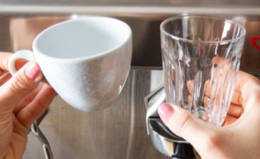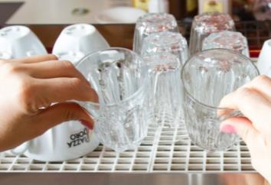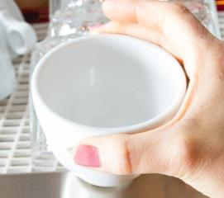

*Pick up cups by the handle or base of the cup or glass.   
Don’t pick them up near the lip of the cup or glass.*

Accompaniments

Your workplace will have its own procedures about what accompaniments to serve with the coffee. For example, you may be required to:

* mix the sugar in takeaway coffee before it is served
* put a paper serviette on the saucer under the cup
* place a small biscuit or chocolate on the saucer
* provide marshmallows if you are making hot chocolate.

Correct temperature

Serve the coffee immediately so that it is at the correct temperature. Customers can get cross if they see their coffee getting cold on the counter.

If you are making the coffee but someone else is serving it, let them know when it is ready.

**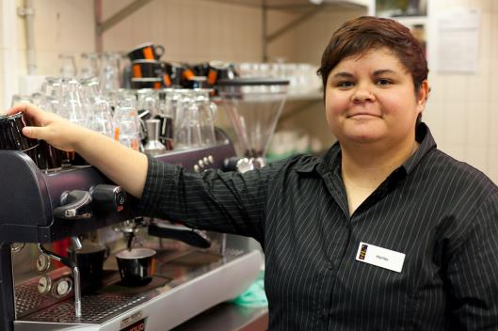**

*I keep the cups and glasses on top of the machine in the cup warming tray. This keeps the coffee hot and also helps keep the crema.*

Work flow

Work out the correct order to make a group of coffees so they all reach the customer hot e.g. make coffees with steamed milk first (cappuccinos, lattes and macchiatos) then espressos and long blacks’. If you make the espresso first it will be cold by the time you do the others.

Pour drinks that require more foam first – pour a cappuccino before a flat white.

|  |
| --- |
| ***Did you know?***  In the annual World Barista Championship, baristas must produce and serve four espressos, four cappuccinos and four other coffee-based drinks of their choice within 15 minutes.  *Source:* World Barista Championship, <http://worldbaristachampionship.com/> |

Takeaway coffee

If you are serving takeaway coffee, write on the lid what type of coffee is inside. This lets people know which one is theirs.

Many takeaway cups are *disposable* (throw away). Some people bring re-usable cups.

|  |  |
| --- | --- |
|  | **Re-usable cups** |
| Disposable cardboard cups often cannot be recycled because they have a plastic lining so they don’t leak. They get dumped in landfill rubbish dumps.  Many coffee shops are now offering re-usable coffee cups for sale to their customers as an alternative which is less harmful to the environment. | |

Coffee art

Some baristas like to decorate their coffee with artwork in the foam. This is sometimes called ‘coffee art’. Decorations can be made in several ways:

* **Free pouring** –while pouring the milk into the cup, make a pattern with the foam by wiggling the jug backwards and forwards.
* **Template** –dust or sprinkle chocolate over a *template* (cut-out shape) on the coffee.
* **Etching** –draw a toothpick through the foam to make a pattern or write words.

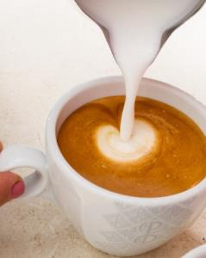

Section summary

Now you have completed this section you should have developed the following skills and knowledge.

Tick each box if you are satisfied that you have those skills and knowledge.

|  |  |
| --- | --- |
|  | Take customers’ orders accurately. |
|  | Serve coffee and accompaniments correctly. |

Notes

|  |
| --- |
|  |
|  |
|  |
|  |
|  |

9 Clean and maintain the equipment

It is important to keep all the equipment you use clean and *sanitised* (treated with a germ-killing substance). This will make sure:

* no customers get sick from contamination of the equipment or coffee
* the café doesn’t get insects or vermin attracted to the heat and food scraps
* the equipment stays in good working order.

Safety

When you are cleaning equipment, always follow workplace health and safety (WHS) guidelines.

Follow the manufacturer’s and workplace instructions for cleaning and sanitising the machines.

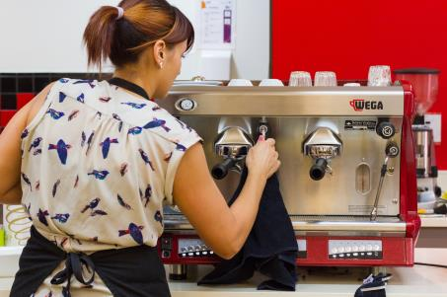Turn off power and unplug cords before cleaning electrical equipment.

Use only the recommended amounts of chemicals.

Wear gloves when handling chemicals.

Read the *Safety Data Sheet* (SDS) or other instructions carefully.

Be careful of sharp edges on the machines.

Be careful with hot water when back flushing and performing other cleaning tasks.

|  |  |
| --- | --- |
|  | **Chemicals can be harmful** |
| If chemicals get into the water supply, they can harm the environment.  Your workplace can prevent this by using environmentally friendly cleaning products that are not *toxic* (poisonous).  These are better for the environment and for you. | |

Cleaning equipment and products

The cleaning equipment and products may include:

|  |  |  |
| --- | --- | --- |
| **Item** | **Use this to …** | |
| **Brushes** | * Clean the group head * Clean the grinder | C:\Users\Alan\Documents\Carol\Consulting\24. WELL_Hospitality _resources\Photos\Coffee\Coffee_small\CoffeeServingSmall-8986.jpg |
| **Cleaning cloths** | * Wipe the steam nozzle * Wipe the bench | C:\Users\Alan\Documents\Carol\Consulting\24. WELL_Hospitality _resources\Photos\Coffee\Coffee_small\CoffeeServingSmall-8725.jpg |
| **Detergent**  **Other cleaning and sanitising products** | * Wipe down the outside of the espresso machine and grinder * Clean the hopper of the grinder * Back flush the espresso machine | C:\Users\Alan\Documents\Carol\Consulting\24. WELL_Hospitality _resources\Photos\Coffee\Coffee_small\CoffeeServingSmall-8989.jpg |

Use different cloths for different tasks to prevent cross contamination.

If a cloth falls on the ground, get a clean one.

Clean the espresso machine

Your workplace will have its own cleaning procedures and schedule for when to clean the different parts of the espresso machine.

Some machines have automatic cleaning cycles.

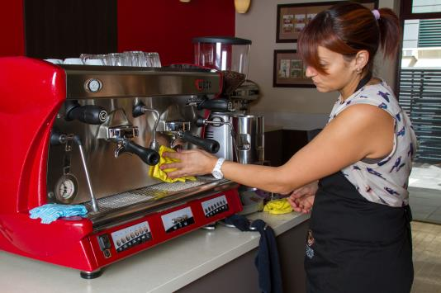

*It is important to follow the cleaning schedule to make sure your coffee tastes good. It is also good for the machines.*

Cleaning schedule

Some tasks are done through the day, as each cup of coffee is made. Other tasks are done each day or each week. Here is a typical cleaning schedule for an espresso machine.

|  |  |
| --- | --- |
| When to clean | What to clean |
| Each time you steam milk | * Wipe the steam wand. |
| During the day | * Back flush machine using a blind filter - 4 times a day in a very busy café. * Wipe down surfaces regularly so the machine and surrounds stays clean. |
| Daily at end of shift | * Clean drip tray and panels of the espresso machine. * Clean the group head, group handle baskets and filters, and steam wand. * Wipe down the whole machine. * Back flush the machine using a blind filter. |
| Weekly | * Do a chemical clean of all removable parts of the machine. * Remove shower screens and wash with warm water, a detergent and a nylon brush. |

|  |  |
| --- | --- |
|  | **Save water** |
| Water is a limited resource, and you can help *conserve* (save) it when you are cleaning.  Don’t leave taps running. Use the water you need, then turn them off.  Wash items in a sink or a bucket rather than under running water.  If you notice a dripping tap, tell your supervisor so it can be fixed.  Only use the dishwasher or glass washer when it is full. | |

Steam wand

The steam wand can easily get blocked with dried-up milk and this can grow *bacteria* (germs). It is very important to keep the steam wand clean.

**Guidelines**

* Each time you finish steaming milk, wipe down the outside of the steam wand with a wet, soft cloth and clear the inside of the wand by *purging*.
* Each day, check that the steam holes are clear:
* Remove the steamer rose from the steam wand and clear any blockages. Clean thoroughly and replace on the steam wand
* Don’t soak the steam wand attached to the machine overnight as some of the dirty water could be sucked back into the machine.
* If there is dried milk on the steam wand, wrap it in a clean, damp cloth and let the milk soften, then wipe it down.
* Don’t use sharp utensils or scouring pads to clean the steam wand as this could make scratches where bacteria could grow.

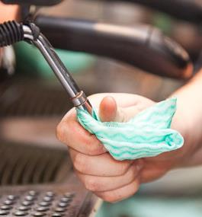

Back flush the machine

*Back flushing* or backwashing cleans the build-up of coffee solids and oils from screens, valves and tubes in the espresso machine.

**Normal back flush procedure**

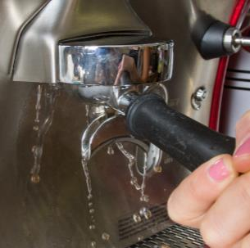Do this at least 4 times a day and at the end of the day or shift.

1. Lock the group handle on.
2. Press the manual button for 10 seconds then turn off. Repeat twice.
3. Remove the group handle and remove the *residue* (what is left behind).
4. Repeat the procedure 3 times.
5. Remove the group handle.

**Chemical back flush procedure**

Do this for every 6 kg of coffee used, and at least weekly.

1. Put a blank filter (blind filter) into the group handle.
2. Put in a small amount of cleaning powder. Follow the manufacturer’s instructions about how much to put in.
3. Lock the group handle into the machine.
4. Press the manual button for 7–10 seconds.
5. Remove the handle and rinse.
6. Repeat 3–5 times, until water in the blind cup is clear.
7. Make and *discard* (throw out) a cup of espresso to make sure no chemicals remain in the machine.

Cleaning other parts

|  |  |
| --- | --- |
| **Group head** | Clean the inside of the group head with a brush or soft cloth to remove any *excess* (leftover) coffee.  **Forward flushing**  To remove any loose grounds from inside the group head, forward flush the machine several times a day.   1. Replace the filter basket with a blind filter. 2. Insert the group handle but don’t lock it in. 3. Press the manual button. 4. Gently jiggle the group handle up and down until the water is clear. |
| **Filter baskets** | Separate the filter baskets from the filter holders. Put them into a container of water to soak. Rinse and dry. |
| **Group handle baskets** | Soak baskets in hot water and cleaning powder, following manufacturer’s instructions. Don’t soak the plastic handles.  Rinse and dry. Replace the filter baskets and return to the espresso machine. |
| **Drip trays and panels** | Remove the drip tray and wash it by hand each day.  Each week do a chemical clean.  Wipe down the panels with a clean cloth. Pay particular attention to the areas where milk may have splashed. |
| **Shower head** | Remove the shower head from the machine and clean it in warm soapy water. Rinse it, then put it back onto the machine. |

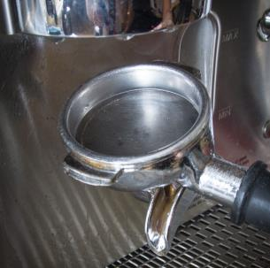

*Don’t leave used coffee in the filter basket.*

*Always leave the group handles empty and clean in the machine.*

Rest of the espresso machine

Wipe down the outside of the machine with a clean, damp cloth.

Clean under the machine. This area can be hard to reach. You could attach a cloth to a long handle, such as a wooden spoon, to clean under the machine.

*Make sure you clean  
under here!*

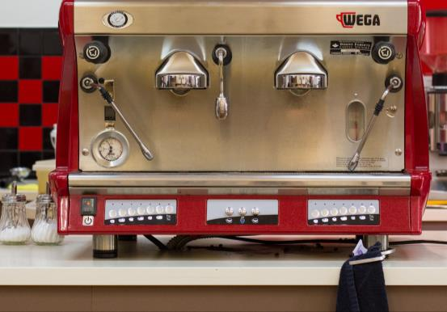

|  |
| --- |
| ***Did you know?***  You season the espresso machine after cleaning to make sure that any chemicals are removed. You do it by making at least 3 espressos. But don’t drink them! |

Service area

Wipe down surfaces regularly during the day so the machine and surrounding area stay clean. Clean and *sanitise* the preparation and service surfaces at the end of the shift.

|  |  |
| --- | --- |
| C:\Users\Alan\Desktop\IMG_1087.jpg | Activity 18  Following manufacturer’s instructions |

1 Ask your supervisor to show you the manufacturer’s instructions for a piece of equipment.

2 Read the instructions and, if you have any queries, ask your supervisor.

3 Practise removing parts of the machine for cleaning.

Clean the grinder

It is important to keep the grinder clean, because oils left from the beans can become *rancid* (smell and taste bad). This can affect the taste of the coffee.

Here are some guidelines for cleaning the grinder. However, each workplace will have its own procedures to follow.

|  |  |
| --- | --- |
| Daily | * Empty the unused beans out of the hopper and store them in an airtight container. * Close the chute to the coffee grinder and grind any remaining beans. * Remove any ground coffee and throw it away. * Turn off and unplug the grinder. * Wipe out the hopper with a clean, dry cloth. * Remove any ground coffee from the dispenser and brush it out with a small brush. * Brush the blades to remove grounds. * Wipe over the outside of the grinder with a clean, damp cloth. * Clean the area around the grinder. |
| Twice weekly | * Wash the hopper in mild detergent and hot water. Don’t put it in the dishwasher. * Rinse and dry carefully. |
| Monthly | * Check the grinding blades for wear and have them replaced if necessary |

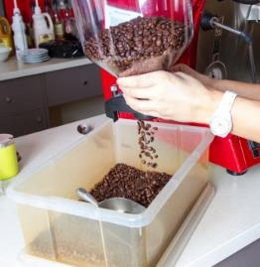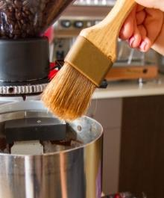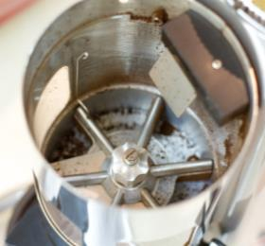

Maintenance

If you keep the espresso machine and grinder clean, it will help stop them breaking down.

If you notice something wrong with the espresso, grinding machine or other equipment, don’t try to fix it yourself. Refer the problem to your supervisor or call a technician.

Here are some typical problems.

|  |  |
| --- | --- |
|  | **Problem** |
| **Espresso machine** | * Steam and pump pressure changes or does not give a high enough pressure. * Low or no pressure from the steam arms. * No water coming through the group head. * *Gaskets* (seals) on the group handle have worn. * Water leaks from under the machine. * Pump or motor is noisy. |
| **Grinder** | * Grind size is not consistent. * Dosing chamber is not measuring the correct dosage. * Machine stops during operation, or won’t start. * Blades are blunt. Signs are: * grounds are of uneven size * the motor is straining to grind the beans * the coffee grounds come out warm from the grinder * there are dregs left at the bottom of the cup. |

If your establishment has a water filtration system, follow procedures to maintain it.

|  |  |
| --- | --- |
| C:\Users\Alan\Desktop\IMG_1087.jpg | Activity 19  Cleaning at your workplace |

What is the schedule for cleaning the equipment at your workplace?

Write down what needs to be cleaned and when.

|  |  |
| --- | --- |
| **Clean when? How often?** | **Clean what?** |
|  |  |
|  |  |
|  |  |
|  |  |
|  |  |
|  |  |
|  |  |
|  |  |
|  |  |

Section summary

Now you have completed this section you should have developed the following skills and knowledge.

Tick each box if you are satisfied that you have those skills and knowledge.

|  |  |
| --- | --- |
|  | Know when and how to clean the espresso machine and grinder. |
|  | Recognise faults in the machines and know when to report them to your supervisor. |

Notes

|  |
| --- |
|  |
|  |
|  |
|  |
|  |

Key words

|  |  |
| --- | --- |
| Word | Meaning |
| ***abbreviation*** | Short form of word |
| ***absorb*** | Soak up, take in |
| ***accompaniments*** | Small treats that go with (or *accompany)* the coffee, e.g. a chocolate or small biscuit |
| ***adjustment*** | Change or alteration. |
| ***affect*** | Change |
| ***aromatic*** | Scented |
| ***bacteria*** | Germs |
| ***barista*** | Person who operates an espresso machine – a barista is trained, experienced and has a wide knowledge of coffee |
| ***beverages*** | Drinks |
| ***coarse*** | Big |
| ***conserve*** | Save |
| ***consistent*** | The same every time |
| ***contamination*** | When something gets into the coffee that should not be there and can make people sick or injure them |
| ***crema*** | A rich, creamy, golden coloured layer that forms on top of freshly extracted espresso. It has a fine foam without big bubbles. |
| ***crockery*** | Cups and saucers |
| ***cross contamination*** | Germs pass from one surface to another |
| ***curdled*** | Separated into different parts |
| ***delay*** | Wait |
| ***disposable*** | Throw away |
| ***dose*** | The amount of coffee to be used |
| ***emulsify*** | Mix together |
| ***estimate, estimating*** | When you judge from your experience, without measuring exactly |
| ***expand*** | Get bigger |
| ***expel*** | Push out |
| ***extract*** | Get the coffee flavour out of the beans and into the water |
| ***extraction*** | The flow of the coffee from the espresso machine. |
| ***extraction rate*** | The amount of time it takes for the coffee to flow from the machine to make an espresso |
| ***fine*** | Small |
| ***grade*** | Size |
| ***group handle*** | Holds the ground coffee for the hot water to go through it. Also called a portafilter or filter holder. |
| ***humid,* *humidity*** | Hot, steamy weather or atmosphere |
| ***husk*** | Outside covering of the coffee cherry |
| ***minimising, minimise*** | Making the smallest amount |
| ***mise en place*** | Making sure that everything is in its place before you start work, e.g. equipment and supplies |
| ***monitor the grind*** | Check to make sure the coffee grounds are the right size. |
| ***on demand*** | Only grind beans when a customer orders a coffee, not beforehand |
| ***polish*** | Make it smooth |
| ***puck*** | Empty used grounds that come out of the filter, sometimes called coffee biscuit or cake |
| ***purge*** | Push out |
| ***rancid*** | When oil goes ‘off’ and smells and tastes bad |
| ***reassemble*** | Put something back together after it is taken apart. |
| ***rotate*** | Turn |
| ***Safety Data Sheet* *(SDS)*** | Information sheet provided with every chemical that details ingredients, correct usage, safety requirements, First Aid etc. |
| ***sanitise*** | Treat with a germ-killing substance |
| ***Season the machine*** | Make at least 3 espressos using each group head to clean out the equipment after cleaning, or to warm it up at the start of the day. Throw them away. |
| ***serviceware*** | Cups, glasses, saucers etc used for serving coffee |
| ***shot*** | Measure of coffee |
| ***spatula*** | A small kitchen tool with a broad, flat blade |
| ***stock*** | Supplies |
| ***stretching milk*** | Using steam to put air bubbles into the milk, so the milk increases in volume |
| ***tamper*** | Used to pack the ground coffee tightly into the filter basket |
| ***template*** | Cut-out shape |
| ***texture*** | The feel |
| ***texturing milk*** | Mixing the air bubbles through the milk until you have the texture or feelyou want |
| ***toxic*** | Poisonous |
| ***vermin*** | Animal pests such as rats and mice |
| ***volume*** | Amount |
|  |  |
|  |  |
|  |  |
|  |  |