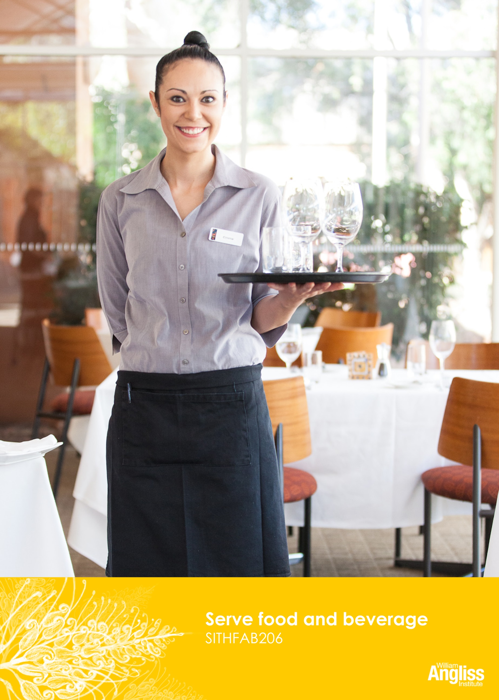

© Commonwealth of Australia 2013



**CC BY-NC-SA**

This work is copyright. Except where otherwise indicated, and save for the Commonwealth Coat of Arms, the Department has applied the [Creative Commons Attribution-Noncommercial-Share Alike 3.0 Australia Licence](http://creativecommons.org/licenses/by-nc/3.0/au) to this work.

The Department of Industry, Innovation, Climate Change, Science, Research and Tertiary Education must be attributed as the author of the Department’s copyright material.

As far as practicable, material for which the copyright is owned by a third party has been clearly labelled. The Department has made all reasonable efforts to ensure that this material has been reproduced on this website with the full consent of the copyright owners.

Requests and enquiries concerning the Department’s copyright material should be addressed to:

The Legal Branch

Department of Industry, Innovation, Climate Change, Science, Research and Tertiary Education

GPO Box 9839 Canberra ACT 2601

Or emaile[d to legalservices@innovation.gov.au](mailto:legalservices@innovation.gov.au)

Funded under the Workplace English Language and Literacy (WELL) Program by the Australian Government Department of Industry, Innovation, Climate Change, Science, Research and Tertiary Education

The views expressed in this publication do not necessarily represent the view of the

Minister for Tertiary Education, Skills, Science and Research or the Australian

Government. The Australian Government does not give any warranty nor accept any liability in relation to the contents of this work

ISBN 978-1-922108-12-8

|  |  |
| --- | --- |
| **Development Team** | |
| Content | William Angliss Institute of TAFE |
|  | Macsmith and Associates |
| Photography & graphics | Benjamin B Photographer |
|  |  |
| **Acknowledgments** | |
| We would like to acknowledge the generous support of the following organisations and the learners and employees in those venues, both Indigenous and non-Indigenous, for giving their permission for photography: | |
| Voyages Ayers Rock Resort, Yulara, NT | |
| Post Office Hotel, Coburg, VIC | |
| Lux Foundry Café, Brunswick, VIC | |
| Charcoal Lane Restaurant, Fitzroy, VIC | |
|  | |
| **Cultural Warning** | |
| People of Aboriginal or Torres Strait Islander descent should be aware that this publication contains images of people who may be deceased | |
|  | |
| **Disclaimer** | |
| Every effort has been made to ensure that this booklet is free from error or omissions. However, you should conduct your own enquiries and seek professional advice before relying on any fact, statement or matter contained in this book. William Angliss Institute of TAFE and Macsmith and Associates are not responsible for any injury, loss or damage as a result of material included or omitted from this course. | |
|  | |

**Contents**

[Welcome vi](#_Toc364006291)

[Icons vi](#_Toc364006292)

[What you will learn vii](#_Toc364006293)

[1 Prepare for service 1](#_Toc364006294)

[Different types of venues 1](#_Toc364006295)

[Prepare for opening 3](#_Toc364006296)

[Check equipment for service 6](#_Toc364006297)

[Polish glassware 10](#_Toc364006298)

[Polish cutlery 11](#_Toc364006299)

[Set up the restaurant 17](#_Toc364006300)

[Display food and beverage items 19](#_Toc364006301)

[Legal requirements 21](#_Toc364006302)

[Section summary 23](#_Toc364006303)

[2 Sequence of service 24](#_Toc364006304)

[Sequence of service 24](#_Toc364006305)

[The 3 minute check 25](#_Toc364006306)

[Welcome customers 26](#_Toc364006307)

[Make recommendations 30](#_Toc364006308)

[Correct the cover 31](#_Toc364006309)

[Section summary 34](#_Toc364006310)

[3 Take and process orders 35](#_Toc364006311)

[Take orders 36](#_Toc364006312)

[The docket 37](#_Toc364006313)

[Special needs customers 40](#_Toc364006314)

[Special requests 40](#_Toc364006315)

[Special dietary or cultural requirements 41](#_Toc364006316)

[Process the account and receive the payment 43](#_Toc364006317)

[Tips 45](#_Toc364006318)

[Section summary 46](#_Toc364006319)

[4 Serve and clear food and drinks 47](#_Toc364006320)

[Collect food and beverages 47](#_Toc364006321)

[Safety 48](#_Toc364006322)

[Hygiene 49](#_Toc364006323)

[Load a drinks tray 51](#_Toc364006324)

[Two plate carrying method 53](#_Toc364006325)

[Serve food 54](#_Toc364006326)

[Serve beverages 55](#_Toc364006327)

[Deal with problems 56](#_Toc364006328)

[Remove used items 59](#_Toc364006329)

[Dispose of leftover food 63](#_Toc364006330)

[Dispose of other waste 63](#_Toc364006331)

[Recycle waste 64](#_Toc364006332)

[Farewell customers 65](#_Toc364006333)

[Section summary 67](#_Toc364006334)

[5 Close down after service 68](#_Toc364006335)

[End of service tasks 68](#_Toc364006336)

[Work safely 69](#_Toc364006337)

[Prepare and set up for next service 71](#_Toc364006338)

[Debrief with colleagues 71](#_Toc364006339)

[The handover 74](#_Toc364006340)

[Section summary 75](#_Toc364006341)

[Key words 76](#_Toc364006342)

Welcome

Icons

These signs tell you what type an activity is:

|  |  |
| --- | --- |
| C:\Users\Alan\Desktop\IMG_1094.jpg | Do this activity in a big group. |
| C:\Users\Alan\Desktop\IMG_1079.jpg | Do this activity in a small group. |
| C:\Users\Alan\Desktop\IMG_1081.jpg | Do this activity in pairs. |
| C:\Users\Alan\Desktop\IMG_1080.jpg | Do this activity by yourself. |
| C:\Users\Alan\Desktop\IMG_1086.jpg | Do this activity using the internet. If you are not connected to the internet, your trainer will provide you with another activity. |
| C:\Users\Alan\Desktop\IMG_1087.jpg | Do this activity in your workplace. If you are not in a workplace, your trainer will provide you with another activity. |

What you will learn

People enjoy going out to bars, cafés and restaurants for a meal and drinks. The job of a food and beverage attendant is to serve the food and *beverages* (drinks), but also to give the customers excellent service and an enjoyable experience while they are in your venue.

In this unit you will learn how to:

* prepare for service in a café or restaurant
* welcome and farewell customers
* take orders
* serve and clear food and drinks
* process accounts and receive payment
* close down after service is finished.

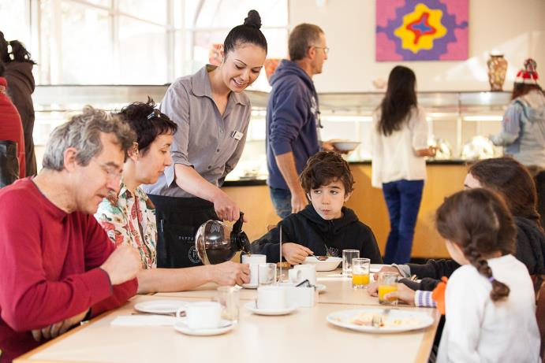

1 Prepare for service

Different types of venues

The hospitality industry has many different types of food and *beverage* (drinks) settings such as restaurants, clubs, cafés, pubs and catering operations. The role of a food and beverage attendant depends on the nature and style of the *venue* (the place where something happens). The basic skills remain the same but the style of service will reflect the type of venue.

|  |  |
| --- | --- |
| **STYLE OF SERVICE** |  |
| **Counter service**  Customer orders and pays at the counter.  Menu is simple, may be on a blackboard or card.  No cutlery is pre-set on tables. It may be collected by the customer.  Food may be carried to the table by the customer or delivered to the table in a casual way.  Includes takeaway food. | C:\Users\Alan\Documents\Carol\Consulting\12. IEP WELL Resource\Photos\Lux\Lux-8202.jpg |
| **Bistro service**  A casual style of table service in smaller cafés and bars with cheaper meals. May or may not serve alcohol.  Menu may be on a blackboard or printed with specials on the board.  No cutlery pre-set on tables. May be in a container on the table. | C:\Users\Alan\Documents\Carol\Consulting\24. WELL_Hospitality _resources\Photos\Serve_FandB\Hospitality2012Uluru-0332.jpg |
| **Buffet service**  Pre-prepared food is displayed on long tables, kept hot or cold as required.  Table places are set with the crockery and cutlery required for the menu.  Customers pay a fixed price and mainly serve themselves.  Another name is smorgasbord.  Often used for functions. | C:\Users\Alan\Documents\Carol\Consulting\24. WELL_Hospitality _resources\Photos\Serve_FandB\Hospitality2012Uluru-0345.jpg |
| **Table service**  More formal service e.g. in a restaurant.   * Á la carte service   Menu generally printed and well-presented. Lists a variety of dishes that are individually priced.  Attendant goes to the table to take orders and deliver food and beverages.  Food is cooked to order.  Crockery, cutlery and glassware pre-set on the table. Setting is changed as food and drink is ordered.   * Table d’hôte   A fixed price meal of set courses. Food is delivered to the table but there is limited or no choice. |  |

|  |  |
| --- | --- |
| C:\Users\Alan\Desktop\IMG_1087.jpg | Activity 1  Style of service |

1. What style of service does your workplace have?

|  |
| --- |
|  |

2. What kind of menu does your workplace have?

|  |
| --- |
|  |

Prepare for opening

Preparing the restaurant before opening for service helps everything to run smoothly. We don’t want problems during service.

Food and beverage attendants are responsible for putting everything in place before the restaurant opens. This is your *mise en place*, making sure you have everything you need in its right place.

|  |
| --- |
| **Learn the language**  The French term *mise en place* is often used in kitchens, cafés and restaurants. It means ’put in place‘ or ’everything in its place‘, and means making sure that everything is in its place before you start work e.g. equipment and supplies. It is pronounced ’meez on pluss‘. |

You should check that:

|  |  |  |
| --- | --- | --- |
| * **It is clean** |  | Customers don’t want to walk into a dirty restaurant e.g. with grubby toilets, sticky table tops or crumbs on chairs. |
|  |  |  |
| * **It is well stocked** |  | So we don’t run out of anything during service. We keep everything we need for service in a *waiters’ station* (or *sideboard*) e.g. sugar, extra plates and napkins. |
|  |  |  |
| * **It is in good working order** |  | Nothing is broken, the tables are not wobbly. |
|  |  |  |
| * **Everything is in the right position** |  | Tables and chairs are placed so customers and staff can walk comfortably between them. |
|  |  |  |
| * **Everything is set** |  | Clean, polished *cutlery* (knives and forks) and water glasses are on the tables. |
|  |  |  |
| * **It is safe** |  | So customers or staff can’t get hurt. Mopped floors are dry, first aid kits are stocked and fire exits are clear. |

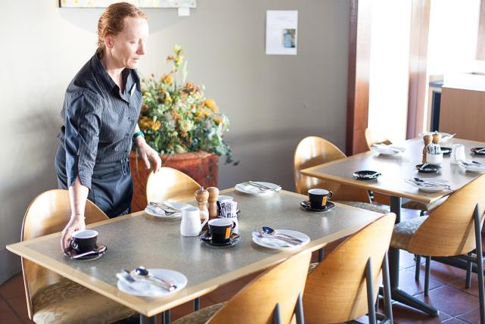

|  |  |
| --- | --- |
| C:\Users\Alan\Desktop\IMG_1079.jpg | Activity 2  Mise en place |

Can you think of another thing you would look for at each check?

|  |  |
| --- | --- |
| **Are things:** | **Example** |
| Clean? |  |
| Stocked? |  |
| In working order? |  |
| In right position? |  |
| Set? |  |
| Safe? |  |

Check equipment for service

The following equipment needs to be checked before service to make sure it is:

* clean – if not, clean it or replace it before service starts
* working correctly – if not, report to your supervisor, get it fixed or remove it
* safe to use – if not, report to your supervisor, get it fixed or remove it.

| **Equipment** | **What to check** |
| --- | --- |
| *Glassware*  Water  Wine  Beer  Highball, rock (spirits)  Cocktail  Jugs | * Clean * Polished * No chips or cracks.   C:\Users\Alan\Documents\Carol\Consulting\24. WELL_Hospitality _resources\Photos\Serve_FandB\Hospitality2012Uluru-0966.jpg |
| *Crockery*  Plates – side, entrée (small starter dish), main  Bowls – cereal, dessert, salad, soup  Cups and saucers | * Clean * Polished * No chips or cracks.   C:\Users\Alan\Documents\Carol\Consulting\12. IEP WELL Resource\Photos\Charcoal Lane\CharcoalLane-2856.jpg |
| *Cutlery*  Forks – entrée, main, fish, serving  Knives – entrée, side, main, steak, fish, cheese, cake  Spoons – teaspoon, soup, dessert, serving  Other – lobster picks, shellfish crackers | * Clean * Polished.   C:\Users\Alan\Documents\Carol\Consulting\24. WELL_Hospitality _resources\Photos\Serve_FandB\Hospitality2012Uluru-0934.jpg |
| *Tablecloths, overlays, napkins and service cloths*  Overlays sit over the tablecloth to protect it.  If dirty, you may only have to replace the overlay and not the tablecloth | * Clean * Pressed with no creases * No marks or stains.   C:\Users\Alan\Documents\Carol\Consulting\24. WELL_Hospitality _resources\Photos\Serve_FandB\Hospitality2012Uluru-0829.jpg |
| *Table decorations*  Flowers and vases  Candles  Placemats | * Flowers are fresh, water is clean, vases are not chipped and are clean * Candles are new with no wax on holders * Placemats are clean.   C:\Users\Alan\Documents\Carol\Consulting\24. WELL_Hospitality _resources\Photos\Serve_FandB\Hospitality2012Uluru-0690.jpg |
| *Condiments (*flavourings on the table for the customer to add to their meal)  Salt and pepper  Oil and vinegar  Butter  Sauces – tomato, bbq, sweet chilli, soy  Relishes, pickles and mustards  Jams, honey, syrups and spreads  Parmesan cheese | * Containers are clean * Containers are topped up * Items are not past their ‘use-by’ date * Items are not contaminated by anything e.g. butter in the jam dish.   C:\Users\Alan\Documents\Carol\Consulting\24. WELL_Hospitality _resources\Photos\Serving\Serving-9269.jpg |
| *Buffet or self-serve facilities*  e.g. tea and coffee making, toaster | * Machine is turned on, clean and ready to use * There is enough crockery, cutlery, stocks and napkins for the service period   C:\Users\Alan\Documents\Carol\Consulting\24. WELL_Hospitality _resources\Photos\Serve_FandB\Hospitality2012Uluru-0355.jpg |
| Menus and wine lists | * Menu boards easy to read and updated * Table menus are clean, current, and there are enough   C:\Users\Alan\Documents\Carol\Consulting\24. WELL_Hospitality _resources\Photos\Serving\Serving-9275.jpg |
| Point of sale (POS) equipment | * Working * Updated with any changes to pricing, specials   C:\Users\Alan\Documents\Carol\Consulting\24. WELL_Hospitality _resources\Photos\Serve_FandB\Hospitality2012Uluru-0672.jpg |
| *Waiters’ station*  Menus and wine lists  Cutlery, crockery  Napkins or serviettes  Sugar bowls, condiments  Service trays  Toothpicks | * Clean * Topped up * Restocked |

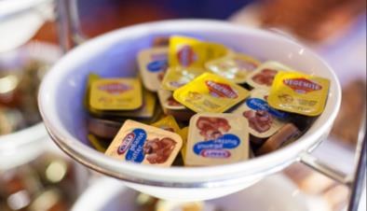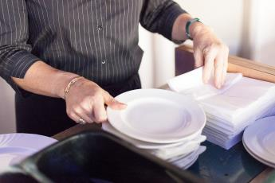

Polish glassware

Glassware should be polished before going on tables.

**To polish glassware:**

1. Hold each glass over a bucket of hot steaming water. Hold wine glasses by the base.
2. Polish with a clean, lint-free cloth. Use one hand to cradle the bowl of the wine glass and polish with your other hand.

Always handle clean glassware by the stem so you don’t put finger marks on the bowl.

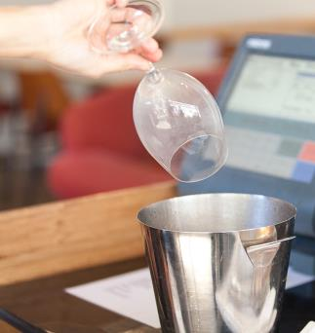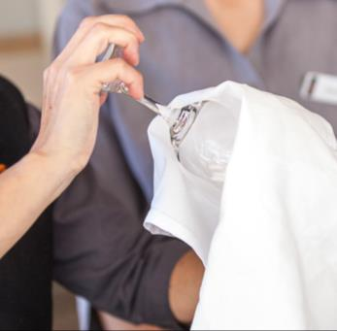

Polish cutlery

Some cutlery may need to be polished before going on the tables.

**To polish cutlery:**

1. Separate the cutlery into the different types.
2. Half fill a container with hot water. Add a little bit of lemon juice or vinegar.
3. Take a handful of cutlery. Hold it by the handles, and dip the *service ends* (the end that goes into the customer’s mouth) into the water.
4. Using a clean, lint-free cloth, polish the cutlery. Don’t let your fingers touch the service ends.
5. Place polished cutlery with handles together.

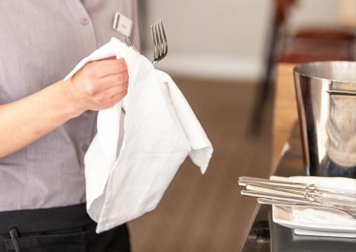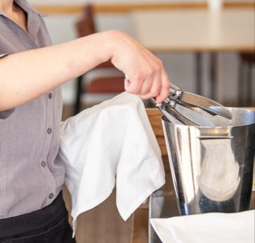

Always place polished cutlery on an under-plate when taking it to the table for set up.

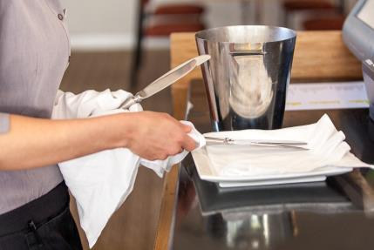

|  |  |
| --- | --- |
| C:\Users\Alan\Desktop\IMG_1079.jpg | Activity 3  Check your equipment |

Discuss these questions together. Then write down your answers.

1. What might happen if equipment is left dirty or poorly maintained?

|  |
| --- |
|  |

1. What would you do in these situations?
2. You find some chipped side plates as you are setting tables.

|  |
| --- |
|  |

1. The waiters’ station has only one spare salt and pepper set.

|  |
| --- |
|  |

1. The menu board still has yesterday’s chicken and salad special written on it. The café is about to open.

|  |
| --- |
|  |

1. The coffee machine has been on for ten minutes but it is not hot.

|  |
| --- |
|  |

Environment

The *environment* is the look and feel of the room. The restaurant needs to look and feel inviting to the customer, with a comfortable and enjoyable atmosphere. This can be affected by:

|  |  |  |
| --- | --- | --- |
| * **Lighting** |  | Not too bright or dim |
|  |  |  |
| * **Music** |  | Right for the time of day and style of venue |
|  |  |  |
| * **Room temperature** |  | Warm in winter, cool in summer |
|  |  |  |
| * **Decorations and displays** |  | Right for the style of venue, help create the atmosphere |
|  |  |  |
| * **Privacy** |  | Some customers want a quiet place for a romantic meal or a chat |
|  |  |  |
| * **Background noise** |  | Keep to a level where customers can converse (talk together) comfortably |

If a customer asks for any of these to be changed and you feel unsure, ask your supervisor.

Your supervisor will check the restaurant to make sure it is ready to open its doors and welcome customers. If it is not ready, then the food and beverage attendant will need to fix it.

Reservations

A *reservation* is when a customer pre-books a table for a particular day and time. The customer needs to provide this information:

* number of customers
* arrival time
* special requests e.g. window seat or quiet table
* any special needs e.g. highchair for a baby, pram access or wheelchair *access* (they can get in ok), or cake and candles for a birthday.

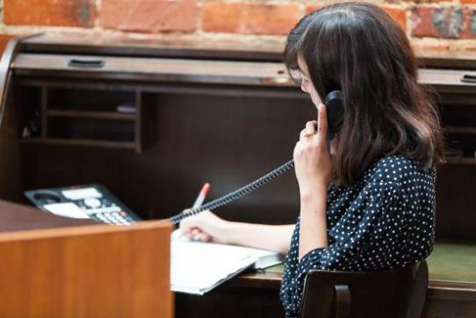

|  |  |
| --- | --- |
| C:\Users\Alan\Desktop\IMG_1079.jpg | Activity 4  Taking reservations |

Look at the bookings in a restaurant diary on the next page.  
Then talk about the questions below.

1. Why do you need to get the person’s full name?

|  |
| --- |
|  |

2. Why might you need a mobile number?

|  |
| --- |
|  |

3. Why do you need to note if there are children in a group?

|  |
| --- |
|  |

4. Why is an ETA important?

|  |
| --- |
|  |

|  |  |  |  |  |  |
| --- | --- | --- | --- | --- | --- |
|  | | | | | |
| **Wednesday 30 JUNE Dinner**  *Name*  *Ask for the full name.* | | | | | |
| **Name** | **Contact** | **Pax** | **ETA** | **Table** | **Special requests** |
| David Anderson | 0461 200 300 | 2 | 7.00 p.m. | 3 | Window |
| John Hill | 9234 6728 | 4 | 8.30 p.m. | 1 |  |
| Raj Ghimir | 0411 117 711 | 3 | 6 p.m. | 2 | Birthday |
| Debbie Bennett | 9888 5678 | 2 | 6.00 p.m. | 6 | Quiet table  *Pax (people)*  *Ask how many people in the group.* |
| David Smith | 0461 915 443 | 5A 1C | 8 p.m. | 4 | Highchair |
| Natalie Bowman | 0412 676 253 | 2 | 6 p.m. | 1 | Window |
| Esther Reed | 0422 989 002 | 4 | 8 p.m. | 6 | Nut allergy |
| Beth Summers | 0413 332 190 | 2 | 8 p.m. | 7 |  |
| George Kumar | 9023 5645 | 5 | 7.30 p.m. | 8 | Front table |
| *5A 1C*  *5 adults, 1 child* |  |  |  |  |  |

Set up the restaurant

For each service, the restaurant must be set up according to the reservations.

If there are no reservations, then the restaurant can be set up in its *standard* or ‘normal’ way.

For example, normally the restaurant may be set up in tables for 4 people. On Saturday night they have a reservation for a birthday party of 12 people. So they put three tables of 4 together to make one table for 12.

**12**

4

4

4

***Standard set up***

***3 tables x 4 = 12 seats***

***Group reservation for 12***

A floor plan

A floor plan is a map that sets out how the restaurant is to be set up. It shows:

* which customers are sitting at which tables
* which tables are put together based on the reservations
* which tables are free to be sold if a customer walks into the restaurant without a reservation.

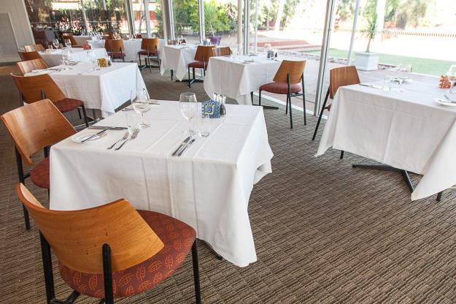

A floor plan considers:

* location of entrances and exits
* location of toilets
* location of things that can’t be moved e.g. stairs and pillars
* space needed for customers and staff to move around comfortably and safely
* clear access to emergency exits.

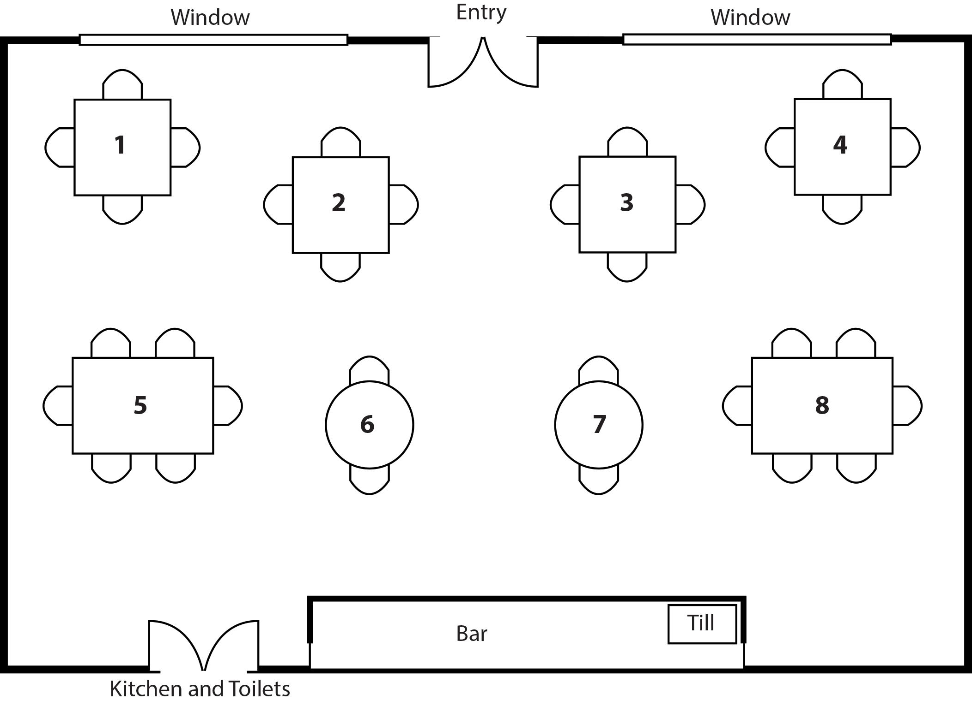

In restaurants*,* a floor plan is created for every service.

In a café or bistro, floor plans are not used as customers sit at a free table of their choice. Often only large groups can make a reservation and then a ‘Reserved’ sign is placed on the table.

Display food and beverage items

Some venues display their food and beverage items for the customer to see, for example:

* café – may display cakes, cookies, sandwiches
* buffet – displays hot and cold food items, and customers can often self-serve.

Food and beverage items can be displayed in different ways, for example:

|  |  |  |
| --- | --- | --- |
| * **Dessert, cheese or drinks trolley** |  | Attendant takes the trolley to the table so the customer can choose what they want and be served at their table. |
|  |  |  |
| * **Cake or sandwich display** |  | Often located in a glass cabinet next to the cash register. Customers go to the display to select. |
|  |  |  |
| * **Bain maries** |  | Keep food hot in a dish over a hot water bath. Customers select and food may be self-serve or plated by the attendant. |
|  |  |  |
| * **Wine rack, fridge or display** |  | Wine is stored based on its variety and is easy for the customer to see. |
|  |  |  |
| * **Carving trolley or display** |  | Roast meats are carved to order in front of the customer |

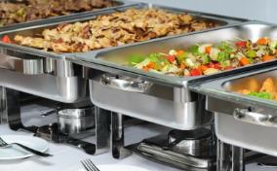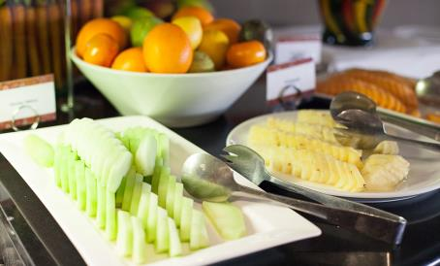

Presentation

If food is attractively presented, customers are more likely to be tempted to buy it or buy more of it, and sales will increase. You should check regularly that food displays look inviting at all times or customers may lose interest. Presentation and colour is important.

Food displays should also be:

* clean and *hygienic* (with no germs)
* regularly restocked
* easy for the customer to locate what they want e.g. separated into hot foods, salads and desserts.

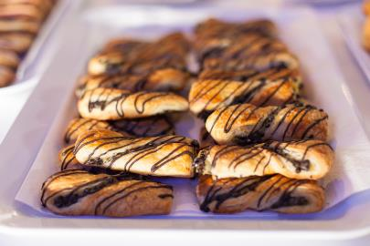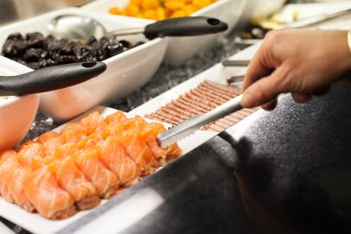

Legal requirements

All venues must follow the laws about preparing, serving and storing food. Also when displaying food, you are legally required to:

* use separate *utensils* (tools for preparing food) and serving cutlery for each item on display
* keep hot food above 60°C
* keep cold food below 5°C
* not top up containers of food but replace them when they run low or run out
* keep display units clean during service and clean them at the end of every service period
* follow personal hygiene practices when handling food e.g. washing hands and wearing gloves. You have learnt about these already*.*

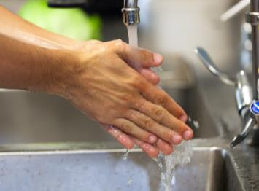

|  |  |
| --- | --- |
| C:\Users\Alan\Desktop\IMG_1081.jpg | Activity 5  Check some food displays |

Visit some food venues in your area. Observe their food and beverage displays. Make some brief notes about them in this table.

|  |  |  |  |
| --- | --- | --- | --- |
| **Questions** | **Venue 1** | **Venue 2** | **Venue 3** |
| What kinds of food are on display?  e.g. cold, hot, drinks, sandwiches, salads, buffet |  |  |  |
| Is the display clean and attractive?  If yes, what do you like about it?  If not, how could it be improved? |  |  |  |
| What food hygiene practices are staff using?  e.g. gloves, tongs, hand washing |  |  |  |

Section summary

Now you have completed this section you should have developed the following skills and knowledge.

Tick each box if you are satisfied that you have those skills and knowledge.

|  |  |
| --- | --- |
|  | Identify different styles of service. |
|  | Check and prepare furniture for service. |
|  | Check and prepare equipment for service (mise en place). |
|  | Make sure the venue environment is comfortable. |
|  | Take reservations. |
|  | Set up furniture to match reservations, using a floor plan. |
|  | Display food and beverage items safely and attractively. |

Notes

|  |
| --- |
|  |
|  |
|  |
|  |
|  |

2 Sequence of service

The *sequence* of service is the order we do things in for the customer. The sequence starts from the moment the customer walks into the restaurant and ends the moment they leave. Following the sequence of service makes sure that every customer gets the same excellent level of service. Here is a basic sequence of service. Each venue may have its own version.

Sequence of service

1. Welcome and seat guests.
2. Lap guests, serve water.
3. Present menus and wine list; explain menu including specials.
4. Take food /drinks order, top up water, remove menus.
5. Serve drinks.
6. *Correct the cover* if necessary (change the table setting for the food ordered).
7. 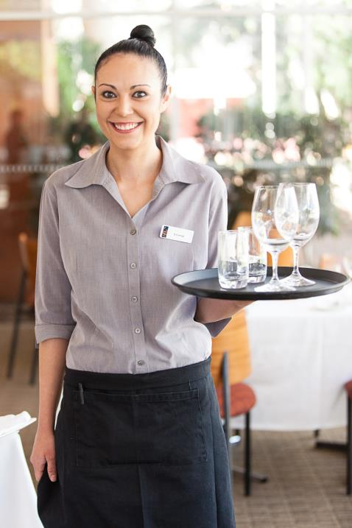Run entrées.

***3 minute check***

1. Clear entrées and any unwanted or unused  
   cutlery and crockery; top up water, ask about   
   more drinks.
2. Run main course.

***3 minute check***

1. Clear main plates, side plates, salt and pepper   
   shakers.
2. Give dessert menus, top up water.
3. Take dessert, coffee and drink orders.
4. Correct cover for dessert, serve dessert and   
   drinks.

***3 minute check***

1. Clear table of everything not being used. Ask   
   if guests want anything else.
2. Prepare and present guest with the account.
3. Accept payment.
4. Farewell guests.

The 3 minute check

About 3 minutes after you serve food, you should return to the table and check that the customer is happy with everything. We call this the *3 minute check*. If the customer has not started eating after 3 minutes, wait until they start eating.

Check to see if guests:

* are happy with their food
* require a refill of their drink
* need glasses or tableware removed
* need your attention for something else.

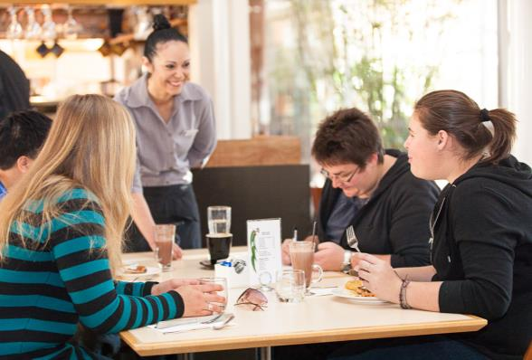

*Is everything alright with your meal?*

*Can I take that away for you?*

*Would you like any more drinks?*

The 3 minute check gives customers an opportunity to tell you if:

* there is something wrong e.g. their steak is not cooked as they ordered, or the food or coffee is cold
* they would like to order something extra e.g. a salad or another drink.

If there is a problem:

* apologise to the customer (see the section *Dealing with problems* later in this workbook for more information on apologising)
* organise a solution quickly
* make sure any replacement item is up to standard
* check the customer is happy this time
* pass this feedback on to the kitchen and your supervisor straight away.

|  |  |
| --- | --- |
| C:\Users\Alan\Desktop\IMG_1081.jpg | Activity 6  The 3 minute check |

Your trainer will organise this activity.

In pairs, practise making a 3 minute check for these items. If there is anything wrong, apologise to the customer. Take turns being the customer and the food and beverage attendant.

Welcome customers

You should welcome customers at the door with a big smile. This gives the customer a good first impression of your venue.

Check if they have a reservation or not.

*Escort* them (walk with them) to their seats.

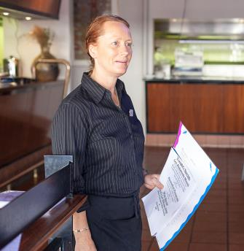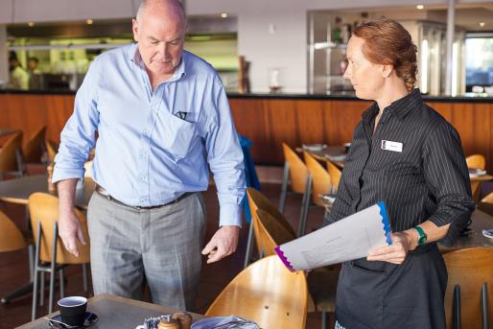

|  |  |
| --- | --- |
| C:\Users\Alan\Desktop\IMG_1079.jpg | Activity 7  Welcome customers |

DISCUSS - How do you greet customers in your restaurant?

|  |  |
| --- | --- |
| C:\Users\Alan\Desktop\IMG_1079.jpg | Activity 8  Seating |

A group of four customers walks into your restaurant. They have a reservation and have requested a window seat. However, they have not been allocated a window seat and there are none available.

What will you do? Discuss together.

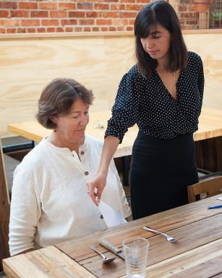Seat and lap the guests

Help the customers get seated and *lap* them from the right hand side. Lapping means:

* unfold the napkin
* refold it into a triangle
* hold it on one corner and place it across the customer’s lap.

Present the menu and drinks list

* Always present from the right hand side.

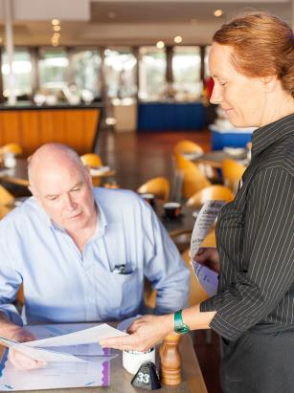

**✓**

**X**

* Mention any drinks specials or changes to the drinks list.

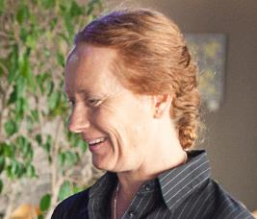

*We have a cocktail special tonight – a martini made with fresh raspberries. It’s really refreshing.*

* Offer water – still, tap or mineral.
* Leave the wine list on the table so the customer can order wine when they order their food.

Provide information to customers

As a food and beverage attendant, you have to sell a product. The customer will expect you to be able to answer their questions and tell them things that will help them select food and beverages that they are happy with. They may ask for your *recommendations* (what you think is good) and suggestions.

Be *patient* (take your time) and polite when answering a customer’s questions.

|  |
| --- |
| **TIP**  You are in the business of selling the restaurant’s product. Use descriptive words to make the food and drinks sound more inviting.  **Refreshing Fresh Velvet**  **Creamy Gooey Delicious** |

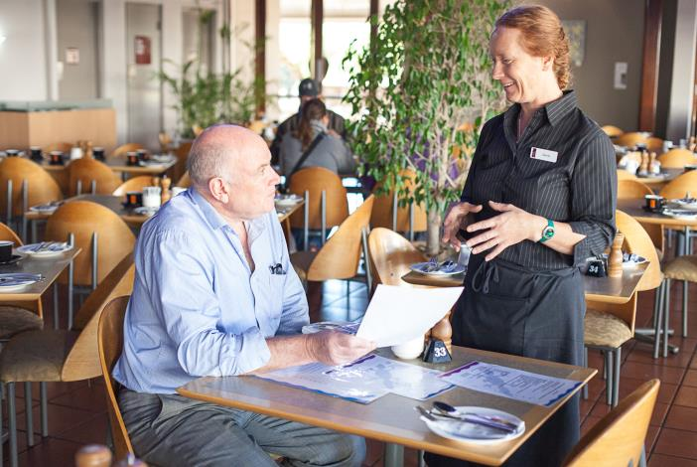

The oysters are straight from the market this morning.

The juice is freshly squeezed.

The mousse is very creamy.

The sorbet has a lovely citrus tang.

Often the kitchen will offer staff a taste of a new dish so they know what they are talking about and be able to make recommendations to the customer.

|  |  |
| --- | --- |
| C:\Users\Alan\Desktop\IMG_1079.jpg | Activity 9  Answering customer questions |

What else might customers want to know?

Can you think of other questions to add to the right hand column below?

|  |  |
| --- | --- |
| **Area of information** | **Customers might ask…** |
| Menu choices, specials and availability | *What is the soup of the day?*  *What vegetables are with the lamb?* |
| Information about a dish e.g. ingredients, serving size and menu *terminology* (specialist words) | *What is ‘jus’?*  *If we order quail, will it be enough for 2 of us?*  *How long will the Moroccan casserole take to cook?* |
| Information about the local area or tourist attractions | *We’ve just arrived here – what would you suggest we do tomorrow?*  *How far is the train station?* |
| Customer facilities | *Could I use the telephone?* |

|  |
| --- |
| **TIP**  If you are not sure of the answer to a question, say to the customer, “I’ll find out for you”.  Ask the chef or your supervisor immediately and pass on the answer to the customer promptly.  Never give a customer wrong information. |

Make recommendations

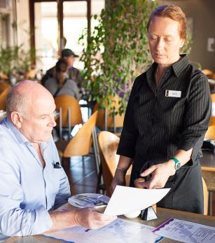This can be tricky. Not everyone likes the same kind of food.

Start by asking the customer questions. Try to find out some information so your recommendations are based   
on the customer’s needs:

*Are you very hungry?*

* *Do you want a large or small meal?*
* *Do you like spicy food?*
* *Do you prefer red or white meat?*
* *Do you want to be adventurous?*

You could also recommend the most popular dishes that you get good feedback on.

Sometimes the kitchen asks staff to recommend a dish, perhaps because:

* they have leftover stock that needs to be used
* they have bought some produce on special or that is hard to find
* they use seasonal produce so the menu changes a lot.

|  |  |
| --- | --- |
| C:\Users\Alan\Desktop\IMG_1094.jpg | Activity 10  Making recommendations |

1. Can you think of a reason why you should not tell the customer what you like?

|  |
| --- |
|  |

2. Why should you be careful about recommending popular dishes?

|  |
| --- |
|  |

|  |  |
| --- | --- |
| C:\Users\Alan\Desktop\IMG_1081.jpg | Activity 11  Describing menu items |

Practise providing information about menu items to a customer. Try to use describing words.

Your trainer will organise this activity for you.

Correct the cover

A *cover* is a place setting at a table. When a customer makes an order, you may need to change the setting, for example:

* if a customer orders soup, you add a soup spoon to their setting
* if a customer orders steak, you replace the table knife with a steak knife.

This is called *correcting the cover.*

|  |
| --- |
| **Where does the cutlery go?**  Think of the order the food comes out in: first entrée, then main.  The customer uses the cutlery on the **outside first**. So place the entrée cutlery outside the main cutlery. |

|  |  |
| --- | --- |
| C:\Users\Alan\Documents\Carol\Consulting\24. WELL_Hospitality _resources\Photos\9807948_s.jpg*A table d’hote setting with a steak knife and dessert spoon* | C:\Users\Alan\Documents\Carol\Consulting\24. WELL_Hospitality _resources\Photos\5733815_s.jpg*An á la carte setting with fish knife and fork* |

|  |
| --- |
| **Learn the language**  **À la carte** is a French term meaning ‘according to the menu’. It means a menu of items priced and ordered separately. |

Provide glassware and serviceware

Depending on what the customer has ordered, you may need to provide more glassware and *serviceware* (utensils to serve food) during the meal.

Glassware

Most set tables have a wine glass and perhaps a water glass. Once customers have ordered drinks, you may need to:

* remove glasses that are not needed
* place any needed glasses.

For example:

* if the table does not want wine, you would remove the wine glasses
* if a customer orders a beer, you place a beer glass at their setting.

|  |
| --- |
| **TIP**   * Always use a tray when removing or replacing glasses at a table. * Remove or replace glasses from the right hand side so you don’t have to lean across the customer. |

Serviceware

Your venue will train you in the service cutlery and/or crockery needed for each dish share or side dish. Some examples are:

* a side dish of vegetables would need a fork and spoon to serve them with
* a sauce or gravy may be provided in a sauce or gravy boat.

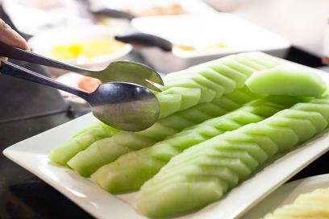

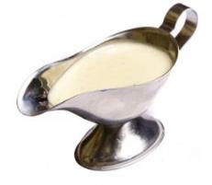

|  |  |
| --- | --- |
| C:\Users\Alan\Desktop\IMG_1081.jpg | Activity 12  Correcting the cover |

How would you correct the cover for the following orders?

What extra cutlery would you need? Would you remove or replace any cutlery?   
Ask your workmates or supervisor, or search on the internet if you need help.

|  |  |
| --- | --- |
| **The customer orders:** | **How would you correct the cover?** |
| * Prawns for an entrée |  |
| * Caesar Salad for an entrée |  |
| * Tomato soup for an entrée |  |
| * Spaghetti Bolognese  for a main course |  |
| * Steak for a main  course |  |
| * A whole snapper for a main course |  |

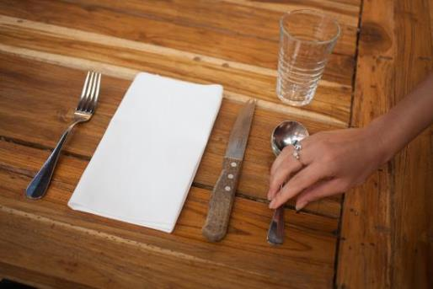

Section summary

Now you have completed this section you should have developed the following skills and knowledge.

Tick the box if you are satisfied that you have those skills and knowledge.

|  |  |
| --- | --- |
|  | Follow the sequence of service. |
|  | Make the 3 minute check. |
|  | Welcome and seat customers. |
|  | Provide information to customers. |
|  | Answer customer questions on menu items. |
|  | Correct the cover. |

Notes

|  |
| --- |
|  |
|  |
|  |
|  |
|  |

3 Take and process orders

When you take a customer’s orders it must be:

* *accurate* (all details are correct)– so the kitchen doesn’t cook the wrong food
* *legible* (easy to read) – so the kitchen can read the order properly.

There are different ways to take an order.

|  |  |
| --- | --- |
| **Order method** |  |
| **1. Remember the order**   * *Positive* – impresses the customer * *Negative* – risky because you might forget something | |
| ***2. Write the order on an order pad***  There is usually a carbon copy. The original docket goes to the kitchen and the copy goes to the cashier.   * *Positive* – there is more than one docket in case one goes missing * *Negative* – can be messy and hard to read | C:\Users\Alan\Documents\Carol\Consulting\24. WELL_Hospitality _resources\Photos\11184730_s.jpg |
| ***3. Electronic order***  A hand-held device that sends the order straight through to the kitchen   * *Positive* – docket is instantly at the kitchen * *Negative* – can feel impersonal when used at the table | C:\Users\Alan\Documents\Carol\Consulting\24. WELL_Hospitality _resources\Photos\Serving\Serving-9311.jpg |

What are orders used for?

An order:

* tells kitchen or bar staff what to prepare
* tells service staff if they need to correct the cover e.g. put out a steak knife
* tells service staff who is eating or drinking the items ordered so they can take it to the correct customer
* tells the person at the register what to put on the account.

If the order says ‘*Fish – 1’*, you can take the fish to the correct person. Don’t ‘auction the food’ by asking “*Who is having the fish*?”

Take orders

|  |  |
| --- | --- |
| **Step** | **Explain** |
| 1. Watch customers so you know when they are ready to order. | They may have the menu closed in front of them. |
| 1. Take the order from each customer’s right hand side. |  |
| 1. Record the order accurately. Use only approved abbreviations. | Instead of writing ‘chicken’, your venue might write ‘chix’. |
| 1. Make recommendations and suggestions if asked. |  |
| 1. Number each guest on the order. Your venue will have its own method for identifying the position numbers. | The guest sitting closest to the front door may be number 1. Number 2 is the next person clockwise (the direction of hands on a clock), and so on. |
| 1. Leave a space and draw a line on the docket between entrées and mains. | This tells everybody there is a break in between the two courses. |
| 1. Repeat the order back to the customer. | This is your last check for correctness. |
| 1. Place the order with the kitchen. |  |

The docket

A docket generally has all these things on it:

|  |  |
| --- | --- |
| **Item** | **Why write it down?** |
| 1. The time the order is taken | We know how long customers have been waiting for food. |
| 1. Who takes the order | If the kitchen needs to ask a question about the docket they know who took the order. |
| 1. The table number | We know who ordered the food and who to give each item to. |
| 1. The number of customers at the table | We can compare this to the number of dishes ordered so we can see if there are more people than dishes. We may have missed something. |
| 1. The docket number | This is a control number. Later we can see how many tables we did in a service period or refer to a particular docket. |
| 1. The number of each dish ordered | Helps the kitchen organise its preparation and check meals going out. |
| 1. The description of the dish ordered | Venues have a short way to write each dish so it is quick to write down and easy to read in the kitchen. |
| 1. Any special requests | These must be clearly written so the kitchen knows exactly what the request is. |
| 1. The position number of the customer who ordered a dish | On the right hand side of the docket. Used by the food and beverage attendant to give each dish to the person who ordered it. |

|  |  |
| --- | --- |
| C:\Users\Alan\Desktop\IMG_1080.jpg | Activity 13  Reading a docket |

Look at the docket on the next page. Can you see each of the 9 items listed?

|  |  |  |  |  |  |  |
| --- | --- | --- | --- | --- | --- | --- |
|  | | | | | | *Mark these things:*   1. Time the order was taken 2. Who took the order 3. Table number 4. Number of customers at the table 5. Docket number 6. Number of each dish ordered 7. Description of the dish that has been ordered. 8. Any special requests 9. Position number of the customer who ordered the dish |
| **Time of order** | | **Waiter** | **Table number** | **No. of customers** | **Docket number** |
| 7.10 pm | | JA | 6 | 4 | 01623 |
| 1 | Prawns (sauce on the side) 2 | | | | |
| 1 | Soup 3 | | | | |
| 2 | Tart 1 4 | | | | |
|  | | | | | |
| 1 | Pasta 1 | | | | |
| 2 | Steak R x 1 2  M x 1 4 | | | | |
| 1 | Salmon 3 | | | | |
|  |  | | | | |
|  |  | | | | |
|  |  | | | | |

Everything above the line is the entrée and everything below is the main course.

|  |  |
| --- | --- |
| C:\Users\Alan\Desktop\IMG_1080.jpg | Activity 14  Writing a docket |

Four customers arrive at 7.30 p.m. and sit on Table 1. This is their order:

|  |  |  |
| --- | --- | --- |
| **Position 1:** | Entrée – Prawns | Main – Salmon |
| **Position 2:** | Entrée – Soup | Main – Steak rare |
| **Position 3:** | Entrée – Cheese tart | Main – Pasta |
| **Position 4:** | Entrée – Prawns | Main – Steak medium |

Write it on the docket below. Make sure the kitchen can read it. If you make a mistake, ask your trainer for another copy of the docket.

|  |  |  |  |  |  |
| --- | --- | --- | --- | --- | --- |
|  | | | | | |
| **Time of order** | | **Waiter** | **Table number** | **No. of customers** | **Docket number** |
|  | |  |  |  | **01624** |
|  |  | | | | |
|  |  | | | | |
|  |  | | | | |
|  |  | | | | |
|  |  | | | | |
|  |  | | | | |
|  |  | | | | |
|  |  | | | | |
|  |  | | | | |
|  |  | | | | |

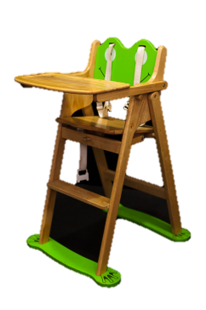Special needs customers

Some customers have special needs, for example:

* people with a disability may need easy access to the doorway   
  or toilets, or space for a wheelchair
* people with childrenor babiesmay need a highchair or   
  somewhere to place a pram
* people with special dietary needse.g. gluten intolerance or allergies may need advice about menu items.

Always look after your customers helpfully and apologise if your venue can’t assist them.

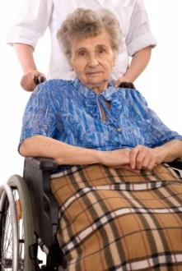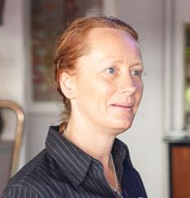

*I’m awfully sorry ma’am – we don’t have a disabled toilet here.*

Special requests

Customers sometimes make special requests, for example:

* to have a main size *portion* (serve) of an entrée dish
* to have a long break between courses
* to be served quickly as they are in a hurry
* to have no sauce or extra sauce on a dish.

You must write all these requests accurately and clearly on your order. Sometimes you may have to advise a customer that their request can’t be met.



*I’m really sorry sir – I’ve checked with the kitchen and they can’t cook your meal that fast. The chicken must be thoroughly cooked through.*

Special dietary or cultural requirements

There are also a number of special dietary needs customers may have.

|  |  |  |
| --- | --- | --- |
| * **Vegetarian** |  | Don’t eat meat. Some eat dairy products, but others don’t. |
|  |  |  |
| * **No dairy** |  | Don’t eat butter, milk, cheese etc. |
|  |  |  |
| * **Gluten free** |  | Can’t eat wheat products e.g. pasta, bread, biscuits. |
|  |  |  |
| * **Allergies** |  | This means people can get ill if they eat the food. People can be *allergic* to many different foods. Some common ones are nuts, shellfish and eggs. |
|  |  |  |
| * **Cultural restrictions** |  | For example, no pork products, meat that has been slaughtered in a special way or no alcohol. |

If a customer has a special request or dietary need, you must tell both the kitchen and your supervisor about it. There may be health effects for the customer, so you must:

* make sure you actually do what the customer has asked

OR

* tell the customer clearly that you can’t meet the request.

|  |
| --- |
| **Note on allergies!**  Allergies can be fatal, so always treat a customer’s request seriously.  Check ingredients with the chef if you are not sure. |

|  |  |
| --- | --- |
| C:\Users\Alan\Desktop\IMG_1086.jpg | Activity 15  Special dietary needs |

Find out some information about the following special dietary needs.

|  |  |
| --- | --- |
| 1. **Halal** | *It is: Religious/ Health-based/ Personal choice?*  *What can the person eat or not eat?* |
| 1. **Kosher** | *It is: Religious/ Health-based/ Personal choice?*  *What can the person eat or not eat*? |
| 1. **Vegan** | *It is: Religious/ Health-based/ Personal choice?*  *What can the person eat or not eat?* |
| 1. **Lactose intolerant** | *It is: Religious/ Health-based/ Personal choice?*  *What can the person eat or not eat?* |

Process the account and receive the payment

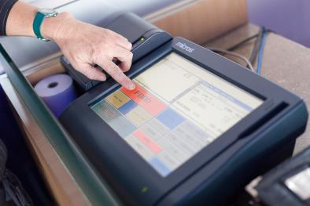After you take an order, you give the hard copy to the cashier or it is automatically entered into an electronic system. This creates the *account* (the list of items bought and their cost).

If the customer orders more food and beverages, these are added to the account until the customer is ready for their bill.

ALWAYS CHECK AN ACCOUNT to make sure it is accurate:

* the customer will be unhappy if they are overcharged for anything
* the restaurant will be unhappy if they miss any items and undercharge.

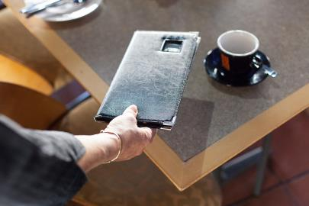Guidelines

When presenting the account to customers:

* check the account is accurate first
* don’t give the account to the customer until they ask for it
* give the account to the person who asked for it
* don’t wait at the table for them to pay – deliver the account, then leave.

Process the account

Customers can pay in different ways.

|  |  |
| --- | --- |
| **Cash** | Processed at the register. The customer may have the exact money or you may need to give change. |
| **EFTPOS** | This stands for ‘electronic funds transfer at point of sale’. This is an electronic system for debit cards. |
| **Credit card** | Visa, MasterCard, AMEX (American Express) or Diners Club. There may be a credit card surcharge (extra cost) that the customer pays for using a credit card e.g. 2.5% added to the total amount owing. |
| **Voucher** | Pre-paid e.g. a gift voucher. |
| **Cheque** | Rarely accepted these days. |
| **Charge to a company account** | A company may have made an agreement with the restaurant to be invoiced later. |

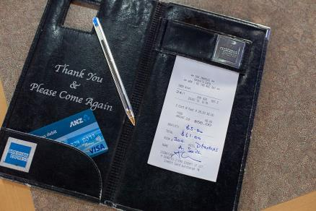

Always follow your venue’s policy for processing accounts.

Tips

Always follow your venue’s policy for what to do with tips.

Sometimes tips are pooled and then divided up between staff later. Or they may ‘belong’ to the staff member who served that customer.

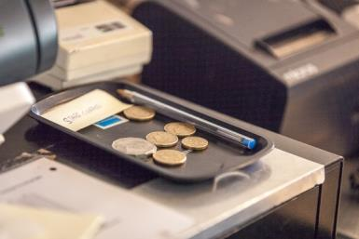

|  |
| --- |
| **TIP**  If the customer is paying cash and you have to give change, count it out to them one note or coin at a time. |

|  |  |
| --- | --- |
| C:\Users\Alan\Desktop\IMG_1094.jpg | Activity 16  What would you do? |

You have just processed a customer’s account for $200. They are paying by credit card but the card has been rejected.

|  |
| --- |
|  |
|  |

Section summary

Now you have completed this section you should have developed the following skills and knowledge.

Tick each box if you are satisfied that you have those skills and knowledge.

|  |  |
| --- | --- |
|  | Take and record orders accurately and legibly on a docket. |
|  | Use the ordering system. |
|  | Tell the kitchen about any special requests or dietary requirements. |
|  | Process accounts and receive payment. |
|  | Take and record orders accurately and legibly on a docket. |

Notes

|  |
| --- |
|  |
|  |
|  |
|  |
|  |

4 Serve and clear food and drinks

Collect food and beverages

The food and beverage attendant who takes the food from the kitchen to the customer is called a *food runner*.

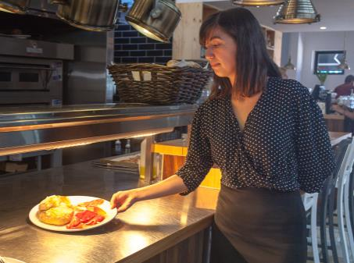

The part of the kitchen that you collect food from is called *the pass*. It is where the kitchen ‘passes’ the food to the floor staff.

Drinks are generally collected from the bar.

Pick up food and drinks promptly from the pass or the bar. This makes sure that:

* hot food stays hot
* cold food does not become warm
* drinks don’t separate
* sauces don’t get a skin on them
* the customer does not wait too long.

The longer food and drinks wait to get to the customer, the more they lose their quality.

You place TWO copies of the docket in the kitchen. The chefs keep one and they put the other one on the pass with the prepared food. You can look at this copy of the docket and see:

* what the order is
* where it is to go
* how long the customer has been waiting
* which customer has ordered each dish.

Check for accuracy and presentation

The food runner checks food on the pass against the docket for these things:

* Is everything on the docket on the pass?
* Does each dish match the docket e.g. special requests, rare steak?
* Is the plate clean?
* Do similar dishes look the same?
* Is hot food hot and cold food cold?
* Does the dish look good? Does it look as it normally does?
* Is it *garnished* (decorated) correctly?

If the answer to any of these questions is NO, then don’t take the food out **and** tell the chef immediately.

Safety

Sometimes plates can be very hot. The chef puts hot food on a hot plate so it stays hotter for longer. So you will have to carry hot plates to the table.

Use a service cloth to carry hot plates so they don’t burn your fingers and wrists.

Some venues use a large tray for hot plates.

Don’t carry more than you are capable of carrying.

Don’t overload your drinks tray.

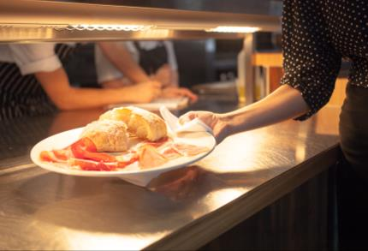

Hygiene

*Hygiene* means being clean.

Remember what you learned about cross-contamination and safe food handling practices in in the units*SITXOHS002A Follow workplace hygiene procedures* or *SITXFSA101 Use hygienic practices for food safety.*

* Never place your fingers on food or on the main part of the plate.
* Never place your fingers on the rim or the top half of a glass.
* Keep your hair tied back.
* Follow the personal hygiene rules.

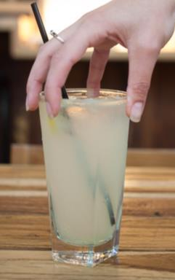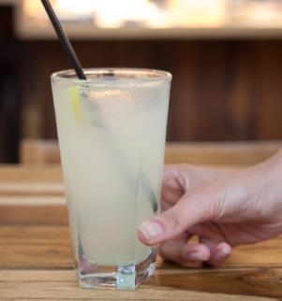

**X**

**✓**

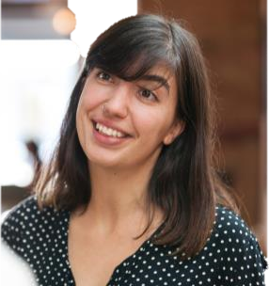

*The top half of the glass is for the customer – the bottom half is for staff.*

|  |  |
| --- | --- |
| C:\Users\Alan\Desktop\IMG_1079.jpg | Activity 17  Safe food handling |

1. What personal hygiene rules can you think of?

|  |
| --- |
|  |
|  |
|  |
|  |

2. Look at the three hygiene rules below. What could happen if you don’t follow each one?

|  |  |
| --- | --- |
| **Hygiene rule** | **What could happen if you don’t follow it?** |
| Never place your fingers on food or on the main part of the plate. |  |
| Never place your fingers on the rim or the top half of a glass. |  |
| Keep your hair tied back. |  |

Load a drinks tray

Never carry trays with two hands or just by the edge or rim.

Always sit the drinks tray on your left hand so you can serve the drinks with your right hand. Carry the tray with your left hand spread and flat under the tray.

Use your right hand to balance the tray if you feel you are losing control of it.

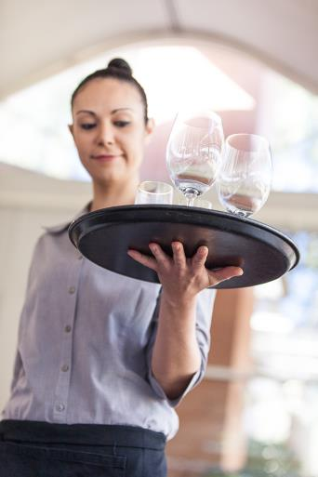

When loading a tray:

* place the heaviest glasses in the middle of the tray
* place the tallest glasses at the back, nearest your body
* place the small or light glasses around the edge of the tray.

Sometimes you might load your tray according to the order in which you will unload it at the table. If you do this, then just be careful not to overload your tray.

|  |
| --- |
| **TIP**  It is better to make two trips to the table than drop your tray or struggle with it. |

|  |  |
| --- | --- |
| C:\Users\Alan\Desktop\IMG_1079.jpg | Activity 18  What would you do? |

Discuss your answers with the group.

1. You check an order that the chef has put on the pass. One portion of prawns is missing.

|  |
| --- |
|  |
|  |

2. An order is ready to be picked up from the pass. One of the plates has a finger mark on it.

|  |
| --- |
|  |
|  |

3. You have been busy and see an order of drinks sitting at the bar. You notice the freshly squeezed orange juice and the mango smoothie have started to separate.

|  |
| --- |
|  |
|  |

4. You arrive at the table carrying three steaks – the docket says there is one rare, one medium rare and one medium. You realise you don’t know which steak is which.

|  |
| --- |
|  |
|  |

5. You check an order that the chef has put on the pass. The docket says ‘sauce on the side’ but the sauce is *on* the fish.

|  |
| --- |
|  |
|  |

Two plate carrying method

As a professional food and beverage attendant, you should use the correct *technique* (way of doing things) for serving and removing plates. This is the ‘two plate carry’.

|  |  |
| --- | --- |
| **STEPS** | |
| 1. Hold the first plate between your thumb, index finger and the middle finger of your left hand. | C:\Users\Alan\Documents\Carol\Consulting\24. WELL_Hospitality _resources\Photos\Serve_FandB\Hospitality2012Uluru-0906.jpg |
| 1. Place the second plate above the first plate, supporting it with your fourth finger, your little finger and the base of your thumb and forearm. | C:\Users\Alan\Documents\Carol\Consulting\24. WELL_Hospitality _resources\Photos\Serve_FandB\Hospitality2012Uluru-0907.jpg |
| 1. Carry a third plate in your right hand. | C:\Users\Alan\Documents\Carol\Consulting\24. WELL_Hospitality _resources\Photos\Serve_FandB\Hospitality2012Uluru-0910.jpg |

* Carry plates away from your body.
* Keep your shoulders back, stand up straight and relax your arms.
* If plates are hot, use a service cloth.

|  |
| --- |
| **TIP**  If you want to give plates to customers in order around the table, check the customer table position before you pick up the plates.  The FIRST plate you pick up in your left hand will be the LAST plate you put down. |

Serve food

Follow the guidelines below for serving all food - entrees, mains, desserts or side dishes.

Guidelines

|  |  |
| --- | --- |
| Serve from the customer’s right hand side.  Make sure the dish is placed in front of the customer so the main item on the dish is closest to the customer. | C:\Users\Alan\Documents\Carol\Consulting\24. WELL_Hospitality _resources\Photos\Serving\Serving-9325.jpg |
| Always announce the dish so the customer knows they are getting what they ordered.  Don’t ‘*auction off’* *the food* (call out the dish to see who asks for it). You will know who is having each meal by the position number on the docket. | **X**  **✓**  *Rare steak with chips and salad.*  *Who’s having the fish?* |

|  |
| --- |
| **TIP**  Step forward and bend your knee when placing items in front of the customer. This will protect your back from strain. |

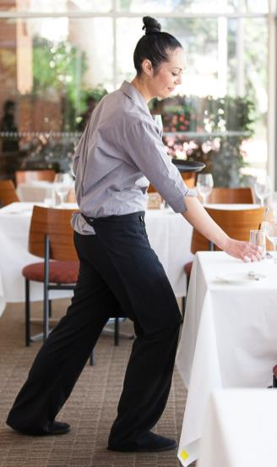

Serve beverages

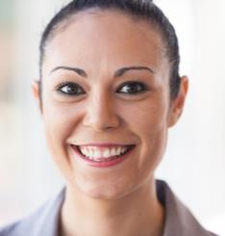Guidelines

* Serve from the right hand side.
* When serving from a drinks tray, bend your knees and not your back. This will stop your tray from sloping forward and drinks spilling or falling on to customers.
* Stand up straight with your shoulders back. Carry the tray at waist level, not touching your body.

*Raspberry and vanilla martini.*

* Announce drinks as you place them in front of the customer.
* When unloading your tray, hold it slightly away from your side so you don’t knock it as you stretch out.

|  |  |
| --- | --- |
| C:\Users\Alan\Desktop\IMG_1081.jpg | Activity 19  Serving correctly |

Practise the serving techniques below. Get someone to take photos or a movie of you so   
you can see what you are doing right and how you can improve. Ask your trainer for help with your technique:

* carrying two plates
* carrying three plates
* carrying two plates and a bowl
* carrying two bowls and a plate
* carrying and serving from a tray of drinks.

Deal with problems

Sometimes there are *delays* (something is late or slow) or problems with the food or drinks. If this happens:

* find out what the problem is – check with the chef, your supervisor or a colleague; find out how long it will take to fix it
* let the customer know there is a problem and how long it will take.

Apologising to a customer

When apologising to a customer:

|  |  |
| --- | --- |
| * Be genuine | Show concern and understanding of their feelings. |
| * Be brief | Don’t make excuses. The customer does not want to know whose fault it is, they just want it fixed. |
| * Give a time for correcting the situation | Now… shortly… as soon as possible…  When another bottle is brought up from the cellar. |

Here are some things you could say.

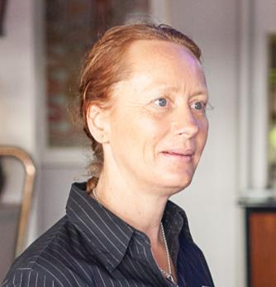

*I’m so sorry your food is delayed.*

*It’s being plated now.*

*I’m very sorry your food is delayed.*

*It will be ready shortly.*

*Can I get you another drink before your meals arrive?*

|  |
| --- |
| **TIP**  If you can’t fix the problem or the customer is not happy after you talk to them, get your supervisor IMMEDIATELY!  “I’ll contact my supervisor at once.” |

|  |  |
| --- | --- |
| C:\Users\Alan\Desktop\IMG_1079.jpg | Activity 20  Dealing with problems |

Discuss these problems and write down some things you could say and do.

| **Problem** | **What would you do? What would you say to the customer?** |
| --- | --- |
| 1. A lot of orders went to the kitchen at the same time, so it may take a little longer for food to be served. |  |
| 1. A customer has asked for a chicken salad. This is not on the menu. |  |
| 1. A customer has ordered a whole grilled fish but you didn’t tell them it would take longer than the other meals. |  |
| 1. Table 5 have complained about their drinks not arriving. You realise you forgot to put the order in. |  |
| 1. You took an order to another table by mistake. |  |
| 1. The kitchen cooked all the steaks well done, so one has to be replaced. |  |

Remove used items

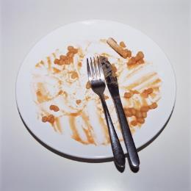How do you know when a customer has finished eating?

The common sign is when they put the knife and fork *parallel* (side by side) in the centre of the plate. This generally means the plate can be cleared.

Other signs are the customer’s body language (sitting back, hands folded on lap) and how much food is left on the plate.

Normally you wait for everyone at the table to finish eating before you clear the table. However, in a café you can clear plates as each customer finishes.

Always check before you start clearing.

*Can I clear your table?*

*Have you finished, sir?*

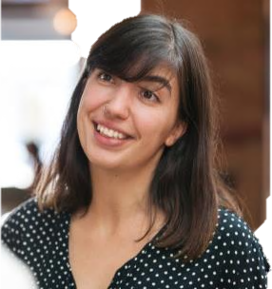

If a group orders some food to share, the plate goes in the middle of the table. When this is finished, clear that plate immediately to give the customers more space.

There are different methods for clearing tables, so follow your venue’s rules.

Guidelines

* Clear all plates, bowls and cutlery. Leave unusually shaped or heavy plates until last.
* Clear any unwanted items e.g. salt and pepper shakers, butter and sauces.
* Remove any unused glassware using a tray.
* Dust away any crumbs on the table with a cloth or a small brush.

Method for clearing

Clear from the right hand side, unless you can’t reach.

Start with the guest who has the most food or scraps left on their plate.

|  |  |
| --- | --- |
| **First plate** | |
| 1. Pick up the first plate and cutlery with your right hand. Then put it in your left hand. | C:\Users\Alan\Documents\Carol\Consulting\24. WELL_Hospitality _resources\Photos\Serve_FandB\Hospitality2012Uluru-0917.jpg |
| 1. Put the end of the fork handle under your thumb so it can’t fall. | C:\Users\Alan\Documents\Carol\Consulting\24. WELL_Hospitality _resources\Photos\Serve_FandB\Hospitality2012Uluru-0918.jpg |
| 1. Slide the knife, cutting end first, under the fork so it can’t fall. |
| **Second plate** | |
| 1. Clear the next guest’s plate. Put the second plate over your left arm balancing it on your thumb, fourth and little fingers. Scrape any food scraps onto the first plate. Scrape away from the customer. | C:\Users\Alan\Documents\Carol\Consulting\24. WELL_Hospitality _resources\Photos\Serve_FandB\Hospitality2012Uluru-0919.jpg |
| 1. Place the next fork and knife on the first plate. Secure the knife by sliding it under the forks. Place the second fork parallel to the first fork (beside it). | C:\Users\Alan\Documents\Carol\Consulting\24. WELL_Hospitality _resources\Photos\Serve_FandB\Hospitality2012Uluru-0921.jpg |

Continue this process until the table is cleared.

Cleaning

As you clear a table, you need to take the dirty items to the kitchen or bar. Your venue will have a place for dirty items.

Sometimes there is another staff member to clean them. At other times, you will need to place items in the dishwasher or glass washer, polish them and put the items away in their correct place.

Even if something looks like it has not been used, it must still be cleaned. You can’t take a chance that it has not been touched.

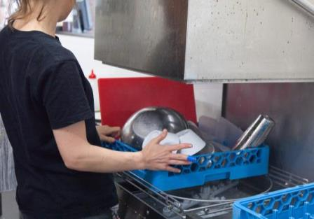

|  |  |
| --- | --- |
| C:\Users\Alan\Desktop\IMG_1087.jpg | Activity 21  Dirty items |

1. Where do you put the dirty items you have cleared from tables?

|  |
| --- |
|  |

2. Who puts dirty items in the dishwasher or glass washer?

|  |
| --- |
|  |

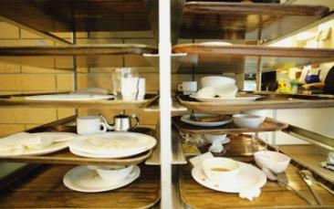

Dispose of leftover food

The kitchen is responsible for dealing with food that has not been served.

**All leftover food** that is cleared from tables MUST be *disposed of* (got rid of). It can’t be re-used in any way.

The only items that can be re-used are things in containers e.g. salt and pepper in shakers, sauces and jams in bottles or jars, and butter or sugar in packets.

**Used cooking oil** is a *hazardous* (dangerous) waste. It must be disposed of in a way that protects the *environment* (land, air and water). It must never be poured down a sink or a gully trap, put into storm water drains or thrown out with normal rubbish.It must be collected in a special kitchen grease trap and taken away by a licensed company.

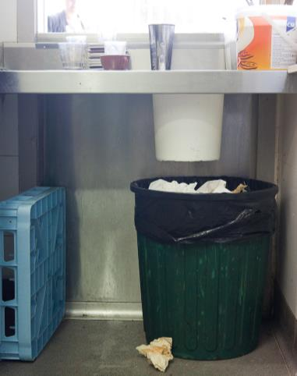

Dispose of other waste

***Disposable* or single-use items** MUST be thrown out after use, for example:

* drinking straws
* paper serviettes

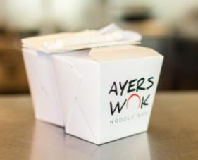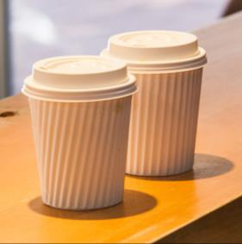

* plastic cutlery
* cardboard pizza boxes
* takeaway coffee cups
* plastic or cardboard takeaway containers.

Recycle waste

A lot of hospitality venues now *recycle* some of their waste. This means the material may be used again in another way e.g. the paper waste may be broken down and made into cardboard again.

The following kitchen and venue waste can be recycled:

* paper and cardboard – takeaway containers, packaging and boxes
* plastic – soft drink, juice and milk bottles, and packaging
* glass – bottles and jars
* cans – food and soft drink
* food scraps that can be *composted* (put in a container to rot down into fertiliser) – plant-based food, including bread, pasta and rice.

Your workplace probably has recycling rubbish bins, where you put bottles and cans in one bin and food scraps in another. There may also be a separate bin for paper and cardboard.

|  |  |
| --- | --- |
|  | **Recycling** |
| Recycling means re-using something in another way.  It is good for the environment because it reduces the number of new things that must be manufactured and there is less rubbish sent to the tip. | |

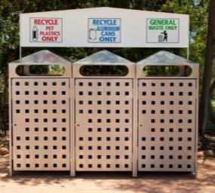

|  |  |
| --- | --- |
| C:\Users\Alan\Desktop\IMG_1087.jpg | Activity 22  Disposing of leftover food and waste |

1. How do you dispose of leftover food and drinks in your workplace?

|  |
| --- |
|  |
|  |

2. What waste does your venue recycle?

|  |
| --- |
|  |
|  |

Farewell customers

You serve your customers until they leave the venue. It doesn’t matter who the customer is or how much money they have spent – you should thank and farewell each customer.

You could smile and say:

*Thank you! I hope you enjoyed your meal.*

*We look forward to seeing you again.*

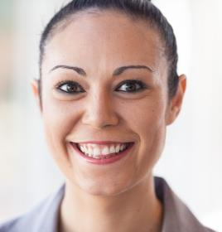

*Thank you! I hope you had a good night.*

*We hope to see you back soon.*

Your final words to a customer can leave a lasting impression and may affect whether they want to come back or tell others to come.

As part of farewelling customers, you might also:

* pull out their chair
* *escort* (walk with them) them to the door
* open the door
* help them with bags, baby prams or any bulky or awkward personal items
* help with jackets, coats and umbrellas
* call them a taxi.

Your venue will have its own procedure for farewelling customers.

|  |
| --- |
| **TIP**  Thanking and farewelling the customer is more important than greeting the customer.  It is the last thing they remember. |

|  |  |
| --- | --- |
| C:\Users\Alan\Desktop\IMG_1081.jpg | Activity 23  Farewelling customers |

Practise thanking and farewelling customers.

Your trainer will organise this activity.

Section summary

Now you have completed this section you should have developed the following skills and knowledge.

Tick each box if you are satisfied that you have those skills and knowledge.

|  |  |
| --- | --- |
|  | Collect food and beverages from the kitchen or bar. |
|  | Check food and beverages for accuracy and presentation. |
|  | Serve food and beverages courteously and to the correct person. |
|  | Load a drinks tray. |
|  | Use the two plate carrying method. |
|  | Check customer satisfaction and deal with any problems. |
|  | Remove used items correctly. |
|  | Dispose of leftover food and recyclable items. |
|  | Farewell customers. |

Notes

|  |
| --- |
|  |
|  |
|  |
|  |
|  |

5 Close down after service

At the end of service the room must be cleared and cleaned so it is ready to go for the next shift or day.

End of service tasks

The end of service procedure could include these tasks:

* *debrief* (talk together about what happened) with staff to discuss what went right and what went wrong, and to allocate closing down tasks
* strip tables and move them back to their standard position
* read the register/POS terminal and *reconcile the takings* (count the money and check the amount is the same as on the dockets)
* check stock levels and order stock
* restock shelves and fridges
* store furniture e.g. put chairs upside down on tables or move outside tables inside
* wipe menus and wine lists, and check for damage
* clean and restock bar area
* clean and restock waiters’ station
* clean and restock coffee machine
* clean and restock salt and pepper, sugar and other condiments
* polish cutlery, crockery and glassware
* sweep and mop floors

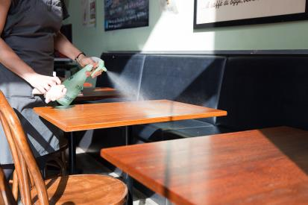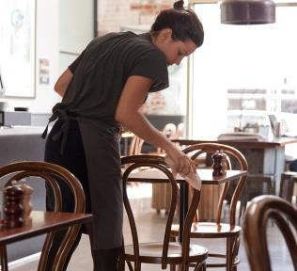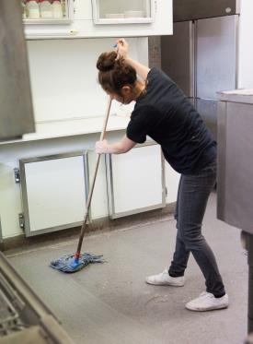

* clean and restock toilets
* turn off electrical items e.g. music, air conditioning and lighting.

Work safely

Always follow your venue’s procedures and work safely.

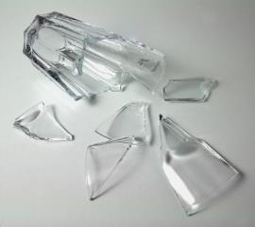Some tasks can be hazardous, for example:

* handling cash
* using chemicals
* handling broken or damaged items
* using electrical equipment.

|  |
| --- |
| **TIP**  Don’t count cash out in the restaurant or café. Do it in the office or a back of house area. |

Store items correctly so no one can get hurt.

If an item is damaged, remove it from the area and report it to your supervisor immediately.

|  |  |
| --- | --- |
| C:\Users\Alan\Desktop\IMG_1081.jpg | Activity 24  End of service tasks |

Look at the end of service checklist from the Blue Gums Restaurant on the next page.  
Then talk about and answer the questions below.

1. What are two other end of service tasks you do in your venue? Write them into the checklist in the blank spaces.

2. Sandra dropped a glass jug when she was unloading the dishwasher. She swept up the pieces and put them in the bin. She was not hurt.

Write a note for the manager in the *Notes* section.

3. When you are moving the tables and chairs, you notice that a chair at Table 3   
wobbles a bit. You place it out the back but now the table is one chair short.

Write a note in the *Comments* column for the next shift.

|  |  |  |  |
| --- | --- | --- | --- |
|  | | | |
| **DINNER END OF SERVICE CHECKLIST DATE: WED 30 FEB** | | | |
| **TASK** | **NAME** | **DONE** | **COMMENTS** |
| Return tables and chairs to standard floor plan |  |  |  |
| Wipe over table tops and chair seats with vinegar spray |  |  |  |
| Wipe over servery and ledges |  |  |  |
|  |  |  |  |
|  |  |  |  |
| Top up coffee cups, saucers, teaspoons in bar |  |  |  |
| Top up plates on servery |  |  |  |
| Collect and check serving trays, serving cloths, food covers |  |  |  |
| Sort cutlery |  |  |  |
| Polish cutlery |  |  |  |
| Polish glasses |  |  |  |
| Take glasses and jugs from dishwasher and put on shelf |  |  |  |
| Check phone is diverted to manager |  |  |  |
| Count till, record in cash book, top up change |  |  |  |
| Turn off:  🞎 lights  🞎 air conditioning  🞎 glass washer  🞎 music |  |  |  |
| Flip *Closed* sign |  |  |  |
| Notes (damage, incidents): |  |  |  |

Prepare and set up for next service

The venue may also require end-of-shift staff to prepare and set up for the next service, or this may be done by the next shift of staff before they open. End-of-shift staff may be required to:

* **fully set up** e.g. do a full clean and set up after lunch service so the venue is ready to open for dinner
* **partially set up** e.g. clean and return furniture to standard position, but table set up is done by the next shift according to bookings
* **not set up –** the entire set up is done by the next shift.

This depends on your venue’s procedures, the time of day and the bookings. If there is a large booking you may need to rearrange the restaurant and put tables together.

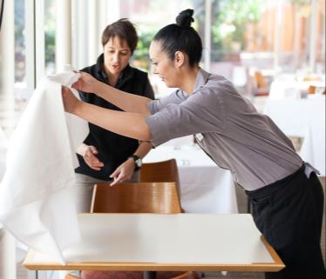

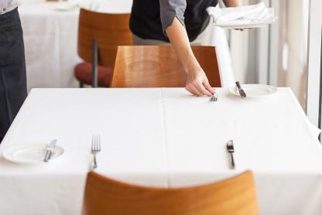

Debrief with colleagues

At the end of service, when all customers have gone, many venues hold a short meeting for about 10 minutes. This is sometimes called a *debriefing*.

Staff talk together about things that happened during the service (*review*) and look at what went well and what areas need to be improved (*evaluate*).

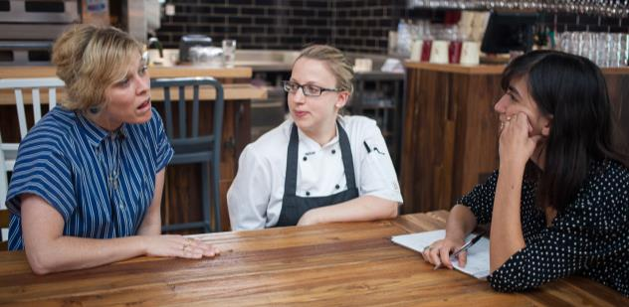

|  |  |
| --- | --- |
| C:\Users\Alan\Desktop\IMG_1094.jpg | Activity 25  Restaurant debriefing |

Listen to what Jay, the supervisor, says to his staff at the debriefing.

Then answer the questions on the next page.

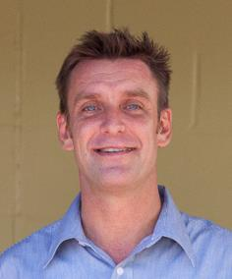

*Thank you everybody for a good service. Everything went smoothly, the food came out on time and it was a good standard. Well done kitchen! We had some good feedback from customers.*

*Can we just talk about a couple of service issues?*

*Don’t forget to offer people the choice of still, tap or sparkling water. We want to give the customer as many options as we have, as well as trying to sell our products.*

*Also, remember to announce the food when you place it in front of the customer. This lets them know that they are getting what they ordered.*

*Tomorrow we’re going to sell the Pepper Tree Shiraz at $5 per glass, so suggest it to customers. We need to get rid of stock.*

*Does anyone have anything else they want to discuss?*

*Once again it was a good service, so well done everybody. Have a good night.*

**Restaurant debriefing**

Listen to your trainer read aloud what Jay said about the evening’s service.

1. What are the two main service issues Jay mentions?

|  |
| --- |
|  |
|  |

2. What compliments does Jay pass on to staff?

|  |
| --- |
|  |
|  |

3. What request does Jay make about tomorrow?

|  |
| --- |
|  |
|  |

The handover

When staff change between service periods, they do a *handover.* The finishing staff tell the arriving staff any important information that will help them on their shift, for example:

* specials of the day, soup or fish of the day
* changes to the menu and wine list
* anything the kitchen has run out of or is running low on
* any group bookings
* any complaints by customers on the previous shift
* staff roles for the service period
* tasks for the end of service.

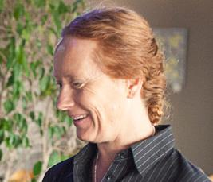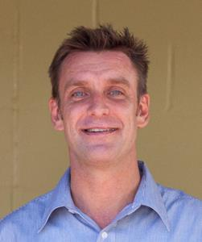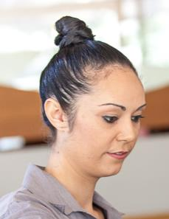

*There are only three portions of salmon left.*

*At end of service today, John is polishing cutlery, Chris can restock the bar and Sara, will you refill condiments and sugar please?*

*There’s a big birthday booking coming in at 1.30 so, Sandy and Josh, you’ll work that table.*

Section summary

Now you have completed this section you should have developed the following skills and knowledge.

Tick each box if you are satisfied that you have those skills and knowledge.

|  |  |
| --- | --- |
|  | Carry out end of service tasks. |
|  | Work safely. |
|  | Prepare and set up for next service. |
|  | Review and evaluate service period with colleagues. |

Notes

|  |
| --- |
|  |
|  |
|  |
|  |
|  |

Key words

| Word | Meaning |
| --- | --- |
| *access* | How you get in |
| *account* | The list of items bought and their cost |
| *accurate* | All details are correct |
| *allergic* | When people can get ill if they eat certain foods e.g. peanuts |
| *auction off’* *the food* | Call out the dish to see who at the table asks for it |
| *bain marie* | A tray over a hot water bath and under heat lamps. Used to *k*eep food hot. |
| *beverage* | Drink |
| *buffet* | Food is on display and customers self-serve |
| *clockwise* | The direction of the hands on a clock |
| *condiments* | Flavourings on the table for the customer to add to their meal e.g. salt, pepper, mustard |
| *composted* | Put in a container to rot down into fertiliser |
| *converse* | Talk together |
| *cover* | A place setting at a table |
| *current* | The latest |
| *crockery* | Plates, bowls, cups and saucers |
| *cutlery* | Knives, spoons and forks |
| *debrief* | Talk together about what happened |
| *delay* | When something is late or slow |
| *disposed of* | Thrown away |
| *EFTPOS* | Electronic Funds Transfer at Point Of Sale – an electronic system for debit cards |
| *entrée* | Small starter dish |
| *environment (room)* | The look and feel of the room |
| *environment (world)* | The land, air and water |
| *escort* | Walk with someone |
| *evaluate* | Discuss what went well and what needs to be improved |
| *food runner* | Person who takes the food from the kitchen to the customer |
| *garnish* | Decoration on food |
| *handover* | Finishing staff tell arriving staff any important information that will help them on their shift |
| *hazardous* | Dangerous |
| *hygiene*  *hygienic* | Being clean, with no germs |
| *lap the guest* | Place the napkin on the guest’s lap |
| *legible* | Easy to read |
| *mise en place* | Organise everything before service starts so it goes smoothly - a French term that means ‘put in place’ or ‘everything in its place’ |
| *parallel* | Side by side |
| *pass* | The part of the kitchen that you collect food from |
| *patient* | Take your time |
| *portion* | A serve |
| *recommendation* | Saying what you think is good or will suit the customer |
| *reconcile the takings* | Count the money and check the amount is the same as on the dockets |
| *reservation*  *reserved* | When a customer pre-books a table  Booked |
| *review* | Look back over things that happened |
| *sequence* | Order you do things in |
| *service end* | The end of a knife, fork or spoon that goes in the customer’s mouth |
| *serviceware* | Utensils to serve food |
| *stagger* | spread out |
| *standard* | Normal |
| *technique* | Way of doing things |
| *terminology* | Specialist words |
| *utensils* | Tools for preparing food |
| *venue* | The food and beverage place you work at |
| *waiter’s station* *sideboard* | The piece of furniture in a restaurant where things are stored that a food and beverage attendant needs to do their job, such as trays, napkins, condiments and extra crockery |
|  |  |
|  |  |
|  |  |
|  |  |