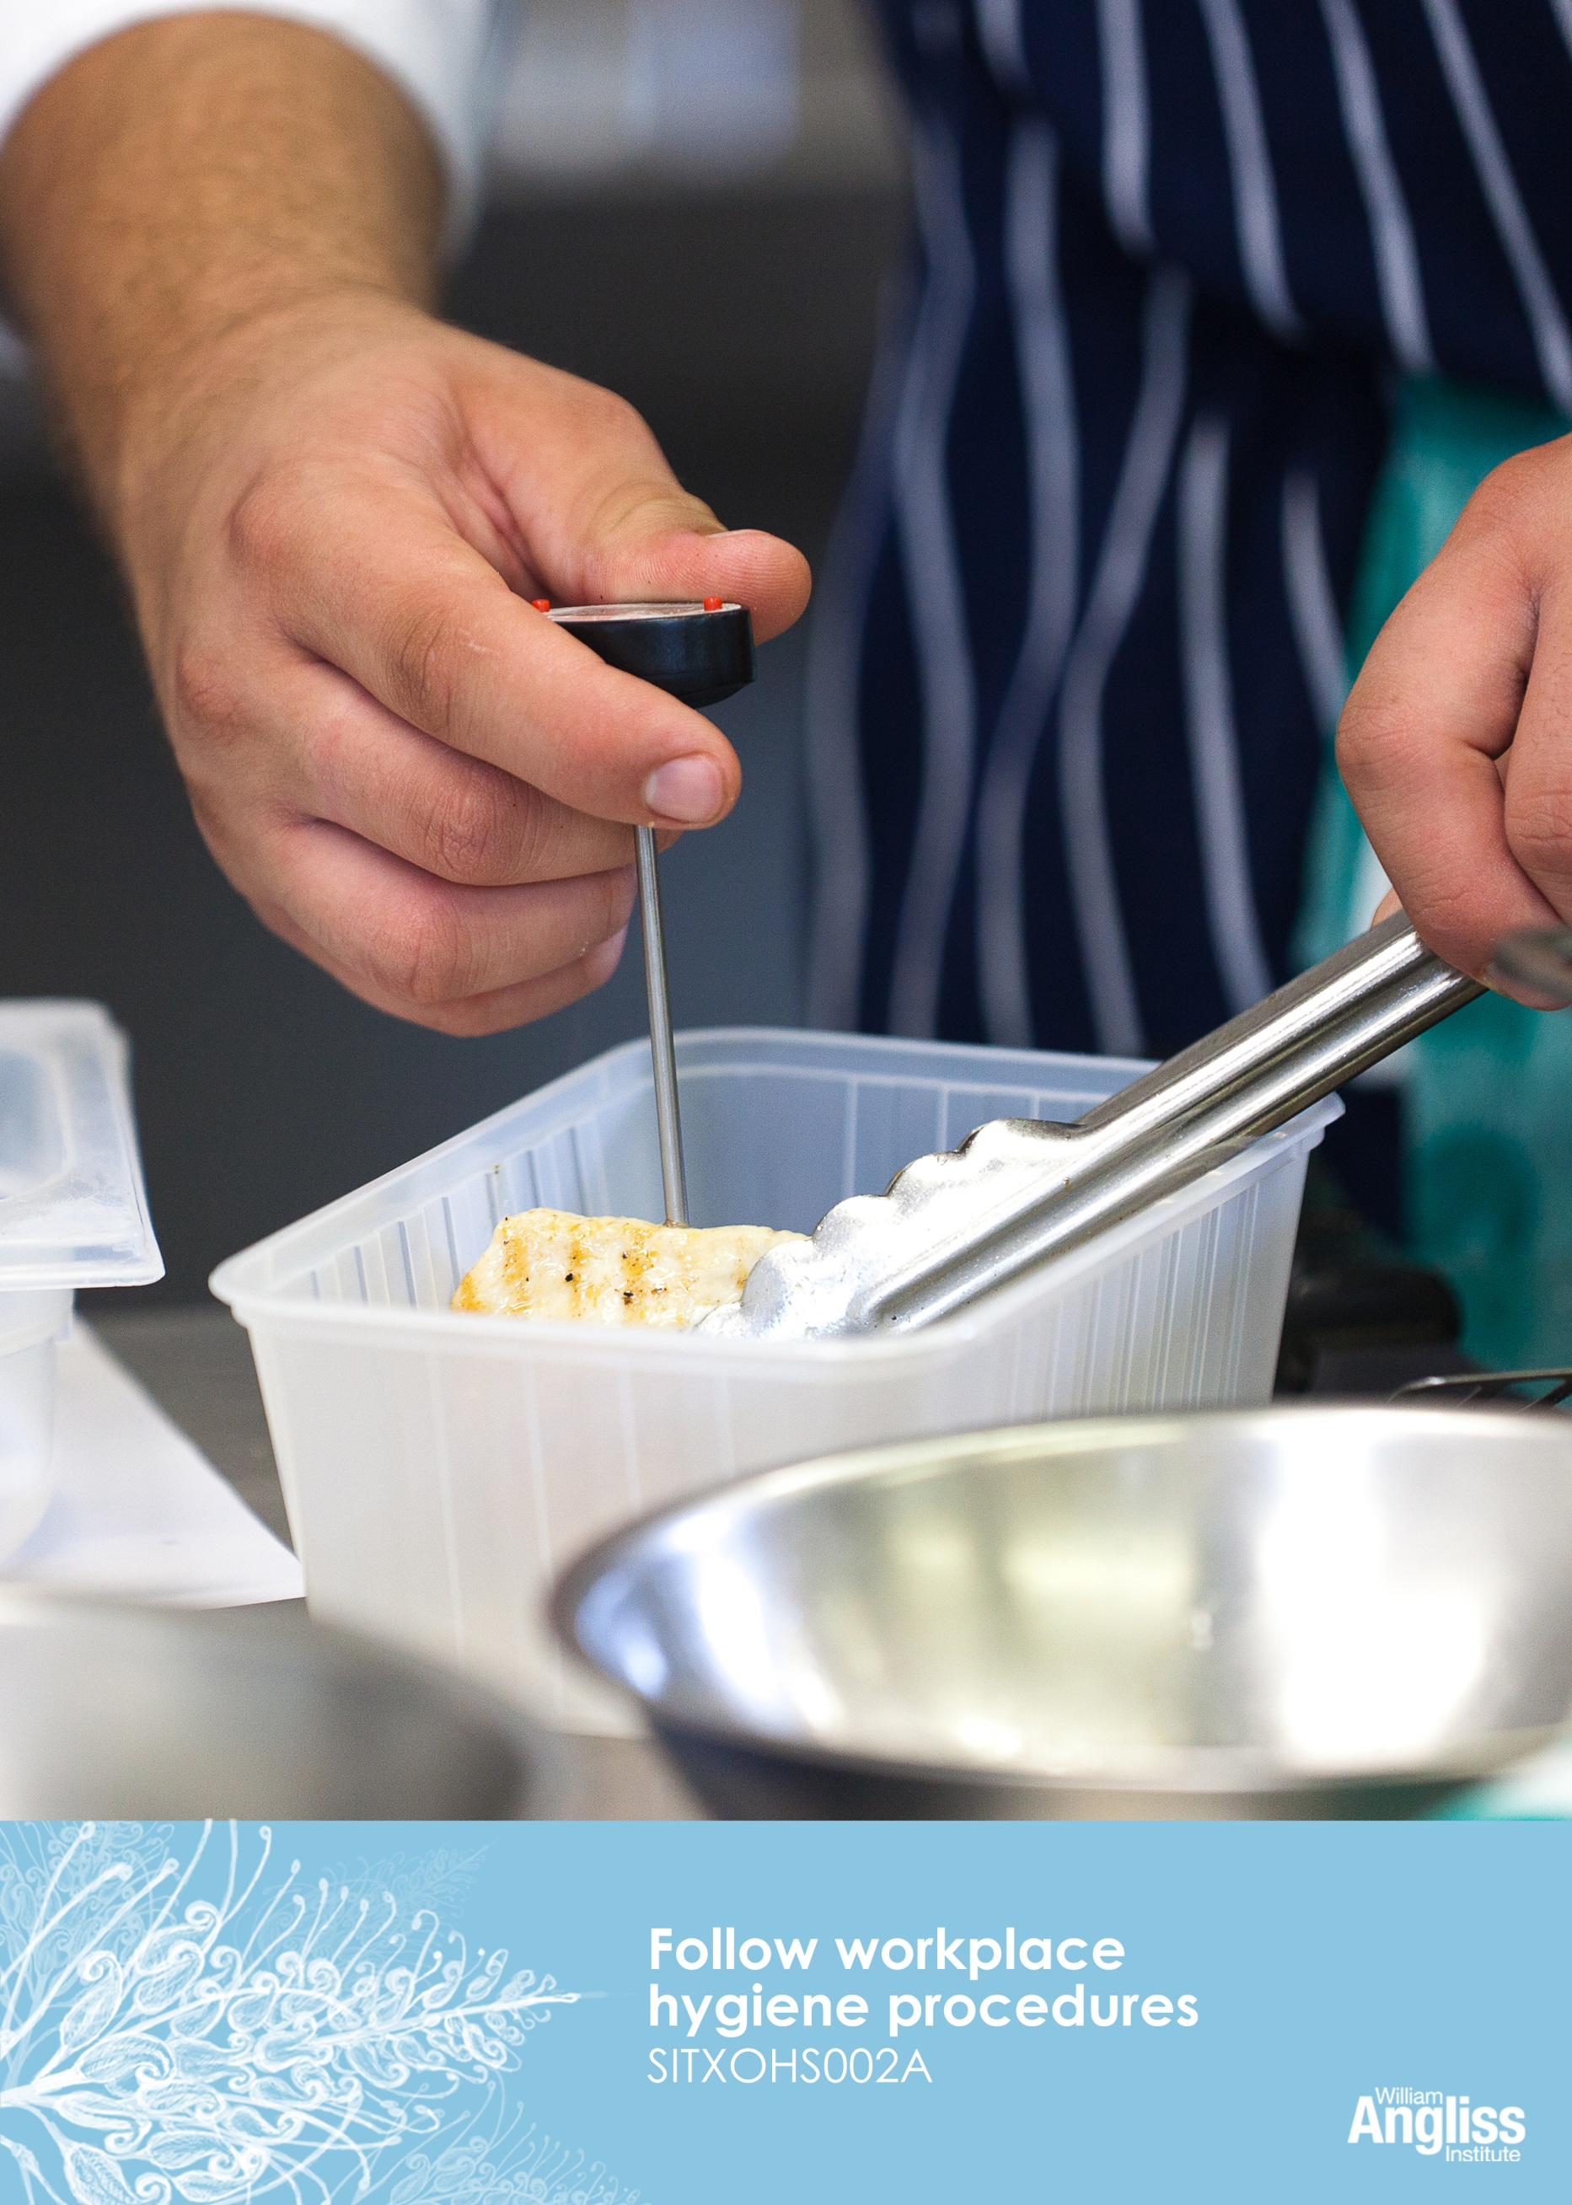

© Commonwealth of Australia. 2012

CC BY-NC-SA
This work is copyright. Except where otherwise indicated, and save for the Commonwealth Coat of Arms, the Department has applied the Creative Commons Attribution-Noncommercial-Share Alike 3.0 Australia Licence to this work.
The Department of Education, Employment and Workplace Relations must be attributed as the author of the Department’s copyright material.
As far as practicable, material for which the copyright is owned by a third party has been clearly labelled. The Department has made all reasonable efforts to ensure that this material has been reproduced in this resource with the full consent of the copyright owners.
Requests and enquiries concerning the Department’s copyright material should be addressed to:

The Copyright Officer
Department of Education, Employment and Workplace Relations
Location code C148CW2
GPO Box 9880 Canberra ACT 2601

Or emailed to copyright@deewr.gov.au
Funded under the Workplace English Language and Literacy (WELL) Program by the Australian Government Department of Education, Employment and Workplace Relations.
The views expressed in this publication do not necessarily represent the view of the Minister for Education or the Australian Government. The Australian Government does not give any warranty nor accept any liability in relation to the contents of this work.
ISBN 978-1-922108-01-2

Development Team
Content | William Angliss Institute  Macsmith and Associates
Photography & graphics | Benjamin B Photography
Acknowledgments
We would like to acknowledge the generous support of the following organisations and the Indigenous learners and employees in those venues for giving their permission for photography:
Ayers Rock Resort, Yulara, NT
Charcoal Lane Restaurant, Fitzroy, Vic
Lux Foundry Café, Brunswick, Vic
Peninsula Palms (Compass Group Australia), Dampier, WA
Permissions
We would like to acknowledge the following organisations who have granted permission for their copyright materials to be incorporated in this resource:
Food Safety Information Council
ComLaw, Attorney-General's Department
Ecolab
Cultural Warning
People of Aboriginal or Torres Strait Islander descent should be aware that this publication contains images of people who may be deceased
Disclaimer
Every effort has been made sure that this booklet is free from error or omissions. However, you should conduct your own enquiries and seek professional advice before relying on any fact, statement or matter contained in this book. William Angliss Institute of TAFE is not responsible for any injury, loss or damage as a result of material included or omitted from this course.

Contents
Welcome v
Icons v
What you will learn vi
1 Importance of safe food handling 1
Food poisoning 2
Contamination of food 4
Food safety and the law 7
Section summary 12
2 Your own health and hygiene 13
Are your work clothes clean? 14
Are your hands clean? 15
Section summary 23
3 Food safety 24
What rules do you have at work? 24
How do you keep food safe for eating? 27
Preventing contamination of food 30
Section summary 39
4 Keep the workplace clean 40
Cleaning and sanitising 40
Cleaning schedule 40
Cleaning products and equipment 43
Steps for cleaning 44
Washing linen 46
Dealing with rubbish 48
Pests in food businesses 50
What should you do if you notice something wrong? 53
Section summary 55
Key words 56
Welcome

Icons
These signs tell you what type an activity is:
 | Do this activity in a big group.
 | Do this activity in a small group.
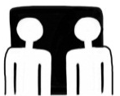 | Do this activity in pairs.
 | Do this activity by yourself.
Do this activity using the internet.
If you are not connected to the internet, your trainer will provide you with another activity.
Do this activity in your workplace.
If you are not in a workplace, your trainer will provide you with another activity.

What you will learn
You may work in a service industry such as a hotel, café, club, commercial caterer, fast food shop or any other business where food is stored, prepared, displayed and served. Whatever the business, part of your job will be to keep food safe to eat using hygiene practices.
In this workbook, you will learn about:
- personal hygiene – making sure that you are clean and wear clean clothes
- food safety – making sure that you handle food in safe ways
- environmental hygiene – keeping the equipment and the premises, such as the kitchen, clean.

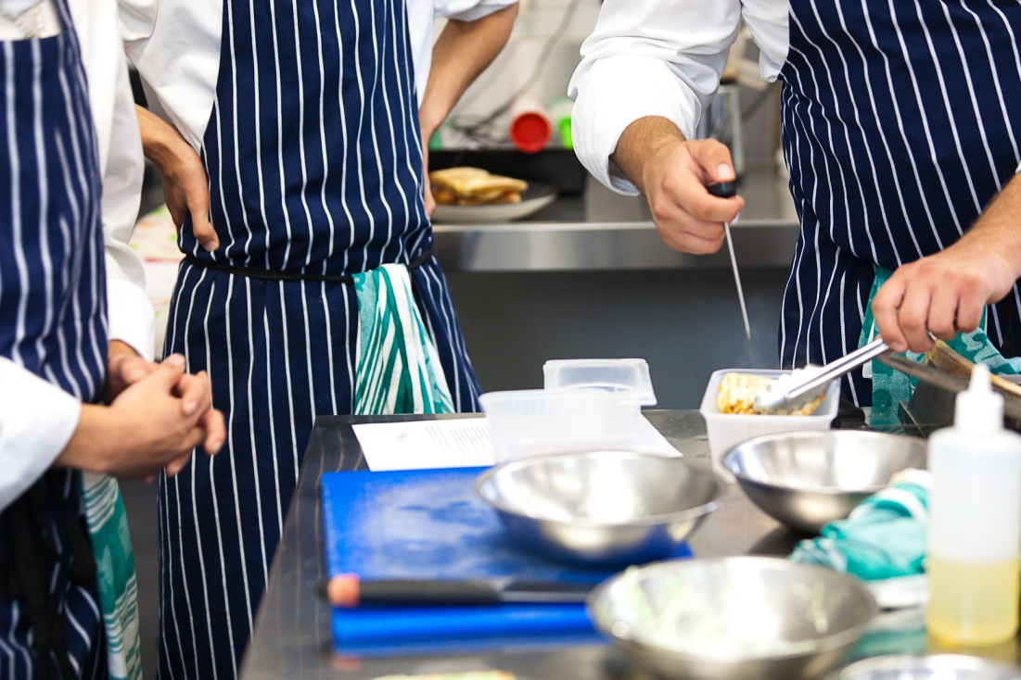

1 Importance of safe food handling
Many jobs in the hospitality industry require you to handle food. You may store it, prepare it, put it away or serve it. This means you are a food handler.
This training will help you learn how to handle food safely so that people don’t get sick. This includes your customers, people you work with and you.
You must handle food in the way you are trained so that you don’t make people sick.
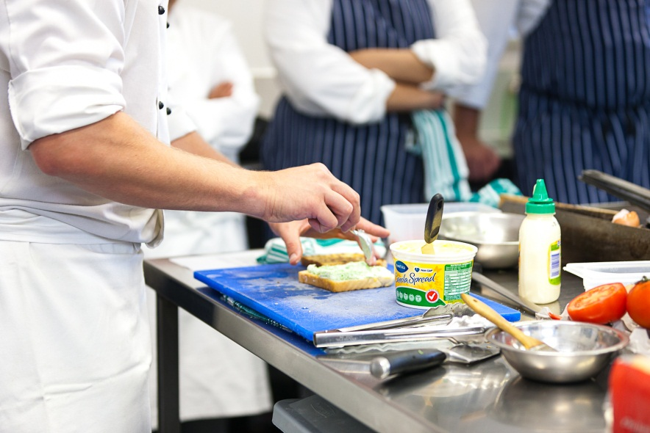

Activity 1
Have you had food poisoning?
Has anyone in the group been sick from eating bad food?
1 How did you feel?
2 How long were you sick for?
3 Do you know which food made you sick?
This could have been food poisoning.

Food poisoning
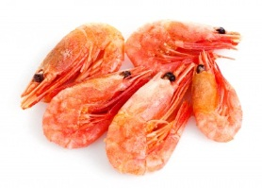
Food poisoning happens when bad germs called bacteria grow in the food and make you sick after you have eaten it.
You can’t see, taste or smell the germs, so there are no signs that you should not eat the food. Food that looks fresh and tasty can still make you sick.
You can also catch a virus such as a cold by eating food that someone else with the virus has touched or sneezed on.

Did you know?
The Australian Health Department estimates 5.4 million Australians get sick annually from eating food contaminated with bacteria or viruses.
From the Food Safety Information Council
<www.foodsafety.asn.au>

A lot of people make themselves sick at home. Other people are made sick by eating food from cafes, hotels, restaurants and take away places where food handling practices are not followed properly.
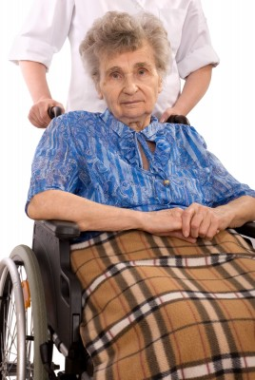
Some groups of people can be more affected by food poisoning than others and you could be handling food for these people at any time.
These people include:
- old people
- pregnant women
- children
- people who are already sick
- people who are allergic to certain foods e.g. peanuts.

Activity 2
Food poisoning at the local pub
Read this article and talk together about the questions.

Food poisoning at local pub
More than 15 people have suffered food poisoning after eating at a popular local pub.  Health authorities have investigated the outbreak. They believe the outbreak is linked to raw eggs used in a sauce.  Health inspectors said they also found some poor food handling practices. | For example, some food was left out of the refrigerator for too long.  The pub management acted immediately to prevent any further problems. They now buy eggs from a different supplier and they have put all their staff through food hygiene refresher training.

1. What happened to the people who ate at the pub?
2. What caused the problem?
3. What do you think was the effect on:
- the pub’s business?
- the tourism industry in the local town?
4. What has the pub done to prevent the problem happening again?

Contamination of food
Contamination of food means something gets into the food that:
- should not be there
- can make people sick or injure them.
There are three main ways food can be contaminated.
Type of Contamination | Explain
- Microbiological | Germs such as bacteria, viruses or mould get into the food. You mainly can’t see these.
- Physical | An object gets into the food, such as hair, dirt, stones, glass or wood. You can usually see this.
- Chemical | Chemicals get into the food e.g. fly spray, detergent, herbicides or pesticides sprayed on vegetables on the farm. You can’t see these.

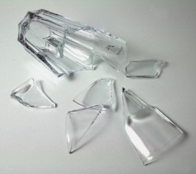

Cross-contamination of food
Cross-contamination happens when germs from one place (e.g. on food surfaces, hands, linen or equipment) pass to another place.
Cross-contamination can happen in many ways.
Pathway | How can cross-contamination happen?
Person person | If you shake hands with someone who has not washed their hands after going to the toilet, or who has sneezed into their hand
Person food | If you don’t wash your hands after going to the toilet, then touch food
Food food | If you allow raw meat to drip onto ready-to-eat food on a lower shelf in the fridge
Equipment food | If you use tongs to take raw chicken to a pan, then use the same tongs to move cooked chicken onto a plate
Linen food | If you handle raw meat, wipe your hands on a tea towel, then use the tea towel to wipe a bench where food will be prepared
Equipment food | If you use a meat slicer to cut raw food, then use the same slicer to cut cooked food
Crockery food area | If you use crockery with chips and cracks. Germs grow in the chips and can then get into the food.

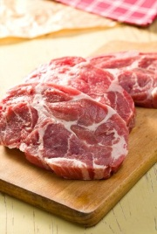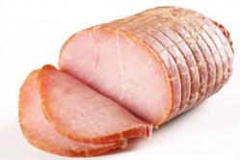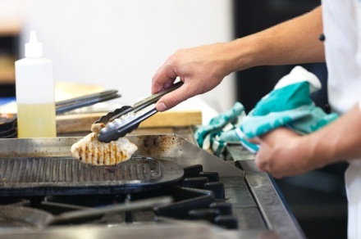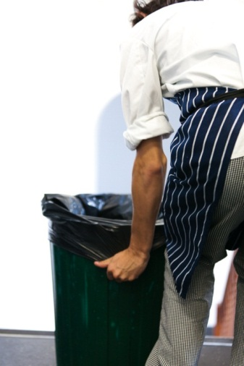

Activity 3
Cross-contamination of food
These pictures tell a story of cross-contamination.
Have a look at the pictures and talk together. Tell the story of how the boy might get sick.

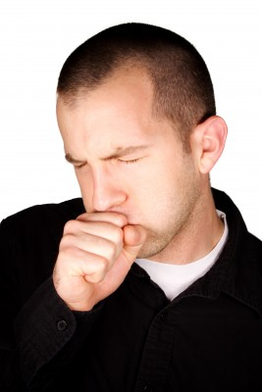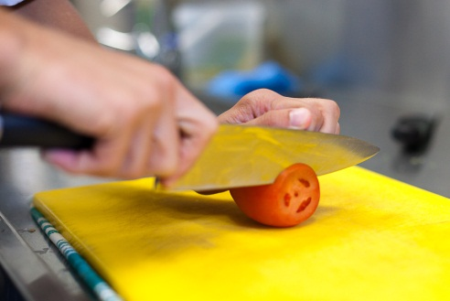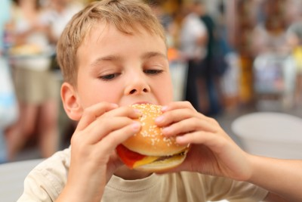

Food safety and the law
The government wants to stop people getting sick from bad food, so it has passed some laws that food businesses and food handlers must follow.

The Food Act
This law requires food business owners to make sure that food they sell or prepare for sale is safe to eat. It sets minimum (lowest) standards of cleanliness for food storage, preparation and service areas, and hygienic food handling practices. Each state has its own Food Act.

Australia New Zealand Food Standards Code
This code contains detailed requirements for food businesses to operate safely, including how to keep food safe to eat. It is the basis for the Food Act in each state.
Your workplace will have procedures to make sure you follow this code at work.
You can find more information at the Food Standards Australia and New Zealand (FSANZ) website <www.foodstandards.gov.au>.

Food Safety Program (FSP)
Food businesses must have a food safety program, which shows their food safety and hygiene practices and procedures. In most states this program must be written, but in some states the business must notify the government department of their food safety activities.
The program usually requires businesses to record information such as food delivery times, food storage temperatures and cleaning schedules.
Your employer will train you in how to follow the food safety program.
Your employer will train you in how to follow the food safety plan.

Environmental Health Officers
Environmental Health Officers usually work for local councils. They check that food businesses in their area are following the food safety laws. They make sure food sold to people is safe to eat and that the kitchens and storage areas are clean and well maintained.
It is an offence to:
- store food at unsafe temperatures
- have unclean kitchen and food storage areas
- not keep the required records
- have hand washing facilities that are not good enough
- not having clean and sanitised food equipment

- have evidence of pests
- not keep facilities maintained e.g. cracks in tiles.
If the officers are not happy with the food safety and hygiene of a business, they can fine the owners and even close the business.

Who can you report food safety issues to?
You can report a food safety issue to your manager, supervisor, chef, owner or purchasing officer. Each workplace will have its own procedure (way of doing things).

Activity 4
Understanding the food safety laws
On the next page is part of the Australia New Zealand Food Standards Code.
1 (b) is circled. Here is what it really means.

Example:
(1) A food handler must, when engaging in any food handling operation –
(b) take all practicable measures to prevent unnecessary contact with ready-to-eat food;

What does it really mean?
I must try not to touch ready-to-eat food unless I have to.

- Groups can choose one part of the code, so that each group is looking at something different.
- See if you can work out what your part means. Try underlining the important words. Look at the previous example.
- Tell the group what you think your part means.
If you are not sure, ask your trainer to help you.

15 Hygiene of food handlers

(1) A food handler must, when engaging in any food handling operation –
(a) take all practicable measures to ensure his or her body, anything from his or her body, and anything he or she is wearing does not contaminate food or surfaces likely to come into contact with food;
(b) take all practicable measures to prevent unnecessary contact with ready-to-eat food;
(c) ensure outer clothing is of a level of cleanliness that is appropriate for the handling of food that is being conducted;
(d) only use on exposed parts of his or her body bandages and dressings that are completely covered with a waterproofed covering;
(e) not eat over unprotected food or surfaces likely to come into contact with food;
(f) not sneeze, blow or cough over unprotected food or surfaces likely to come into contact with food;
(g) not spit, smoke or use tobacco or similar preparations in areas in which food is handled; and
(h) not urinate or defecate except in a toilet.

(2) A food handler must wash his or her hands in accordance with subclause (4) –
(a) whenever his or her hands are likely to be a source of contamination of food;
(b) immediately before working with ready-to-eat food after handling raw food; and
(c) immediately after using the toilet.

Sourced from the ComLaw website on 1 May 2012.
For the latest information on Australian Government law please go to <http://www.comlaw.gov.au/>.
All legislative material herein is reproduced by permission but does not purport to be the official or authorised version. It is subject to Commonwealth of Australia copyright.
Permission to reproduce the Commonwealth Coat of Arms granted by the Department of the Prime Minister and Cabinet.

Activity 5
What can you see in this kitchen?
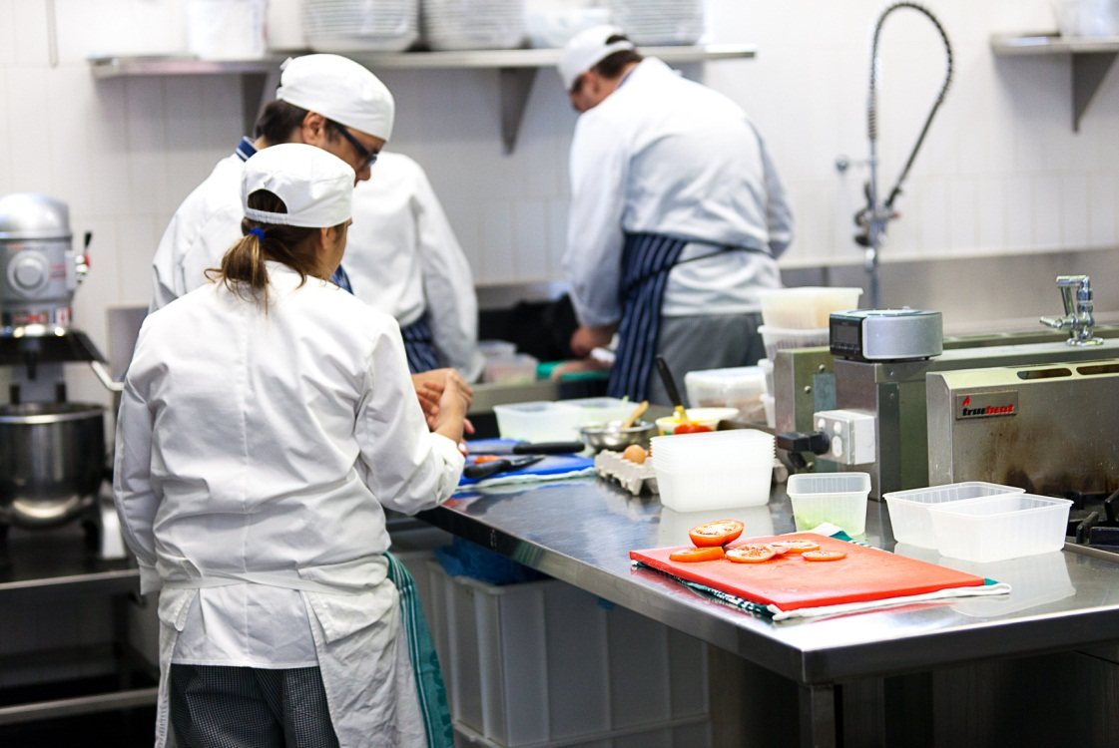
Look at these pictures.
Circle some of the things that mean this kitchen produces safe food.
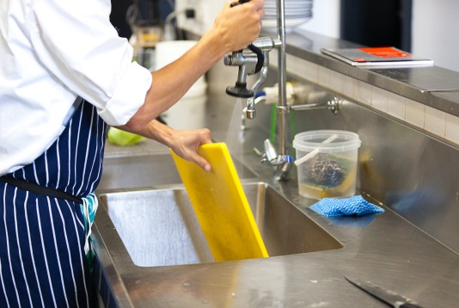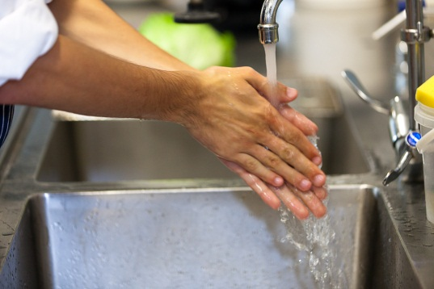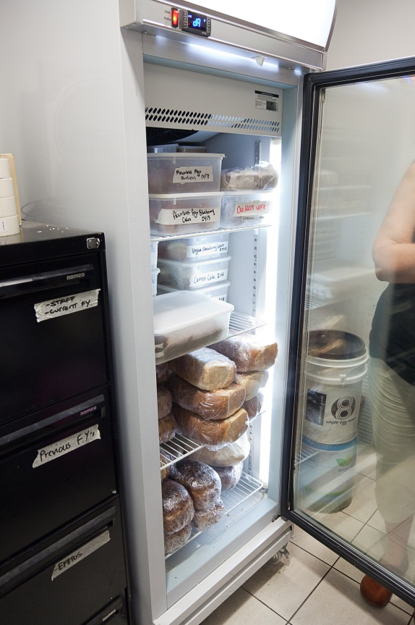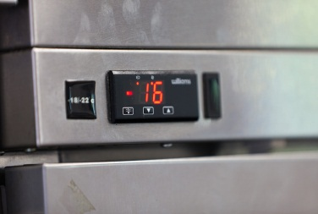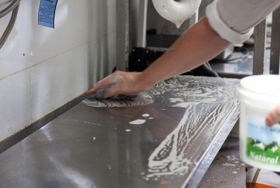
Activity 6
Your workplace kitchen
Look at the kitchen in your workplace. What safe food handling practices can you see?
Write them down, or talk about them to your trainer or another learner.

Activity 7
Food poisoning in the news
In Activity 2 you looked at a newspaper about food poisoning.
Find another newspaper article about food poisoning.
Read the article and see if you can find out any of this information.
Underline or highlight the key information in the article.
1 Who got food poisoning?

2 How serious was it?

3 How did they get it?

4 What happened to the food venue?
Now tell another group about your article
.

Section summary
Now you have completed this section you should have developed the following skills and knowledge.
Tick each box if you are satisfied that you have those skills and knowledge.
Understand the importance of keeping food safe to eat.
Understand food safety and the law.
Notes

2 Your own health and hygiene
Keeping yourself and your clothing clean is called personal hygiene. Good personal hygiene is important for a food handler, so you don’t contaminate food and make it unsafe to eat.
Here is a checklist of things you should do to stay clean and stop the spread of germs to the food you handle.

Activity 8
Your personal hygiene
How do you rate on the checklist? Tick a box for each item.
Personal cleanliness checklist | I do this well | I could do this better | Does not apply
1 Have a shower every day, using soap and hot water.
2 Wash my hair regularly with shampoo.
3. Shave.
4. Brush my hair before I start work to get rid of any loose hair.
5. Never comb my hair in the food handling area.
6. Tie long hair back off my face.
7. Keep my nails short and clean.
8. Remove nail polish and artificial nails.
9. Make sure any cuts on my hands are covered with a coloured bandaid or other dressing.
10. Remove any piercings from my face or cover with a bandaid.
11. Take off jewellery for work.
12. Leave my personal things (such as bag, clothes and phone) away from the food handling area.

Are your work clothes clean?
When you start work you may be given a uniform or told what to wear. It is important to keep these clothes clean and wear clean ones for each shift.

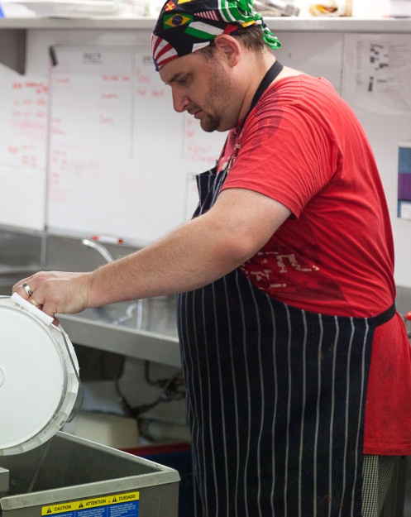
CAP OR HAIR NET
To make sure hair does not fall into the food

APRON
- Protects your clothes from stains
- Change it as soon as it gets dirty
SHOES
- Strong, comfortable
- Clean and polish them to stop food sticking to them
- Non-slip soles because floors can be slippery

Looking after your uniform
Do you have a uniform in your workplace? If you do, the following will help.
- Your uniform might be washed at work. If you have to wash it yourself, use hot water and a sanitiser.
- Iron your uniform. This can help kill germs and also looks professional.
- Don’t wipe your hands on your clothes. Use a paper towel instead.
- Don’t wear your work clothes to travel to work. This includes shoes, as they can gather germs on the way. This is a legal requirement.

Are your hands clean?

Did you know?
In 2009 the Food Safety Information Council oberved 200 people in the food hall of a shopping centre. 29% of men and 8% of women did not wash their hands after using the bathroom.
From the Food Safety Information Council
<www.foodsafety.asn.au>

How hands can pass on germs
You can get germs on your hands in many ways, such as when you go to the toilet, touch raw food or touch any part of your body. You can’t see these germs.
A lot of germs can be passed on to other people or food through your hands. You can pass these germs on to other people by touching them e.g. shaking their hand or by touching food that they will eat.
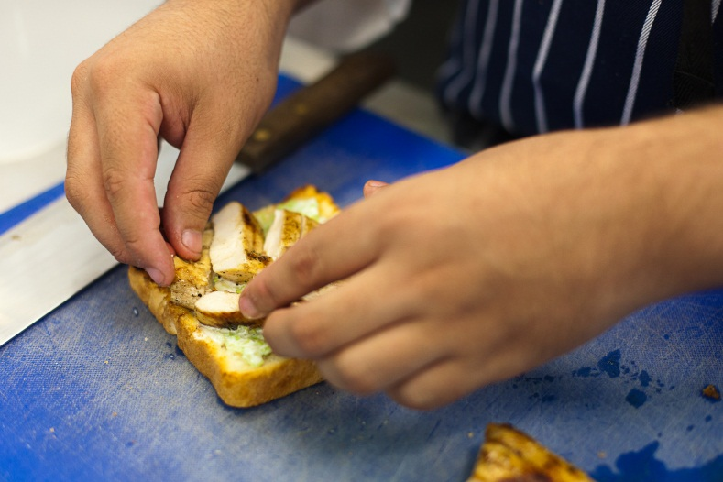

Activity 9
Hands can pass on germs
Look at these photos.
Can you tell a story of how germs could be passed on from hands to food?
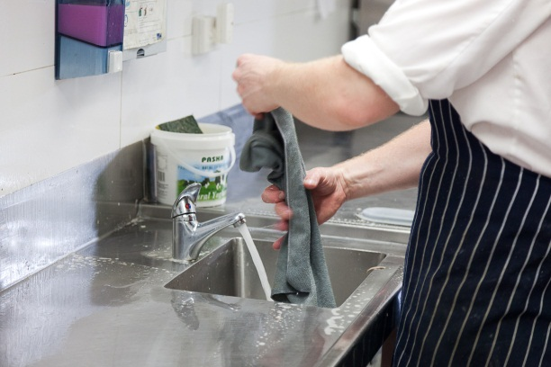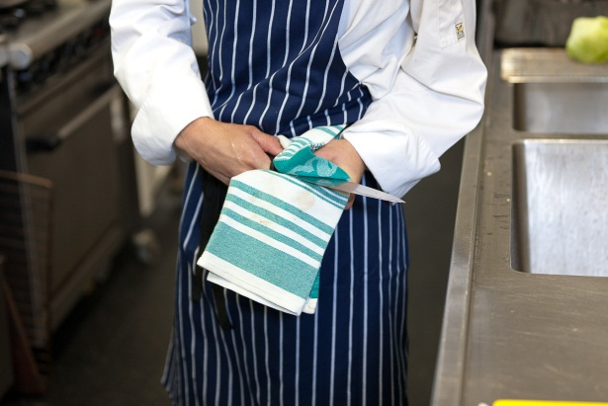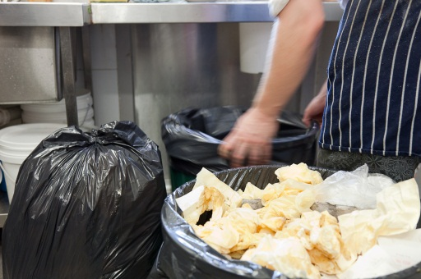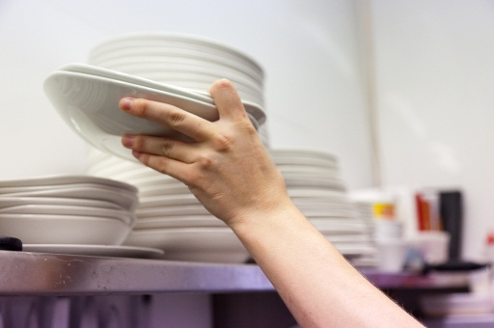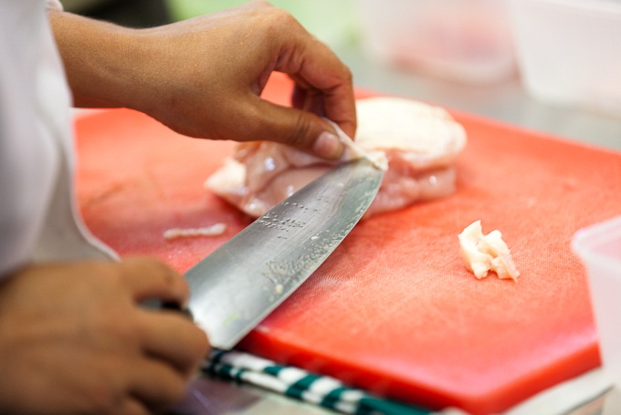

When should you wash your hands?
Washing your hands might seem like a waste of time if you are in a hurry or if your hands LOOK clean. But they could still be covered with germs.
So it is important to wash your hands often and properly to stop the spread of germs.

You must ALWAYS wash your hands at these times.

BEFORE
- At the start of your shift.
- Before handling any food.
- When you return from a break.
- Every time you come into a food preparation area, even if you washed your hands after going to the toilet.

AFTER
- After you have been to the toilet.
- After handling anything else other than food e.g. money, cleaning cloths, cleaning equipment or rubbish bags.
- After handling raw ingredients, such as raw chicken.
- After coughing, sneezing or blowing your nose.
- After eating or drinking.
- After smoking.
- After touching your body or face e.g. scratching, fiddling with your hair, picking your nose or rubbing your face.
- After handling animals.

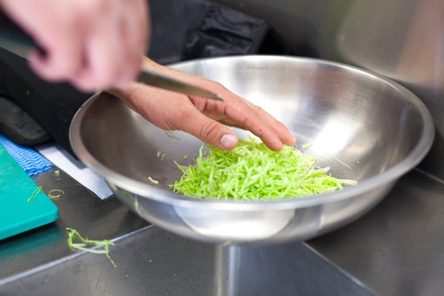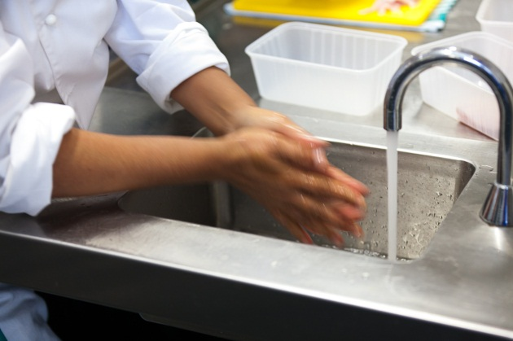

Where should you wash your hands?
There should be a special sink where you only wash your hands and nothing else. Don’t wash your hands in a basin where food is prepared and washed.
Often you can turn the tap on with your forearm, elbow, foot or knee. This means you won’t get germs on your hands from the tap.
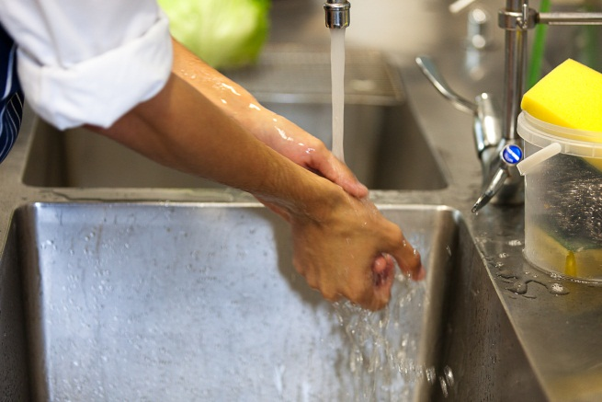
Obey any hand washing signs in your workplace.
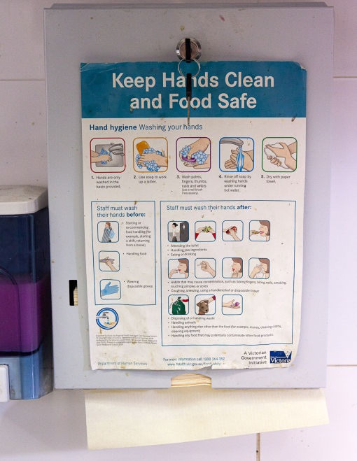

Wash your hands correctly
Washing your hands in a food workplace is different from how you might do it at home.
You must follow this process every time you wash your hands at work.

Step 1  Wet your hands with warm water. | 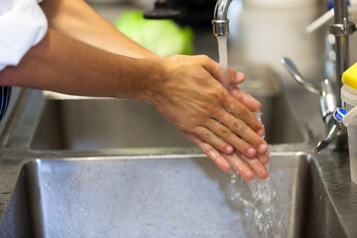
Step 2  Use soap to work up a lather. | 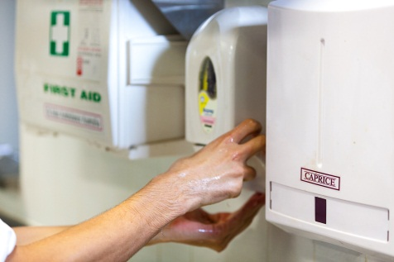
Step 3  Rub back and front of your hands for at least 20 seconds.  Clean between your fingers and under your nails.  Rub your wrists and lower arms.  Don’t forget your thumbs. | 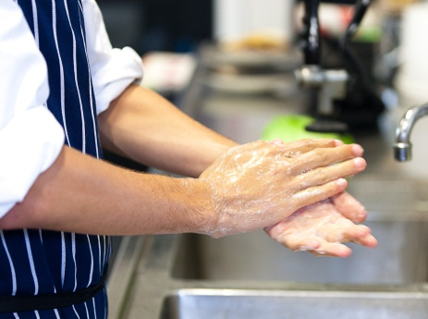
Step 4  Rinse off soap under running warm water. | 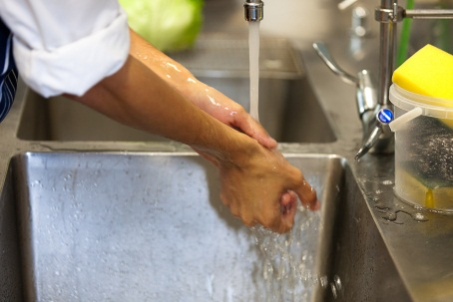
Step 5  Dry thoroughly with a clean paper towel. | 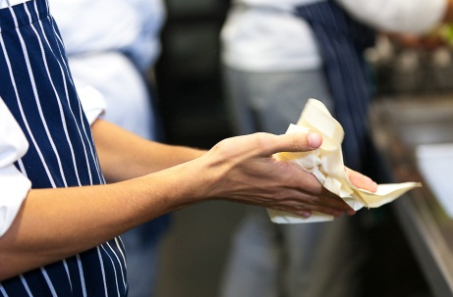

Activity 10
Practise hand washing
Take turns to practise washing your hands correctly.
Watch your partner and let them know if they leave something out.
Then they can do the same for you.

Wearing gloves
Wearing disposable gloves (ones that can be thrown away) will help prevent the spread of germs.

Wash and dry your hands before putting on the gloves.
Change your gloves often, for example:
- after you touch something that could spread germs e.g. putting out the bins or cleaning the floor
- if they get a hole in them
- after you handle raw food and change to handling ready-to-eat food
- after you finish one task and before you start a different one e.g. you put out a rubbish bag, then you plan to clean a bench.

NOTE
Just because you wear gloves does not mean you can’t contaminate anything.
You need to change your gloves as often as you would wash your hands.

What if you cut your finger?
It is easy to cut yourself in kitchens. Cuts can pass on germs from your blood.
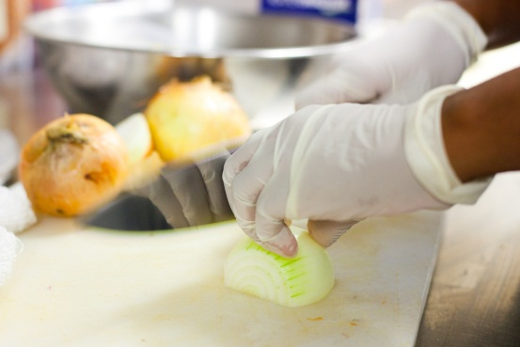

Put antiseptic on a cut so it does not get infected, and cover it with a clean bandage or bandaid. Then tell your supervisor.

Bandaids used for food preparation are bright blue so they can easily be seen if they fall off into the food.

The bandaid should be covered with a glove, bandage or finger glove to keep the cut dry and away from any food you handle. This will also stop the bandaid falling off.

What if you are sick?
If you are sick and you handle food, you can pass the germs on to the food and make people who eat it sick. It could be a cold (coughing or sneezing) or a tummy upset. Any illness that makes you vomit or have diarrhoea is very infectious (other people can catch it easily).
If you are sick:
- you must not touch food or be near food
- you must tell your supervisor at work.
The supervisor may tell you to stay home until you are better, or give you other work to do away from food.

If you accidently sneeze or cough on food, or bleed on food from a cut, you must tell your supervisor so the food can be thrown out.

Activity 11
Give Marcia some advice
Marcia has just started work and is learning what to do.
If you see Marcia do any of these things, what advice should you give her?
- Marcia cuts her finger and it is bleeding. | Marcia, I’ll tell you how we do things here …
- Marcia sneezes while she is preparing a sandwich on the kitchen bench.
- Marcia sneezes into a tea towel. | Marcia, did you know that …  Hi Marcia, can I help you? …
- Marcia is sitting on a chair looking pale. She says she feels a bit sick.
- Marcia has a quick cigarette while she is unpacking the meat delivery.

Activity 12
Telling your supevisor
If you are sick and think you can’t come to work, you should always ring work and tell your supervisor.
Your trainer will organise an activity so you can practise doing this.

Section summary
Now you have completed this section you should have developed the following skills and knowledge.
Tick each box if you are satisfied that you have those skills and knowledge.
Understand the importance of personal hygiene.
Understand the importance of keeping your clothes clean.
Wash your hands thoroughly.
Know what to do if you cut yourself.
Know what to do if you are sick.
Notes

3 Food safety
Food safety is how to make sure that food is safe to eat. Things that make food unsafe to eat and make the workplace dirty are called hygiene hazards.
Some hygiene hazards are:
- poor staff hand washing and personal hygiene
- poor cleaning practices, dirty equipment and utensils
- food stored at the wrong temperature
- poor procedures for receiving food deliveries
- food cooled incorrectly
- pests e.g. insects, rats and mice
- poor procedures for disposing of dirty linen and rubbish.

What rules do you have at work?
Your workplace has to follow the law about food safety and hygiene. There will be workplace procedures (ways of doing things) for you to follow to make sure you do things properly.

Your workplace has to give you the correct training.
Your supervisor may show you what to do when you first start work (induction).
There will also be posters and signs around the workplace to remind you of correct procedures.
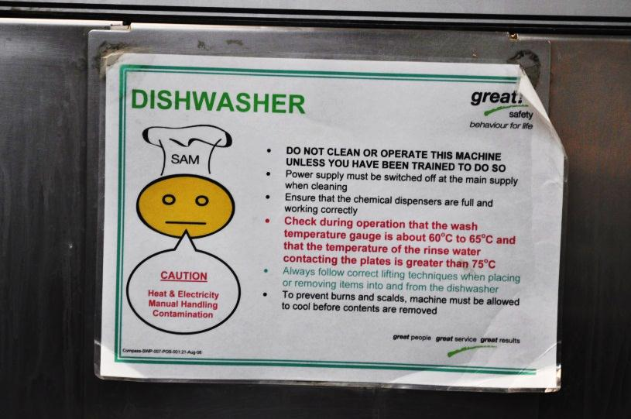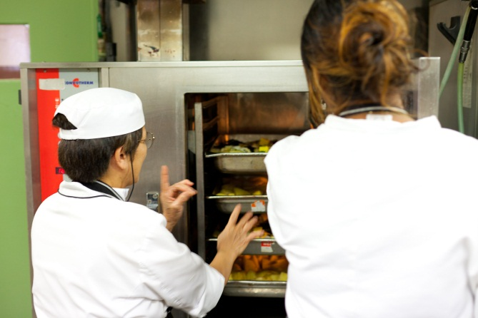

Activity 13
Following workplace procedures
1 What food handling tasks have you been given at work?
2 How did you find out what to do?
Supervisor told me
Given a written procedure to read
Workmate explained to me
Read signs in the workplace
Other ____________________________________________

Activity 14
Read the signs
Look at each sign below.
1 What is it telling you to do?

2 Why do you think you have to do this?
You can write down the answer, or tell your trainer or someone else in your group.
Sign | What does it tell you to do? | Why should you do it  this way?
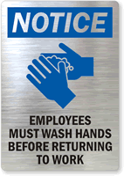

Activity 15
Signs in your workplace
1 What signs are there in your workplace, especially in the food preparation area?

2 What do they tell you to do? Write your answers, or talk about them to your trainer or another learner.
How do you keep food safe for eating?
Sometimes you can tell straight away if food is not safe to eat. It may look, smell or taste bad e.g. milk that smells bad or bread that is mouldy. This food is spoiled.
But you can’t always tell if food is unsafe. Food can have germs in it that you can’t see or smell. These germs can multiply quickly and cause food poisoning.
So you must make sure that all food is stored, prepared, cooked and served safely.

Which foods spoil easily?
Germs grow more easily on some foods than others, so some foods need special treatment. The foods that spoil most easily are high in:
- moisture (water)
- protein (mainly in meats like chicken, beef, lamb and fish)
- fat.

Here are some examples.

Raw meat and poultry | 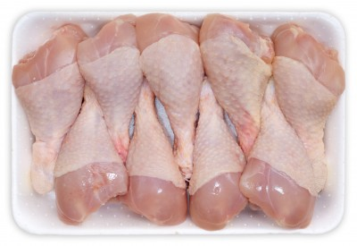
Smallgoods, such as ham and salami | 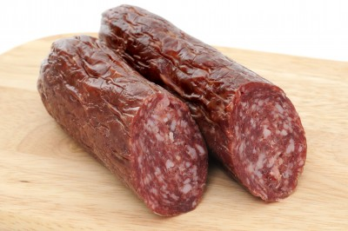  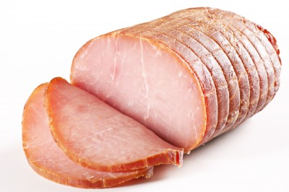
Dairy products, such as milk and custard | 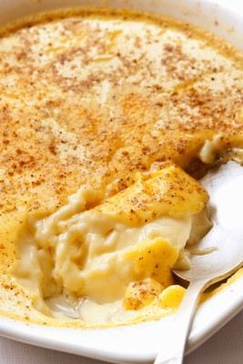
Seafood | 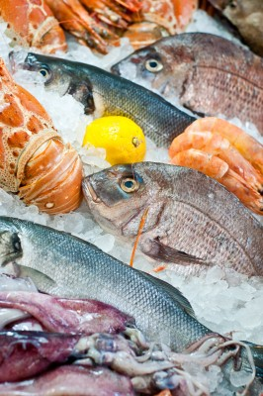
Processed fruits and vegetables, such as salads | 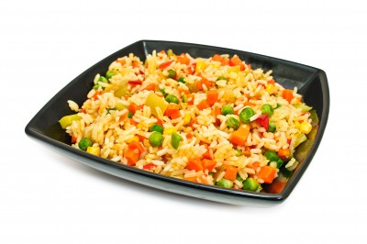
Cooked rice | 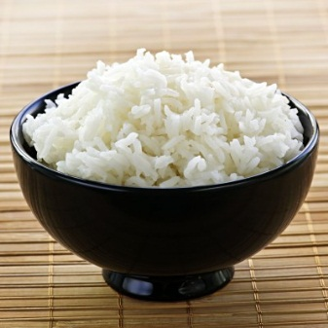
Eggs | 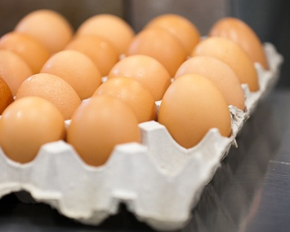

Did you know?
In the right conditions, a single food poisoning bacterium can grow into more than two million bacteria in just seven hours.

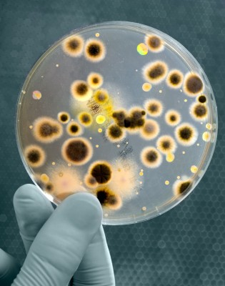

Preventing contamination of food
If fresh food is prepared safely and eaten soon afterwards, people usually don’t get sick from eating it.
You must follow your workplace procedures and make sure the food you handle is safe to eat.

Here are the main ways to prevent contamination of food.
1 Keep food at the correct temperature.
2 Prevent cross-contamination.
3 Wash fruit and vegetables carefully.
4 Make sure objects don’t fall into the food.
5 Keep chemicals away from food.

Let’s look at these one by one.

1 Keep food at the correct temperature
If food is stored, cooked or served at the wrong temperature, germs can quickly multiply. You need to know the correct temperatures so that you can tell your supervisor if you see something wrong e.g. fridges or freezers at the wrong temperature or food left out of cold storage for too long.
Here are the guidelines for correct food temperatures.
Hot food  High risk food must be cooked so that the centre reaches 75°C or more.  Must be kept at 60°C or hotter. | 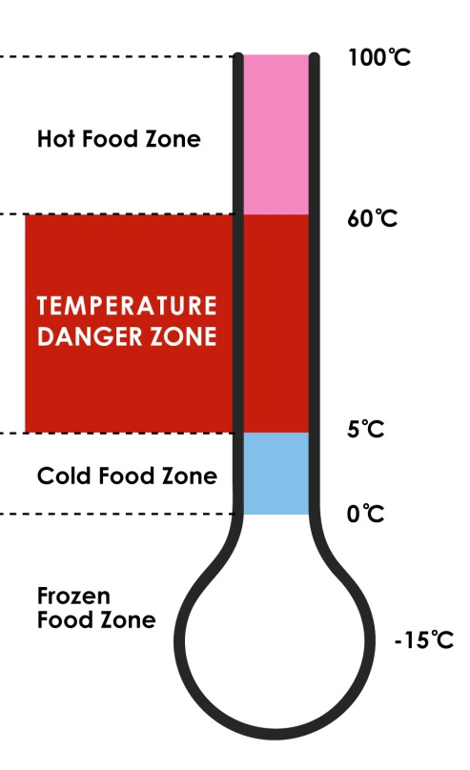

Danger zone
Food between 5°C and 60°C is in the danger zone – germs will grow easily and quickly on food at these temperatures.

Cold food
Must be kept between 0°C and 5°C.

0°C to -15°C

Frozen food
Must be 15°C or colder. This figure may differ between states and territories.
Food is often kept ready for eating in a water bath or bain marie. Check the temperature regularly to make sure the food stays in the hot zone and does not cool into the danger zone.

Cooling cooked food
- Cool cooked food from 60°C to 21°C in the first 2 hours.
- Then put it in the fridge or freezer.
- The food must cool to 5°C or lower (cold food zone) in the next 4 hours.
- Divide large amounts of food into smaller containers so they cool more quickly.

Reheating food
- Food must be reheated to 75ºC within one hour. Don’t reheat food in a bain marie – it is not quick enough.
- Use a probe thermometer to regularly measure the temperature of different parts of the food, including the thickest part of the food.
- Only reheat cooked food once.
- Stir or mix food to make sure the food is evenly heated and there are no cold spots.
- Pre-heat oven or grill when reheating. Otherwise it may not be quick enough.

Thawing frozen food
- Frozen food should be thawed in the fridge or in a microwave.
- In the fridge, keep it separate from cooked or ready-to-eat food.

Activity 16
Fridge and freezer temperatures
Look at these pictures of fridge and freezer thermostats.
Which ones are on fridges and which are on freezers?
Are they all in the correct temperature zones?
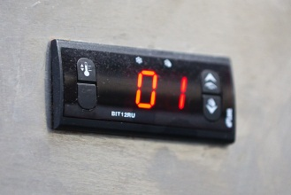
Activity 17
Correct food temperatures
1 Some rice is cooked at 12 pm for lunch on Tuesday. The chef tells you to put the leftover rice in the fridge at 1.30 pm after lunch is over.
a) What temperature should the rice be at by 2 pm?
b) What temperature should the rice be at by 6 pm?
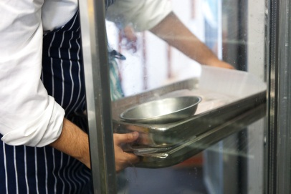

2 Can you use half the rice again on Wednesday for a cold rice salad at lunchtime?

YES / NO

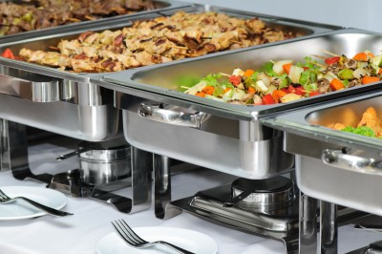
3 Can you reheat the rest of the rice on Wednesday night to go with a curry at dinner time?

YES / NO

4 If YES - How would you reheat it?
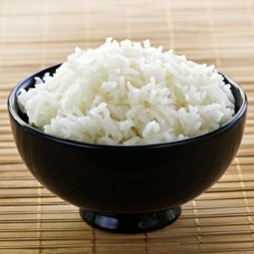
5 Should you keep the little bit that is left to microwave for your own lunch on Thursday lunchtime?

YES / NO

Activity 18
Your workplace fridge
Find out this information in your workplace and make notes.
1 What is the temperature of:
a) the fridge or fridges?
b) the freezer?
2 Are they at the correct temperature? _______________
3 How is hot food kept at the correct temperature?
4 How is cooked food cooled and stored?

2 Prevent cross-contamination
You have already seen how cross-contamination happens when germs from one place pass to another place e.g. on food surfaces, hands, linen or equipment.
Here are some actions to prevent cross-contamination of food in the workplace.

Activity 19
Prevent crosss-contamination of food
Tick the boxes for the actions you can see in your workplace.
If you are in different workplaces, compare to see how things may be done differently.
Action | Done in my workplace | Not done in my workplace | Does not apply
1 Store ready-to-eat food and raw food in different refrigerators or freezers.
2 In the fridge, store ready-to-eat food in covered containers.
3 In the fridge, store ready-to-eat food above raw food.
4 In the fridge, store ready-to-eat food in a separate part of the refrigerator from raw food.
5 Use separate utensils (e.g. knives and serving spoons) when preparing and serving different types of food.
6 Use colour coded cutting boards.
7 Wash hands frequently.
8 Cover food so dirt can’t get into it.
9. Use blue bandaids on cuts.
10 Everyone wears a clean uniform and other clothes.
11 No jewellery allowed.
12 Tea towels never used for cleaning tasks.
13 Other?

3 Wash fruit and vegetables carefully
Fruit and vegetables must be washed carefully in clean water. This washes off dust, sand, dirt, packaging materials or insects in the food. It also washes off chemicals that may have been sprayed on the food.
If these things are not washed away, they could make someone sick or injure them.
Wash everything, even if it says ‘ready-to-eat’ or ‘pre-washed’.

Some guidelines for washing fruit and vegetables
- There may be a special sink for washing fruit and vegetables. If there is, make sure you always use this sink.
- Use cold running water.
- Rub soft fruit or vegetables gently e.g. tomatoes.
- For harder things, use a vegetable brush e.g. carrots or potatoes.
- Get dirt out of any cracks or creases.
- Before washing, cut out any damaged parts and remove outer leaves or stalks e.g. outer leaves of a lettuce.
- Don’t use soaps, detergents or bleaches.
- Dry with paper towels.
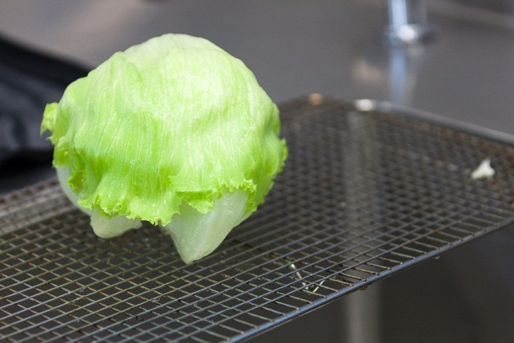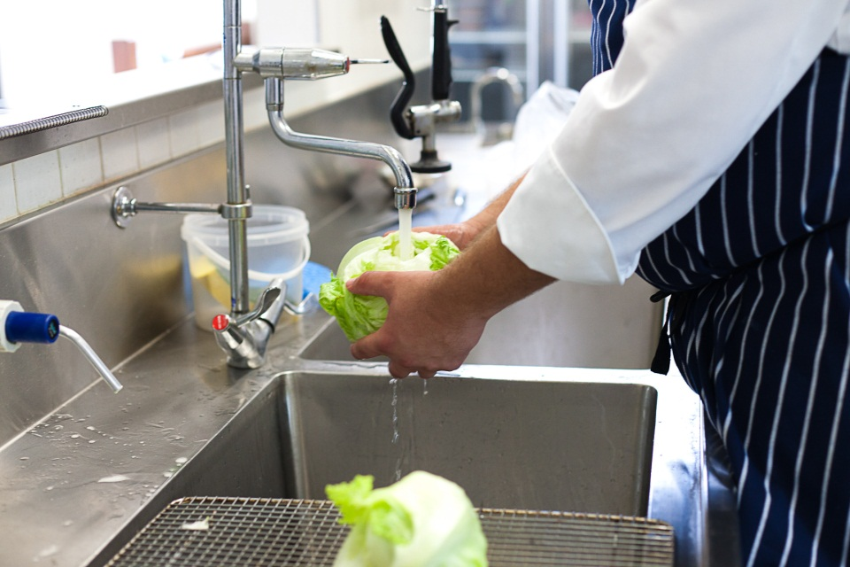

Activity 20
Washing fruit and vegetables
Wash a piece of fruit or a vegetable. As you do it, tell another learner what you are doing and why.

4 Make sure objects don’t fall into the food
Some things that could fall into food are:
- bandaids from a cut finger
- hair, if it is not covered or tied back
- insects
- parts of packaging when you are opening a packet of food
- dirt from a shelf or stove hood above the food
- glass or crockery chips from something that has broken.
To prevent this, cover any food that has been prepared and follow all personal and food hygiene guidelines.
If you notice that something has fallen into food, tell your supervisor immediately.

5 Keep chemicals away from food
Chemicals e.g. cleaning products should have their own separate storage. Keep all chemicals away from food.
If you are cleaning a food preparation area, remove the food from the area so that it does not get contaminated by the chemicals.
Rinse chemical residue (what is left over) off utensils, cooking equipment and food preparation benches. Wipe down thoroughly with single use cloths.

Section summary
Now you have completed this section you should have developed the following skills and knowledge.
Tick each box if you are satisfied that you have those skills and knowledge.
Find out about food safety in your workplace.
Keep food safe to eat.
Notes

4 Keep the workplace clean

Cleaning and sanitising
Keeping your workplace clean is called environmental hygiene. It will help keep the food safe to eat. There are two main processes used to keep the workplace and equipment clean.

Cleaning
Cleaning means getting rid of dirt you can see. This could be grease, food scraps, dust or something that has been spilt.
But there may still be germs on the surface so you may need to take another step, called sanitising.

Sanitising
Sanitising means reducing the number of germs that you can’t see. This is very important for food preparation areas and equipment.

Cleaning schedule
It may be part of your job to regularly clean all or part of your workplace so that there are no food hygiene hazards.
All areas should be cleaned regularly, including:
- benches and cutting boards  - floors and walls  - utensils  - equipment and machines  - refrigerators and cool rooms | - storerooms  - sinks and wash basins  - crockery and cutlery  - linen e.g. tea towels and cloths.

Your workplace may have a cleaning schedule or plan that tells you about each job. A cleaning schedule should tell you:
- what areas to clean
- when to clean
- how to clean
- who does the cleaning.
Following is a part of a cleaning schedule for the Sunrise Café.

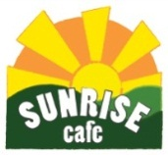 |  | Sunrise Café Cleaning Schedule
Area | How often |  | When | How | Equipment | Products | Who
Benches | Twice daily  and between raw and cooked foods |  | Morning and afternoon  Minimum every  4 hours | Wash  Sanitise | Soft cloth  Bucket of warm water | XY detergent  AB sanitiser | Joe
Utensils | After use  and between raw and cooked foods |  | As required  Minimum every  4 hours | Wash  Sanitise | In dishwasher  If by hand, use clean sponge and warm water with detergent and then sanitiser in sink | XY detergent  AB sanitiser | Joe
Meat slicer | Twice daily  and between raw and cooked foods |  | Morning and afternoon  Minimum every  4 hours | Take apart before washing  Read the instructions on the slicer  Wash  Sanitise | Soft brush for cleaning small areas  Clean sponge  Soak in sink of water or use dishwasher | XY detergent  AB sanitiser | Joe
Bain marie | Daily  and as required |  | Before close | Make sure it is turned off  Read the instructions next to the bain marie  Wash  Sanitise | Clean sponge  Soft brush for hard to get to areas  Use clean bucket of water | XY detergent  AB sanitiser | Joe
Floors | Daily  and as required |  | Before close | Sweep and mop  Sanitise | Floor mop and bucket  Change water as needed | XY detergent  FJ sanitiser in spray bottle | Susan

Activity 21
Your workplace cleaning schedule
Look at a kitchen or restaurant cleaning schedule from your workplace.
Choose 3 areas that need to be cleaned.
Use the information to fill in the table below.

Area to be cleaned | How often | When | How

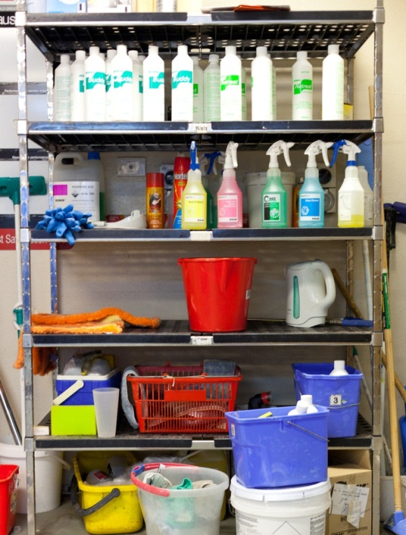
Cleaning products and equipment

Cleaning products
Cleaning products include detergents, sanitisers and disinfectants.
All chemicals must be kept away from food.
Cleaning products must be stored in a separate area, such as a locked cupboard.

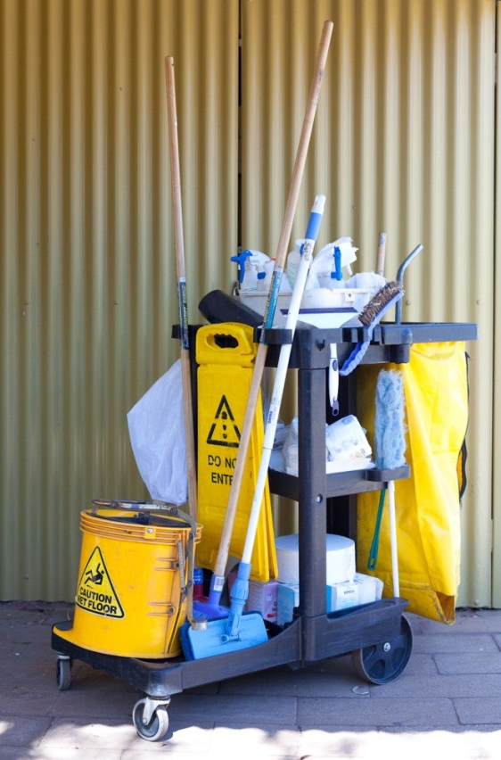

Cleaning equipment
Cleaning equipment includes brooms, mops, vacuum cleaners, brushes, buckets and cleaning cloths.
They should be clean and in good condition.

Steps for cleaning
Here are some general steps for cleaning. Each workplace will have its own workplace procedures, which may be a bit different.
- Pre-clean | Loosen or remove any dirt you can see e.g. rinse dirty plates with a pressure washer and sweep dirt from the floor.
- Wash and rinse | Use detergent and warm water to get rid of the rest of the dirt you can see.
- Sanitise | Use a sanitiser to kill most of the germs you can’t see.  You can use:  - a spray-on chemical sanitiser; – you must rinse it off afterwards from food preparation surfaces  - heat – a dishwasher gets hot enough to sanitise kitchen utensils and equipment.
- Dry | Air dry or dry with a single use cloth or paper towel.  Don’t wipe things dry with a cloth. This can transfer germs from the cloth back onto the equipment.

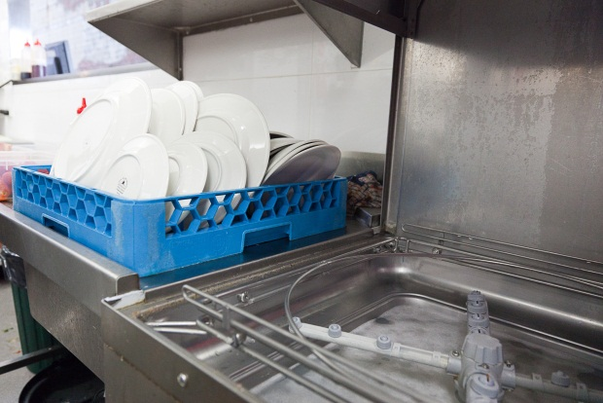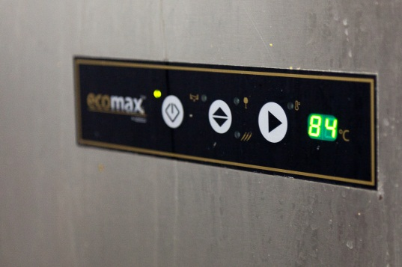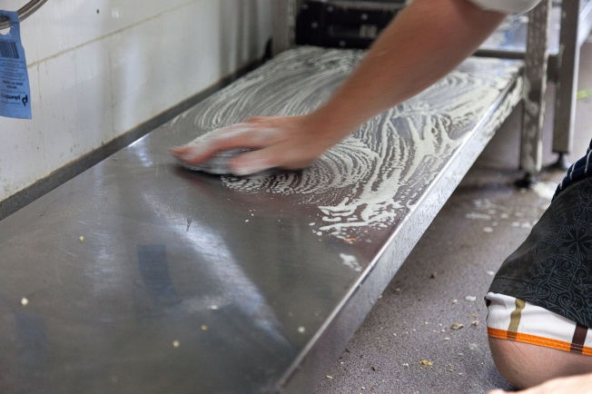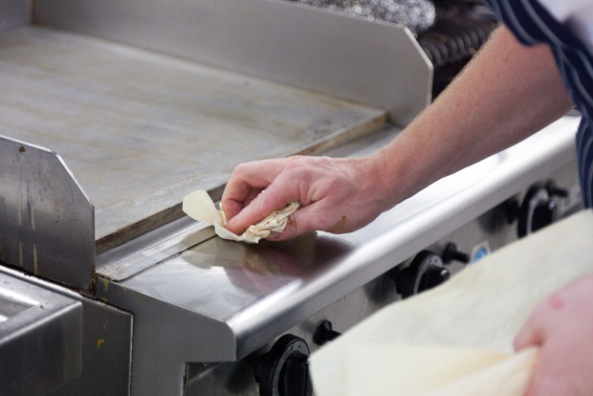

Activity 22
Cleaning at your workplace
In your workplace:
1 Where are the cleaning products and equipment stored?
2 Does the equipment look clean and in good condition? For example, does anything need to be:
- replaced?
- relabelled?
- cleaned?
3 Do you have any other suggestions to improve the equipment?
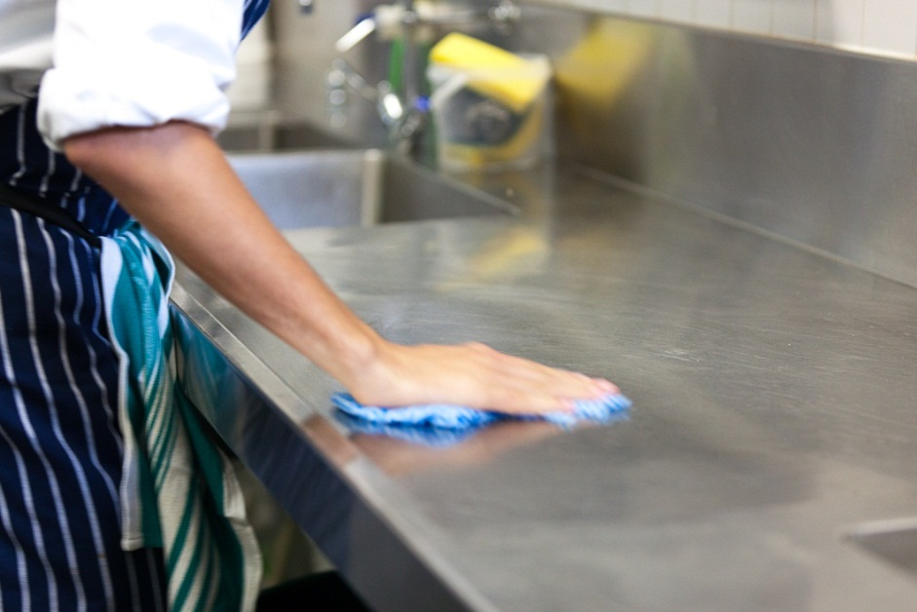

Washing linen
Whatever work you do in the hospitality industry, you will use cloths of some sort. These cloths are often called ‘linen’ although they can be made out of different materials.
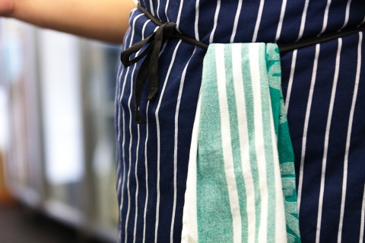
In food services, linen can include:
- tea towels
- chef’s cloths
- aprons and other uniforms
- tablecloths
- napkins.
In accommodation services, linen can include:
- sheets and pillow cases
- towels, bath mats and facecloths.
Linen must be washed and stored properly so there is no cross-contamination.
Germs in linen can be killed by the high temperature in industrial washing machines, by chemicals e.g. bleach, and with the heat of ironing.

Wear gloves
Germs from linen can be passed on to other people, equipment or food. If you handle any used linen, wear gloves so you don’t infect yourself and don’t pass on germs to other surfaces. Change them as required.

Sorting linen

Linen needs to be sorted into bags for washing.
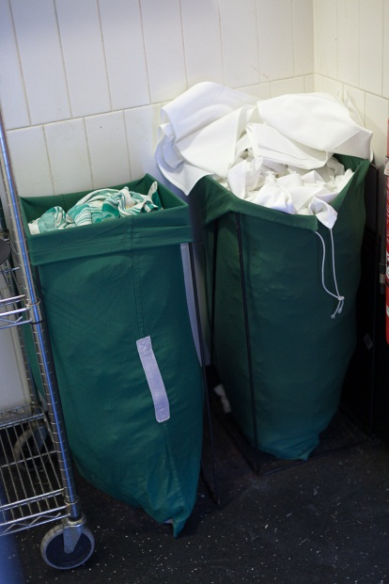

If linen is stained with human body fluids e.g. with blood or vomit, it should be put it in a biohazard waste bag so that it can’t contaminate other surfaces or people. These waste bags are usually red.

Activity 23
Handling linen at your workplace
1 How is linen washed in your workplace?
2 Who is responsible for this task?

Dealing with rubbish
Food waste and other rubbish can encourage pests and contaminate food. Your supervisor will tell you what to do with rubbish and you must follow the procedures.
Here are some guidelines for handling rubbish.
Rubbish bins must:
- be lined
- be emptied regularly before they are overfilled
- have a tight-fitting lid, to stop pests such as flies and rats feeding on the food scraps.

You must:
- wear gloves when handling rubbish
- wash your hands after you have touched the rubbish bin, even if you have been wearing gloves
- change your apron or overalls after you take rubbish to the outside bins, before going back into the food preparation area.

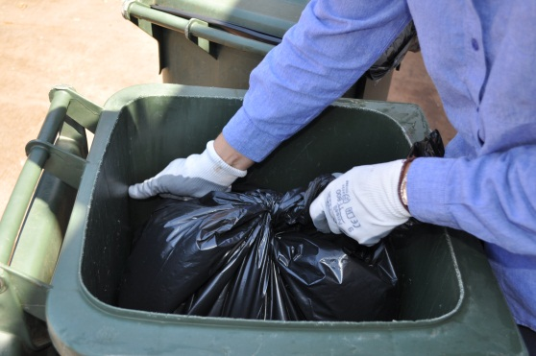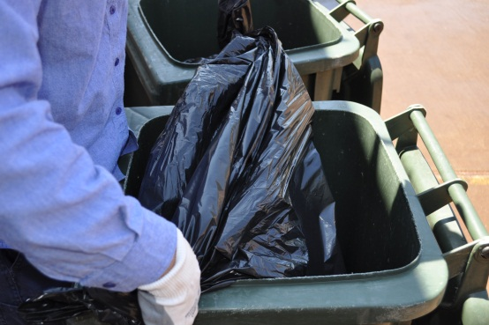

Activity 24
Handling rubbish at your workplace
1 Are the bins in the kitchen covered and lined in your workplace?
2 How often are they emptied?
3 How often are they washed?
4 Whose job is it to empty and wash the bins?

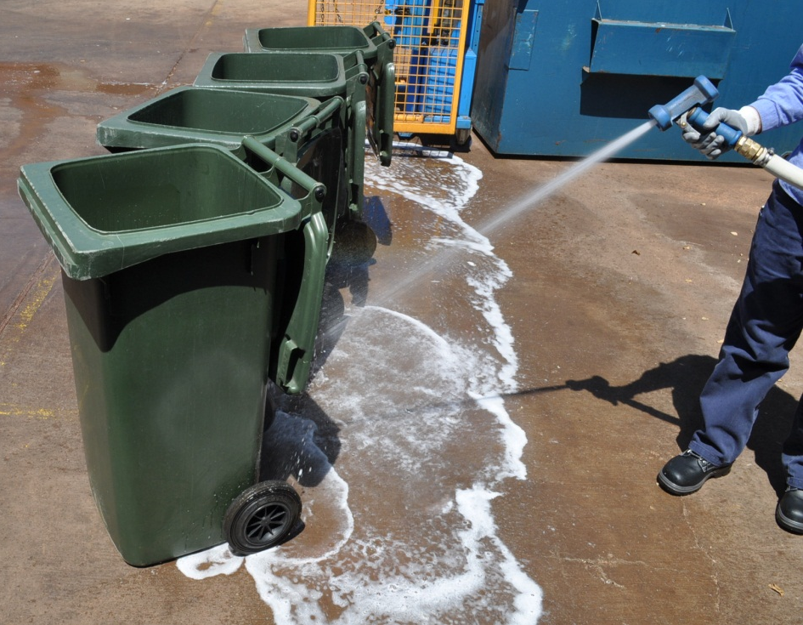

Pests in food businesses
Pests are things like mice and rats, birds, moths, animals, spiders, flies, cockroaches and other insects. Food businesses have to control them because they contaminate food and spread disease.
If pests are found at your workplace, the workplace could be fined.
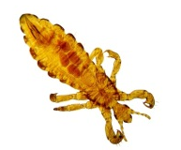 | 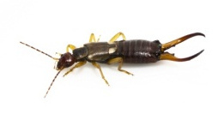 |  | 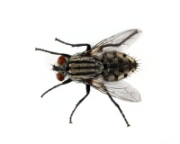
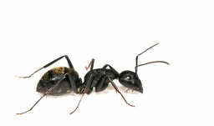 | 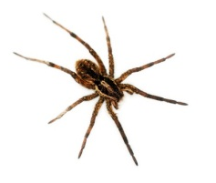 | 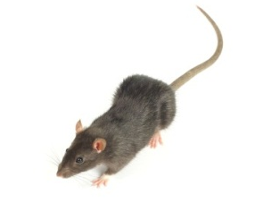 | 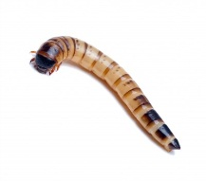

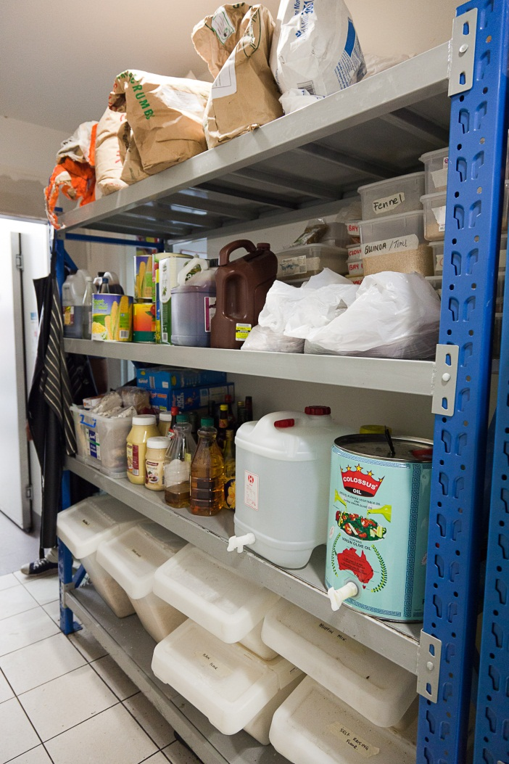
Controlling pests
If your workplace is kept clean, food is stored properly and there is a method of pest control, then pests will probably not be a problem.

Follow any workplace rules and procedures for the control of pests.

If you notice any pests, or signs that pests have been around, ALWAYS tell your supervisor.

Activity 25
Controlling pests at your workplace
Here are some ways of controlling pests. Use the list as a checklist for your own workplace.
Tick the box if the method is used in your workplace. Comment if it is not.
If you are in different workplaces, compare to see how things may be done differently.
Method of pest control |  | Comment
1 Keep food storage areas clean.
2 Store food in sealed containers so that pests can’t smell it.
3 Put fly screens on windows or doors.
4 Check for holes or cracks in walls where rats, mice or insects could get in or breed.
5 Use bait or traps.
6 Inspect food storage areas regularly for signs of pests e.g. mouse droppings, spider webs or nibbles in packaging.
7 Throw out any food that shows signs of pest damage e.g. insects in the flour or nibbles in packages.
8 Never let animals (e.g. pets) into an area where food is prepared or stored.

Activity 26
Dealing with pests
What would be the best way of dealing with these pests in a workplace?
Pest problem | What should be done?
1 There are mouse droppings in the food storage area.
2 A bag of flour has been nibbled by something at the corner. No flour seems to have been touched.
3 You see a fly walking across the raw food that is ready to be cooked.
4 The flyscreen door on the kitchen is propped open while staff move new stock into the fridges.
5 There are spider webs in the corner of the crockery cupboard.
6 Someone has brought their little pet dog to work at lunchtime to show a friend.

NOTE
Don’t spray insect killer around food. It could contaminate food and make it unsafe to eat.

What should you do if you notice something wrong?
You must follow your workplace’s hygiene and food handling procedures, doing everything that you have been shown.
If you see a small hygiene hazard, you might fix it yourself.
If you see something bigger that looks wrong, tell your supervisor.

Activity 27
Dealing with hygiene hazards
Look at each hygiene hazard below.
Could you fix it yourself? Or should you tell your supervisor?
Hygiene hazard | Fix it  myself | Tell my supervisor
1 The liquid soap dispenser is empty.
2 There is mouldy bread in the bread bin.
3 A workmate is coughing and blowing his nose in the kitchen.
4 You notice someone cutting raw chicken, then using the same cutting board and knife to cut tomatoes.
5 Raw chicken is on the shelf above a pasta salad in the fridge.
6 You see a cockroach in the dry goods storage area.
7 The fridge is at the wrong temperature.
8 A workmate has worn the same dirty uniform all week.
9 The rubbish bin is overflowing.
10. People are starting to throw dirty cloths on a corner of the food preparation bench.

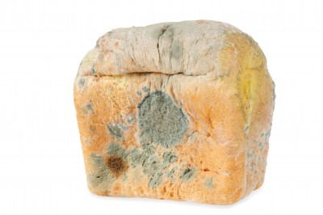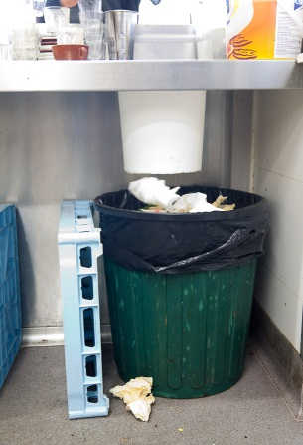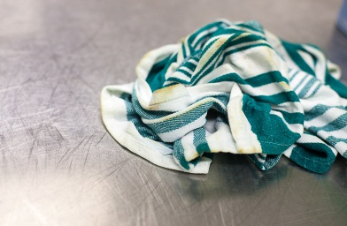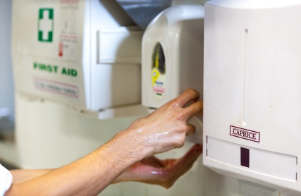
What should I do?

Activity 28
What should I do?
Your trainer will give you each a card with a situation to think and talk about.
What could happen if you did not point out the problem?
Say what you think you would do. Share ideas in the group.

Section summary
Now you have completed this section you should have developed the following skills and knowledge.
Tick each box if you are satisfied that you have those skills and knowledge.
Find out about environmental hygiene in your workplace.
Keep the workplace and equipment clean and hygienic.
Know what to do if you notice something is wrong.
Notes

Key words
Word | Meaning
bacteria | Germs you can’t see. Some bacteria don’t harm humans, but others can make us sick if they multiply in food we eat
contamination, contaminated | When something gets into food that should not be there. It can make someone sick or injure them if they eat it
cross-contamination | When germs that may be in one place (e.g. on food, benches, hands or equipment) pass to another place (e.g. Food)
detergent | Like soap, removes grease and dirt
diarrhoea | Having to go to the toilet a lot
disinfectant | A chemical used to kill germs on surfaces such as floors and toilets
disposable | Throw away after one use
environmental hygiene | Keeping the equipment and the premises, such as the kitchen, clean
food handler | Someone who is involved in any food activity e.g. preparing, cooking, serving or transporting food
food poisoning | An illness caused by eating contaminated food
food safety | Making sure that food is safe to eat
hazard | Something that is a risk or danger to people
hygiene | Being clean
induction | Training when you first start work so you know how to do things the right way
infectious, infection | An illness that can be easily passed on to other people
lather | Foam from soap or detergent
linen | Fabric items e.g. tea towels, aprons, tablecloths, sheets, pillow cases and towels
micro-organism | A very small living thing that can only be seen with a microscope e.g. bacteria and viruses
personal hygiene | Keep yourself and your clothing clean
pests | Unwanted creatures in food premises e.g. mice and insects
physical contamination | When an object is found in food that should not be there e.g. glass, a bandaid or a stone
premises | A place of business
procedure | A written list of steps telling you how to do a work task
raw food | Uncooked food
ready-to-eat food | Food that is ready to eat without more preparation
residue | What is left over
sanitise/sanitiser | To kill germs by using a chemical or heat
thermostat | A device that establishes and maintains the desired temperature automatically
utensils | Tools used in the kitchen e.g. knives, peelers, graters, mixers and serving spoons
virus | A micro-organism, a bit like bacteria

