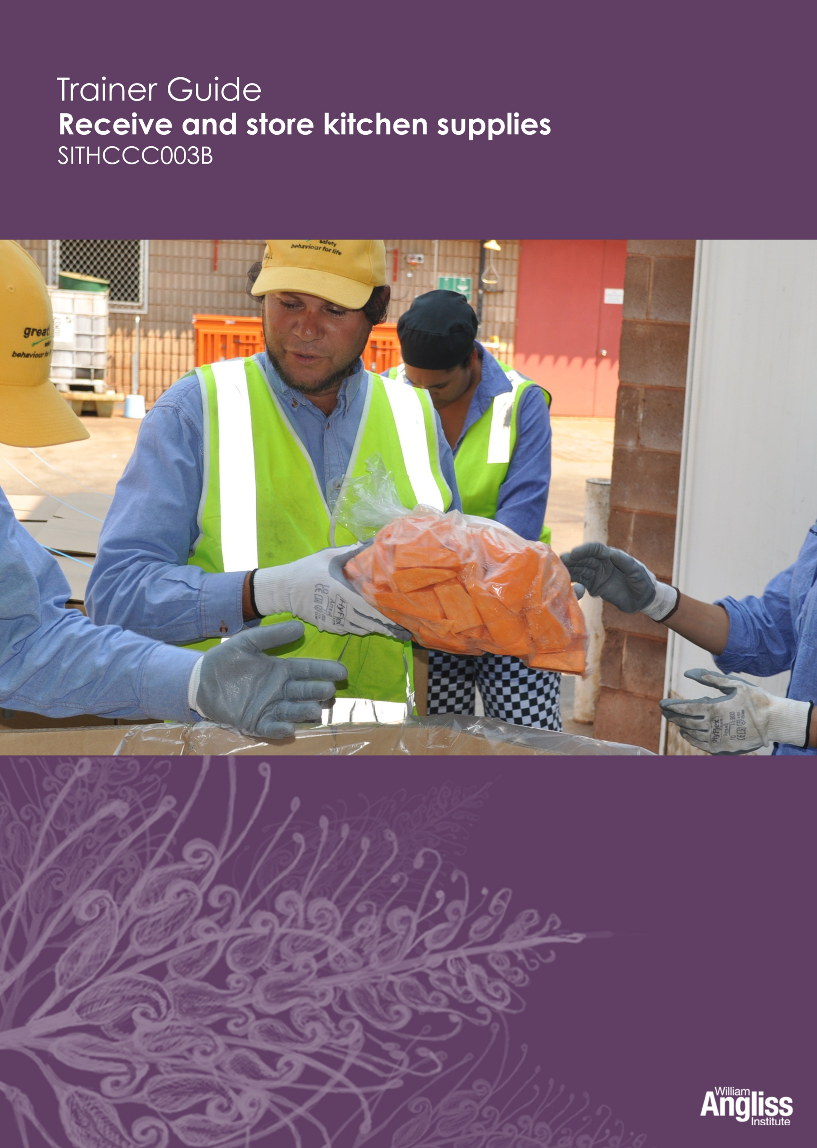

© Commonwealth of Australia. 2012
CC BY-NC-SA
This work is copyright. Except where otherwise indicated, and save for the Commonwealth Coat of Arms, the Department has applied the Creative Commons Attribution-Noncommercial-Share Alike 3.0 Australia Licence to this work.
The Department of Education, Employment and Workplace Relations must be attributed as the author of the Department’s copyright material.
As far as practicable, material for which the copyright is owned by a third party has been clearly labelled. The Department has made all reasonable efforts to ensure that this material has been reproduced in this resource with the full consent of the copyright owners.
Requests and enquiries concerning the Department’s copyright material should be addressed to:
The Copyright Officer
Department of Education, Employment and Workplace Relations
Location code C148CW2
GPO Box 9880 Canberra ACT 2601
Or emailed to copyright@deewr.gov.au
Funded under the Workplace English Language and Literacy (WELL) Program by the Australian Government Department of Education, Employment and Workplace Relations.
The views expressed in this publication do not necessarily represent the view of the Minister for Education or the Australian Government. The Australian Government does not give any warranty nor accept any liability in relation to the contents of this work.
ISBN 978-1-922108-06-7
Development Team
Content | William Angliss Institute  Macsmith and Associates
Disclaimer
Every effort has been made sure that this booklet is free from error or omissions. However, you should conduct your own enquiries and seek professional advice before relying on any fact, statement or matter contained in this book. William Angliss Institute of TAFE is not responsible for any injury, loss or damage as a result of material included or omitted from this course.

Contents
What is in this guide? 1
LLN requirements of the unit 2
Guide to the activities 3
Activity 1 Non-food supplies 3
Activity 2 Supplies in your workplace 3
Activity 3 Temperature and food 3
Activity 4 Your workplace storage areas 3
Activity 5 Use correct storage areas 4
Activity 6 Prepare for a delivery 4
Activity 7 Check documentation (1) 5
Activity 8 Incoming goods record 5
Activity 9 Check documentation (2) 5
Activity 10 Dealing with delivery problems 5
Activity 11 PPE for manual handling 5
Activity 12 What are they doing wrong? 6
Activity 13 Store things in the correct order 6
Activity 14 Storing supplies in your workplace 6
Activity 15 Dispose of spoiled stock 6
Appendix 7
Cards for Activity 5 7
Product cards 10
Resources for Activity 9 14

What is in this guide?
This Trainer Guide to Activities is part of a set of resources to support delivery of 9 units from qualifications in the SIT07 Hospitality Training Package.
The resources have 3 components:
1. Learner Workbook.
2. General Trainer’s Guide
This single guide contains information to assist trainers to understand:
- the purpose and design of the resources
- strategies for working with learners with lower LLN levels
- strategies for working with Indigenous learners
- strategies for designing and conducting assessment appropriate to these learner groups and AQF levels.
3. Trainer’s Guide to Activities
There is one of these for each unit. It contains:
- a summary of the LLN requirements of that unit
- advice on using the Learner Workbook activities for that unit.
This Trainer Guide to Activities supports the highlighted unit.
- SITHIND001B Develop and update hospitality industry knowledge
- SITXCOM001A Work with colleagues and customers
- SITXCOM002A Work in a socially diverse environment
- SITXOHS001B Follow health, safety and security procedures
- SITXOHS002A Follow workplace hygiene procedures
- SITHACS005B Prepare rooms for guests
- SITHACS006B Clean premises and equipment
- SITHCCC003B Receive and store kitchen supplies
- SITHCCC004B Clean and maintain kitchen premises

LLN requirements of the unit
SITHCCC003B Receive and store kitchen supplies
Skill | Applications
Reading | Read and check delivery documentation against order specifications, including quantity, size, weight, use-by dates and discrepancies
Speaking and listening | Report any problems
Writing | Complete records relating to deliveries  Record temperature checks  Record details of any damage, use-by dates, breakages or discrepancies  Record supply levels accurately  Complete reports on stock levels and quality  Report any problems
Numeracy | Use a thermometer correctly  Count and check quantities of stock  Compare and check numbers between two documents
Computer literacy | None
Research | None

Guide to the activities
This guide to the activities provides:
- advice on carrying out an activity where it may not be obvious from the design of the activity itself. When the design of an activity speaks for itself, comments are on possible variations, enhancements or extensions of the activity that would ensure it is useful for learners with lower LLN skills
- possible answers where this may assist the trainer to understand the intent of the activity.
Activity 1 Non-food supplies
You may need to prompt learners or suggest possibilities yourself to fill any gaps.
Give positive reinforcement to individuals who volunteer ideas. Ask quiet people early so all the obvious ideas are not gone, but not first so it is not too challenging for them.
You could draw the grid on the whiteboard, and write down the examples, or have learners write them in if they are confident. Learners can then copy this into their workbooks.
Activity 2 Supplies in your workplace
This activity will help build vocabulary about products used in hospitality.
Your approach to this activity will depend on the learners’ access to the workplace:
- Ask the learners to look at the stores next time they go into the workplace, and come back to the group with the table completed.
- Ask for ideas about what they remember.
- Ask them to imagine what stores would be used in a local hospitality business such as a hotel or café.
Activity 3 Temperature and food
Use the questions to discuss and reinforce the importance of temperature control. Encourage all learners to contribute.
Check that all learners have the underpinning knowledge and the language to express it.
Activity 4 Your workplace storage areas
Your approach to this activity will depend on the learners’ access to the workplace. See Activity 2.

Activity 5 Use correct storage areas
This is a more kinetic activity, with learners moving around. The cards for this activity are in the Appendix of this guide. Copy and cut out a set of the cards.
Learners are given a series of cards with names of kitchen supplies on them. They will have to decide where they go, and put them in the correction ‘storage area’.
Destination cards
There are 5 large Storage Area cards, which are the destinations for the incoming supplies - Fridge, Cool room, Freezer, Dry store and Chemical store.
Place them in 5 different parts of the room.
Product cards
There are 60 smaller product cards, covering a range of supplies that would be stored in the 5 areas.
- Divide the product cards up among pairs of learners, trying to ensure each pair gets a mix of types of supplies.
- Ask the pairs to move around the room, storing their supplies in the correct storage place. Encourage them to discuss with their partner why they are putting a product in a storage place. Don’t just follow others, but learners can rethink a placement and change it, as long as they can explain why.
- Remind learners that some products could go in more than one place e.g. fridge or coolroom.
- When learners have finished, read out what is each destination and ask whether there are any in the wrong storage place.
Alternative activities:
- Change the products or the destinations to suit a particular workplace.
- Use photos of the workplace storage areas and typical products instead of the cards.
Activity 6 Prepare for a delivery
Elicit suggestions from the group.
Give positive reinforcement to individuals who volunteer ideas.
Encourage discussion about the reasons and check that learners understand

Activity 7 Check documentation (1)
This is a reading activity which gives practice in checking the details of documentation.
Ask learners to do it in pairs. Move around the room checking for signs of difficulty, and give help where appropriate.
Don’t “correct it” publicly, as this will make it feel competitive.
If learners need extra practice, you can use the model and alter the order details.
Activity 8 Incoming goods record
This is a writing activity, giving practice in completing documentation.
If learners have difficulty with this activity, you could complete a form and ask them to copy it.
If learners need extra practice, you can use the model and alter the order details.
Activity 9 Check documentation (2)
Use the delivery docket and order form which are in the Appendix of this guide.
Divide the group into pairs, and give each pair a delivery docket and an order form.
Explain that some mistakes have been made on the delivery docket for Sunrise Café.
Ask them to work together to find out the mistakes, and mark them on the delivery docket. One has already been done.
If learners are in a workplace you could change the goods to reflect what is typically received at their workplace.
Activity 10 Dealing with delivery problems
This is a problem-solving activity. Elicit suggestions from the group. Give positive reinforcement to individuals who volunteer ideas. Discuss the pros and cons and check that all learners understand the reasons for a particular course of action.
Alternative activity: Small groups could work on 1 or 2 problems, and give suggestions orally or write them on a grid on the board.
Depending on their level of authority, learners in some cases may simply report the problem to their supervisor. However, the unit requires them to think about what would be done with the goods, so ask them to think about what the supervisor would do.
Activity 11 PPE for manual handling
Encourage the learners to browse through the workbook. You could also show some pictures electronically.
Activity 12 What are they doing wrong?
Learners do this activity in in pairs. Check that all learners have the underpinning knowledge and the language to express it. Then recap as a group what problems may result from using poor lifting techniques.
Activity 13 Store things in the correct order
You could ask learners to do this activity in small groups and then compare notes as a whole group.
The focus should not be on who got the right or wrong answers, but on being able to explain the reasons for the decisions i.e. applying the underpinning knowledge.
Activity 14 Storing supplies in your workplace
The way you handle this activity will depend on the learners’ access to the workplace.
If learners are in different workplaces, encourage discussion about different storage practices
Activity 15 Dispose of spoiled stock
This is a problem-solving activity. The focus should not be on who got the right or wrong answers, but on being able to explain the reasons for the decisions i.e. applying the underpinning knowledge. Encourage them to look back through the workbook to get some ideas, if appropriate.
Alternative activities:
- Read each scenario aloud to the learners, then lead a discussion about disposal methods.
- Students discuss the scenarios in small groups, then share their ideas with the rest of the group.
- Give small groups 2 scenarios to discuss, then share their ideas with the rest of the group.

Appendix
Cards for Activity 5

DESTINATION CARDS

Fridge

Coolroom

Freezer

Dry store

Chemical store

Product cards

Almonds | Apples | Bananas
Beer | Paper serviettes | Bottled water
Bread | Butter | Cakes
Cordial | Cream | Cucumbers
Custard | Detergent | Dried beans
Dried fruit | Dry biscuits | Eggs
Floor cleaner | Flour | Fresh beans
Fresh prawns | Frozen cakes | Frozen chicken
Frozen peas | Hard cheese | Ice-cream
Jars of jam | Lettuce | Light bulbs
Margarine | Milk | New tea towels
Onions | Oranges | Paper cups
Paper serviettes | Pens | Potatoes
Raspberries | Raw beef | Raw chicken
Raw fish | Rubber gloves | Salami
Sanitiser | Sausages | Pre-sliced ham
Soft cheese | Soft drink | Sugar
Tinned peaches | Tinned tomatoes | Toilet paper
Tomatoes | Pasta | Rice
Vegemite | Window cleaner | Yoghurt

Resources for Activity 9

 | Sunrise Café  PURCHASE ORDER No. SC3482 |  |  | 32 Main Road  Parkland 8333  Phone: 08 987 3456
To: Greensleeves Grocers
52 South Road
Parkland 8333
Tel: 08 987 3629
Order to be delivered: 4th January
Quantity |  | Unit | Description
5 |  | Kg | Sugar, Cane brand
2 |  | Cases of 12 x 400gm | Canned tomatoes, Home brand
6 |  | Jars, 500 gm | Green olives, Fresh brand
2 |  | Kg | Home brand cornflour
5 |  | Kg | White Clouds plain flour
8 |  | Kg | Jasmine Rice, Sunblest brand
4 |  | Jars, 500 gm | Strawberry jam, Farmland brand
4 |  | Rolls | Cling wrap, Home brand
5 |  | Packets of 100 | Paper serviettes, white
Delivery instructions
Come to kitchen back door to get receiving staff, entrance in lane behind cafe.
Authorised by: J Brown Date: 3rd January

DELIVERY DOCKET  Greensleeves Grocers  52 South Road  Parkland 8333  Delivery No. 12-8790  Order No: SC3482 |  |  | Deliver to:  Sunrise Café  32 Main Road  Parkland 8333  Delivery instructions: Go to kitchen back door to get receiving staff, entrance in lane behind café.
Delivery for:  Sunrise Café  32 Main Road  Parkland 8333  Tel: 08 987 3456  Should be 5 |  |  |  | Order No: SC3467  Date: 4th January
Delivery instructions:
Before 7 am. Come to kitchen back door to get receiving staff, entrance in lane behind café.
Quantity | Unit | Specifications
4 | Kg | Sugar, Cane brand
2 | Cases of 12 x 400 gm | Canned tomatoes, Home brand
6 | Jars, 250 gm | Green olives, Fresh brand
2 | Kg | Cornflour, Home brand
10 | Kg | White Clouds Self Raising Flour
8 | Kg | Jasmine rice, Sunblest brand
4 | Jars, 250 gm | Strawberry jam, Farmland brand
4 | Rolls | Cling wrap, Home brand
5 | Packets of 100 | Paper serviettes, white
Signature of supplier: B Green
Signature of recipient: ____________________________

