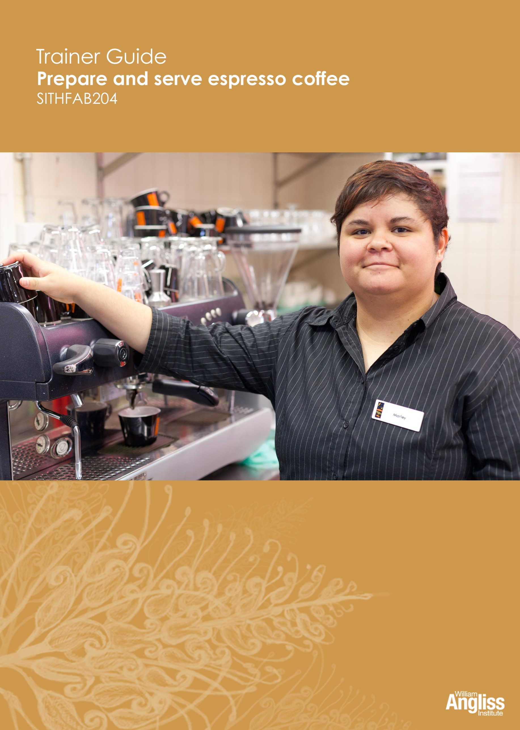

© Commonwealth of Australia 2013

CC BY-NC-SA
This work is copyright. Except where otherwise indicated, and save for the Commonwealth Coat of Arms, the Department has applied the Creative Commons Attribution-Noncommercial-Share Alike 3.0 Australia Licence to this work.
The Department of Industry, Innovation, Climate Change, Science, Research and Tertiary Education must be attributed as the author of the Department’s copyright material.
As far as practicable, material for which the copyright is owned by a third party has been clearly labelled. The Department has made all reasonable efforts to ensure that this material has been reproduced on this website with the full consent of the copyright owners.
Requests and enquiries concerning the Department’s copyright material should be addressed to:
The Legal Branch
Department of Industry, Innovation, Climate Change, Science, Research and Tertiary Education
GPO Box 9839 Canberra ACT 2601
Or emailed to legalservices@innovation.gov.au
Funded under the Workplace English Language and Literacy (WELL) Program by the Australian Government Department of Industry, Innovation, Climate Change, Science, Research and Tertiary Education.
The views expressed in this publication do not necessarily represent the view of the Minister for Tertiary Education, Skills, Science and Research or the Australian Government. The Australian Government does not give any warranty nor accept any liability in relation to the contents of this work.
ISBN 978-1-922108-13-5
Development Team
Content | William Angliss Institute of TAFE  Macsmith and Associates
Disclaimer
Every effort has been made to ensure that this booklet is free from error or omissions. However, you should conduct your own enquiries and seek professional advice before relying on any fact, statement or matter contained in this book. William Angliss Institute of TAFE and Macsmith & Associates are not responsible for any injury, loss or damage as a result of material included or omitted from this workbook.

Contents
What is in this guide? iv
LLN requirements of the unit v
Guide to the activities 1
Activity 1 Your workplace coffee beans 1
Activity 2 Your coffee menu 1
Activity 3 Your workplace equipment 1
Activity 4 Misse en place in your workplace 1
Activity 5 Personal safety 2
Activity 6 Food handling when making coffee 5
Activity 7 Storage in your workplace 8
Activity 8 Grinding coffee at your workplace 8
Activity 9 Your workplace preparation 8
Activity 10 Extracting coffee at your workplace 8
Activity 11 Measurement and estimating liquids 8
Activity 12 Checking the extraction rate 9
Activity 13 What could go wrong? 10
Activity 14 Stretching and texturing milk 11
Activity 15 What can go wrong when texturing milk? 11
Activity 16 Abbreviations in orders 13
Activity 17 Serving customers 13
Activity 18 Following manufacturer’s instructions 15
Activity 19 Cleaning at your workplace 15
Appendix 1 Resources for Activity 17 16
What is in this guide?
This Trainer Guide to Activities accompanies the Learner Workbook for the unit SITHFAB204 Prepare and serve espresso coffee in the SIT12 Hospitality Training Package.
The Trainer’s Guide contains:
- a summary of the LLN requirements of the unit
- advice on carrying out an activity where it may not be obvious from the design of the activity itself. When the design of an activity speaks for itself, comments are on possible variations, enhancements or extensions of the activity that would ensure it is useful for learners with lower LLN skills
- possible answers where this may assist the trainer to understand the intent of the activity
- resources to support the activities, such as role play cards or sample documents.
Many activities assume that learners have access to a workplace or simulated workplace. If this is not the case, trainers should adapt or omit the activity. If learners are in different workplaces, they could compare the different ways things are done.

LLN requirements of the unit
SITHFAB204 Prepare and serve espresso coffee
Skill | Applications
Reading | - Read menus and standard recipes for espresso coffee beverages  - Read procedures for operating, cleaning and maintaining equipment  - Read Plain English safety procedures  - Read Plain English versions of Safety Data Sheets (SDS) for cleaning agents and chemicals
Speaking and listening | - Advise customers on coffee beverages,  - Identify customer preferences  - Take orders
Writing | - Take orders  - Write basic notes on customer preferences  - Mark beverage type on take-away lids
Numeracy | - Visually estimate amounts of milk  - Make adjustments to doses of ground coffee  - Estimate appropriate pour rate for espresso coffee  - Visually estimate volume of the espresso  - Check water and steam pressure
Digital literacy | Use electronic ordering systems

Guide to the activities
Activity 1 Your workplace coffee beans
This activity is workplace specific. If learners are in different workplaces, encourage them to compare types of coffee used.
If learners are already at the workplace, this can be a general discussion about what they remember. If they are not yet in the workplace, you could ask them to gather the information when they are next in the workplace and bring the information back to the group.
Activity 2 Your coffee menu
As for Activity 1.
These activities could provide an opportunity to encourage learners with lower LLN skills to practise some critical workplace reading, and writing by copying accurately.
Activity 3 Your workplace equipment
As for Activity 1.
If your learners do not have access to an espresso machine and other equipment at this point, show a picture e.g. a PowerPoint slide, of a typical espresso machine and grinder and other equipment, or the equipment at their workplace. Point to each part and ask them to name the part.
You could also visit cafés so they can look for different equipment and supplies.
Activity 4 Misse en place in your workplace
As for Activity 1.
Learners must be aware that different workplaces have different equipment and supplies, such as different types of cups and glasses for serving coffee.
As learners talk about the serviceware, supplies and procedures make a list on the board, as this may prompt others to remember what they have seen.

Activity 5 Personal safety
This activity is intended to encourage learners to:
- apply what they have learnt in the unit, SITXOHS001B Follow health, safety and security procedures or SITXWHS101 Participate in safe work practices
- understand their own workplace safety procedures
- take responsibility for their own safety
- think about some common problems and how to prevent them.
The first part of this activity is workplace specific, but could be adapted to ask what “What safety procedures should be followed in a workplace…?”
In the second part of the activity, don’t expect the learners to know all the answers. Elicit learner suggestions and suggest possibilities yourself as required to fill any significant gaps. Write reasonable suggestions in a table on the board. Learners can then copy this into their workbooks.
Some responses have been suggested but the list is not comprehensive

Hazards of coffee making | Possible risks | What would you do to prevent injury?
- Working in a small space | Bumping into equipment  Knocking over hot liquids  Wrong height of machine, causing back strain | Make sure all equipment is set out so that it is easy to reach.  Make sure the machine is at the right height.
- Using hot water, steam and hot machine | Burns | Learn how to use the machine correctly.  Beware of steam.  Use a cloth when touching hot surfaces.  Wear clothes that cover your skin.
- Using electrical equipment | Electrocution  Cutting fingers | Check that cords are not frayed or loose – if they are, don’t use the equipment and tell your supervisor.  Wipe up all liquid that has spilled.  Don’t put fingers or utensils in moving parts e.g. grinding machine.
- Spills on the floor | Slipping and falling over on the floor | Wipe up all liquid that has been spilled on the floor immediately.  Use non-slip mats.  Wear non-slip shoes.
- Working fast to serve customers quickly | Making mistakes  Injuring yourself and others e.g. through burns, cuts or knocking things over as you are hurrying | Use a system and work carefully.  Follow procedures.  Stay calm.
- Standing for long periods, bending over the workbench | Back problems  Strain on legs and knees  Sore feet | Use good posture – stand with back straight and shoulders square.  Use supportive mats, usually made from rubber, which take strain off feet, knees and back.  Wear supportive shoes.  Make sure bench is at correct height
- Using chemicals to clean the equipment | Inhaling fumes  Irritation of skin | Follow instructions for mixing and using chemicals – read Material Safety Data Sheet (MSDS) or other instructions in the workplace.  Check the room is well ventilated.  Use personal protective equipment (PPE) e.g. gloves.

Activity 6 Food handling when making coffee
Don’t expect the learners to know all the answers. This activity is intended to encourage learners to apply what they have learnt about food safety previously.
Elicit learner suggestions and suggest possibilities yourself as required to fill any significant gaps. Write reasonable suggestions in a table on the board. Learners can then copy this into their workbooks.
Some responses have been suggested but the list is not comprehensive.

Type of contamination | How it can happen | Possible examples when making coffee | What you can do to prevent contamination
Microbiological contamination | Germs such as bacteria, viruses or mould get into the coffee.  You mainly can’t see these. | Milk has ‘gone off’ because:  - it is out of date  - the fridge is kept at the wrong temperature  - the milk has been left out of the fridge when not being used.  Someone sneezes or coughs while making coffee.  A barista has dirty clothes or hands.  Crockery (cups and saucers) is chipped, allowing germs to grow.  Equipment not kept clean, e.g. steam wand. | Check use-by date on milk.  Make sure milk is kept in the fridge when not being used.  Smell milk to check it is OK, even if it is not past its use-by date.  Don’t work when sick.  Make sure hands and clothes are clean.  Don’t used chipped cups or other containers – throw them out.  Clean and sanitise equipment as required.
Physical contamination | An object gets into the coffee.  Insects and other vermin can get into the coffee, milk or machine.  You can usually see this type of contamination. | Things can fall into the milk jug or coffee, such as:  - a chip from a broken glass or cup  - hair from the barista  - packaging items  - dirt  - bandaid from a cut finger.  Insects and other vermin might be attracted to spilt milk, crumbs from biscuits served with the coffee or open sugar bowls. | Clean up any breakages immediately and check chips have not gone into containers or cups.  Keep hair tied back or covered.  Wear disposable gloves if you have a bandaid on your finger, and make sure the bandaid is blue or brightly coloured so you can see it.  Wipe up any spills.  Keep biscuits, sugar and other food items covered.
Chemical contamination | Chemicals get into the coffee.  You can’t see these. | Cleaning chemicals used to clean the equipment are not washed off thoroughly. | Use workplace and manufacturer’s instructions for diluting and using chemicals.  Rinse equipment thoroughly after using chemicals.

Activity 7 Storage in your workplace
As for Activity 1.
Discussion should include ways to recycle packaging and using less packaging.
Activity 8 Grinding coffee at your workplace
As for Activity 1.
Activity 9 Your workplace preparation
As for Activity 1.
This activity is workplace specific. Some of this material about procedures and checklists may have been covered in Activity 4 when talking about mise en place.
Activity 10 Extracting coffee at your workplace
As for Activity 1.
Elicit differences in coffee extracting processes between the learners’ workplace and what is given in their workbook.
Encourage them to compare the differences in coffee making in different workplaces.
Activity 11 Measurement and estimating liquids
Part A:
Bring in some containers of different sizes and shapes, e.g. a café latte glass, an espresso cup, a mug, an empty milk bottle, various sizes of jugs and spoons.
Ask the group to estimate how much liquid each container would hold when full.
Then pour water into each, and measure using a measuring jug.
See how close they were.
Part B:
Show the group some cups, glasses and jugs used for making and serving coffee.
Ask learners to mark with a felt tip pen where they think certain amounts would come to in the container.

Check their estimation by pouring in this amount of water.
Container | Mark where this amount would come to
Café latte glass | 30 ml of espresso (the amount needed for a café latte or flat white coffee and a short black)
Café latte glass | 60 ml of espresso (the amount needed for a double espresso or a long black)
Milk jug | 1/3 of the jug (the amount of milk you should put in a jug for steaming)
Milk jug | 300 ml of milk (the amount of milk needed for 2 cappuccinos)
Cup used for a long black coffee | 2/3 of a cup (the amount of hot water that goes into a cup for a long black coffee before adding 60 ml of espresso)
Activity 12 Checking the extraction rate
Divide groups into pairs.
Person A estimates the two times below. Suggest they use one of the counting methods in the workbook.
- estimate 5 seconds (the delay before coffee comes out of the machine)
- estimate 27 seconds (the time it should take to produce 30 ml of espresso).
Person B tells Person A when to start and times them with a stopwatch, e.g. on mobile phone. B tells A the actual time A took.
Then swap roles.
Keep practising until they are accurate.

Activity 13 What could go wrong?
Elicit learner suggestions and suggest possibilities as required to fill any significant gaps. Write reasonable suggestions in a table on the board. Learners can then copy this into their workbooks.
Some responses have been suggested but the list is not comprehensive.
Problem | Possible cause of problem | Possible solution
Extraction is too fast so that:  - water rushes through the coffee  - the crema is thin and pale  - the taste is watery. | Not enough coffee  Tamp too soft  Temperature too cold  Grind too coarse | Check dose  Check damping process  Check temperature  Check grind
Extraction is too slow so that:  - water has trouble getting through the coffee  - the crema is very dark brown  - the coffee tastes bitter. | Too much coffee  Tamp too hard  Temperature too hot  Grind too fine | Check dose  Check damping process  Check temperature  Check grind
Coffee grounds in the cup | Grind too fine  Worn grinder blades  Worn filter holders  Group head dirty  Coffee on the edge of the filter holder  Water not hot enough | Check grind and blades in grinder  Clean group heads and check filter holder  Wipe coffee off filter holder before extraction  Check water temperature, or let machine warm up before use
Coffee tastes burnt | Machine dirty  Coffee old  Hopper in grinder needs cleaning | Clean machine and grinder  Use fresh coffee and use coffee as soon as it has been ground

Activity 14 Stretching and texturing milk
As for Activity 1.
Activity 15 What can go wrong when texturing milk?
Elicit learner suggestions and suggest possibilities as required to fill any significant gaps. Write reasonable suggestions in a table on the board. Learners can then copy this into their workbooks.
Some responses have been suggested but the list is not comprehensive.

Problem | Possible cause of problem | Possible solution
Too much foam | Too much air has entered the milk, making big, messy bubbles | Hold the wand as instructed in the jug.  Watch how the milk is reacting as you are texturing it.
Milk does not foam | Steam wand held too far under the milk  Milk and jug not cold enough  Milk not fresh or wrong type  Too much milk in the jug  Steam temperature and pressure not high enough  Wrong technique used | Hold the wand as instructed in the jug.  Check the use-by date of the milk is current.  Keep jugs in fridge and rotate them.  Keep milk in fridge until you need it.  Check amount of milk in jug.  Check steam temperature and pressure.  Watch how the milk is reacting as you are texturing it.
Steam wand is blocked | Wand not wiped and purged after each use | Always wipe arm and purge wand straight after steaming milk.
Milk has boiled | Did not check temperature during heating | Use thermometer or keep your hand on jug to judge temperature.
Milk has curdled (separated into different parts) | Milk may be old or ‘off’ | Check milk is fresh before using it.
Milk smells bad | Left out of the fridge  Past its ‘use-by’ date  Fridge temperature not correct | Throw out any milk that has gone ‘off’.  Keep milk covered and in fridge when not being used.  Don’t use milk past its use-by date.

Activity 16 Abbreviations in orders
Ask learners what abbreviations are used in their workplace.
Here are some possible abbreviations, although any reasonable answer from learners is acceptable.
Order | Abbreviation | Order | Abbreviation
Short black | SB | Mocha | MOC
Espresso | ESP | Affogato | AFF
Long black | LB | Soy milk | SOY
Café latte | CL | Weak | WK
Flat white | FW | Strong | STR
Cappuccino | CAP | Decaffeinated | DE
Doppio | DOP | Long | L
Macchiato | MAC | Short | S
Ristretto | RIS | Sugar | SU
Skim milk | SKIM
Activity 17 Serving customers
Q 1:
Discuss with learners the different systems for taking orders in the workplace.
Q 2:
Prepare by cutting up the customer cards and making copies of the order form and price list in Appendix 1.
NOTE: If learners are all in the same workplace you could adapt this activity so they use the ordering system in their own workplace.

Put learners in pairs.
Person A is the customer –
- Take a customer card
- Ask for the coffee.
Person B takes the orders –
- Take a card for the person taking the orders, an order form and a price list.
- ask questions until it is clear what the customer wants
- Write the order on the order form using abbreviations, including the price. Add up the total cost of the order.
If learners are less confident, the trainer could model one interaction with a more confident learner.
Demonstrate how to complete the order form. Here is a suggestion.

Server:  Trudy |  | Table No:  3 | No of people:  4
No of items | Description of items |  |  | Price
1 | CAP STR |  |  | $4.40
1 | CL SOY |  |  | $4.40
1 | SB |  |  | $3.50
1 | MAC L |  |  | $3.80
Total |  |  |  | $16.10

Extension activities
1. Ask learners to swap their completed order forms with another learner.
- Can they understand what is written? This is a check that the order is clear enough for the barista to understand.
- Are the prices and total are correct?
2. Learners practise giving and recording orders unscripted.

Activity 18 Following manufacturer’s instructions
This activity is workplace specific.
After they have practised removing parts of the machine, ask each learner to describe what they did and how they felt about it. For example, did they feel confident? Would they be able to do it by themselves?

Activity 19 Cleaning at your workplace
This activity is workplace specific. If learners are in different workplaces, encourage them to compare the schedules.
If learners are already at the workplace, this can be a general discussion about what they remember.
If learners are not yet in the workplace, you could ask them to gather the information when they are next in the workplace and bring the information back to the group.

Appendix 1 Resources for Activity 17
Role cards
Situation 1 – Customer
I’d like a black coffee please.
Use this information to answer questions:
- It is long
- It is takeaway.
Situation 1 – Person taking the order
Ask questions to get details:
- Do they want short or long?
- Is it to drink in the café or take away?

Situation 2 – Customer
I’d like two white coffees please.
Use this information to answer questions:
- They are flat whites
- One is with soy milk
- They are to drink in the café.
Situation 2– Person taking the order
Ask questions to get details:
- Do they want a flat white or a café latte?
- Is it to drink in the café or take away?
- What type of milk do they want?

Situation 3– Customer
I’d like a latte, a strong flat white and a macchiato please.
Use this information to answer questions:
- They are to drink in the café
- You want skim milk
- The macchiato is short.
Situation 3 – Person taking the order
Ask questions to get details:
- Is it to drink in the café or take away?
- What type of milk do they want?
- Is the macchiato long or short?

Situation 4– Customer
I’d like four takeaway coffees please.
Use this information to answer questions:
- You want café lattes
- One decaffeinated
- Ordinary milk
- Normal size
- Sugar in one but not in the others.
Situation 4 – Person taking the order
Ask questions to get details:
- What types of coffee do they want?
- What type of milk?
- What size do they want?
- Do they want sugar in it?
Activity 17 Order Form
Server: |  | Table No: | No. of people:
No. of items | Description of items |  |  | Price
2
Total

Activity 17 Price List
Item | Price | Item | Price
Short black | $3.50 | Macchiato – short | $3.50
Espresso | $3.50 | Macchiato – long | $3.80
Long black | $3.80 | Ristretto | $3.50
Café latte | $4.00 | Mocha | $4.00
Flat white | $4.00 | Strong | Extra 40c
Cappuccino | $4.00 | Soy milk | Extra 40c
Doppio | $3.80 | Decaffeinated | Extra 40c

