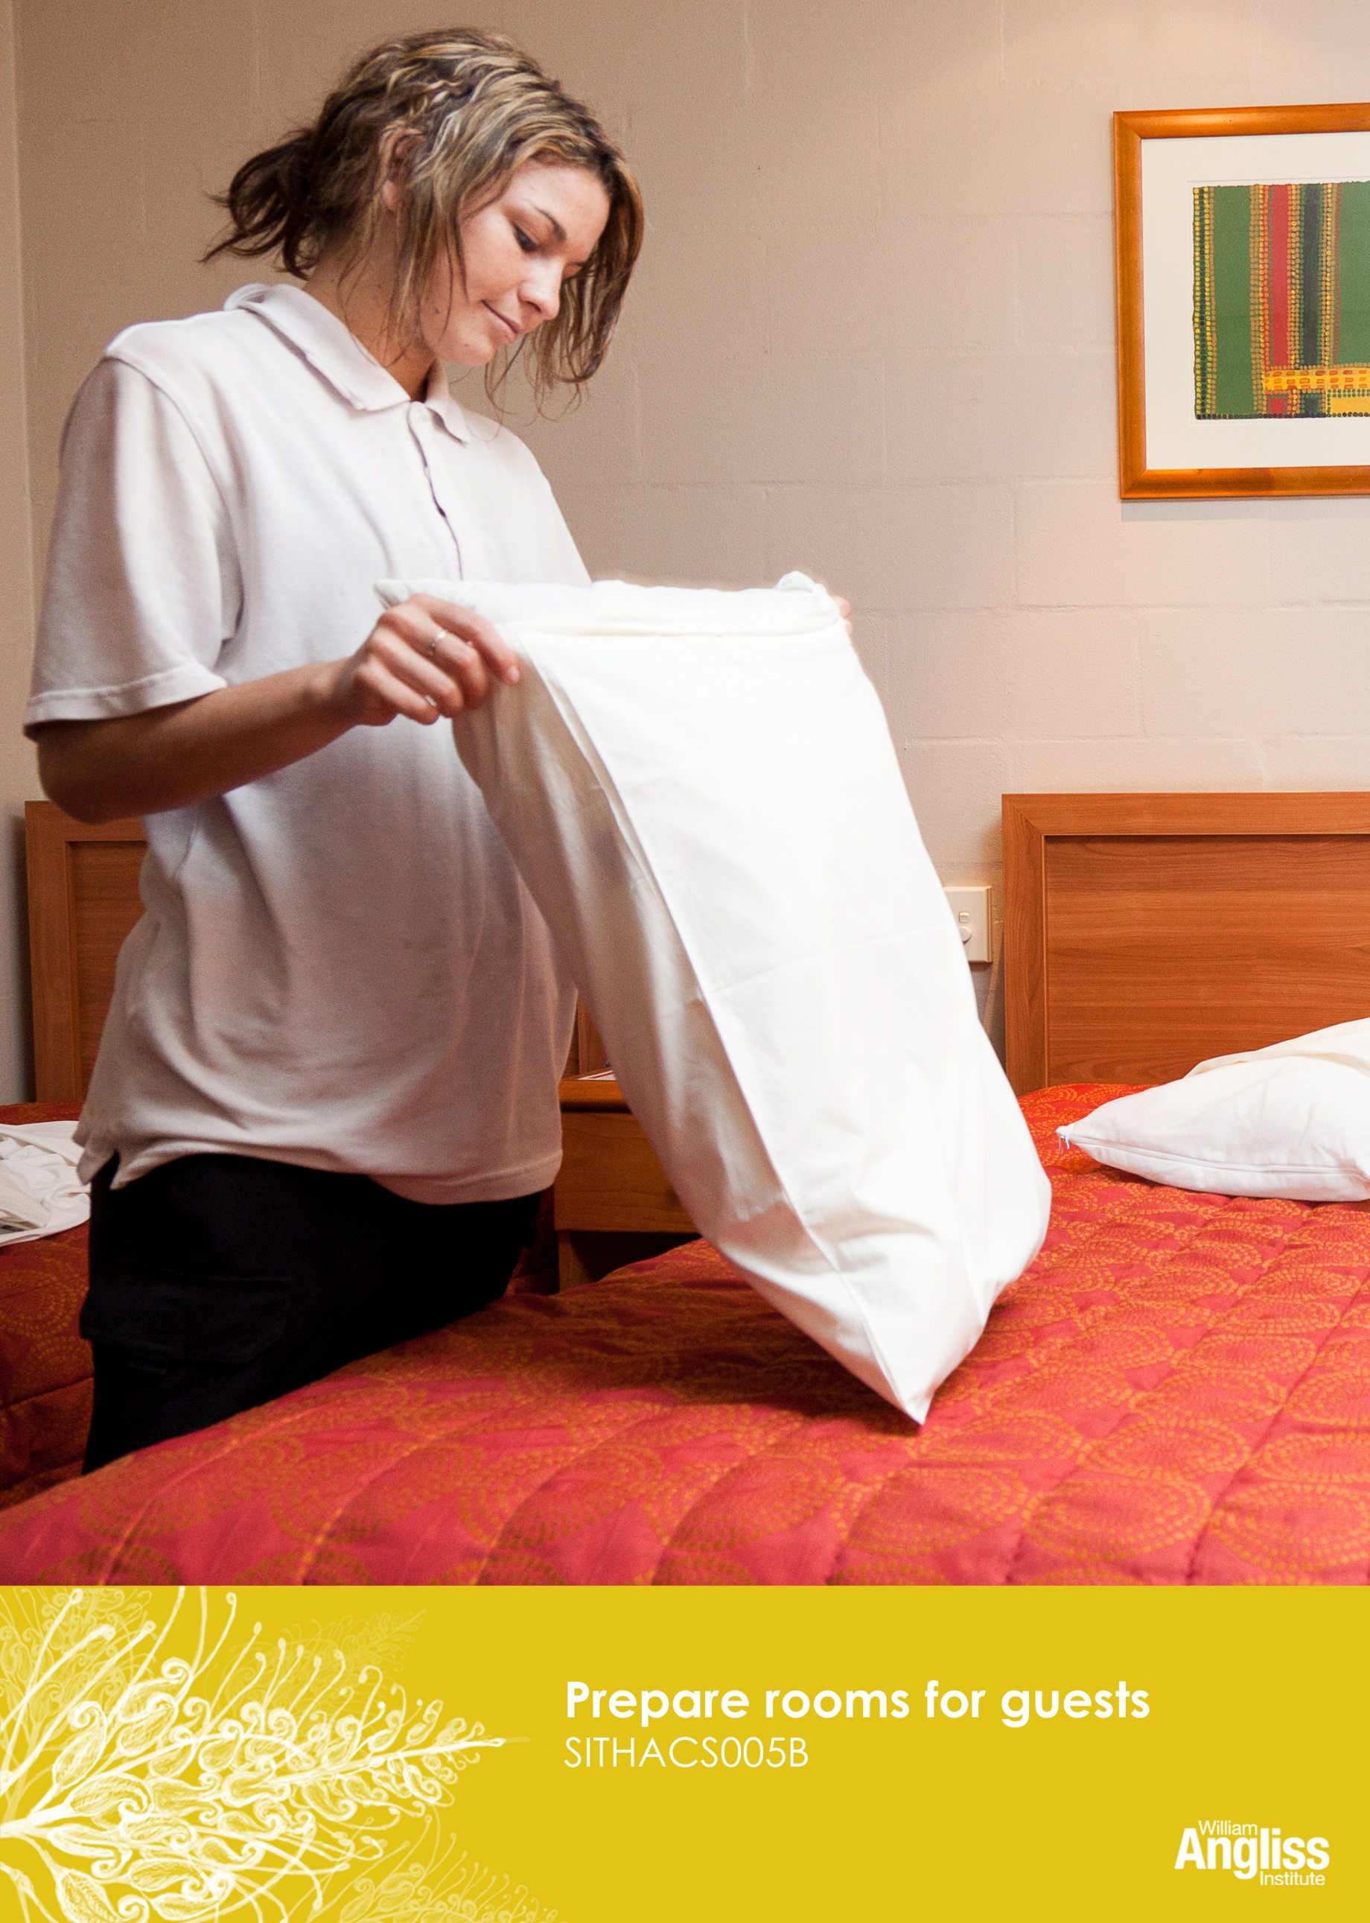
-Workbook

© Commonwealth of Australia. 2012
CC BY-NC-SA
This work is copyright. Except where otherwise indicated, and save for the Commonwealth Coat of Arms, the Department has applied the Creative Commons Attribution-Noncommercial-Share Alike 3.0 Australia Licence to this work.
The Department of Education, Employment and Workplace Relations must be attributed as the author of the Department’s copyright material.
As far as practicable, material for which the copyright is owned by a third party has been clearly labelled. The Department has made all reasonable efforts to ensure that this material has been reproduced in this resource with the full consent of the copyright owners.
Requests and enquiries concerning the Department’s copyright material should be addressed to:
The Copyright Officer
Department of Education, Employment and Workplace Relations
Location code C148CW2
GPO Box 9880 Canberra ACT 2601
Or emailed to copyright@deewr.gov.au
Funded under the Workplace English Language and Literacy (WELL) Program by the Australian Government Department of Education, Employment and Workplace Relations.
The views expressed in this publication do not necessarily represent the view of the Minister for Education or the Australian Government. The Australian Government does not give any warranty nor accept any liability in relation to the contents of this work.
ISBN 978-1-922108-04-3

Development Team
Content | William Angliss Institute  Macsmith and Associates
Photography & graphics | Benjamin B Photography

Acknowledgments
We would like to acknowledge the generous support of the following organisations and the Indigenous learners and employees in those venues for giving their permission for photography:
Ayers Rock Resort, Yulara, NT
Charcoal Lane Restaurant, Fitzroy, Vic
Lux Foundry Café, Brunswick, Vic
Peninsula Palms (Compass Group Australia), Dampier, WA
Permissions
We would like to acknowledge Ecolab who have kindly granted permission for photographs of their products to be incorporated in this resource.
Cultural Warning
People of Aboriginal or Torres Strait Islander descent should be aware that this publication contains images of people who may be deceased.
Disclaimer
Every effort has been made sure that this booklet is free from error or omissions. However, you should conduct your own enquiries and seek professional advice before relying on any fact, statement or matter contained in this book. William Angliss Institute of TAFE is not responsible for any injury, loss or damage as a result of material included or omitted from this course.

Contents
Welcome vi
Icons vi
What you will learn vii
1 Housekeeping tasks 1
Health and safety in housekeeping work 4
Safe work practices and procedures 8
Section summary 13
2 Set up and clean the trolley 14
Equipment on the trolley 14
Equipment in the cleaning bucket 15
Fresh linen 16
Cleaning supplies and room supplies 17
Trolley safety 18
Clean your trolley at the end of the shift 20
Section summary 25
3 Accessing rooms 26
Type of room 26
Housekeeping worksheet 26
Accessing rooms 29
Key control 32
Section summary 34
4 Making beds 35
Bed making tasks 38
Section summary 41

5 Cleaning rooms 42
Cleaning different types of rooms 43
Cleaning procedures 44
Using fewer resources when we clean 48
Cleaning products 58
Section summary 61
6 Pests and other problems 62
Pests 62
Unusual or suspicious items or activities 64
Lost property 66
Section summary 69
7 Your environmental impact 70
Cleaning in an environmentally friendly way 71
Hazardous substances and biological waste 73
Section summary 78
Key words 79
Welcome
Icons
These signs tell you what type an activity is:
 | Do this activity in a big group.
 | Do this activity in a small group.
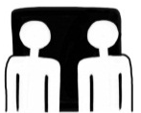 | Do this activity in pairs.
 | Do this activity by yourself.
Do this activity using the internet.
If you are not connected to the internet, your trainer will provide you with another activity.
Do this activity in your workplace.
If you are not in a workplace, your trainer will provide you with another activity.

What you will learn
The room attendant keeps rooms clean and ready for guests. This can include cleaning:
- bedrooms
- bathrooms
- lounges
- kitchens
- balconies
- cabins or holiday apartments.
This unit shows you how to set up cleaning equipment and trolleys and to safely clean guest rooms. It also shows you how to use cleaning processes which reduce harm to the environment.

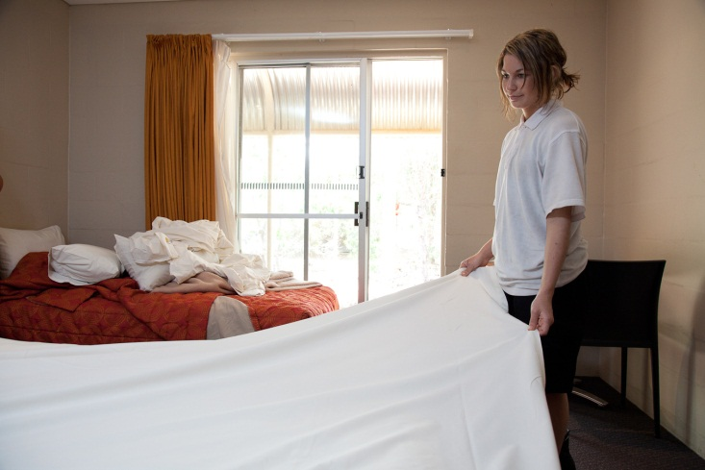
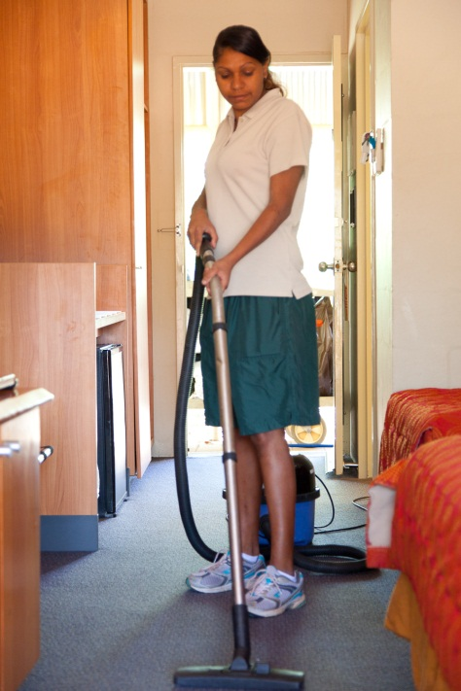

1 Housekeeping tasks
The Gums Eco Resort is advertising two housekeeping jobs.

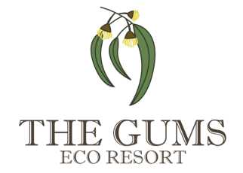 | 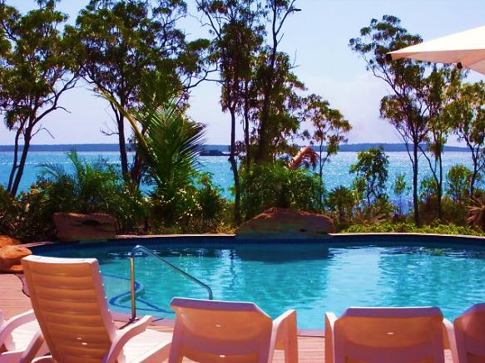
THE GUMS is an eco-resort on the beach front near Dusty Bay National Park. We have 20 cabins, one 6-bed backpacker dorm and a cafe.
We also run cultural tours and bush tucker walks in the national park and provide Indigenous cultural performances.
We have two positions available to join our housekeeping team. The positions report to the Housekeeping Supervisor.
Key responsibilities
- Clean rooms
- Make up beds
- Replenish room supplies
- Check furniture, fixtures and fittings
- Set up and clean trolley.
We are looking for energetic people with an eye for detail, who can work safely and effectively in a team. Our eco-resort prides itself on its environmentally sound cleaning practices, so applicants should be keen to learn new ideas.
Successful applicants will be employed as trainees and will be able to train on the job to gain a national hospitality qualification.

Activity 1
Housekeeping tasks
Look at the housekeeping tasks listed in the following table.
Draw an arrow to connect each task with what you have to do in that task.

Task |  | You have to...
- Set up and clean trolley |  | - Check that nothing in the room is broken or not working e.g. lights, TV, furniture.
- Make up beds |  | - Put cleaning equipment and supplies on trolley. Clean and organise it neatly after you’ve finished.
- Clean rooms |  | - Top up guest supplies e.g. in the bathroom, tea and coffee.
- Replenish room supplies |  | - Let the supervisor know what work you have completed and about any problems.
- Check furniture, fixtures and fittings |  | - Reduce use of energy, water and chemicals so we do less harm to the environment.
- Report to housekeeping supervisor |  | - Strip dirty linen off beds and put clean linen on. Check for stains and damage.
- Work in environmentally sound ways |  | - Empty bins, clean crockery and glassware, dust, vacuum, mop.
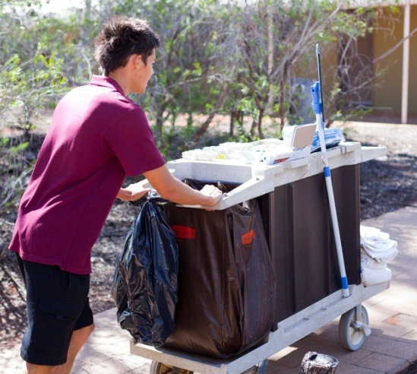

Activity 2
Employability skills
Employability skills make anyone in any job a better worker.
1. Go back to the advertisement for the housekeeping jobs at The Gums. Underline the words you think describe the kind of person the employer is looking for.
These are called employability skills.
2. Look at the employability skills listed in the following table.
Draw an arrow to connect each task with what you have to do in that task.
Task |  |  | You have to...
 | - Work effectively |  | - Work in ways which are safe to you, other workers and guests e.g. when lifting heavy loads.
 | - Work efficiently |  | - Clean a room in the amount of time set for cleaning one room.
 | - Work safely |  | - Get on with other workers and help them out when needed.
 | - Work in a team |  | - Clean rooms so that they meet hotel standards. Always follow our procedures.
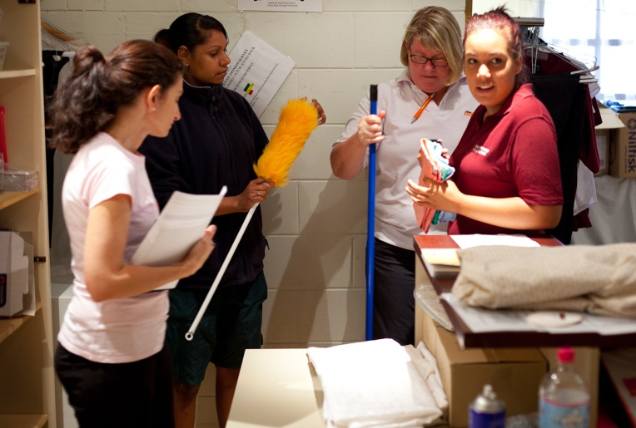

Health and safety in housekeeping work
Housekeeping is an energetic and physical occupation. You must be careful how you do the tasks so you don’t get injured.
Housekeeping injuries
What common injuries can room attendants get?
- Strained muscles and joints
- Back injuries
- Neck, shoulder, arm and wrist injuries.
What movements can cause those injuries?
Observe the work tasks to see what movements they involve.
Do you have to:
- lift and carry heavy things
- push and pull things
- work high (above shoulder height, stretch)
- reach awkward places (stretch, twist)
- work low (squat, bend, kneel)
- make repetitive arm, wrist and hand movements (do the same action many times)
- carry out the task for long periods of time
- work in a slippery, uneven or restricted work space?

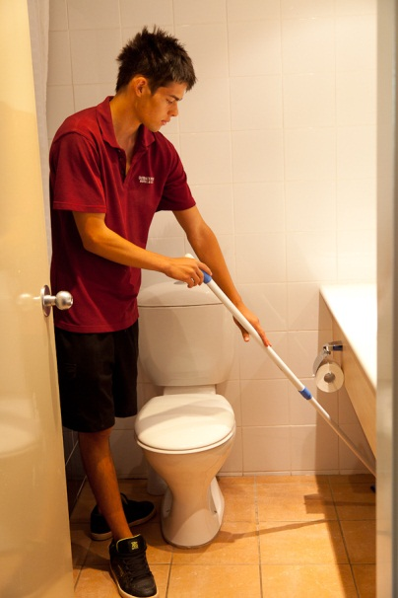

Activity 3
Working safely
Look at the room attendant’s tasks. What movements does each task involve? How can you do these movements safely?
With your trainer, fill in the missing information in this table.
1. Task | 2. What movements does the task involve? | 3. How can I do these movements safely?
Make beds  - Move bed  - Strip bed  - Put on clean linen  - Replace bedding  - Lift dirty linen and place into bag  - Put pillows into pillowcases |  | - Push bed away from wall, do not pull it  - Move around the bed, do not stretch across it  - Push bed with my knees  - Bend my knees or kneel on floor when working low  - Place linen and bedding on chair or spare bed, not on floor  - Don’t shake anything above shoulder level  - When lifting linen make sure the load is manageable, hold items close to my body, never twist
Clean bathroom  - Clean basin, bath, shower, toilet  - Place towels on high shelves  - Use chemicals  - Polish mirror | Repetitive motions  Stretch, forceful arm movements  Slips, trips and falls  Work high, work low  Awkward reaching, twisting | - Place chemical bucket under the vanity against the wall to avoid a trip hazard  - Kneel or squat to clean toilet and lower half of shower  - Hold on to tap handle for balance when coming up  - Do not reach above shoulder height
Vacuum floors  - Move furniture  - Push and pull vacuum cleaner  - Stretch into awkward corners | Repetitive motions  Stretch, forceful arm movements  Slips, trips and falls  Heavy work
Dust room  - Repetitive motions |  | - Squat or kneel to work low  - Move frequently rather than over-reaching  - Use extension tools for high work
Mop floors  - Move heavy bucket  - Mopping | Repetitive motions  Stretch, forceful arm movements  Lift heavy object  Slips, trips and falls
Clean kitchen area  - Clean mini bar fridge  - Clean benches | Bend, stretch, twist  Repetitive motions  Work low | - Take care around light and electrical switches  - Squat or kneel to clean fridge, do not bend
Move trolley  Push and pull trolley |  | - Always push the trolley, never pull  - If the trolley is stuck, never lift it – get help  - Squat or kneel to reach low items – never bend my back  - I must be able to see over the top of your trolley
Restock trolley  - Squat, kneel to reach low shelves in storeroom  - Reach for bundles of linen from store  - Lift clean linen on trolley | Push, pull, bend, stretch  Heavy work  Work low | See safe work procedure later in this section.
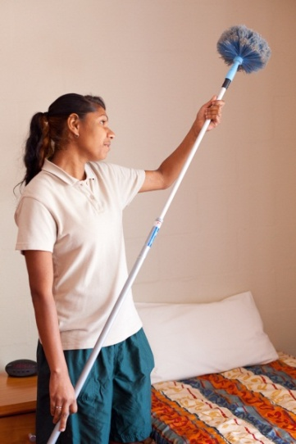
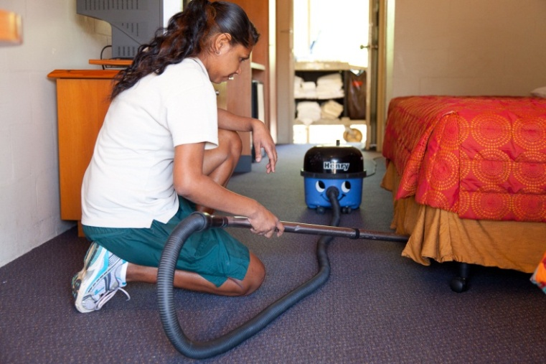
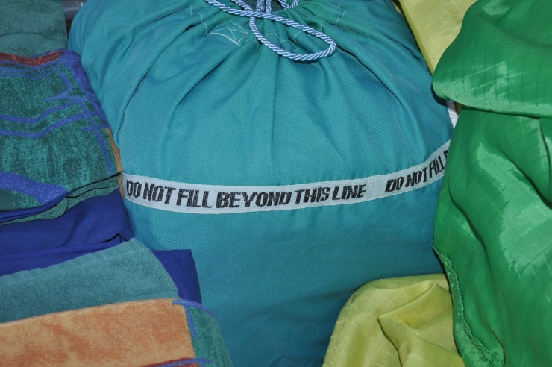
Task

Safe work practices and procedures
Safe work practices are the way we try to prevent injuries caused by work.
Here is a list of safe work practices for room attendants who work at The Gums. During their induction, new room attendants at The Gums are trained in:
- how to use the personal protective equipment (PPE)
- correct manual handling techniques
- handling chemicals safely
- how to identify and report hazards.

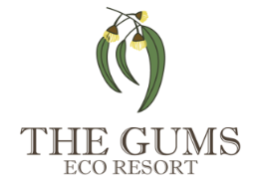 | Housekeeping Department  Safe Work Procedure
- Use the right personal protective equipment (PPE) e.g. gloves, closed in non-slip shoes, safety glasses.
- Use safe posture and movements when sitting, standing, twisting and bending.
- Use correct manual handling techniques for lifting, transferring, pushing and pulling.
- Take designated breaks and rotate tasks.
- Handle chemicals and hazardous materials safely.
- Identify and report any hazards.
- Remove hazards from immediate work area.
- Pay attention to all safety signs.
- Ask for help if you think you need it.
- Drink plenty of water when working in hot weather.
New employees are also trained in The Gums’ Safe Work Procedures (SWPs). They have to sign off on each procedure as they are trained in it. Following is one of these procedures.
Task

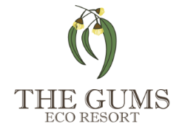 |  | Safe Work Procedure 201  Restocking a trolley from storeroom |  |  | Approved by Manager, Housekeeping Department  Date: 15 June 2012  Review Date: 15 June 2013
Step | Job |  | Hazard Analysis | Risk Evaluation | Safe Work Procedure | Risk Evaluation
1 | Prepare |  | Slips, trips and falls | Medium | - Check for any hazards.  - Dispose of any rubbish.  - Remove any unnecessary items. | Low
2 | Stock the trolley |  | Slips, trips and falls  Manual handling | Medium  Medium | - Check the pathway is clear from the storeroom to the trolley.  - Select equipment to be put onto trolley. When lifting linen bags or other heavy items, use correct manual handling techniques.  - Place equipment on the trolley in the correct area e.g. chemical bottles in the bucket, linen on shelves. | Very Low  Low
3 | Leave the storage area tidy |  | Slips, trips and falls  Manual handling | Medium  Medium | - If you have moved any equipment, put it out of the walk way before leaving.  - Order any more stock that is needed through your supervisor.  - Lock the door after leaving the storeroom.  - Check your pathway is clear before pushing the trolley.  - If the trolley runs away from you do not attempt to catch it while moving. Wait until it has stopped moving, and then recover it. | Low  Low
Sign here to show you understand the procedure and will comply with it:
Employee Signature: Date:

The cleaning worksheet
Melissa and Mark were successful in getting the housekeeping positions at The Gums Eco Resort.
The resort has 20 tourist cabins, a 6-bed backpacker dorm and a cafe.
Each cabin has one or two bedrooms, a small kitchen and sitting area, a bathroom and a deck.
Melissa and Mark
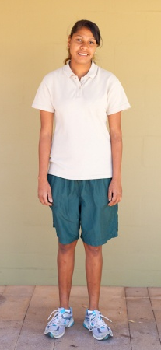

Melissa and Mark report to Janis, the Housekeeping Supervisor.
At the start of each shift Janis tells them what to do. She gives them a list of cabins to clean (a worksheet).
They see Janis during their shift and report any problems to her as they arise. At the end of the shift Melissa and Mark report back to Janis and tell her what they have done.

DAILY HOUSEKEEPING WORKSHEET
Name: Melissa Branna Date: 23/09/12
CABIN | BEDS |  | STATUS | STANDARD  MAKE-UP? | NOTES | SIGNOFF | ROOM ATTENDANT COMMENTS
1 | 1 queen |  | CO |  | Strip beds only. Do not make bed – bedhead needs repair  Defrost fridge; clean floors
2 | 1 queen |  | VR |  | Inspection and light dusting only
3 | 1 queen |  | OCC |  | No linen change
4 | 1 queen  2 single |  | OCC |  | Extra pillow needed, queen bed
5 | 1 queen  2 single |  | CO |  | Linen change queen bed only
6 | 1 queen  2 single |  | CO |  | Linen change queen bed only
STATUS KEY  CO = Check-Out  OCC = Occupied  VR = Vacant Room |  |  |  |  | STANDARD MAKE-UP PROCEDURE  - Change bed linen and towels.  - Clean bedroom, bathroom and kitchen.  - Restock bathroom, bedroom and kitchen supplies.  - Vacuum and mop floors.  - DO NOT replace light globes – inform Maintenance.

Activity 4
Melissa’s housekeeping worksheet
Look at Melissa’s worksheet. Then answer the questions.
1. Which cabins have guests leaving?

2. Which cabins have guests staying on?

3. Which cabins needs the fridge defrosted and floors cleaned?

4. Which cabins need the bathroom and kitchen supplies restocked?

5. In Cabin 5, Melissa finds the guests have slept in two beds. What should she do?

6. In Cabin 3, Melissa finds that the bedside lamp light bulb is not working. What should she do?

Activity 5
Workplace housekeeping worksheet
Look at a housekeeping worksheet from your workplace.
Is it different to Melissa’s? YES / NO
If YES – How is it different?

Section summary
Now you have completed this section you should have developed the following skills and knowledge.
Tick each box if you are satisfied that you have those skills and knowledge.

Know the tasks done by room attendants.
Understand the employability skills an employer looks for in a room attendant.
Know safe work practices and procedures for room attendants.
Read a housekeeping worksheet.
Notes

2 Set up and clean the trolley
Room attendants need equipment and materials to clean rooms and make up beds.
They carry everything they need on their trolleys. Then they wheel the trolley to the cabins or rooms to do the bed making and cleaning.
Equipment on the trolley
Activity 6
What’s on the trolleys?
Look at the 3 photos of trolleys. What items are on them?
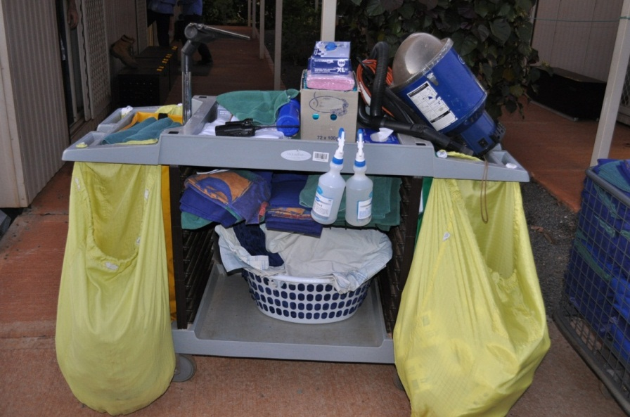

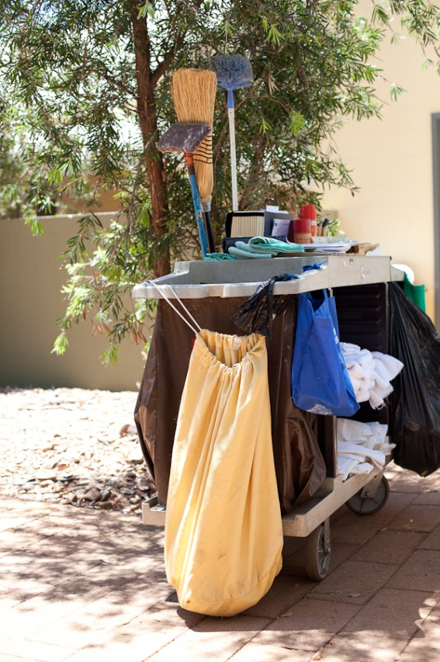
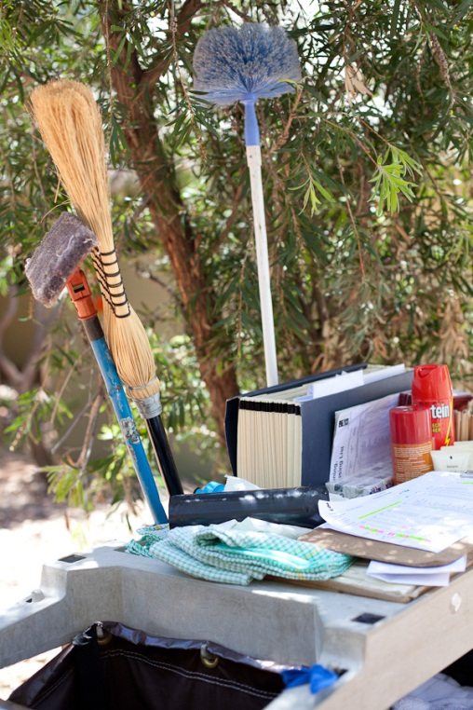

What’s on the trolleys?

Equipment in the cleaning bucket
Activity 7
The cleaning bucket
Here is a cleaning bucket. What items should go in it?

- air freshener  - all-purpose cleaner  - bathroom cleaner  - brushes  - cleaning cloths  - dishwashing liquid  - dustpan and shovel  - disposable gloves | 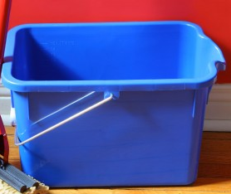 | - morning snack  - mobile phone  - purse/wallet  - tea, coffee and sugar sachets  - toilet cleaner  - toilet rolls  - two-way radio  - water bottle.

Fresh linen
Melissa needs to go to the storeroom to get the clean linen she needs to complete her scheduled cabins. She has to work out how much of each item she needs.
Activity 8
How much linen?
Look at Melissa’s housekeeping worksheet in Activity 4.
Work out how much linen she should get from the storeroom for this shift.
Type of linen | Melissa needs this number …
Single fitted bottom sheets
Single flat top sheets
Queen fitted bottom sheets
Queen flat top sheets
Pillow cases (2 per person)
Towels (1 per person)
Bath mats (2 per cabin)
Hand towels (1 per person)
Tea towels (2 per cabin)
Face washers (1 per person)
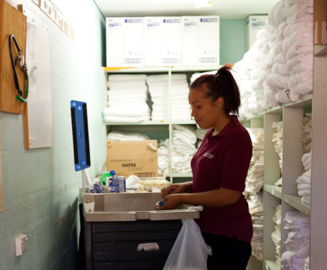

Cleaning supplies and room supplies
Melissa needs to check her trolley and bucket to see that she has:
- the cleaning equipment she needs
- enough room supplies.
Activity 9
Cleaning supplies and room supplies
Find these items in the storeroom at your workplace. Tick them as you find them.
CLEANING SUPPLIES
Personal protective equipment including disposable gloves
Cleaning products and chemicals
Cleaning equipment – mop, bucket, brushes, brooms, cloths
Vacuum cleaner
Rubbish bags
Linen bag for soiled linen
ROOM SUPPLIES
Paper products – toilet paper, tissues, sanitary bags
Toiletry items – soaps, shampoos, conditioners, shower caps
Stationery – pen, notepads
Advertising material – doorknob cards, service directory, guest laundry list, café menus
Food items – coffee, tea, biscuits, sugar, milk, hot chocolate

Trolley safety
At The Gums Eco Resort, health and safety are taken seriously.
Before starting to clean the cabins, Mark and Melissa had to do training and pass the trolley safety test. They had to remember quite a few things that Janis, their supervisor, told them.

5. Load everything safely so it can’t fall off.

- Check that nothing is sticking out over the trolley edges.

2. Push the trolley. Do NOT pull it!
4. Don’t lift heavy weights on your own. Ask for help and offer to help others.
3. Put heavy things nearer the top and lighter things lower down.
9. Or you can park your trolley across the door to stop people entering the room.
8. Keep your trolley near the wall so it is not in the way of guests.
7. Check the trolley is working properly. Report any problems.
6. Don’t put too much on the trolley. If necessary, go back to the store during your shift to get more supplies.

Activity 10
Trolley safety rules
Talk about Janis’s advice. Why is each point important?
Trolley safety rule | If you don’t do this, what could happen?
- Check that nothing is sticking out over the trolley edges.
- Push the trolley. DO NOT pull it!
- Put heavy things nearer the top and lighter things lower down.
- Don’t lift heavy weights on your own. Ask for help and offer to help others.
- Load everything safely so it can’t fall off.
- Don’t put too much on the trolley. If necessary, go back to the store during your shift to get more supplies.
- Check the trolley is working properly. Report any problems.
- Keep your trolley near the wall so it is not in the way of guests.
- Or you can park your trolley across the door to stop people entering the room.
Activity 11
Trolley safety
Can you think of three more trolley safety points?
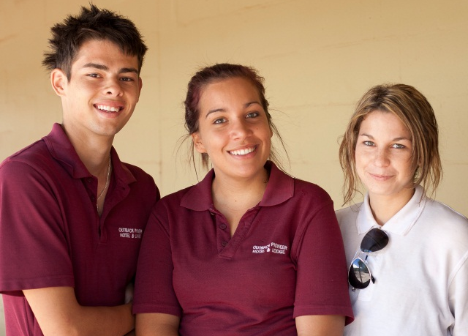

Clean your trolley at the end of the shift
Mark and Melissa are responsible for cleaning their trolleys and equipment at the end of their shift. They must also store their trolleys and equipment in a safe way.
There is a standard operating procedure that tells them exactly what to do.

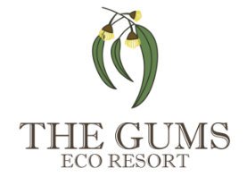 |  | Housekeeping Department  Standard Operating Procedure 11  Clean and restock trolley
Step | Action
1. | Wheel trolley inside trolley room. All cleaning must be done here.  Use gloves and safety glasses at all times.
2. | Place all dirty linen and garbage in appropriate containers.
3. | Clean trolley with eco-friendly cleaning products and cloths.
4. | Clean all equipment and attachments.
5. | Wash and rinse mops and buckets and leave in drying area.
6. | Empty vacuum cleaner bag when it is full and replace with new bag.  Roll up cords safely.
7. | Restock trolley with new guest supplies. All items to go in correct place.
8. | Restock bucket with cleaning supplies. Use safe bottle refill methods
9. | Report any damage to trolley or equipment.

Activity 12
Clean and restock your trolley
1. When do you clean and restock your trolley?
2. Where do you do this?
3. Is there a procedure or checklist for doing this?

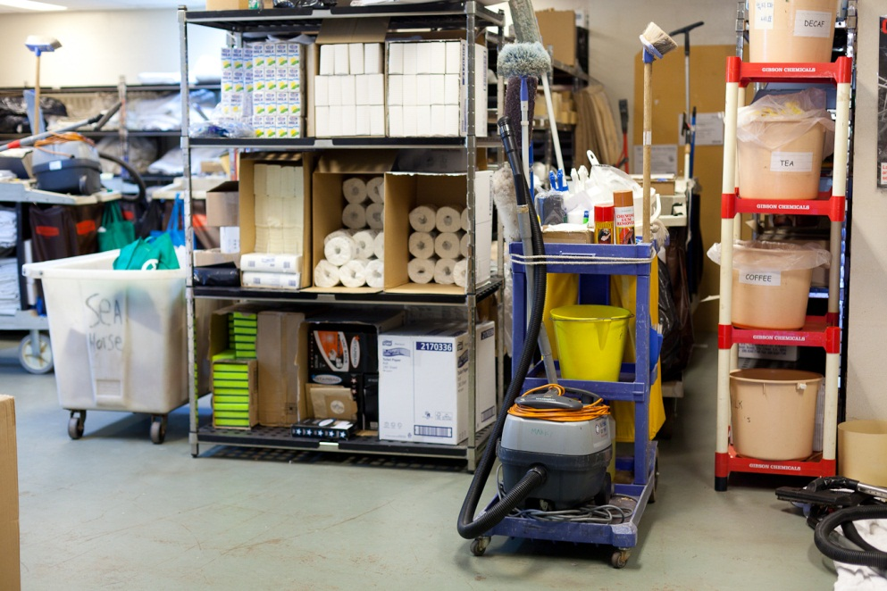

Ordering supplies
At the end of his shift, Mark re-stocks his trolley so it is ready for the next day.
He gets what he needs from the housekeeping storeroom.
This means he doesn’t need to go back to the storeroom during his shift.
If supplies of an item are getting low, he writes it on an order form and gives it to his team leader. When the new stock arrives he has to check that it matches what he had on the order form.
If there is anything missing he tells the team leader.
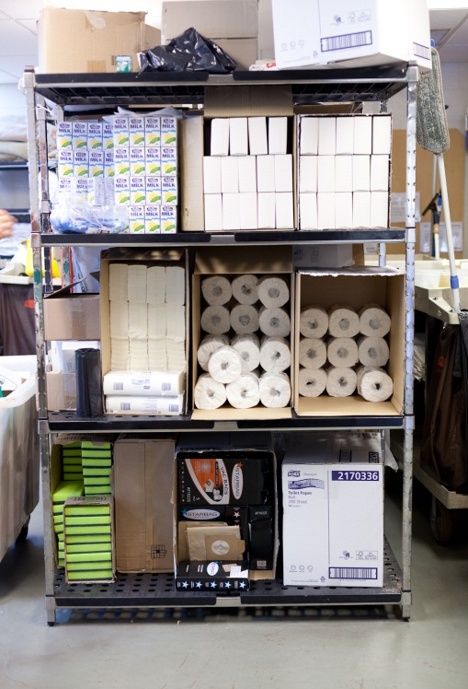
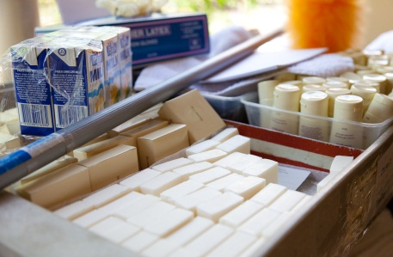

Here is an order Mark made:
Housekeeping Department
Stock order Form
Ordered by: Mark Lontis |  |  | Date: 12/09/12
Number |  | Item | Check received:
3 packs x 12 rolls |  | Kleen toilet paper (unbleached) | ML
2 boxes x 24 packets |  | Softie tissues white, packet of 30 | ML
1 pack of 6 |  | Vacsac Vacuum cleaner bags NTX 3098 | 4 only ML
1 box x 6 bottles |  | Green Wizard bicarbonate bath cleaner liquid | ML

Activity 13
Ordering supplies
These supplies are running low in the storeroom. You need to fill in the order form below.
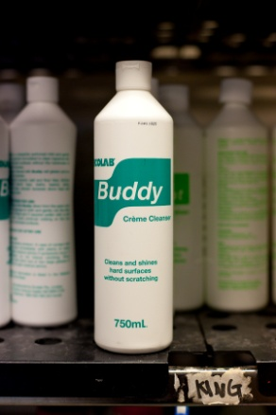
- Butee mop head 1 pack of 3
- Buddy general cleaner 2 boxes x 4 bottles
- Softie brand tissues, 1 box x 24 packets
- Quiksmart disinfectant, 2 boxes x 4 bottles
- Swish disposable gloves, 4 boxes x 50 pairs.

Housekeeping Department
Stock order Form
Ordered by: |  |  | Date:
Number |  | Item | Check when received:

Section summary
Now you have completed this section you should have developed the following skills and knowledge.
Tick each box if you are satisfied that you have those skills and knowledge.

Identify what goes on the cleaning trolley and in the cleaning bucket.
Work out the amount of clean linen you need.
Know how to use a trolley safely.
Know how to clean and restock your trolley at the end of the shift.
Know how to order supplies.
Notes
3 Accessing rooms
Now Mark and Melissa are ready to start cleaning the cabins or rooms. They check their housekeeping worksheets to see what tasks need to be done in each room.
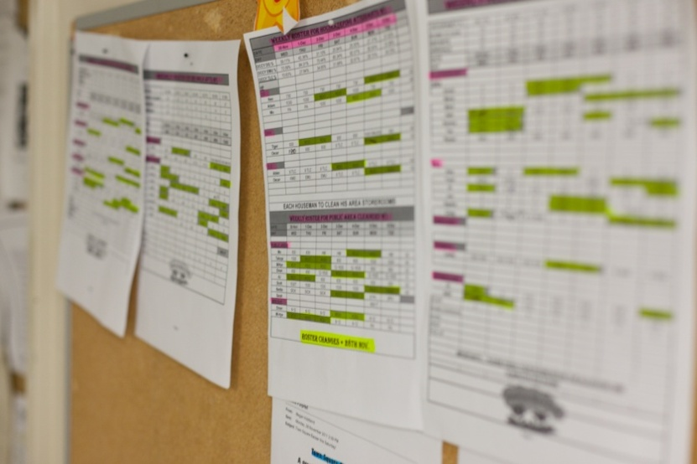
Type of room
Before Mark and Melissa start cleaning they need to know what type of room is being cleaned. Here are the different types of rooms. They are called by different names at different hospitality businesses.
Type of room | Could be called:
Guest departing | - check-out room  - departing room  - vacant dirty room
Guest staying another night | - occupied room  - stayover room
Vacant room | - vacant clean room  - vacant ready room
Housekeeping worksheet
Following is a housekeeping worksheet given to Mark by Janis, the supervisor. It tells him what tasks he has to do.
Read the worksheet. Then answer the questions.

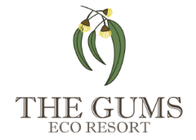
HOUSEKEEPING WORKSHEET
Name: Mark Lontis Date: 18/06/12
CABIN | BEDS | STATUS | STANDARDMAKE-UP? | NOTES | SIGNOFF | ATTENDANT COMMENTS
1 | 1 queen | CO |  | Clean inside cupboards
2 | 1 queen | OCC |  | No linen change
3 | 1 queen | CO
4 | 1 queen  2 single | OCC |  | Change all linen and towels  Extra blanket for queen bed requested
5 | 1 queen  2 single | CO |  | Clean inside cupboards
6 | 1 queen  2 single | VR |  | Inspection and light dusting only
STATUS KEY  CO = Check-Out  OCC = Occupied  VR = Vacant Room |  |  |  | STANDARD MAKE-UP PROCEDURE  - Change bed linen and towels  - Clean bedroom, bathroom and kitchen  - Restock bathroom, bedroom and kitchen supplies  - Vacuum and mop floors  - DO NOT replace light globes – inform Maintenance

Activity 14
Mark’s housekeeping worksheet
1. Look at Cabin 5.
a) What is its status?
b) What does this mean?
c) What cleaning does Mark need to do?
d) Does the linen need to be changed?
e) If so, what linen is needed?
2. Look at Cabin 6.
a) What is its status?
b) What does this mean?

c) What cleaning does Mark need to do?
d) Does the linen need to be changed?
Accessing rooms
Most accommodation businesses have a standard operating procedure (SOP) for accessing (entering) guest rooms.
You should always follow this procedure.

Activity 15
Accessing rooms
Here is The Gums Standard Operating Procedure for accessing rooms.
Read the procedure. Then answer the questions.
Housekeeping Department
Standard Operating Procedure 12
Guest room access
No. | Action
1 | Entering rooms  - Knock 3 times loudly on door (with knuckles, not keys) and say clearly: ‘Housekeeping’.  - Count to 5.  - If no reply, knock and call again, count to 5 again, then use key to enter.  - Enter room and call out ‘Good morning (or afternoon). Housekeeping to service your room’.  - If the guest is still in bed, undressed, in the shower, or seems distressed by you coming into the room, leave the room quickly and quietly and say ‘Sorry’.  - If the guest is up and dressed, say: ‘I‘m from Housekeeping. Would you like me to service your room?’  - If they answer YES, commence room servicing.  - If they answer NO, ask if they want you to come back later. Ask if they want towels or tea, coffee, milk, soap. Then leave the room.
2 | Do Not Disturb signs  - Never enter a room showing a ‘Do Not Disturb’ (DND) card, even if it is a check-out.  - If ‘Do Not Disturb’ card has not been removed by 2 pm, report this to supervisor. There may be a problem (for example, guest is ill) or the guest may have forgotten to remove the sign.
3 | Trolley location  - When you have opened the room to clean it, leave the door wide open.  - Park the trolley across the door to prevent others entering the room.  - Do not take the trolley into the room.
What should Melissa or Mark do?
1 Melissa could not clean Cabin 4 because there was a ‘Do Not Disturb’ sign on the door.
Her housekeeping worksheet says that the room is a check-out room. She still has not serviced the room.
It is 2.00 pm and she finishes her shift at 3.30 pm. What should she do?
2. Mark knocks on a cabin door and counts to 5. There is no reply so he goes in, saying ‘Housekeeping!’ There is a lady there wearing only a bath towel.
What should he do?
3. Melissa is servicing an empty cabin.
Where should she park her trolley while working?
4. Cabin 5 is listed as check-out.
But Mark notices a ‘Do Not Disturb’ sign on the door. He checks with Janis. The guests have changed their minds and are going to stay another night.
What should he do?

Activity 16
Your workplace procedures
Check the procedure for accessing rooms in your workplace.
Are they different to The Gums? YES/NO
If so, how?

Key control
Housekeeping Department
Standard Operating Procedure 3
Key control
TYPES OF KEYS
Hotel master key |  | Opens all doors in resort.  Used by the Executive Housekeeper or Housekeeping Manager on Duty.
Cabin master key |  | Opens all cabins or cabins in a particular section.  Used by the Room Attendant or Housekeeping Supervisor.
Room key |  | Opens guest cabin or dorm only.  Used by the guest or the Room Attendant.
YOUR RESPONSIBILITIES
- All keys must be signed out.
- When you have signed out a key it is your responsibility.
- Do not lend or give keys to anyone else – staff or guests.
- Do not let keys out of your sight.
- Do not take keys out of the resort.
- Never let a guest into a room with your key, even if they say they have lost theirs. Send the guest to Reception who will check they are really a guest and issue another key.

Activity 17
Key control
A guest asks Mark if he will open her cabin as she has locked her key inside.
What should he say?

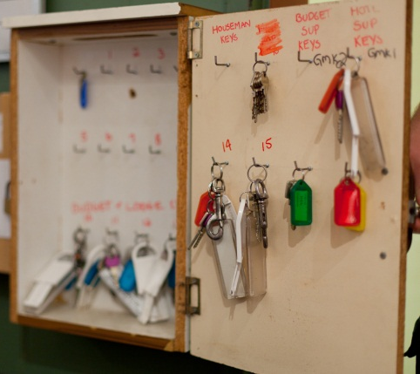

Section summary
Now you have completed this section you should have developed the following skills and knowledge.
Tick each box if you are satisfied that you have those skills and knowledge.

Understand the different types of rooms.
Know the correct procedure for entering rooms.
Know how to be responsible with keys.
Notes

4 Making beds
In a guest room, the bed is generally the biggest thing in the room and the first thing a guest looks at. If the bed looks attractive, it creates a good impression.
The method for making beds is a bit different at each premises.
Read the standard operating procedure for making beds in a vacant dirty room at The Gums Eco Resort. Then answer the questions.
Housekeeping Department
Standard Operating Procedure 13
Making beds – Vacant dirty rooms
These are the steps for VACANT DIRTY ROOMS. (check-out rooms)
For OCCUPIED ROOMS our policy is:
- Make beds daily without replacing linen.
- Replace linen on third day if the guest is staying on.
STEP |  | DETAILS
- STRIP THE BED  and  CHECK FOR STAINS |  | - Blanket, quilt or doona  - Remove and air. Do NOT place on floor  - Check it is clean. Replace if required  - Sheets  - Remove and put in soiled linen bag  - Mattress protector  - Check it is clean  - Remove and replace if stained or dirty. Place items with difficult stains in a separate bag  - Pillows  - Do NOT place on floor  - Remove pillow case and place in soiled linen bag  - Replace pillow if required
- Bedspread
- Remove and air
- Replace if required
2. MAKE THE BED |  | - Place mattress protector in correct position  - Put clean fitted bottom sheet on bed  - Smooth out creases  - Position top sheet, correct side up (check hem), top edge at bed head  - If using quilt or doona, put in new quilt or doona cover and smooth it down – make sure corners of quilt or doona are in corners of cover  - Place quilt, doona or blanket on bed  - Turn top of sheet over quilt, doona or blanket at bed head end  - Mitre corners of top sheet and quilt, doona or blanket together  - Smooth out creases  - Put bedspread in position  - Fold back bedspread twice at bed head end  - Plump up pillows and put in pillowcases  - Put pillows on bed with opening towards wall; square pillows then regular pillows

Mitre corners (hospital corners)
This is a special way of tucking in sheets and blankets neatly and firmly.

Activity 18
Making beds
Look at The Gums standard operating procedure for making beds and answer these questions.
1. The guests in Cabin 3 have checked out. What are Melissa’s bed making tasks?
2. The guests in Cabin 1 have been staying for 2 nights. They are staying for 2 more days. When should Melissa change the sheets?

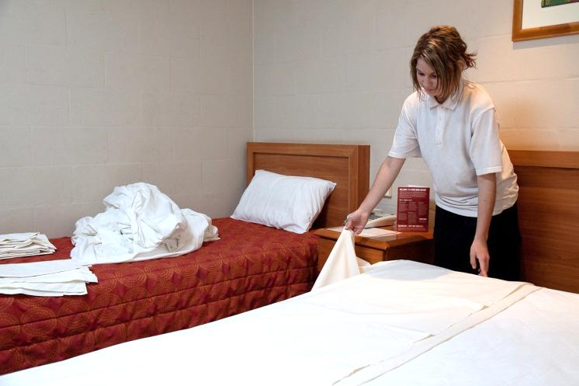

Bed making tasks

Activity 19
Bed making procedure
Look at each picture. What part of the procedure are the room attendants doing?

1.
2.

3.

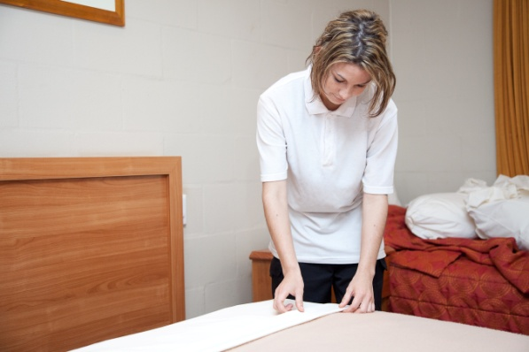
4.

5.
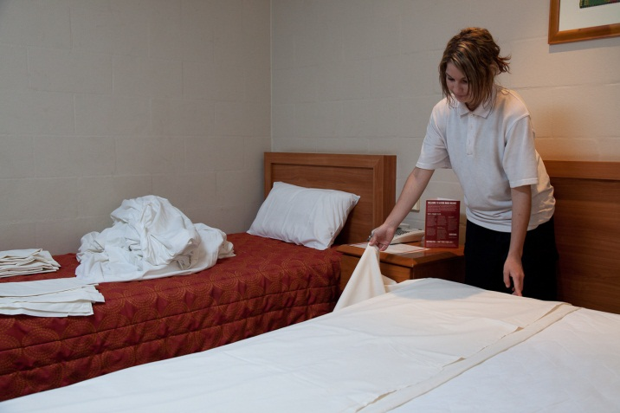
6.

7.

Section summary
Now you have completed this section you should have developed the following skills and knowledge.
Tick each box if you are satisfied that you have those skills and knowledge.

Know how to make a bed in a vacant dirty room (check-out room).
Notes
5 Cleaning rooms
Guests staying in hotels expect a clean and tidy room. Look at these remarks from guests who were unhappy about the state of the rooms they stayed in.

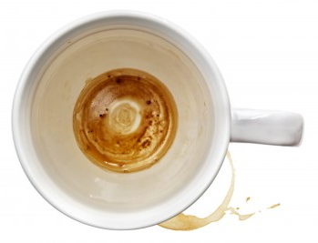

!!! XXX
*%!
Nobody washed the coffee cups in my room. They were just left filthy!
The bath was full of hair, and there was toothpaste on the vanity unit!

There were someone’s dirty socks under the bed and the rubbish bin in the bathroom had not been emptied!
I woke up covered in bed bug bites!

There were mouse droppings in the toaster cupboard and old milk in the fridge!

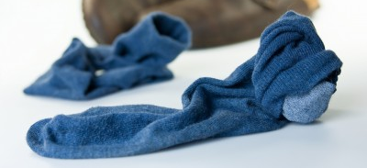

Cleaning different types of rooms
Rooms need different levels of cleaning, depending on what is happening with them.
Type of room | Cleaning comments
Guest departing  May be called:  - Check-out room  - Departing room  - Vacant dirty room. | Take longer to clean than occupied rooms because they need a full clean.
Guest staying another night  May be called:  - Occupied room  - Stayover room. | Clean after the check-out rooms.  - Make the bed  - Tidy the bathroom  - Replenish supplies  - Empty bins  - Wet wipe surfaces around guest personal belongings  - Vacuum floors.
Vacant room  May be called:  - Vacant clean room  - Vacant ready room. | Inspect and basic service.  - Dust  - Flush toilet  - Check fridge.

Cleaning procedures
All hotels have their own cleaning procedures so that everyone does things in the same way, and to the same standard.
Here is the procedure for cleaning a vacant dirty room at The Gums Eco Resort.
Housekeeping Department
Standard Operating Procedure 17
Cleaning vacant dirty rooms
Step |  | Action
1. General |  | - Clean rooms in the correct order and with minimum disruption to guests.  - Use colour-coded cleaning chemicals and colour-coded cloths for specific tasks only.  - Never use room towels or linen for cleaning. Only use cleaning cloths provided.  - Never touch any guest items including magazines and newspapers. If business papers are on the desk or table, do not clean or tidy there.
2. Check for damage and pests |  | While cleaning, check for any damage and signs of pests. Look out for:  - frayed cords, broken lamps, flickering lights  - broken fridge door seals  - chipped or broken glass, e.g. on mirror or shower  - dripping taps  - torn curtains or furnishings  - noisy refrigerator  - fuzzy television picture  - remote control that won’t work  - leaking air conditioner.  You should replace any broken crockeryand missing shower curtain rings from the store room.  Tell your supervisor immediately if you find serious damage e.g. electrical faults. Complete Maintenance Tag.  DO NOT DO ANY REPAIRS YOURSELF.
3. Order of cleaning tasks |  | - Prepare room:  - Turn on all lights.  - Open all blinds and curtains.  - Open windows or sliding doors to let in fresh air.  - Collect and remove dirty towels, dishes, bottles and rubbish; wrap any broken glass in newspaper.  - Remove any room service trays, cover them with a napkin and leave in the corridor for collection.  - Turn off fridge or set on defrost. Place towel in open door to catch any drips.  - Spray chemical in bathroom and toilet to enable it to sanitise surfaces.  - Strip and make bed.  - Dust and polish.  - Clean bins.  - Clean kitchen area, including washing crockery.  - Clean fridge.  - Clean bathroom.  - Replenish bathroom supplies.  - Replenish guest supplies (kitchen, stationery).  - Vacuum starting from furthest corner working your way towards the door.  - Mop bathroom floor.  - Spray air freshener.  - Make final inspection, close curtains, turn off lights, leave room.

Activity 20
Cleaning rooms
Read through the procedure for cleaning a vacant dirty room at The Gums Eco Resort.
Look at the questions below.
Talk together about why you do each task in that way.
1. Why do you turn on all the lights?
2. Why do you spray the chemical in the bathroom so early?
3. Why do you make the bed before you dust?
4. Why do you spray air freshener last?
5. Why do you start vacuuming in the furthest corner and work your way towards the door?

Mopping
With a cloth mop
- Start in one corner and clean around the room edges (framing)
- Then start in the back corner again
- Mop in a figure 8 movement to “fill in” the frame
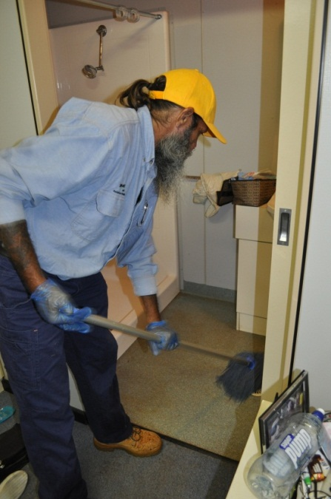
- Work towards the exit.

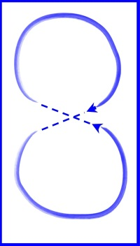

With a rectangular sponge or microfibre mop
- Mop in straight lines
- Start in the back corner work towards the exit.

Using fewer resources when we clean
We use a lot of resources such as water and energy (electricity and gas) when we are cleaning.
Here are some ways to reduce harm to the environment by reducing the amount of resources we use.

Don’t waste water
- Don’t leave taps running when you are not using them.
- Rinse by filling up another container with clean water rather than rinsing under running water.
- If any taps are dripping, let your supervisor know so they can be fixed.
- Only use as much water as you need. If you only need to wash a small thing don’t fill the sink full.

Don’t waste energy
Use and maintain cleaning equipment properly.
- Turn off any equipment when it is not being used so it does not use electricity.
- Clean equipment after you have used it e.g. empty the vacuum cleaner. This means it will work more efficiently and use less energy next time.
- Keep equipment maintained. Equipment that is not working properly could use more electricity.

Housekeeping Department
Standard Operating Procedure 18
Cleaning rooms
Step |  | Action
1. Dust and polish  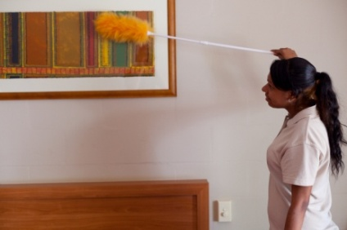 |  | - Dust high areas before vacuuming and changing the bed.  - Dust low areas and wet wipe after making the bed.  - Dust with a duster or a damp lint-free cloth. Don’t use a damp cloth if water could affect the surface. Change the cloth when it gets dirty.  - When polishing, spray the cleaning product onto the cloth, not the surface. Polish after cleaning to remove any streaks.  - Start dusting or polishing in one spot and work around the room. Pick up small items to dust or polish underneath.  - Things to clean include:  - air conditioning vents  - doors – including top ledge and handles  - picture frames – glass as well as frame  - mirrors – including frame  - skirting boards  - bedside table and drawers  - wardrobe, cupboards and internal shelving  - windows – glass, frames ledges and sills  - walls – check for cobwebs and marks  - lamps – base, shade and cord  - telephone – main unit and hand receiver  - seat furniture – remove cushions and check sides, legs, back and underneath  - all furniture – top, sides, legs, underneath, and inside the drawers.
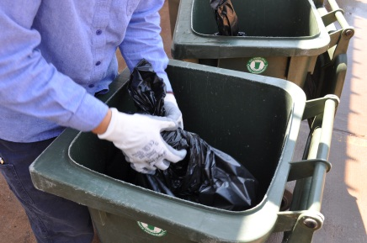  2. Clean bins |  | - Always wear protective gloves.  - Empty bins daily.  - Be careful when handling the bin as there may be sharp or dangerous items. Don’t put your hand in to remove items. Don’t hold the bin liner against your body.  - Wrap up all broken glassware or bottles in newspaper and dispose of separately and safely.  - Clean out bins and put in a new bin liner.
3. Clean kitchen area  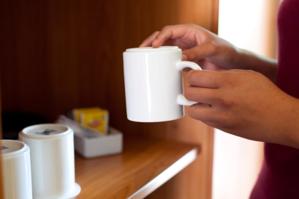 |  | - Wash and dry dirty dishes.  - Clean toaster, microwave and kettle.  - Check coffee and tea supplies.  - Tidy and put crockery and cutlery in correct places.  - Check dishwashing liquid and replace tea towels.
4. Clean fridge  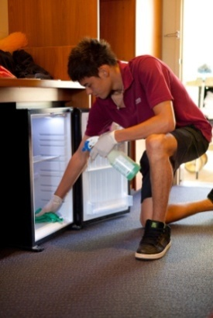 |  | For check-out rooms:  - Always wear protective gloves.  - Take food items found in the fridge to the Housekeeping Department.  - Clean inside of the fridge, including seals, with hot soapy water, then dry with clean cloth.  - Replenish items such as milk sachets and ice cubes.  - Turn fridge on, re-set to correct temperature and close door.
5. Vacuum  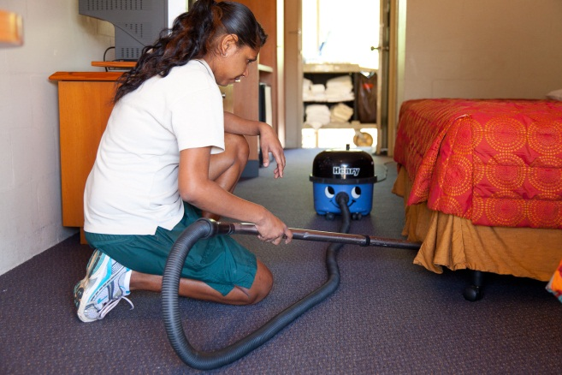 |  | - Vacuum carpeted and non-carpeted areas, being careful not to suck up water on bathroom floor.  - Treat carpet stains with spray-on product. If this does not remove the stain, report it to your supervisor.  - Start vacuuming in the corner furthest from the door and work back towards the exit.  - Vacuum around and under all furniture including the bed.  - Vacuum the corners of the room.  - Bend your knees when cleaning under items.  - Do not bend over the machine.
6. Final check  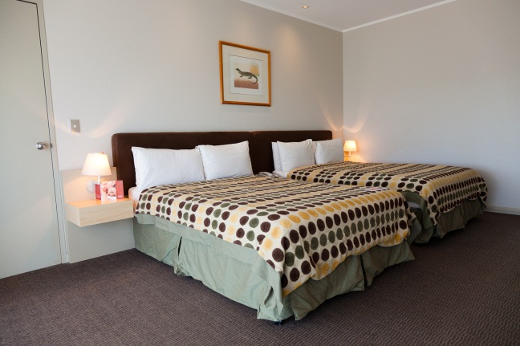  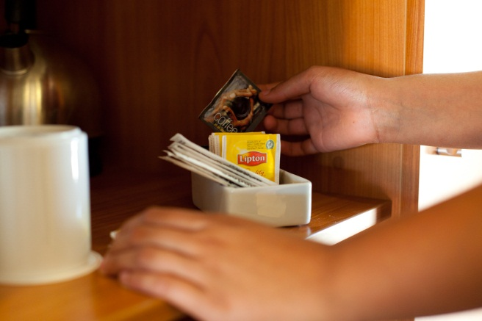 |  | Before you leave, check presentation:  - Equipment is re-set and operating correctly – clock radio, video remote, telephone volume.  - Crockery and glassware are correctly arranged.  - Picture frames are straight.  - Furniture is in the correct location.  - Guest and bathroom supplies are correctly arranged.  - Bin liners have been replaced.  - Windows are closed.  - Blinds and curtains are in place.  - Lights are turned off.

Activity 21
Clean rooms
Read the procedure for cleaning a room at The Gums Eco Resort.
Also have another look at the previous general procedure for cleaning vacant dirty rooms.
Then answer the questions.
1. Melissa likes dusting things in a different order in each room to make the task more interesting. Is this right? Why or why not?
2. Mark is going to clean an occupied room. Should he clean the drawers?
3. Melissa is cleaning an occupied room. The guest has left his paperwork scattered over the table and she thinks it looks messy. What should she do?
4. Mark has found an electrical socket that is loose in the wall. What should he do?

Housekeeping Department
Standard Operating Procedure 19
Clean bathrooms
Step |  | Action
1. Bathroom: prepare for cleaning |  | - Turn on fan for ventilation.  - Collect all dirty towels and place in soiled laundry bag.  - Collect and throw out all used bathroom supplies – shampoo, conditioner, soap, etc.  - Check shower curtain for cleanliness – remove if soiled.  - Check all light globes and report if need replacing.  - Check all electrical equipment for damage or faults and report to your supervisor.  - Check all fixtures and fittings for damage or defects. Report these to your supervisor.  IF YOU FIND A SYRINGE:  - don’t touch it  - call the supervisor to dispose of it safely.
2. Toilet  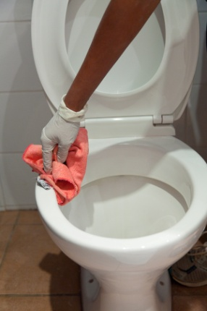 |  | - Always wear protective gloves and safety glasses.  - Flush toilet to wet the sides of bowl.  - Pour in toiler cleaner – leave to soak for at least 6 minutes.  - Clean bowl thoroughly with toilet brush.  - Wash seat – both sides and near back hinges.  - Wash outsides of the bowl.  - Wash lid – both sides and near back hinges.  - Wash water holding unit and polish button.  - Start at the top again and work your way down the outside of the toilet to the floor using a drying cloth.  - Flush toilet to wash away dirt and chemical.  - Final inspection.  - Close lid.
3. Bath  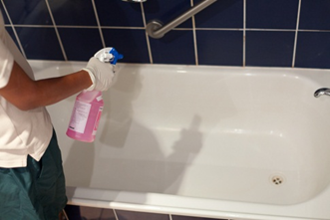 |  | - Always wear protective gloves and safety glasses.  - Spray chemical in tub to sanitise and remove stains and marks.  - Remove hair and dirt from plughole.  - Scrub bath using scourer.  - Rinse bath thoroughly.  - Dry and polish with cloth including any chrome and taps.  - Final inspection.
4. Shower  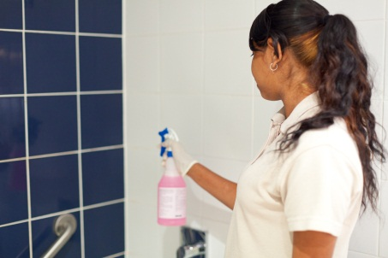 |  | - Wet shower basin and sides.  - Spray chemical on walls.  - Clean tiles and floor – check plughole for hair and dirt.  - Clean shower curtain – check pole is clean and all hooks run smoothly.  - Rinse and dry walls and floor thoroughly.  - Polish fittings.  - Final inspection – leave shower curtain neat and to one side.
5. Vanity area  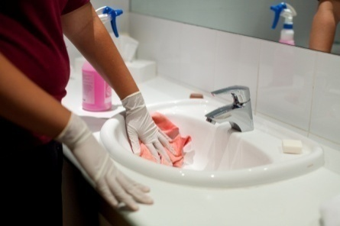 |  | - Clean and dry shelves.  - Clean and dry wall tiles.  - Clean and polish mirror.  - Scrub hand basin, rinse, then dry and polish with clean cloth.  - Clean, dry and polish bench top.  - Polish fittings.  - Check under bench for cleanliness – cobwebs, etc.  - Replace supplies – shampoo, conditioner, soap, tissues, shower caps.  - Replace towels – bath, face, hand, and bath mats.  - Final check.
6. Bathroom floor  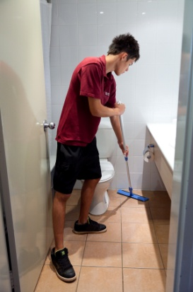 |  | - Sweep if necessary.  - Mop floor tiles, beginning in one corner and working around the edges (framing). Check under the bench and behind the door.  - Use microfibre mop so rinsing and drying not required and so it can reach into hard to reach places and corners.  - Leave bathroom door open for air circulation.
7. Bathroom: final check  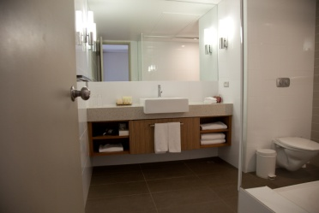 |  | Before leaving the bathroom, check that:  - bathroom looks clean and tidy  - towels and guest supplies have been replenished  - all appliances (e.g. hairdryer) are working  - all surfaces are clean and dry  - fan is turned off  - lights are turned off.

Activity 22
Clean barhrooms
Read the standard operation procedures for cleaning bathrooms at The Gums. Then answer the questions.
1. Mark is cleaning the bathroom of an occupied cabin. The towels are hung up on the rails, but the occupants have been in the room for 3 nights. Should he replace the towels?

2. Mark is going to clean the bathroom floor before cleaning the toilet and shower. Is this right? Why or why not?
3. Mark has finished cleaning the bathroom. What things should he look for in his final check?

Three ways to use fewer chemicals
Cleaning chemicals are often toxic and bad for the environment. When we empty our buckets down the sink, the poison can get into the water. Here are 3 ways your workplace can reduce the effect of cleaning chemicals on the land, water and air.
- Use microfibre cloths for cleaning. These are made of a special material that removes dirt, grease and dust without chemicals.
- Choose biodegradable cleaning products which are less harmful to the environment.
- When you dilute chemicals with water, only use the amount stated on the label. Using more won’t clean any better and puts extra chemicals into the environment.

Cleaning products
Activity 23
Cleaning products and equipment
What cleaning products and equipment are used in your workplace? Fill in this table.

To clean this … | I need these cleaning products | I need this cleaning equipment
Bath and shower
Bathroom vanity bench and basin
Bathroom floor
Toilet
Kitchen bench
Fridge
Carpet
Furniture
Light fittings
Phone
Appliances
Windows
Blinds and curtains
Pictures

Diluting cleaning products – the maths
Here are the instructions on the label for diluting Shyne Floor Cleaner with water.
Shyne
Floor Cleaner
Mix 10 ml in 1 litre
of warm water

ml = millilitres

Your bucket holds 10 litres.
- Multiply the amount of warm water (1litre) by 10 to fill your bucket.
- Also multiply the amount of floor cleaner by 10 to match the water.

The water and the chemical must stay in the same ratio or balance with each other.

WATER | CHEMICAL | RATIO
1 litre | 10 ml | 1:10
x 10 | x 10
= 10 litres | = 100 ml | 10:100  = 1:10

- ALWAYS measure cleaning product. NEVER guess how much to use.
- ALWAYS follow the manufacturer’s instructions.
- ALWAYS put the cleaning product into the water so there is no splashing.
NEVER pour water into the cleaning product.
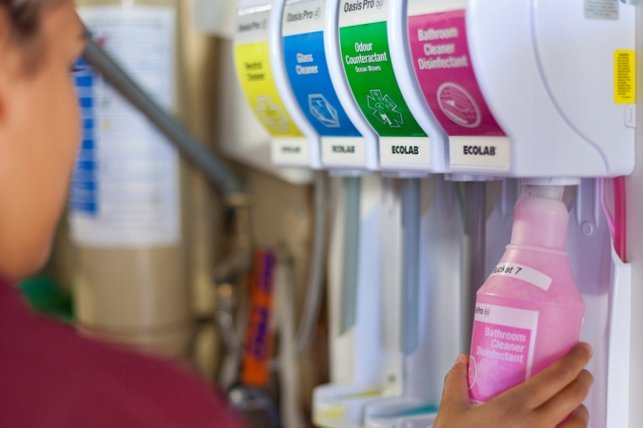

A lot of cleaning products are pre-mixed so you don’t need to dilute them yourself.

Activity 24
Diluting cleaning products
You have to mix up the floor washing detergent in a 10 litre bucket.
On the label it says 20 mls per litre of water.

- How much detergent will you put in?
WATER | CHEMICAL
1 litre | ml
x 10 | x 10
= 10 litres | = ml
- The detergent cap is also a measuring cup. It holds 20 mls. How many caps of detergent will you put in the bucket?

Chemicals and the environment
Some chemicals are toxic and bad for the environment. When we empty our buckets down the sink, the chemicals can get into the water.
Here are 3 ways to reduce the effect of cleaning chemicals on the land, water and air.
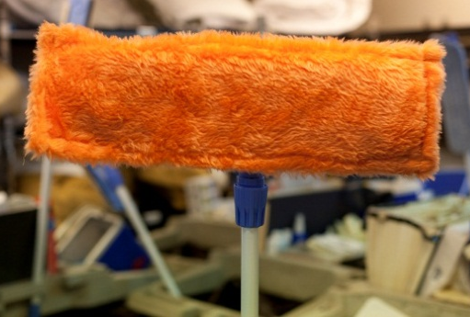
- Use microfibre cloths for cleaning. These are made of a special material that removes dirt, grease and dust without chemicals.

- Choose bio-degradable cleaning products, which are less harmful to the environment.

- When you dilute chemicals with water, only use the amount stated on the label. Using more won’t clean any better and puts extra chemicals into the environment.

Section summary
Now you have completed this section you should have developed the following skills and knowledge.
Tick each box if you are satisfied that you have those skills and knowledge.

Know the order to do room cleaning tasks in.
Understand cleaning procedures for rooms and bathrooms.
Identify what types of damage to check for.
Know how to mop correctly.
Identify what cleaning products and equipment to use for each task.
Dilute cleaning products.
Notes
6 Pests and other problems
This section deals with some of the less common situations you may come across in housekeeping. They include:
- pests
- unusual or suspicious items or activity
- lost property.
Pests
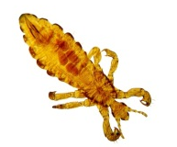 | 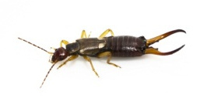 |  | 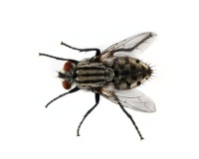
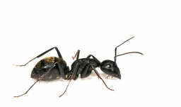 | 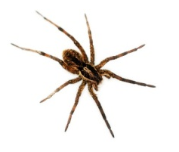 | 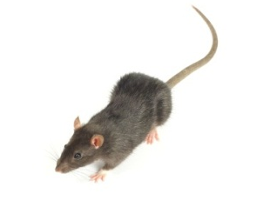 | 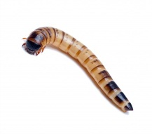

Pests include:
- flies | - possums
- cockroaches | - bed bugs
- silverfish | - moths
- fleas | - ants
- mice or rats | - wildlife e.g. lizards, snakes.
Pests can cause discomfort and also spread diseases. Guests will be very upset if they find pests in their rooms. They may leave, or ask to be moved to another room. They might also complain to government public health departments and the media, which is very bad for the hotel’s reputation.
It is the responsibility of the hotel to keep the place clean and healthy.

Here is the procedure for pest control at The Gums.
Housekeeping Department
Standard Operating Procedure 23
Pest control
TO PREVENT PESTS:
- Never leave food out on benches or tables.
- Keep bins clean and in good repair.
- Clean premises thoroughly and disinfect when necessary.
- Remove all rubbish on a regular basis.
TO DEAL WITH PESTS:
- If you see insect pests such as flies, ants and silverfish, use the eco-friendly insect spray on your trolley. Use only a small amount and wear gloves and a mask.
- Report all pests immediately to supervisor for further investigation.

Activity 25
Signs of pests
1. What are some possible signs that pests may be in a room?
2. What should Mark do if he sees ants on the bench in a cabin kitchenette at The Gums?

Activity 26
Pest control procedure
Find out the procedure for pest control at your workplace.
Is it different to the procedures at The Gums? YES/NO
If so, how?
Unusual or suspicious items or activities
Room attendants have access to rooms where many different people stay. Sometimes you may come across something that seems unusual or suspicious – not quite normal.
An unusual item may include: | Suspicious occurrences may include:
- package left unattended  - item that is heavily bloodstained  - large amounts of cash  - weapons – guns and knives  - drugs such as white powder on table. | - someone behaving nervously or anxiously  - someone in an area they shouldn’t be in  - someone using excessive force against another person  - loud voices and swearing  - sounds that indicate damage is being done  - someone loitering on a floor, along corridors, in public areas  - someone asking you to let them into a room

Activity 27
Unusual or suspicious items or activity
Read the procedure about unusual or suspicious items or activity from The Gums and then answer the questions.
Housekeeping Department
Standard Operating Procedure 24
Unusual or suspicious items or activity
If you see an item or an activity that looks unusual or suspicious:
1. Contact your supervisor or security immediately by phone or in person.
2. DO NOT APPROACH.
3. Try to remember as much as possible about the person or event.
1. When Melissa was cleaning out Cabin 3, she found a syringe in the bin. What should she do?

2. When Mark was pushing his trolley down the corridor, he saw a parcel sitting against the door to the emergency stairwell. What should he do?

3. When Mark was on his way back to the housekeeping office he noticed a car parked outside the fence and a person looking into a cabin window. What should he do?

Activity 28
Security in your workplace
1. How do you contact security?
2. How do you contact your supervisor?
3. What is the security procedure in your workplace if you think someone is breaking into a room?
Lost property
Guests often leave things behind in rooms. Some of the things guests have left behind include:

- sunglasses, reading glasses
- mobile phones and chargers
- books and magazines.
- shampoo and conditioner
- medicine

- alcohol
- food
- valuables (cameras, money, watches, jewellery, wallets, keys)
- clothing (underwear, pyjamas, jackets, shoes, hats).

Activity 29
Lost property
Read the procedure from The Gums and then answer the questions.
Housekeeping Department
Standard Operating Procedure 25
Lost property
If you find items in check-out rooms that have been left behind by the guest:
- Treat the item as valuable, no matter what they are actually worth.
2. Fill in the Lost Property Tag.
3. Take item to the Housekeeping Department and report to the supervisor.
4. Do not take lost property off the premises without the supervisor’s approval.
What happens to lost property?
Items are bagged, tagged and placed in the lost property cupboard.
Valuable items are placed in the hotel safe.
If items have not been claimed after three months (for low-value items) or six months (for high-value items), the item will be given to the finder.

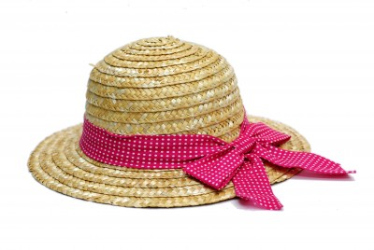
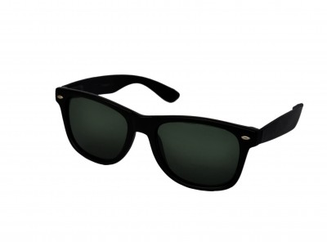
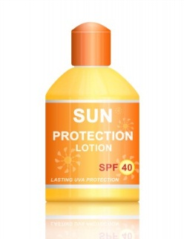

1. Melissa has found a smart phone and charger in the bedside cupboard in a check-out room. What should she do?
2. If you find lost property in your workplace, what is the procedure?
3. If you find opened alcohol in a check-out room, what should you do?
4. You found a pair of black Rayban sunglasses in Cabin 3 yesterday.
Fill in The Gums Lost Property Tag. The claim expiry date will be 3 months after you found them.

LOST PROPERTY TAG
38072
DATE FOUND ________________________________________
LOCATION FOUND ____________________________________
DESCRIPTION OF ITEM ____________________________________________________
____________________________________________________
____________________________________________________
NAME OF FINDER _____________________________________
CLAIM EXPIRY DATE ___________________________________

Was the item claimed? YES / NO
DATE RETURNED _____________________________________
OWNER DETAILS _____________________________________
____________________________________________________
REMARKS ___________________________________________
____________________________________________________

Section summary
Now you have completed this section you should have developed the following skills and knowledge.
Tick each box if you are satisfied that you have those skills and knowledge.

Know pest control procedures.
Know what to do if you see unusual or suspicious items and activities.
Know what to do about lost property.
Notes
7 Your environmental impact
Cleaning tasks use a lot of water and chemicals. These days, people are concerned about damage to the environment. We are changing our approach to how we use resources and how they affect the land, sea and air around us.
It is important for room attendants to be aware of the environmental impact of cleaning rooms. You should use practices which:
- save water
- reduce energy use (electricity and gas)
- use fewer chemicals
- reduce the waste we produce
- dispose of hazardous chemicals safely.
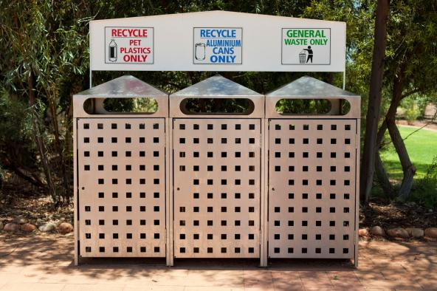
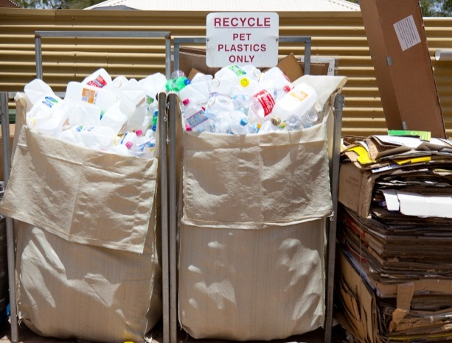
Recycling
Recycling means re-using something.
Your workplace probably has recycling rubbish bins. There may be separate bins for plastics, aluminium cans, food scraps, and for paper and cardboard.
Things like paper, glass and plastic can be re-processed and used again. Food can be turned into compost and used on garden beds.
It is good for the environment because less rubbish is sent to the tip and fewer new things are manufactured.

Cleaning in an environmentally friendly way
The Gums has a procedure telling room attendants how to follow environmentally sound practices.
Housekeeping Department
Standard Operating Procedure 29
Environmental cleaning practices
The Gums Eco Resort is committed to environmentally friendly cleaning practices.
Help us be environmentally responsible by doing these things:
1. Turn off all electrical appliances and lighting when not in use.
2. Don’t use excessive amounts of water for cleaning.
3. Only use the cleaning products provided, which are biodegradable and septic-tank-friendly.
4. Always use the microfibre mops, brooms and cloths provided. They do not need chemicals.
5. Only send towels to the laundry when specified or when towels are left by guest on floor.
6. Place rubbish in correct recycling bins.

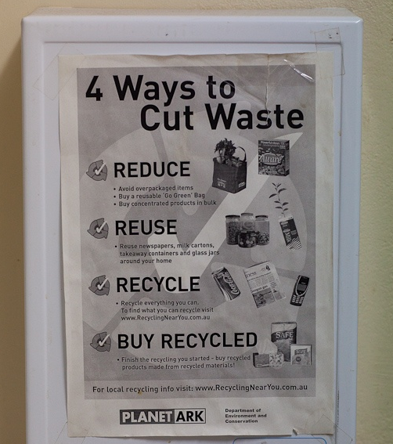

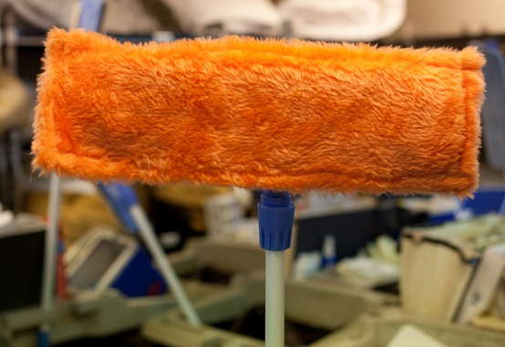

Activity 30
An environmentally friendly workplace
In this workbook, you have found out about approaches to cleaning that help protect the environment.
Which ones are used in your workplace?
Tick YES or NO for each question.
At your workplace … | YES | NO
1. Are any of the cleaning products biodegradable or non-toxic?
2. Does your workplace use spray bottles instead of aerosol cans?
3. Do you use microfibre cleaning products?
4. When you dilute (mix) chemicals with water, do you only use the amount on the label?
5. Is the vacuum cleaner efficient (with a high star rating)?
6. Is the vacuum cleaner well maintained?
7. Are you encouraged to save water e.g. not rinsing under running water?
8. Do you turn off taps when you are not using them?
10. Do you let your supervisor know if you find a dripping tap?
11. Are you encouraged to save energy e.g. turning off lights and equipment when it is not being used?
12. Are recycling bins used?

Hazardous substances and biological waste
Hazardous substances
Hazardous substances are dangerous to people and the environment.
Some hazardous chemicals are used for cleaning, for example:
- laundry and dishwashing detergents | - ammonia
- window cleaning sprays | - carpet and spot removers
- oven cleaners | - polishes
- bleach | - pesticides
- deodorisers.

Hazardous chemicals are dangerous because they can:
- pollute (poison) the waterways and land if they are washed down drains
- hurt us if they touch our eyes, skin or we breathe them in
- cause explosions
- cause fires.

Biological waste
Biological waste comes from people or animals and includes body fluids such as blood, vomit and semen.
When you are cleaning rooms and other parts of the premises, you may come into contact with biological waste through:
- discarded needles and syringes
- soiled laundry
- rubbish in bins.
This may expose you to infectious disease risks, including blood-borne viruses such as hepatitis B, hepatitis C and HIV (the virus that can cause AIDS).

Disposing of hazardous substances and biological waste
Your workplace will have procedures for getting rid of hazardous chemicals and biological waste.
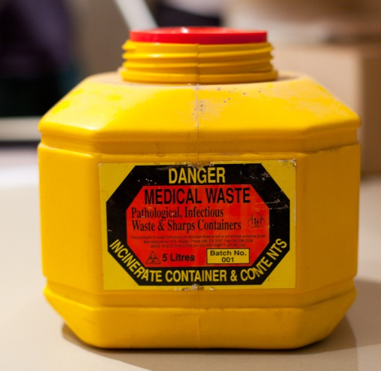
Many of these chemicals can’t be put into normal rubbish bins or tipped down drains.
Your workplace may have a chemical waste trap for diluted chemicals.
You will be shown:
- how to handle soiled linen safely
- what to do if you find a syringe
- where to dispose of used cleaning water.

Housekeeping Department
Standard Operating Procedure 35
Handling hazardous substances
The Gums Eco Resort tries to minimise the use of hazardous substances. However it is important for all staff to use safe practices when handling hazardous substances.
1. Biological waste |  | You may be exposed to biological waste such as blood or vomit when:  - handling soiled linen and towels  - emptying waste bins.  To reduce the risk of contracting infection:  - use personal protective equipment (PPE) – gloves, face mask, safety glasses  - cover cuts or abrasions before starting work  - put waste in a biological waste bag and take it directly to place of disposal  - wash hands thoroughly after contact with contaminated items  - do not touch syringes - call your supervisor immediately if you find one.
2. Cleaning products |  | When using cleaning products:  - only use products provided by the resort  - always follow instructions on the container - ask your supervisor if you are unsure  - make sure you have completed our training in safe handling of chemicals  - always wear correct personal protective equipment – gloves, face mask, safety glasses  - make sure there is plenty of fresh air  - never mix products together  - only use as much as you need to, no more  - do not eat, drink or smoke while working with a cleaning product  - wash your hands thoroughly after handling cleaning products.
3. Other |  | Dispose of the following items separately from other waste. Use marked bin in housekeeping waste disposal area:  - batteries  - light globes  - aerosol cans.

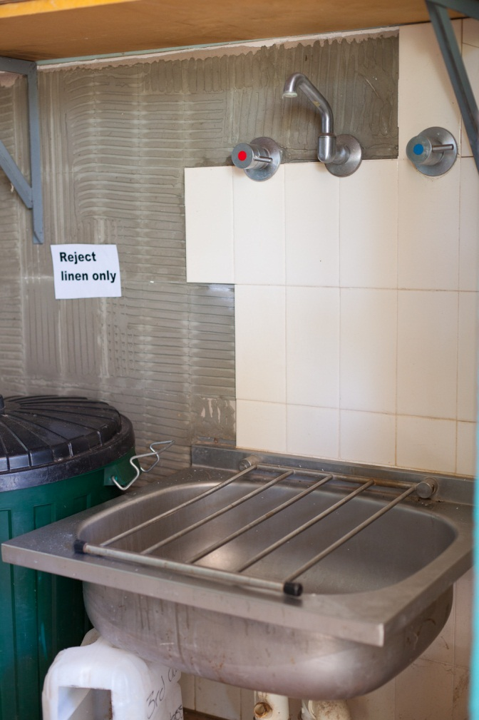

Activity 31
Hazardous substances
1. How do you dispose of biological waste in your workplace?
2. What hazardous chemicals are used in your Housekeeping Department?
3. How do you dispose of diluted cleaning products?
4. How do you dispose of undiluted cleaning products?
5. How do you dispose of batteries, light globes and aerosol cans?

Section summary
Now you have completed this section you should have developed the following skills and knowledge.
Tick each box if you are satisfied that you have those skills and knowledge.

Use environmentally sound cleaning practices.
Know how to dispose of hazardous substances and biological waste correctly.
Know how to handle cleaning chemicals safely.
Notes

Key words
Word | Meaning
adequate | Enough
defect | A fault, something wrong
designated | Allocated
dispose of | Get rid of
disrupt, disruption | Disturb or upset
fixtures | Items fixed in place e.g. taps, sinks, baths
hazardous | Dangerous
induction | Training for new employees in how to do things in their new workplace
loitering | Hanging around, without a reason to be there
minimum | Smallest amount
mitre | A neat way of folding the corners of bed linen and blankets; also called a hospital corner
procedure | A list of steps for how to do something
replenish | Refill
restricted | Cramped
SOP | Standard operating procedure – the set way of doing tasks at a particular workplace
substances | Liquids, solids or gases
SWP | Safe work practice
toxic | Dangerous
ventilation | Fresh air
worksheet | A list of things to do and the time to do them by

