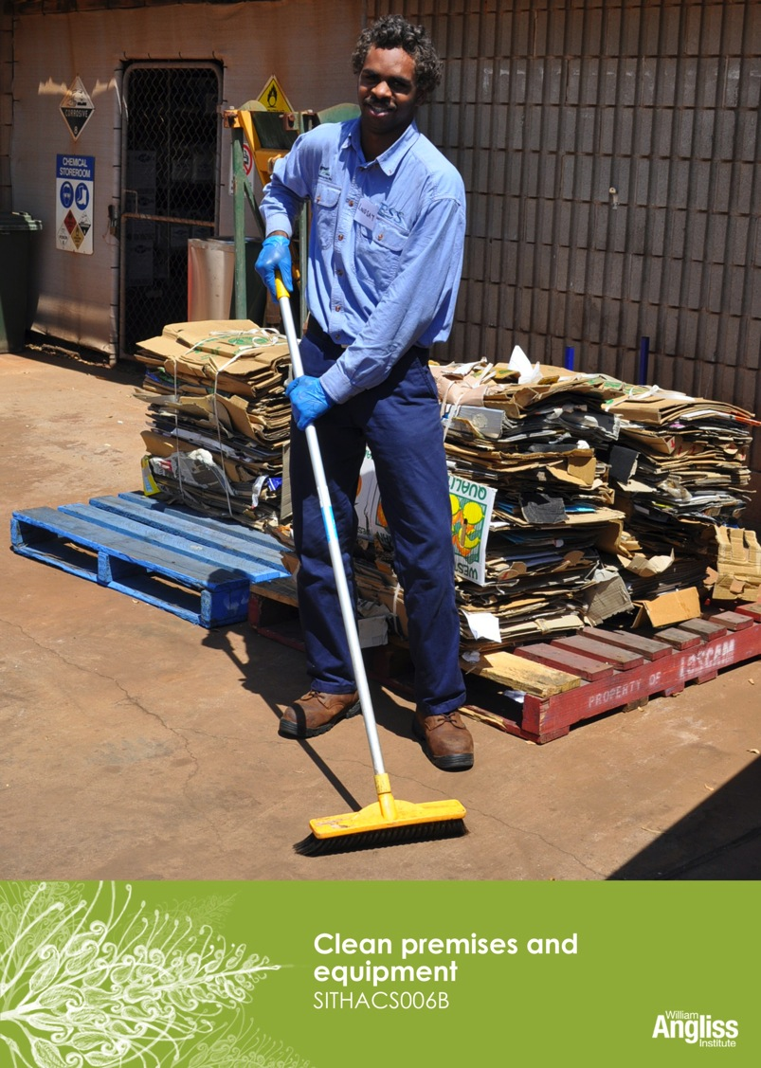

© Commonwealth of Australia. 2012
CC BY-NC-SA
This work is copyright. Except where otherwise indicated, and save for the Commonwealth Coat of Arms, the Department has applied the Creative Commons Attribution-Noncommercial-Share Alike 3.0 Australia Licence to this work.
The Department of Education, Employment and Workplace Relations must be attributed as the author of the Department’s copyright material.
As far as practicable, material for which the copyright is owned by a third party has been clearly labelled. The Department has made all reasonable efforts to ensure that this material has been reproduced in this resource with the full consent of the copyright owners.
Requests and enquiries concerning the Department’s copyright material should be addressed to:
The Copyright Officer
Department of Education, Employment and Workplace Relations
Location code C148CW2
GPO Box 9880 Canberra ACT 2601
Or emailed to copyright@deewr.gov.au
Funded under the Workplace English Language and Literacy (WELL) Program by the Australian Government Department of Education, Employment and Workplace Relations.
The views expressed in this publication do not necessarily represent the view of the Minister for Education or the Australian Government. The Australian Government does not give any warranty nor accept any liability in relation to the contents of this work.
ISBN 978-1-922108-05-0

Development Team
Content | William Angliss Institute  Macsmith and Associates
Photography & graphics | Benjamin B Photography

Acknowledgments
We would like to acknowledge the generous support of the following organisations and the Indigenous learners and employees in those venues for giving their permission for photography:
Ayers Rock Resort, Yulara, NT
Charcoal Lane Restaurant, Fitzroy, Vic
Lux Foundry Café, Brunswick, Vic
Peninsula Palms (Compass Group Australia), Dampier, WA
Permissions
We would like to acknowledge Ecolab who have kindly granted permission for their photographs of their products to be incorporated in this resource.
Cultural Warning
People of Aboriginal or Torres Strait Islander descent should be aware that this publication contains images of people who may be deceased
Disclaimer
Every effort has been made sure that this booklet is free from error or omissions. However, you should conduct your own enquiries and seek professional advice before relying on any fact, statement or matter contained in this book. William Angliss Institute of TAFE is not responsible for any injury, loss or damage as a result of material included or omitted from this course.

Contents
Welcome vi
Icons vi
What you will learn vii
1 Why is cleaning important? 1

2 Cleaning equipment 3
The cleaner’s trolley 3
The cleaning equipment 6
Use cleaning equipment safely 10
Check equipment before you start work 12
Care of cleaning equipment 12
Cleaning electrical equipment 16
Reporting damaged equipment 17
Section summary 19
3 Cleaning products 20
Types of cleaning products 20
Types of surfaces to clean 22
Use cleaning products safely 24
Diluting chemicals – the maths 29
Emergency procedures 33
Section summary 35
4 The cleaning schedule 36
Section summary 44
5 Cleaning safely 45
How to get rid of syringes safely 48
Make sure you know what to do 49
Section summary 50

6 Cleaning procedures 51
The basic processes 51
Preparation for cleaning 51
Match the procedure to the surface 52
Cleaning floors 55
Washing walls and ceilings 60
Cleaning storerooms and cupboards 60
Cleaning public and staff toilets 61
Cleaning rubbish bins 64
Cleaning outside areas 65
Pest control 66
Section summary 68
7 Safe disposal of waste 69
Disposal of hazardous waste 69
Recycling 71
Section summary 73
Key words 74

Welcome
Icons
These signs tell you what type an activity is:
 | Do this activity in a big group.
 | Do this activity in a small group.
c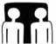 | Do this activity in pairs.
 | Do this activity by yourself.
Do this activity using the internet.
If you are not connected to the internet, your trainer will provide you with another activity.
Do this activity in your workplace.
If you are not in a workplace, your trainer will provide you with another activity.

What you will learn
You may work in a hotel, a café or a reception centre. Whatever the business, part of your job will be to help keep buildings and equipment clean so that visitors find it pleasant to visit.
In this workbook, you will learn how to:
- choose and set up the equipment and products you need for cleaning different areas
- clean safely and efficiently
- keep the cleaning equipment in good condition
- store the cleaning equipment and products safely
- use cleaning processes that reduce harm to the environment.

The following units are about cleaning in specific hospitality areas:
- SITHACS005B Prepare rooms for guests
- SITHCCC004B Clean and maintain kitchen premises.
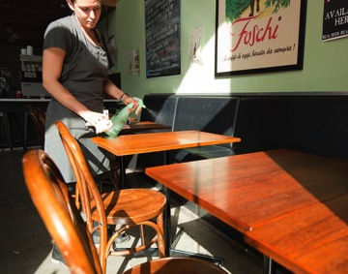

1 Why is cleaning important?
First impressions are very important in the hospitality industry.
If the public areas of a business are clean, visitors will be able to relax and enjoy themselves. They will want to return or recommend the venue to others. If any areas are not clean, guests will see this straight away and not want to stay or recommend the hotel to other people.
Public areas are every area that is not a guest room or the kitchen and where a visitor or guest can go.
Public areas include:
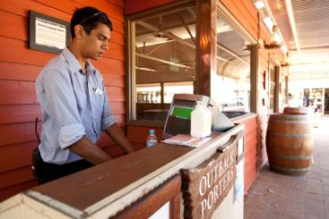
- restaurants and bars
- function rooms
- storage areas
- balconies and patios
- lifts and automatic doors
- hallways
- lounges and lobbies
- driveway and porte-cochere
- swimming pool area
- public and staff toilets.

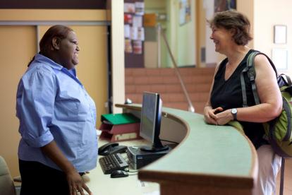

Activity 1
Would you stay in this hotel?
There are websites where people can write about their experiences with different hotels. Here is what three different people wrote about one hotel.

My 18 month old daughter had dirty feet and clothes from sitting on the floor. The toilet leaked. On our second day there, my daughter reached under the bed for a toy and found a cockroach sticky pad with several bugs on it.

This place is INFESTED with mice. Trust me, you don't want to stay here. We only stayed one night.

When we arrived at the hotel the office smelled bad. A man came out and the entire time he was helping me he was coughing without covering his mouth. The room also smelled bad and the floor in the kitchenette was sticky! He brought in a dirty mop and ‘cleaned’ the floor.
1. How do you think visitors felt about this hotel?
2. Would they recommend it to their friends?
3. What does this hotel need to do to make visitors want to stay?

2 Cleaning equipment
There are many different types of cleaning equipment and each piece has a special purpose.
The cleaning equipment used depends on what areas a business has and what they are made of.
Smaller businesses may only have domestic cleaning equipment (what you use at home) kept in a cupboard. Bigger establishments have commercial or industrial equipment because it is more powerful and is built for constant use. They may also have a purpose-built cleaning storeroom where equipment, cleaning chemicals and protective clothing is kept.
The cleaner’s trolley
A cleaner has a trolley to hold all the equipment and cleaning products that are needed for cleaning tasks so they can easily be moved around.
Here are some things to be careful about when you are using the trolley.
When you are… | Make sure you…
loading the trolley | - check the equipment, cleaning products and other supplies you need for cleaning are on the trolley before you start  - load everything safely and make sure nothing will fall off  - have nothing sticking out over the trolley edges  - put things in the right place on the trolley.
moving the trolley | - check the trolley is working properly – report any problems  - push the trolley – do NOT pull it!  - keep the trolley near the wall so it is not in the way of guests.
finishing up | - replenish cleaning products and other supplies  - clean the trolley and put it away.

When cleaning rooms such as guest rooms, storerooms or toilets, you can park the trolley across the door to stop people entering the room.

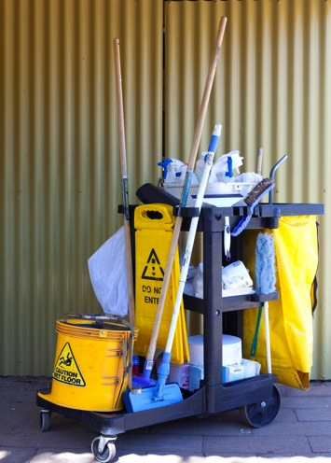

Activity 2
The cleaning trolley
What equipment and cleaning products can you see on the trolley in the previous picture?

Activity 3
Your workplace cleaning trolley

Find your workplace cleaning trolley and find out this information.
1. Show each other:
a) where the tall items are kept
b) where the chemicals are kept
c) where the soft cloths are kept.
2. Where is the trolley kept?
3. Who is responsible for putting all the items on the trolley?
4. Is there a checklist to tell you what should be on the trolley?

The cleaning equipment
Here is a list of cleaning equipment commonly used in hospitality establishments.
Manual cleaning equipment
Item | Purpose
Microfibre cleaning cloths and pads  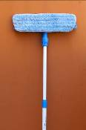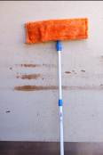 | For general cleaning.  Very small synthetic (not natural) fibres catch the dirt. No chemicals are required. Just rinse out after use.
Brooms | For sweeping dirt and other rubbish off floors and other surfaces, both inside and outside.
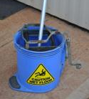  Buckets | Hold water and cleaning products when mopping or other cleaning.  Mop buckets have rollers to squeeze water from the mop head.
Cleaning cloths | For wiping and polishing wet or dry hard surfaces such as benches, furniture and washbasins.
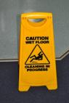  Cleaning safety sign | To warn people that cleaning is in progress or there is a cleaning hazard, such as wet floors.
Dusters  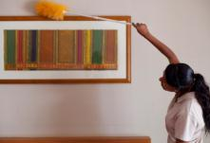  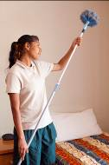 | For cleaning surfaces where there is dust, light dirt or cobwebs.  Extender handles let you dust up high.  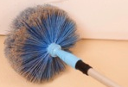
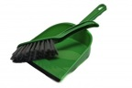  Dustpan and brush | For sweeping up small spills and collecting dust and dirt swept into a pile.
Mops | For washing smooth floors such as tiles or vinyl with water after sweeping or vacuuming.
Scrubbing brushes  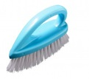 | To scrub off dirt where it is hard to remove.  Scrubbing brushes could include:  - carpet brush  - sink brush  - silk brush  - wall brush.
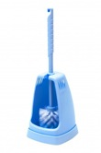  Toilet brush | Used ONLY to clean toilets.  Must NOT be used for anything else.
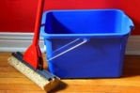  Window squeegee mop | To clean windows.
Disposable gloves | Wear when cleaning and handling chemicals to protect your hands.
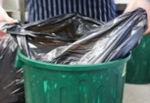  Rubbish bin and heavy-duty bags | For putting food and other waste in before it is collected.
Cleaner’s sink | A sink where you can fill and empty buckets and wash mops.  It usually has a grate over the top to rest the buckets while they are being filled, and a chemical trap.

Electrical cleaning equipment
Item | Purpose
Polishing machines | Used on hard floor surfaces after cleaning to add shine and help protect surface.  Some can vacuum at the same time.
Vacuum cleaners | Wet and dry types.  Backpack, cylinder and upright.  Used to remove dust and dirt from carpets and other large floor surfaces. They can also be used on furniture and curtains.  Wet vacuum cleaners can suck up liquid spills and are also used for wet cleaning of carpets.
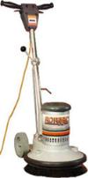  Automatic floor scrubbers | Used to wash large areas of hard floors, using revolving brushes, water and detergent. The dirty cleaning solution is sucked up under the machine. The floor is left clean and almost dry.
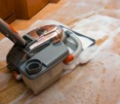  Carpet cleaning machines | Hot water extraction machines (steam cleaning machines) suck up most of the dirty water from the carpet.  There is also a dry foam machine. You spray on the foam, let it dry, then vacuum to pick up the dry chemical.

Activity 4
Use the correct equipment for the job
1. Would you use a vacuum cleaner to vacuum sand and leaves from an outside path? Why/why not?
2. Would you use a toilet brush to get into the difficult corners in the bathroom? Why/why not?
3. Would you use a squeegee mop to clean a tiled wall? Why/why not?
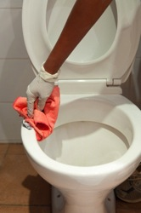

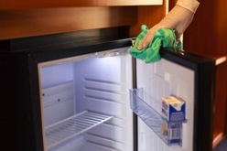

Use cleaning equipment safely
If you are not sure how to use a piece of equipment, ask a workmate or your supervisor before you begin the task. If you forget, ask again.
If you don’t know how to use equipment properly, you might:
- injure yourself
- injure other people
- damage the equipment and whatever you are cleaning.

Activity 5
Using equipment safely
Talk about each guideline in the table below.
Why is it important? What could go wrong if you did not follow the guidelines?
Make brief notes in the right hand column.
Guidelines for using cleaning equipment safely | Important because …?
- Never use equipment if you are not sure how to use it.
- Always follow the manufacturer’s instructions.
- Always check that equipment is clean and safe to use before you use.
- Don’t lift heavy equipment. Ask for help. If possible, use ramps or lifts.
- Don’t leave equipment lying around.
- If equipment is not working properly or is damaged, don’t use it.
Tell your supervisor.
- Don’t let electric cords trail behind you.
- Unplug electrical equipment when it is not being used.
- Don’t use electrical equipment near water.
- Put equipment away in its correct place after you have finished with it.

Cleaning equipment and the environment
You can help look after the environment by using and maintaining cleaning equipment properly.
- Equipment that is not working properly could use more electricity.
- Clean equipment after you have used it e.g. empty the vacuum cleaner and clean the brushes. This means it will work more efficiently and use less energy next time.
- Turn equipment off when it is not being used so it does not use electricity.
- Use microfibre cleaning, dry mopping, leaf blowing and sweeping rather than hosing to save water.

Check equipment before you start work
Before you start work, check the equipment and other items. Make sure that:
- there are no jagged parts or sharp edges
- the equipment looks clean and presentable
- buckets do not leak, are not smelly and have secure handles
- you have enough cleaning cloths, disposable gloves and other supplies so you don’t run out before your shift ends
- you have the right tools and attachments for your tasks – you will waste time and effort if you have to go back to the storeroom
- the electrical equipment does not have frayed cords or exposed wires
- any battery-operated equipment is fully charged.
Care of cleaning equipment
Take care of cleaning equipment and keep it clean, so the equipment stays in good working order.
Equipment should be cleaned after every use so that dirt from a previous task is not transferred (moved) on to another surface.
Every workplace will have its own procedures, but here are some general guidelines.

Equipment | Care
Vacuum cleaner | Empty the dust bag at the end of the shift or replace the bag if necessary.  If you are using a wet/dry vacuum cleaner you will need to empty the liquid, dirt and debris.  Wipe the outside of the machine and its attachments with a damp soft cloth.  Tidy the electrical cord to avoid kinks.  Replace the filters regularly – follow the manufacturer's instructions.
Brooms and brushes | Shake the bristles clean.  Sometimes wash them in hot soapy water and leave them to air dry.
Washing mops | Wash in hot soapy water, rinse thoroughly, sanitise, squeeze dry, then hang up to air dry.
Polishing mops | Regularly remove fluff and rinse mops in a solvent to remove polish.
Dusters and cloths | Shake thoroughly outside.  Wash in hot soapy water and hang up to air dry OR follow the manufacturer’s instructions.
Buckets | Wash thoroughly after each use with hot soapy water and leave to air dry.  Clean around the rollers on mop buckets to remove mop fibres and other dirt.
Other electrical equipment | After each use, wipe the outside clean.  Store the power cord correctly.  Clean the inside and all the attachments on a regular basis – follow the manufacturer's instructions.

Activity 6
Care of cleaning equipment
What might happen if equipment is left dirty or poorly maintained?
Talk about these questions together.
1. What might happen if a vacuum cleaner has a clogged filter and a full dust bag?
2. What might happen if a mop that was used to clean up broken glass is not properly cleaned before being used again?
3. Fran arrives at 7 am to start her shift as a public area cleaner in a hotel. She goes to the equipment storeroom to collect a cleaning trolley. She checks the equipment on the trolley and finds that it is a mess and nothing has been cleaned or topped up after the last shift.
Fran’s schedule requires her to wash the lobby floor in the first hour. She knows she does not have time to clean the equipment AND wash the floor, so she takes the trolley as it is to the lobby and starts work. The area is quite busy with guests checking in and out.
What do you think of Fran’s decision? What else could she have done?

Activity 7
Your workplace cleaning equipment
1. Where is the cleaning equipment kept in your workplace?
2. Look at the cleaning equipment in your workplace. Find 3 items that are new to you and write down what each item is used for. Ask your trainer or supervisor to help you.

Equipment | What it is used for

3. Does all the equipment look clean and in good condition? Can you make any suggestions to improve it?

Cleaning electrical equipment
You may need to clean electrical cleaning equipment such as a steam cleaner or floor polisher. You might need to take the equipment apart before you wash it and then put it back together again.
Before you clean any electrical equipment, you must be shown how to do it. Once you have been shown, follow the instructions. If you forget how to do it, ask someone.
Here are some guidelines for cleaning electrical equipment.
- Make sure electrical items are turned off and unplugged before you start.
- Be careful with sharp edges such as blades.
- Wear correct personal protective equipment (PPE) e.g. gloves, rubber apron and safety goggles.
- Sanitise the equipment following workplace procedures e.g. spray the equipment with a sanitiser after you have rinsed it.

Activity 8
Clean a piece of hospitality equipment
Your trainer will show you how to take apart a piece of equipment, clean it and then put it together again.
Practise taking the piece of equipment apart and cleaning it, then putting it together again.
When you are confident, demonstrate it to your trainer. As you do it, explain to your trainer what you are doing and why.
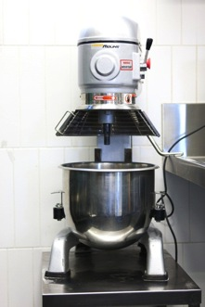

Reporting damaged equipment
If you notice something wrong, don’t use the equipment. Report it to your supervisor immediately.
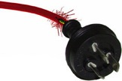
Some examples of things you might notice are:
- frayed electrical cord
- broken switch
- cracked hose on the vacuum cleaner
- screws coming loose or missing
- rattles or strange noises in the equipment
- smells, smoke or sparks coming from the equipment
- warning light or temperature gauge not working
- broken accessories
- broken handles
- lack of power in an electric machine.
You may need to fill in a workplace report form. Or you might have to tell your supervisor about the problem, and they will fill out the form.

Activity 9
Reporting damaged equipment
Discuss together:
The floor polisher has a frayed cord, but you need to finish cleaning the conference room floor because there is a group coming in tomorrow morning. So you decide to report it after you have finished.
Is this the right decision? Why/why not?

Activity 10
Fill in a Maintenance Request tag
You were using an electric floor scrubber in the staff canteen when you noticed that it was making funny rattling noises and there is a burning smell coming from the machine.
Fill in the following Maintenance Request tag. Say what the problem was and what you did when it happened. Use today’s date and your workplace location.
MAINTENANCE REQUEST 254875
ITEM _________________________________
______________________________________
REPORTED BY __________________________
DATE _________________________________
LOCATION _____________________________
PROBLEM _____________________________
______________________________________
______________________________________
______________________________________
______________________________________

ASSIGNED TO ________________________
DATE COMPLETED ______________________
COMPLETED BY ________________________
REMARKS _____________________________
______________________________________
______________________________________
______________________________________

Section summary
Now you have completed this section you should have developed the following skills and knowledge.
Tick each box if you are satisfied that you have those skills and knowledge.

Know what to use the different cleaning equipment for.
Choose the right equipment for the task.
Use cleaning equipment safely.
Care for cleaning equipment.
Clean the equipment after use.
Identify and report faults.
Notes

3 Cleaning products
Types of cleaning products
There are many different types of cleaning products. Different products are used for different purposes.
Your workplace supervisor will tell you which cleaning products to use for each cleaning task and how to use the products properly and safely.
Cleaning products can be dangerous chemicals. Always follow the manufacturer’s instructions and wear correct PPE.
Here are the main types you will find in a hospitality business. They may have different brand names.
Type of cleaner | Use
Abrasive cleaners | Used for scouring and cleaning ceramic or enamel surfaces e.g. toilet bowl or shower basin. Don’t use on surfaces that scratch easily.  They can be hard to rinse away, so wipe and rinse as soon as possible after you use them.
Detergents | Come in different strengths, so always follow dilution instructions on the label.  Some detergents are for heavy-duty cleaning e.g. fat, grease and oil on steel, most plastics, glass, ceramics and concrete.
Solvent cleaners | Used to dissolve heavy grease and oil, but can damage surfaces such as leather. Rinse the surface thoroughly after cleaning with a solvent.
Chlorine or bleach | Used to disinfect, bleach and deodorise.  They can attack rubber, plastic and aluminium.  They should never be mixed with toilet cleaners or ammonia as they will give off toxic fumes.
Disinfectants | Used to destroy germs. They should be used in toilet, bathroom and change areas.
Sanitisers | Used to reduce germs on a surface. Use them on food preparation surfaces.
Deodorisers | Used to cover up or get rid of unpleasant smells. They are often aerosols. You should spray only a little so they don’t overpower.
Specialist cleaning agents | Used for a specific cleaning task e.g. removing carpet stains, or cleaning windows and glass, stainless steel, leather, timber or rubbish bins.
Spot cleaning agents | Used to clean stains from small areas that other chemicals generally can’t remove.
Polishes | Used to protect surfaces and form a barrier against liquids that may harm the surface. Floors can be slippery after they have been polished.

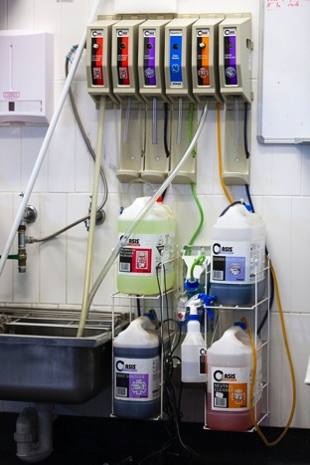

Types of surfaces to clean
You will need to clean many different surfaces. Each one needs the right equipment and products.
Activity 11
Different surfaces
What different materials could these areas be made of? The first one has been done for you.
Area | Could be made of:
Floors | wood, vinyl tiles, ceramic tiles, cement, carpet
Walls, skirting boards and ceilings
Furniture, fixtures and fittings, including:
- mirrors and glassware
- wardrobes
- soft furnishings
- desks
- light fittings
- telephones
- televisions
- refrigerators.
Bathroom basins and toilet bowls

Activity 12
Use the right equipment and products
Look back at the list of cleaning equipment in section 2 and list of cleaning products in this section.
Which equipment and products would you use for the 4 cleaning tasks below?
Cleaning task | Equipment | Products
Clean a toilet bowl
Clean a food preparation bench
Clean a red wine stain off a carpet
Clean a bathroom mirror
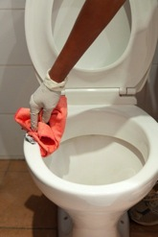
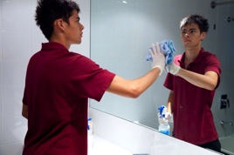

Use cleaning products safely
Your workplace will have procedures that tell you what products to use for each task and how to use them safely.
Some of the cleaning products are toxic (poisonous) if you breathe the fumes (gas), touch them or they get into food.
If you are not sure what to use and how to use it, ask a workmate or your supervisor.
If you use a product wrongly you could:
- harm yourself e.g. splash chemicals into your face or eyes or onto your skin or clothes
- harm other people you work with e.g. spill chemicals onto them
- mix he wrong chemicals together and cause toxic fumes
- damage surfaces by using the wrong chemical on them
- poison food and make it unsafe for eating.
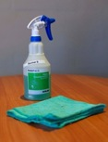
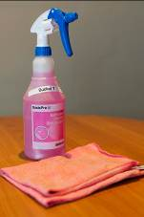
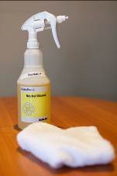
If you are not sure what to use and how to use it, ask a workmate or your supervisor.

A lot of chemicals are coloured so you can tell what they are by their colour e.g. blue = glass cleaner.
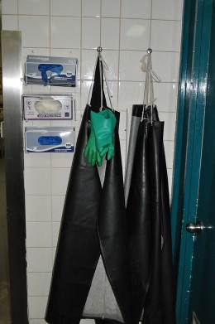
There are also symbols (pictures or signs) and words on the bottle, so if you are colour blind you can still identify what they are.
Personal protective equipment (PPE)
Personal protective equipment (PPE) is clothing and equipment that you wear or use to make sure you are safe in the workplace, such as when you are using cleaning products. It includes:
- non-slip shoes or waterproof boots
- thick rubber gloves
- goggles
- face masks
- overalls
- rubber aprons.

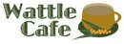 | Guidelines for using cleaning products safely
- Store all cleaning products in a locked storeroom or safe place.
- Use the correct PPE when you handle chemicals, so that you don’t splash or spill it on your skin, eyes or clothes.
- Put all cleaning products back in the correct place after you have finished using them.
- Don’t use toxic chemicals near food. Clear the food from work areas before you start cleaning. If chemicals splash onto food, the food must be destroyed.
- Never light a cigarette or a match near chemicals or chemical storage areas.
- Never smell a chemical, because you might burn inside your nose or faint.
- Follow the manufacturer’s instructions exactly when you are diluting chemicals (mixing them with water).
- Always put the chemical into water rather than water into the chemical to avoid splashing.
- Use the correct lifting method for heavy containers of chemicals. Bend from your knees, not from your back. Or ask someone to help you.
- Always read warning signs or labels about cleaning products. There might be a label on the container or a notice where the products are kept.
- Know where the MSDSs (Material Safety Data Sheets) are kept, and how to use them.

MSDSs are the manufacturer’s information about each chemical. They tell you:
- what a chemical is made from
- if it is hazardous
- how to handle it safely
- first aid instructions if you are exposed to it.
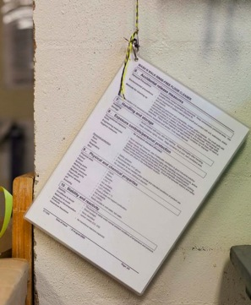
Material Safety Data Sheet
KLEENIT CHEWING GUM REMOVER AEROSOL CAN
HEALTH HAZARD INFORMATION
Health Effects
Acute – Eye Contamination of the eyes may result in irritation, watering eyes and redness. Not expected to cause permanent eye damage.
Acute – Skin May cause mild irritation, and can cause freezing of tissue on contact with the skin, similar to a thermal burn.
Acute – Inhalation Breathing in vapours may result in irritation of the throat and lungs. This may result in lung congestion and pulmonary oedema. Inhalation of large amounts may result in headache, dizziness and mental confusion.
First Aid
Eye Wash with large amounts of water for approximately 15 minutes holding eyelid(s) open. Seek medical attention.
Skin If contact with the skin occurs, immediately remove contaminated clothing and wash affected area with soap and water. Ensure contaminated clothing is washed before re-use. If irritation persists seek medical attention.
Inhalation Remove the source of contamination or move the victim to fresh air. In the case of severe exposure, seek medical attention.
PRECAUTIONS FOR USE
Engineering Controls Good ventilation should be used. Avoid generating and inhaling vapour. Use a non-sparking, grounded ventilation system.
Personal protective equipment
Respirator Type (AS Class AUS, organic vapour (Type A) filter, with half facepiece may be required 1716) in confined spaces.
Eye Protection Wear suitable chemical goggles/glasses.
Glove Type Neoprene or butyl rubber gloves may be required.
Flammability
Fire Hazards HIGHLY FLAMMABLE. Remove all sources of ignition, heat and naked flames. Prevent build-up of flammable vapours. Vapour/air mixture may ignite explosively.
Fire Extinguisher Use fog, foam or dry agent.
SAFE HANDLING INFORMATION
Storage Precautions
Store in a well-ventilated area, out of direct sunlight. Store away from heat, naked flames and sparks. Store away from strong oxidising agents. Use suitable, approved storage cabinets, tanks, rooms and buildings. Inspect regularly for deficiencies such as damage or leaks. Have appropriate fire extinguishers available in and near storage area.
Handling Ensure a high level of personal hygiene is maintained when using this product. Always wash hands before eating or drinking, and after smoking or using the toilet.
Spills and Leaks Remove all sources of ignition. Increase ventilation. Evacuate all unnecessary personnel. Wear respirator and full protective clothing to minimise skin exposure. Use clean non-sparking tools to collect the material and place into a suitable labelled container. Contact fire brigade and emergency services immediately. If this material enters stormwater drains contact the Environmental Protection Authority.

Activity 13
Reading an MSDS
Look at the MSDS for Kleenit Chewing Gum Remover in an aerosol can.
1. What are three parts of your body that could be affected if you get the product on you?
2. What PPE should you wear when you use it?
3. What first aid should you give if someone gets it in their eye?
4. What advice does the MSDS give about handling this chemical safely?
5. Should you smoke in an area where you have recently used this chemical?
6. Can you use a garden hose or a bucket of water to put out a fire with this chemical in it?
7. If the chemical is spilled or leaks, how should you dispose of it? Can you wash it away with a hose into the drains?
Diluting chemicals – the maths
Here are the instructions on the label for diluting Wundakleen with water.
Wundakleen
Floor Polish
Mix 10 ml in 1 litre
of warm water

ml = millilitres

Your bucket holds 10 litres.
- Multiply the amount of warm water (1litre) by 10 to fill your bucket.
- Also multiply the amount of floor cleaner by 10 to match the water.
The water and the chemical must stay in the same ratio or balance with each other.

WATER | CHEMICAL | RATIO
1 litre | 10 ml | 1:10
x 10 | x 10
= 10 litres | = 100 ml | 10:100  = 1:10

- ALWAYS measure cleaning product. NEVER guess how much to use.
- ALWAYS follow the manufacturer’s instructions.
- ALWAYS put the cleaning product into the water so there is no splashing.
NEVER pour water into the cleaning product.
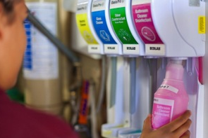

A lot of chemicals are pre-mixed so you don’t need to dilute them yourself.

Activity 14
Diluting cleaning products
You have to mix up the floor washing detergent in a 10 litre bucket.
On the label it says 20 mls of detergent per litre of water.
1. How much detergent will you put in?
WATER | CHEMICAL
1 litre | ml
x 10 | x 10
= 10 litres | = ml

2. The detergent cap is also a measuring cup. It holds 20 mls. How many caps of detergent will you put in the bucket?

Chemicals and the environment
Some chemicals are toxic and bad for the environment. When we empty our buckets down the sink, the chemicals can get into the water.
Here are 3 ways to reduce the effect of cleaning chemicals on the land, water and air.
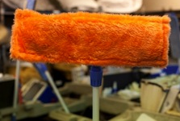
- Use microfibre cloths for cleaning. These are made of a special material that removes dirt, grease and dust without chemicals.

- Choose bio-degradable cleaning products, which are less harmful to the environment.

- When you dilute chemicals with water, only use the amount stated on the label. Using more won’t clean any better and puts extra chemicals into the environment.

Activity 15
Cleaning products in your workplace

1. Where are the cleaning products kept in your workplace?
2. What signs are on the door of the storage area?
3. Where is the PPE kept?
4. Where are the MSDSs kept?
5. Are there any chemicals that need to be diluted? Or are most of them pre-mixed?
6. Choose 4 cleaning products and fill in the table below. If you can’t find the information, ask your trainer or supervisor to help you.
7. Choose one of the cleaning products and tell someone else about it

Cleaning products in your workplace
Name of cleaning product | What is it used for? | Warnings on label | Safe for environment?

Emergency procedures
Your workplace induction should include emergency procedures.
Each workplace will be a little bit different, but here are some typical guidelines.
- Report any accidents or incidents to your supervisor or first aid representative immediately.
- Emergency telephone numbers - know where the list is (e.g. ambulance, medical centre and poisons information centre).
- If there is a fire caused by chemicals - don’t try to put it out yourself. Someone at your workplace will be trained to use the fire extinguishers.
- If you get chemicals on yourself or in your eye - know the first aid to use on yourself e.g. eye bath or chemical shower.
- If chemicals are splashed or spilled onto food – report it to your supervisor immediately. The food must be destroyed.
- If you spill chemicals in a food preparation area – the area must be cleaned and sanitised so that the chemicals can’t get into the food.

Activity 16
Emergency procedures in your workplace
Find your workplace emergency procedure.
1. Who is the emergency warden?
2. Who do you contact first in an emergency?
3. How do you contact them?
4. Where is the eye bath?
5. Where is the chemical shower?

Section summary
Now you have completed this section you should have developed the following skills and knowledge.
Tick each box if you are satisfied that you have those skills and knowledge.

Know what different cleaning products are used for.
Identify the right cleaning product for the task.
Use and store cleaning products safely.
Calculate how to dilute cleaning products.
Know which personal protective equipment to use.
Know what to do if there is an accident when handling cleaning products.
Notes

4 The cleaning schedule
Cleaning is part of the regular routine of a hospitality business rather than something that happens when people feel like it. A well organised business has a list of when everything needs to be cleaned and who is going to do it. Without it, things might not get cleaned often enough.
This list is called a cleaning schedule. It tells you:
what to clean
when to clean it
how to clean it
who cleans it.

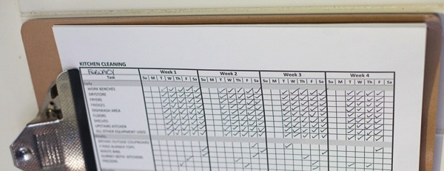

Activity 17
What needs to be cleaned at the Wattle Café
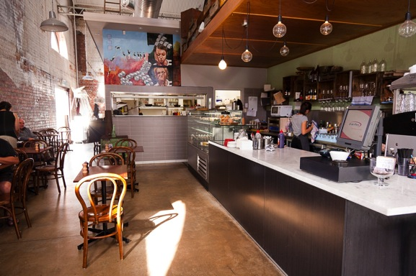
Look at this picture of the Wattle Café.
- In the following table, list 8 things in the café that need to be cleaned.

2. How often do you think each thing should be cleaned?
- As needed during every day
- Every day
- Every week
- Every month
- Other.

Thing to be cleaned | How often

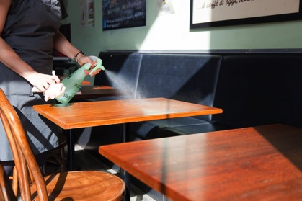

Activity 18
What to clean in your workplace
What surfaces and equipment can you see in your workplace that you think need to be cleaned daily?

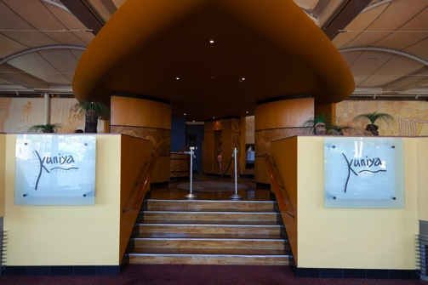

Cleaning tasks are timed to cause the least amount of inconvenience for guests.
For example, don’t vacuum around guests while they are eating their breakfast.
Also don’t clean their rooms while they are still in them, unless they ask you to.
Here is a daily cleaning schedule for the Reception area of Eagle’s Nest Hotel.
Eagle’s Nest Hotel
Reception Area Cleaning Schedule
What | When | How | Who
Tiled area just inside door | Daily, early morning and as required | Sweep.  Mop with tile cleaner. | Joe
 | Once a week, Friday afternoon | Scrub with hard bristled broom, tile cleaner and sanitiser. | Meena
Carpets | Daily, early morning | Vacuum.  Spot clean when needed.  Steam clean when required, and at least once a month, Monday. | Joe
Reception desk | Daily, early morning | Wet wipe with soft cloth, all-purpose cleaner and sanitiser. | Chester
Reception chairs and couches | Daily, early morning | Dust, wipe with all-purpose cleaner. Use furniture polish for wooden surfaces. | Chester
Stair banisters | Daily, early morning | Wipe with soft cloth, all-purpose cleaner and sanitiser. | Chester
Doors | Daily, early morning and when needed | Clean glass.  Clean metal plates and handles with brass cleaner.  Wipe down wood panels with soft cloth and all-purpose cleaner. | Joe
Walls | Clean up splashes, scuff marks, finger prints etc. as they happen | Wash with soft cloth and all-purpose cleaner. May need extension (long) stick for high areas. | Joe
 | Weekly, Friday early morning |  | Meena
Ceilings | Monthly, last Friday early morning of the month | Cobweb and dust using long handled brush.  Wash with detergent. | Meena
Pictures on wall | Daily, early morning | Dust using damp soft cloth or feather duster.  Clean glass with glass cleaner and soft cloth. | Chester
Light fittings | Weekly, last Friday of the month, early morning | Make sure light is switched off before you start.  Dust with soft damp cloth. | Meena

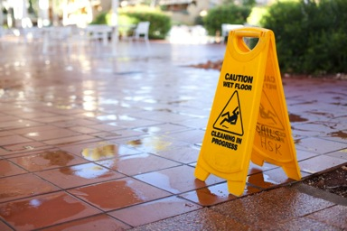

Activity 19
Eagle’s Nest Hotel cleaning schedule
Circle one of the names below.
I am Joe / Meena / Chester.

Tel the other people in your group what you have to clean and the order you will clean in.

For example:

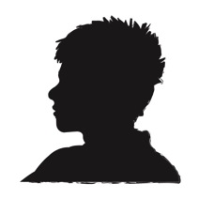
I’m Joe. First I will clean the ………..
Then I will do the ......
After that, I will clean the …..
And last I will …..

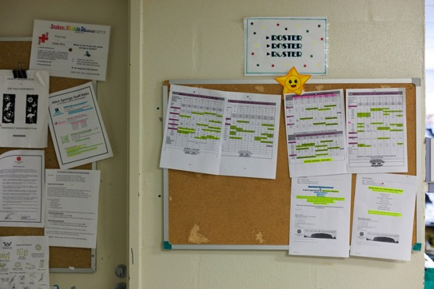

Activity 20
Your workplace cleaning schedule
Look at a cleaning schedule from your workplace.
1. Choose 5 things that need to be cleaned. Write down what has to be cleaned and when it is cleaned.
Item to be cleaned | When it is cleaned

2. When do you think is a good time to clean each of these areas? What is a time that would cause the least inconvenience to guests?
Area to be cleaned | Best time to clean
Reception area and lobby
Restaurant
Corridors
Outside areas e.g. pathways and pool surrounds
Public toilets
Automatic doors and lifts
Hotel gift shop
Section summary
Now you have completed this section you should have developed the following skills and knowledge.
Tick each box if you are satisfied that you have those skills and knowledge.

Understand a cleaning schedule.
Carry out cleaning tasks to cause least problems to customers.
Now how to carry out cleaning tasks efficiently.
Notes

5 Cleaning safely
You have already learnt about handling cleaning equipment and products safely.
In this section you will look at other possible hazards when you are cleaning.

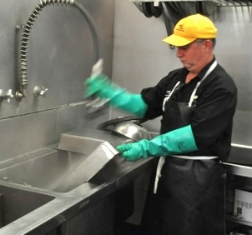

Always wear correct PPE.

Activity 21
Workplace hazards for cleaners
Some possible hazards or dangers that you could find when you are cleaning in a hospitality business are listed in the following table.
For each hazard talk about:
1. the injuries or damage that it could cause
2. what you should do to reduce the risk or eliminate the hazard.
Some ideas have been written in for the first hazard.
Share your ideas and write some short notes in each space.

Possible hazard | Injury or damage it could cause | What you should do
Liquids spilt on the floor, such as water, oil or cleaning products | Slips.  Chemical contamination e.g. a rash if it gets onto someone’s skin. | Clean up and mop area as soon as possible.  Put up ‘Wet Floor’ signs.  Put up barriers to keep people out until it is safe.
Heavy equipment such as floor scrubbers
Broken glass and china
Broken or damaged furniture
Washing electrical equipment without turning it off and unplugging it
Needles and syringes in bins
Human waste, vomit, blood, used condoms and used bandages or bandaids in bins
Sharp things e.g. knives and scissors, food scraps such as chop bones and shells from shellfish
Hot surfaces e.g. in kitchens and dining rooms

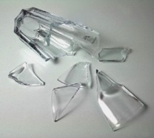

How to get rid of syringes safely
Being pricked by a syringe or needle can be dangerous, as you could catch some serious diseases from them.
If you see a syringe, let your supervisor know and follow your workplace procedures.
If you must deal with a syringe yourself, here is a suggested procedure.
Suggested procedure
- Wear thin gloves. Wearing thick gloves or using tongs can be dangerous as you won’t have as much control.
- Don’t try to put the cap back on the syringe or bend the needle.
- Bring the sharps container to the syringe, if possible. Put it on the ground next to the syringe.
- Pick up the syringe in the middle of the barrel. Always keep the sharp end of the needle facing away from you.
- Place the syringe in the sharps container, sharp end first. Sharps disposal containers are one way so that the syringe cannot come out, and they do not have a lid so that they cannot be opened.
- Remove gloves carefully so that any contaminated fluid on the glove does not come into contact with your hand.
- Wash your hands with running water and soap.

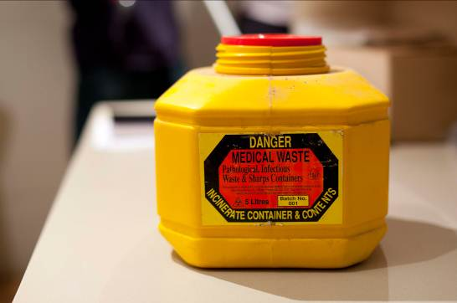

Make sure you know what to do
The most important part of working safely is knowing what to do.
- How do you find out what to do?
- How do you know what equipment and chemicals to use for each cleaning task?
- How do you know what to do if there is a problem?
Watch and listen to someone | You should be shown how to do your cleaning tasks in your induction training or on the job.
Ask | If you are still not sure what to do, ask someone, even if you have been told before. There are a lot of things to remember when you start work in a new workplace!  If someone is explaining something to you and you don’t understand them, ask them to explain again or show you. Sometimes people forget that you are new to the work and they go too fast.  If you have a problem on the job, ask for advice or help.
Read | Instructions on equipment or products.  Notices on the wall.  Workplace procedures.  Labels on chemical containers.  Safety signs.
Make notes | Write down things you find hard to remember in a small notebook or draw pictures to help you remember next time.
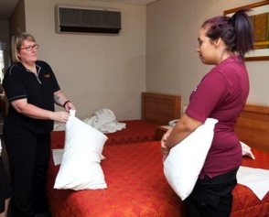

Section summary
Now you have completed this section you should have skills and knowledge about these topics.
Tick each box if you are satisfied that you have those skills and knowledge.

Check for common hazards when cleaning.
Know how to deal with the hazards.
Know how to safely handle syringes.
Understand what you need to do in your workplace.
Notes

6 Cleaning procedures
Most businesses have their own written procedures that describe how you should clean. You will also be shown how to do each task. If you are not sure what to do, ask!
In this section you will be given some guidelines for common cleaning tasks. Remember that each workplace is a little different and will have its own way of doing things.
The basic processes
There are two basic processes used in professional cleaning.
Cleaning
Cleaning means getting rid of the dirt and debris you can see. This could be grease, food scraps, dust or something spilt. Cleaning may be done by sweeping, dusting, scrubbing, vacuuming, mopping or wiping a surface or item.
However, there may still be germs on the surface, so you might need to take another step called sanitising.
Sanitising
Sanitising means reducing the number germs by spraying, rinsing or wiping the surface or item with a germ-killer, called a sanitiser. This is particularly important for areas that people touch, such as bathrooms. Sanitising can be done using a cleaning chemical or heat.
Preparation for cleaning
- Wear the correct PPE for the job.
- Choose the correct equipment and products for the task.
- Put up ‘Cleaning in Progress’ signs.
- Put up barriers to stop people going into the area e.g. witches’ hats, furniture across a doorway, fluoro-tape or put the cleaning trolley across the doorway.
- Pre-clean if necessary by removing dirt and things you can see, e.g. sweep floors or wipe food waste from benches.
- Treat any stains or spills using the correct products.

Match the procedure to the surface
Surfaces that need cleaning include floors, benches, walls and the ceiling.
They can be made from different materials that all need to be treated in different ways. Here are some different surfaces you may need to clean:
- carpet | - vinyl | - brass
- marble | - leather | - stainless steel
- tiles | - painted surfaces
- wood | - glass and mirrors
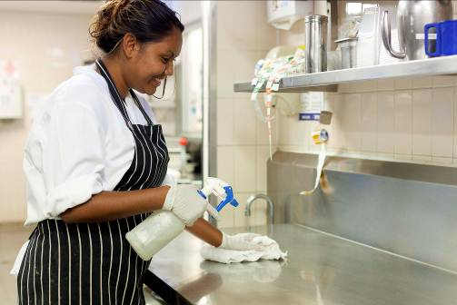

Don’t waste water
- Don’t leave taps running when you are not using them.
- Rinse by filling up another container with clean water rather than rinsing under running water.
- If any taps are dripping, let your supervisor know so they can be fixed.
- Only use as much water as you need. If you only need to wash a small thing, don’t fill the sink full.
- Use cold water rather than hot if possible as this will save electricity.
- If you are using a hose to wash down outside areas, use a trigger nozzle.

Activity 22
Match the procedure to the surface
The table below tells you how to clean five different surfaces. They tell you the cleaning product, equipment and the method.
The five surfaces are:
- furniture | - stainless steel | - bathroom tiles and basins
- glass | - inside walls

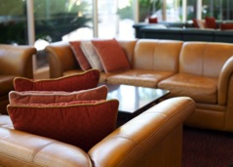
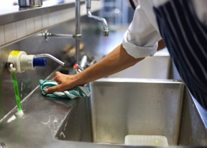

Read the processes and then decide which surface it is for.
Surface | How to clean the surface
Use a soft cloth or microfibre cloth.
Use warm water and a mild detergent to wash, then rinse.
If it is a food preparation area, use a sanitiser.
Dry with a soft cloth.
Use a special cleaner if the surface is scratched or stained. This will also give it a nice polish.
Spray the surface with cleaning product. Use the sponge side of a squeegee to wash the surface.
You can also use water and a neutral detergent or vinegar.
Scrape off water and cleaning product with the hard side of the squeegee.
Polish with a lint free cloth.
Dust or vacuum the area first to remove loose dirt.
Spot clean if necessary with a damp cloth and an all-purpose detergent or cleaner. Rinse off thoroughly.
Dip the mop into the washing solution bucket and wring.
Start washing at the bottom and work up, so the cleaning solution does not run down.
Rinse the mop in a clear water rinse bucket and rinse the surface.
Rub gently to avoid damage to the paint.
Dry off any excess moisture with soft cloths.
Dust using a damp dusting cloth.
Apply the polish using a polishing cloth. Don’t use too much.
Wipe excess polish off with a second cloth or the clean side of the cloth you are using.
Use a special leather cleaning product on leather.
Wipe down with a solution of detergent and hot water or a foam cleaner. Don’t use abrasive cleaners as these can scratch the surface.
Disinfect with a spray-on disinfectant.
Mop up excess water and allow to dry. Polish with a dry cloth to reduce spotting.
For stains or mould, use bleach or bleach-based cleaners. Wear gloves and other PPE. Rinse the surface thoroughly with clean water.

Cleaning floors
Floors get dirty very quickly. They can get slippery and dangerous, so they must be swept, washed and sanitised at least once a day. Sometimes they might need to be cleaned more often, such as when there is a spill.
Floors in areas such as a reception area or restaurant may not get as dirty as a kitchen, but they still need to be cleaned daily.
Different floor surfaces require different methods. Hard surfaces need sweeping, mopping and polishing, while carpets need vacuuming and shampooing.
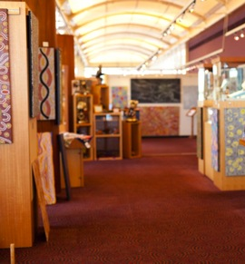

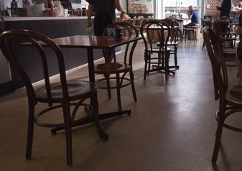

Activity 23
Wet mopping
Look at the following Standard Operating Procedure (SOP) for wet mopping at Wattle Café. Then answer these questions.
1. List the equipment and products you need to do this cleaning task.
2. Highlight the actions in the SOP where you may be lifting heavy items. What should you do to avoid back or shoulder injury?
3. Underline the actions where you are handling chemicals. What should you do to protect yourself from contact with them?
4. The Wattle Café has 5 tables with 4 chairs at each one. How long do you think this cleaning task would take you, from start to finish?

Wattle Café
Standard Operating Procedure
Wet Mopping
Step | Actions and precautions
1. Prepare the area | Set up ‘Cleaning in Progress’ signs.  Pick up loose rubbish.  Move items that are in the way e.g. chairs.  Sweep the floor and collect dirt in a dustpan.
2. Prepare equipment and materials | Put on safety gloves and glasses.  Fill the mop bucket with warm water.  Add 250 mls of XYZ detergent – use red measuring jug.
3. Mop the floor | Move the mop and bucket to the area to be mopped.  Start in a corner away from the door so you don’t have to walk over wet floors when you have finished.  Put the mop in the bucket to wet it thoroughly.  Use the rollers to wring the mop until it is damp.  Apply the mop to the floor. Use smooth but firm strokes in a figure 8 pattern on open surfaces and straight strokes against the walls.  Rinse the mop and repeat until you have finished. Change the water and detergent as often as you need.  Empty the bucket into the gully trap, then rinse the mop and bucket.  Fill the mop bucket with warm water.  Add 250 mls of XYZ sanitiser – use yellow measuring jug.  Apply sanitiser using the same method for mopping the floor.  Allow to dry. Set up ‘Wet Floor’ signs where appropriate.  Return moved items.
4. Clean up | Remove and dispose of rubbish picked up during preparation – put it in an outside bin.  Wash the mop and bucket with hot soapy water, sanitise and leave to air dry.  Dispose of the protective gloves.  Return the equipment and chemicals to storage.  Wash your hands.

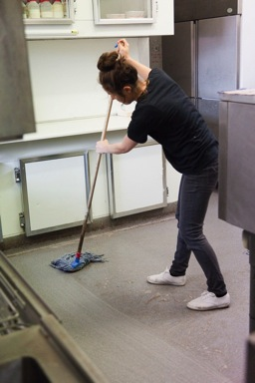

Vacuuming
Your workplace will have procedures for vacuuming floors. However, here are some suggestions.
- Pick up large items and move furniture such as chairs if necessary.
- Use a special product for spots and stains.
- Make sure you vacuum around and under all furniture, and the corners of the room, including the skirting boards.
- Use the different attachments for different tasks e.g. crevice tool for corners or edges.
- Bend your knees when cleaning under items. Don’t bend over the machine.
- After cleaning, empty the vacuum cleaner bags and put the equipment away.

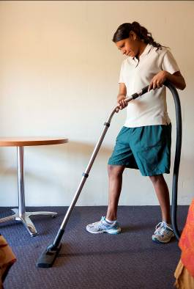

Large electrical appliances
You might have to use large electrical appliances such as steam cleaners, polishing machines and scrubbers to clean some floors. You will be show how to use them, but remember that they can be very heavy, so push rather than pull them. As you are pushing, stand straight and move at a gentle walking pace.
Washing walls and ceilings
Your workplace will have procedures for washing walls and ceilings. However, here are some suggestions.
- Walls and ceilings are usually washed each month, depending on the nature of the workplace.
- Always clean walls from bottom to top. The bottom of a wall is usually dirtier than the top. You don’t want the dirt to get into the wall from drips, so clean the dirtiest part first.
- Some water may drip onto the floor, so put up a ‘Wet Floor’ warning sign in case the floor gets slippery.
- Use an all-purpose cleaner and a wall mop.
- Sanitise walls with a spray-on sanitiser if necessary.
- For greasy marks, use a scourer and stronger cleaning products, but be careful you don’t damage the walls.
Cleaning storerooms and cupboards
Storerooms and cupboards need to be cleaned regularly, particularly if food is stored in them. The floor should be swept and washed at least weekly. Shelves should be dusted, cleaned and sanitised weekly and also whenever something has been spilled on them.
When you are cleaning storerooms and cupboards that contain food:
- check for anything that has spilled, broken, or come out of its packet
- check that nothing has been affected by mice, rats, cockroaches or other insects.
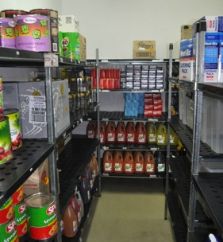
Look out for things such as:
- mouse droppings
- bags that have been chewed
- grubs or moths in containers, or moths flying around
- spider webs.
If you notice anything that looks wrong, tell your supervisor.
Also tell your supervisor if you see that something in the storeroom or cupboard is in the wrong place.
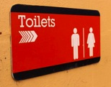
Cleaning public and staff toilets
Hospitality venues usually have public and staff toilets. Everyone wants to find toilets looking and smelling clean. They also want them to be well stocked with soap, toilet paper and paper towels.
Activity 24
Cleaning a public toilet
Look at the following SOP for cleaning toilets at Wattle Café. Then answer these questions.
1. List the equipment and products you need to do this cleaning task.
2. What PPE should you wear for this cleaning task?
3. Underline the actions where you are handling chemicals. What should you do to protect yourself from contact with them?
4. What should you do if someone is in the toilets when you want to clean them?
5. When would you use the pest aerosol spray?
6. How can you avoid needle stick injuries when emptying a bin?
Wattle Café
Standard Operating Procedure
Cleaning Toilets
Step |  | Actions/precautions required
1. Prepare the area |  | - Knock on the door and announce that you want to come in to clean.  - If there is someone in there, wait until they leave.  - Set up ‘Cleaning in Progress’ signs across the entry door.  - Turn exhaust fans on and leave exit doors open.  - Put on safety gloves and glasses.  - Pick up loose rubbish. Beware of syringes.  - Remove the liners from the rubbish bins and dispose of the rubbish.  - Wash the bins with a disinfectant and put in a new bin liner. Don’t place your hands in the bin or put the bin liner against your body. Beware of syringes.  - Sweep the floor.
2. Prepare the equipment and materials |  | - Fill the trigger spray bottle – ABC disinfectant.  - Gather supplies:  - 1 litre ABC disinfectant  - 1 litre XYZ toilet bowl cleaner  - glass cleaner  - pest aerosol spray  - deodoriser spray.
3. Clean the toilets and urinals |  | - Flush toilets and urinals.  - Apply undiluted XYZ toilet bowl cleaner directly into the toilet bowl and urinal. Leave to soak.  - Use the spray bottle of XYZ toilet bowl cleaner to spray the seat, hinges and hardware of the toilet fittings and urinal fittings.  - Use the toilet brush and bowl mop to clean the urinal and toilet bowl. Clean the splashback, return areas and under the rim.  - Wipe down the seats and the outside of the toilet bowls using a disinfectant solution.  - Flush the toilet or urinal.  - Spray deodoriser in each cubicle and above the urinals.  - Check for damage.  - Spot clean the walls.
4. Clean the handbasin area |  | - Dust all areas, starting with high areas. Clean dust from the ceiling fans and vents, and dust the tops of doors.  - Clean mirrors with glass cleaner and a soft cloth. Make sure there are no streaks left.  - Wash handbasins:  - clean inside the sink using the correct cleanser, such as a cream cleanser  - wipe the outside of the sink, taps, pipes and under basins, polishing any chrome  - check the taps work properly and the basins drain properly.  - Replace all supplies – fill soap dispensers, and paper towel and toilet paper holders.  - Wipe doorknobs and soap dispensers with a sanitiser.
5. Mop the floors |  | Following mopping standard operating procedure.
6. Clean up |  | - Turn off exhaust fans.  - Remove safety or warning signs.  - Remove and dispose of rubbish picked up during preparation.  - Clean the toilet brush and bowl mop.  - Rinse and sanitise the floor mop. Allow it to air dry.  - Dispose of protective gloves.  - Return equipment and chemicals to storage.  - Wash hands.
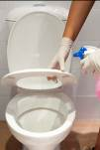  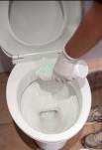 | 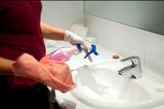  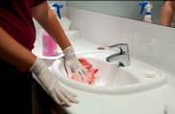
Cleaning rubbish bins
You will be shown how to clean rubbish bins. However, here are some guidelines.
- Wear gloves.
- Clean up anything that has fallen out of the bins.
- Wash and scrub the bin and its lid, using hot water, detergent and a scrubbing brush.
- Use a hose if you are cleaning a large outside bin.
- Rinse out the bin with hot water and disinfect it, using bleach or other chemical.
- Wash the area around the bin, such as floors and walls, or hose the area surrounding the outside area.
- Tip the bin over on its side to allow it to air dry, if it is small enough to do so.
- Take off your gloves and wash your hands well after you have finished.

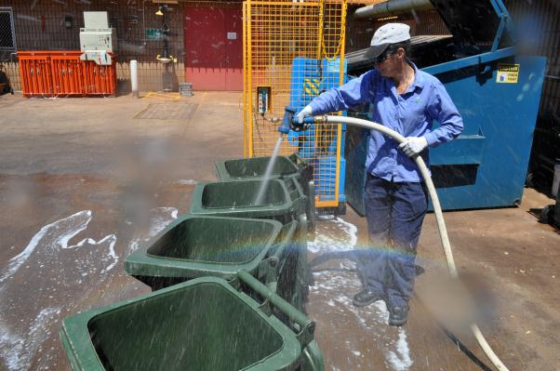

Cleaning outside areas
It is also important to keep outside areas clean, with no food or other rubbish left around the place. This is because:
- it makes the venue attractive to look at
- it makes guests feel comfortable
- it stops pests such as insects, mice and rats coming into the area
- it stops animals such as birds, snakes, possums and dogs finding food.

The cleaning procedures for outside areas will depend on the type of venue.

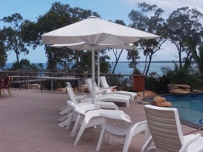 | 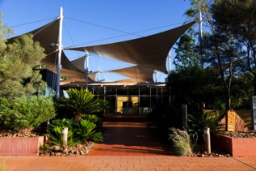
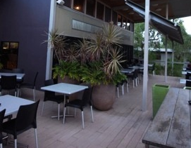 | 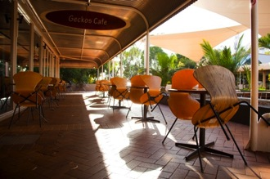
Pest control
Guests will be upset if they find pests anywhere in the premises. Pests can cause discomfort and also spread diseases. Your workplace will have procedures for dealing with pests. Look out for pests and tell your supervisor if you see any signs of them.
Pests include:
- insects (flies, cockroaches, silverfish, fleas, ants and bed bugs)
- vermin (mice, rats and possums).

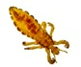 | 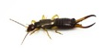 |  | 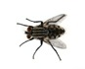
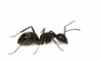 | 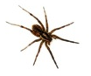 | 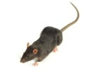 | 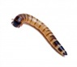

Signs of pests may include droppings, spots on walls and surfaces, eggs and cocoons.
If you see any of these signs, tell your supervisor immediately.

If you are cleaning guest rooms, you may be able to spray flies, ants or silverfish with an environmentally friendly insect spray. But only use a small amount and wear gloves and a mask.
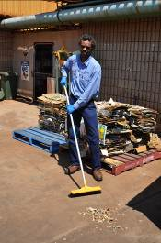
Section summary
Now you have completed this section you should have developed the following skills and knowledge.
Tick each box if you are satisfied that you have those skills and knowledge.

Know the basic cleaning process
Choose the right equipment for the task.
Clean a range of surfaces.
Know how to control pests.
Notes

7 Safe disposal of waste
Disposal of hazardous waste
Some things used in the hospitality industry must be disposed of (got rid of) properly or they can damage the environment (the land, sea, water and air) and cause pollution. Some examples are:
- cleaning chemicals
- corrosive products such as oven and drain cleaners
- used cooking oils
- aerosol containers
- insecticides and pesticides such as mouse bait
- flammable products.
These substances must never be poured down a sink or a gully trap, put into storm water drains or thrown out with normal rubbish.

Reduce use of chemicals
Many chemicals can’t be put into normal rubbish bins or tipped down drains. Your workplace will have its own guidelines for disposing of toxic products safely.
Best of all is if the workplace tries to use fewer and less harmful chemicals, such as:
  - using microfibre cleaning products that don’t need chemicals
  - using cleaning products that are not toxic
  - using spray bottles rather than aerosol sprays
  - using environmentally friendly methods to remove pests, such as mouse traps instead of bait, and insect screens on windows.

Disposal of hazardous waste
Hazardous waste | How to dispose of it
Unwanted concentrated chemicals, aerosol sprays and empty chemical containers | Your workplace should have them collected by a licenced industrial waste company who will dispose of them safely.
Diluted chemicals e.g. used cleaning water | Pour it down a cleaner’s sink with a chemical waste trap that feeds into the sewer system, not the storm water.
Used cooking oil and grease | Your workplace should have it collected in a special kitchen grease trap and use a licensed company to take it away.

There are federal, state and local laws about the environmentally safe disposal of chemicals and used cooking oil. Any business that does not follow these laws can be fined and get bad publicity.
Your workplace will have a procedure for disposing of hazardous waste. If you notice that this waste is being disposed of wrongly, tell your supervisor.
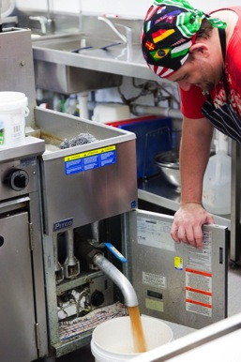
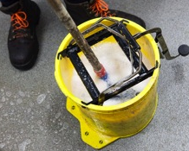

Recycling
Recycling
Recycling means re-using something.
Your workplace probably has recycling rubbish bins where you put bottles and cans into one bin and food scraps in another. There may also be a separate bin for paper and cardboard. Things like paper, glass and plastic can be used again; food can be turned into compost and used on garden beds.
It is good for the environment because it reduces the number of new things that must be manufactured and there is less rubbish sent to the tip.

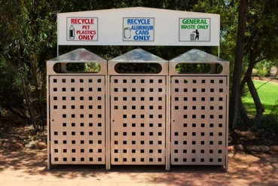
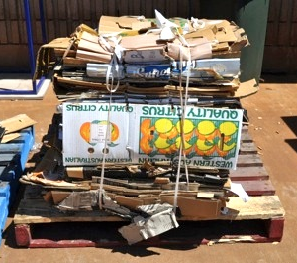

Activity 25
Is your workplace environmentally friendly?
In this workbook, you have found out about ways to clean that help protect the environment.
Which ones are used in your workplace?
Tick the YES or NO box for each question.
At your workplace … | YES | NO
1. Are any of the cleaning products biodegradable and non-toxic?
2. Are spray bottles used instead of aerosol cans?
3. Is the electrical cleaning equipment energy efficient e.g. a floor polisher with a high star rating?
4. Are you encouraged to save water e.g. when rinsing cleaning equipment, or turning off taps when you are not using them?
5. Are you encouraged to save energy e.g. by turning off lights and equipment when it is not being used?
6. Are recycling bins used?
7. Are chemicals disposed of properly?
8. Do you use microfibre cleaning products?
9. Are dry mopping, leaf blowing and sweeping used rather than hosing to save water?
10. When you dilute chemicals with water, do you only use the amount on the label?
11. Do you let your supervisor know if you find a dripping tap?
12. Is a hose with a trigger nozzle used to wash down outside areas?

Section summary
Now you have completed this section you should have developed the following skills and knowledge.
Tick each box if you are satisfied that you have those skills and knowledge.

Understand the environmental effects of cleaning.
Know about a range of environmentally sound cleaning practices that use less energy, water and chemicals.
Know how to dispose of waste and chemicals in an environmentally sound way.
Notes

Key words
Word | Meaning
abrasive cleaner | Scratches dirt off
aerosol | Container where liquid is kept under pressure, which can be sprayed out by pressing a button (it can contain gas that could harm the environment)
biodegradable | Breaks down naturally so does not cause as much pollution
ceramic | Made of clay with a hard shiny surface
corrode, corrosive | A chemical that eats away other things
defect | A fault in something or something wrong
detergent | Similar to soap, used to remove grease and dirt
disinfectant | Kills germs
environment | The natural world – land, sea, water, air and living creatures
excess | More than you need
flammable | Catches fire easily
fumes | Smell or gas from chemicals; can harm you if you breathe them in
hazard | Something that causes a risk or danger
hygiene | Being clean
induction | Training when you first start work so you know what to do to follow workplace procedures
legislation | Laws
maintenance | Keep in good repair
microfibre cloth | Special material that removes dirt without chemicals
MSDS | Material Safety Data Sheet – contains information from the manufacturer about a chemical product e.g. Hazards, safety precautions and first aid treatment
non-toxic | Not poisonous
pests | Creatures that may spread disease e.g. Mice, flies, ants and cockroaches
porte-cochere | A porch covering a driveway at the entrance of a building to provide shelter while people get in or out of a vehicle
PPE | Personal protective equipment – safety equipment and clothing e.g. Gloves, masks, goggles, rubber aprons and non-slip shoes
precautions | Things you can do to be safer
premises | A place of business such as a restaurant or hotel
procedure | A set way of doing things, often written as a list of steps telling you how to do a task
recycling | Using something again, such as bottles and paper
replenish | Fill up
sanitise | An important step in the cleaning process, done after washing, involving killing germs, for example by using a cleaning chemical or heat
schedule | A plan or list of tasks to be done
solvent | A chemical that dissolves grease and oil
SOP | Standard Operating Procedure – a formal written procedure in a workplace
toxic | Poisonous
waste | Something that is thrown away because it is not needed

