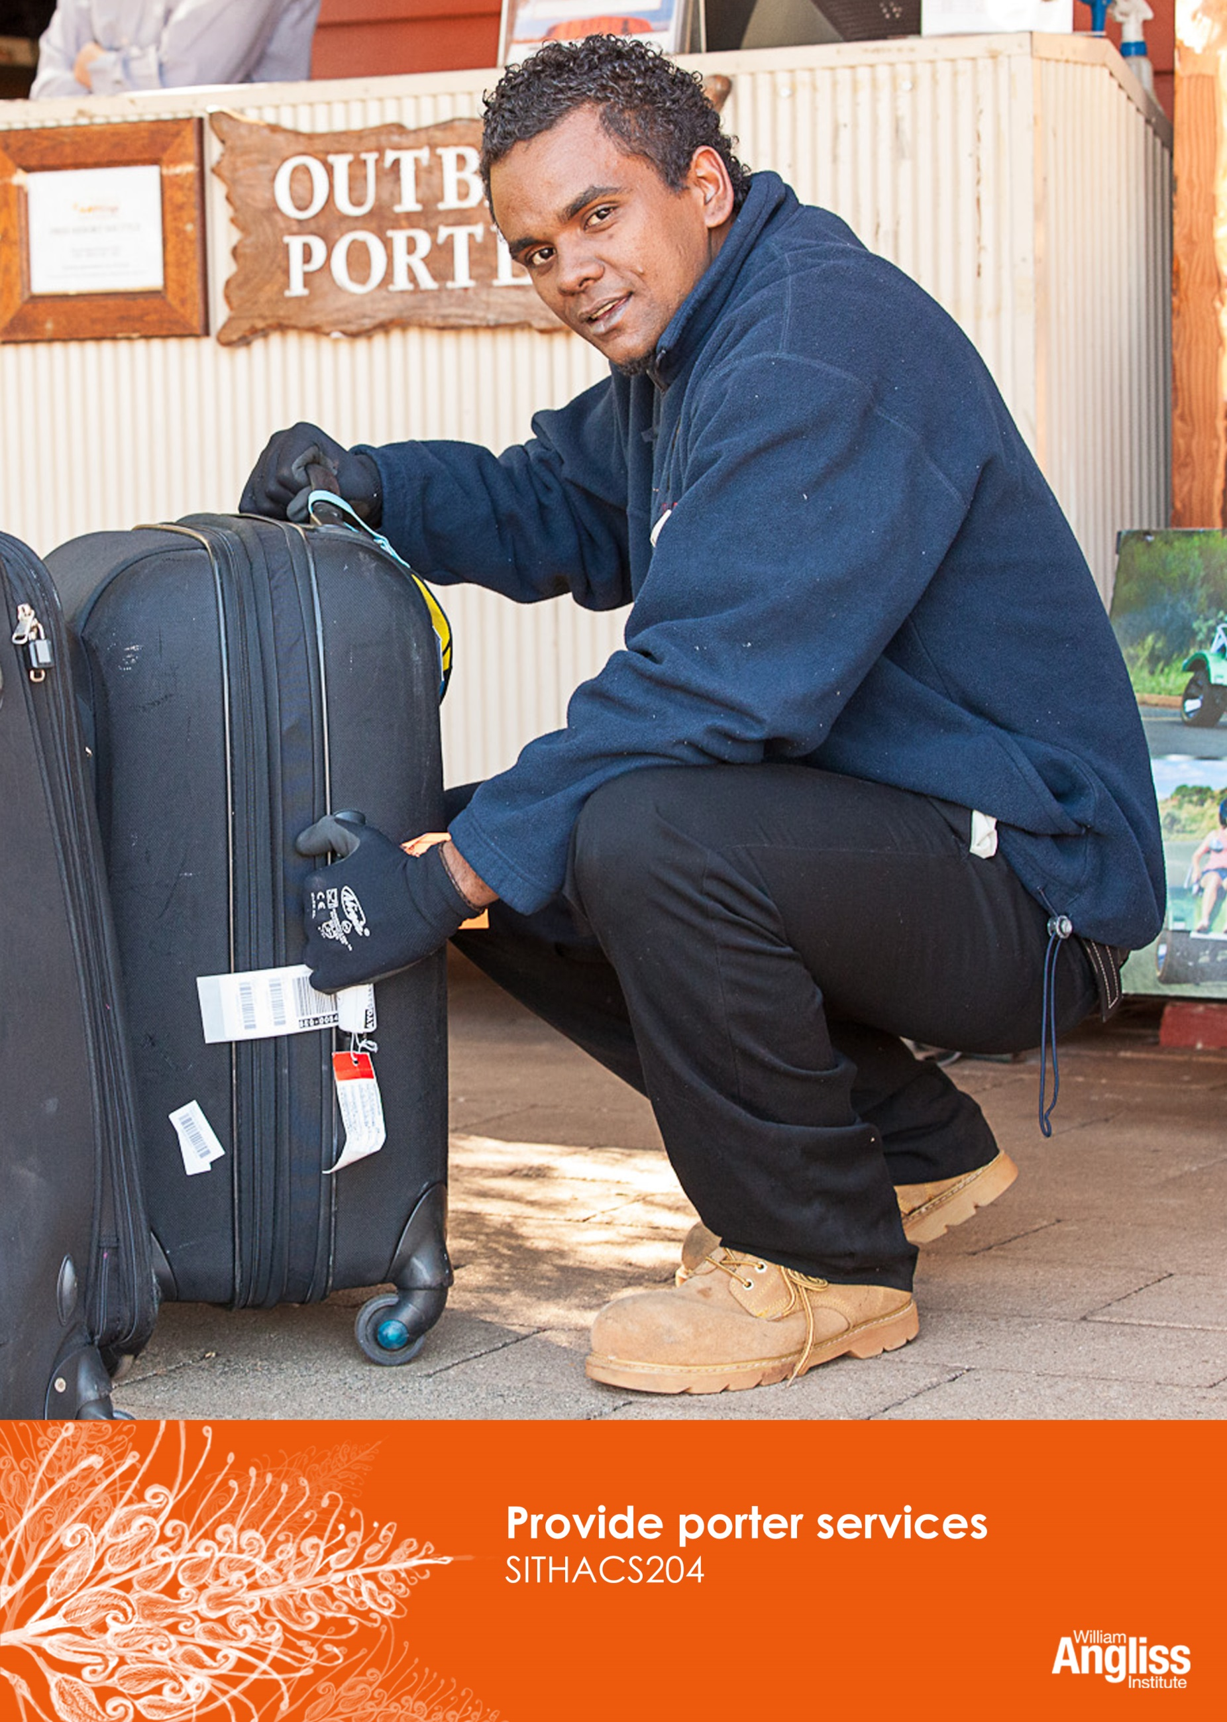

© Commonwealth of Australia 2013



**CC BY-NC-SA**

This work is copyright. Except where otherwise indicated, and save for the Commonwealth Coat of Arms, the Department has applied the [Creative Commons Attribution-Noncommercial-Share Alike 3.0 Australia Licence](http://creativecommons.org/licenses/by-nc/3.0/au) to this work.

The Department of Industry, Innovation, Climate Change, Science, Research and Tertiary Education must be attributed as the author of the Department’s copyright material.

As far as practicable, material for which the copyright is owned by a third party has been clearly labelled. The Department has made all reasonable efforts to ensure that this material has been reproduced on this website with the full consent of the copyright owners.

Requests and enquiries concerning the Department’s copyright material should be addressed to:

The Legal Branch

Department of Industry, Innovation, Climate Change, Science, Research and Tertiary Education

GPO Box 9839 Canberra ACT 2601

Or emaile[d to legalservices@innovation.gov.au](mailto:legalservices@innovation.gov.au)

Funded under the Workplace English Language and Literacy (WELL) Program by the Australian Government Department of Industry, Innovation, Climate Change, Science, Research and Tertiary Education

The views expressed in this publication do not necessarily represent the view of the

Minister for Tertiary Education, Skills, Science and Research or the Australian

Government. The Australian Government does not give any warranty nor accept any liability in relation to the contents of this work

ISBN 978-1-922108-11-1

**ALTER AS RELEVANT**

|  |  |
| --- | --- |
| **Development Team** | |
| Content | William Angliss Institute of TAFE |
|  | Macsmith and Associates |
| Photography & graphics | Benjamin B Photographer |
|  |  |
| **Acknowledgments** | |
| We would like to acknowledge the generous support of the following organisations and the learners and employees in those venues, both Indigenous and non-Indigenous, for giving their permission for photography: | |
| Voyages Ayers Rock Resort, Yulara, NT | |
|  | |
| **Cultural Warning** | |
| People of Aboriginal or Torres Strait Islander descent should be aware that this publication contains images of people who may be deceased | |
|  | |
| **Disclaimer** | |
| Every effort has been made to ensure that this booklet is free from error or omissions. However, you should conduct your own enquiries and seek professional advice before relying on any fact, statement or matter contained in this book. William Angliss Institute of TAFE and Macsmith and Associates are not responsible for any injury, loss or damage as a result of material included or omitted from this course. | |
|  | |

**Contents**

[Welcome vi](#_Toc360964712)

[Icons vi](#_Toc360964713)

[What you will learn vii](#_Toc360964714)

[1 The porter’s role 8](#_Toc360964715)

[Front Office Department 8](#_Toc360964716)

[What does a porter do? 9](#_Toc360964717)

[What makes a good porter? 12](#_Toc360964718)

[Personal hygiene 14](#_Toc360964719)

[Working conditions 16](#_Toc360964720)

[Section summary 18](#_Toc360964721)

[2 When guests arrive 19](#_Toc360964722)

[The Arrivals List 19](#_Toc360964723)

[Plan your work 20](#_Toc360964724)

[The 24 hour clock 21](#_Toc360964725)

[Greet guests 25](#_Toc360964726)

[Take guests and luggage to rooms 27](#_Toc360964727)

[Group arrivals 31](#_Toc360964728)

[Section summary 32](#_Toc360964729)

[3 When guests depart 33](#_Toc360964730)

[The Departures List 33](#_Toc360964731)

[Collect luggage from rooms 36](#_Toc360964732)

[Group departures 38](#_Toc360964733)

[Other departure tasks 39](#_Toc360964734)

[Section summary 41](#_Toc360964735)

[4 Handle luggage safely 42](#_Toc360964736)

[What is manual handling? 42](#_Toc360964737)

[Guidelines for safe lifting and carrying 43](#_Toc360964738)

[If the load is too heavy 46](#_Toc360964739)

[Section summary 49](#_Toc360964740)

[5 Store luggage safely 50](#_Toc360964741)

[Store luggage 50](#_Toc360964742)

[Lost luggage 54](#_Toc360964743)

[Section summary 57](#_Toc360964744)

[6 Communicate with colleagues and guests 58](#_Toc360964745)

[Communicate with guests from other cultures 59](#_Toc360964746)

[Communicate with other staff 65](#_Toc360964747)

[Section summary 68](#_Toc360964748)

[7 Provide other services 69](#_Toc360964749)

[Provide information to guests 69](#_Toc360964750)

[Porters’ information 70](#_Toc360964751)

[Arrange transport 71](#_Toc360964752)

[Provide security 72](#_Toc360964753)

[Assist in emergencies 72](#_Toc360964754)

[Section summary 75](#_Toc360964755)

[Appendix 1 The 24 hour clock 76](#_Toc360964756)

[Key words 78](#_Toc360964757)

Welcome

Icons

These signs tell you what type an activity is:

|  |  |
| --- | --- |
| C:\Users\Alan\Desktop\IMG_1094.jpg | Do this activity in a big group. |
| C:\Users\Alan\Desktop\IMG_1079.jpg | Do this activity in a small group. |
| C:\Users\Alan\Desktop\IMG_1081.jpg | Do this activity in pairs. |
| C:\Users\Alan\Desktop\IMG_1080.jpg | Do this activity by yourself. |
| C:\Users\Alan\Desktop\IMG_1086.jpg | Do this activity using the internet. If you are not connected to the internet, your trainer will provide you with another activity. |
| C:\Users\Alan\Desktop\IMG_1087.jpg | Do this activity in your workplace. If you are not in a workplace, your trainer will provide you with another activity. |

What you will learn

A porter helps guests with their luggage on arrival and departure and may also organise some extra services for them. You are often the first and last person the guests see, so you should always be friendly, polite and helpful.

In this unit you will learn how to:

* welcome guests as they arrive
* help guests with their luggage when they arrive and depart
* move and store luggage safely and securely
* communicate professionally with guests and colleagues
* provide information and other services to guests.

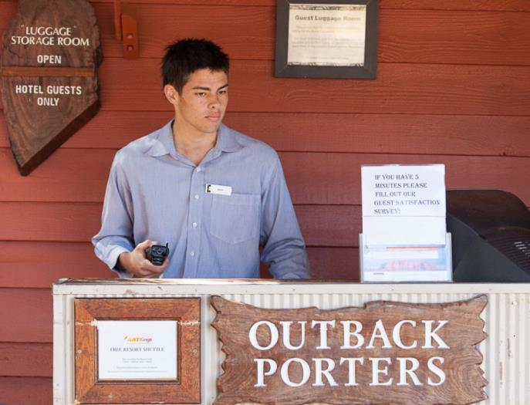

1 The porter’s role

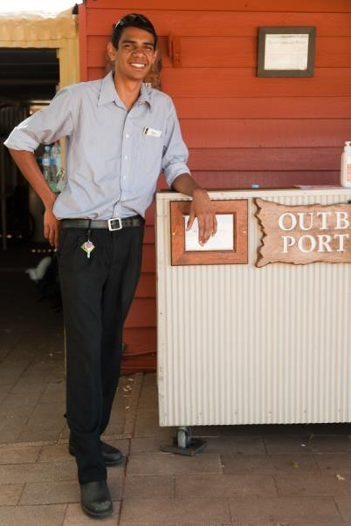You have just started working as a porter at The Gums Resort.

This resort has luxury rooms, standard rooms and self-contained units where people can cook their own food.

As a porter at the venue, your role is very important. You may be the first person to greet a guest and the last person they see when they leave.

If you are friendly, efficient and well presented, you will make a good impression and the guests may want to come again. If you are unfriendly, slow and look untidy, guests may leave with a bad feeling about the whole venue.

At The Gums Resort your supervisor, Joe, will show you how to do the job.

Front Office Department

You are part of the Front Office Department. The front office (sometimes called front of house) is the area where guests first arrive and use the services of the hotel. Porters belong to this department as well as receptionists, and people who take reservations and accept phone calls. In some hotels they are known as Guest Service Agents.



*Welcome to The Gums Resort.   
I’m Joe. I’ll be showing you how to do your job here as a porter.*

What does a porter do?

The porter’s role depends on the size and type of the accommodation. In a small workplace the porter may do a wider variety of jobs. In a larger workplace such as The Gums Resort, the role is more specialised.

In all the jobs you do, you should aim to provide excellent customer service so guests are happy.

Main tasks

Your main jobs at The Gums Resort are:

* welcome guests as they arrive
* take the luggage of arriving guests to their room
* show guests to their room and explain some of the features of the room
* collect departing guests’ luggage from their room and bring it to the reception area
* store luggage safely and securely, and label it correctly.

Other tasks

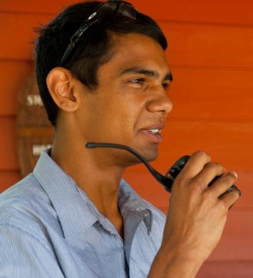Some other jobs porters may do are:

* take mail and messages to guests’ rooms
* park guest cars – also known as valet parking
* organise taxis
* provide guests with information about transport   
  and tourist facilities
* organise extra services for guests, such as restaurant reservations
* organise wake up calls
* assist at Reception when it is busy, checking guests in and out.

Planning

When planning your work on a shift, remember that your two most important tasks are:

* greeting guests when they arrive and moving their luggage to their rooms
* collecting guest luggage from their rooms before they leave.

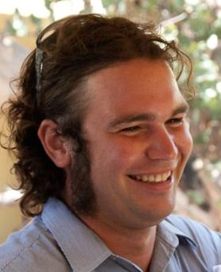

*All your jobs are important, but you must plan your day so that the other jobs don’t interfere with these two major activities.*

The Porters’ Desk

The Porters’ Desk is generally in or near the main lobby with a clear view of the entrance. This way, you can see guests as they arrive and depart. This provides some security as well, as you can keep your eye out for anything suspicious and report it to your supervisor.

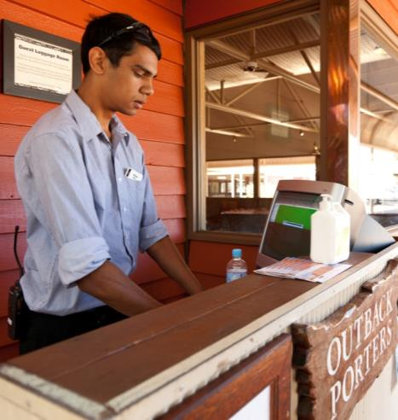

At The Gums Resort there is a computer at the desk so you can check the daily list of guest arrivals and departures and update information if things change.

There are also maps and brochures of local attractions.

It is important to keep the desk and the surrounding area neat and tidy so the area looks professional to guests.

|  |  |
| --- | --- |
| C:\Users\Alan\Desktop\IMG_1087.jpg | Activity 1  Porters at your workplace |

In your workplace:

1 Talk to a porter at your workplace and ask these questions.

* What are 4 different tasks you have to do in a shift?

|  |
| --- |
|  |
|  |

What types of information do guests ask about?

|  |
| --- |
|  |
|  |

What shifts do you work?

|  |
| --- |
|  |
|  |

2 Do the porters wear a uniform?

|  |
| --- |
|  |
|  |

What makes a good porter?

A good porter has some special:

* **qualities** – this is your character e.g. friendly, calm and active
* skills – these are things you can do e.g. move luggage
* knowledge – this is what you know e.g. the local tourist attractions.

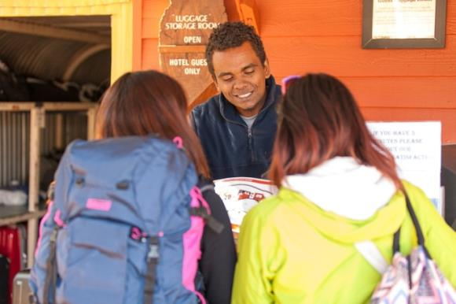

|  |  |
| --- | --- |
| C:\Users\Alan\Desktop\IMG_1081.jpg | Activity 2  Advertising for a porter |

Look at the following advertisement for a porter.

|  |  |
| --- | --- |
|  | ***The Gums Resort – Porter*** |
| The Gums Resort is looking for an energetic person to train as a porter. You will be working with guests so you must know how to maintain a high standard of guest service.  The resort is located on the river. It has 300 recently renovated luxury and standard rooms and 20 self-contained units. It has a conference centre, two bars, a fine dining restaurant and a café.  The porter greets guests, handles guest luggage, directs guests to their rooms, parks guest cars and provides information to guests.  Essential requirements:   * a friendly, professional and welcoming manner * excellent communication skills * ability to work alone and as part of a team * basic computer skills * fit and energetic * well presented.   Experience is not necessary. However, you must be willing to learn about the local area, including transport and tourist attractions.  This is a physically demanding position so you must be fit and healthy, and be able to stay calm under pressure.  A driver’s licence is essential.  We will train you in all parts of the job and provide a uniform. | |

1 What qualities, skills and knowledge are needed for this position?   
Mark them on the advertisement with a highlighter.

2 Do you think The Gums Resort would give you the job?   
If not, what qualities, skills and knowledge do you need to develop?

|  |
| --- |
|  |
|  |
|  |

Personal hygiene

Keeping yourself and your clothing clean is called *personal hygiene*. Good personal hygiene is important for a porter, so you give guests a good impression. It also prevents hygiene hazards such as passing on germs to other people or contaminating food.

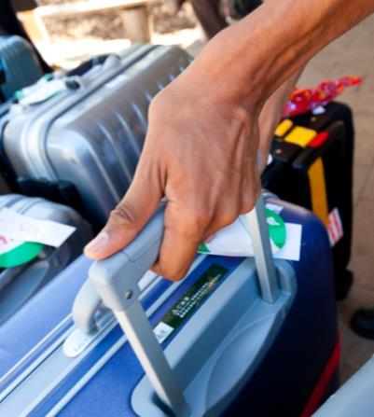Don’t pass germs on to others

Germs can:

* pass through the air e.g. when you cough or sneeze around other people
* be passed on from your hands to a surface e.g. when you don’t wash your hands after going to the toilet, then pick up someone’s luggage, the guest will take their luggage and may pick up your germs.

Don’t get germs from others

You are handling many different people’s luggage, so you can also get germs from guests if they are sick or haven’t washed their hands.

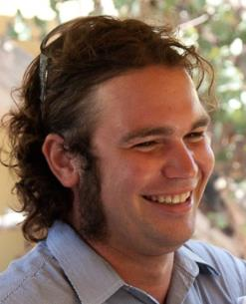

*We keep a bottle of hand sanitiser at the porters’ desk. Rub it on your hands before and after you handle luggage.*

|  |  |
| --- | --- |
| C:\Users\Alan\Desktop\IMG_1080.jpg | Activity 3  Your personal hygiene |

Here are some suggestions to prevent passing on or getting germs.

1 How do you rate yourself on the checklist below? Tick a box for each item.

| **When I am at work as a porter I …** | **I do this well** | **I could do this better** |
| --- | --- | --- |
| * keep my uniform neat and clean |  |  |
| * have a shower every day |  |  |
| * wash my hands after I go to the toilet |  |  |
| * wash my hands before and after I eat |  |  |
| * wash my hands after having a cigarette |  |  |
| * wash my hands after scratching my skin and hair |  |  |
| * use a hand sanitiser regularly during the day |  |  |
| * use a tissue when blowing my nose or sneezing, throw it away, then wash my hands |  |  |
| * turn away from people and cover my mouth when I cough, then wash my hands |  |  |
| * use my own cup, glass or water bottle to drink from and never borrow from anyone else |  |  |
| * never spit |  |  |
| * never put luggage or personal items on surfaces where food may be prepared e.g. the kitchen bench of a hotel unit |  |  |

2 If you ticked anything in the column *‘I could do this better’*, what things can you do to improve?

|  |
| --- |
|  |
|  |

Working conditions

You will probably work in shifts, as large venues may want porters on duty 24 hours a day.

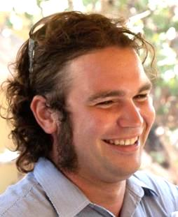

*At The Gums Resort we have three shifts -*

* *07:00 to 15:00*
* *15:00 to 23:00*
* *23:00 to 07:00.*

This is a physically demanding job. You will be on your feet most of the time. You also have to lift and move guest luggage and other items.

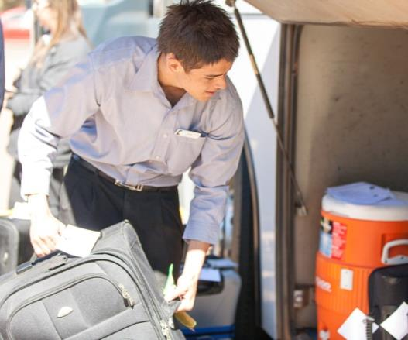

Some of the jobs are outside, such as helping guests from cars and unloading luggage from coaches.

Section summary

Now you have completed this section you should have developed the following skills and knowledge.

Tick each box if you are satisfied that you have those skills and knowledge.

|  |  |
| --- | --- |
|  | Know the role of a porter and the importance of the role to the business. |
|  | Know what makes a good porter. |

Notes

|  |
| --- |
|  |
|  |
|  |
|  |
|  |

2 When guests arrive

Guests may arrive in tourist buses, in taxis, on foot, on an airport shuttle bus or in their own private car.

They may be young, old, families, tourists, business people, not speak much English or have special needs.

As a porter, you have to greet and assist them all in the same way, and it is easier to be calm and professional if you have a plan for the shift.

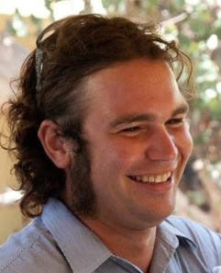

*The first thing you should do on every shift is check the Arrivals and Departures Lists.*

*Find out how many guests are arriving and departing, and at what times.*

The Arrivals List

The Arrivals List has information about who is arriving that day. It includes:

* guest name
* number of guests
* arrival and departure dates
* estimated (not exactly) arrival time
* room type and allocation (which room they have been given or allocated)
* special requests.

The list may include other information, such as:

* The name of the company if they are a business traveller or the name of the travel agent if they are part of a tour or booked through a travel agent
* whether the person is a Very Important Person (VIP)
* how the person booked the room.

Plan your work

The Arrivals List and the Departures List may be separate or combined.

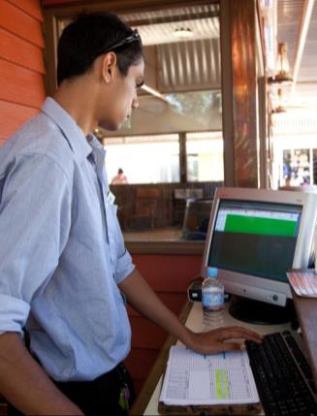These Lists are on the computer at the Porters’ Desk. You may also get a print-out of the lists each day, so you can mark off when guests have arrived and departed, and make notes about any changes.

*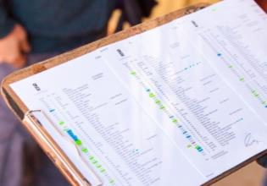*

Use the Arrivals List to plan your work during your shift. It tells you when you will be busy, such as when a large group will arrive.

Read both lists carefully so you and your team can work out which will be your busy times and who will do each task.

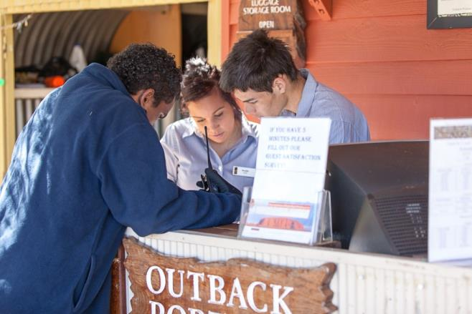

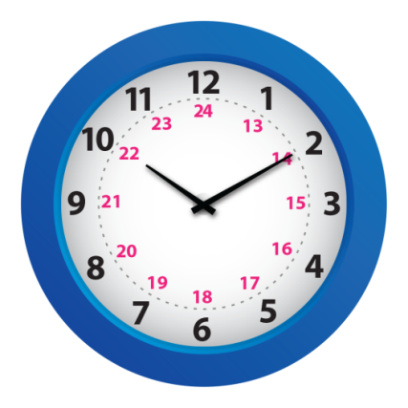The 24 hour clock

Each day has 24 hours. We can count the time in two different ways – using the 12 hour clock or the 24 hour clock.

The hospitality and travel industries use the 24 hour clock for many different purposes, such as:

* hotel check-in and check-out times
* arrival and departure times
* flight times
* staff rosters
* hire car bookings
* delivery times.

The 24 hour clock starts counting from midnight. It means you don’t get confused about *am* (morning) and *pm* (afternoon and evening).

* Midnight is 00:00 hours.
* One minute after midnight is 00:01 hours.
* 7.30 am (7 ½ hours after midnight) is 07:30 hours.
* 12 noon (midday, or 12 hours after midnight) is 12:00 hours.
* 1.00 pm (13 hours after midnight) is 13:00 hours.

To work out the 24 hour time after midday, add 12 to the 12 hour clock time.

*Example:*

|  |  |  |
| --- | --- | --- |
| 12 hour time | + 12 = | 24 hour time |
| * 1.00 pm | 1 + 12 = 13 | 13:00 hours. |
| * 4.00 pm | 4 + 12 = 16 | 16:00 hours. |
| * 7.00 pm | 7 + 12 = 19 | 19:00 hours. |
| * 8.00 pm |  |  |
| * 10.00 pm |  |  |

|  |  |
| --- | --- |
| C:\Users\Alan\Desktop\IMG_1081.jpg | Activity 4  Using the 24 hour clock |

1 Fill in the gaps in this table of clock times.

|  |  |  |
| --- | --- | --- |
| **12 hour clock** | **How long after midnight?** | **24 hour clock** |
| 5.30 am |  |  |
|  |  | *07:05 hours* |
| 11.30 am |  |  |
|  | *14 ¼ hours* |  |
| 5.15 pm |  |  |
|  |  | *22.45 hours* |
| 2.30 pm |  |  |
|  | *23 ½ hours* |  |
| 12.00 am (midnight) |  |  |
| 12.00 pm (midday) |  |  |

2 Are these times morning (am) or afternoon/evening (pm)? Circle the correct answer.  
The first one has been done for you.

|  |  |
| --- | --- |
| 1. 22:15 | morning afternoon/evening |
| 1. 07:30 | morning afternoon/evening |
| 1. 00:10 | morning afternoon/evening |
| 1. 11:20 | morning afternoon/evening |
| 1. 18:30 | morning afternoon/evening |
| 1. 14:30 | morning afternoon/evening |
| 1. 06:25 | morning afternoon/evening |

|  |  |
| --- | --- |
| C:\Users\Alan\Desktop\IMG_1079.jpg | Activity 5  Plan your work |

On the next page is part of an Arrivals List for The Gums Resort for 25 July. The times are written using the 24 hour clock

You are on the 07:00 to 15:00 shift. Use the list to plan your day on the timetable below.

|  |  |
| --- | --- |
| **Daily tasks: 25 July 2013** | |
| **TIME** | **TASKS** |
| 07:00 |  |
| 08:00 |  |
| 09:00 |  |
| 10:00 |  |
| 11:00 |  |
| 12.00 |  |
| 13:00 |  |
| 14:00 |  |
| 15:00 |  |

|  |  |  |  |  |  |  |  |  |  |  |
| --- | --- | --- | --- | --- | --- | --- | --- | --- | --- | --- |
|  | | | | **The Gums Resort Arrivals List** | | | | | **Date: 25 July 2013** | |
| **Guest name** | **No. of guests** | **Arrival date** | **ETA** | | **Dep. date** | **Room type** | **Rate code** | **Room No.** | **Special requests** | **Status** |
| Liu, Bin, Mr & Peng, Bo, Ms | 2A 1C | 25/07/13 | 11:00 | | 26/07/13 | 1 BRS | RO | A12 | 1 year old child, free of charge  Extra cot in room | Arrived |
| Sweetman, John, Mr & Mrs | 2A 0C | 25/07/13 | 13:30 | | 26/07/13 | L - K | LB | 103 | Honeymoon. Provide flowers and champagne |  |
| Jacoma, Arnold, Dr | 1A 0C | 25/07/13 | 13:30 | | 31/07/13 | L - K | LB | 304 | Room with a lake view |  |
| Saleh, Yasim, Mr & family Harvey World Travel | 2A 3C | 25/07/13 | 13:30 | | 27/07/13 | 2 BRS | LW | B103 | Extra bed in 2nd bedroom  Charge to agent |  |
| Bernard, Jane, Mrs & family | 2A 2C | 25/07/13 | 14:30 | | 28/07/13 | 2 BRS | LB | B105 |  |  |
| Billington, Sara, Miss & Billington, Harriet, Miss | 2A 0C | 25/07/13 | 16:00 | | 28/08/13 | S - S | RO | 145 | Arrange airport pickup QF 123 at 15:20 |  |
| Stearman, Olga, Ms & Myer, Hetty, Ms Telstra | 2A 0C | 25/07/13 | 22:00 | | 01/08/13 | L - KS | CP | 206 | Late arrival. Don’t re-sell room  Charge to company room only, pay own extras |  |
| **Rate Code:**  CP Corporate contract  LB Bed and breakfast  LW Domestic wholesale  RK Rack rate  RO Room only | | | | | | **Room Type Code:**  L – Luxury room (king bed K or 2 x king single beds KS)  S – Standard room (double bed D or 2 x single beds S)  1 BRS – 1 bedroom self-contained unit  2 BRS – 2 bedroom self-contained unit | | | | |

Greet guests

When you are greeting and talking to guests, always use a professional and welcoming manner, even when you are tired.

Welcome the guests and direct them to Reception for registration.

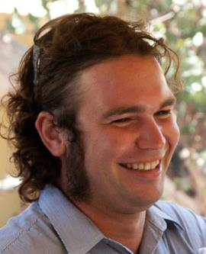

*We have a standard greeting for The Gums Resort that we want all our staff to use.*

*Use the guest’s name and title if you know it.*

The standard greeting could be something like this:

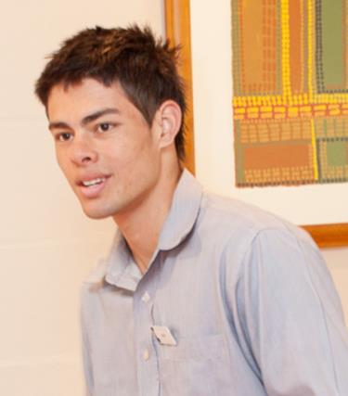

*Good afternoon ma’am. Welcome to The Gums Resort. Can I help you with your luggage?*

*Good morning Mr Jackman. Welcome back to The Gums Resort. Lovely to see you again. Can I get your bags?*

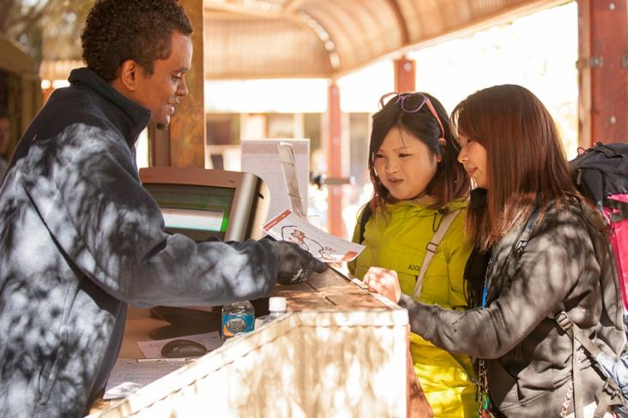

Speak clearly

Look at the guest – unless you believe they are from a culture where it is not polite to look people in the eye

Smile

Be courteous and polite

Use gestures or maps if you think the guest does not speak much English

Take guests and luggage to rooms

Once guests have checked in, you may have to *escort* them (take them) to their room with their luggage.

Never give opinions

Don’t discuss personal issues such as religion and politics.

Don’t talk about other people staying at the venue.

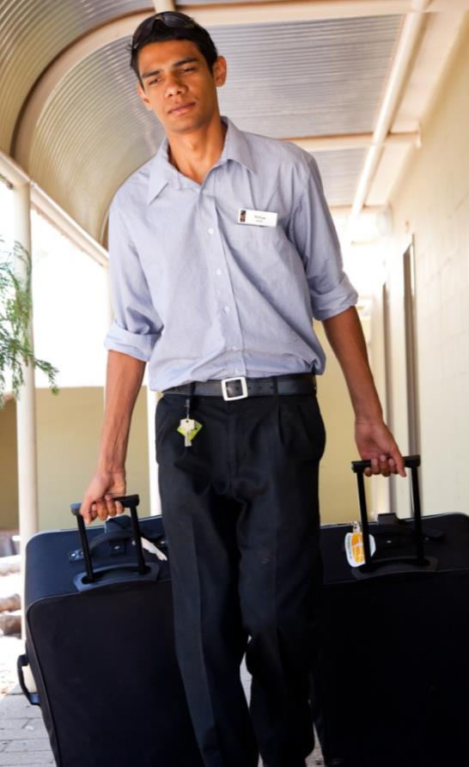

You could make some polite small talk e.g. “How was your flight?”  
“Where have you come from today?”

Answer questions accurately. If you don’t know the answer, tell the guest you will find out the answer and let them know. Always follow up.

Let the guest set the walking pace even though you may be in front.

If you are *accompanying* (going with) guests in a lift, let them enter and exit the lift first.

Point out features of the venue

As you are taking people to their rooms, point out features of the venue such as where to eat, guest laundry, gym facilities, *valet* (someone who can look after the guest’s clothes) or floor facilities such as a special lounge.

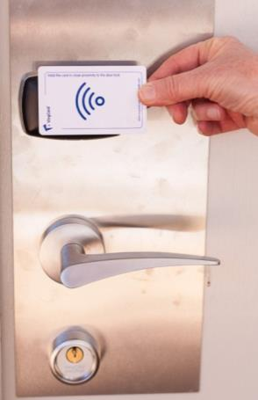Open the door

When you get to the room:

* show the guest how to open the door.
* show guests how to use the key card to turn on   
  the electricity.

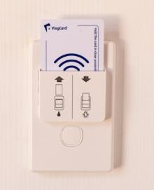

Enter the room

Check the procedure at your workplace about who enters the room first – the guest or the porter.

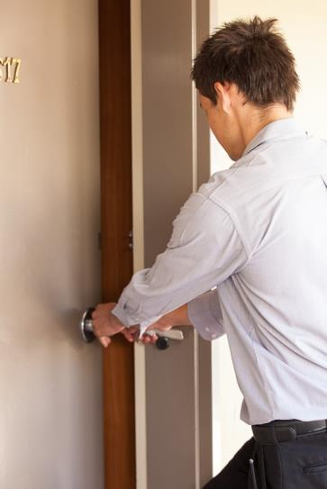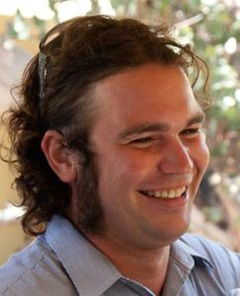

*At The Gums Resort, the porter goes in first and turns on the lights.*

Put the luggage on the luggage rack.

* If there is extra luggage that won’t fit on the luggage rack, put it out of the walkway.
* Hang up any hanging bags in the wardrobe.
* Don’t put luggage or other items on food preparation surfaces, such as the benches of a kitchen in a unit.
* Always use safe manual handling methods when you are handling luggage.

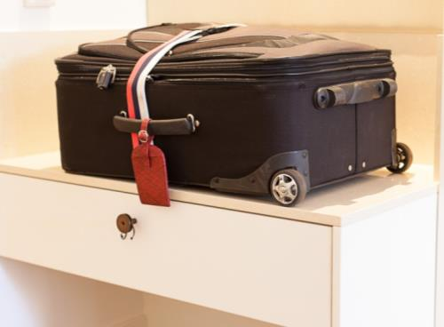

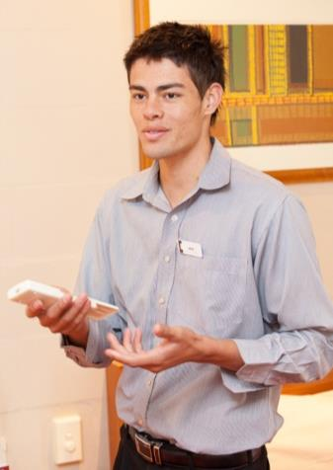Point out room facilities

Show guests the facilities in their room, such as:

* tea and coffee making facilities
* air conditioning
* television and remote control
* telephone
* room safe
* mini-bar
* wi-fi connection
* bathroom facilities e.g. spa
* the *compendium* (collection) of venue information
* where extra blankets and pillows are kept.

Answer guest questions

Guests may have other questions, such as:

* when and where breakfast is served
* what adapter plugs work in Australian power points
* eating options
* where to buy and post a postcard
* other hotel facilities such as leisure facilities e.g. pool and gym, business centre, tour desk, babysitting, laundry and other housekeeping services.

You need to know all this information so you can provide a professional service to guests.

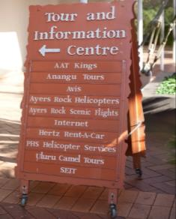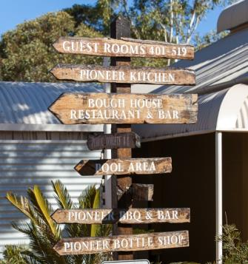

|  |  |
| --- | --- |
| C:\Users\Alan\Desktop\IMG_1081.jpg | Activity 6  Welcoming guests |

In this activity you will practise welcoming guests in a range of situations.

Group arrivals

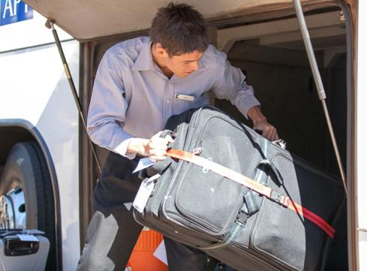A group check-in is a busy time so you and your team need to have a procedure for this.

Direct the group to seats where they can wait comfortably while the tour leader checks them in. This also means they are not blocking the reception area for other guests.

If guests have arrived in a coach, you help the coach driver take the luggage out of the coach.

You then move it inside where it is safe.

Count the luggage.

You should have a separate Room List for the group with all the names and room numbers.

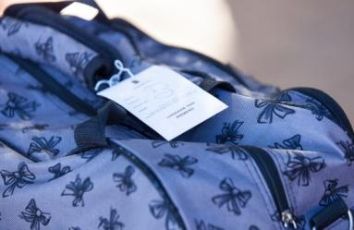

Read guests’ names from the labels on their bags and check them against the Room List.

Attach a luggage tag to each bag with the right room number on it.

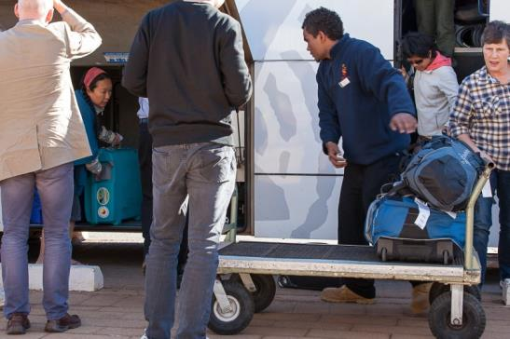Take the luggage to the rooms as quickly   
as possible.

Plan your trips and organise your trolley loads so you are efficient.

For example, choose luggage going to   
rooms in the same area.

If it is extremely busy, let your supervisor know and they may organise someone to help out.

Section summary

Now you have completed this section you should have developed the following skills and knowledge.

Tick the box if you are satisfied that you have those skills and knowledge.

|  |  |
| --- | --- |
|  | Know how to read the Arrivals List and plan your day. |
|  | Greet guests correctly. |
|  | Take guests’ luggage to their rooms efficiently. |

Notes

|  |
| --- |
|  |
|  |
|  |
|  |
|  |

3 When guests depart

An important part of your job as a porter is to farewell guests. You are often the last person a guest sees, so you must make a good impression.

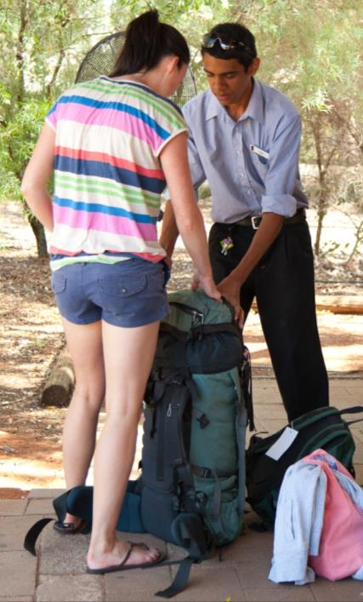

The Departures List

The daily Departures List is similar to the Arrivals List.

Here is an example of a Departures List at The Gums Resort.

|  |  |  |  |  |  |  |  |  |  |
| --- | --- | --- | --- | --- | --- | --- | --- | --- | --- |
|  | | | | **The Gums Resort Departures List** | | | | | **Date: 25 July 2013** |
| **Guest name** | **No. of guests** | **Arrival date** | **Dep. date** | | **Dep. time** | **Room type** | **Room No.** | **Pay’t meth** | **Special requests** |
| Fowler, Jack, Mr & Mrs | 2A 0C | 24/07/13 | 25/07/13 | | 07.30 | L - K | 103 | VA | Have bag removed from room by 07:00 |
| ABC Tours (Leader Anthony Black) | 2A 0C | 23/07/13 | 25/07/13 | | 07.00 | S – S x 10 | 204 -213 | MC | Have bags removed from rooms by 06.45 – begin 06.30 |
| Suzuki, Mr & Mrs | 2A 0C | 22/07/13 | 25/07/13 | | 10.00 | L - KS | 105 | VA | Order a taxi for 10:15 to airport |
| Wang, Li, Mr & Cheng, Xiao, Ms | 2A 1C | 24/07/13 | 25/07/13 | | 09.00 | A BRS | A12 | CL | Book limo for airport transfer at 11:00 |
| Richmond, Ross, Mr | 2A 0C | 19/07/13 | 25/07/13 | | 18.00 | S - D | 314 | VA | Will check out at 10:00 and leave luggage to be collected at 18:00 |
| Thomas, Charles, Mr | 4A 0C | 22/07/13 | 25/07/13 | | 07.30 | 2 BRS | B106 | MC | Joining High Country Tours at 08.00 |
| Brown, John, Mr | 1A 0C | 24/07/13 | 25/07/13 | | 07.30 | L - K | 107 | VA | Order taxi for airport 07.45 |
| **Rate Code:**  CP Corporate contract  LB Bed and breakfast  LW Domestic wholesale  RK Rack rate  RO Room only | | | | | | **Room Type Code:**  L – Luxury room (king bed K or 2 x king single beds KS)  S – Standard room (double bed D or 2 x single beds S)  1 BRS – 1 bedroom self-contained unit  2 BRS – 2 bedroom self-contained unit | | | |

|  |  |
| --- | --- |
| C:\Users\Alan\Desktop\IMG_1081.jpg | Activity 7  Reading the departures list |

Read the Departures List for 26 July and answer these questions.

1 What will be the busiest time?

|  |
| --- |
|  |

2 What times have taxis been ordered? Who are they for?

|  |
| --- |
|  |

3 Who has a limo booked?

|  |
| --- |
|  |

4 How many rooms do bags have to be removed from?

|  |
| --- |
|  |

5 What time is Mr Ross leaving the hotel?

|  |
| --- |
|  |

6 What time is Mr Thomas joining a tour?

|  |
| --- |
|  |

7 Go back to *Activity 5* where you made a plan from the Arrivals List. Add to this list with information from the Departures List.

Collect luggage from rooms

Guests may ask for their luggage to be collected from their room.   
If the guest is checking out straight away, you should take it to the guest at Reception.  
If the guest is not checking out straight away, you should take it to the Porters’ Desk for storage.

Guests can ask for luggage to be collected from their rooms in several ways. They might:

* fill out a Luggage Collection Card
* ring or speak to Reception the night before or in the morning before they leave their room
* talk to someone at the Porters’ Desk.

Time your collection so that guests won’t be kept waiting for their luggage. They may have appointments or planes to catch.

Knock before you enter the room and announce yourself.

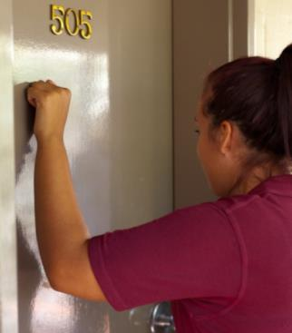

*Good Morning,* *Porter, I’m here to collect your luggage.*

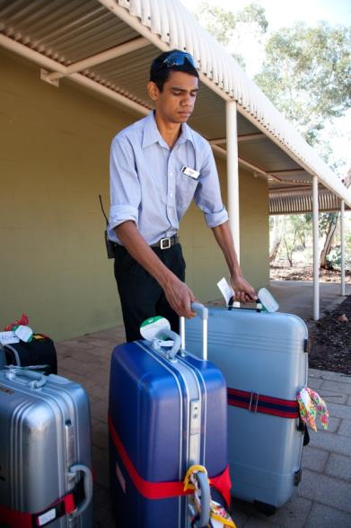

If the guest is still in the room, tell them what you will do with the luggage, e.g. put it in the tour bus or leave it at the Porters’ Desk.

Make sure that you have collected all the luggage by checking the luggage against the Departures List.

|  |  |
| --- | --- |
| C:\Users\Alan\Desktop\IMG_1081.jpg | Activity 8  Read a Luggage Collection Card |

Here is an example of a Luggage Collection Card for a guest at The Gums Resort.

|  |  |
| --- | --- |
|  | **The Gums Resort**  **Luggage Collection Card** |
| We hope you are enjoying your stay with us.  If you need assistance with your luggage, please complete this card and return it to Reception the evening before you depart. Our porters will bring your luggage to Reception.  **PLEASE REQUEST PORTER SERVICE AT LEAST 30 MINUTES BEFORE YOU WISH TO DEPART.**  Please make sure your luggage is clearly labelled with your name.  Name: …… **Mr & Mrs Suzuki** …….Room No. …**105**….  Departure date: …**25/07/13**…..Departure time: **9.00 am**  Number of pieces: …**2 cases, 1 overnight bag** ………..  **Method of departure:** (please ✓)  € Airport shuttle (free) Flight time: ………………………….  € Private vehicle Estimated departure time: …………..  € Tour coach Time: …………………………………..  ✓ Taxi Time: …**9.15. am** ………..………..  € Other Time: …………………………………..  Please note that check-out is at 11 am (11:00).  If your departure is later in the day, we can store your luggage in our secure luggage room.  Do you need your luggage to be stored? Yes No | |

Read the information on the card and answer these questions.

1 What is Mr and Mrs Suzuki’s room number?

|  |
| --- |
|  |

2 What time should you be at their room to collect the luggage?

|  |
| --- |
|  |

3 How many pieces of luggage will you collect?

|  |
| --- |
|  |

4 When and how will Mr and Mrs Suzuki leave the resort?

|  |
| --- |
|  |

5 What will you do with the luggage when you bring it down?

|  |
| --- |
|  |

Group departures

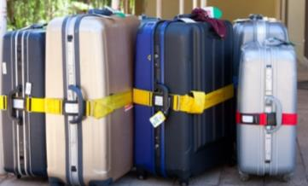Group departures are listed on the daily Departures   
List so you can plan for them.

Tour group members *assemble* (gather) in the   
reception area or lobby. The tour leader usually checks out the whole group at Reception.

You and other porters must collect all the luggage   
from rooms and bring it to a central secure area.

Count and check the number of pieces of luggage for each room against the Room List to make sure all the luggage is collected.

If the numbers do not match, you must find out why. For example, a guest may have bought new luggage, got rid of a bag or decided to take a bag with them in the bus today.

Then help the coach driver load the luggage onto the bus. As you do this, check items off again against the Room List.

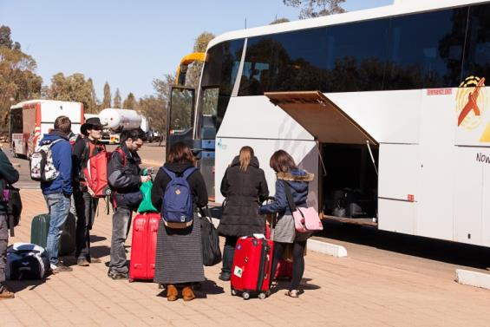

Other departure tasks

Arrange transport

Guests may ask you to arrange transport to the airport or another *destination* (place they want to go to).

Assist at Reception

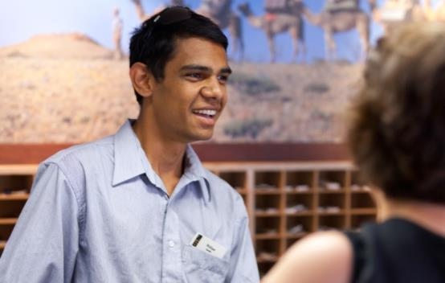At busy times, you may be asked to help out on the reception desk and check guests in or out. You will be shown the procedures to follow.

This may include:

* finalising the account
* processing credit cards or taking   
  money
* issuing a receipt
* receiving keys from guests.

A note about tipping

Most workplaces have rules about *gratuities* (tips) and you must follow these rules. Some countries have a stronger ‘tipping culture’ than Australia, so some guests may offer you a tip when you handle their bags.

Never give the impression that you expect a tip. However if you are offered a tip, you should thank the person even if the amount is very small.

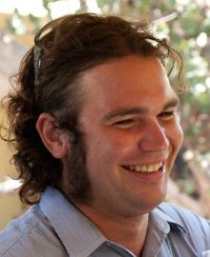

*At The Gums Resort, we put any tips into a ‘tips jar’ and spend the money on the staff Christmas party. Everyone here gives excellent service, so this way we all share the tips equally.*

Section summary

Now you have completed this section you should have developed the following skills and knowledge.

Tick each box if you are satisfied that you have those skills and knowledge.

|  |  |
| --- | --- |
|  | Read the Departures List and plan your time. |
|  | Collect luggage from rooms when guests are departing. |
|  | Perform other tasks when requested. |

Notes

|  |
| --- |
|  |
|  |
|  |
|  |
|  |

4 Handle luggage safely

Porters lift, move and carry luggage and other items to and from guest rooms. The luggage can be heavy and awkward. It is important to do it properly so you don’t injure yourself.

What is manual handling?

Manual handling is when you use your strength to move something. It includes pushing, pulling, lifting, lowering, holding and carrying.

Your workplace is legally required to train you in correct manual handling techniques.

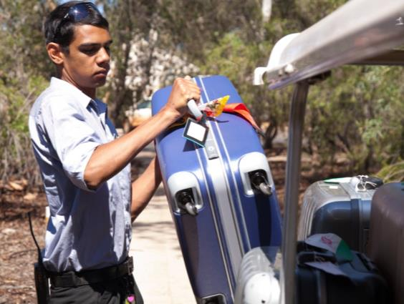

|  |  |
| --- | --- |
| C:\Users\Alan\Desktop\IMG_1087.jpg | Activity 9  Manual handling training |

1 Have you done training at work about lifting and carrying luggage safely?

YES NO

2 If YES - What are the main things you learnt?

|  |
| --- |
|  |
|  |

3 Do you feel confident lifting and carrying luggage safely?

YES NO

Common manual handling injuries

Almost half of the injuries in the hospitality industry involve manual handling. Here are some common injuries from lifting and carrying heavy things. You might:

* strain your back, neck, shoulders or arms
* tear your muscles or tendons
* lose your balance and fall over
* slip, trip or fall over something
* drop something on your foot or on someone else.

Guidelines for safe lifting and carrying

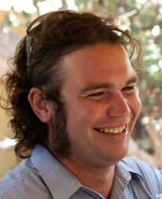

*ALWAYS follow The Gums Resort guidelines for safe lifting and carrying. We don’t want you to hurt yourself and be off work.*

Look at the luggage carefully

* Is it big? Is it heavy? Is it an awkward shape?
* Do you think you need help to lift and carry it?

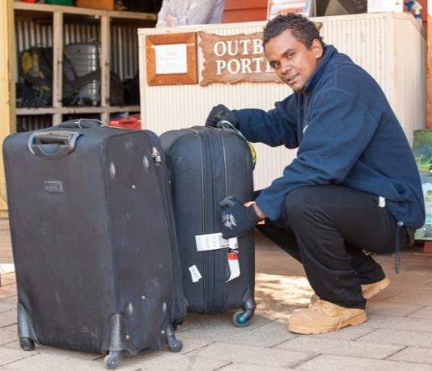

Plan your route

* Where is the luggage going to?
* Is there anything in the way (trips, slips, falls)?
* Which route will you take to reduce moving the luggage through public areas? Some workplaces have a special goods lift.

Pick up the load

* Place your feet slightly apart.
* Bend your knees, not your back.
* Keep your back straight.
* Get a firm hold on the load.
* Rest your chin against your chest. As you lift the load, lift your head to avoid neck injuries.
* Straighten your legs and use your leg muscles to lift, not your back.
* 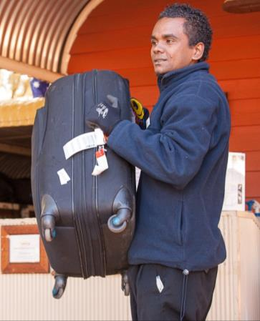Move smoothly and avoid jerky movements.

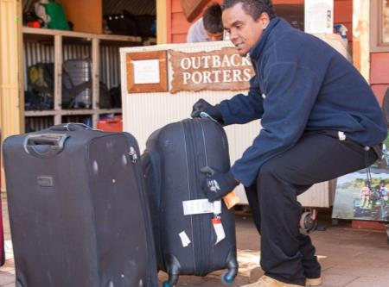

Carry the load

* Keep the load close to your body, around waist level.
* Change directions by turning or moving your feet, not your back. Don’t twist your body.
* Look ahead, not down, when you are carrying the load so you can see where you are going. If you can’t see over the load, don’t carry it.
* To put the load down, bend your knees and keep your back straight.

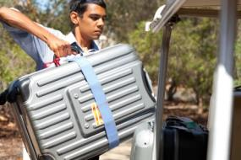

If the load is too heavy



*Never try to lift or carry loads if you think they’re too heavy. You don’t want to injure your back.*

There is no maximum weight limit for lifting loads. It depends on the size and strength of the person. Younger people are more likely to over-estimate how much they can carry.

If the load is too heavy for you, you must not lift it.

Here are some safe ways of moving heavy luggage.

Do a trial lift

If you are not sure about the weight of a load, do a trial lift first to get an idea of how heavy it is.

Try to pick up the load a little bit OR push the load a short distance with your foot. If it feels too heavy, don’t lift it.

Use mechanical aids

Mechanical aids such as luggage trolleys or electric luggage carts (sometimes called a buggy) can help you move a load. However, you still have to put the luggage on and take it off safely.

Here are some guidelines for using a trolley safely.

* Don’t overload the trolley. Make two trips rather than overload a single trip.
* Put the heaviest items on the bottom so they won’t fall off.
* Always push the trolley, don’t pull it.
* Never use a damaged trolley e.g. if the wheels don’t go straight.

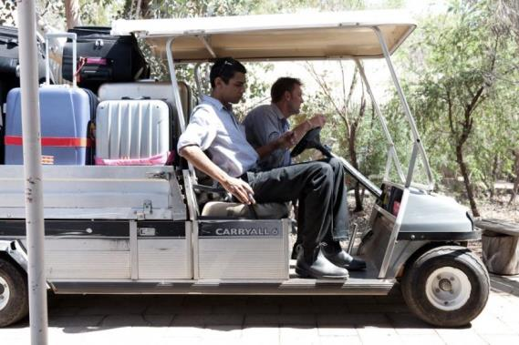

*We move larger amounts of luggage to the units in the buggy.*

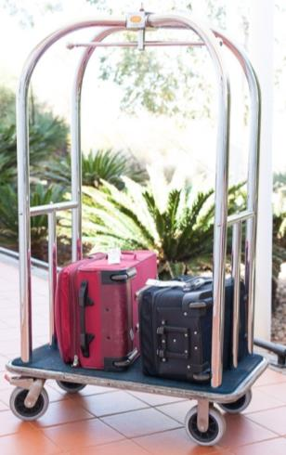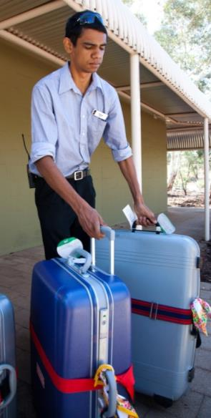

*Use the handles and wheels on the luggage to help move them.*

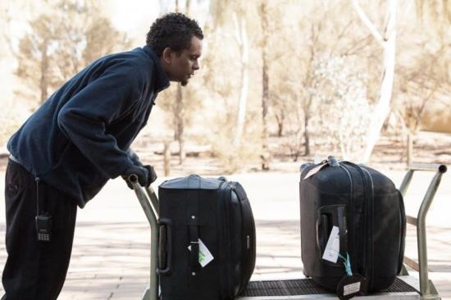

*Always push the trolleys, don’t pull them. It saves strain on your back*

*We use this type of trolley too, in the luxury section of the hotel.*

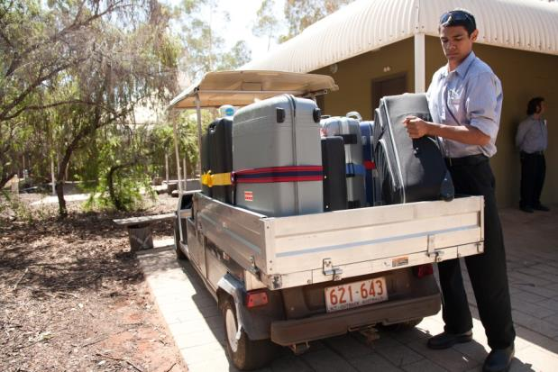

Do a team lift

Ask someone else to help you lift and carry items. This is called a *team lift.*

* Make sure you both have a good grip on the item.
* One person should give the directions. Make sure the instructions are clear so you are doing the same thing at the same time.
* Follow safe manual handling procedures.

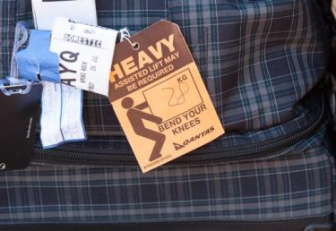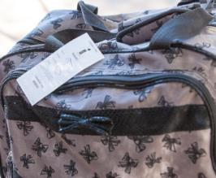

Section summary

Now you have completed this section you should have developed the following skills and knowledge.

Tick each box if you are satisfied that you have those skills and knowledge.

|  |  |
| --- | --- |
|  | Handle luggage safely. |
|  | Know what to do if the luggage is too heavy. |

Notes

|  |
| --- |
|  |
|  |
|  |
|  |
|  |

5 Store luggage safely

Store luggage

Guests may need their luggage stored:

* for a few hours while they wait for a room to be free or for a flight
* for longer periods of time e.g. if they are going on a short tour and don’t want to take all their luggage with them.

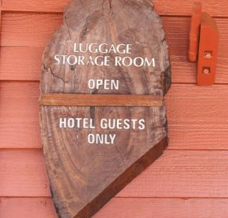

Label luggage for storage

When you receive luggage to be stored, label it with a luggage collection tag. This may also be called a luggage claim check.

You record the guest’s information on this, including:

* guest’s name
* room number
* number of pieces
* date left
* date to be collected.

**STEPS**

1 Fill in the tag.

2 Tear the bottom piece off and give it to the guest. This is the guest’s numbered receipt.

3 Tie the rest of the tag to the luggage.

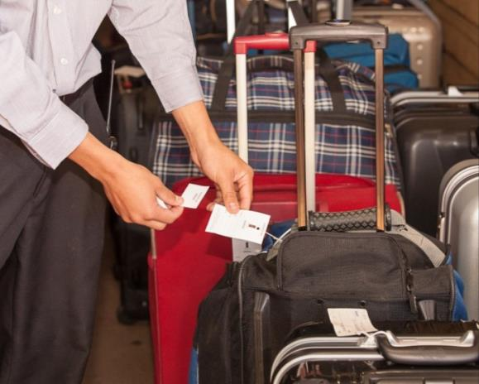

When the guest returns, they show you their receipt and you look in the luggage store for the luggage with the matching tag.

If you are storing luggage for a group, you may use tags that are all the same colour to identify them easily, or you may store the luggage together in a separate place.

|  |  |
| --- | --- |
| C:\Users\Alan\Desktop\IMG_1080.jpg | Activity 10  Fill in a luggage tag |

Fill in the guest details on the top part of this luggage tag.

Jasmine Ballucci has been in Room 63 at The Gums Resort for 3 nights.   
She wants to leave her suitcase and another soft bag in the luggage room for a week, as she is going on a tour and will only take a small backpack with her.   
She will be back in a week before 10:00 to pick up her luggage, as she is catching a 12:30 flight.

Use today’s date as the date the luggage was left.

|  |
| --- |
| 🔾  **The Gums Resort**  **Luggage tag No. 592367**  Name: ………………………………………….  Room number: ………………………………..  Number of pieces: …………………………….  Date left: ……………………………………….  Date to be picked up: …………………………  Time to be picked up: …………………………  - - - - - - - - - - - - - - - - - - - - - - - - - - - - - - - - -  **Luggage tag receipt**  **592367** |

Store the luggage

Be careful when you are storing the luggage. It is valuable and may contain breakable items.

* Don’t throw the luggage or handle it carelessly.
* Store it standing up.
* Don’t stack things on top of it.
* Use a system for placing it so it can be easily found e.g. guest’s name alphabetically or date of collection.

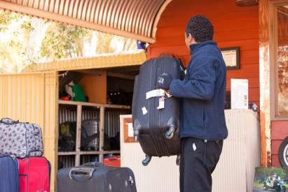

If the luggage room is full, there are other ways to store luggage safely. You could put the luggage:

* into a vacant room
* in a corner of the lobby and secure it with rope through the handles or a luggage net over the top.

|  |  |
| --- | --- |
| C:\Users\Alan\Desktop\IMG_1087.jpg | Activity 11  Storing luggage |

What is the system for labelling and storing guest luggage at your workplace?

|  |
| --- |
|  |
|  |

Lost luggage

Your workplace will have a procedure for dealing with lost luggage.

Security

As a porter you must be very careful with the security of guest luggage. Always check luggage tags when returning stored luggage. Never take a guest’s word for which bags are theirs, as often luggage looks alike.

If luggage is lost

If a guest reports that their luggage is missing, you should ask for a description of the missing item. Then check these areas:

* the room the guest has just vacated – look in wardrobes, the bathroom and under the bed
* other rooms it could have been delivered to by mistake e.g. the room number was 116 but it was delivered to 611 or 616 or 161 or 119.
* the public areas - perhaps the guest put it down somewhere and forgot it
* the luggage room - perhaps it has been stored under the wrong name or pickup date
* the luggage storage compartment of a tour bus waiting to depart
* the dining room where the guest had breakfast.

If you don’t find the item, follow the procedures of your workplace.



*At The Gums Resort, report missing luggage to your supervisor. They’ll take the guest’s contact details and explain how the missing bag will be returned if it’s found.*

|  |  |
| --- | --- |
| C:\Users\Alan\Desktop\IMG_1079.jpg | Activity 12  Deciding what to do |

Here are some situations you might come across as a porter. What would you do?

Talk together and make some notes in the right hand column.

| **Situation** | **What would you do?** |
| --- | --- |
| 1. A guest arrives with luggage that looks very heavy. You need to take it to the room. |  |
| 1. A guest is collecting luggage from the storage room and says she has lost her luggage tag receipt.   She says: *That’s my bag over there, the blue one with the red strap around it.* |  |
| 1. You see a man wandering around the entrance to the resort. You don’t think he is a guest, but you are not sure. |  |
| 1. A guest has to leave immediately to catch a plane, but can’t find his bag. He said he brought it down to breakfast before checking out. |  |
| 1. There is a suitcase in the middle of the reception area. You didn’t put it there and you don’t know who it belongs to. |  |
| 1. A guest has just left the hotel and is on the way to the airport. He rings to say he left his laptop computer somewhere, but is not sure where it is. |  |
| 1. Mr and Mrs Jones ring to say they checked into Room 919 two hours ago and their bags have not been delivered to their room yet.   You check the arrivals list and it shows their bags have been delivered. |  |

Section summary

Now you have completed this section you should have developed the following skills and knowledge.

Tick each box if you are satisfied that you have those skills and knowledge.

|  |  |
| --- | --- |
|  | Label and store luggage safely. |
|  | Deal with lost luggage. |

Notes

|  |
| --- |
|  |
|  |
|  |
|  |
|  |

6 Communicate with colleagues and guests

Porters communicate with guests for many different reasons, such as:

* greeting and farewelling guests
* giving directions
* passing on messages
* giving instructions
* answering enquiries.

Some guests may come from different cultures. Cultural differences can affect verbal and *non-verbal communication* (communicating without using words e.g. with eye contact, body language).

Other guests may have a disability so they need particular help from you.

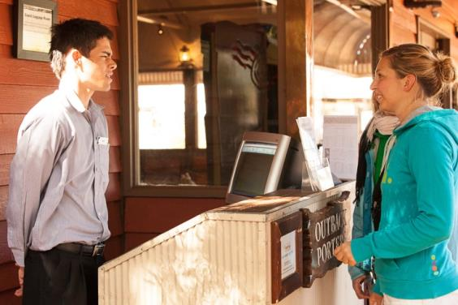

You also need to communicate well with people you work with, such as:

* other porters, if you work in a team
* people from other departments, to help you meet the needs of the guests.



*The staff at The Gums Resort also comes from many different countries.*

Communicate with guests from other cultures

Visitors to Australia come from many countries.   
Some of these countries have cultures similar to Australia’s culture. However, many are very different.

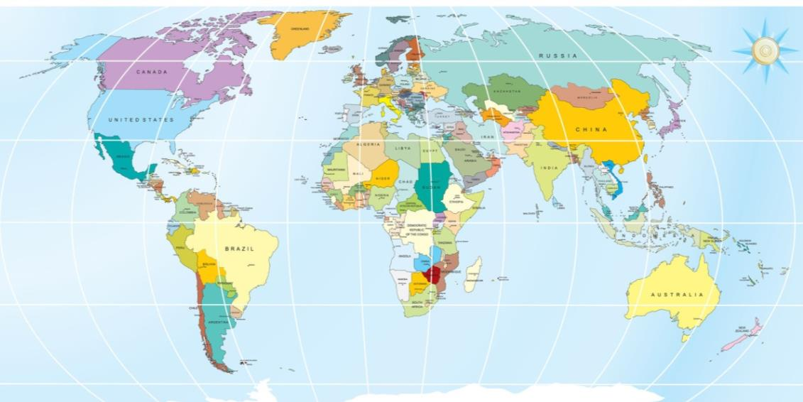

Many visitors come from these 11 countries:

* China
* Germany
* Hong Kong
* India
* Japan
* Malaysia
* New Zealand
* Singapore
* South Korea
* United Kingdom
* United States.

Can you find them on the map?

|  |  |
| --- | --- |
| C:\Users\Alan\Desktop\IMG_1094.jpg | Activity 13  Your guests |

Discuss the questions with the other people in your group.

1 What are the main countries that your guests come from?

|  |
| --- |
|  |

2 What do you know about people from these cultures? In particular think about:

* how people from this culture greet others
* differences to Australians in non-verbal communication
* *taboos* – things you should not do
* level of *formality* (how serious or relaxed) when dealing with strangers.

|  |
| --- |
|  |
|  |
|  |
|  |
|  |
|  |

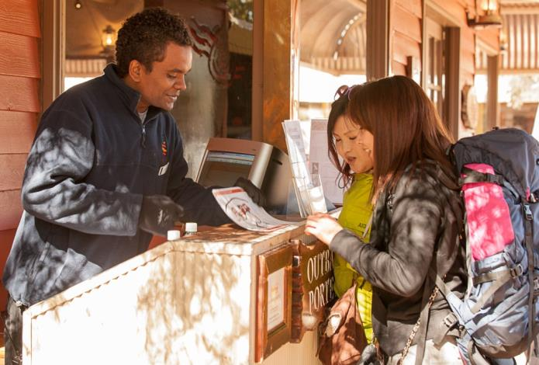

Communicating with people from other cultures

Here are some guidelines for communicating with people from other cultures.

**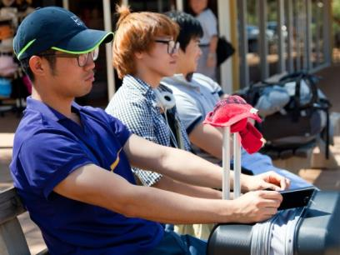1 Don’t stereotype**

Don’t assume all people from a particular culture behave in the same way. Treat people as individuals first.

**2 Speak clearly and concisely** (not too many words)

Speak at close to normal speed but sound words out properly.

Use simple words and short sentences.

Don’t use slang (such as togs, mozzie or barbie).

**3** **Use visual communication**

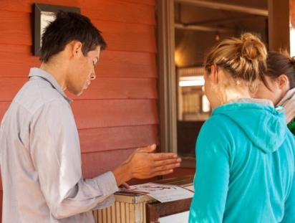For example, use maps, photos, drawings and diagrams.

**4** **Your non-verbal communication is important too**

Use gestures or sign language to communicate.

Be careful. Eye contact, facial expressions, *gestures* (how you move your hands) and *posture* (how you stand) can mean things   
to the guests that you don’t expect.

**5 Check for understanding**

If you are having difficulty understanding a question, ask the person to repeat or *clarify* (explain) it.

**6 Be friendly but not over-familiar**

Don’t stand too close to people or touch them.

Don’t make jokes. There are cultural differences about what is funny.

Don’t discuss religion or politics.

Check for understanding

Watch for signs that the listener doesn’t really understand what you have said. Check that you have understood the other person, and that they understand you.

* Ask them politely to repeat what they said
* Repeat back to them what you believe they said, so they can *confirm* (say yes or no)
* Ask if they would like you to repeat something
* Repeat yourself slowly and clearly. Restate what you have said in different words.

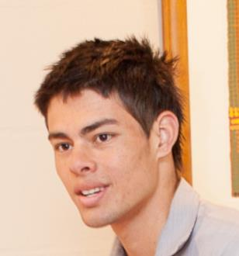

*I’m sorry, I didn’t understand.*

*Could you say that again please, ma’am?*

*So you want a taxi at 7 am tomorrow to go to the airport, sir?*

*Would you like me to say that again, sir?*

|  |  |
| --- | --- |
| C:\Users\Alan\Desktop\IMG_1081.jpg | Activity 14  Practise commuicating |

Your trainer will organise this activity, so you can practise communicating with people from different cultures.

People with disabilities can face barriers when accessing facilities or services.

Some disabilities that people may have are:

* 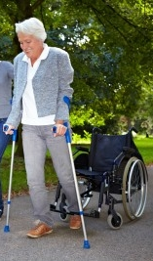loss of sight
* loss of hearing
* mobility disability
* speech disability
* intellectual disability
* mental health problems.

Some people may have more than one disability.

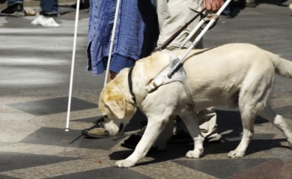

Use positive language

Use language that puts the person first and the disability second.

|  |  |
| --- | --- |
| **✓ Positive language** | **X Negative language** |
| He has a disability | He’s disabled |
| A person with a disability | A handicapped person |
| A person with a hearing disability | Deaf |
| A person with a vision disability | Blind |
| A person with a physical disability | Handicapped, a spastic, a cripple |
| Uses a wheelchair, a wheelchair user | Wheelchair-bound, confined to a wheelchair |
| A person with an intellectual disability | Mentally retarded |

Offer assistance

Many people with disabilities don’t need any *assistance* (help). However, always ask if they need assistance and how you can assist.

Be patient. People with some kinds of disability may take a little longer to understand and respond.

|  |  |
| --- | --- |
| C:\Users\Alan\Desktop\IMG_1094.jpg | Activity 15  Assisting people with a disability |

Think about the problems guests with different types of disability might have.

Discuss together and put some ideas into the table below.

|  |  |
| --- | --- |
| **What problems might a person with a disability face in a hotel environment?** | **As a porter, how could you assist that person?** |
| Communicating needs |  |
| Climbing stairs |
| Getting in and out of cars and buses |
| Hearing answers to questions |
| Finding where the lifts are |
|  |

Workplace facilities

As a porter, it is important to know what facilities your workplace has to assist people with disabilities. There may be signs around your workplace that give assistance to people with disabilities. Here are some examples.

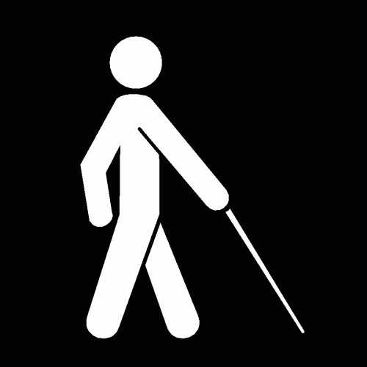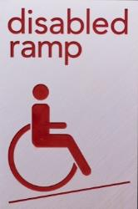

Communicate with other staff

As a porter, you don’t work alone. Here are some reasons you may have to communicate with staff from other departments.

|  |  |
| --- | --- |
| **Department** | **Reason** |
| **Reception** | Share information about changes to arrivals and departures |
| **Maintenance** | Report anything you or the guests see that needs fixing |
| **Housekeeping** | Report any problems guests have reported with the rooms |
| **Security** | Report any suspicious items or activity |
| **Food and beverage** | If a guest asks you to arrange food or drink for them |

* Make sure your messages are clear.
* Check that people have understood your messages.
* Check that you understand instructions or messages you receive. Ask questions if you don’t understand the message or instruction.

Sometimes people are very busy and forget to tell you all the information you need, or *assume* (take it for granted) you know what they are talking about.

Here are some ways to check a message or instructions.

*Can I check, Jay, do you mean …?*

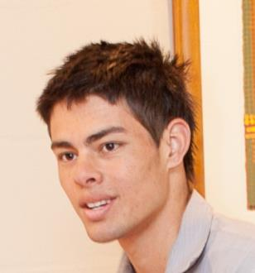

*Sorry, can you repeat that please Brenda?*

*Is that what you mean, Mr Jackson?*

*So you want me to …*

|  |  |
| --- | --- |
| C:\Users\Alan\Desktop\IMG_1081.jpg | Activity 16  Check that you understand |

In this activity you will practise checking you understand what someone has said to you.

Your trainer will organise this activity for you.

Log book

Porters often have a log book, on the computer or on paper, where they note down things that have happened during the shift. You must keep it up to date.

This is a security and safety measure, in case there are any problems in the future.

In the log book you might note down:

* messages, parcels, mail or faxes that arrive
* any unusual events
* any messages that have to be passed on to guests or other departments.

This information is important for the porters on the next shift, so they know what has been happening and what to expect.

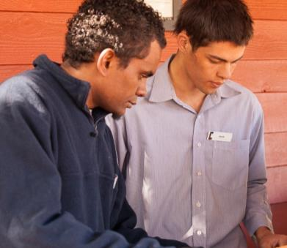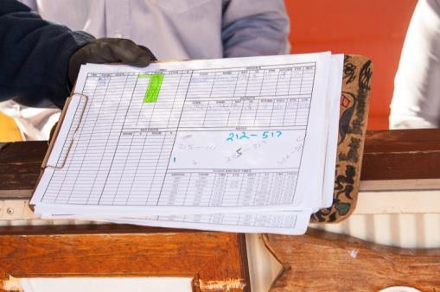

|  |  |
| --- | --- |
| C:\Users\Alan\Desktop\IMG_1080.jpg | Activity 17  Complete a log book |

Enter these messages and events into the following log book. Use today’s date. Make the entries in point form. The first one has been done for you.

|  |  |
| --- | --- |
| 09:00 | A parcel arrived for Mr Jones in Room 302. Another porter, Don Simmonds, delivered it. |
| 09:15 | There is a telephone call for Ms Janson from her mother, asking her to ring as soon as she arrives. |
| 09:20 | Mr Lin called to ask for an extra bed in his room as his young son decided to come with him. |
| 11.00 | A pane of glass in a side window was broken when a small boy threw a ball at it. Maintenance has covered it temporarily, but someone will come to replace the window in the afternoon at about 3 pm. |
| 11:30 | Mrs Goodall left in a hurry to catch her plane and left some documents in the safe deposit box. She called to ask for it to be sent to her home using Registered Mail. |

|  |  |  |  |  |
| --- | --- | --- | --- | --- |
| **Porters’ Log Book** | | **Date: 26/06/13** | | |
| **Time** | **Message** | **Action needed** | **Action taken** | **Who** |
| *09:00* | *Parcel arrived for Mr Jones* | *Send to Room 302* | *Done* | *DS* |
|  |  |  |  |  |
|  |  |  |  |  |
|  |  |  |  |  |
|  |  |  |  |  |

Section summary

Now you have completed this section you should have developed the following skills and knowledge.

Tick each box if you are satisfied that you have those skills and knowledge.

|  |  |
| --- | --- |
|  | Communicate effectively with guests and colleagues. |

Notes

|  |
| --- |
|  |
|  |
|  |
|  |
|  |

7 Provide other services

A porter may also be asked to provide other services. These are called *ancillary* (additional) services.

This is part of being a good team member and a professional who puts service to guests first. However, if you don’t know how to do a task or you are not sure about whether you should be doing it, check with your supervisor.

You are expected to help other porters without being asked if you see that they are very busy. Always be willing to lend a hand.

Provide information to guests

Guests often ask questions about the area.

This may ask for information about:

* major tourist attractions, how to get there and opening hours
* public transport
* major festivals, sporting events, theatre productions or concerts
* the weather.

Often there will be maps and tourist information at your desk and beside the reception area to give to guests.

Keep this area tidy as guests can see it.

Get more brochures and maps when stocks start to run low.

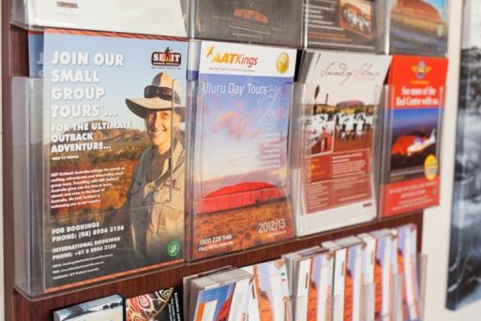

If you don’t know something, you may need to check brochures, look things up on the internet or make phone calls to find out.

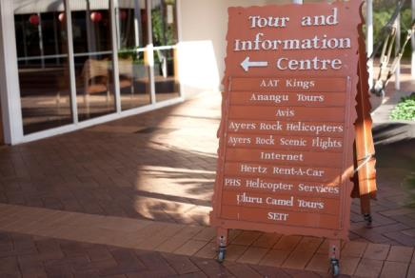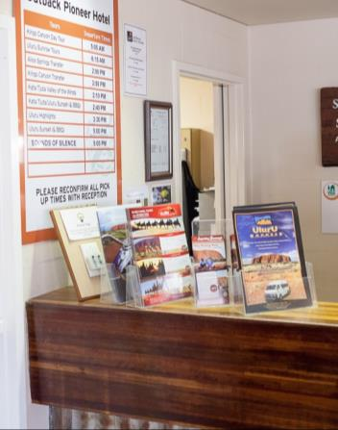

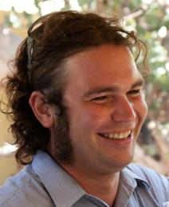

*At The Gums Resort, there’s a tour desk where guests can book tours, transport or even accommodation in other cities.*

Porters’ information

Porters often have a reference file of information that guests frequently ask for. It may contain:

* frequently called phone numbers such as airlines, taxis and local restaurants
* emergency numbers
* information about local restaurants, tourist attractions and transport.

Information must be kept up to date as it can change.

If there is something that you think should be added to this list, talk to your supervisor.

|  |  |
| --- | --- |
| C:\Users\Alan\Desktop\IMG_1079.jpg | Activity 18  Find out about your local tourist attractions |

Find out some information about one tourist attraction or facility in your local area so you can inform guests accurately. Write the key points you think should go into the porters’ information file.

Your trainer will organise this activity.

Arrange transport

Often a porter is the person who organises taxis or other transport for guests. At some workplaces, the porter may go outside to hail a taxi from the street or a taxi rank.

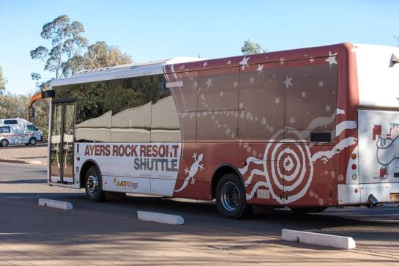

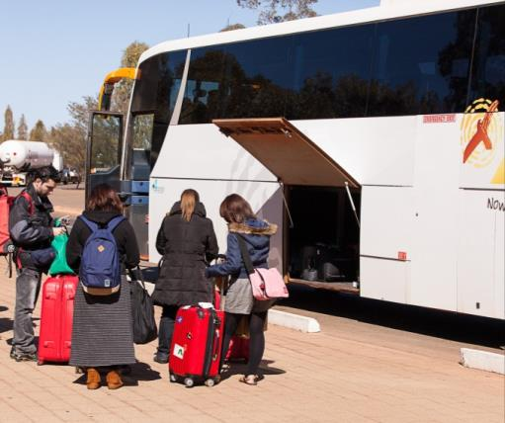Guests may also ask you about local public transport such as buses and trains. You may need to give them information about how to get to a destination:

* where to catch the transport
* how often it goes
* where it goes to
* how much it costs
* how to get tickets.

|  |  |
| --- | --- |
| C:\Users\Alan\Desktop\IMG_1079.jpg | Activity 19  Find out about your local transport |

Find out some information about the transport in your area, so you can inform guests accurately.

Your trainer will organise this activity.

Provide security

Because you are based near the front door, you play a role in the security of the venue. If you see anything suspicious, you should let your supervisor or Security know immediately.

Some suspicious things you might see are:

* luggage left unattended
* people loitering (wandering about without any real purpose) who don’t appear to be guests
* people who are drunk or acting strangely.

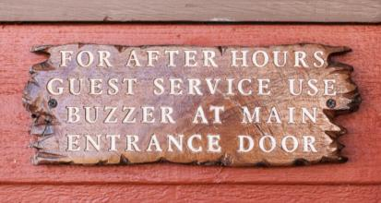

Assist in emergencies

You may need to assist in emergencies e.g. if there is a need to evacuate the venue in case of a fire. You will be shown the emergency evacuation procedures.

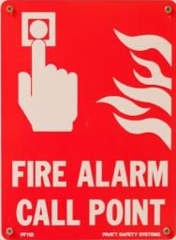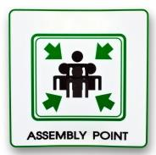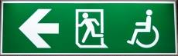

Special requests

Sometimes guests have special requests that you may have to organise, particularly if the request comes after hours, such as:

* different furniture in rooms e.g. a cot for a baby or a rollaway bed – this would be organised by Housekeeping; but you may have to help with the move or organise it if the request is after hours
* special food or drink e.g. fruit, chocolates or champagne – this would be organised by Food and Beverage unless the request was after hours
* wake up calls – this would be organised by Reception unless they are very busy.

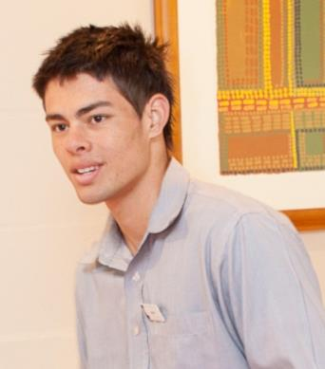

*Last month we had a pop star staying here. At midnight he asked for a bottle of French champagne in his room!*

*Sometimes I help Housekeeping move a cot into a room. We keep them in the storeroom for families with babies.*

Deliver mail and messages

You may be asked to deliver mail and messages to guests’ rooms.

Page guests

You may be asked to *page* guests, or call their name to find them. You could make an announcement in the dining room or other public areas, or you could call their mobile phone if you have the number.

Pick up goods

You may need to collect luggage from the airport for a guest. You should deliver it to the guest immediately and ask the guest to check that everything is correct.

Valet parking

In some venues, guests leave their cars at the front and the porter parks the car in the car park. This is called *valet parking*. Of course you must have a driver’s licence to drive guest cars. Be very careful when driving guests’ cars!

Emergency cleaning

You may have to do some emergency cleaning if something happens to make the reception area and foyer unpleasant for guests. You can clean up quickly before someone from Housekeeping comes to do a more thorough clean.

You will be shown where the cleaning materials and equipment are, and how to use them.

|  |  |
| --- | --- |
| C:\Users\Alan\Desktop\IMG_1087.jpg | Activity 20  Ancillary services at your workplace |

What ancillary services are provided by porters at your workplace?

|  |
| --- |
|  |
|  |

Section summary

Now you have completed this section you should have developed the following skills and knowledge.

Tick each box if you are satisfied that you have those skills and knowledge.

|  |  |
| --- | --- |
|  | Know the range of ancillary services a porter may have to provide. |

Notes

|  |
| --- |
|  |
|  |
|  |
|  |
|  |

Appendix 1 The 24 hour clock

|  |  |  |
| --- | --- | --- |
| 12 hour clock | How long after midnight? | 24 hour clock |
| 12.00 am (midnight) | 0 hours | 00:00 hours |
| 12.30 am | 30 minutes | 00:30 hours |
| 1 am | 1 hour | 01:00 hours |
| 2 am | 2 hours | 02:00 hours |
| 3 am | 3 hours | 03:00 hours |
| 4 am | 4 hours | 04:00 hours |
| 5 am | 5 hours | 05:00 hours |
| 6 am | 6 hours | 06:00 hours |
| 7 am | 7 hours | 07:00 hours |
| 8 am | 8 hours | 08:00 hours |
| 9 am | 9 hours | 09:00 hours |
| 10 am | 10 hours | 10:00 hours |
| 11 am | 11 hours | 11:00 hours |
| 12 pm (midday) | 12 hours | 12:00 hours |
| **TIP: After midday, add 12 to the clock time.** | | |
| 1 pm | 13 hours | 13:00 hours |
| 2 pm | 14 hours | 14:00 hours |
| 3 pm | 15 hours | 15:00 hours |
| 4 pm | 16 hours | 16:00 hours |
| 5 pm | 17 hours | 17:00 hours |
| 6 pm | 18 hours | 18:00 hours |
| 7 pm | 19 hours | 19:00 hours |
| 8 pm | 20 hours | 20:00 hours |
| 9 pm | 21 hours | 21:00 hours |
| 10 pm | 22 hours | 22:00 hours |
| 11 pm | 23 hours | 23:00 hours |
| 12 am | 0 hours | 00:00 hours |

Key words

| Word | Meaning |
| --- | --- |
| *allocation* | Which room they have been given or allocated |
| *ancillary* | Additional |
| *assemble* | Gather |
| *assistance* | Help |
| *assume* | Take it for granted |
| *compendium* | Collection of information that a guest may need |
| *confirm* | Say yes or no |
| *concise, concisely* | Not too many words |
| *destination* | Place someone is going to |
| *escort* | Take guests to their room, walk with them |
| *estimated* | Not exactly |
| *formality* | How serious or relaxed |
| *front of house* | Area of an accommodation establishment where employees have extensive contact with guests |
| *gestures* | How you move your hands |
| *gratuity* | Tip – extra money given for service |
| *limo* | Limousine – a large, luxurious car, often driven by a chauffeur |
| *lobby* | The entrance to a hotel, where the reception desk and porters are usually situated |
| *loitering* | Wandering around with no obvious purpose |
| *non-verbal communication* | Communicating without using words e.g. with eye contact, body language |
| *page* | Find guests by calling their name in public places |
| *posture* | How you stand |
| *stereotype* | Assume all people from a particular culture behave in the same way |
| *taboo* | Thing you should not do |
| *valet parking* | A car parking service offered by a hotel, where the porter parks the guests’ cars for them |
|  |  |
|  |  |
|  |  |
|  |  |
|  |  |
|  |  |