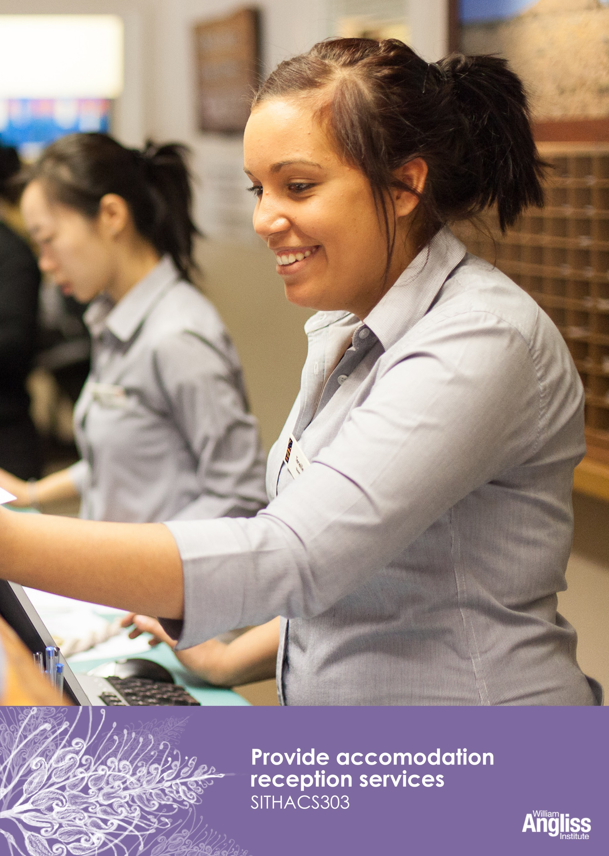

© Commonwealth of Australia 2013



**CC BY-NC-SA**

This work is copyright. Except where otherwise indicated, and save for the Commonwealth Coat of Arms, the Department has applied the [Creative Commons Attribution-Noncommercial-Share Alike 3.0 Australia Licence](http://creativecommons.org/licenses/by-nc/3.0/au) to this work.

The Department of Industry, Innovation, Climate Change, Science, Research and Tertiary Education must be attributed as the author of the Department’s copyright material.

As far as practicable, material for which the copyright is owned by a third party has been clearly labelled. The Department has made all reasonable efforts to ensure that this material has been reproduced on this website with the full consent of the copyright owners.

Requests and enquiries concerning the Department’s copyright material should be addressed to:

The Legal Branch

Department of Industry, Innovation, Climate Change, Science, Research and Tertiary Education

GPO Box 9839 Canberra ACT 2601

Or emaile[d to legalservices@innovation.gov.au](mailto:legalservices@innovation.gov.au)

Funded under the Workplace English Language and Literacy (WELL) Program by the Australian Government Department of Industry, Innovation, Climate Change, Science, Research and Tertiary Education

The views expressed in this publication do not necessarily represent the view of the

Minister for Tertiary Education, Skills, Science and Research or the Australian

Government. The Australian Government does not give any warranty nor accept any liability in relation to the contents of this work

ISBN 978-1-922108-10-4

|  |  |
| --- | --- |
| **Development Team** | |
| Content | William Angliss Institute  Macsmith and Associates |
| Photography & graphics | Benjamin B Photographer |
|  |  |
| **Acknowledgments** | |
| We would like to acknowledge the generous support of the following organisations and the learners and employees in those venues, both Indigenous and non-Indigenous, for giving their permission for photography: | |
| Voyages Ayers Rock Resort, Yulara, NT | |
|  | |
| **Permissions** | |
| We would like to acknowledge the following organisations who have granted permission for their copyright materials to be incorporated in this resource: | |
| Sustainability Victoria | |
|  | |
| **Cultural Warning** | |
| People of Aboriginal or Torres Strait Islander descent should be aware that this publication contains images of people who may be deceased | |
|  | |
| **Disclaimer** | |
| Every effort has been made to ensure that this booklet is free from error or omissions. However, you should conduct your own enquiries and seek professional advice before relying on any fact, statement or matter contained in this book. William Angliss Institute of TAFE and Macsmith and Associates are not responsible for any injury, loss or damage as a result of material included or omitted from this course. | |
|  | |

**Contents**

[Welcome vii](#_Toc361760497)

[Icons vii](#_Toc361760498)

[What you will learn viii](#_Toc361760499)

[1 New on the job 9](#_Toc361760500)

[The Front Office Department 9](#_Toc361760501)

[The tasks 10](#_Toc361760502)

[The personal qualities 11](#_Toc361760503)

[The guests 12](#_Toc361760504)

[Learn the language 12](#_Toc361760505)

[The 24 hour clock 15](#_Toc361760506)

[Section summary 19](#_Toc361760507)

[2 Prepare the reception area 20](#_Toc361760508)

[Handover and reception diary 21](#_Toc361760509)

[Check equipment 23](#_Toc361760510)

[Check stationery supplies 24](#_Toc361760511)

[Keep the reception area attractive 25](#_Toc361760512)

[Prepare guest paperwork 27](#_Toc361760513)

[Reduce waste at work 28](#_Toc361760514)

[Section summary 31](#_Toc361760515)

[3 Prepare guest paperwork 32](#_Toc361760516)

[Check the Arrivals List 32](#_Toc361760517)

[Send the list to other departments 34](#_Toc361760518)

[Special requests 36](#_Toc361760519)

[Allocate rooms 37](#_Toc361760520)

[Room rates 40](#_Toc361760521)

[Section summary 42](#_Toc361760522)

[4 Welcome and register guests 43](#_Toc361760523)

[Show a welcoming manner 44](#_Toc361760524)

[Complete registration 45](#_Toc361760525)

[Monitor arrivals 53](#_Toc361760526)

[Section summary 54](#_Toc361760527)

[5 Different check-in situations 55](#_Toc361760528)

[Group check-in 55](#_Toc361760529)

[Room not immediately available 56](#_Toc361760530)

[Overbooking 57](#_Toc361760531)

[Room change requested 58](#_Toc361760532)

[Guest without a reservation 58](#_Toc361760533)

[Guest wants to stay longer 59](#_Toc361760534)

[Guest does not have the correct documentation 59](#_Toc361760535)

[Guest has insufficient funds 59](#_Toc361760536)

[Late or uncertain arrivals 59](#_Toc361760537)

[No shows 60](#_Toc361760538)

[Cancellations 60](#_Toc361760539)

[The Black List 61](#_Toc361760540)

[Section summary 62](#_Toc361760541)

[6 Organise guest departures 63](#_Toc361760542)

[Check the Departures List 63](#_Toc361760543)

[The check-out procedure 66](#_Toc361760544)

[Process an account 67](#_Toc361760545)

[Receive the payment 71](#_Toc361760546)

[Provide assistance with departure 73](#_Toc361760547)

[Section summary 74](#_Toc361760548)

[7 Different departure situations 75](#_Toc361760549)

[Express check-out 75](#_Toc361760550)

[Group check-out 75](#_Toc361760551)

[Deposits and pre-payments 76](#_Toc361760552)

[Guest checks out late 76](#_Toc361760553)

[Early departures 76](#_Toc361760554)

[Complaints 78](#_Toc361760555)

[Section summary 80](#_Toc361760556)

[8 Prepare reports 81](#_Toc361760557)

[Types of reports 82](#_Toc361760558)

[Distribute reports 84](#_Toc361760559)

[Section summary 85](#_Toc361760560)

[Appendix 1 The 24 hour clock 86](#_Toc361760561)

[Key words 88](#_Toc361760562)

Welcome

Icons

These signs tell you what type an activity is:

|  |  |
| --- | --- |
| C:\Users\Alan\Desktop\IMG_1094.jpg | Do this activity in a big group. |
| C:\Users\Alan\Desktop\IMG_1079.jpg | Do this activity in a small group. |
| C:\Users\Alan\Desktop\IMG_1081.jpg | Do this activity in pairs. |
| C:\Users\Alan\Desktop\IMG_1080.jpg | Do this activity by yourself. |
| C:\Users\Alan\Desktop\IMG_1086.jpg | Do this activity using the internet. If you are not connected to the internet, your trainer will provide you with another activity. |
| C:\Users\Alan\Desktop\IMG_1087.jpg | Do this activity in your workplace. If you are not in a workplace, your trainer will provide you with another activity. |

What you will learn

Providing a reception service in a hotel, resort or other accommodation business is a very important role. You are in constant contact with guests, so guests notice your manner and service. If you are efficient and welcoming, it gives guests a good impression of the business. It encourages them to want to visit again or recommend it to other people.

In this workbook you will learn how to:

* prepare and maintain the reception area
* welcome and register guests
* organise guest departures
* deal with unusual or difficult situations
* prepare reports.

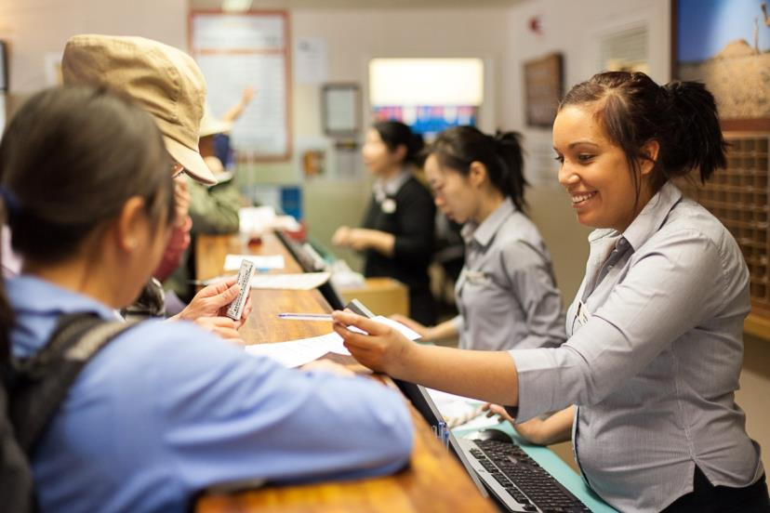

1 New on the job

The Front Office Department

The front office of a hotel is where guests first use the services of the venue. The Front Office Department is usually made up of several different areas.

* Reception or Front Desk – where the guest registers, keys are issued and information is provided.
* Reservations – where guests make future bookings or changes to current ones.
* Communications – where all phone calls come in. Calls are then transferred to guests or other departments.
* Concierge – where guests can go if they have questions or want to make bookings for tours. Porters belong to this area and handle guest luggage, mail and messages, and car parking (valet parking). In large 5-star hotels there may also be doormen, bellboys and a chief concierge.

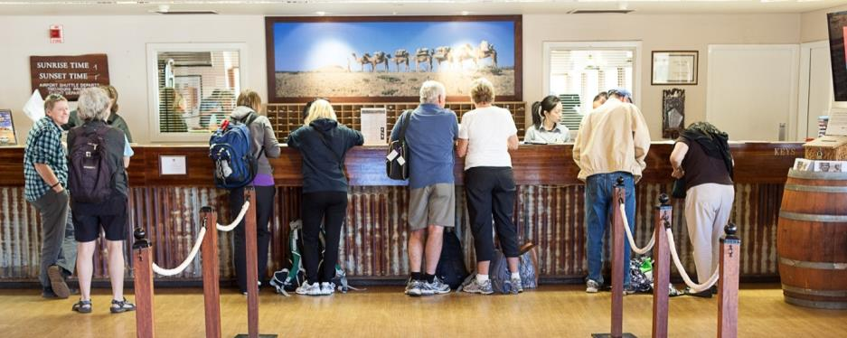

The reception desk

You have just started work as a receptionist (sometimes called a guest service agent) for The Gums Eco Resort, working on the reception desk.

This resort provides three different levels of accommodation. It has luxury rooms, standard rooms and self-contained budget units where people can cook their own food.

This is a very important job. You are usually the first person and the last person the guests talk to so you must make them feel welcome and give them efficient service.

The tasks

Your main tasks are:

* check guests in and out
* 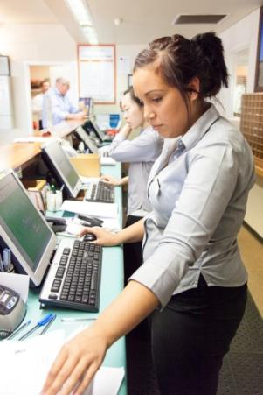make guest reservations
* answer questions about the hotel and local tourist activities
* use the computer systems
* solve problems that arise
* receive and process payments
* prepare reports.

Angela is your supervisor – she is an experienced receptionist.



*I love my job. I meet lots of interesting people from all over the world and there is something new every day.*

The personal qualities

|  |  |
| --- | --- |
| C:\Users\Alan\Desktop\IMG_1094.jpg | Activity 1  What kind of person makes a good receptionist? |

Circle the words that describe a person who would be a good receptionist.

One has been done for you.

|  |  |  |
| --- | --- | --- |
| organised | irritable | good computer skills |
| patient | bored | friendly |
| shy | efficient | informative |
| nervous | slow | calm |
| unhelpful | bad computer skills | unfriendly |
| helpful | rude | polite |

The guests

As a receptionist, you will meet a wide range of people. Guests may be:

|  |  |
| --- | --- |
| * from overseas | * families |
| * from Australia | * people on holidays |
| * individuals | * people on business |
| * couples * groups | * people attending a conference, meeting or function. |

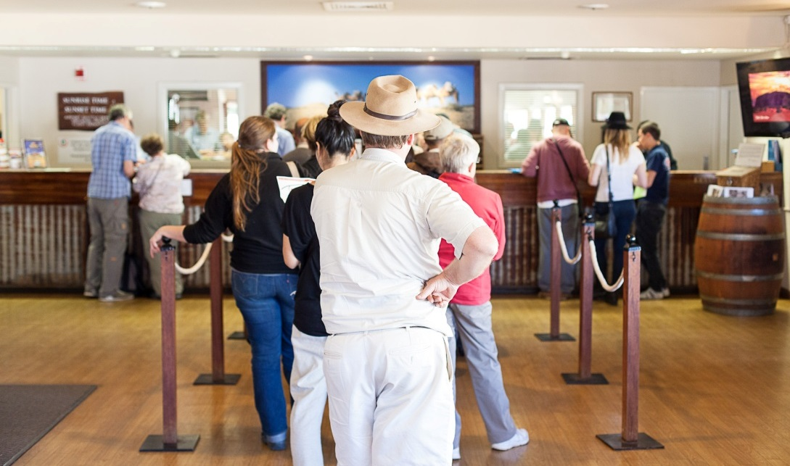

They may speak different languages, behave differently and have different needs. But you must treat all guests with the same welcome and respect.

Learn the language

The hospitality industry has lots of special words only used in the business. This is called *jargon*. When you first start work, you might not understand some of the things people say.

Here is some jargon receptionists need to know. The words may be a bit different in different workplaces.

|  |  |  |
| --- | --- | --- |
| Jargon | Meaning | 🗸 |
| *Adjoining rooms* | Rooms side by side but without a connecting door between them |  |
| *BAR* | Best Available Rate – the cheapest room rate available for that night |  |
| *Bump* | Move a guest to other accommodation due to overbooking. Sometimes called a ‘walk’ |  |
| *Cancellation* | A guest with a booking cancels the room in time for the room to be resold |  |
| *Check-in* | Registering the guest by checking and collecting guest information, method of payment and issuing them a room key |  |
| *Check-out* | Finalising the guest’s account, accepting payment and collecting their room key before the guest leaves the hotel |  |
| *Closed dates* | Particular dates when the hotel is fully booked |  |
| *Deposit* | Payment received in advance to guarantee a booking |  |
| *Early departure* | The guest leaves before their booked departure date |  |
| *ETA* | Estimated Time of Arrival |  |
| *Extension* | Guest stays in the room longer than the time booked |  |
| *ETD* | Estimated Time of Departure |  |
| *Extras* | Extra items that the guest may have to pay for, such as mini bar items |  |
| *FOC* | Free of charge |  |
| *FIT* | Free Independent Traveller – someone not booked through an agent or with a group, charged at full rack rate |  |
| *Folio* | A guest account or bill |  |
| *Guaranteed booking* | Full payment has been made so even if the guest does not arrive, the room is held overnight |  |
| *Handover* | Staff from the shift just ending pass on any important information to the staff on the next shift |  |
| *Inclusions* | Things that are included in the bill, such as room and breakfast or use of gym |  |
| *Interconnecting rooms* | Rooms side by side with a connecting door between them |  |
| *No show* | A person who has made a booking but does not arrive and does not contact the hotel to let them know |  |
| *Occupancy* | How full the hotel is – this is usually given as a percentage (%) |  |
| *OOO* | Out of order – something does not work |  |
| *Overbooked* | The hotel has accepted more bookings than rooms available |  |
| *Posting* | Entering charges onto a guest’s account |  |
| *Rack rate* | Highest advertised rate, without any discounts |  |
| *Reservation* | Booking for a room |  |
| *Skip* | Someone who leaves the hotel without paying their bill. This can also be known as a ‘walk-out’ |  |
| *Stay over* | The guest is not expected to check out today and will stay in the hotel tonight |  |
| *Trace* | Special guest requests or comments that the hotel needs to act on |  |
| *VIP* | Very important person |  |
| *Walk-in* | People who don’t have a reservation, but arrive at the hotel wanting a room for that night |  |
|  |  |  |

|  |
| --- |
| **NOTE**  Always ask someone to explain if you don’t know a term they have used. |

|  |  |
| --- | --- |
| C:\Users\Alan\Desktop\IMG_1087.jpg | Activity 2  Learn the langugage |

What different words have you heard used at work?

1 Tick (🗸) a word in the previous list if you have heard or seen it in your workplace.

2 Does your workplace use any other jargon? If so, add it to the previous list.

The 24 hour clock

Each day has 24 hours. We can count the time in two different ways – the 12 hour clock and the 24 hour clock.

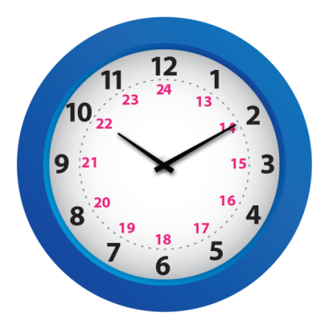The hospitality and travel industries use the 24 hour clock for many different purposes, such as:

* hotel check-in and check-out times
* arrival and departure times
* flight times
* staff rosters
* hire car bookings
* delivery times.

The 24 hour clock starts counting from midnight. It means you don’t get confused about *am* (morning) and *pm* (afternoon and evening).

* Midnight is 00:00 hours.
* One minute after midnight is 00:01 hours.
* 7.30 am (7 ½ hours after midnight) is 07:30 hours.
* 12 noon (midday, or 12 hours after midnight) is 12:00 hours.
* 1.00 pm (13 hours after midnight) is 13:00 hours.

*Example:*

|  |  |  |
| --- | --- | --- |
| 12 hour time | + 12 = | 24 hour time |
| 1.00 pm | 1 + 12 = 13 | 13:00 hours. |
| 4.00 pm | 4 + 12 = 16 | 16:00 hours. |
| 7.00 pm | 7 + 12 = 19 | 19:00 hours. |
| 8.00 pm |  |  |
| 10.00 pm |  |  |

There are 60 minutes in every hour.

So if this clock time was the morning, we would say:

*Oh six hundred and ten hours (06:10 hours)*



If this clock time was the afternoon, we would say:

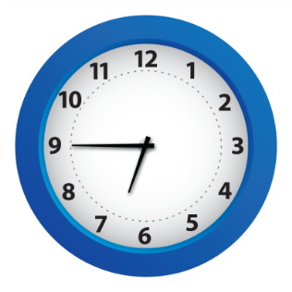*Eighteen forty-five hours (18:45 hours)*

See *Appendix 1 The 24 hour clock* for a table of matching 12 hour and 24 hour times.

|  |  |
| --- | --- |
| C:\Users\Alan\Desktop\IMG_1081.jpg | Activity 3  Using the 24 hour clock |

1 Are these times morning (am) or afternoon/evening (pm)?  
Circle the correct answer. The first one has been done for you.

|  |  |  |
| --- | --- | --- |
| 07:30 | morning | afternoon/evening |
| 06:25 | morning | afternoon/evening |
| 11:20 | morning | afternoon/evening |
| 00:00 | morning | afternoon/evening |
| 00:10 | morning | afternoon/evening |
| 14:30 | morning | afternoon/evening |
| 22:15 | morning | afternoon/evening |

2 Change these times from the 12 hour clock to the 24 hour clock.

|  |  |
| --- | --- |
| 12 hour clock | 24 hour clock |
| 6.15 am | *06:15* |
| 3.05 am | *03:05* |
| 6.15 pm | *18:15* |
| 111.45 pm | *23:45* |
| 10.45 am | *10:45* |
| 11.00 am | *11.00* |
| 2.30 pm | *14:30* |
| 12.15 pm | *12:15* |
| 8.30 pm | *20.30* |

Section summary

Now you have completed this section you should have developed the following skills and knowledge.

Tick each box if you are satisfied that you have those skills and knowledge.

|  |  |
| --- | --- |
|  | Understand the role of the receptionist. |
|  | Know hospitality jargon. |
|  | Use the 24 hour clock. |

Notes

|  |
| --- |
|  |
|  |
|  |
|  |
|  |

2 Prepare the reception area

You have just begun your first shift as a receptionist at The Gums Eco Resort. There will be busy periods with guests checking in and out, so you need to be prepared.

Angela has given you a checklist to follow at the start of each shift.

|  |  |  |
| --- | --- | --- |
|  | **The Gums Eco Resort Reception**  **Start of Shift Checklist** | |
| **Task** | | **Done ✓** |
| 1. Complete handover with previous shift | |  |
| 1. Check reception diary and occupancy of the hotel | |  |
| 1. Count and record your cash float | |  |
| 1. Check office equipment is working | |  |
| 1. Check stationery supplies | |  |
| 1. Check emails and other messages | |  |
| 1. Check reception area is tidy and attractive | |  |
| 1. Prepare guest paperwork for the day’s arrivals and departures | |  |



*If you prepare thoroughly at the start of your shift, things will go more smoothly for you.*

Handover and reception diary

At The Gums Eco Resort, the night shift and the morning shift overlap between 7 am and 7.30 am for a handover. A *handover* is when staff from the finishing shift tell staff on the next shift about:

* things that have happened during the shift
* requests guests have made that need to be acted on.

Important information might also be recorded in the reception diary. This is sometimes known as the communications diary. The Gums Eco Resort has an electronic diary on the computer but at other workplaces it might be paper based.

Also check the occupancy of the hotel so you know how many rooms are empty if there are enquiries.

Here are some things you learned at handover time.

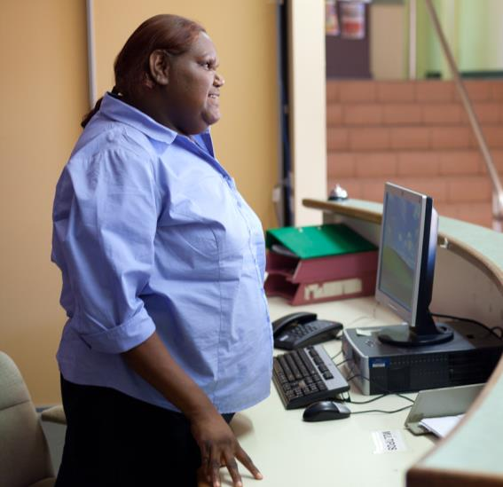

*The Simons family in Suite 132 left a day early because their child is sick. So that room is now vacant.*

*I’ve changed the Room Allocation list, but I haven’t told Housekeeping yet.*

*Mr Jones in Room 303 had to change rooms during the night as the tap was dripping. He’s now in Room 305.*

*Maintenance has been called, but you need to check with them the tap is fixed before you book anyone else into the room.*

*17:00 - TV in Room 220 broken. Called service people, can’t come till tomorrow. Please organise Maintenance to replace TV.*

|  |  |
| --- | --- |
| C:\Users\Alan\Desktop\IMG_1087.jpg | Activity 4  Handover |

1 What is the reception handover procedure at your workplace?

|  |
| --- |
|  |
|  |
|  |

2 Look at the three pieces of handover information on the previous page.   
What 3 things do you need to do to follow up from this information?

|  |
| --- |
|  |
|  |
|  |

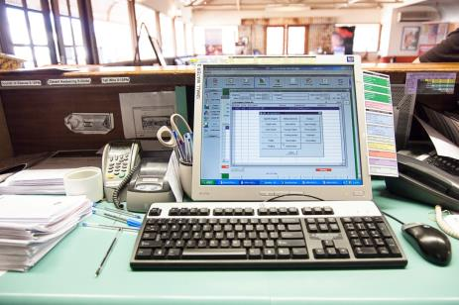Check equipment

Receptionists have to use different kinds of office equipment including:

* computer
* printer
* fax machine
* 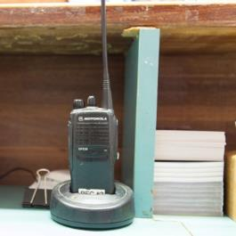photocopier
* key card programmer
* cash register
* EFTPOS machine
* telephone.

At the start of each shift, you should:

* check each piece of equipment is turned on or working
* check there is paper in the printer
* check the toner – print a short document to make sure it is clear and dark enough to be easily read
* report any flashing lights or ‘error’ messages to your supervisor.

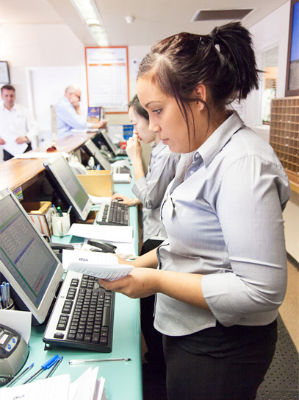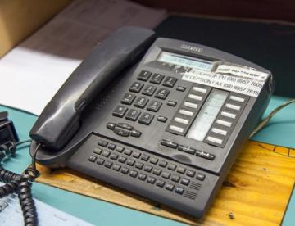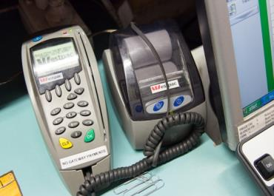

|  |  |
| --- | --- |
| C:\Users\Alan\Desktop\IMG_1087.jpg | Activity 5  Check equipment |

1 What equipment do you have at the reception area in your workplace?

|  |
| --- |
|  |
|  |

2 What checks do you have to make at the start of your shift?

|  |
| --- |
|  |
|  |

Check stationery supplies

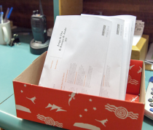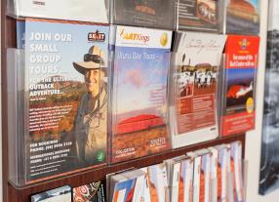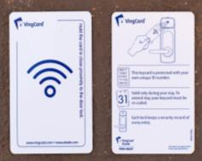

Receptionists use a lot of stationery. You should check that you have enough supplies at the desk including:

* pens, note paper and printer paper
* internal forms and cards e.g. registration cards, message forms, complaints forms and maintenance request forms
* key cards (if your business uses them)
* resort business cards
* information brochures for guests.

If the supplies are low, get them or request them from the storeroom or other departments.

Keep the reception area attractive

The reception area is cleaned daily. But the receptionist is often responsible for keeping the area clean and tidy during the day. When you start your shift, have a look around to see if there is anything you could do to make it more pleasant for guests.

**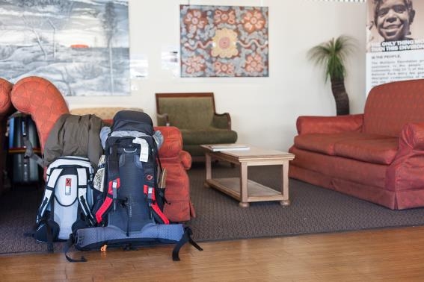**

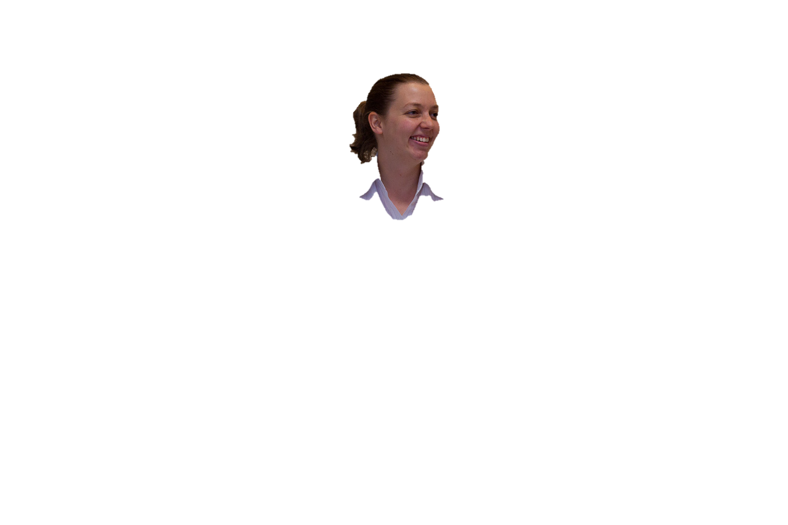

*Guests have been coming and going all day, so the reception area is starting to look a bit scruffy.*

*It’s often the first thing that our guests see so it’s important to keep it attractive and welcoming.*

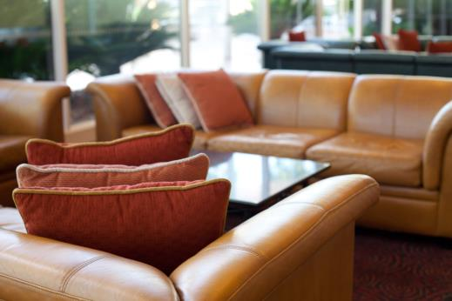

|  |  |
| --- | --- |
| C:\Users\Alan\Desktop\IMG_1094.jpg | Activity 6  Keep the reception area attractive |

You notice some things that are not right about the reception area. What will you do?

|  |  |
| --- | --- |
| You notice … | What will you do? |
| 1. The flowers on the desk are wilting. |  |
| 1. There is a lolly wrapper on the floor. |  |
| 1. A light globe has blown. |  |
| 1. There is some unattended luggage by the door. |  |
| 1. The rack of tourist brochures is untidy. |  |
| 1. There are finger marks on the glass door. |  |
| 1. Some guest newspapers and magazines are lying open on the chairs and low tables. |  |
| 1. The reception counter has marks on it and there are a couple of pens lying on it. |  |

Prepare guest paperwork

* Check the Arrivals List for the shift and make sure all the registration forms you will need have been printed out.
* Check for any special requests.
* Check emails for any guest messages and attach them to that guest’s registration form.
* Start work on room allocation (matching arriving guests with room numbers). Use the Housekeeping Report to know which rooms are available and where a special request may affect the allocation e.g. a guest with a disability or someone asking for a room with a view.

Room allocation in many hotels is done by senior staff.

|  |
| --- |
| **NOTE**  Some hotels don’t pre-allocate rooms (allocate rooms before the guest arrives) except for VIPs and special request rooms. Other guests are allocated a room by computer on check-in, so all available rooms can be considered. |



*Check all the guest paperwork is ready before people arrive. Then you’ll be able to register them quickly.*

*People are often tired and just want to go to their rooms.*

|  |  |
| --- | --- |
| C:\Users\Alan\Desktop\IMG_1087.jpg | Activity 7  Preapre guest paperwork |

What is the procedure in your workplace for preparing guest paperwork?   
Make a list of the things you need to do.

|  |
| --- |
|  |
|  |
|  |
|  |

Reduce waste at work

You can help protect the environment by using office equipment and supplies carefully to reduce waste. Here are some things you or your workplace can do to *minimise* waste (produce the smallest possible amount).

|  |  |
| --- | --- |
|  | **How you can reduce waste at Reception** |
| * Only print out what is necessary. * Print double sided when you can. * Use recycled paper. * Print internal documents using the ‘draft’ option, which uses less ink. * Put used paper into the recycling bin, including old guest newspapers and magazines. * Use email rather than paper messages where possible. | |

|  |
| --- |
| **DID YOU KNOW?**  Every Australian office worker uses about 10,000 sheets of A4 paper each year.  It takes 24 trees to create one tonne of virgin office paper, but each tonne of paper that is recycled saves 13 trees.  *Save paper © Sustainability Victoria 2012*  *Creative Commons Attribution 3.0 Australia* |

|  |  |
| --- | --- |
|  | **How your employer can reduce waste at Reception** |
| * Use *recycled* (reused) paper in printers. * Buy products with less packaging. * Provide paper recycling bins in the office. * Send toner cartridges to a recycling centre instead of throwing them away. * Have an environmental policy to minimise waste through the whole business. * Train staff in how to reduce waste. | |

|  |  |
| --- | --- |
| C:\Users\Alan\Desktop\IMG_1087.jpg | Activity 8  How do you reduce waste at work? |

Which ones are used in your workplace?

Tick the YES or NO box for each question.

|  |  |  |
| --- | --- | --- |
| At your workplace do you… | YES | NO |
| 1. Only print out what is necessary? |  |  |
| 1. Print double sided when you can? |  |  |
| 1. Print internal documents using the ‘draft’ option? |  |  |
| 1. Use email instead of memos when you can? |  |  |
| 1. Have a paper recycling bin in the office? |  |  |
| 1. Put used paper into the recycling bin? |  |  |
| 1. Buy products with less packaging? |  |  |
| 1. Use *recycled* (reused) paper in printers? |  |  |
| 1. Send toner cartridges to a recycling centre? |  |  |
| 1. Have an organisation environmental policy to minimise waste? |  |  |



Section summary

Now you have completed this section you should have developed the following skills and knowledge.

Tick the box if you are satisfied that you have those skills and knowledge.

|  |  |
| --- | --- |
|  | Know how to prepare the reception area at the start of the shift. |
|  | Know how to reduce waste in the reception area. |

Notes

|  |
| --- |
|  |
|  |
|  |
|  |
|  |

3 Prepare guest paperwork

Check the Arrivals List

The Arrivals List provides details about who is arriving. It includes these details:

* guest name
* company name, tour operator or travel agent name (if travelling for a company or part of a tour group)
* number of guests
* arrival date and departure date
* estimated time of arrival (ETA)
* room type and rate
* special requests.

It may include other information such as how the person booked the room, how they are going to pay and whether the person is a VIP.

The Arrivals List helps you to:

* plan your daily tasks, according to busy times and quiet times
* prepare for group arrivals e.g. request extra porters or luggage storage
* prepare for special requests e.g. request extra bed in the room
* prepare for VIPs e.g. request added security, special gifts or a welcome.

This list is *generated* (produced) through the Computerised Reservation System (CRS) and you can read it on the computer screen. You can also print copies for other departments, such as Housekeeping and the porters.

On the computer screen there is also a section where you can record the *status* – when a person has checked in.



*Here’s part of an Arrivals List for The Gums Eco Resort. Have a look through it.*

|  |  |  |  |  |  |  |  |  |  |  |
| --- | --- | --- | --- | --- | --- | --- | --- | --- | --- | --- |
|  | | | **The Gums Resort Arrivals List** | | | | | | **Date: 25 July 2013** | |
| **Guest name** | **No. of guests** | **Arrival date** | | **ETA** | **Dep. date** | **Room type** | **Rate code** | **Room No.** | **Special requests** | **Status** |
| Sweetman, John, Mr & Mrs | 2A 0C | 25/07/13 | | 13:30 | 26/07/13 | L - K | LB | 103 | Honeymoon. Provide flowers and champagne |  |
| Billington, Sara, Miss & Billington, Harriet, Miss | 2A 0C | 25/07/13 | | 16:00 | 28/08/13 | S - S | RO | 145 | Arrange airport pickup QF 123 at 15:20 |  |
| Jacoma, Arnold, Dr | 1A 0C | 25/07/13 | | 13:30 | 31/07/13 | L - K | LB | 304 | Room with a lake view |  |
| Liu, Bin, Mr & Peng, Bo, Ms | 2A 1C | 25/07/13 | | 11:00 | 26/07/13 | 1 BRS | RO | A12 | 1 year old child, free of charge Extra cot in room | Arrived |
| Stearman, Olga, Ms & Myer, Hetty, Ms Telstra | 2A 0C | 25/07/13 | | 22:00 | 01/08/13 | L - KS | CP | 206 | Late arrival. Don’t re-sell room Charge to company room only, pay own extras |  |
| Saleh, Yasim, Mr & family Harvey World Travel | 2A 3C | 25/07/13 | | 13:30 | 27/07/13 | 2 BRS | LW | B103 | Extra bed in 2nd bedroom Charge to agent |  |
| Bernard, Jane, Mrs & family | 2A 2C | 25/07/13 | | 14:30 | 28/07/13 | 2 BRS | LB | B105 |  |  |
| **Rate Code:**  CP Corporate contract  LB Bed and breakfast  LW Domestic wholesale  RK Rack rate  RO Room only | | | | | | **Room Type Code:**  L – Luxury room (king bed K or 2 x king single beds KS)  S – Standard room (double bed D or 2 x single beds S)  1 BRS – 1 bedroom self-contained unit  2 BRS – 2 bedroom self-contained unit | | | | |

|  |  |
| --- | --- |
| C:\Users\Alan\Desktop\IMG_1079.jpg | Activity 9  Reading the Arrivals List |

Have a look at the Arrivals List for The Gums Eco Resort for 25 July. Answer these questions.

1 Some guests have already checked in. Who are they?

|  |
| --- |
|  |

2 How many days are Miss Sara and Miss Harriet Billington planning to stay?

|  |
| --- |
|  |

3 What time is Dr Jacoma expected to arrive?

|  |
| --- |
|  |

4 What special instructions are there for Ms Stearman and Ms Myer?

|  |
| --- |
|  |

5 What type of accommodation has Mrs Bernard booked?

|  |
| --- |
|  |

6 How many people are booked in under Mr Saleh’s name?

|  |
| --- |
|  |

Send the list to other departments

You need to send the list to the other departments that also use information in it. Your supervisor will tell you how to do this.

|  |  |
| --- | --- |
| C:\Users\Alan\Desktop\IMG_1094.jpg | Activity 10  Send the list to other departments |

Following is a list of the departments that need information from the Arrivals List at The Gums Eco Resort. Why do you think they need this information?

|  |  |  |
| --- | --- | --- |
| Department | What information do they need? | Why do they need this information? |
| Housekeeping | * Total number of guests * Room allocation * Number of guests in each room * ETA of guests * Special requests |  |
| Food and Beverage | * Total number of guests * Special food and beverage requests |  |
| Laundry | * Total number of guests |  |
| Maintenance | Any special requests that require their services  When rooms are vacant |  |

Special requests

Guests might make special requests when they make a reservation, when they check in or during their stay. You must either meet the request yourself or pass the request on to the appropriate department. This may be called a *trace*.

|  |  |
| --- | --- |
| C:\Users\Alan\Desktop\IMG_1094.jpg | Activity 11  Who meets the special request? |

Look at the special requests in the following table.

1 Which ones will you deal with yourself?

2 Which departments will you pass the other requests on to?

|  |  |
| --- | --- |
| Special request | Whose job is it? |
| 1. A cot or extra bed |  |
| 1. A room for someone with a disability |  |
| 1. Early or late check-out |  |
| 1. A quiet room |  |
| 1. Extra towels in the room |  |
| 1. Fruit or flowers in the room |  |
| 1. Special food because of *food allergies* (some food makes them sick) |  |
| 1. Champagne in the room |  |
| 1. A room with a view |  |
| 1. The bill to be paid by the guest’s work |  |

Allocate rooms

Room allocation in a large business may be done automatically through the Computerised Reservation System (CRS). It is usually completed on night shift by a senior Front Office staff member.

However, sometimes you will need to allocate a room yourself e.g. if a guest asks for a change or if a guest arrives without a reservation (*a walk-in*).

Always follow the procedures at your workplace when allocating rooms. For example, your workplace may require you to:

* not allocate premium rooms (with good views, in quiet locations) to guests paying a discounted rate
* allocate group bookings to the same one or two floors.

Check room availability

You should check the Arrivals List against the Housekeeping Report to make sure rooms that have been allocated are available when the guests check in.

The Housekeeping Report tells you the status of each room.

|  |  |
| --- | --- |
| Room status | What does this mean? |
| *Occupied Inspected (OI)* | The guest in the room is staying on for another night and their room has been cleaned and checked by Housekeeping. |
| *Occupied Dirty (OD)* | The guest in the room is staying on for another night and their room has not yet been cleaned by Housekeeping. |
| *Vacant Inspected (VI)* | Clean, inspected and ready to be sold. |
| *Vacant Clean (VC)* | The room has been cleaned but not inspected by Housekeeping. You can allocate the room but can’t send the guest there until Housekeeping tells you it is ready. |
| *Vacant Dirty (VD)* | Vacant but not cleaned yet. You can allocate the room but can’t send the guest there until Housekeeping says it is ready. |
| *Due Out (D)* | The guest is leaving but they have not checked out yet. |
| *Out of Order (OOO)* | Maintenance is being carried out. |
| *Show Room* | Clean room, but can’t be allocated for some other reason e.g. it is being shown to a tour operator. |

|  |  |
| --- | --- |
| C:\Users\Alan\Desktop\IMG_1081.jpg | Activity 12  Housekeeping report |

Here is part of a Housekeeping Report for The Gums Eco Resort.  
Check it against the Arrivals List.

Then answer the questions below.

|  |  |  |  |  |  |  |  |
| --- | --- | --- | --- | --- | --- | --- | --- |
|  | | | | THE GUMS RESORT  Housekeeping Report | | | Date: 25/07/13 |
| Room | Room type | Beds | Room status | | Available now? | Notes | |
| 101 | *L* | *1 king* | VC | | NO |  | |
| 102 | *L* | *2 king single* | OI | | NO |  | |
| 103 | *L* | *1 king* | VC | | NO | Leaking tap. Maintenance request sent. Should be available late afternoon. | |
| 104 | *S* | *1 double* | OI | | NO |  | |
| A12 | *1 BRS* | *1 king* | D | | NO |  | |
| *A14* | *2 BRS* | *1 king*  *2 single* | VI | | YES |  | |
| * **Status key** * OI = Occupied Inspected * OD = Occupied Dirty * VI = Vacant Inspected * VC = Vacant Clean * VD = Vacant Dirty * D = Due Out * OOO = Out of Order | | | **Room code**  L – Luxury room (king bed K or 2 x king single beds KS) S – Budget room, (double bed D or 2 x single beds S) 1 BRS – 1 bedroom self-contained units 2 BRS – 2 bedroom self-contained units | | | | |

Activity 12 Questions

1 Can you see any problems?  
If so, what are the problems?

|  |
| --- |
|  |
|  |
|  |
|  |

2 What should you do about the problems?

|  |
| --- |
|  |
|  |
|  |
|  |

3 A walk-in family of 4 arrives.   
Is the 2 bedroom self-contained unit available?  
Is it ready for the guests to go into immediately?

|  |
| --- |
|  |
|  |
|  |

Room rates

The Gums Eco Resort has three different types of accommodation, which have different *rates* or prices. The standard rate is often called the *rack rate*. This is the full price of the room.

However, guests can be charged different rates for the same room. Rooms can be *discounted* (made cheaper) for some types of guests. The Gums Eco Resort offers discounted rates to:

* people attending conferences at the resort
* tour groups
* people who stay at the resort regularly
* business people booking through their organisation (corporate rate)
* people who combine accommodation with other services such as a spa package
* guests who come during the winter when there are fewer tourists.

This is why it is important to confirm the rate with the guest.

|  |  |
| --- | --- |
| C:\Users\Alan\Desktop\IMG_1087.jpg | Activity 13  Room rate codes |

Look at the Room Rate codes on the following page.

Are they the same as in your workplace?

Are any different codes used in your workplace?

|  |
| --- |
|  |
|  |
|  |

Rate codes

The rate for a particular guest is shown as a code on the Arrivals List. Here are some examples:

|  |  |  |
| --- | --- | --- |
| Rate code | Market segment | Description |
| CP | Corporate contract | A discounted rate for businesses that have contracted to always stay with your property |
| GT | Government contract | A discounted rate for government employees whose department has contracted to always stay with your property |
| CF | In-house conference | A discounted rate for guests attending an in-house conference or event |
| AL | Airline crew | A discounted rate negotiated with a particular airline for their crew |
| BAR | Best available rate | The lowest available rate the hotel can offer at a particular time. Room pricing may vary from night to night e.g. Friday or Monday nights, school holidays, special events |
| LB | Bed and breakfast | A bed and breakfast package |
| RO | Room only | Fixed rate for room only |
| FO | Complimentary | Room is free of charge |
| RK | Rack rate | The full advertised room rate; does not contain any discounts |
| LW | Domestic wholesale | A discounted rate for wholesale travel agents who may promote your property to their customers |

Section summary

Now you have completed this section you should have developed the following skills and knowledge.

Tick each box if you are satisfied that you have those skills and knowledge.

|  |  |
| --- | --- |
|  | Know how to prepare guest paperwork. |
|  | Read and understand information on an Arrivals List. |
|  | Know how to allocate rooms. |
|  | Understand different room rate codes. |

Notes

|  |
| --- |
|  |
|  |
|  |
|  |
|  |

4 Welcome and register guests

You have prepared the reception area for service and prepared the guest paperwork. Now you are ready to greet guests with a welcoming and courteous manner.

It is important to be efficient. Don’t keep people waiting longer than necessary. People are often tired after a journey and are keen to get to their room and relax.

At The Gums Eco Resort guests usually arrive in the afternoon, after 2 pm, as rooms are not ready until this time.

The Gums Eco Resort has written guidelines so that all the receptionists welcome guests in a similar way.

Here is how Angela has shown you to welcome guests

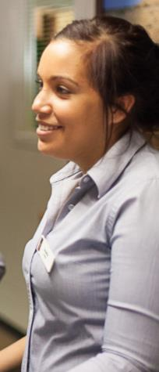

*Good afternoon ma’am. Welcome to The Gums Eco Resort, how can I help you?*

Show a welcoming manner

Here is some advice Angela gave you to help make guests feel welcome.

|  |  |
| --- | --- |
| Angela’s advice | How can I do this? |
| 1. Use positive body language. | Face the person you are talking to. Smile and look at the guest. |
| 1. Greet the guest immediately, even if you are busy with another guest. | You could say:  *I’ll be with you shortly ma’am*. |
| 1. Use people’s names if you know them.   Don’t use the guest’s first name.  Use their correct title such as Mr, Mrs, Ms and Dr. | You could say:  *Good morning Mrs Bertram.* |
| 1. Know how to address people from different cultures. | For example, in some cultures the family name comes first. Chen Bing is from China. You should address him as *Mr Chen*, not *Mr Bing*. |
| 1. Acknowledge guests who have stayed before. | You could say:  *Welcome back to The Gums Eco Resort, Ms Jones.* |
| 1. Actively listen to any requests or queries the guest makes. | Pay attention to what the guest is saying to you.  Use non-verbal signals to show you are paying attention e.g. make eye contact and nod (except for cultures where this is not appropriate).  Don’t interrupt the guest.  Summarise what they have said to check you understood.  You could say:  *So you want me to book you and your wife in for another two nights, Dr Bellini.* |

|  |  |
| --- | --- |
| C:\Users\Alan\Desktop\IMG_1081.jpg | Activity 14  Welcoming guests |

Practise welcoming guests. Your trainer will organise this activity.

Complete registration

The Gums Eco Resort has a registration procedure it asks all receptionists to follow, so they don’t forget anything and so that all guests get similar treatment.

1 Confirm guest details

2 Complete registration form

3 Process payment

4 Issue keys

5 Explain safety deposit facility if your hotel provides this

6 Explain the hotel facilities

7 Mention local tourist facilities

8 Organise luggage.

You should always:

* display a warm manner
* be polite
* be efficient.

1 Confirm guest details

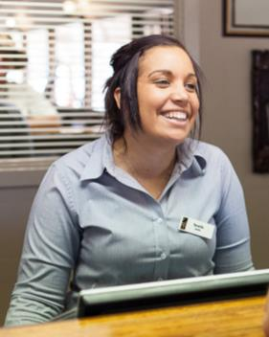

*Do you have a reservation?*

*What’s your name? I’ll just check on the system. Yes, there you are.*

*Can I just confirm these details with you?*

You need to confirm:

* 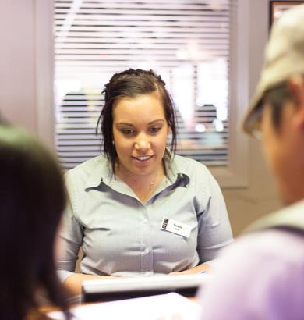name of the guest or guests – check spelling of any unusual names
* contact details – home address, phone number, email
* which country they come from
* how long they will stay, including departure date
* how they will pay – cash, credit card, charge to company, charge to agent
* type of room requested – to check they have been allocated the right type of room
* room rate quoted (although some rates are not quoted, such as for tour groups)
* any special requests.

If the guest has made a reservation, some of this information is already on the registration form.

f a guest queries their room rate, check the code on the Arrivals List and explain it politely to them. If you are not sure, refer them to your supervisor.



2 Complete registration form

Ask the guest to complete any missing details in the registration form and sign it.

The registration form is a legal document and by signing it the guest agrees to the conditions stated, including paying any charges.

Guests without a reservation will have to complete the entire registration form.

Here is a registration form for a guest who is checking in to The Gums Eco Resort . It is not complete.

|  |  |  |  |  |  |  |  |  |  |
| --- | --- | --- | --- | --- | --- | --- | --- | --- | --- |
|  | | | | **The Gums Resort**  **Guest Registration Form** | | | | | |
| **Arrival date:** 27/06/13 | | **Departure date:** 29/06/13 | | | | **No. of nights:** 2 | | | |
| **Family name** | | Blackland | | | | | | | |
| **Given name** | | Brian | | | | | | | |
| **Title** | | Mr | | | | | | | |
| **Address (include country)** | |  | | | | | | | |
| **Email** | |  | | | | | | | |
| **Telephone:** | **M:** 0400 123 456 | | **H:** | | | | | **B:** 03 9689 1244 | |
| **Number of guests** | | 2 | | | | | | | |
| **Check-in date** | | 27/06/13 | | | | | | | |
| **ETA** | | 1400 | | | | | | | |
| **Room type** | | King | | | | | | | |
| **Room rate** | | $145 | | | | | | | |
| **Room number** | | 306 | | | | | | | |
| **Method of payment** | | 🞎 MasterCard | | | ✓ Visa | | 🞎 Amex | | 🞎 Diners |
|  | | 🞎 Cash | | | 🞎 CTC | | 🞎 CTA | |  |
| **Guest signature** | |  | | | | | | | |

|  |  |
| --- | --- |
| C:\Users\Alan\Desktop\IMG_1081.jpg | Activity 15  Reading a registration form |

Look at the registration form for Mr Blackland.  
Answer the questions.

1 How many people are being registered?

|  |
| --- |
|  |
|  |

2 How long are they staying?

|  |
| --- |
|  |
|  |

3 What time do they plan to arrive?

|  |
| --- |
|  |
|  |

4 What is the charge per night for the room?

|  |
| --- |
|  |
|  |

5 Which room have they been allocated?

|  |
| --- |
|  |
|  |

6 How is Mr Blackland paying for the room?

|  |
| --- |
|  |
|  |

7 How much will he pay for the room in total?

|  |
| --- |
|  |
|  |

8 Which parts of the form does Mr Blackland have to complete?

|  |
| --- |
|  |
|  |
|  |

3 Process payment

Ask the guests how they will be paying and enter this on the registration form.

Most businesses ask the guest to allow them to swipe a credit card as security for payment.

4 Issue keys

Electronic key cards are commonly used now. They are used to open doors and turn on the electricity.

Put the key card into a cover or envelope with the room number on it and give it to the guest. For security reasons, don’t say the room number out aloud. Just give the key to the guest and show them the room number on the key wallet or tag.

Key cards are reprogrammed for each guest and your supervisor will show you how to program them.

You may need to explain how to use them.

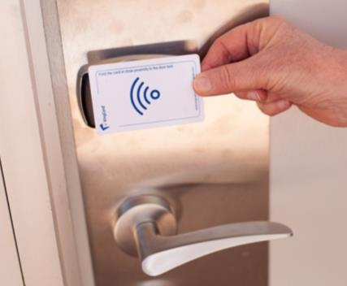

*To unlock the door, swipe the card in the card reader.*

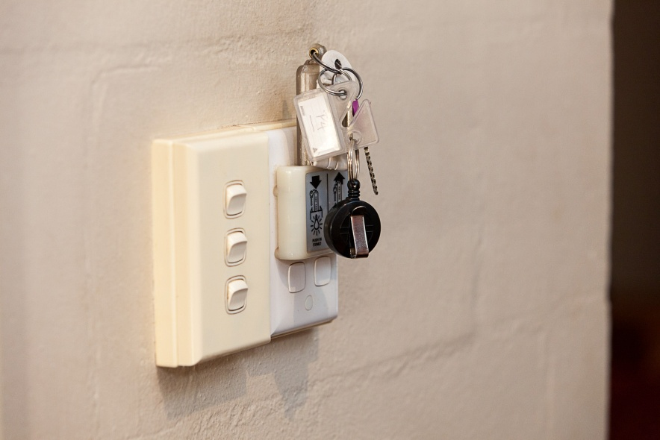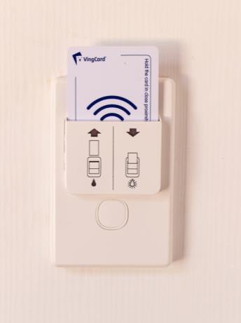

*Normal keys may have a card attached. Insert it into a slot to turn on the electricity.*

*Once you’re inside, put the card into the slot on the wall to turn on the electricity.*

5 Explain safety deposit facility

Your business may provide a safe in each room or it may provide a safety deposit facility at Reception. Either way, guests should be informed of the service and encouraged to use it for any valuables such as passport, money and jewellery. This will help provide security for the guests.

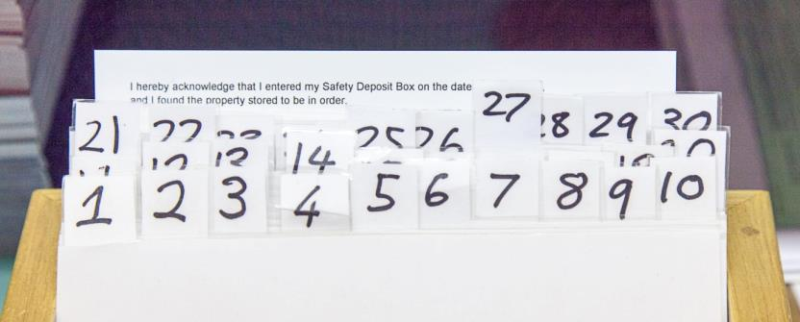

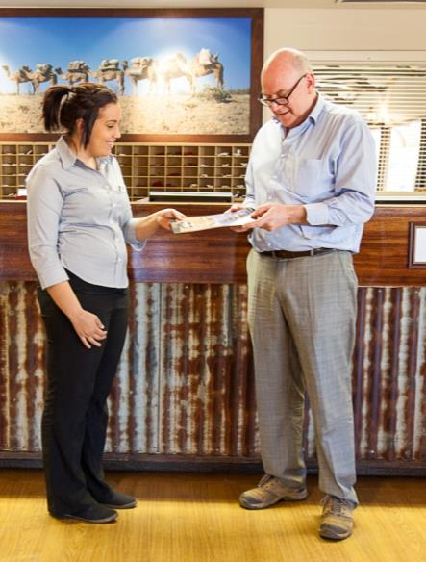6 Explain the hotel facilities

Quickly give an overview of the hotel facilities to encourage guests to use them. This may include:

* where and when breakfast is available
* cafés and restaurants
* leisure facilities e.g. swimming pool, spa, gym
* the business centre
* how messages are delivered
* tour desk.

You might give guests a brochure and map, pointing out where their room is and where the facilities can be found. Brochures may be in different languages.

If guests use facilities such as a spa, cafés and restaurants or other services that are charged, this will help the establishment make a profit.

|  |  |
| --- | --- |
| C:\Users\Alan\Desktop\IMG_1081.jpg | Activity 16  Expalin the hotel facilities |

Explain the facilities of The Gums Eco Resort to some guests, using the resort brochure or other information.

Your trainer will set up this activity for you.

7 Mention local tourist activities

Ask the guest if they need information about the local tourist activities.

Depending on your hotel, you may refer guests to brochures, to a tour desk that can make bookings or to external tourist operators that you are confident recommending.

8 Organise luggage

Ask the porter to take the guest’s luggage to the room. The porter may be the person who explains to the guest how to use the card key and the facilities in the room.

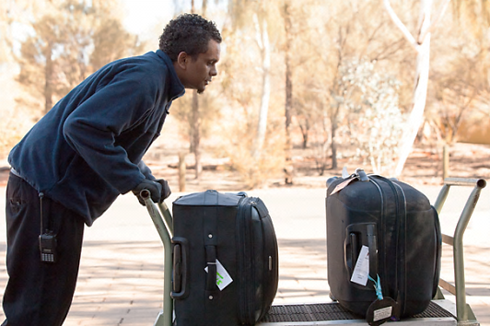

|  |  |
| --- | --- |
| C:\Users\Alan\Desktop\IMG_1081.jpg | Activity 17  Welcome and register a guest |

Practise registering a guest. Your trainer will set up this activity for you.

Monitor arrivals

Part of your role at Reception is to *monitor* guest arrivals. This means checking that all the guests on the Arrivals List have in fact arrived.

If there is a big cancellation or a large number of no shows, you should tell your supervisor.

Section summary

Now you have completed this section you should have developed the following skills and knowledge.

Tick each box if you are satisfied that you have those skills and knowledge.

|  |  |
| --- | --- |
|  | how to welcome and register guests. |
|  | Know how to monitor arrivals. |

Notes

|  |
| --- |
|  |
|  |
|  |
|  |
|  |

5 Different check-in situations

Some common ones are:

* group check-in
* room not immediately available
* overbooking
* room change requested
* guest wants to stay longer
* guest does not have correct documentation
* guest has insufficient funds
* late or uncertain arrivals
* no shows
* cancellations
* the ‘Black List’.

Group check-in

Tour groups do group check-ins. The tour guide usually does the registration for all the group members. Tour members are sometimes shown to a waiting area where they can sit and get a cool drink while the check-in occurs.

Prepare room keys and a brochure for each member of the tour group. This is generally completed before the group arrival so check-in is a smooth process for both parties. The tour guide generally hands these out.

The porter labels luggage with guest names and room numbers.

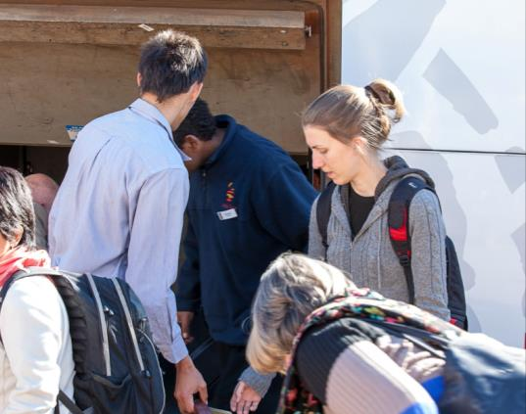

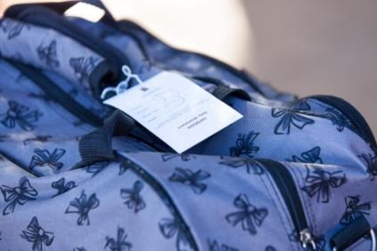

Room not immediately available

Sometimes guests can’t get into their room when they arrive, for example:

* the guest arrives early – normal hotel check-in time is 1400
* the previous guest did not leave the room on time so Housekeeping was not able to get into the room to clean it.

If this happens, you should:

* apologise for the inconvenience
* tell the guest the approximate time that the room will be ready
* register the guest
* invite them to leave their luggage and use the resort facilities until their room is ready.

The guest will feel that you have looked after them well.

|  |  |
| --- | --- |
| C:\Users\Alan\Desktop\IMG_1094.jpg | Activity 18  The room is not available yet |

You are on Reception and a family arrives before their room is ready. They are tired from driving a long distance and the two young children are complaining that they are hungry.

You expect their room to be ready in an hour.

What are some things you could do to make their wait more pleasant?

|  |
| --- |
|  |
|  |
|  |
|  |

Overbooking

Hotels regularly have cancellations, no shows and early departures, so many properties have a policy of overbooking rooms by about 5%. This makes sure that the property is as full as possible, which is important for it to make a profit.

This usually works, but sometimes all the people who have booked actually turn up! This is rare but if it happens you must deal with the situation calmly.

If you see there is going to be an overbooking problem, contact your supervisor immediately.

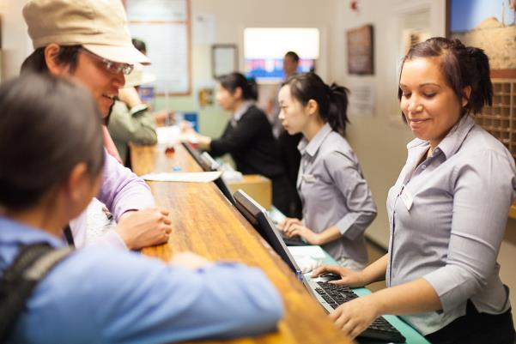

Properties often have an arrangement with similar nearby properties to accept each other’s guests. This is sometimes called ‘*bumping*’ or ‘*walking*’ a guest – that is, moving a guest to other accommodation of a similar standard and price.

Your supervisor will decide which guests will be moved. Generally there is a policy of not bumping corporate clients, long-staying guests or people with pre-paid bookings.

Guests who are bumped will be provided with pre-paid transport to the other accommodation. They may also be offered a gift such as a free meal in the restaurant, a bottle of wine or a free tour.

Room change requested

Sometimes guests ask to have a room changed. Maybe the room was not what they expected or they have a problem such as a noisy refrigerator.

In other instances, management may decide to *upgrade* (give a better room to) a guest, perhaps because they stay at the resort regularly. This is generally done at check-in.

If a room is to be changed, you must:

* check that the new room is available for the whole period of the guest’s stay
* change the registration details
* distribute the new information to everyone who needs it e.g. Housekeeping
* arrange for the porter to help the guest move rooms.

Guest without a reservation

* Most guests who arrive at The Gums Eco Resort will have a reservation. However, some travellers may just walk through the door looking for accommodation. These are called *walk-ins*. Offer them the same welcome that you give to all guests.
* Walk-ins are very important, as they mean that an otherwise empty room will be sold. If you don’t sell a room today you can’t sell it twice tomorrow to make up the loss!
* Tell the guest what is available. In some establishments, the receptionist may be advised to try to sell a more expensive room and then work down from that if the price is too expensive.
* In other establishments, the price is reduced to encourage people to fill the rooms.



*Guests without a reservation are important. They’re paying for rooms that would be empty otherwise.*

*It’s extra income for the business.*

Guest wants to stay longer

Some guests want to stay longer than they had booked for. This is called an *extended stay*. If this happens, you must:

* check the room is still available – you may need to move the guest to another room
* update the registration form with the new departure date and new room if that is necessary
* let Housekeeping know as it will affect the cleaning schedule.

Guest does not have the correct documentation

A guest who has been booked by an airline or travel agent may not have the proper documentation. For example, they may have lost their *voucher* (the ticket to show that they have paid) or the information may not be correct e.g. the wrong dates.

Whatever happens, don’t check the guest in – even if the guest says they will talk to their travel agent later. Your supervisor will tell you what to do.

Guest has insufficient funds

If a guest is unable to pay their bill, ask your supervisor for advice. Never embarrass the guest.

Late or uncertain arrivals

When a property expects to be very full, it may be the hotel’s policy to ring people who don’t have a *guaranteed booking* (no credit card details taken or deposit paid). Also, if a guest is late, you may ring them to check they are still coming.

When you check that the guests are actually coming, confirm their arrival time. Always speak politely and positively.

If the guest cancels, you can update the reservation system and make the room available to offer to someone else. If you are unable to contact them, let your supervisor know.



*Mr Bakoulis was due to arrive at 3 pm but now it’s 5 pm and he hasn’t arrived. His room is non-guaranteed.*

*I’ll try to contact him before we put the room back on the Availability List.*

No shows

People who don’t arrive at the resort without phoning to cancel are called *no shows.*

* **If the booking is *guaranteed*** (credit card details taken or deposit paid), then you can’t resell the room as the guest may just be late. But the hotel can charge the guest for the room whether they arrive or not.
* **If the reservation is *non-guaranteed*** (no credit card details taken or deposit paid), the room can be put back on the Availability List to be sold to someone else. In some hotels this is called a *1600 hold* – after 4 pm the room is made available to sell.

Cancellations

If people cancel up to 24 hours before their arrival date, many properties have a policy of not charging. If anyone calls with a cancellation, treat them warmly and politely. They are doing you a favour by letting you know. You can now offer the room to someone else, such as someone on a waiting list or a walk-in.

For cancellations less than 24 hours ahead of the booking, your supervisor will decide whether or not to charge the guest.

Update the records so it is clear that the room is now available. This means that the room can be sold to someone else.

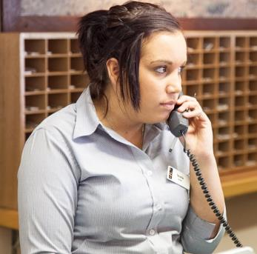

The Black List

Most properties have a ‘Do not book’ or ‘Black List’ of people who have caused problems at the property in the past. They may have:

* damaged rooms
* been drunk and noisy, upsetting other guests
* abused staff or other guests
* left without paying their bill.

If a person arrives without a reservation, or when a person makes a reservation, you should check the Black List before you accept their booking.

|  |  |
| --- | --- |
| C:\Users\Alan\Desktop\IMG_1094.jpg | Activity 19  Dealing with different check-in situations |

Practise dealing with some different check-in situations. Your trainer will organise this activity.

Section summary

Now you have completed this section you should have developed the following skills and knowledge.

Tick each box if you are satisfied that you have those skills and knowledge.

|  |  |
| --- | --- |
|  | Know how to deal with different check-in situations. |

Notes

|  |
| --- |
|  |
|  |
|  |
|  |
|  |

6 Organise guest departures

The beginning of the day is when most guests check out. Most properties have a check-out time of either 10 am or 11 am but the busiest time is usually between 7 am and 9 am.

It is important that the check-out procedure is *efficient* (quick and with no problems) as guests may need to get to a meeting, catch a plane or join a tour.

The receptionist is often the last person the guest sees, so create the best impression you can.

Be calm, efficient, courteous and helpful, even when you are very busy.

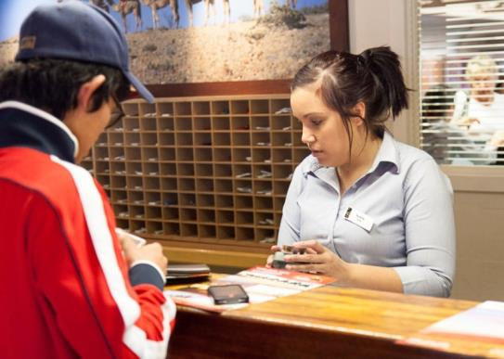

Check the Departures List

Each day, a property generatesa Departures List with details of the guests who are leaving that day including these details:

* guest name
* room number
* ETD, if this is known
* cash paying guests, so mini bar can be checked prior to the guest checking out and leaving the hotel.

This Departures List gives you an idea of busy times, such as a group check-out or a lot of people wanting to catch a particular plane. It helps you see when you need to have guest accounts prepared by.

Here is an example of a Departures List at The Gums Eco Resort .

|  |  |  |  |  |  |  |  |  |  |
| --- | --- | --- | --- | --- | --- | --- | --- | --- | --- |
|  | | | | **The Gums Resort Departures List** | | | | | **Date: 26 July 2013** |
| **Guest name** | **No. of guests** | **Arrival date** | **Dep. date** | | **Dep. time** | **Room type** | **Room No.** | **Pay’t meth** | **Special requests** |
| Sweetman, John, Mr & Mrs | 2A 0C | 25/07/13 | 26/07/13 | | 11:00 | L - K | 103 | VA | Book limo for airport transfer at 11:00 |
| ABC Tours (Leader Anthony Black) | 2A 0C | 24/07/13 | 26/07/13 | | 07:30 | S–S x 10 | 204 - 213 | MC | Have bags removed from rooms by 07:00 |
| Matsuto, Miki, Ms | 1A 0C | 23/07/13 | 26/07/13 | | 09:00 | L - K | 105 | VA | Order a taxi for 09:15 to airport |
| Liu, Bin, Mr & Peng Bo, Ms | 2A 1C | 25/07/13 | 26/07/13 | | 17:00 | 1 BRS | A12 | CL | Will check out at 10:00 and leave luggage to be collected at 17:00 |
| Vowels, Raymond, Mr | 2A 0C | 20/07/13 | 26/07/13 | | 09:00 | S - D | 314 | VA |  |
| Tomlinson, Ben, Mr | 4A 0C | 23/07/13 | 26/07/13 | | 07:30 | 2 BRS | B106 | MC | Joining ABC tours at 08:00 |
| Jacobs, John, Mr | 1A 0C | 24/07/13 | 26/07/13 | | 09:30 | L - K | 106 | VA | Order taxi for airport 10:00 |
| **Rate Code:**  CP Corporate contract  LB Bed and breakfast  LW Domestic wholesale  RK Rack rate  RO Room only | | | | | | **Room Type Code:**  L – Luxury room (king bed K or 2 x king single beds KS)  S – Standard room (double bed D or 2 x single beds S)  1 BRS – 1 bedroom self-contained unit  2 BRS – 2 bedroom self-contained unit | | | |

|  |  |
| --- | --- |
| C:\Users\Alan\Desktop\IMG_1081.jpg | Activity 20  Read the Departures List |

Read the previous Departures List for 26 July and answer these questions.

1 What will be the busiest time at Reception on 26 July?

|  |
| --- |
|  |

2 What times do you have to order taxis?

|  |
| --- |
|  |

3 How many days has Ms Matsuto stayed?

|  |
| --- |
|  |

4 What room type did Mr Tomlinson and his family stay in?

|  |
| --- |
|  |

5 What time are Mr Tomlinson and his family joining a tour?

|  |
| --- |
|  |

6 Who needs a limo booked?

|  |
| --- |
|  |

7 How many rooms do bags have to be removed from?

|  |
| --- |
|  |

8 What time are Mr Liu and Ms Peng leaving the resort? When will they check out?

|  |
| --- |
|  |

The check-out procedure

The check-out procedure usually contains these steps. Your property will have its own procedure.

|  |  |
| --- | --- |
| Step | You could say: |
| 1. Greet the guest courteously and ask if they are checking out. | *Good morning Ms Matsuto, are you checking out?* |
| 1. Ask for their name, if you don’t know it, and room number. Confirm this information on your computer. | *Can you tell me your name and room number please?* |
| 1. Ask the guest if they had any mini bar items last night or this morning, had breakfast or made any phone calls, in case it has not yet shown up on the computer system.   Get any information you need from other departments to help prepare the account. | *Did you use any mini bar items last night, Mr Jones?* |
| 1. Generate the guest account and check it is correct. | *I’ll just prepare your account now.* |
| 1. Print the account and show it to the guest for *verification* (checking). | *Here’s your account Ms Matsuto. Would you like me to explain these extra items?* |
| 1. Explain account clearly and courteously to the guest. | *You’ve been charged for dinner for two people last night. That wasn’t included in your room rate.* |
| 1. Receive and process payment. | *How would you like to pay?* |
| 1. Ask for keys or electronic cards from guests and process correctly. | *Can I take your key card for you, Mr Vaksalis?* |
| 1. Ask guests if they need any other help with their departure, such as help with luggage, making forward bookings or organising transport. | *Do you need any other assistance this morning, Mrs Blackwood?*  *Can I book organise a taxi for you?* |
| 1. Farewell them. | *I hope you enjoyed your stay with us Ms Raine, we look forward to seeing you again.* |

Process an account

It is important to be very accurate when preparing accounts so ask your supervisor if you need help. A guest account is called a *folio.*



*As much as possible, prepare guest accounts before they check out to save guest time.*

Get information from other departments

You need information from other departments to make up the guest accounts. There may be other charges such as:

|  |  |
| --- | --- |
| * restaurant and café | * mini bar |
| * telephone calls | * laundry |
| * internet use | * business centre |
| * spa or salon | * in-house movies. |

A charge is called a *posting* and items are normally posted to the guest account as they occur. However some charges may not yet have gone through, such as breakfast or late mini bar charges. A quick telephone call to the restaurant or Housekeeping may be needed.

Check the documents

Before you give the account to the guest, check that it has all the necessary information. The account should include:

* name of guest
* dates of arrival and departure
* room rate and extra charges
* amount of money already paid
* amount of money owed.

Check that the account is accurate.

Check the account with the guest

Print the account, and show it to the guest for *verification* (checking).



*Remember the privacy of the guest. Discuss their account details carefully and quietly, so others can’t hear.*

Explain the charges to the guest. Sometimes a guest may want further information or *query* (question) an account e.g. overseas visitors may not understand the Goods and Services Tax (GST).

You can say:

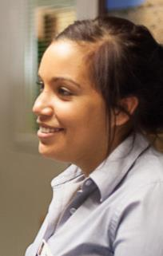

*That’s a charge for the internet, ma’am. It’s $5 per hour and the account says you used 2 hours’ worth.*

**Look for signs that a guest is confused** – you want them to leave the resort knowing that they have only paid for services they have used. If they are unsure, it will leave a bad impression and a fear you have overcharged them.

**If a guest *disputes* (disagrees with) part of the account**, always be polite. If a mistake has been made on the account, apologise and fix it up immediately. Make sure the corrections are entered on the resort’s computer system. You may need to ring another department to verify the incorrect charge.

****You can say:

*Oh, I’m very sorry, Mrs. Wilson. I can see that a mistake has been made.*

*I’ll fix it up straight away.*

**If there is a problem that you can’t solve**, don’t argue with the guest. For example there might be an item for a service that the guest continues to claim they did not use, or was of poor quality. If this happens, ask your supervisor for help.

A guest account

Here is part of a guest account from The Gums Eco Resort .

|  |  |  |  |  |  |
| --- | --- | --- | --- | --- | --- |
|  | | | **The Gums Eco Resort**  **Guest Account** | | |
| **Guest details:**  Ms Miki Matsuto 1156 Minamishi Matsubara  Tokyo JAPAN | | | **Date:**  26/07/13 | | |
| **Room No:** 105 | | |
| **Arrival:** 23/07/13 **Departure:** 26/07/13 | | |
| **Cashier:** Sara Brunton | | |
| **Tax invoice: 1821160** | | | | | |
| **Date** | **Description** | | | **Debit AUD** | **Credit AUD** |
| 23/07/13  23/07/13  24/07/13  24/07/13  24/07/13  25/07/13  25/07/13  26/07/13  26/07/13 | Dinner x 2 (Palm Restaurant)  Accommodation + breakfast  Mini bar purchases  Telephone  Accommodation + breakfast  The Gums Eco tour x 2  Accommodation + breakfast  Credit card surcharge  Payment – Visa | | | 86.45  213.00  24.00  12.00  213.00  150.00  213.00  9.11 | 920.56 |
| **Total** | | | | **$920.56** | **$920.56** |
|  | | Total all charges Total includes GST of | | $920.56 AUD $83.69 AUD | |
| **Guest signature:** | | | | | |

|  |  |
| --- | --- |
| C:\Users\Alan\Desktop\IMG_1081.jpg | Activity 21  Explain the account |

Look at the previous account for Ms Matsuto’s stay at The Gums Eco Resort.  
Ms Matsuto has some questions about her account.

Your trainer will organise this activity.

Receive the payment

Guests can pay in a variety of ways.

|  |  |
| --- | --- |
| Credit cards | If the guest’s credit card was swiped when they checked in, this speeds up check-out |
| EFTPOS | Electronic Funds Transfer at Point Of Sale. Similar to a credit card payment but the money comes out of the guest’s bank account rather than being put on credit. |
| Cash | When guests pay in cash, check the amount of money they give you carefully and count out any change clearly. |
| Cheques | Generally cheques are not accepted in hotels unless they are bank or company cheques and they are pre-authorised by the hotel. Personal cheques are usually not accepted. If guests pay by cheque you must get identification, e.g. a driver’s licence, passport or credit card details. Photocopy the identification and attach it to the cheque so if there is a problem, the guest can be contacted. |
| Travel agent or airline vouchers | Guests who book through a travel agent or airline may have pre-paid *vouchers* (a receipt showing they have already paid for the item). If guests present a voucher, check the details (guest name, number of nights, inclusions). |
| Direct billing | Some businesses may have direct billing arrangements for their employees. Check inclusions and extras before you present the account to the guest. If they are not covered by the billing arrangement, the guest will have to pay themselves. |
| Foreign currency and travellers’ cheques | Overseas guests may wish to pay in *foreign currency* (money from their country) or *travellers’ cheques* (pre-purchased cheques in a major currency). Your supervisor will deal with these situations. |

Issue a receipt

When the payment has been made, print a receipt and hand it to the guest.

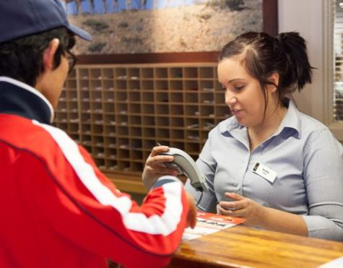

|  |  |
| --- | --- |
| C:\Users\Alan\Desktop\IMG_1081.jpg | Activity 22  Processing payments |

Practise taking payments, calculating the total and giving change.

Your trainer will organise this activity.

|  |  |
| --- | --- |
|  | **Save paper** |
| Ask if the guest wants the receipt in an envelope, rather than automatically putting it into the envelope. | |

Collect the key

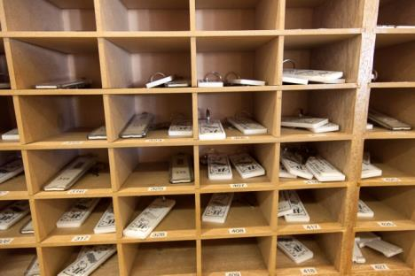Most guests will automatically hand the key or key card to you when they check out.

If the guest does not give it to you, politely ask for it when you hand over the receipt.

Immediately put the key or key card in the secure box behind the reception desk. Never leave keys lying around.

For an electronic system the key can be recut and reused.

Provide assistance with departure

Ask the guest if they need any further assistance with departure. They might ask for help with a range of things.

|  |  |
| --- | --- |
| Assistance with … | You should … |
| Luggage to be brought down | Pass the request on to the porter immediately. Ask for:   * guest name * room number * amount of luggage * where to take the luggage e.g. reception area, taxi rank |
| Transport | Call a taxi or organise a hire car  Advice about public transport, such as buses, trains and ferries  Help with an airline booking |
| Forward bookings | Refer guest to the tour desk, if there is one  Suggest a tour operator they could contact  Make a reservation by phone |
| Leave a forwarding address | Record details in the relevant guest profile |

Section summary

Now you have completed this section you should have developed the following skills and knowledge.

Tick each box if you are satisfied that you have those skills and knowledge.

|  |  |
| --- | --- |
|  | Know the check-out procedures. |
|  | Process guest accounts and receive payments |
|  | Provide assistance with departure. |

Notes

|  |
| --- |
|  |
|  |
|  |
|  |
|  |

7 Different departure situations

Check-outs are not all the same. At a busy reception desk, you will have to deal with different departure situations.

Express check-out

Express check-out is for guests who want to leave early or with no delay, waiting in a queue. If the guest has provided their credit card details on check-in, or the account is going back to the company or agent, then the guest can use express check-out.

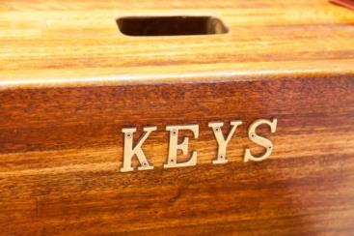Give the guest an express check-out form to complete. When they leave, they place the completed and signed express check-out form in the express check-out box. The account is then charged to their credit card or sent to their employer for payment.

Ask guests to put their key or key card in the secure box at Reception.

Group check-out

Tour group check-out needs to be handled efficiently. You want to clear reception of all the people and luggage quickly.

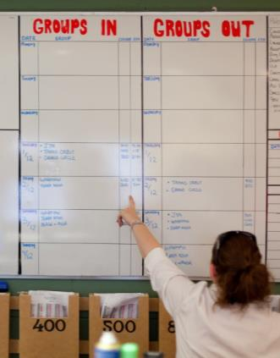The tour guide usually handles the check-out for the group. Individual guests may need to pay for extras such as mini bar, in-house movies or phone calls.

You should direct guests to a waiting area while check-out is being processed.

Porters will bring down the luggage from guests’ rooms.

Deposits and pre-payments

If a guest has paid a deposit on their room, check that the deposit has been subtracted from the total amount owing.

If a guest has fully pre-paid, you still process a final account as there may be charges for extra services. Guests will have been sent a receipt at the time they made the deposit or pre-payment.

Guest checks out late

If a guest does not check out by the stated time, they may be charged an extra day’s room rate or a percentage of that rate. In this situation, check with your supervisor.

A guest can request a late check-out, usually for an extra charge. You need to know your property’s policy – ask your supervisor if you are not sure. If the property is full, it may not be possible to meet this request.

Early departures

Sometimes guests check out on an earlier date than expected. Inform Housekeeping so they can clean and prepare the room for a new guest.

Check with your hotel’s policy on early departures as the guest may be charged for that night’s accommodation.

Guests may check out much earlier than the hotel departure time. Let Housekeeping know as soon as possible so they can clean it for the next guest. Then we can check a guest who arrives early into that room.

|  |  |
| --- | --- |
| C:\Users\Alan\Desktop\IMG_1087.jpg | Activity 23  Different check-out situations |

1 What is the procedure in your workplace for;

* express check-outs?

|  |
| --- |
|  |
|  |

* group check-outs?

|  |
| --- |
|  |
|  |

2 What is the policy in your workplace for charging:

* guests who check out late?

|  |
| --- |
|  |
|  |

* early departures?

|  |
| --- |
|  |
|  |

Complaints

Occasionally a guest is not happy with the service or room and will complain to the receptionist at check-out.

They may also make a complaint through a feedback form provided by the establishment.

Your property will have a complaints procedure to follow. Always follow this policy. It may include recording the complaint later.



*Take all complaints seriously.*

*They can bring to our attention problems we didn’t know about, and they can lead us to think about better ways to provide services to guests.*

Use all your communication skills when dealing with a guest who is complaining:

* apologise
* listen actively
* use positive body language
* *paraphrase* (briefly restate) what they have said to confirm you understand.

If a guest becomes aggressive or can’t be calmed down, contact your supervisor immediately.

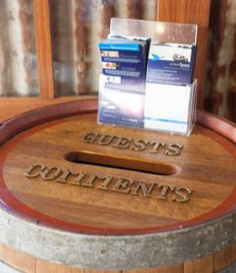

|  |  |
| --- | --- |
| C:\Users\Alan\Desktop\IMG_1087.jpg | Activity 24  Complaints procedure |

What is the procedure in your workplace for dealing with complaints at check-out (or at other times)?

|  |
| --- |
|  |
|  |
|  |

|  |  |
| --- | --- |
| C:\Users\Alan\Desktop\IMG_1081.jpg | Activity 25  Dealing with a guest who has a complaint |

In this activity, you will practise dealing with complaints from guests.



Section summary

Now you have completed this section you should have developed the following skills and knowledge.

Tick each box if you are satisfied that you have those skills and knowledge.

|  |  |
| --- | --- |
|  | Know how to deal with different check-out situations. |
|  | Know how to deal with complaints. |

Notes

|  |
| --- |
|  |
|  |
|  |
|  |
|  |

8 Prepare reports

Receptionists need to prepare reports for two reasons:

1. So all departments know what is happening each day. These reports are **daily** and need to be *updated* (information added in as things change) during the day.



*We often have to* ***change*** *reports and lists. We can use different words for this.*

*We can say we are* ***revising, updating, altering*** *or* ***amending*** *them.*

1. So Management can keep track of how the business is going and make decisions about the future. These reports may be **daily, weekly** or **monthly.**

Receptionists have access to a lot of important business information and also to guests’ personal information.



*You must never discuss guest information or business information with anyone.*

|  |  |
| --- | --- |
|  | **Save paper** |
| * When you are putting together reports for management, do them on the computer. You can store and send them electronically, e.g. by email. * There is no need to print out reports unless you are asked to do so. | |

Types of reports

Bigger businesses may produce more reports than smaller businesses.

Some reports may be generated automatically through the computer system. Others need to be manually updated throughout the day.

On the following page are some of the reports you may need to help *compile* (put together).

|  |  |
| --- | --- |
| C:\Users\Alan\Desktop\IMG_1094.jpg | Activity 26  Your workplace reports |

1 Discuss with your group:

* What types of reports are produced daily in your workplace?
* How do you enter *data* (information) into them?
* Who are they *distributed* (sent) to?
* What are the timelines for distribution?

2 Someone rings and cancels their reservation for tomorrow. What reports and records will you have to change?

|  |
| --- |
|  |
|  |
|  |

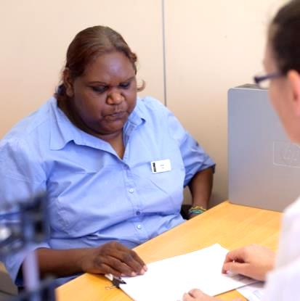

Types of reports

|  |  |  |
| --- | --- | --- |
| Report | What is in the report? | What departments need the report? How would they use it? |
| Arrivals List and Departures List | Lists who is arriving and departing on a single day. Needs to be updated every time a change occurs e.g. cancellations, new reservations, walk-ins or early departures. |  |
| Room status report | Lists the status of every guest room for the day e.g. Vacant Inspected, Vacant Dirty, Due Out or Out Of Order.  Updated constantly along with the Arrivals and Departures Lists, and if room changes or upgrades are made. |  |
| Special requests report | List of special requests made by booking and arriving guests. |  |
| Occupancy reports | Shows how full the property is as a percentage e.g. 53%, 78% or even 100% full. Compiled daily and used to create weekly and monthly reports. |  |
| Room maintenance records | Shows which rooms need maintenance, when a maintenance request is made and when the maintenance has been completed. Updated daily. |  |
| Guest feedback summary | A summary of feedback (including complaints) received from guests. Compiled from the feedback form issued to all guests. |  |

Distribute reports

Different reports are sent to different departments. They are sent daily, weekly or monthly, depending on the report. The main departments are:

|  |  |
| --- | --- |
| * Reception | * Food and Beverage |
| * Reservations | * Finance |
| * Concierge (e.g. porters) | * Management and Administration |
| * Housekeeping | * Sales and Marketing. |
| * Maintenance |  |

Some reports, such as the Arrivals and Departures Lists, are printed out so that Housekeeping and the porters can easily use them during the day.

Other reports are sent electronically, such as to the Marketing Department, the Finance Department and Management. The *statistics* (numbers) in them help with planning, for example:

* how much to spend on marketing and advertising
* staff levels needed at different times of the year
* how much to charge for rooms at different times of the year.

|  |  |
| --- | --- |
| C:\Users\Alan\Desktop\IMG_1094.jpg | Activity 27  Distributing reports |

Look at the previous table *Types of reports*.

Discuss Questions 1 and 2.

Then fill in the third column.

1. Who needs the report? e.g. Housekeeping, Finance, Maintenance, Concierge (porters), Restaurant, Laundry, Management, Sales and Marketing …?

Some go to more than one department.

2 How would they use the information?

Section summary

Now you have completed this section you should have developed the following skills and knowledge.

Tick each box if you are satisfied that you have those skills and knowledge.

|  |  |
| --- | --- |
|  | Know which reports to prepare. |
|  | Know who to distribute reports to. |

Notes

|  |
| --- |
|  |
|  |
|  |
|  |
|  |

Appendix 1 The 24 hour clock

|  |  |  |
| --- | --- | --- |
| 12 hour clock | How long after midnight? | 24 hour clock |
| 12.00 am (midnight) | 0 hours | 00:00 hours |
| 12.30 am | 30 minutes | 00:30 hours |
| 1 am | 1 hour | 01:00 hours |
| 2 am | 2 hours | 02:00 hours |
| 3 am | 3 hours | 03:00 hours |
| 4 am | 4 hours | 04:00 hours |
| 5 am | 5 hours | 05:00 hours |
| 6 am | 6 hours | 06:00 hours |
| 7 am | 7 hours | 07:00 hours |
| 8 am | 8 hours | 08:00 hours |
| 9 am | 9 hours | 09:00 hours |
| 10 am | 10 hours | 10:00 hours |
| 11 am | 11 hours | 11:00 hours |
| 12 pm (midday) | 12 hours | 12:00 hours |
| **TIP: After midday, add 12 to the clock time.** | | |
| 1 pm | 13 hours | 13:00 hours |
| 2 pm | 14 hours | 14:00 hours |
| 3 pm | 15 hours | 15:00 hours |
| 4 pm | 16 hours | 16:00 hours |
| 5 pm | 17 hours | 17:00 hours |
| 6 pm | 18 hours | 18:00 hours |
| 7 pm | 19 hours | 19:00 hours |
| 8 pm | 20 hours | 20:00 hours |
| 9 pm | 21 hours | 21:00 hours |
| 10 pm | 22 hours | 22:00 hours |
| 11 pm | 23 hours | 23:00 hours |
| 12 am | 0 hours | 00:00 hours |

Key words

|  |  |
| --- | --- |
| Word | Meaning |
| *balance* | The amount of money in your cash drawer matches the amount of money registered on the cash register |
| *bump a guest* | Move a guest to other accommodation due to overbooking |
| *cash float* | The amount of money you start with at the beginning of the shift |
| *compile* | Put together |
| *deviation* | Something that is different to what you expect |
| *discounted rate* | Cheaper than the standard rate |
| *dispute* | Disagree with, say it is wrong |
| *distribute* | Send |
| *EFTPOS* | Electronic Funds Transfer at Point Of Sale – similar to a credit card payment but the money comes out of the guest’s bank account rather than being put on credit |
| *ETA* | Estimated time of arrival – when you expect the guest to arrive |
| *extension* | Guest staying in a room longer than the time booked |
| *extras* | Extra items that the guest may have to pay for, such as drinks from the mini bar |
| *FIT* | Free independent traveller – a guest who is not booked through a travel agent or other agency, usually charged at the full rack rate (usually an international traveller) |
| *FOC* | Free of charge – things the guest does not have to pay for |
| *folio* | A guest account |
| *foreign currency* | Money from another country |
| *generated* | Produced |
| *guaranteed booking* | A deposit has been paid on the booking, such as through cash or credit card so the room can’t be sold |
| *handover* | Change from one shift to another, giving any important information to the people on the new shift |
| *inclusions* | Things that are included in the room package, such as room and breakfast |
| *minimise* | Produce the smallest possible amount |
| *monitor* | Check on |
| *no show* | A person who has made a booking but does not turn up |
| *OOO* | Out of order – something is broken so it can’t be used |
| *pre-allocate rooms* | Allocate rooms before the guest arrives |
| *rack rate* | The full cost of the room, without any discounts |
| *recycled* | Reused |
| *status* | Whether or not a person has checked in |
| *stay over* | The guest is not expected to check out today and will remain in the hotel for that night |
| *terminal* | Cash register |
| *toner* | Used in printers and photocopiers to form the printed text and images on the paper |
| *trace* | Special guest requests or comments that the hotel needs to act on |
| *traveller’s cheque* | Pre-purchased cheque in a major currency |
| *upgrade* | Give a better room than booked or other service |
| *verification* | Checking |
| *VIP* | Very important person – someone who will receive special treatment |
| *voucher* | Ticket to show that something has already been paid for |
| *walk-in* | People who don’t have a reservation, but come to the hotel looking for a room |
|  |  |
|  |  |