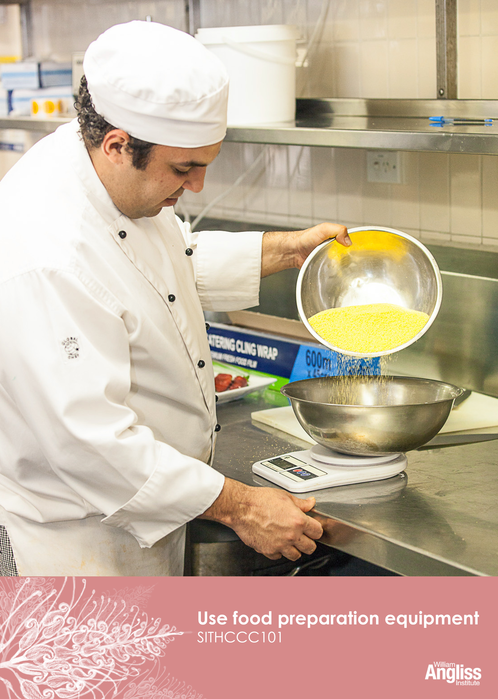

© Commonwealth of Australia 2013

CC BY-NC-SA

This work is copyright. Except where otherwise indicated, and save for the Commonwealth Coat of Arms, the Department has applied the Creative Commons Attribution-Noncommercial-Share Alike 3.0 Australia Licence to this work.

The Department of Industry, Innovation, Climate Change, Science, Research and Tertiary Education must be attributed as the author of the Department’s copyright material.

As far as practicable, material for which the copyright is owned by a third party has been clearly labelled. The Department has made all reasonable efforts to ensure that this material has been reproduced on this website with the full consent of the copyright owners.

Requests and enquiries concerning the Department’s copyright material should be addressed to:

The Legal Branch
Department of Industry, Innovation, Climate Change, Science, Research and Tertiary Education
GPO Box 9839 Canberra ACT 2601

Or emailed to legalservices@innovation.gov.au

Funded under the Workplace English Language and Literacy (WELL) Program by the Australian Government Department of Industry, Innovation, Climate Change, Science, Research and Tertiary Education

The views expressed in this publication do not necessarily represent the view of the
Minister for Tertiary Education, Skills, Science and Research or the Australian
Government. The Australian Government does not give any warranty nor accept any liability in relation to the contents of this work

ISBN 978-1-922108-15-9

Development Team
Content | William Angliss Institute of TAFE
 | Macsmith and Associates
Photography & graphics | Benjamin B Photographer
Acknowledgments
We would like to acknowledge the generous support of the following organisations and the learners and employees in those venues, both Indigenous and non-Indigenous, for giving their permission for photography:
William Angliss Institute Coffee Academy, Melbourne, VIC
Voyages Ayers Rock Resort, Yulara, NT
Permissions
We would like to acknowledge the following organisations who have granted permission for their copyright materials to be incorporated in this resource:
ClipArt ETC, The Florida Center for Instructional Technology
Cultural Warning
People of Aboriginal or Torres Strait Islander descent should be aware that this publication contains images of people who may be deceased
Disclaimer
Every effort has been made to ensure that this booklet is free from error or omissions. However, you should conduct your own enquiries and seek professional advice before relying on any fact, statement or matter contained in this book. William Angliss Institute of TAFE and Macsmith and Associates are not responsible for any injury, loss or damage as a result of material included or omitted from this course.

Contents
Welcome vi
Icons vi
What you will learn vii
1 Introduction 1
The Gums 1
Mise en place 3
Section summary 5
2 Food preparation equipment 6
Types of kitchen equipment 6
Selecting kitchen equipment 8
Assembling equipment 11
Handling electrical equipment safely 13
Section summary 14
3 Using knives 15
Parts of a knife 15
Types of knives 16
Knife maintenance 19
Cutting techniques 22
Traditional cuts 24
Handling knives safely 26
Section summary 30
4 Weighing and measuring ingredients 31
Weighing ingredients 31
Measuring ingredients 33
Calculating ingredient requirements 36
Section summary 40

5 Using equipment for food preparation 41
Food processor 42
Grater 44
Chef’s knife 46
Measuring spoon 46
Whisk 47
Filleting knife 54
Measuring jug 55
Electric mixer 57
Vegetable peeler 59
Scales 60
Blender 62
Section summary 65
6 Cleaning and maintaining kitchen equipment 66
Cleaning the equipment 66
Maintaining equipment 77
Section summary 80
Recipe book 81

Key words 87
Welcome

Icons
These signs tell you what type an activity is:
Do this activity in a big group.
Do this activity in a small group.
Do this activity in pairs.
Do this activity by yourself.
Do this activity using the internet.
If you are not connected to the internet, your trainer will provide you with another activity.
Do this activity in your workplace.
If you are not in a workplace, your trainer will provide you with another activity.

What you will learn
Working in a commercial kitchen is different from working in your kitchen at home. In a commercial kitchen, the equipment is often bigger, the knives are sharper and there are many specialised utensils (kitchen tools used for particular a purpose). It is important to learn how to use this food preparation equipment correctly.
In this unit you will learn how to use commercial kitchen equipment safely while preparing a range of foods.
You will learn how to:
- select the food preparation equipment to use, including the correct knives
- put equipment together safely and hygienically
- use equipment safely and hygienically to prepare food
- use knives to cut food into different sizes and shapes
- keep the equipment clean and well maintained.
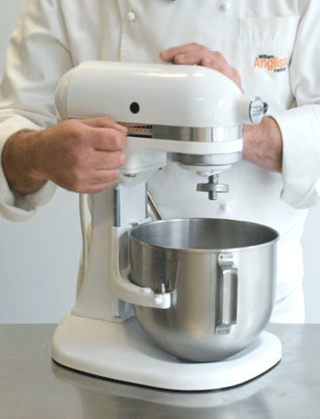

1 Introduction

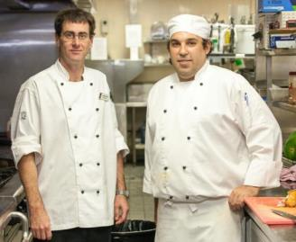
Hi, I’m Daniel. I’ve just started working in the kitchen of The Gums Café. The main part of my job is basic food preparation, so I have to learn how to use the equipment.
I’m Liam, Daniel’s supervisor. I’ll be giving Daniel advice about how to work safely and efficiently in the kitchen when he is using the equipment to prepare food.

The Gums
The Gums Resort has a café where visitors and guests can have lunch as well as snacks and drinks throughout the day.
Here is the lunch menu. The recipes for some of these dishes are in the Recipe Book at the end of this workbook.

LUNCH MENU
- Entrées
Tempura onion rings served with garlic and paprika mayonnaise
Minestrone soup with cheese croutons
Vegetable spring rolls
- Main courses
Parmesan crumbed chicken breast
Steak sandwich
Beer battered fillet of fish with crisp fries and tartare sauce
- Desserts
Dutch apple cake with cream
Lemon meringue pie
Fresh fruit salad
- Drinks
Fresh fruit juice
Fruit smoothie

Activity 1
The recipes
1 Have you made any of these recipes? Or any similar ones?

2 What would you choose if you were eating at The Gums? Why?
Mise en place
Part of Daniel’s job is to prepare the ingredients and equipment that the chef needs to make the items on the menu. This preparation is called mise en place.
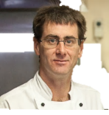
If Daniel is efficient when he does the mise en place, it helps the kitchen run smoothly.

Learn the language
Mise en place is a French term that means ‘put in place’. It means making sure that all the equipment and ingredients are ready before the chef starts work. You say, ‘Meez on pluss’.

Mise en place includes these tasks.
Tasks
- Gather all the ingredients needed for the recipe.
- Check that the ingredients are suitable for use e.g. are they fresh?
- Gather and assemble (put together) all the equipment needed.
- Check the equipment is clean and safe.
- Weigh, count or measure the quantities (amounts) of ingredients accurately (exactly).
- Basic preparation of ingredients e.g. washing, peeling and cutting up vegetables in the size and shape needed.
- Basic cooking of ingredients to be added to a recipe later e.g. cooking pasta for the minestrone soup.
- Put the prepared ingredients into individual containers e.g. milk into a small jug, chopped vegetables into bowls.

Activity 2
Mise en place at your workplace
1 Look at the previous table of tasks. Tick () in the column if you have done this task.
2 Think about some of the tasks you do in your workplace.
What are some other examples of mise en place you have to do on a typical day?

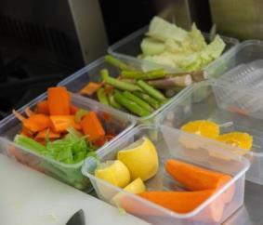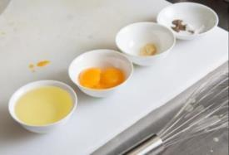

Section summary
Now you have completed this section you should have developed the following skills and knowledge.
Tick each box if you are satisfied that you have those skills and knowledge.
Understand the importance of mise en place in a commercial kitchen.
Notes

2 Food preparation equipment
The food preparation equipment in a commercial kitchen is very different from a home kitchen. The equipment is usually larger, stronger and of better quality than the equipment used in a home kitchen. This is because a larger amount of food is prepared.
Types of kitchen equipment
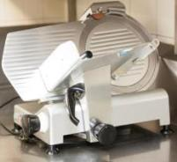 | Small electrical equipment  - mixer  - blender  - food processor  - meat slicer
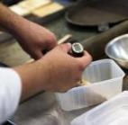  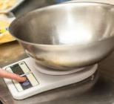 | Measuring equipment  - scales  - jugs  - cups  - spoons  - thermometers
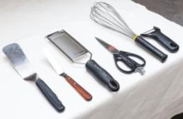 | Hand tools
 | - ladle | - peeler
 | - grater | - tongs
 | - corer | - palette knife
 | - spatula | - zester
 | - whisk | - spoon

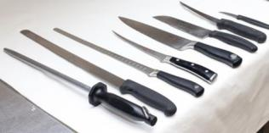 | Knives
 | - chef’s | - turning
 | - cleaver | - boning
 | - filleting | - butcher
 | - paring | - sharpening steel or stone

Activity 3
Your workplace equipment
Look at the equipment in your workplace.
1 Find one piece of equipment from each of the types.
2 What is each piece of equipment used for?
3 Have you used it yet?
Type of equipment | One example at your workplace | What is it used for? | Have you used it?
Small electrical equipment
Measuring equipment
Hand tools
Knives

Selecting kitchen equipment
When using equipment in the kitchen, select (choose) and assemble (put together) all the items you need before you start preparing food. When doing this, you should think about these things:
Is it the right size?
Has it been put together safely?
Will it do the task we need done?
Is it clean?

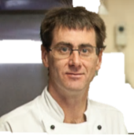

If you aren’t sure which type or size of equipment to choose, ask someone.

Check the equipment and reduce waste
If you don’t check equipment, the food may not be prepared the way the chef wants it.
It may have to be thrown away, which is a waste. It could also be bad for the environment, as the food could go into landfill.

Activity 4
What could go wrong?
If you don’t check equipment or choose the right equipment, some problems may occur.
Look at the list of problems in the following table.
What could have caused each problem?

Problem | What could have caused the problem?
- Poor quality food
- Contaminated food
- Accidents
- Spills
- Damage to the equipment
- Waste of food

Activity 5
Select kitchen equipment
Go to the Recipe Book and read the recipe for Onion rings in tempura batter.
1 Write down all the kitchen equipment you need to prepare the recipe.
2 What will you use each piece of equipment for? One is done for you.
Piece of equipment | What you will use it for
Knife | Cut onion rings

Assembling equipment
Electrical and mechanical equipment may have several parts that need to be assembled (put together) correctly in order to work safely and effectively.
This equipment also needs to be disassembled (taken apart) correctly after you have used it so it can be cleaned and stored.
How can you learn to do this correctly and safely?

Activity 6
Learning in your workplace
When you need to use a new piece of kitchen equipment in your workplace, how do you learn to use it?
1 Tick the box or boxes for the methods you have used.
Ask questions
Trained by a more experienced colleague
Have a go
Read the instruction booklet
Watch someone else
Read the instructions on the wall nearby
2 Talk about the methods with other people in your group.
- Which methods are more effective?
- Which methods are less effective?
- Which methods are safest for you?
- Which methods mean something is more likely to go wrong?

Assembling the mixer
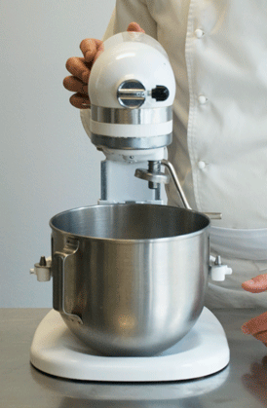 |  | 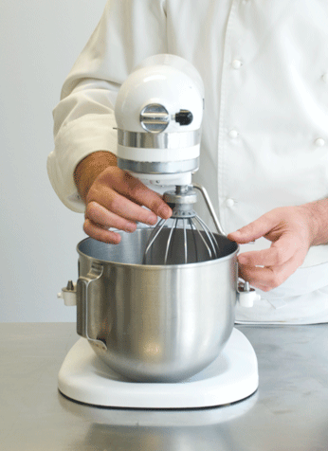
Place the bowl onto the stand and make sure it is firmly in place. | Check the speed setting is turned to zero (0) before you start. | Put in the attachment you need. This attachment is the balloon whisk, used for beating things like cream, batter or eggs.

Activity 7
Reading isntructions
Your trainer will give you a set of instructions about a piece of kitchen equipment.
1. Underline or highlight any parts of the instructions which are about safety.
2. DISCUSS - What problems could happen if you did not follow the instructions?

Safety tip
Never use equipment unless you have been properly trained in how to assemble it, use it, disassemble it and clean it safely and correctly.

Handling electrical equipment safely
You may have to use electrical equipment such as:
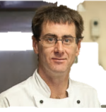
- blenders
Electrical equipment can be dangerous if you don’t use it properly. Here are some safety rules we follow at The Gums.
- food processors
- mixers
- meat slicers.

Safety Rules for Handling Electrical Equipment
DO
Check the equipment is correctly assembled.
Check cords to make sure they are not frayed or wet.
Use any safety guards which come with the equipment.
Switch off electrical equipment after use.
Before cleaning, switch equipment off and pull out the power plug.
Report any unsafe equipment to your supervisor. Then label it and remove it from the work area.
DON’T
Do not operate electrical equipment on a wet bench or floor.
Never put electrical equipment into water.
If the power point looks damaged, do not use it.
Do not put kitchen utensils into a piece of equipment that is running.
Never put your hands near any moving parts.

Section summary
Now you have completed this section you should have developed the following skills and knowledge.
Tick the box if you are satisfied that you have those skills and knowledge.
Recognise different types of equipment to use for preparing food in a commercial kitchen.
Understand the importance of choosing the right equipment for the job.
Assemble and disassemble a piece of kitchen equipment.
Know how to handle electrical equipment safely.
Notes

3 Using knives
Knives are the piece of equipment you will probably use most.

Parts of a knife
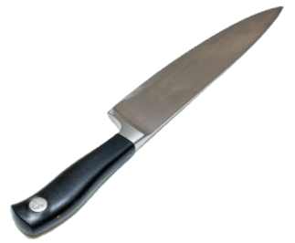
Point
Cutting edge
Heel
Tip
Bolster
Handle
Back

Point | Used to make holes.
Tip | Used to slice small items such as mushrooms or onions.
Cutting edge | Used for all cutting, slicing and chopping. Most of the knife’s work happens in the centre of the cutting edge.
Heel | Can be used to cut or chop light bones which need some force e.g. chicken or small fish.
Handle | Can be made of metal, wood or a synthetic material.
Back | Used to mark or scrape.
Bolster | A thicker strip of steel between the blade and the handle.  Helps balance the knife and makes the handle stronger.

Types of knives
Many different types of knives are used in the kitchen. Here are some common types.

Chef’s knife  The blade is 20–25 cm long.  It is wide at the heel and tapers (gets thinner) to a point.  This is the knife you will use the most e.g. for slicing vegetables. | 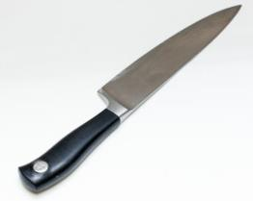
Boning knife  Thin pointed blade about 12–17 cm long.  Used for removing bones from raw meat, poultry and fish. Can also be used to separate bones at joints and trim meat.  A stiff boning knife is good for boning red meat.  A flexible (bendy) boning knife is better for poultry and fish. | 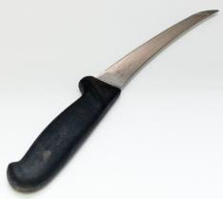
Cleaver  A heavy knife with a broad blade.  Mainly used for cutting meat into joints or pieces as it can cut through bone. | 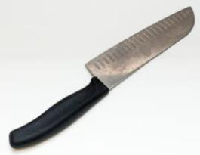
Vegetable knife or paring knife  Small with a pointed blade about 7 cm long.  Used for many small jobs in the kitchen e.g. peeling, trimming, coring, making decorative garnishes. | 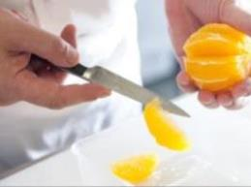
Filleting knife  Has a thin, flexible (bendy) blade from 15–30 cm long.  Good for filleting fish because it can get into hard-to-reach areas. | 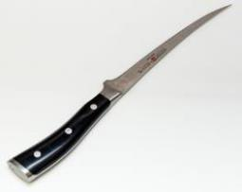
Palette knife  Used for spreading butter and other spreads such as margarine and cream cheese.  Also used for lifting small food items e.g. from baking trays. | 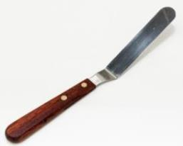

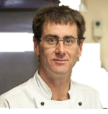
You will use the chef’s knife most because it’s best for chopping, slicing and dicing.
Activity 8
Types of knvies
Look at the following picture of knives and related equipment.
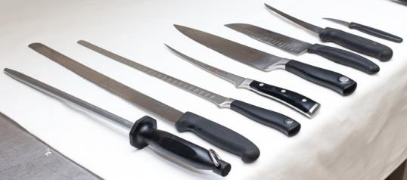
1 2 3 4 5 6 7 8

Which one would you use for these tasks?
Write the number of the knife or other tool in the box.
Slice bread or rolls
Fillet a fish
Chop a whole chicken into pieces
Peel an apple
Carve a ham or roast
Slice onions
Bone a leg of lamb
Sharpen a knife
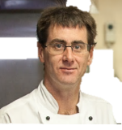
Knives are your most important tools. Look after them so they work at their best and last longer.
Knife maintenance
- Keep knives sharp.  Use a knife sharpener, steel or a stone. | 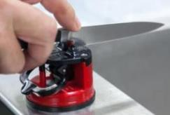
- Wash knives carefully after use.  Pay attention to where the handle joins the  blade as food may stick here.  - Don’t wash knives in the dishwasher  unless they are labelled as dishwasher safe.  - Dry knives before storing them  to prevent rust spots developing. | 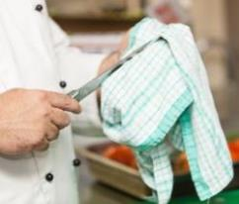
- Always use a cutting board.  Never cut on a hard surface like stone or metal. This will damage the blade. | 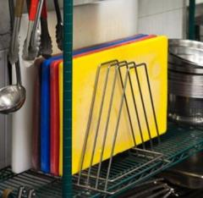

Storing knives
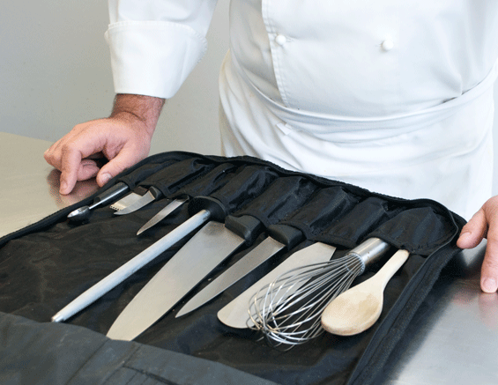
Don’t store knives loose in a drawer. The blades will get blunt and damaged.
Store them in a toolbox, knife wrap or case, a wooden storage block or magnetic knife rack.

Using a steel to sharpen knives
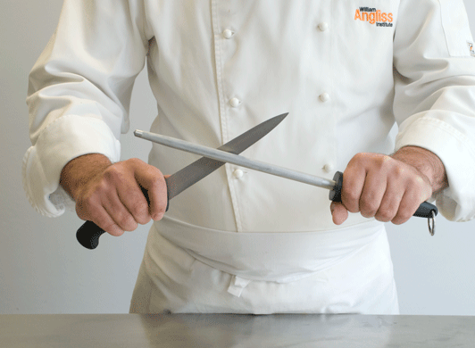 | Hold the steel firmly away from your body, at a slight angle.  Run the knife smoothly down the steel.  Start from the heel of the blade and move towards the tip.  Repeat the process on the other side.  Do this 3–6 times.  Flick your wrist to move the knife. Don’t move your whole hand or arm.
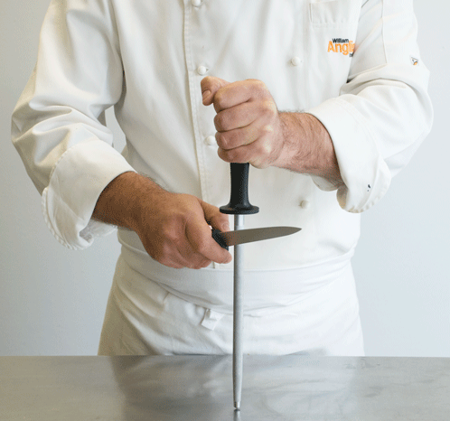 | Another method is to keep the steel steady by holding it against the bench.

Using a stone to sharpen knives
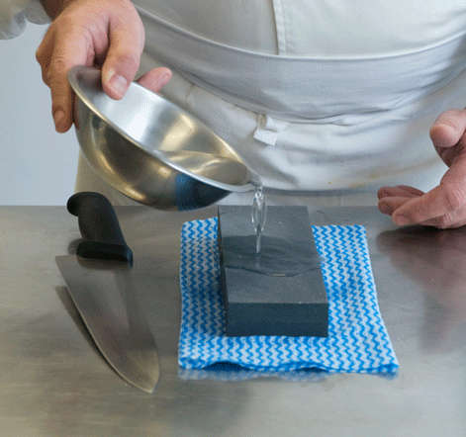 | Put a cloth under the stone.  Pour some water on the stone to allow the blade to move smoothly.
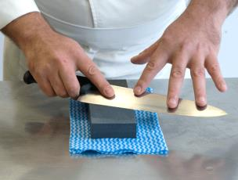 | Place knife blade on stone at a 15 degree angle (see below).  Have your fingers splayed (spread out) over the blade to get an even pressure.  Move the blade across the stone, from the tip to the heel of the blade.  Turn the blade over and do the other side.  Do 10 times on each side, turning between each time.
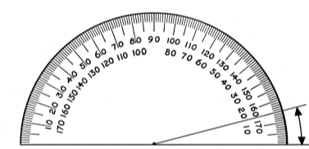
Stone
15 degrees OR 15°
Knife blade
Cutting techniques
These cutting techniques will help you use knives more confidently and safely.
Place a damp cloth underneath the chopping board to stop it from slipping. | 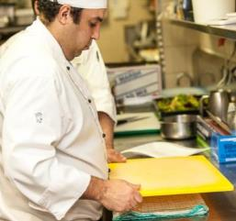
Hold the knife correctly. This means less chance of cutting yourself if the knife slips.
Some workplaces require staff to wear a protective glove on their non-cutting hand.
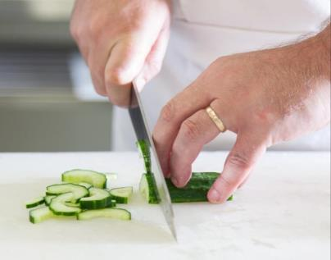
Hold the food steady with your other hand.
Keep the point of the knife on the cutting board.
Hold the knife comfortably but firmly with all fingers wrapped around the handle.
Press your thumb on the other side of the handle.
Keep your fingers curled under, out of the way of the knife blade.
You can use your hand to control the thickness of the cut.
Use the back of the knuckle of your middle finger as a guide for the knife blade.

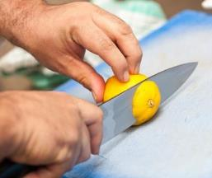
When I was learning to cut,
I practised a lot to get better at cutting uniformly and safely.
Your thumb sits behind the food.

Use the right knife for the job. Change knives between jobs as often as you need to.
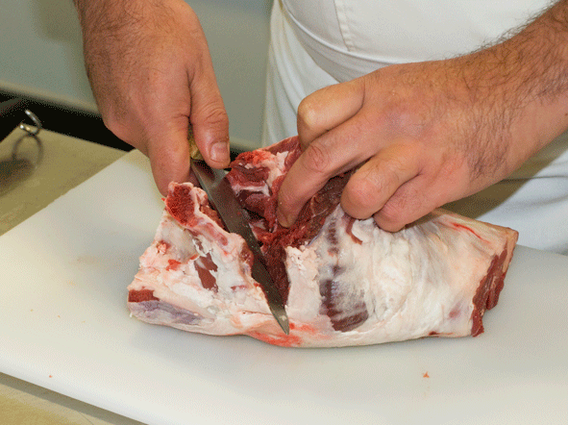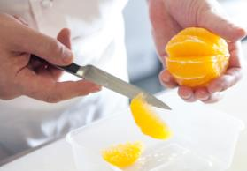

Traditional cuts
Some recipes ask for the ingredients to be cut into special shapes and sizes. These traditional cuts have French names.
I had to learn the names of the different cuts so I could follow the chef’s directions.
Brunoise  (BROON-WAAS) |  |  | Cubes  2 mm x 2 mm x 2 mm small dice  e.g. onion | 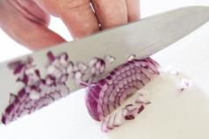
Chiffonnade  (SHIF-ON-ARD) |  |  | 2 mm thin shred  e.g. leaf vegetable | 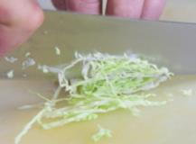
Jardinière  (JAR-DIN-YER) |  |  | Batons (stick-shaped)  4 mm x 4 mm x 20 mm baton  e.g. carrot | 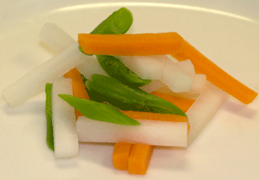
Julienne  (JEW-LEE-EN) |  |  | Strips  2 mm x 2 mm x 40 mm (match stick) size  Sometimes a longer, thinner cut is asked for  e.g. carrot, celery | 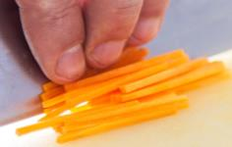
Macedoine  (MAS-E-DWAAN) |  |  | Cubes  10 mm x 10 mm x 10 mm dice  e.g. fruit salad | 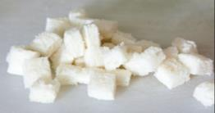
Mirepoix  (MEER-PWAH) |  |  | Rough but even cut  e.g. carrot, onion, celery for flavouring stocks and soups | 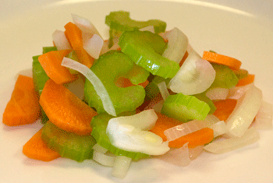
Paysanne  (PAYS-ANN) |  |  | Thin slices about 1 mm thick  Match the shape of the vegetable  Often used for garnishing soups | 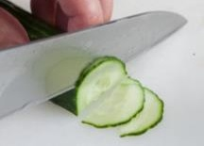
Concassé  (conk-a-SAY) |  |  | The tomatoes have been peeled, seeded and roughly chopped. | 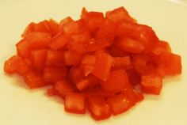
Activity 9
Using knives at work
Discuss together:
1 What knives have you used at work? What have you used them for?
2 What safety rules have you been shown at work when handling knives?
3 Is there a safety sign in your workplace about handling knives? If so, what does it say?

Handling knives safely

To walk with a knife safely
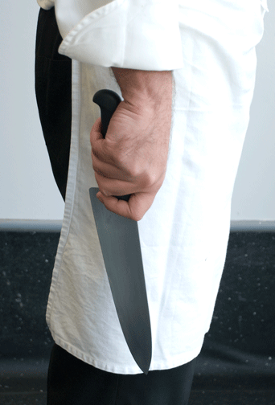
Hold it firmly, pointing down and close to your body.

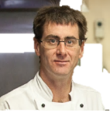
Knives cause a lot of accidents in kitchens. Here are some safety rules we follow at The Gums.

 | Safety Rules for Knives
ALWAYS … |  | WHY?
- Wash a knife before you use it.
- Wipe a knife dry with the blade pointing away from your hand.
- Check the knife is dry before you use it.
- Choose the correct knife for the job.
- Keep knives stored safely when not being used.
- To walk with a knife, carry it pointing toward the ground and close to your body.
- If your knife falls off the bench, step away. Do not try to catch it.
- To give a knife to someone, place it on the bench and let them pick it up.

 | Safety Rules for Knives
NEVER … |  | WHY?
- Never run with a knife.
- Never play with knives.
- Never throw a knife.
- Never hand a knife to someone.
- Never leave a knife on a bench with the blade facing upwards.
- Never leave a knife on a bench when it is not being used.
- Never place a knife into a sink of water and walk away.
- Never leave a knife unattended next to a washing up area.
- Never cover a knife e.g. with a kitchen cloth.

Activity 10
Knife safety
Look at the previous guidelines for knife safety.
Talk together about the reasons for each guideline.
Make a brief note beside each one.

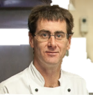
I have my own knives and I’m responsible for looking after them.
I never lend them to anyone else.
I keep them in a lockable toolbox when I’m travelling to and from work.
They are engraved with my name so I know they are mine.

Activity 11
What is wrong?
Look at the following photo of someone preparing food. One piece of equipment is being used wrongly.
What is wrong in the picture?
What could be the result?
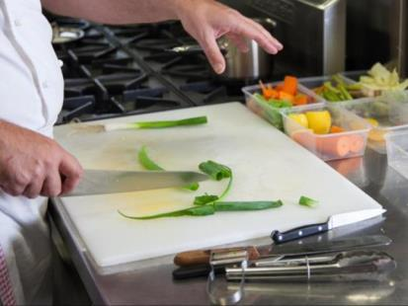

Section summary
Now you have completed this section you should have developed the following skills and knowledge.
Tick each box if you are satisfied that you have those skills and knowledge.
Know the parts of a knife.
Recognise different types of knives and what they are used for.
Know how to look after knives properly.
Use knives safely to cut a range of food.
Notes

4 Weighing and measuring ingredients
As part of mise en place, you need to weigh and measure ingredients.
Metric measurements are used in modern Australian recipes.
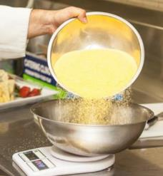
Weighing ingredients
g | grams
kg | kilograms

Use scales to weigh:
- dry ingredients e.g. flour, sugar
- butter
- fruit and vegetables.

Activity 12
Weight – How much do you need?
1 Look at the recipe for Danish apple cake in the Recipe Book.
How much do you need of the following ingredients?
Ingredient | Amount
butter
castor sugar
self-raising flour
Golden Delicious apples

2 Have a look at these scales. What is the weight shown on each one?
Scale | Weight
1
2
3
4
5
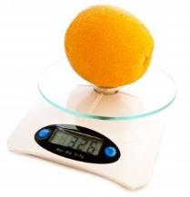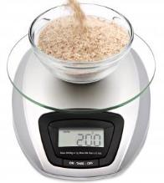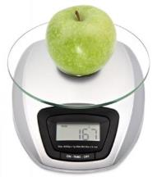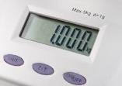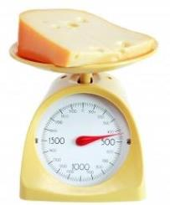

Measuring ingredients
ml | millilitre
l | litre
tsp | teaspoon
tbsp | tablespoon
Use measuring jugs, cups or spoons to measure volume (amount) of liquids and some dry ingredients such as sugar, herbs and spices.

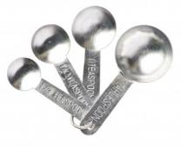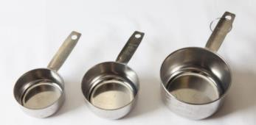

Activity 13
Volume – How much do you need?
1 Have a look at the recipe again for Danish apple cake in the Recipe Book.
How much volume do you need of the following ingredients?
Ingredient | Amount
Ground cinnamon
White sugar

2 Have a look at the recipe for Onion rings in tempura batter. How much liquid do you need for the following ingredients?
Ingredient | Amount
Soda water
Mayonnaise

3 On the following jug, draw two lines to show where you would fill it up to for:
- the soda water
- the mayonnaise.
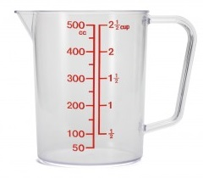

Activity 14
How much is in the jug?
Look at the following jug. The arrows point to different volumes in the jug.
How much is in the jug at each level? Write down the volume next to each arrow.

Maths is good for the environment!
Doing your sums right is good for the environment – it means less food gets thrown away. If you prepare too much, the extra gets wasted, especially with food that spoils (goes bad) quickly.

Calculating ingredient requirements
When you are using a recipe for the first time, take the time to read it carefully so you know exactly what is required – the ingredients, quantities, equipment, preparation and cooking methods.
A standard recipe may use these terms:
- yield – the total amount produced by the recipe e.g. 500 ml or 4 pieces
- portions – the number of individual serves e.g. 2 serves or 2 portions.
Often you need to adjust (change) the recipe quantities to produce the number of portions you need. Then you can gather the right quantity of ingredients.
To adjust a recipe, you have to multiply or divide.
It’s easy to make a mistake when you’re adjusting a recipe so I take special care.

Some maths help
Words | Fraction | Decimal fraction | How it looks
two, twice | 2 | 2.0 | 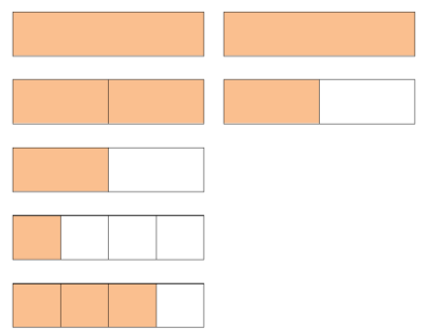
one and a half | 1 ½ | 1.5
half | ½ | 0.5
quarter | ¼ | 0.25
three quarters | ¾ | 0.75

Multiply ( x or times)
To make this much | Multiply the recipe amount by … | The maths
One and a half times as much | Multiply by 1.5 | 200 ml x 1.5 = 300 ml
Twice as much | Multiply by 2 | 200 ml x 2 = 400 ml
6 times as much | Multiply by 6 | 200 ml x 6 = 1200 ml

How does it look?
4 x 200 ml = 800 ml
200 ml
200 ml
200 ml
200 ml

4 x 200 ml = 800 ml
 | 200 ml | 200 ml
 | 200 ml | 200 ml

1 |  | 2 |  | 3 |  | 4
200 ml | + | 200 ml | + | 200 ml | + | 200 ml | = 800 ml

Divide ( ÷ )
To make this much | Divide the recipe amount by … | The maths
Half of the amount | Divide by 2 | 4 litres ÷ 2 = 2 litres
A quarter of the amount | Divide by 4 | 4 litres ÷ 4 = 1 litre
Three quarters of the amount | Divide by 4  Then multiply by 3 | 4 litres ÷ 4 = 1 litre  1 litre x 3 = 3 litres

How does it look?
¾ of 800 ml = 600 ml
200 ml
200 ml
200 ml
200 ml

½ of 800 ml = 400 ml
 | 200 ml | 200 ml
 | 200 ml | 200 ml

¼ of 800 ml = 200 ml
1 |  | 2 |  | 3 |  | 4
200 ml | + | 200 ml | + | 200 ml | + | 200 ml

Activity 15
Calculate the ingredients
Look at the recipe for Danish apple cake again in the Recipe Book. The chef is going to make 3 cakes.
How much will the chef need of each ingredient? You can use a calculator to multiply each ingredient amount by 3.
Ingredients for 1 cake | Ingredients for 3 cakes (multiply by 3)
175 g butter, softened
175 g castor sugar
3 eggs
175 g self-raising flour
500 g Golden Delicious apples
1 tsp ground cinnamon
1 tbsp white sugar

Activity 16
Calculate portions
One portion of Minestrone soup is 250 ml.
Chef has asked you to make 2 litres of the soup.

How many portions will you get from 2 litres of the soup?

Section summary
Now you have completed this section you should have developed the following skills and knowledge.
Tick each box if you are satisfied that you have those skills and knowledge.
Find out from a standard recipe how much of each ingredient is needed.
Read weights on scales and amounts on measuring jugs.
Calculate ingredient requirements.
Calculate portions.
Notes

5 Using equipment for food preparation
I’m doing the mise en place for today’s lunch menu at The Gums.
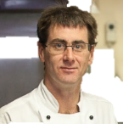
I’ll show you how we use the equipment as we go along.

Activity 17
Equipment for the kitchen
Look at the recipe for Parmesan crumbed chicken breast in the Recipe Book.
1 What equipment do you need to make the recipe?
2 What will you use each piece of equipment for?
RECIPE: Parmesan crumbed chicken breast
Equipment | What it will be used for
Here is how to use some of the equipment you will need to prepare ingredients for this recipe.
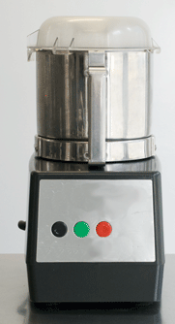
Food processor
Make the breadcrumbs in the food processor.
For a large amount of ingredients, use a large processor.
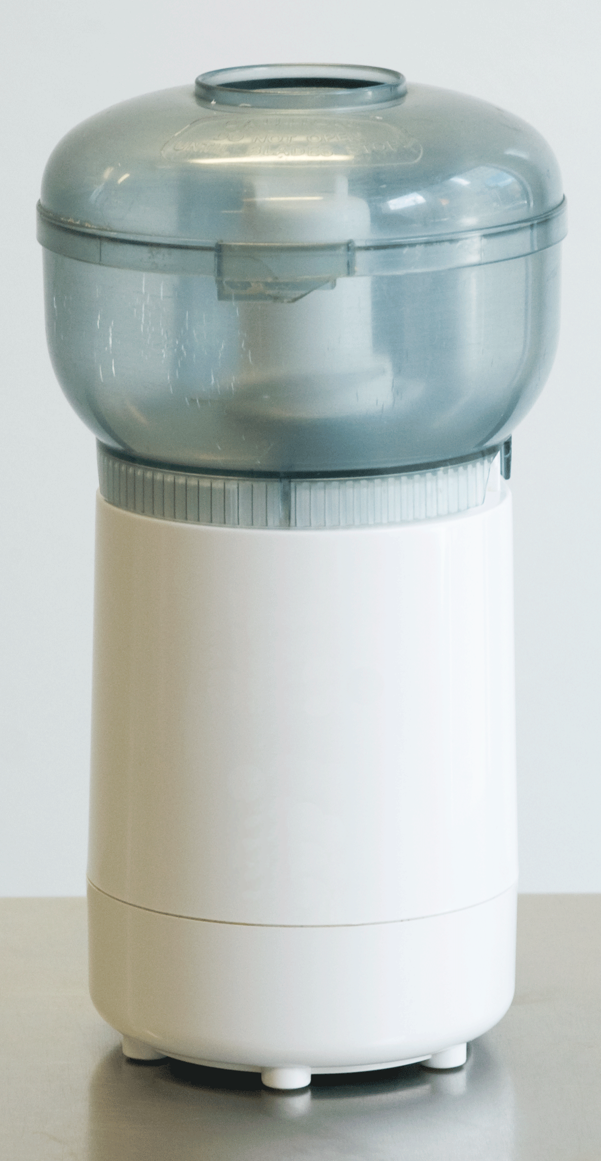

For a smaller amount of ingredients, you can use a small processor.

You can use a food processor for other food preparation tasks such as:
- chopping herbs, nuts or vegetables
- pureeing (crushing) fruit and vegetables
- blending cake ingredients
- making pastry.

Activity 18
Parts of the food processor
Label the 5 parts on this picture of a food processor.
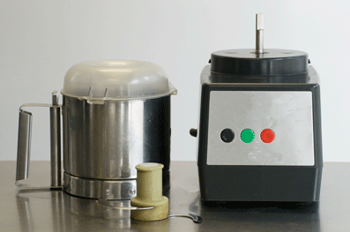
1
3
2
4
5

How to use a food processor
STEP
- Check it is unplugged.
- Check the controls are turned off.
- Put the food processor together following the instructions.
- Plug it in.
- If the ingredients are in large pieces, cut them into smaller pieces so you don’t damage the motor.
- Take the lid off and put the ingredients into the processor.
- Close the lid firmly.
- Turn on the food processor.
- Process, pausing often to stop the motor from over-heating.
- Turn off the processor and unplug it.
- Open the lid and take out the food.

Checklist – Did you do this?
Food Processor Safety Tips
Check the work bowl and blades are firmly in place before you start.
Keep your hands and kitchen utensils away from all blades and moving parts.
Never put food in with your fingers. Always use the feed tube and food plunger.
Turn off the machine and unplug before you remove food or clean the processor.
Be careful when you are washing and storing the sharp blades and disks.
Grater
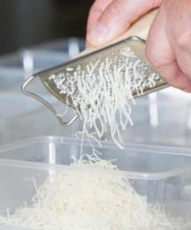
Use a grater to grate the parmesan cheese.
There are different types of graters with different sized holes, so you can:
- grate finely using smallest holes (chocolate or lemon rind)
- grate coarsely using bigger holes (semi-soft cheese e.g. mozzarella or hard food e.g. potato or carrots)
- slice hard food using single slit (carrots or hard cheese)
- zest (grate long thin strips) the rind of lemons and oranges using small holes.

How to use a grater
- Spray the grater lightly with cooking oil to make grating easier.
- Hold the food firmly and push it down over the holes.
- Grate food onto a cutting board or directly into a bowl.
- Be careful not to grate your fingers or knuckles.
- Rinse the grater in hot water as soon as you finish so food does not dry on.
- If food does stick, soak the grater in hot water and then scrub it with a brush.

Activity 19
Using a grater
Which parts of the graters in the picture would you use for each task?
Write the number/s in the box.
Task | Number/s
Slice carrots
Grate lemon rind finely
Zest orange rind
Grate hard cheese
Grate parmesan cheese finely

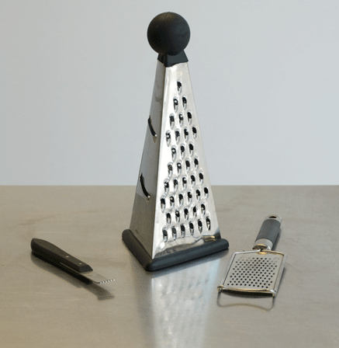
1
3
2
4

Chef’s knife
Cut the crusts off the bread before you make the breadcrumbs.
Chop the parsley.
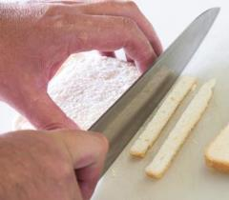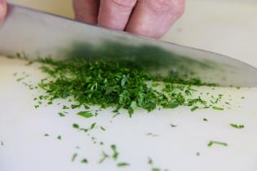

Measuring spoon
Measure the dried herbs.
Level the ingredient off in the spoon with a knife.
You need to be exact with small amounts as the ingredients often have very strong flavours.

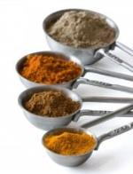

Whisk
Use a whisk to beat the eggs for coating the chicken.
A whisk can also be used to:
- blend ingredients smoothly e.g. sauces
- aerate (mix air bubbles through) a mixture so that it froths up e.g. egg whites or cream.
Whisks can have different shapes and different numbers of wires.
- A round whisk with many wires is best for aerating. It makes the mixture light and fluffy. Use it with egg whites or cream.
- A flat whisk with fewer wires is better when you need less air. It makes the mixture smooth and dense (heavy). Use it with sauces.

How to use a whisk
- Choose a bowl that is wide enough for the movement and large enough for the ingredients to expand (get bigger).
- Hold the bowl in one arm and whisk with the other OR whisk with the bowl on a surface. Put down a tea towel to hold the bowl in place.
- Don’t stop in the middle of whisking.
The speed you whisk will affect the mixture.
If you whisk faster, more air gets mixed in to create a light foam e.g. to make fluffy egg whites.
If you whisk more slowly, you will get a denser texture e.g. to make a smooth sauce.

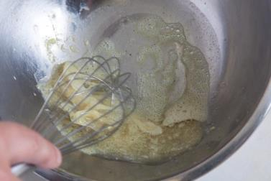

Activity 20
What else do you need for it?
Look at the other recipes in the Recipe Book.
1 Which recipes use the equipment below?
2 What are they used for?

Equipment | Recipes | What is it used for?
Grater
Chef’s knife
Measuring spoon
Whisk

Activity 21
Equipment for the vegetable spring rolls
Look at the recipe for Vegetable spring rolls in the Recipe Book.
1 What equipment do you need to make the recipe?
2 What will you use each piece of equipment for?
RECIPE: Vegetable spring rolls
Equipment | What it will be used for

Chef’s knife
Use a chef’s knife to cut the vegetables into the different shapes the recipe asks for.
Check the shapes and sizes of different cuts in Part 1 of this workbook.
Slice spring onions | 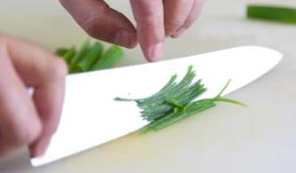
Chiffonnade cabbage | 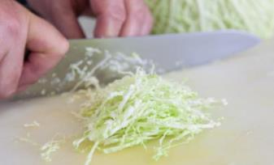
Julienne carrots | 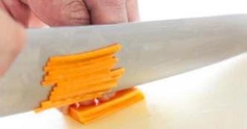
Chop mushrooms | 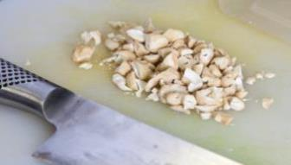
Dice onions | 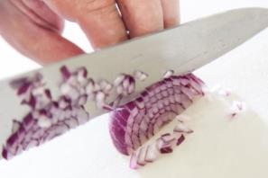

Activity 22
Cutting different shapes and sizes
Look at these recipes in the Recipe Book.
Which ingredients need to be cut to a particular shape and size?
Write down what you find out in the table below.
Recipe | Ingredients | Type of cut
Minestrone soup
Fruit smoothie
Danish apple cake
Parmesan crumbed chicken breast
Onion rings in tempura batter

Activity 23
Equipment for the beer battered fillet of fish
Look at the recipes for the Beer battered fillet of fish and the Beer batter in the Recipe Book.
What equipment do you need to make these recipes?
What will you use each piece of equipment for?
RECIPES: Beer battered fillet of fish, Beer batter
Equipment | What it will be used for

Filleting knife
Use a filleting knife to fillet the fish (take the flesh from the bones) for the beer battered fillet of fish.
The filleting knife is sharp enough to cut the fish open. | 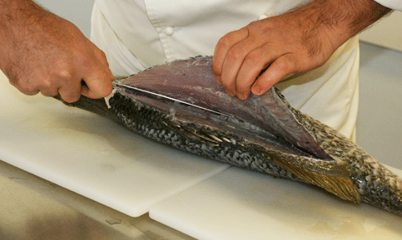
The filleting knife is flexible (bendy) so it can stay close to the bone. This means that not much flesh is wasted by being left on the bone. | 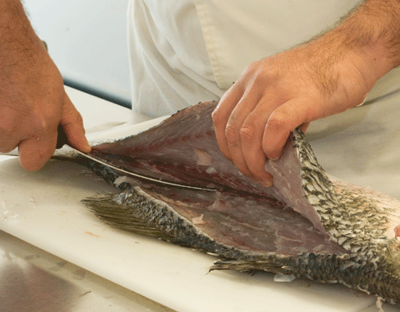
You can remove any bones using fish tweezers. | 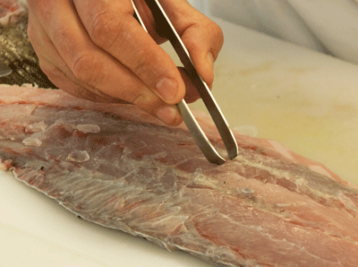

Measuring jug
Use a measuring jug to measure 400 ml of beer for the beer batter.

Activity 24
Measuring the beer
On the measuring jug, mark where you would fill it to with beer for the beer batter.

Activity 25
Equipment for the cake
Look at the recipe for Danish apple cake in the Recipe Book.
What equipment do you need to make this recipe?
What will you use each piece of equipment for?
RECIPE: Danish apple cake
Equipment | What it will be used for
Scales | Weighing butter, caster sugar, self-raising flour, apples

Electric mixer
Use an electric mixer to beat the butter, sugar and eggs for the Danish apple cake. Use the speed stated in the recipe.

How to use the mixer
- Check the mixer is turned off.
- Place the bowl securely onto the base.
- Attach the correct beaters.
- Lower the beaters down into the food.
- Check the speed is set to zero (0).
- Turn the mixer on.

Place bowl firmly onto the base.
Attach the correct beater,
then lower into the bowl.
Check the speed is set to 0 before you turn the mixer on.

Activity 26
Mixer attachments
Look at the picture of a mixer with its attachments. The mixer at your workplace may be a different type, but it will probably have similar attachments.
Which attachment in the picture would you use for each task below?
Write the number in the box.
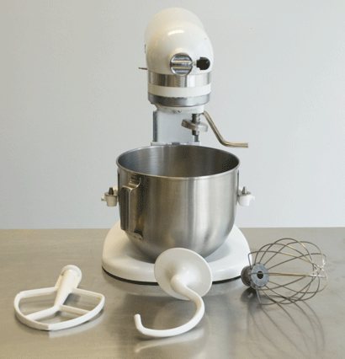
1
2
3

Task | Number
- Mix cake mixture
- Mix pastry for a pie
- Whip egg whites for meringue
- Cream butter and sugar
- Whip cream

Activity 27
Safety tips for the mixer
Read through the safety tips below.
Why is each one important?
Safety tips | Why?
- Turn the mixer off before lifting the beaters out of the bowl.
- Tie your hair back if it is long.
- Don’t wear long sleeves or loose scarves.
- Don’t put your fingers into the bowl while the mixer is running.
- Don’t put utensils such as spoons or spatulas into the bowl while the mixer is running.

Vegetable peeler
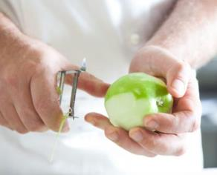
Use a peeler to peel the apples for the cake.
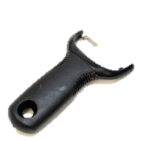

Scales
Use scales to weigh the flour for the cake.
Your kitchen may have a digital (electronic) scale or a mechanical scale.

How to use the scales
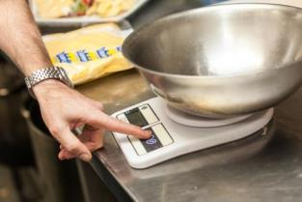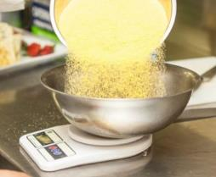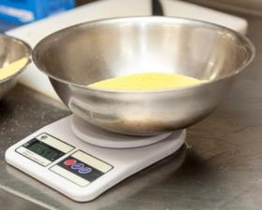
1. Place your bowl on the scale and set the scale to zero.

2. Pour in the ingredients.
3. Check when the correct weight shows on the scale.

Activity 28
Equipment for the fruit smoothie
Look at the recipe for Fruit smoothie in the Recipe Book.
What equipment do you need to make this recipe?
What will you use each piece of equipment for?

RECIPE: Fruit smoothie
Equipment | What it will be used for

Blender
Use a blender to make the fruit smoothie.
A blender chops and mixes soft foods and liquids until they are smooth. It can also be used to finely chop small amounts of hard ingredients such as nuts or even ice.
Activity 29
Parts of blender
Look at this picture of a blender. What is the name of each numbered part?
Write the number/s in the box.
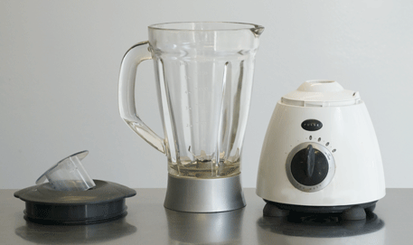
1
3
4
5
6
2

Number | Part
 | Jar
 | Base and motor
 | Controls
 | Lid
 | Blades
 | Jar base

How to use a blender
STEP
- Check the blender is turned off.
- Put liquids into the jar first, then the rest of the ingredients.
- Cut vegetables and other food items into small pieces so they don’t choke the blade.
- Don’t overfill the jar. As foods aerate, they expand.
- Check the jar is securely in place.
- Put the lid on tightly.
- Turn the blender on.
- Run the blender in short bursts or it can damage the motor.
- Wait for the blender to completely stop.
- Take the jar off the base and empty out the food.
- Wash the jar in warm water immediately after you finish.

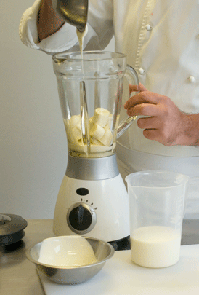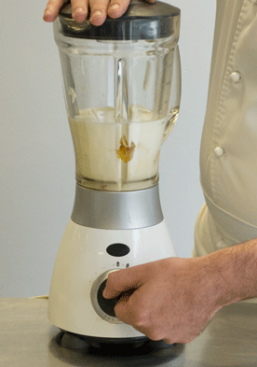
Activity 30
What can go wrong?
Read through the following mistakes some trainees made when they were using a blender.
What do you think happened?
Trainee did this | What happened?
- Sandra put a spatula into the jar to scrape down the sides while the blender was running.
- Jay forgot to put the lid on when he was pureeing hot pumpkin soup.
- Alison put 3 big chunks of pineapple in the jar to puree for a cake.
- Paddy filled the jar to the top with milk and strawberries so he could make 3 smoothies at once.

A stick blender
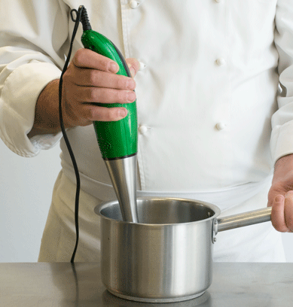
You can also use a stick blender for blending.

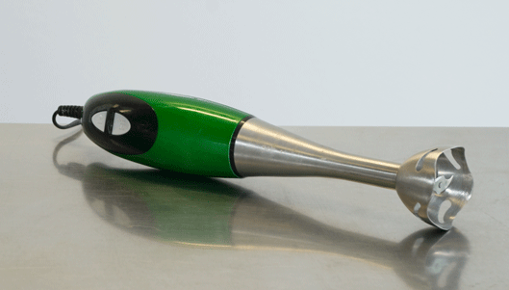
Blade and hood
Handle

Use a container with high sides.
Have the blender in the food when you turn on and off.
Keep the blade and hood fully under the food when blending.
Move the blender steadily up and down through the ingredients.
Section summary
Now you have completed this section you should have developed the following skills and knowledge.
Tick each box if you are satisfied that you have those skills and knowledge.
Use a range of kitchen equipment safely to prepare food.
Notes

6 Cleaning and maintaining kitchen equipment
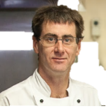
Keeping our equipment clean helps us to produce high quality and safe food for our customers.
Cleaning the equipment
Daniel may have to do these cleaning tasks at The Gums:
- disassemble equipment
- scrape and rinse
- scrub
- wash by hand or in the dishwasher
- sanitise (use a special cleaning chemical or heat) to make sure there are no germs left on the equipment
- store items safely and hygienically (with no germs).

Don’t waste water
Don’t wash things under a running tap. Fill a bucket or sink instead.
Rinse by filling up another container with clean water rather than rinsing under running water.
Only use as much water as you need. If you only need to wash a few things, don’t fill a big sink right up.
Turn off taps when they are not being used.
If any taps are dripping, let your supervisor know so they can be fixed.

Cleaning products
Cleaning products help remove stains, grease, dirt, carbon (burned food) and bacteria (germs).
Here are some types of cleaning products used at The Gums.
Cleaning product | What it does | Use it where
Detergent | Removes grease and food residue (food left on items) | cooking equipment, benches, floors, walls, plates
Decarboniser | Removes heavily burned on carbon | pots, pans, ovens
Sanitiser | Kills bacteria | benches, cutting boards, small equipment
Disinfectant | Kills bacteria, mould and fungus | toilets and hand sinks

Environmentally friendly cleaning products
Cleaning products go down the sink and into the environment – the land, the waterways and the ocean.
Environmentally friendly cleaning products are ones that don’t harm the environment after we wash them down the sink.
They may be labelled ‘biodegradable’, ‘non-toxic’, ‘phosphate-free’ or ‘green’.

Handle chemicals safely
Be careful when using or mixing cleaning products.
Some products can be harmful if you:
- swallow them
- inhale (breathe in) their fumes
- splash or spray them on your skin or in your eyes.
Many workplaces try to reduce their use of toxic (poisonous) products.
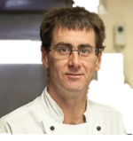
Everyone does chemical handling training when they start work at The Gums.
Check you know the rules for safe chemical handling.

Activity 31
What can go wrong?
Read this news item and discuss what might have gone wrong.
Salt mix-up at chicken store
May 23, 2013
Eleven people needed hospital treatment after they ate hot chips sprinkled with caustic soda instead of salt.  Their visit to a fast food chicken restaurant in Bunbury, south of Perth, left them with mouth and throat burns. Five children aged under 10 were among those affected.  A spokesman for the WA Department of Health said they had received a report about 7pm that an employee had accidentally put caustic soda into a salt shaker. | Caustic soda, or sodium hydroxide, is commonly used as a detergent or drain cleaner and causes chemical burns in contact with the skin.  Police, WorkSafe, the State Department of Health and the local government authority are all investigating how the caustic soda came to be in the salt shaker.  The City of Bunbury’s Environment Health Services team has started an investigation into a possible breach of the Food Act. The fast food outlet remained closed today.

Activity 32
Chemical safety rules
Read these statements about safe handling of cleaning products and other chemicals at
your workplace.
Put a tick () in the correct column for you.
Discuss with the rest of the group.
Checklist | Yes | No | Not sure
- I have been trained to handle cleaning products and other chemicals safely at work.
- In my workplace, all the cleaning products and other chemicals are stored separately from the food.
- I know where the instructions are for the cleaning products and other chemicals I have to use.
- I use the correct personal protective equipment (PPE) when I use cleaning products and other chemicals.
- In my workplace, there are no chemicals in the wrong containers or unlabelled containers.
- In my workplace, all the cleaning products and other chemicals are in clearly marked containers.
- I never spray cleaning products above my shoulder so that droplets can blow back towards my face.
- I know what to do in case there is an accident with cleaning products and other chemicals.
- I know where the Material Safety Data Sheets (MSDS) are.

I’ve been shown how to clean kitchen equipment. This checklist helps me remember all the steps.

Steps to clean equipment effectively
- Select correct cleaning product for the task.
- Disconnect electrical equipment from any power source.
- Safely disassemble (take apart) equipment.
- Soak to soften any dried-on food (if required).
- Rinse to remove any loose food.
- Apply cleaning product. | Or put in dishwasher. The water is so hot that it sanitises the equipment.
- Scrub or wipe.
- Rinse.
- Apply sanitiser (if required).
- Leave to air dry if possible.

Activity 33
Cleaning the food processor
Look at the following instructions for cleaning the food processor at The Gums.
1 Underline any parts of the procedure where you could hurt yourself.
2 What should you do so you don’t get hurt?

 |  | Safety Procedure for Cleaning Food Processor
How often | Every day after use.  Between processing different food types.
Safety | Do not clean this machine unless you have been trained.  Unplug the machine from the wall.  Use correct PPE – rubber gloves, safety glasses, rubber apron.  Be careful with sharp blades. Wipe them from the centre out.
Cleaning products | Shinee detergent diluted (mixed with water) following manufacturer’s instructions.  Sanitiser: use Blanco bleach – 2 ml per 5 litres of water. Wear rubber gloves.
Equipment | Dry brush, bucket or sink, cleaning cloth, spray bottle.  Removable parts (except the blades) can also be cleaned in the dishwasher on the top rack.

 |  | Safety Procedure for Cleaning Food Processor
Procedure | 1. PREPARE  Take the food processor apart. Remove all leftover food. Be careful of sharp blades.
2. WASH THE REMOVABLE PARTS
Wash all the removable parts of the food processor in warm water and detergent.
Do not scrub the parts with abrasive (scratchy) cleaners or pads.
Gently wipe down blades. Do not soak them in water.
Sanitise the parts with a sanitiser, or wash in the dishwasher (except the blades).
3. WIPE DOWN THE BASE AND MOTOR
Use a damp cloth to wipe down the base and motor unit.
Do not put it into water or pour water over it.
For stains that are hard to remove, rub with mild soap or a baking soda paste.
4. DRY AND REASSEMBLE
Dry the pieces of the processor completely.
Reassemble so it is ready to use.
Store in its correct place.

Cleaning the mixer
Use the same procedure (set of steps) for cleaning a mixer.
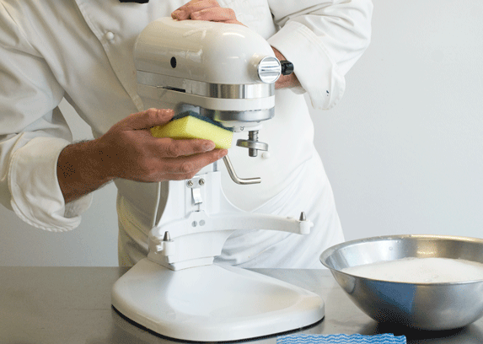 | Use a basin of warm water and detergent.  Wipe down the base and motor area. Don’t put in water.  The attachments can be washed in a dishwasher.
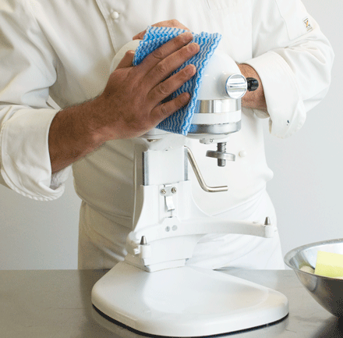 | Dry with a clean cloth.

Activity 34
Reading an instruction booklet
Look at the Table of Contents from the Quixo Food Processor booklet.
Quixo Food Processor
TABLE OF CONTENTS
Important Safety Advice . . . . . . . . . . . . . . . . . . . . . . . . . . . . . | 2
The Parts . . . . . . . . . . . . . . . . . . . . . . . . . . . . . . . . . . . . . . . . | 3
Assembling the Parts . . . . . . . . . . . . . . . . . . . . . . . . . . . . . . . | 4
Operating the Controls . . . . . . . . . . . . . . . . . . . . . . . . . . . . . . | 5
Removing Processed Food . . . . . . . . . . . . . . . . . . . . . . . . . . . | 6
Chopping and Puréeing . . . . . . . . . . . . . . . . . . . . . . . . . . . . . | 7
Slicing . . . . . . . . . . . . . . . . . . . . . . . . . . . . . . . . . . . . . . . . . . . | 7
Fruits and Vegetables . . . . . . . . . . . . . . . . . . . . . . . . . . . . . . . | 8
Hard Foods . . . . . . . . . . . . . . . . . . . . . . . . . . . . . . . . . . . . . . . | 8
Herbs . . . . . . . . . . . . . . . . . . . . . . . . . . . . . . . . . . . . . . . . . . . | 8
Meat, Poultry and Fish . . . . . . . . . . . . . . . . . . . . . . . . . . . . . . | 9
Nuts . . . . . . . . . . . . . . . . . . . . . . . . . . . . . . . . . . . . . . . . . . . . . | 9
Cheese Spreads and Dips . . . . . . . . . . . . . . . . . . . . . . . . . . . | 9
Beating Egg Whites . . . . . . . . . . . . . . . . . . . . . . . . . . . . . . . . | 10
Whipping Cream . . . . . . . . . . . . . . . . . . . . . . . . . . . . . . . . . . . | 10
Making Mayonnaise . . . . . . . . . . . . . . . . . . . . . . . . . . . . . . . . | 10
Making Crumbs and Crumb Crusts . . . . . . . . . . . . . . . . . . . . . | 11
Making Pastry . . . . . . . . . . . . . . . . . . . . . . . . . . . . . . . . . . . . . | 11
Making Breads . . . . . . . . . . . . . . . . . . . . . . . . . . . . . . . . . . . . | 12
Processing Yeast Dough . . . . . . . . . . . . . . . . . . . . . . . . . . . . | 13
Cleaning and Storing. . . . . . . . . . . . . . . . . . . . . . . . . . . . . . . . | 14
Recipes. . . . . . . . . . . . . . . . . . . . . . . . . . . . . . . . . . . . . . . . . . | 15

Questions - Reading an instruction booklet
1 Which page or pages would you look at for information on how to use the food processor safely? Mark your answer with a highlighter.
2 You are not sure whether the bowl can go in the dishwasher or not.
What page would you look at to find out?
3 You have a large, hard piece of parmesan cheese which you need to grate.
What page will give you advice on how to do this correctly?

4 Chef has asked you to take the parts of the food processor out of the dishwasher and assemble it. You have never done it before.
Which page will you look at to get some help?

Questions - Reading an instruction booklet
5 Your trainer will give you a copy of Important Safety Advice from page 2 of the Quixo booklet. Some of it is hard to understand. Look at No. 15.
15. To keep its powerful motor well ventilated, fans in the food processor base provide a stream of cooling air. To ensure proper ventilation of the motor during heavy use, place the machine so there is at least 10 cm of clear space on all sides.
This would be easier to understand if it said:
15. The motor needs air to cool it, so make sure there is at least 10 cm of clear space all around it.

Choose 2 other pieces of Important Safety Advice. Can you write them more simply?
1.

2.

Maintaining equipment

Report damaged equipment
If you notice something wrong, don’t use the equipment. Report it to your supervisor immediately.
Some examples of things you might notice are:
- frayed electrical cord
- broken switch
- screws coming loose or missing
- rattles or strange noises in the equipment
- smells, smoke or sparks coming from the equipment
- ON light or temperature gauge not working
- broken accessories
- broken handles
- no power in an electric machine.
You may need to fill in a workplace report form. Or you might have to tell your supervisor about the problem and they will fill out the form.
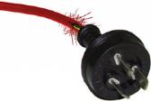

Activity 35
Reporting damaged equipment 1
In your workplace, how do you report equipment that is damaged or broken?

Activity 36
Reporting damaged equipment 2
The food processor has a frayed cord.
But you need to finish preparing the food before the chef needs it, so you decide to report it after you have finished.
DISCUSS: Is this the right decision? Why or why not?
Don’t waste electricity
You can help look after the environment by using and maintaining kitchen equipment properly.
- Report electrical equipment that is not working properly as it could use more electricity.
- Clean equipment after you have used it. This keeps the equipment working efficiently and using less energy.
- Turn off equipment when it is not being used so it does not use ‘standby’ electricity.

Make minor adjustments
You may be able to make some minor adjustments to equipment so that it works correctly. However, only do this if you have been taught to do it safely.
Some small adjustments you may learn to do are:
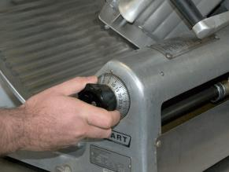
- adjust blades in the meat slicer
- sharpen knives
- adjust the speed settings on mixers or food processors
- adjust scales if they are not measuring accurately.

Activity 37
Fill in a Maintenance Request Tag
You were using an electric blender when it started making a rattling noise and giving off a burning smell.
Fill in the following Maintenance Request tag.
Say what the problem is and what you did when it happened. Use today’s date and your workplace location.

MAINTENANCE REQUEST 254875
ITEM _________________________________
______________________________________
REPORTED BY ________________________
DATE ________________________________
LOCATION ____________________________
PROBLEM _____________________________
______________________________________
______________________________________
______________________________________
______________________________________

ASSIGNED TO _________________________
DATE COMPLETED _____________________
COMPLETED BY _______________________
REMARKS ____________________________
______________________________________
______________________________________

Section summary
Now you have completed this section you should have developed the following skills and knowledge.
Tick the box if you are satisfied that you have those skills and knowledge.
Clean equipment safely.
Know how to use cleaning agents safely, including chemicals.
Follow procedures and cleaning instruction booklets for equipment.
Know how to maintain equipment correctly.
Notes

Recipe book
Onion rings in tempura batter
Portions – 2
Ingredients  1 large onion cut into rings  Plain flour for coating | Method  - Preheat clean deep fryer to 190°C.  - Separate the onion rings and coat with flour.
Tempura batter  80 g self-raising flour  40 g cornflour  250 ml very cold soda water  1 egg  50 ml garlic and paprika mayonnaise | - Sift both flours together.  - Whisk the egg and cold soda water together.  - Quickly whisk in flour.  - Mix the onion rings through the batter then place carefully into hot deep frying oil.  - Remove and drain when light golden in colour.  - Serve immediately garnished with garlic and paprika mayonnaise.  - This batter should be used immediately as it must be very cold to ensure crispness.

Minestrone soup with cheese crouton
Yield – 500 ml
Portions – 2 x 250 ml
Ingredients  20 ml olive oil  100 g carrot, celery, potato cut to paysanne  20 g sliced onion  30 g cabbage chiffonnade  20 g bacon julienne  1 clove crushed garlic  20 g tomato paste  20 g kidney beans  20 g chopped tomato  20 g cooked macaroni  20 g green beans in small slant cut – blanched  400 ml chicken stock  1 tbsp chopped parsley | Method  - Sweat the bacon and vegetables in oil.  - Add tomato paste and cook out.  - Add stock, bring to boil, and then turn down to simmer. Skim.  - Cook on a gentle simmer for about 20 minutes.  - Add the macaroni and beans just prior to serving.
Cheese crouton  2 x 1 cm slices from French bread stick (baguette)  20 g grated parmesan cheese | - Toast the bread on 1 side then turn over and sprinkle with cheese.  - Place under grill and melt cheese.  - Place as a garnish on soup just before serving and sprinkle with chopped parsley.

Vegetable spring rolls
Yield – 4 pieces
Ingredients  1 tablespoon vegetable oil  3–4 drops sesame oil  30 g spring onions, finely sliced  30 g cabbage, fine chiffonnade  30 g carrots, fine julienne  30 g mushrooms, finely chopped  30 g bean shoots  ¼ teaspoon grated ginger  ¼ teaspoon crushed garlic  ½ teaspoon soy sauce  Spring roll wrappers  Egg white | Method  - Heat oils in pan.  - Add ginger and garlic and cook briefly.  - Add remaining vegetables and allow to sweat until just tender.  - Stir through soy sauce. Remove from heat and allow to cool.  - Lay wrappers with points facing north/south.  - Brush edges with a little egg white.  - Place a portion of cold vegetable mixture onto wrapper, fold over twice. Then fold sides to the centre and continue rolling forward into a neat firm cylinder.  - Cover and refrigerate until required.  - To cook, deep fry rolls at 180°C until golden brown.

Parmesan crumbed chicken breast
Portions – 2
Ingredients  4 slices white bread – crust removed  20 g parmesan finely grated  1 tsp dried mixed herbs  Flour for coating  2 eggs whisked for coating  2 chicken breasts – skin removed  Olive oil  Pinch each salt and white pepper  Cooked tomato concassé  Finely chopped parsley | Method  - Place bread into food processor and work until a fine crumb is achieved.  - Place crumbs on a flat tray and place in an oven at 100°C until dried out.  - Allow crumbs to cool then mix in parmesan and herbs.  - Cover chicken breasts with plastic wrap and using a mallet or rolling pin, flatten to an even thickness.  - Place chicken through flour, then egg wash, then parmesan crumb mix.  - Place crumbed chicken on a tray or plate, cover and refrigerate for at least 30 minutes before cooking.  - Heat oil in pan and add chicken.  - Cook to light golden colour on both sides.  - Place on absorbent paper to drain excess oil.  - To serve, plate the chicken and garnish with cooked tomato concassé and chopped parsley.

Beer batter
Yield – 600 ml
Ingredients  200 g plain flour  2 tsp baking powder  1 pinch salt  400 ml beer | Method  - Sift flour, baking powder and salt together.  - Make a bay in the centre and pour in beer.  - Whisk beer into flour until all lumps have been removed.  - Pour through a fine strainer to remove excess lumps.

Beer battered fillet of fish
Portions – 2
Ingredients  2 fillets of fish e.g. whiting  100 g plain flour  Pinch salt and pepper  250 ml beer batter  Cooking oil (for deep frying)  60 g tartare sauce  4 lemon wedges  2 large sprigs flat leaf parsley | Method  - Preheat the deep fryer to 180°C.  - Pat fish pieces dry with clean kitchen paper then lightly season with salt and pepper.  - Pass fish through flour to lightly dust, then dip into beer batter, ensuring an even coating. Allow excess to drip off.  - Carefully lay the pieces of fish into the hot oil (don’t drop from a height as this will cause oil to splash).  - Using a deep frying lifter, gently move and turn the fish pieces until an even light golden crust is formed.  - Lift fish pieces out, allow to drain well, then place onto absorbent paper.  - Serve immediately or keep warm until required (the longer the fish sits the more soggy the batter will become).  - Serve with tartare sauce and lemon wedges.  - Garnish with sprigs of parsley.
Danish apple cake
Portions – 8
Ingredients  175 g butter, softened  175 g castor sugar  3 eggs  175 g self-raising flour  500 g Golden Delicious apples, sliced thinly  1 tsp ground cinnamon  1 tbsp white sugar | Method  - Preheat oven to 180°C. Grease a 22 cm round cake tin.  - Beat butter and sugar with an electric mixer until the mixture is light and fluffy. Beat in eggs, one at a time. Sieve flour into mixture and fold in thoroughly. The mixture will be quite stiff.  - Peel, core and quarter apples, then slice them thinly.  - Spread half the mixture in the bottom of the cake tin and cover with half the sliced apple. Cover with the rest of the mixture and arrange the remaining apple in a wheel pattern over the top.  - Mix cinnamon and white sugar, then sprinkle over the apple.  - Place in the centre of the oven and bake for 35 minutes.  - To check if it is ready, insert a skewer in the centre; it should come out clean.

Fruit smoothie
Portions – 2
Ingredients  ½ cup fruit, diced e.g. peaches, bananas, pineapples, strawberries, mangos  ¾ cup plain yogurt  1 cup milk  1 tbsp sugar (optional) | Method  - Peel the fruit, if appropriate, and cut up into small pieces.  - Put all the ingredients into a blender and puree them together until smooth.  - Pour into a chilled glass and serve with a straw.

Key words
Word | Meaning
abrasive | Scratchy
accurate | Exact
adjust | Change
aerate | Mix air bubbles through
assemble | Put together
bacteria | Germs
baton | Stick-shaped
calibrate | Adjust
dense | Heavy
diluted | Mixed with water
disassemble | Take apart
expand | Get bigger
fillet (a fish) | Take the flesh from the bones
flexible | Bendy
food residue | Food left on items
hygienic, hygienically | With no germs
inhaled | Breathed in
mise en place | Gather all the equipment and ingredients you need before you start work
offset | Not on the same level
portions | The number of individual serves produced by a recipe
procedure | Set of steps
purée | Crush or mash finely
quantity | Amount
rigid | Stiff
sanitise | Use a special cleaning chemical or heat to get rid of germs
select | Choose
specialised | Used for particular a purpose
splayed | Spread out
tapers | Gets thinner
toxic | Poisonous
utensils | Kitchen tools
volume | Amount
yield | The total amount produced by a recipe
zest | Finely grate

