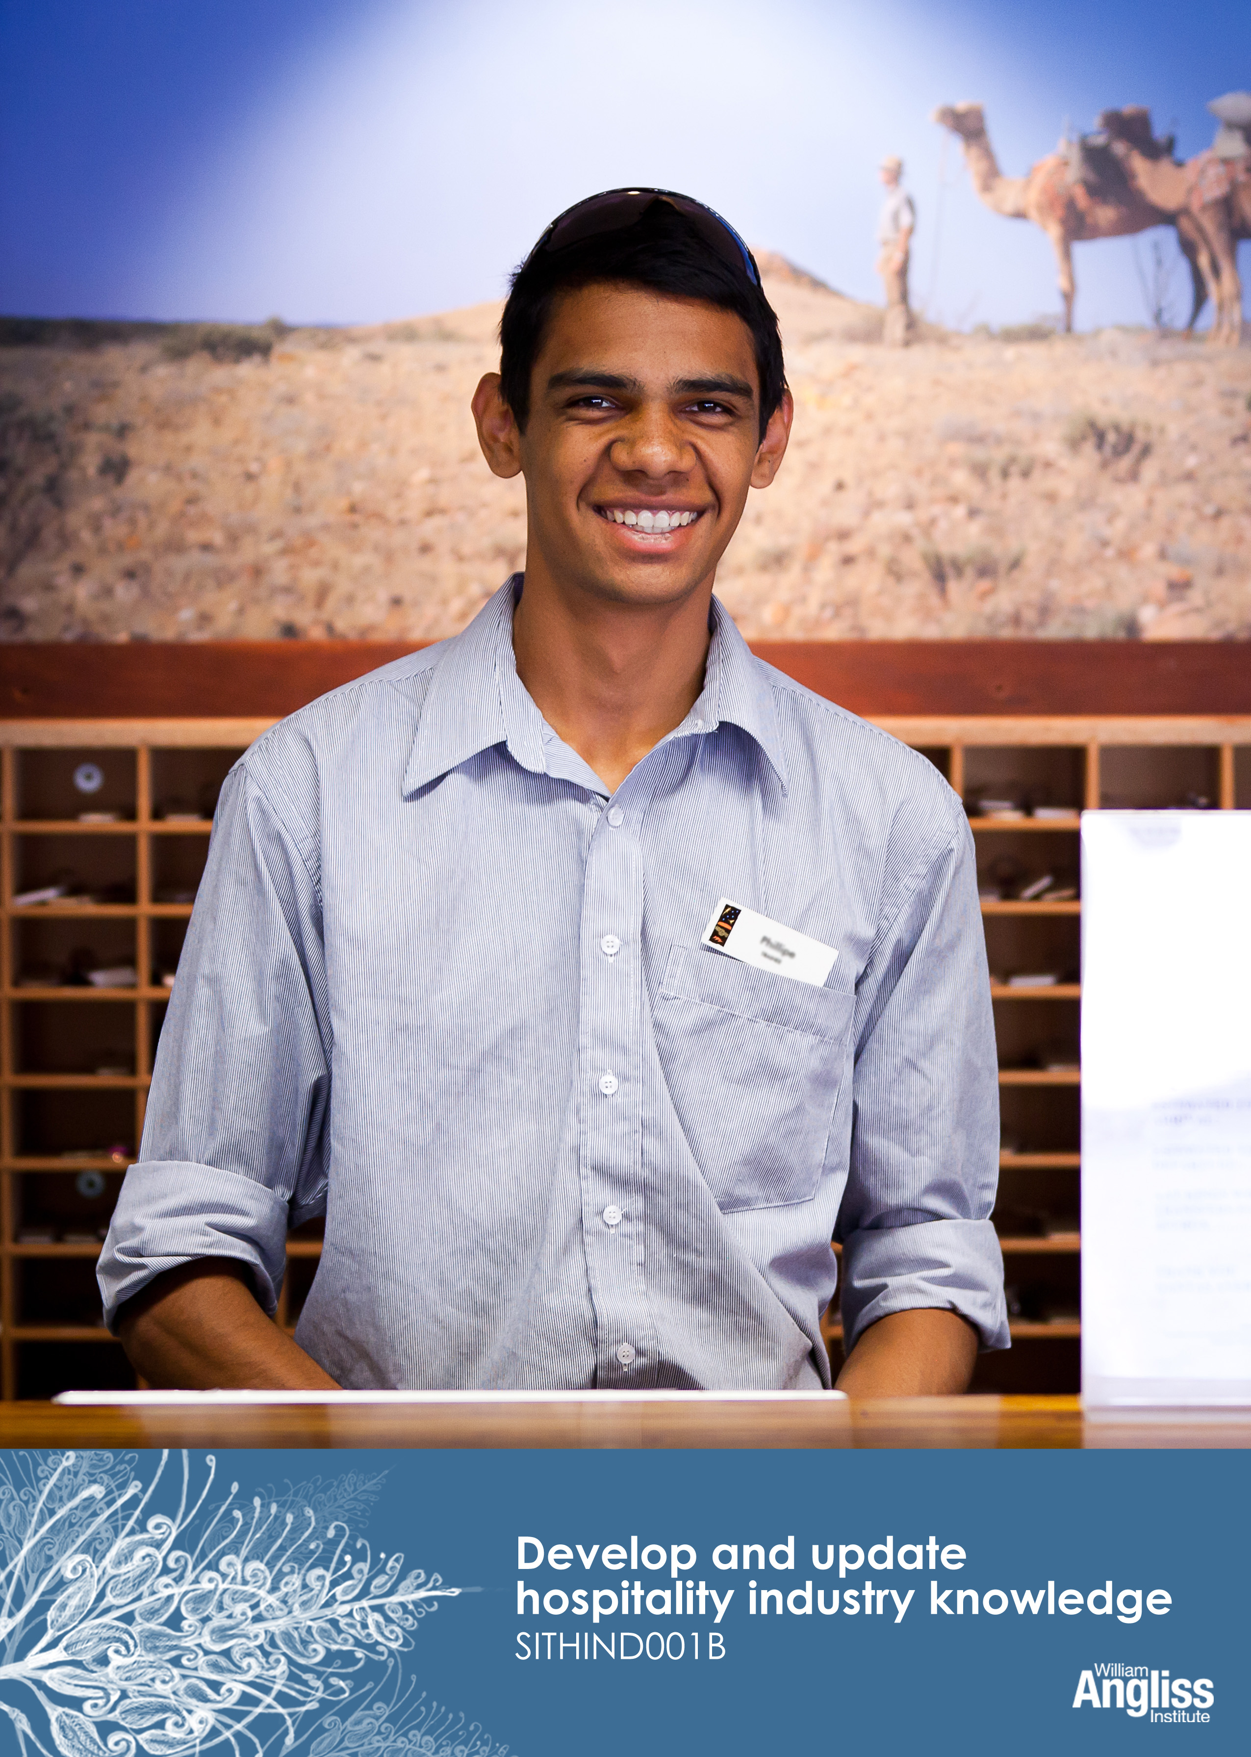

© Commonwealth of Australia. 2012
CC BY-NC-SA
This work is copyright. Except where otherwise indicated, and save for the Commonwealth Coat of Arms, the Department has applied the Creative Commons Attribution-Noncommercial-Share Alike 3.0 Australia Licence to this work.
The Department of Education, Employment and Workplace Relations must be attributed as the author of the Department’s copyright material.
As far as practicable, material for which the copyright is owned by a third party has been clearly labelled. The Department has made all reasonable efforts to ensure that this material has been reproduced on this website with the full consent of the copyright owners.
Requests and enquiries concerning the Department’s copyright material should be addressed to:
The Copyright Officer
Department of Education, Employment and Workplace Relations
Location code C148CW2
GPO Box 9880 Canberra ACT 2601
Or emailed to copyright@deewr.gov.au
Funded under the Workplace English Language and Literacy (WELL) Program by the Australian Government Department of Education, Employment and Workplace Relations.
The views expressed in this publication do not necessarily represent the view of the Minister for Education or the Australian Government. The Australian Government does not give any warranty nor accept any liability in relation to the contents of this work.

ISBN 978-1-922108-00-5

Development Team
Content | William Angliss Institute  Macsmith and Associates
Photography & graphics | Benjamin B Photography
Acknowledgments
We would like to acknowledge the generous support of the following organisations and the Indigenous learners and employees in those venues for giving their permission for photography:
Ayers Rock Resort, Yulara, NT
Charcoal Lane Restaurant, Fitzroy, Vic
Lux Foundry Café, Brunswick, Vic
Peninsula Palms (Compass Group Australia), Dampier, WA
Permissions
We would like to acknowledge the following organisations who have granted permission for their copyright materials to be incorporated in this resource:
Discover Hospitality
News Limited
Service Skills Australia
Reed Magazines
Cultural Warning
People of Aboriginal or Torres Strait Islander descent should be aware that this publication contains images of people who may be deceased.
Disclaimer
Every effort has been made sure that this booklet is free from error or omissions. However, you should conduct your own enquiries and seek professional advice before relying on any fact, statement or matter contained in this book. William Angliss Institute of TAFE is not responsible for any injury, loss or damage as a result of material included or omitted from this course.

Contents

Welcome vi
Icons vi
What you will learn vii
1 The hospitality industry 1
Hospitality businesses 2
Hospitality businesses 5
Hospitality employment 6
Hospitality training 11
Career pathways in the hospitality industry 13
Here are some possible jobs you might get if you do these qualifications. 13
Training pathways 14
Hospitality, tourism and retail 17
The tourism industry 19
Hospitality support services 21
Section summary 23
2 Keeping up to date 24
How can I keep up to date? 25
Sources of information 26
Industry unions 28
Keeping up to date with technology 30
Industry working conditions 33
Legal controls on working conditions 34
Share your knowledge 35
Change in the industry 36
Section summary 38
3 Quality Assurance 39
Quality Assurance and your work 41
Section summary 43

4 Employability skills 44
Developing employability skills 50
Section summary 52
5 The law and the hospitality industry 53
A quick guide to hospitality legislation 54
Duty of care 57
Social responsibility 59
Section summary 60
6 Ethical behaviour at work 61
Confidentiality 62
Tipping 63
Taking property 63
Accepting gifts 64
Prices and charging 64
Section summary 66
Key words 67

Welcome
Icons
These signs tell you what type an activity is:
Do this activity in a big group.
Do this activity in a small group.
Do this activity in pairs.
Do this activity by yourself.
Do this activity using the internet.
If you are not connected to the internet, your trainer will provide you with another activity.
Do this activity in your workplace.
If you are not in a workplace, your trainer will provide you with another activity.

What you will learn
The hospitality industry has many different types of businesses and a jobs. There is a lot of information about the industry. To work in the hospitality industry it is important to be be able to find and understand this information. This will help keep you up to date with your work as you continue in your career.
In this workbook, you will learn:
- the different parts of the hospitality industry and jobs in the industry
- how to keep up to date with information about the industry and jobs
- how to make sure you produce high quality work
- how to develop employability skills
- about the law and the hospitality industry
- how to behave in an ethical manner at work.

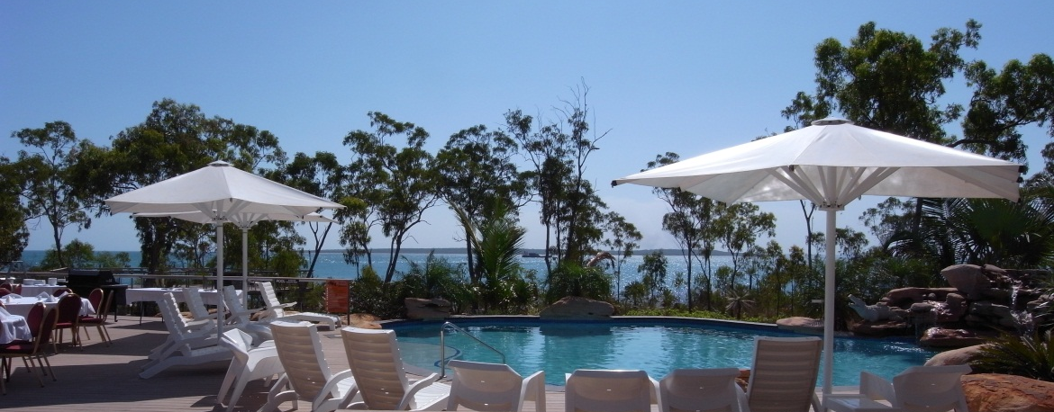

1 The hospitality industry
The hospitality industry provides food and accommodation services. In August 2011, the industry employed approximately 788,800 people (6.9% of the Australian workforce).
Service Skills Australia, Tourism Hospitality and Events Environmental Scan 2012,
<www.serviceskills.com.au>
Activity 1
Hospitality jobs
What jobs might all these people do?
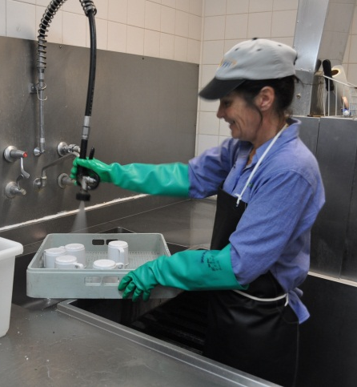
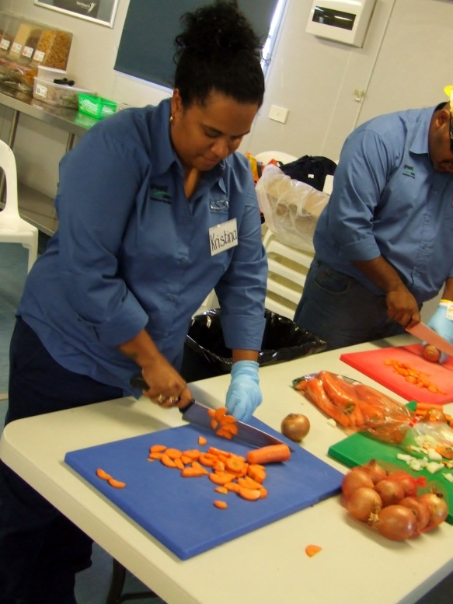

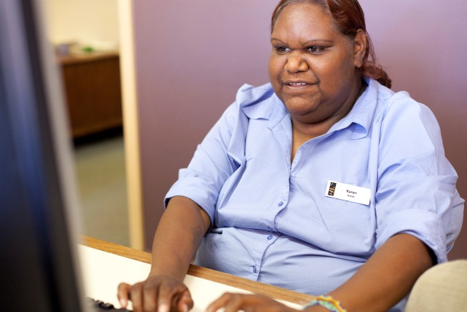

Hospitality businesses
The hospitality industry has many different types of businesses. Some common ones with their main activities are listed in the following table.
Activity 2
Hospitality businesses
Can you think of examples for each type of hospitality business? Your examples could be local, interstate or international.

Hospitality business | Main activities | Examples
Restaurants | Produce and serve food to be eaten on the premises.  May be licensed to sell alcohol.  May have a speciality e.g. Thai, vegetarian, tramcar restaurant, sea view.
Cafés | More casual than a restaurant.  Usually counter service.  Serve cheaper meals, snacks and coffee.  No alcohol served in cheaper ones.  Often only operate in daytime.
Fast food outlets | Includes roadhouses, fish and chip shops, fast food chains, fried chicken shops, donut and hot dog vans and food courts.  A lot of fast food is pre-prepared and kept on display for quick sale.
Hotels and pubs | Provide accommodation.  At different standards, up to 5 star-rated.  Can have many departments, including food and beverage, functions, housekeeping.  May have facilities such as bottle shops and gyms.
Motels | Provide accommodation and a basic breakfast.  Cater for travellers so are often at the side of roads.
Clubs | Clubs serve their members; non-members have to be signed in.  May have accommodation, restaurants, bars, function areas, gyms and gaming.
Bars | Focus is mainly on serving alcohol, with some food.
Casinos | Similar to 5 star hotels, but have a large gaming area with specialist staff.  Often have restaurants, bars, function facilities and shops.
Convention centres | Specialise in conferences for large groups of people.  Include conference rooms of varying sizes.
Nightclubs | Focus on bar and entertainment at night.  Food is generally not as important.
Resorts | Provide accommodation, food and beverage in attractive locations.  Offer other services including functions, conferences, nightclubs, sporting activities, entertainment and leisure activities.  Often designed so the guest don’t have to leave the premises so may have retail and hairdressing facilities as well.

Hospitality businesses
Hospitality businesses can be divided into three main categories.
- Commercial – provide services to consumers for a profit.
- Industrial – provide services to employees in their workplace.
- Institutional – provide services to residents, inmates or patients.
All the businesses in the previous table were commercial.
Activity 3
Types of business
1. Put these hospitality businesses into the right category.
 | Nursing homes |  | Wedding and party caterers
 | Backpacker hostels |  | Prisons
 | Caravan parks |  | Mining camps
 | School canteens |  | Film crew catering
 | Take-away restaurants |  | Hospitals
 | Licensed clubs |  | Defence forces
Commercial  Provide services to consumers for a profit |  | Industrial  Provide services to employees in their workplace |  | Institutional  Provide services to residents, inmates or patients

2. Can you think of any other types of hospitality businesses?
Hospitality employment
The hospitality industry is mainly made up of small businesses. 85% of hospitality businesses employ less than 20 people.
A large hospitality business, like a big hotel, can have many different departments. A smaller business, like a café, may only have one or two.

Activity 4
Hospitality departments
What tasks might employees do in each of these 10 departments?
Department | Tasks
Food and Beverage
Kitchen
Front Office
Housekeeping
Sales and Marketing
Accounts and Finance
Human Resources
Leisure
Maintenance
Security
Front-of-house and back-of-house
Hospitality departments are often divided into front-of-house and back-of-house.
- Front-of-house (FOH) is where staff normally deal directly with customers.
- Back-of-house (BOH) is where staff don’t normally deal directly with customers.

Activity 5
FOH or BOH?
Go back to the table of departments in the previous activity. For each department, write one of these:
FOH = Front-of-house
BOH = Back-of-house.

Activity 6
Describe a hospitality workplace
If you are currently in a workplace, describe it.
If not, choose a hospitality business you know and describe it.
a) What type of business is it?

b) What departments does it have?

c) If accommodation – how many rooms?

d) How many staff are employed?

e) Does it have a liquor licence?

f) Who owns it?

Activity 7
Find out about these jobs
1. Go to this website <http://careersgateway.serviceskills.com.au/>
2. Click on the drop-down arrow
3. Click on Hospitality

4. Click on SEARCH
Activity 8
Describe a job
Choose three jobs from the website in the previous activity.
Write down here what you found out about them.
- Job 1:

- Job 2:

- Job 3:

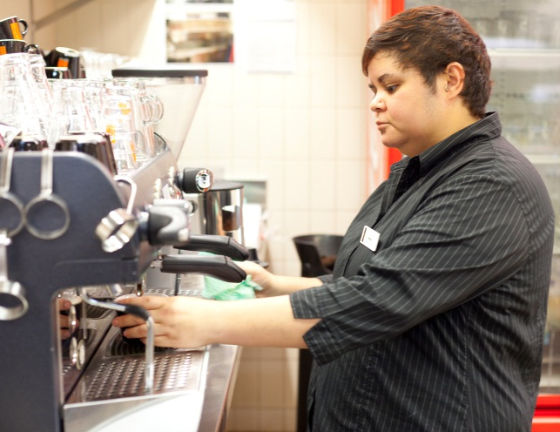

Activity 9
Share your information
In a small group, tell other learners about the jobs you have researched.
Write some notes about 2 different jobs other learners talked about.

- Job 4:

- Job 5:
Hospitality training
To learn new skills, you need to do training.
1. National qualifications
Courses that give you a national qualification are run by TAFEs and private training providers. These qualifications are accepted by employers all over Australia. Different qualifications train you at different levels and for different jobs. Some examples are:
- Certificate I in Hospitality (Kitchen Operations)
- Certificate III in Commercial Cookery
- Certificate III in Tourism (Retail Travel Sales)
- Advanced Diploma of Hospitality.
2. Industry licence courses
For many hospitality jobs you need an industry licence. The most important ones are:
Food safety courses, e.g. Hygiene for Food Handlers
- Responsible Service of Alcohol (RSA)
- Responsible Service of Gaming (RSG)
- TAB courses.
These courses are also run by TAFEs and private training providers.

3. In-house training
Once you are employed, your employer may give you in-house training such as emergency and evacuation procedures, food and beverage preparation and service. This training is important but it does not give you a national qualification.
Activity 10
RSA training
Google ‘RSA training provider’ plus your state or territory.
Find a training provider near you who provides RSA training.
- Who is the provider of the course? Is it a TAFE or a private training provider?

- Where can you do the course? Or can you do it online?

- How long is the course?

d) What is the cost of the course?

Career pathways in the hospitality industry
Here are some possible jobs you might get if you do these qualifications.
Qualification | Housekeeping | Kitchen | Front Office | Food and Beverage | Gaming
Diploma  Advanced Diploma  Degree | Rooms Division Manager | Executive Chef | General Manager  Duty Manager  Front Office Manager | Catering Manager  Venue Manager  Restaurant Manager | Club Manager  Gaming Manager
Certificate IV in Hospitality | Housekeeping Supervisor  Butler | Chef  Sous Chef  Chef De Partie | Night Auditor  Front Office Supervisor | Restaurant or Catering Supervisor  Sommelier | Gaming Supervisor  Games or Promotions Director
Certificate III in Hospitality | Floor Supervisor | Short Order Cook  Cook  Patissier | Cashier  Front Office Supervisor | Food and Beverage Attendant  Restaurant Cashier  Host or Hostess | TAB or Keno Operator
Certificate II in Hospitality | Housekeeping Attendant  Public Area Cleaner  Laundry Attendant | Sandwich and Salad Hand  Catering Assistant | Clerical Assistant  Guest Service Agent  Reservationist  Concierge | Snack Bar Attendant  Barista  Bottle Shop Attendant  Coffee Shop Attendant  Store Person  Bar Attendant  Bus Person  Bar Useful | Gaming Attendant
Certificate I in Hospitality |  | Kitchen Attendant | Bell Desk Attendant  Porter  Valet |  | Door Steward  Cloak Room Attendant  Change Steward
Adapted from: Pathways to your Career in Tourism and Hospitality, Tourism Training Australia, <www.tourismtraining.com.au>
Where are you?
Underline or highlight the qualification you are doing, and the job you are training for.
Training pathways
 | Qualifications & Training | What does it involve?
Further experience  and training | Degree  Advanced Diploma  Diploma  Certificate IV | Management jobs usually require a lot of practical industry experience and study at a higher level.
Apprenticeship  while working | Certificate III | Get a qualification on the job.  Your workplace experience can be recognised and counted towards the qualification.  Your employer may support you by allowing you to attend some training part-time.
Traineeship  while working | Certificate II | Combine on the job work experience with training.  Usually lasts for twelve months.  The training may all be done on the job or be a combination of on the job and off the job.
Entry level | Certificate I | At TAFE or with a private training provider.  Could be full-time or part-time.  Could include some work experience.
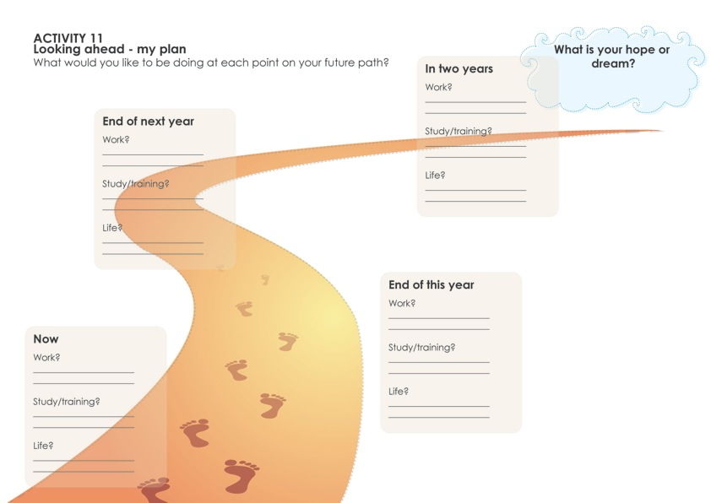

Activity 12
Find a mentor
Ask someone to spend a bit of time with you every week or so. Half an hour would be a good start. Choose someone you respect who has had some experience in the business. It could be someone from outside your workplace.
- Ask them about their views, opinions and experiences.
- Listen to them carefully.
- Talk about your experiences.
- Ask them questions you have.
Asking a person to be your mentor is a compliment to them. It also shows you are serious about your job.
This is a big step, but worthwhile. Maybe it is something you can do later, not right now.

Who could you ask?

Hospitality, tourism and retail
We often talk about hospitality and tourism together.
Tourists are people who travel on a holiday. They may be from Australia or overseas. They may travel by plane, bus, rail, ship or car.
They may visit tourist attractions. And they may use travel agents and tour guides to help them.

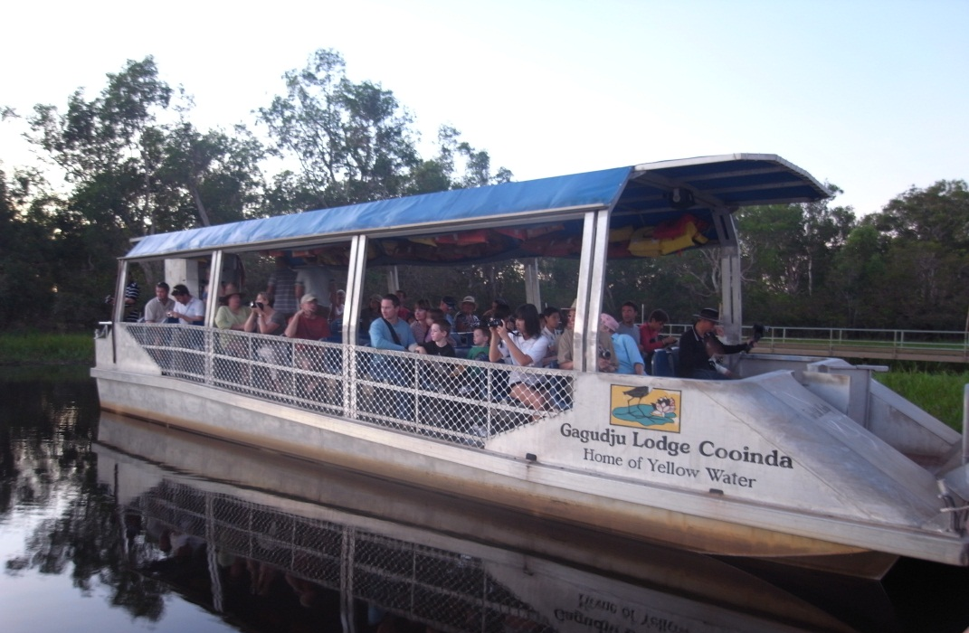

Tourists use hospitality services such as accommodation, food and beverage, and entertainment services. They also use retail (shopping) services.
So where tourists go, hospitality businesses have customers.
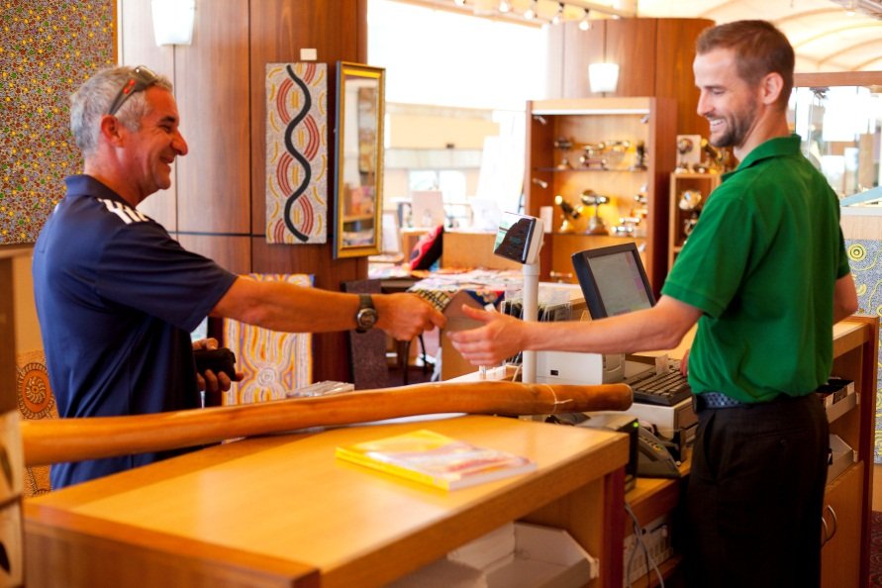

Activity 13
Hospitality, tourism and retail
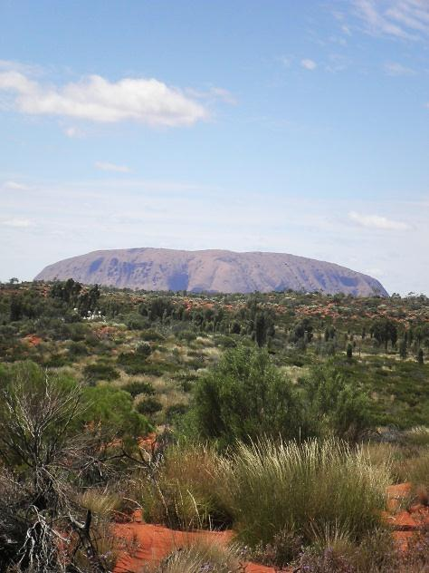
A family from Melbourne goes on a 1-week holiday to Uluru.
Before they go they will do these things.
Visit a travel agent to book a travel and accommodation package.
Buy a guide book to Uluru.
Buy a small camera.

While they are away, they will do these things.
Fly to Alice Springs.
Hire a car to drive to Uluru.
Stay at Yulara Resort for 4 nights.
Eat breakfast there every morning.
Ask for advice about the weather from the information centre.
Do an organised daytrip to Kata Tjuta.
Eat in one of the resort restaurants at night.
Order room service one night.
Buy drinks and snacks at the shop.
Walk the base of Uluru with an Indigenous guide.
Swim in the resort pool.
Buy a piece of Indigenous art work from the resort gallery.
In the box for each activity above, write T for Tourism, H for Hospitality or R for Retail.

The tourism industry
The tourism industry has different sectors.
Sector |  | What do they do? | Examples
Travel agents |  | Make travel bookings for customers.  Work with other businesses (such as hotels, tourist attractions, hire car companies) to develop ‘packages’ to sell to customers.
Tours |  | Show and explain interesting places and experiences to tourists.  May be short tours, long tours or specialised tours.
Tourist attractions |  | Staff on-site – display, demonstrations, catering, reception, gardening and maintenance.
Events management |  | Arrange events such as conventions, festivals, and exhibitions.
Activity 14
Tourism sectors
Put these examples in the right sector: Harvey World Travel ATP Bus Tours Sydney Aquarium Melbourne Cup Festival
Can you think of another example for each sector?

Activity 15
Research the tourism industry
Go to one of these websites.
1. The Hyatt – a 5 star hotel offering meeting and convention services
<http://www.hyatt.com/hyatt/meetings/index.jsp>
2. Mossman Gorge Visitor Centre – an Indigenous cultural visitor centre
<http://www.mossmangorge.com/>
3. Holiday Special Packages Travel – a travel agent that organises package holidays
<http://www.hsptravel.com.au/>
4. Tourism Western Australia – a state government tourism site
<http://www.tourism.wa.gov.au/>
5. AAT Kings – a camping coach tour company
<http://www.aatkings.com.au/>
6. A region advertising its attractions, including wineries and food and wine tours
<http://www.southaustralia.com/food-and-wine/wine-region-coonawarra.aspx>

- Find out something new that interests you about the tourism industry.

- Share your information with another group of learners.

- Write down something interesting you learned from someone else.

Hospitality support services
Hospitality businesses buy services and products from other businesses. These other businesses are called ‘support services’ and they supply many different things.
Activity 16
Support services
Fill in the gaps in the table below.
Support service | What do they supply?
 | Meat, poultry, fruit, vegetables, dairy, bakery goods, dry goods, snack foods
 | Beer, wine, spirits, soft drinks
Non-food goods | Cigarettes, newspapers, toilet paper
Linen | Bedding, towels, tablecloths, napkins
Laundry
Cleaning | Cleaning chemicals and tools  Soaps and shampoos for guest rooms  May subcontract out cleaning
Pens, paper, envelopes for administration
Note pads for rooms
Cash register rolls
Security | May subcontract out
 | Electrical, plumbing, maintenance, refrigeration
Entertainment agents | Book acts and bands
Equipment
Florists
Advertising and promotion | Pamphlets or brochures  Menu production
Travel agents | Accommodation packages

Activity 17
External supplies
What goods and services are supplied from outside businesses?

Section summary
Now you have completed this section you should have developed the following skills and knowledge.
Tick each box if you are satisfied that you have those skills and knowledge.
Know the different types of hospitality businesses.
Identify different departments and tasks in hospitality businesses.
Understand the connection between the hospitality, tourism and retail industries.
Identify career and training pathways in hospitality.
Identify hospitality support services.
Notes

2 Keeping up to date
It’s important in any job to keep up to date with changes and new ways of doing things.
You need to keep up to date with your industry so you can:
- know about changes which affect how you do your work e.g. legal responsibilities, occupational health and safety (OHS), technology and industry best practice
- provide a better service e.g. answer customer questions correctly
- plan your career.

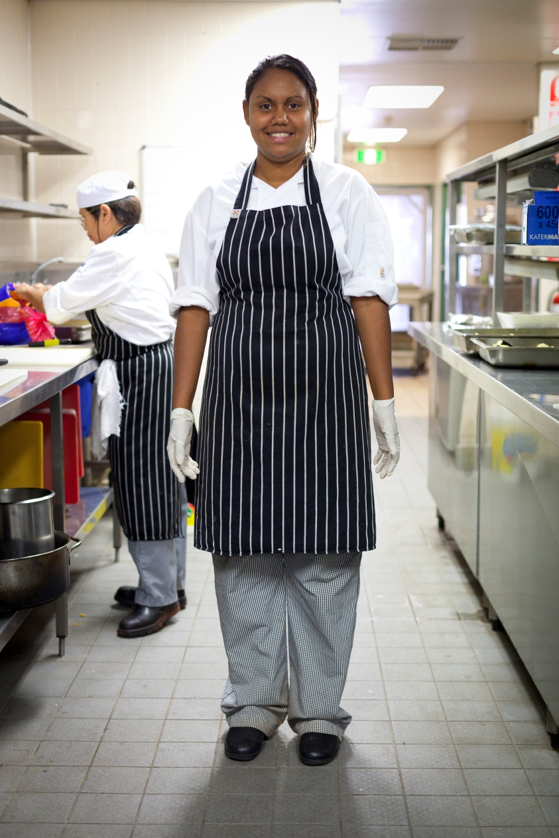

How can I keep up to date?
READ
I check the memos on the staff notice board at the start of every week to see if anything has come up.

What other things could you read?
- Trade magazines | - Industry newsletters (get on the mailing list)
- Newspaper articles | - Text books (maybe some at work or in libraries)

TALK
I never miss a staff meeting – I might miss out on something important.

Who could you talk and listen to?
- Other staff at staff and team meetings | - Colleagues, supervisors, managers or training officers
- People you meet in other businesses | - Travelling representatives who visit your workplace
- The trainer at training sessions

VIEW
I like computers – I can check my work emails and find out news about the industry.

What organisations could have useful websites?
- Industry associations and unions | - Government websites – liquor, gaming, food safety, OHS regulations
- Suppliers – food, beverages, other supplies, equipment | - Specific venues – choose properties similar to the one where you are working so you can compare them
Sources of information
Two important sources of information about the hospitality industry are industry associations and industry unions.
Industry associations
Businesses and employers can join these organisations. Their job is to:
- represent the industry to unions, the media and government
- lobby the government on issues
- provide legal advice to their members e.g. about industrial relations issues
- organise conferences for members on products, services and industry issues
- set industry standards or ‘best practice’
- organise discounts from industry suppliers for members.
Many have newsletters or magazines to keep their members up to date.

Industry associations include:
- The Australian Hotels Association <http://aha.org.au/>
- Restaurant and Catering Australia <http://www.restaurantcater.asn.au/>
- Clubs ACT <http://www.clubsact.com.au/>
- Clubs New South Wales <http://www.clubsnsw.com.au/Home.aspx>
- Clubs Queensland <http://www.clubsqld.com.au/>
- Clubs South Australia <http://www.clubssa.com.au/>
- Clubs Victoria <http://www.clubsvic.org>
- Clubs Western Australia <http://www.clubswa.com.au/>

Activity 18
The AHA
Go to the Australian Hotels Association (AHA) website: <http://aha.org.au/>
1. What are two government policies is the AHA concerned with?
2. What sort of businesses do most AHA members run?

Industry unions
Unions represent the interests of employees (workers). All workers have the right to join a union. The job of unions is to:
- negotiate working conditions with employers
- make workplaces safer
- make sure workers are treated fairly and equally.
The union that represents hospitality workers is called United Voice.

Activity 19
The union
Go to the union website at <http://unitedvoice.org.au/>
Find the Hospitality workers section.
Click on Industries.
Then click on Hospitality.

What things do they have information about?

Activity 20
Share your knowledge
Look at one of the following websites OR another website from earlier in this section.
Find some interesting information about the hospitality industry.
Tell the group about this new information.

Look at a magazine online here:
<http://www.hospitalitymagazine.com.au/>

Learn about the hospitality industry here:
<http://www.discoverhospitality.com/
public_panel/index.php>

In your workplace:
- ask your supervisor if your workplace is a member of an industry association
- ask where the newsletters or magazines are kept so you can look at them.
Keeping up to date with technology
Modern information technology has changed how customers do business and how employees do their work.
Customers and new technology
Customers now may have access to your industry and perhaps your business 24 hours a day, 7 days a week. Here are some examples:
Technology | Use In hospitality
Smart phones and tablet computers | Customers can access businesses wherever they are
Online reservation systems | Guests can check availability and make reservations themselves
Websites | Customers can get information about businesses, events and tourist destinations  Travel advisory sites are frequently updated
Wi-fi | People can access the internet in guest rooms, the café, lobby or restaurant
Social networking sites | Twitter and Facebook can be used to notify subscribers of updates
Email | Customers can ask questions and gather information
Blogs | Provide non-commercial information about the industry, an establishment or an experience
Intranets (the internal network of the business) | Guests can access their bill, messages, local information or the restaurant menu
Apps (applications) for smart phones | Can be used to make bookings for things like rental cars, flowers, tickets

Employees and new technology
Technology also helps staff do their jobs more efficiently. Here are some examples:
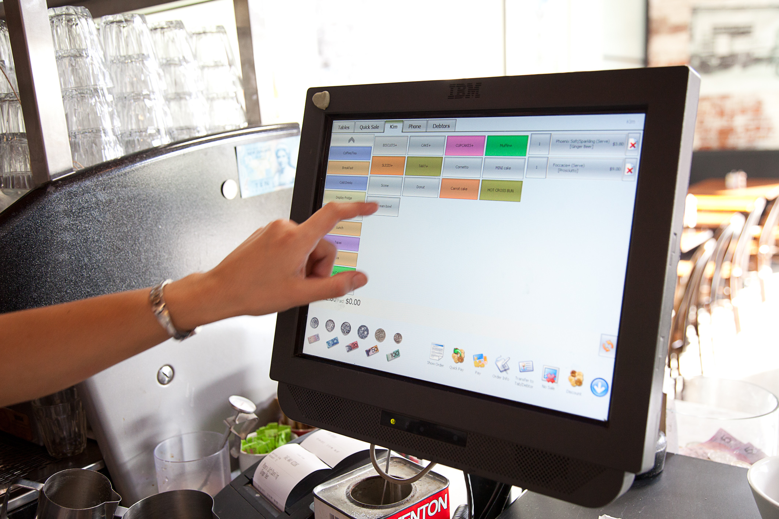

Staff use electronic touch screens to work out your bill.

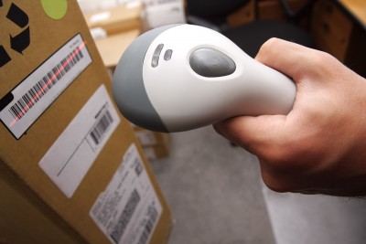

Barcoded goods are scanned on arrival. Electronic stock control system automatically orders stock needed.

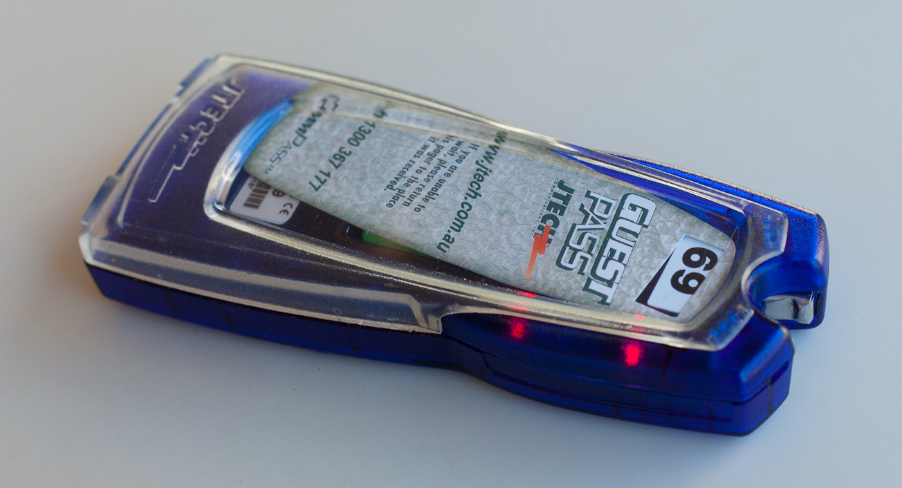

Staff set the electronic guest alert to let you know when your order is ready to collect.

Activity 21
My technology skills
a) Which of these technologies or applications have you used?
Tick the box that best describes your experience.
 | 0  Never | 1  Once or twice | 2  Sometimes | 3  Often
Internet
Email
Social networking sites
(e.g. Twitter, Facebook)
Smart phone
Apps on smart phones
Blogs
Wi-fi
Intranet
Tablet computer
Online reservation system
Electronic stock control system
b) Which ones would you like more experience in?
Highlight them.
c) How could you get more experience?

Industry working conditions
The hospitality industry can have demanding working conditions.
Hospitality jobs often require:
- a lot of contact with other people – colleagues and customers
- long periods on your feet – standing, walking, working
- working under pressure – you often need to work quickly
- shift work – at night, on weekends and on public holidays, when other people including your family and friends aren’t working.

Activity 22
Working conditions
Talk to someone in your workplace about their working conditions.
Ask them the questions below and write down their answers.
a) How many hours a week do you work?
b) How many weeks of annual leave do you get every year?
- What time do you start and finish work?
- Do you work on weekends?

Legal controls on working conditions
Employment contracts
Your working conditions will be covered by an employment contract that you sign. You might be employed under:
- an Award
- an Agreement
- a Contract.
Legally your employer must tell you what type of employment you have and must make sure you have a copy of your own contract.
What is superannuation?
Superannuation (often just called ‘super’) is a system which helps you save for your old age. There are many different companies which run superannuation funds.
If you are over 18 years of age and you earn over a certain amount each month, your employer must put some money into a superannuation fund in your name. This amount is on top of your normal wage.
You might change workplaces, so it is important for you to keep track of your superannuation accounts and try to keep them all with one organisation.
The hospitality industry ‘super’ scheme is called HostPlus <www.hostplus.com.au>.
What is workers' compensation?
Legally, all employers must have all their workers protected by workers' compensation insurance. This insurance policy will pay any costs, such as medical bills, if you are injured or ill due to your work.
Workers’ compensation includes payment of your wages (or part of them) while you recover.
The law also says that the employer must try to rehabilitate the worker i.e. help them return to work.
Workers must co-operate with any Return To Work program that is set up to help them return to work.

Share your knowledge
Things change in workplaces. People who have been sick or on holidays, or away for some other reason, might have missed out on important information about changes or new procedures.
When you have new information, knowledge or skills, share it with your colleagues. This makes sure everyone knows what’s going on.
You could do this by:
- chatting with colleagues
- showing a new skill or procedure to a workmate.

Activity 23
Pass on a work memo
Your trainer will put you with a partner and give each of you a different staff memo.
1. Read your memo. Underline the really important bits.
2. Then explain the key message to your partner.
Don’t read your memo out. Don’t show it to your partner.
3. If your partner asks you a question, answer it clearly and briefly.

I missed the meeting on Monday – did the boss say anything important?
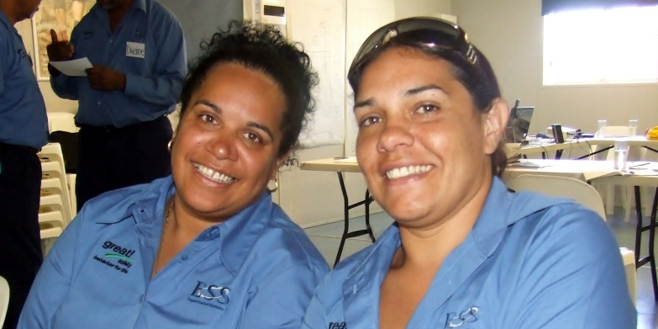

Change in the industry
The business environment changes all the time. Events and changes will affect the industry. Some may cause problems for businesses and others may open up opportunities.
Some factors which can affect hospitality businesses are:
Factor | Examples
The state of the Australian economy and the world economy | Interest rates go up or down  Drop or rise in the Australian dollar  Level of unemployment  Global Financial Crisis
Extreme weather | Floods, bushfires, cyclones
Industrial disputes | Qantas dispute
Outbreak of disease | Avian flu, swine flu
Technological changes | Increase in self-booking online  Businesses need to have a website to advertise
Legislative changes | Mandatory training e.g. RSA, RSG, OHS requirements  Changes to Industrial Relations legislation e.g. dismissal procedures  Visas to allow skilled overseas workers to fill job vacancies
Increased focus on environmental considerations | Noise affecting residents near venues  Reduce and recycle packaging, reduce power usage, save water
Government initiatives | Advertising campaign to promote a certain location
Changing consumer behaviours and spending patterns | New markets e.g. spa and wellbeing industry, adventure holidays, eco-tourism  Increasing spending by ‘grey power’ (retired) consumers
Terrorism | Bali bombing
Changing social concerns of the population | Respect for Indigenous lands and culture  Consumer protection  Venues should be more responsible for problems related to alcohol and gaming  Stricter planning requirements to reduce the impact of buildings on the landscape, meet heritage requirements etc.

Activity 24
Change in the industry
How could these things affect the Australian hospitality industry?
Discuss your topic together and write some brief notes.
Factor | Effect on hospitality industry
Flu epidemic in Asia
Advertising campaign to promote Indigenous cultural tourism in Western Australia
Brisbane flood
Australian dollar rises in value against the US dollar
Now share your ideas with another group.
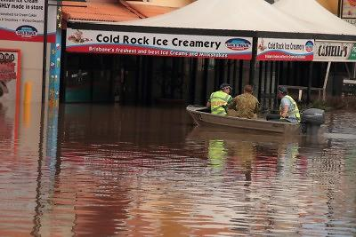

Section summary
Now you have completed this section you should have developed the following skills and knowledge.
Tick each box if you are satisfied that you have those skills and knowledge.
Know how to find information about the hospitality industry.
Understand why it is important to keep up to date.
Understand how technology is changing work in the industry.
Identify the role of industry associations and industry unions.
Understand working conditions in the industry.
Share information with your colleagues.
Understand causes of change in the industry.
Notes

3 Quality Assurance
Many hospitality businesses follow the principles of Quality Assurance (QA).
The aim of QA is to control the quality of the products and services provided to customers.
QA does not always aim to deliver the highest possible quality. It aims to work out what level of quality suits the business and then make sure that this standard is always achieved.
This gives customers confidence in the business – they know they will get the same quality of product or service every time. They know what to expect.

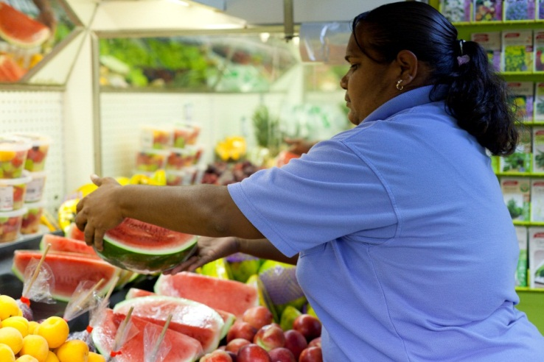

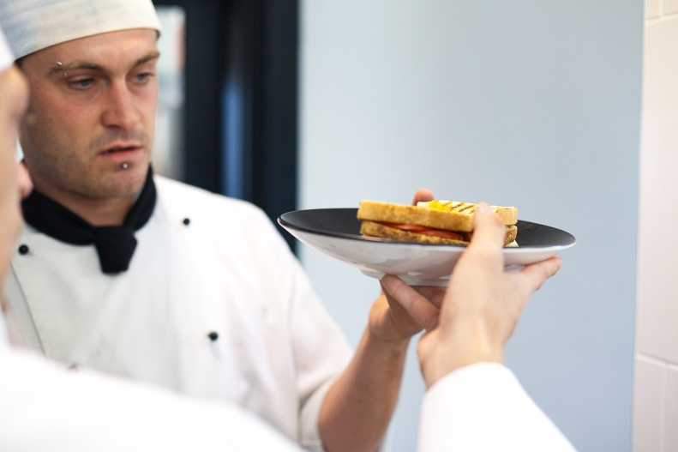

Activity 25
Quality standards
What level of standard would you expect in these three different food businesses?
Write H, M or L in each box.
H = High standard, M= Medium standard, L = Low standard
Standard | Fish and chip shop | Corner pub | Fine dining restaurant
Price
Food presentation
Hygiene
Surroundings
Service times
Politeness of staff interaction
Personal presentation of staff
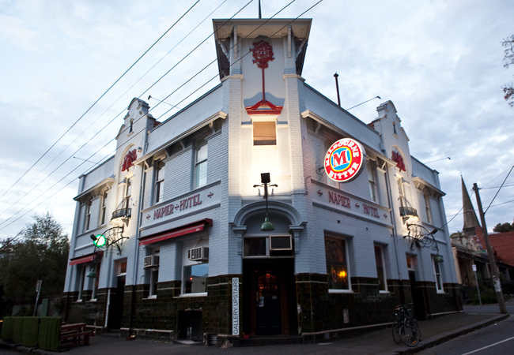
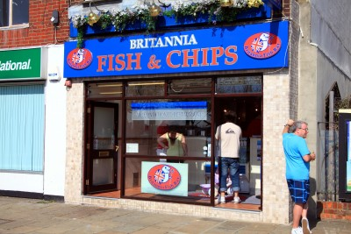

Quality Assurance and your work
In your work, QA may involve you in different practices.
QA practice | Example
Follow set processes and procedures in your work | Use checklists, standard operating procedures (SOPs), rosters
Check the finished quality of your product or service | Supervisor or self-check e.g. look of a meal on a plate, time taken to do a task, how clean a kitchen bench is
Look at situations where quality levels were not good enough and fix them up | Discuss at team meetings  We regularly ask our customers if there is anything about our service we could improve. If there is a complaint, the team sits down and talks about why it might have happened and what they can change, to make sure it doesn’t happen again.  Fill in suggestions form
Here at Swaying Palms Motel, we want to make sure our guests are happy and will come back to stay again. So we have some Quality Assurance practices we follow.

.

At breakfast, we aim to have every order delivered to the room within 10 minutes of the requested delivery time. So we type up a timeline of the day’s orders for the cook and delivery staff.
This means the cook can see when the peak busy time is and prepare for it.
And the delivery staff record on their copy when the delivery was made, so we can check if we are meeting our quality target.

Our head housekeeper does random spot checks of the rooms. If there is a problem with cleanliness, she sits down with the cleaner responsible to chat about how they could improve.

Activity 26
QA in your workplace
In your workplace, what Quality Assurance procedures are used?

Activity 27
Quality standards in other businesses
Think of some hospitality businesses that you have used.
Have you ever had any problems with the quality of the product or service? YES / NO
a) If NO – The service or product met your expectations. What was good about it?

b) If YES – What do you think the business could do to improve their product or service?

Section summary
Now you have completed this section you should have developed the following skills and knowledge.
Tick each box if you are satisfied that you have those skills and knowledge.
Understand what Quality Assurance means.
Identify some Quality Assurance practices in hospitality businesses.
Understand how Quality Assurance practices help to maintain a consistent standard of work, product and service.
Notes

4 Employability skills
In a hospitality job, you generally work in a team with other people. You also often deal with members of the public – your customers.
So as well as having good ‘hands-on’ skills to do your job, it is very important to have a good attitude to your work and the people you work with. These are often called employability skills.
Employers know how important these employability skills are, and they look for them.
Activity 28
What is the employer looking for?
Kitchen Hand
The Casuarina Restaurant is looking for a kitchen hand to join our professional and friendly team. You are an energetic and reliable team player. Some night work is required. Must be presentable.
Duties include:
- maintain standards of cleanliness and hygiene in kitchen and back-of-house area
- coordinate kitchen supplies
- perform other tasks as and when required.
Experience a plus but not essential. Driver’s licence preferred.
Contact John Bradfield, Manager on 9458 3322.

The Casuarina Restaurant needs to employ a new kitchen hand.
a) Underline or highlight the words that describe the kind of person the manager is looking for.
Discuss together and make sure you understand what these words mean.
b) Are you the kind of person the manager is looking for? YES / NO
c) Why or why not?

Activity 29
Who would you employ?
The manager of the Casuarina Restaurant is going to interview three people.
Hi, my name’s Mark. I’ve worked as a kitchen hand for four years and I’m good at the work.
But I don't like it if my supervisor gets bossy and sometimes I lose my temper.

Hi, I’m Shana. I’ve worked in kitchens for a year. I did the Certificate I in Hospitality and I’d like to study a bit more in the future so I can earn more.
I enjoy working with people and I get on with everyone. I can’t drive a car.

G’day, I’m Pat. I’ve worked in a warehouse and I’d like a change.
I have an old car that breaks down all the time so sometimes I can't help but be late for work.

a) Who would you pick for the job?

b) Why?

Activity 30
Who would you rather work with?
Employability skills are not just important to employers. They also make a difference to how we get on with our workmates and how well our team works.
Cross out the words of the person you don’t want to work with.
Tick the words of the person you would like to work with.

Don’t ask me, I don’t know.

I’ll see if I can find someone who can answer your question.

That looks dangerous – I’ll tell maintenance.
I don’t like that maintenance bloke – let him find out himself.

It’s not my job!

Here – let me help you.

I’ll just clean this up and then the next person will have a clean bench to start.
It’s the end of my shift – someone else can clean it up.

Why do they send emails? I can’t be bothered with that!

I’ll have to learn how to do some new things in this job.

Activity 31
The effect of employability skills on others

If I do this .. | The result will be …
Always turn up for my shifts 10 minutes early | Employer feels …
Often turn up for my shifts 10 minutes late | Employer feels …
Complain a lot about my wife, husband, partner, children | Workmate feels …
Be friendly and have a joke with my workmate | Workmate feels …
Come to work with clean hair and neatly dressed | Customer feels …
Look at the floor and quickly walk away if I think a customer is going to ask me a question | Customer feels …
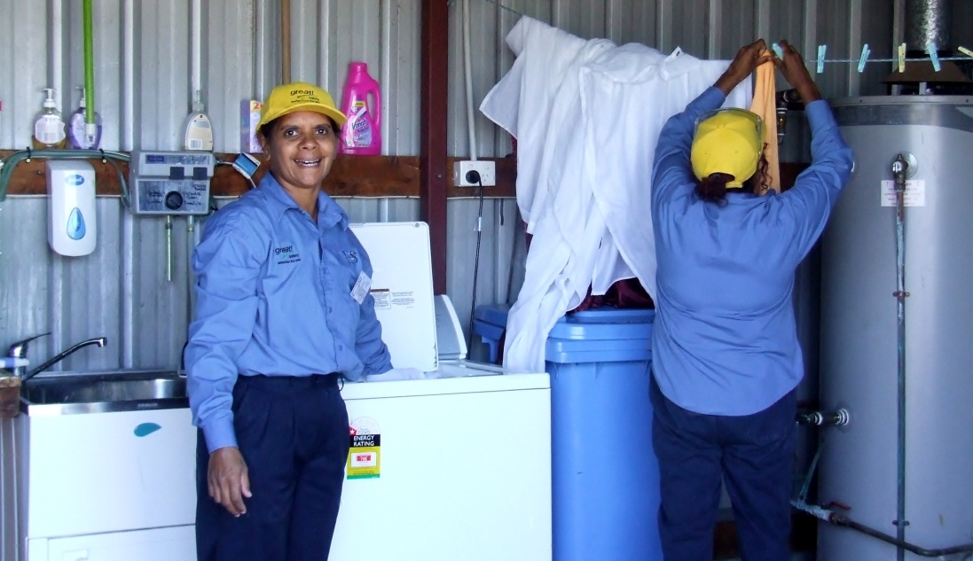

Activity 32
My employability skills
Do you have these employability skills?
Tick a box for each skill. Be honest, but don’t be too hard on yourself!
Employability Skill | How do I show this skill? | Do I have this skill now?
 |  | 1 Not much | 2 Okay | 3 Good | 4 Excellent
1. Good communication skills | Ask questions to check work tasks or a new procedure  Speak clearly and directly to customers  Report problems to supervisor  Communicate well with people from other cultures
2. Smart presentation and grooming | High standard of personal hygiene  Uniform or clean pressed clothing  Hair tied back etc.
3. A strong customer focus | Help customers  Don’t keep customers waiting  Stay calm when customers complain
4. A good team member | Follow instructions accurately  Complete my own workload to time  Help out other team members  Punctual and reliable  Share information with my workmates
5. Show initiative, be able to work independently without direction | Get to work on time  Plan my workload so I complete it on time  Fix small problems when I see them  Identify and report bigger problems  Follow OHS and food hygiene regulations without constant supervision
6. A positive attitude | Am friendly and smile  Work calmly under pressure  Leave my problems at home
7. Technology – be willing to learn new things | Use correct personal protective equipment (PPE)  Use email if required  Use new cleaning methods and equipment
8. Learning and improving | Know how to find out information about my workplace and the industry  Keep up to date with changes  Share information with my workmates

Developing employability skills
We are not all born with good employability skills, just like we are not all born with good cooking skills.
But we can learn them. You can develop these skills by thinking about them and making them a standard you aim for in your work.
As you do your training, watch where other staff use these skills to do a good job. Then you will understand why they are important to help you get and keep a job.

Activity 33
How could you improve?
Look at the employability skills table in the previous activity.
Choose three areas where you would like to improve.
What could you do?
Area 1 _________________________________________

Area 2 _________________________________________

Area 3 _________________________________________

This week I will …
List here three things you will do in the next week to improve your employability skills.
1.

2.

3.

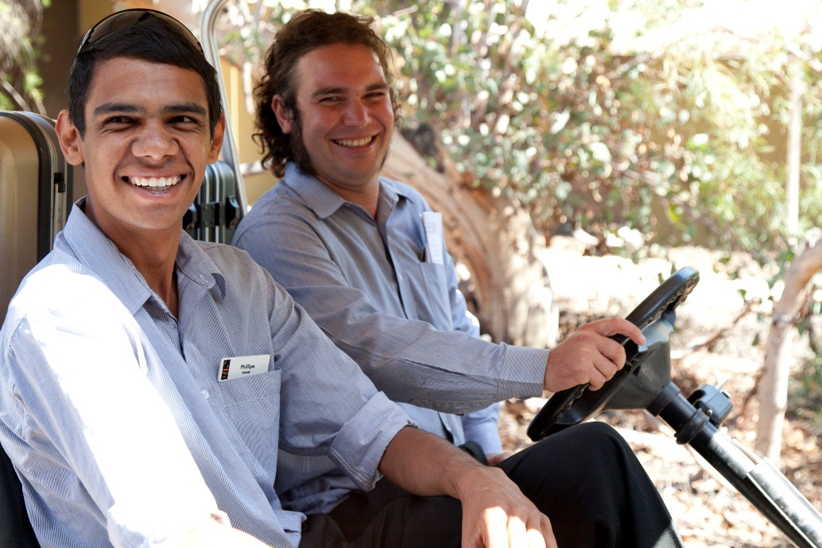

Section summary
Now you have completed this section you should have developed the following skills and knowledge.
Tick each box if you are satisfied that you have those skills and knowledge.
Know what employability skills are.
Understand why employers prefer to employ people with good employability skills.
Understand the effect of employability skills on people around me.
Identify what employability skills I have now.
Know how I can develop my employability skills.
Notes

5 The law and the hospitality industry
In every workplace you work in, you and your employer are affected by legislation.
What is legislation?
Legislation is laws made by the Federal and state or territory governments in their parliaments.
What is an Act?
An Act is another name for a law passed by Parliament. It becomes law through an Act (action or decision) of Parliament.
Some useful language
Word | Meaning
breach | Break the law
comply, compliance | Follow the law
discriminate, discrimination | Favour or show disrespect for someone because of their age, disability, race, gender, sexual preference or marital status
fraud, fraudulent | Fake, cheat
minimum | The lowest
penalise, penalty | Punish, punishment
regulate, regulation | More detailed rules that support an Act of legislation
violate, violation | Break the law

What legislation affects you?
The following table briefly explains some of the legislation that affects hospitality workers and employers.

A quick guide to hospitality legislation
Legislation | What is it mainly about? | Possible penalties
Occupational Health and Safety Act | Employers and employees must both comply with these Occupational Health and Safety regulations. They aim to provide a safe and secure working environment.
Workers Compensation Act | Employers must have insurance to cover workers who have an accident or are injured at work.
Liquor Control Reform Act | Sets liquor licensing conditions e.g. trading hours, rules for serving alcohol. All staff serving alcohol must have the RSA certificate.  Operational regulations vary between states and territories.
Food Act | Sets minimum standards for food storage, preparation and service areas, and hygienic food handling practices.
Equal Opportunity Act  Anti-Discrimination Act | Employers must make sure there is no discrimination in their workplace, to employees or customers.
Trade Practices Act  Consumer Protection laws  Fair Trading laws | Protect consumers and businesses against fraudulent or unfair business practices e.g. pricing collusion, unsupported warranties, unsafe products, false advertising.
Gaming Machine Control Act | Regulates the gaming industry e.g. licensing, who can own machines, hours of operation, reasons to cancel a licence, records required.  All staff who work directly in a gaming environment must have the RSG certificate.
Casino Control Act | Regulates the casino industry, similar to above.
Privacy laws | Employers and employees must not release personal information about their customers without their consent.

Activity 34
What could happen if you break these laws?
Discuss ideas for the column Possible penalties in the previous activity.

Activity 35
Chat’n’Chew Café
Steve runs the Chat’n’Chew Café. It serves takeaway food such as hamburgers and sandwiches. It is bright and clean with some nice tables and chairs inside and the service is cheerful. But it is on a busy road opposite a large furniture shop with its own carpark.
Steve has designed some advertising to go in the local newspaper.
Here is Steve’s ad.

Gourmet food
Friendly service
Chat’n’Chew Café

1. Is Steve breaking the law?
YES, Steve is breaking the law.
NO, Steve is advertising his café positively.

2. If YES, which law is he breaking?
Occupational Health and Safety laws
Trade Practices Act
Food Act

Activity 36
The Capricorn Hotel
Sharon and Trevor are both applying for a job at the Capricorn Hotel. The boss, Brian, has to make the decision.
Sharon and Trevor are both experienced but Brian chooses Trevor because he thinks Trevor is more likely to stay long term. Sharon is engaged to be married and Brian thinks Sharon might leave to have children.
1. Is Brian breaking the law?
YES, Brian is breaking the law.
NO, Brian is choosing the best person for the job.

2. If YES, which law is he breaking?
Occupational Health and Safety laws
Privacy Act
Equal Opportunity Act
Duty of care
In Australia the law says that every person has a duty of care. This means we all have a responsibility to make sure our actions don’t cause harm to others. This could be things we do, or things we fail to do. There is no Act for this. It is a moral duty or obligation. It has been supported by court decisions.
If a business or staff fail in their duty of care to someone, and it results in damage or injury, the business or individual can be taken to court and prosecuted for negligence.
Employers have a duty of care to their staff, customers and members of the public. They must provide a safe venue and workplace, and make sure that no-one is injured at the premises.
Businesses also have a duty of care towards customers after they have left the venue if they are intoxicated (affected by alcohol). That duty is to make sure they get home safely.
Employees have a duty of care to comply with all the regulations that control their work such as OHS, responsible service of alcohol and food safety.
A worker who has not followed safety practices would find it harder to accuse their employer of negligence if they had an accident.
damages – payment to make up for the injury
negligent – careless
liable – responsible
The duty of care
In 1997 the Chevron Hotel in Surfers Paradise had to pay $125,000 damages to a heavy drinking regular patron who was hit by a car while waiting at a bus stop across the highway from the hotel.
The hotel staff knew that the drunken patron would have to cross a busy highway to catch a bus home but they continued serving him. The judge said the staff should have provided him with a safe means of transport. He decided the hotel had negligently contributed to the dangerous situation that caused the patron’s injuries.
Publicans are not automatically liable for a patron getting drunk. However, they may be liable if they continue to serve a drunken patron alcohol to the point where he has lost self-control and the publican should know that unless staff do something, the patron may put themselves in a dangerous situation.
Adapted from an article at
<http://www.findlaw.com.au/>
Activity 37
Duty of care
- What could the staff have done to help the drunken patron get home safely?

- Why is it important for staff to know about cases like this?

Social responsibility
All licensed premises must operate in a way that protects ‘the amenity of the area’. This means the business mustn’t interfere with how local people enjoy their own homes.
Problems could be from:
- noise e.g. loud music or patrons leaving the premises
- fighting in the street
- the activities of patrons after they leave
- patrons’ cars parked in a residential street.

Party patrons block streets  November 30th, 2009  Darwin's party strip was closed down after hundreds of drunken patrons spilled into the street yesterday morning.  Several people were arrested when about 300 partygoers on Mitchell St refused to disperse just after Discovery Nightclub closed about four am. Traffic was diverted for about 20 minutes as the wild mass clogged up the street. | Darwin Duty Superintendent Mike Murphy said the crowd's safety was at risk.  "Police were in the area as about 300 patrons left pubs and clubs," he said. "Only a handful were arrested."  Supt Murphy said police would sit down and have further discussions with license holders to avoid similar events in the future.

© News Limited, adapted from an article at
<http://www.ntnews.com.au/> November 30th, 2009
Activity 38
Social responsibility
What could licensees do to prevent this kind of thing in the future?
Section summary
Now you have completed this section you should have developed the following skills and knowledge.
Tick each box if you are satisfied that you have those skills and knowledge.
Identify the main legislation that affects the hospitality industry.
Know how these laws can affect the way you work.
Understand what duty of care means and how it affects hospitality businesses.
Understand the social responsibility of hospitality businesses.
Notes

6 Ethical behaviour at work
Ethics is behaving morally – doing what is right and fair, not what is wrong or unfair.
Employers and employees in the hospitality industry need to act ethically when dealing with customers and colleagues.
In most cases, your organisation will have policies and procedures or a code of conduct to guide you.
But you may find yourself in situations where you have to make an ethical decision about what to do and you must use your own judgement.
In these situations, ask yourself these questions.
- Is this legal?
- Is this fair to the people concerned?
- Would I like to be treated in this way?
- Would I feel comfortable telling others what I have done?

What happens if I get caught?
Will anybody notice?

If you are asking yourself these questions,
the action is probably not ethical,
and possibly not legal.

Some areas where ethical behaviour is important are:
- confidentiality
- tipping
- prices and charging
- taking property
- accepting gifts.

Confidentiality
Staff in hospitality businesses have access to a lot of personal information about the business, the customers and the suppliers. This information must remain confidential (private).
You should not disclose (tell) it to anyone, including family, friends or even other staff members. This includes information about the following things.
Who? What? | For example
Customers | Personal details, purchases made
Security | Alarm codes, combinations of safes, routes taken by security patrols, banking routines
Trade | Amount of money the business makes, the volume of liquor sold, the number of meals sold, occupancy rates, staffing levels
Purchases | Volumes bought, amount of money the business spends on purchases, commercial deals the business has made with suppliers
Events | Fights, incidents where police, ambulances or doctors have attended, OHS issues, problems involving customers, staff dismissals, emergency situations including hold-ups.

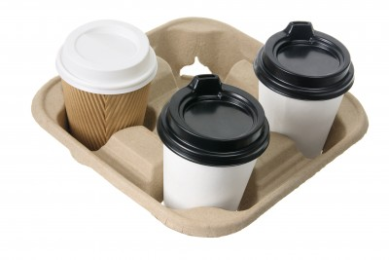
The coffee’s awful at my work. The only time we get some decent coffee is Thursday afternoon, when the receptionist does the banking and brings back a decent coffee from that café next to the bank.

Tipping
Tipping is not compulsory in Australia. Staff are not entitled to a tip, and customers are not obliged to give them one. Some businesses do not allow tipping.
Ethical behaviour here means:
- don’t give the impression to customers or guests that you expect a tip
- don’t show annoyance if a customer does not tip
- don’t give worse service to a customer who does not tip
- always thank a customer for a tip sincerely, no matter how small it is.

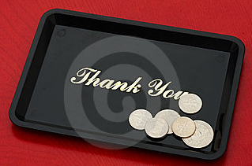
Oh no – it’s that awful man again. He always complains about something and he never tips! I’m not going to smile when I serve him, maybe then he’ll get the message.

Taking property
Staff should never take property from the business for their own personal use without permission. Things such as stationery items, sweets or cleaning products may seem like small items but if you remove them from the property without permission, it is theft.
Sometimes you may believe the items are of no further use to your employer, but you should still ask for permission to take them home. For example, if the business is upgrading its tables and chairs, or has changed its logo so stationery with the old logo will be thrown out.
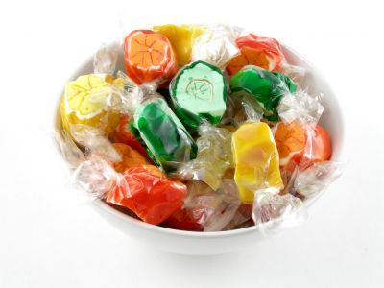
I’m hungry by about 10 am after an early start, so I just take a couple of those sweets off the front desk as I go past. It’s no loss to the business.

Accepting gifts
Suppliers sometimes give gifts to their customers, sometimes directly to the person placing the order or receiving the delivery. Gifts may be things like a cap, a key ring, a bottle of liquor, or perhaps a sample cleaning product or a sample of a new food product.
Legally any gifts given by suppliers belong to the business owner or manager. Always report gifts to your supervisor and, if you think it is something small that you could take home, ask for permission.

The boss gets his cleaning products from a local company, so he won’t want to try a new brand. I’ll take this sample home.

Prices and charging
Ethical employers should:
- make sure that the price quoted to customers is correct. Sometimes businesses advertise a low price to get people in, but then charge for ‘hidden extras’.
Ethical employees should:
- make sure staff members are charged for products and services they receive. Many businesses give a staff discount but generally staff are not allowed to have products or services free
- not give discounts that people are not entitled to e.g. to friends and family.

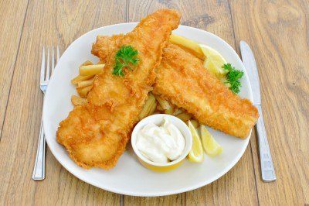
Oh, that’s the price without salad. With salad, it’s $10 more.

Activity 39
House policies
Find out what some of the house policies and standard operating procedures (SOP) are in your workplace.
Then fill in the table below.
Area | House policy or SOP
Confidentiality
Tipping
Staff discounts

Section summary
Now you have completed this section you should have developed the following skills and knowledge.
Tick each box if you are satisfied that you have those skills and knowledge.
Understand what ethical behaviour is.
Know some areas in hospitality where ethical behaviour is important.
Identify some relevant house policies in your workplace.
Notes

Key words
Word | Meaning
Act | A law passed by Parliament. It becomes law through an Act (action or decision) of Parliament
back-of-house | Hospitality departments where staff don’t normally deal directly with customers
beverage | Drink
cashier | Person who takes payment
comply with | Follow a law, obey
confidential | Private
consumer | A person who buys goods or services for their own use
duty of care | Responsibility to make sure our actions don’t cause harm to others
entitlements | Work benefits that you have a legal right to have
ethics, ethical | What is morally right or fair
front-of-house | Hospitality departments where staff normally deal directly with customers
fraud, fraudulent | Fake, cheat
functions | Special events, often formal
gaming | Gambling
gourmet food | Food which is high standard and very delicious
hygiene | Being clean
independent | Able to make some work decisions by yourself, without constant advice
Industrial Agreement | An agreement between employer and employee representatives that states minimum working conditions and pay rates
initiative | Directing yourself, without being told exactly what to do by a supervisor
issue | Problem
legal | To do with the law
legislation | Laws suggested by a government and passed through a parliament
liable | Responsible for an injury or damage
licensee | Person who holds the licence to run a hotel
liquor | Alcohol
lobby | Work to get decisions made in your favour
negligence | Not take proper care, neglect
occupational | At work
patron | Customer
premises | A place of business
punctual | Arriving on time
quality | Standard
Quality Assurance | The things we do to make sure customers receive a level of service that is always the same
regulation | Detailed rules that tell people how to follow the law in particular situations
reliable | Other people can count on you to do what you say
represent | Speak for someone else
retail | Shopping
sector | Section
supplier | A business that supplies someone else with goods or services
venue | A hospitality business
violate | Break the law

