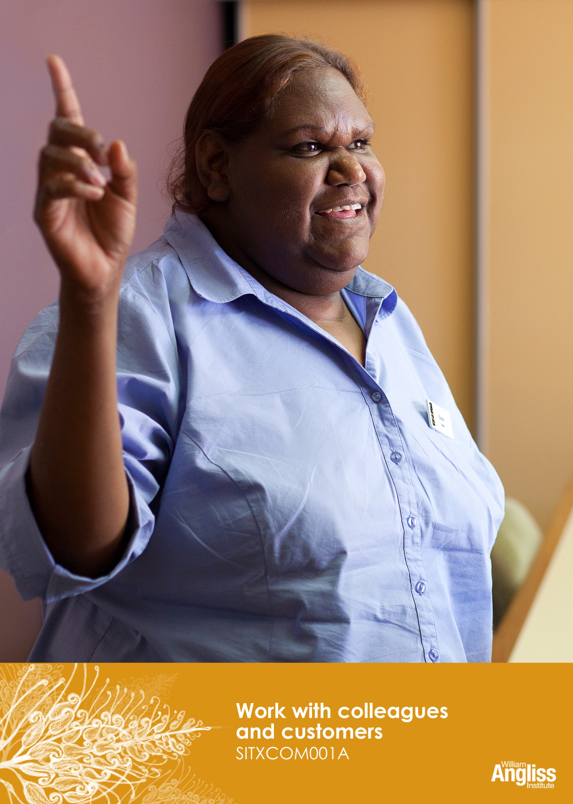

© Commonwealth of Australia. 2012
CC BY-NC-SA
This work is copyright. Except where otherwise indicated, and save for the Commonwealth Coat of Arms, the Department has applied the Creative Commons Attribution-Noncommercial-Share Alike 3.0 Australia Licence to this work.
The Department of Education, Employment and Workplace Relations must be attributed as the author of the Department’s copyright material.
As far as practicable, material for which the copyright is owned by a third party has been clearly labelled. The Department has made all reasonable efforts to ensure that this material has been reproduced in this resource with the full consent of the copyright owners.
Requests and enquiries concerning the Department’s copyright material should be addressed to:
The Copyright Officer
Department of Education, Employment and Workplace Relations
Location code C148CW2
GPO Box 9880 Canberra ACT 2601
Or emailed to copyright@deewr.gov.au
Funded under the Workplace English Language and Literacy (WELL) Program by the Australian Government Department of Education, Employment and Workplace Relations.
The views expressed in this publication do not necessarily represent the view of the Minister for Education or the Australian Government. The Australian Government does not give any warranty nor accept any liability in relation to the contents of this work.
ISBN 978-1-922108-08-1

Development Team
Content | William Angliss Institute  Macsmith and Associates
Photography & graphics | Benjamin B Photography

Acknowledgments
We would like to acknowledge the generous support of the following organisations and the Indigenous learners and employees in those venues for giving their permission for photography:
Ayers Rock Resort, Yulara, NT
Charcoal Lane Restaurant, Fitzroy, Vic
Lux Foundry Café, Brunswick, Vic
Peninsula Palms (Compass Group Australia), Dampier, WA
Permissions
We would like to acknowledge the following organisations who have granted permission for their copyright materials to be incorporated in this resource.
WorkSafe Victoria
Australian National Training Authority (ANTA)
Cultural Warning
People of Aboriginal or Torres Strait Islander descent should be aware that this publication contains images of people who may be deceased
Disclaimer
Every effort has been made sure that this booklet is free from error or omissions. However, you should conduct your own enquiries and seek professional advice before relying on any fact, statement or matter contained in this book. William Angliss Institute of TAFE is not responsible for any injury, loss or damage as a result of material included or omitted from this course.

Contents
Welcome vi
Icons vi
What you will learn vii
1 A communication skills toolbox 1
What is communication? 1
Types of communication 3
Barriers to communication 5
Non-verbal communication 7
Blocks to listening 11
Active listening 13
Summarising 14
Asking questions 15
Section summary 19
2 Communicating at work 20
Communicate in a professional way 20
Speak in clear language 22
Communicate with people from other cultures 23
Check instructions 25
Ask questions 27
Writing at work 28
Answer the telephone 32
Take messages 33
Section summary 37
3 Providing customer service skills 38
What is good customer service? 38
Help customers with special needs 42
Provide information to customers 44
Section summary 45

4 Responding to conflicts and complaints 46
Conflict with a customer 46
Customer warning signs 47
Conflict between workmates 48
Steps to resolve a problem 49
Section summary 53
5 Personal presentation 54
Uniforms 55
Posture 56
Section summary 57
6 Working in a team 58
What is a team? 58
Meetings 65
Make decisions and set priorities 67
Ask for assistance 68
Giving and responding to feedback 70
Negotiate changes in your work 73
Section summary 75
Key words 78

Welcome
Icons
These signs tell you what type an activity is:
Do this activity in a big group.
Do this activity in a small group.
Do this activity in pairs.
Do this activity by yourself.
Do this activity using the internet.
If you are not connected to the internet, your trainer will provide you with another activity.
Do this activity in your workplace.
If you are not in a workplace, your trainer will provide you with another activity.

What you will learn
This unit will help you to learn about the communication and customer service skills you need to work with workmates and customers in the hospitality industry.
It will help you to:
- communicate clearly and professionally with customers
- keep up a high standard of personal presentation
- provide excellent service to customers
- understand how to deal with conflicts and customer complaints
- work well in a team.

1 A communication skills toolbox

What is communication?

SPEAKER
LISTENER
Message
Feedback

Communication is a two-way process.
SPEAKER – sends a message and listens for feedback.
LISTENER – listens to the message and sends feedback.
We look for feedback (something back to us, a response) from the LISTENER. Otherwise, we can’t be sure they understood what we meant.

Activity 1
Feedback
a) How do you show you have understood someone?

b) How do you show someone that you didn’t understand their message?

Activity 2
Methods of communication
What are some different ways we communicate with other people at work?

Types of communication
We communicate for different reasons and with different people. Some kinds of communication are more formal than others.
Formal = public, serious, official, may need a record to refer to later
Informal = personal, private, casual

Activity 3
Formal or informal?
Look at each communication. Is it formal or informal? Write F or I in the box.
F or I? | Communication
 | - You tell the manager you are resigning from your job.
 | - Your supervisor tells you what a great job you are doing.
 | - You tell your supervisor that a personal problem means you can’t come to work tomorrow.
 | - You tell your workmate that a personal problem means you can’t come to work tomorrow.
 | - Your supervisor tells the team about a new procedure.
 | - You tell your workmate that your daughter is getting married.
 | - You tell your supervisor that your daughter is getting married so you need two days off work.
 | - Your manager tells you the date of your performance appraisal.
 | - You tell your workmate how nervous you are at the thought of a performance appraisal.

Activity 4
Communication in your workplace
- Who do you communicate with in the workplace?
- What kinds of things do you communicate with them about? Note some ideas in the ‘Topics’ column.
- Is this communication mainly formal or mainly informal?
- Look at the methods of communication at work from Activity 2. Put these into the Methods column.
Who? | Topics | F =Formal  I = Informal | Suitable methods
Workmates
Supervisor/manager
Customers/guests
Staff from other hospitality businesses
Government departments
The union/industry association
Local community
Media
Other?

Barriers to communication
Look at the communication model again. The red zigzag lines are barriers that can block or confuse messages.
Many different things can be a barrier between the speaker and the listener.
Type of Barrier | Example
- Physical barriers | - Background noise  - Feeling rushed or tired  - Deafness
- Cultural, language or social differences | - Speaker and listener don’t speak the same language  - Speaker and listener come from different cultures or social groups so they understand words, situations or gestures differently
- Problems with the message | - Speaker speaks too quickly  - Speaker speaks with a strong accent  - Speaker uses words that the listener doesn’t know e.g. slang or jargon  - Speaker uses non-verbal communication that says something different to their words (see following section)
- Personal feelings and beliefs about the other person | - The listener is a type of person you don’t like  - The listener should know this or be able to do this
Communication barriers can lead to frustration, confusion, customer dissatisfaction and sometimes conflict or danger.
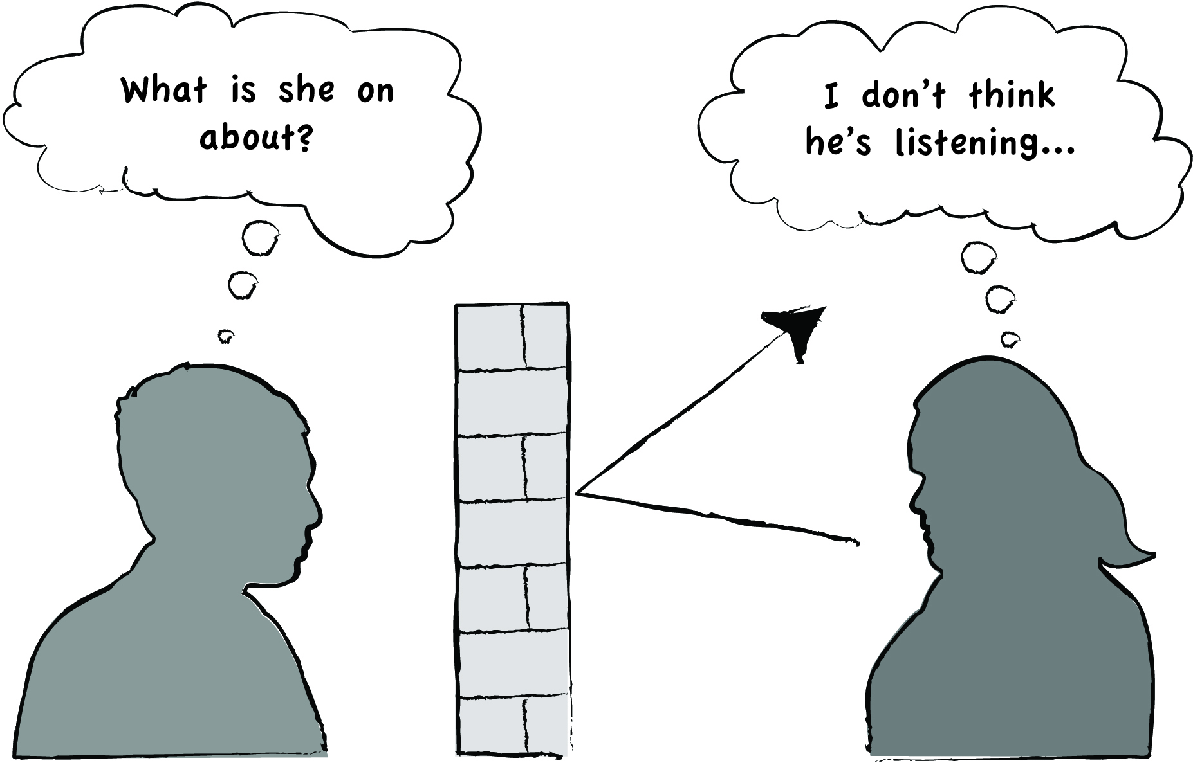
Activity 5
Barriers to communication
Look at these thoughts.
What kind of barrier is blocking the communication?
What feelings will the speaker and listener have?
Don’t they speak ANY English?
Why is he pointing?
That’s so rude!
Why won’t she look at me?
That’s so rude!

Rich people – they think they own the place!!
Those (a nationality), they always act superior.
She never listens to me properly…
Doesn’t he speak ANY Chinese?
I’m exhausted – I just want to go home.

Non-verbal communication
Non-verbal communication is all the ways we communicate without using words. Another word for this is ‘body language’.
Some experts say that only 30% of the meaning in a message is carried in the words, and 70% of the meaning is sent by body language.
Listeners notice body language, often unconsciously (without realising it).
Activity 6
Non-verbal communication
Look at the two speakers below.
Which person do you think really means what they are saying? Why?
Speaker 1
Oh, that’s really interesting!

Speaker 2
Oh, that’s really interesting!

Mouth relaxed
Smiling
Making eye contact
Mouth turned down
Frowning
No eye contact, looking away

Arms crossed in front of body
Hunched shoulders

Facing the person
Arms and legs relaxed
Leaning forward
More positive body language
Nodding
Varied tone of voice
Normal volume
More negative body language
Body turned away Monotonous tone of voice
Hands on hips Voice too soft or too loud
Jiggling a foot, tapping a finger, checking watch
NEGATIVE or CLOSED BODY LANGUAGE
POSITIVE or OPEN BODY LANGUAGE

All non-verbal communication communicates something to the listener.
Open body language says:

I’m happy
I’m confident and respectful
I enjoy my job
I’m a professional

I’m listening
I’m interested in what you’re saying
I’ll do my best to help you

Closed body language says:

I’m not interested in what you’re saying
I’ve got better things to do
I’m blocking you out
I’m unhappy
I’m distracted
You’re bothering me

Activity 7
How important is non-verbal communication?
Try these two activities.
- Watch a television program where people are talking e.g. a soap opera. Turn the volume down, and see how much you can follow of what's going on.
- Sit on your hands. Now talk with people in a small group for 5 minutes without moving your hands and arms.
Talk about your experiences with other learners.

Activity 8
Non-verbal communication from customers
You work in a restaurant and you are watching some customers.
Could you guess what they wanted or were feeling from their body language, before they spoke to you?
YES / NO / SOMETIMES / NOT SURE
Think about these situations.
Show how you think these customers might show their feelings in their body language.
- A customer has been talking but now he is ready to order.
- A customer is not happy with her meal.
- A customer wants to order another drink.

Blocks to listening
Listening is just as important as speaking. If the receiver doesn’t listen properly, communication isn’t effective (doesn’t work properly).
There are many different ways of not listening properly. Everyone does it, but we can learn to do it less by noticing it in ourselves.

Activity 9
Blocks to listening
On the following page, you can see the words or thoughts of some listeners.
Are they really listening to the person speaking to them?
If they are not listening, what are they doing?

He thinks he’s so smart, I wish he’d leave me alone!
I don’t like her purple hair!
You’ve got a backache? I had a really bad one last week …
I’ll wait until she’s finished her story, then I’ll tell her about the time I …
What will we have for tea tonight?
Mm-hmm … uh-huh……

Active listening
You can get better at listening actively by practising.
How you can listen actively
- Don’t interrupt the speaker.
- Concentrate on what the speaker is saying to you. Avoid your personal listening blocks.
- Send non-verbal signals which show you are paying attention e.g. make eye contact, use open posture, and nod.
- Encourage the speaker to continue by using murmurs or short words of encouragement.
Uh-huh … Mmmm …
- Summarise what they have said.
So you think that… So you want me to …

Activity 10
How does it make the speaker feel?
Look at the words and phrases in the box below.
Circle some words to describe how it makes the speaker feel when you listen actively.
respected disrespected valued
important unimportant silly
encouraged embarrassed they are boring
judged ashamed you are interested
you are bored a nuisance bothering you

Activity 11
Active listening
In this activity, you can practise active listening.
Talk together about what you felt and learned during the activity.
.
Summarising
Summarising is a useful communication skill when feelings are strong, e.g. when someone is angry. You do it by summing up what the speaker has said and repeating it using similar words. You should try to acknowledge the way the speaker feels, as well as what they are saying.
It is useful because:
- it slows down the interaction, giving a calmer feeling
- it lets you check you understand what the problem is
- it shows the person you are really listening and trying to understand
- It shows you understand they are upset.
Here are some ways you can summarise what a person is saying.
So what you mean is…
So what you are saying…
And you think that’s the reason…

So you think…
So you feel…
I see…

I can see you are upset/in a hurry…
You seem angry with that…

Activity 12
Summarising
In this activity, you can practise summarising what someone has said.

Asking questions
Asking questions is an important communication skill. In the workplace, you might need to:
- check a request (get clear what the person means)
- check the details of a task
- chat with a customer and put them at ease.
You can be more effective if you understand the different types of questions you can use.
Closed questions
People can only answer ‘yes’ or ‘no’ to these questions.
Ask a closed question if:
- you want a clear decision from someone
- time is short.

Do you want me to book you a ticket on the tour?
Will you be staying on tomorrow, sir?
Are you in Room 203?

Open questions
These questions ask for more information.
Ask an open question if:
- you want to encourage someone to talk to you
- you need a specific piece of information.

Open questions begin with words such as:
How …? When …? Who …?
Where …? What …? Why …?

What are you planning to do today?
What time are you leaving tomorrow?
How did you like the show?

Activity 13
Open or closed questions
Are these questions open or closed?
Question | Open | Closed
- Can I help you?
- What would you like today?
- Would you like some garlic bread?
- When do you want to take the tour?
- Would you like to take the tour tomorrow?
- Where should I store the spare toilet rolls?
- How will you pay for that?
- Do you understand?
- What will you do first?
- When should I take my lunch break?
- Can I take a break now?

Activity 14
What is the best question to ask?
- Kara is cleaning rooms. One guest is just walking out as she wheels her trolley up.
What is the best question for her to ask?
- Are you going out now?
- When would you like your room cleaned?
- May I clean your room now?

- The chef has put up the quantities for preparing the evening menu but has just written “Potatoes 3’’. The kitchen attendant thinks this is probably wrong – it’s not many potatoes.
What is the best question for the kitchen attendant to ask?
- How many potatoes should I cut up?
- Do you want me to cut up all the potatoes?
- Did you mean 3 kilos of potatoes?

- Pat is at reception when an elderly couple come up looking a bit confused.
What is the best question for Pat to ask?
- What room are you in?
- How can I help you?
- What do you want?

- The elderly couple want to see the city but aren’t sure where to start.
What is the best question for Pat to start with?
- Would you like to see the harbour?
- What kinds of things are you interested in?
- How long are you spending here?

Section summary
Now you have completed this section you should have developed the following skills and knowledge.
Tick each box if you are satisfied that you have those skills and knowledge.

Understand the communication model.
Know about some barriers to communication.
Know about some blocks to listening.
Use non-verbal communication to encourage a speaker.
Listen actively.
Ask open and closed questions.
Notes

2 Communicating at work
Communication is very important in the hospitality workplace because it is a service industry where you will deal with customers all the time. Effective communication is important to:
- understand what customers want so you can provide good service
- give customers a good impression of the business
- help workmates get along in their teams
- prevent misunderstandings.
When you are communicating at work, you should use your whole ‘toolbox’ of communication skills – active listening skills, questioning skills and non-verbal communication skills.
Communicate in a professional way
Communication at work is different from communicating at home.
We use more formal, professional language instead of the informal ways we talk to each other in our private lives.
We also behave more formally and politely to people.
Here are some ways to behave in a polite, professional and friendly way when you are communicating with others at work:
- use pleasantries (polite social words) such as ‘please’ and ‘thank you’
- stand up when you are introduced to someone
- introduce yourself and any other people with you
- use people’s names in conversation
- open doors for others, especially customers
- always offer a chair to elderly and special needs customers.
Many bigger hospitality businesses have clear guidelines (protocols) about workplace communication. For example:
- staff may be required to answer the telephone in a particular way
- it may not be okay to address senior staff by their first name.

Activity 15
Use formal language
Look at the informal language in this table. How could you say these things in a more formal and professional way?
Informal language | Formal language
Yep
Uh-huh
Nope
Nah
Sure
Okay
No worries
Not a problem
Hang on
Hang on a tick
Just a sec
What was your name again?
I don’t understand
What?
What did you say?
Huh?
What’s your problem?
Have you got a problem?
Youse
Youse all
Mate Buddy
Darl Love Dearie
Speak in clear language
This is another part of speaking formally, not informally. In our private lives, we may use slang, idioms, jargon, acronyms and unclear pronunciation, because we know the people we are talking to will understand what we mean.
But at work, it is important to use standard English words and pronounce them clearly. Otherwise, your customers and workmates may not understand you.
In the following table are some examples of different types of informal language.
Type of language | Meaning | Example
Slang | Words that a particular social group use instead of standard words. Very informal, more common in talking than writing. | deadly  aggro  It’s cactus, mate  dodgy  flat out
Idioms | The meaning is well-known to native speakers of English, but is not literal | Raining cats and dogs  Beat around the bush  Bite off more than you can chew  Use some elbow grease
Jargon | Special words or expressions that are used by a particular profession or group. Often meaningless to outsiders. | Vacant dirty room  Mitre corners (on a bed)
Acronyms | A word formed from the first letters of a name. | SOP OHS  PPE MSDS  FIFO DND
Unclear speech | Australians often run words together, which is hard for non-native speakers to understand. | Goodonya  Doyewanna…?

Activity 16
Communicating at work
In this activity, you will practise communicating at work. Use the communication skills you have learnt in this unit, such as active listening, questioning and summarising. And make sure you speak clearly.

Communicate with people from other cultures
In hospitality, you will probably often have customers from different cultures.
Also Australia is a multicultural nation so you will often have workmates from cultures different to yourself.
Different culture
People from other countries and cultures may do some things differently from you, such as:
- dressing differently
- eating different food
- speaking differently
- using different non-verbal communication (body language)
- treating relationships between men and women differently.
What is polite or acceptable in one culture may be rude or unacceptable in another.
Can you think of any examples?
You can’t know and understand everything about every other culture. But it is important to learn something about the culture of the people who will be visiting your hospitality workplace, so you can understand how to treat them correctly.

Different language
Many international visitors to Australia have some knowledge of English, but have difficulty with the Australian accent and the use of idioms and slang.
So how can we communicate well with people we may not understand very well? Or people who do not understand us very well.
- Be patient and tolerant when you don’t understand what someone’s behaviour means.
- Show interest and acceptance so your customers enjoy their visit and your workmates feel accepted in the workplace.
- Speak clearly and avoid running words together or using slang.
- Watch for signs that the listener doesn’t really understand what you have said. You may need to repeat yourself slowly and clearly, restate what you have said in different terms.
- Ask your supervisor for advice if a situation makes you feel awkward or unsure.

Activity 17
Communicate with people from other cultures
Your trainer will organise an activity where you find information about another culture.
- Once you have gathered some information, share it with the rest of the group. Then you will all know a bit more about some different cultures and how people from different cultures like to communicate.
- Now together work out some guidelines for communicating well with people from other cultures.

Check instructions
Supervisors often give instructions verbally and sometimes they may not be clear to you.
It might be because:
- the instructions were not detailed enough
- there was too much at once so you couldn’t remember it all
- you didn’t have time to ask questions
- you didn’t understand some of the words
- you didn’t understand the person’s accent
- you felt silly for not understanding.

Check you understand
What can you do if you get instructions that aren’t clear to you?
Here are some ideas.
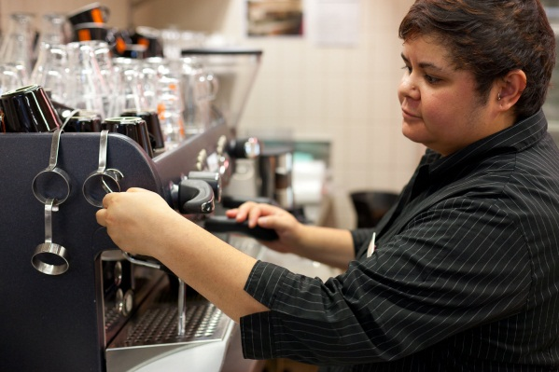
Can you just hang on a minute? I’ll grab a pen and paper and make a list of instructions to remind myself with.
Could you tell me a bit more slowly please? It was a bit too quick for me to remember it all.

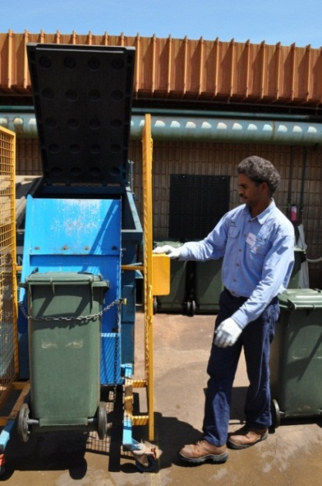
Can you please go through that again one step at a time?
It was a bit quick for me to follow you.
I think I've got it. Could you just show me how it's done now, to make sure?
Adapted from WorkSafe Victoria
Safety tips for young workers
http://www.worksafe.vic.gov.au

Ask questions
Asking questions is an important way to check that you understand something.
Some question words you could use are:
Should I …?
Is that what you mean?
So you mean I should …
Sorry, can you repeat that?
Can I check, do you mean …?
Can you show me how …?
Can you explain exactly what you want me to do?

Here is an example:
Request | What questions might you need to ask to do the right job?
Tom, can you clean the storeroom please? | Which storeroom do you mean – the food or chemical storeroom?  When should I clean it? Right now, sometime today, this week, next time we do a big clean?

Another way to check you understand is to identify key words and action words.
Here is an example:
Request | Key words and questions to check understanding
Can you set up the function room please Jackie? Use six round tables and thirty chairs. We’ll need the hot water urn too. | OK … six round tables …thirty chairs … the hot water urn, is that the one in the kitchen?

Activity 18
Check your understanding
In this activity you will be practising asking questions to check your understanding.
Your trainer will organise this activity for you.

Writing at work
At work you may have to write messages to people.
Some examples might be:
- an email to your supervisor to say what dates you prefer for holidays
- a message to a guest from someone who has called on the telephone
- a note to the head housekeeper saying that a room needs attention
- an entry in the porter’s diary to tell the people on the next shift some things that need to be done.
You might also have to fill in forms, such as:
- registration forms
- luggage tags
- maintenance request forms
- incident and accident reports.

Activity 19
Writing at work
What writing do you need to do at work?

Clear and simple
Keep your writing clear and simple. People only need the important information.
Before you send a message, check what you have written. Check that:
- the meaning is clear
- all the important information is in included
- spelling and grammar are correct.

Activity 20
Read and write an email
Here is an email from a housekeeping supervisor to people in her team.
Read it and then answer the questions below.
mjohnson@wattlepark.com.au

Read an email
- Who is the email from?

- What information does she want from each team member?

- When does she prefer they do not take holidays?

- Why?

- How many weeks holiday can a team member take in total?

- When does Mirabelle need this information?

Write an email
Write a short reply to Mirabelle.
Tell her when you want to take your holidays next year. If it is during school holidays, give her a reason.
Write your message in the following space.
Check your message to make sure that:
- the meaning is clear
- all the important information is in included
- spelling and grammar are correct.

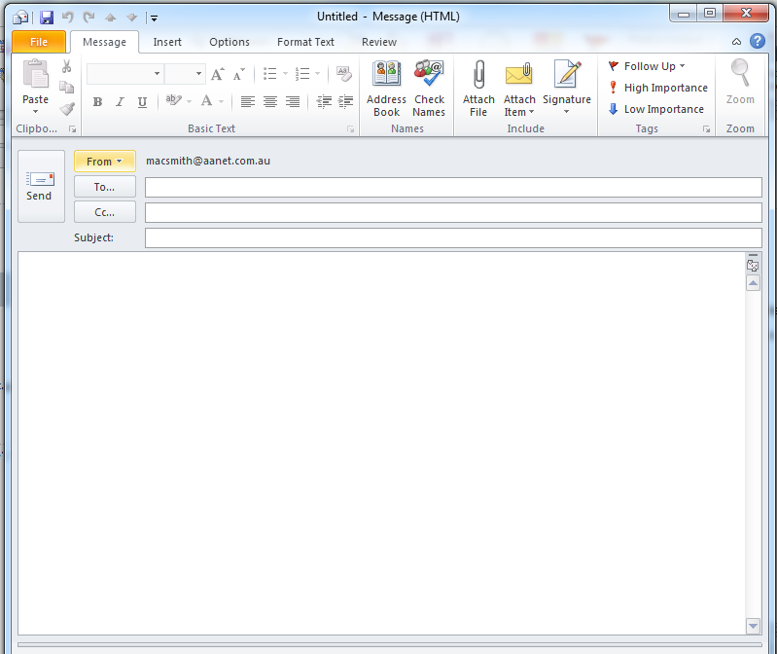

Answer the telephone
When you answer a telephone at work, you give the caller their first impression of your organisation. So every time you answer the telephone, be polite, professional and assist the caller as much as you can.
Guidelines for answering the phone
Look at these guidelines. Why do you think each one is important?
- Ask your supervisor how you should answer the phone
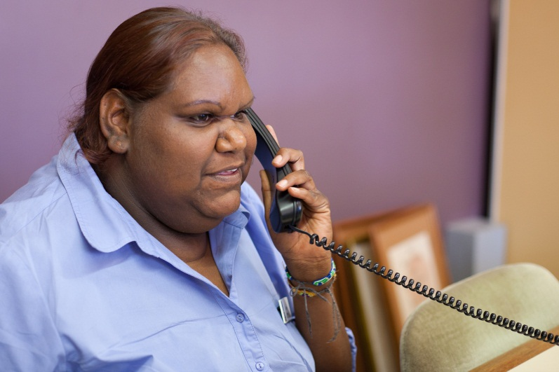
Good morning, Jasmina Restaurant, Keeta speaking.
How may I help you?

- Answer the phone promptly.
- Have a pen and a note pad by the phone.
- Do not answer a call with food or chewing gum in your mouth.
- Do not answer the phone while speaking to someone else.
- If you need to put a caller on hold:
- introduce yourself and the business
- ask them if they mind being put on hold.

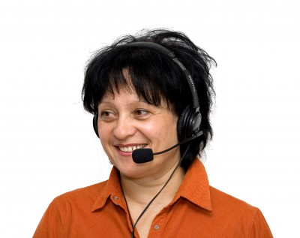
Good afternoon, Wattle Park Hotel, Jane speaking. I’m sorry, I have another call at the moment.
Can I put you on hold please?

Take messages
If you have to take messages at work, either from the telephone or from a person face-to-face, be very careful when you write down the message. You need to get it right. This may mean that you have to ask questions until you are sure about the message.

Here are some suggestions to help you take messages down correctly.
- Don’t write and listen at the same time.
- Check with the person on the other end of the phone or the person you are talking to.
- Read back the message.

When you are taking a telephone message, take down these details:
- the caller's name
- the name of the person the to whom the message is directed
- the time of the call
- the details of the call purpose or action to be taken
- time for a call to be returned or when the caller will phone back
- the caller’s contact number.

Confirm the message
When you have taken a message, check you have the message right. An easy way is to repeat the message to the caller.
Here is an example. The key words that you will put onto a message form have been highlighted.
I'll confirm the details you have given me if that is all right?

Your name is Mrs Julie Parks. You want to book a Standard Room for 3 nights from 27 – 29 November this year. There will be 2 adults and a child in the group. You expect to arrive at 3 pm on 27th. Your contact number is 04 8769 2314.

Is that correct?

I’ll pass this message on to George Hobart who deals with our reservations. He will contact you as soon as possible.

Activity 21
Take a message
Here is a message that has been left on the answering machine at work. It is for the restaurant night shift supervisor, Rita, and you need to write a message for her.
Read the message and highlight the main points that you need to write down.
Good morning, this is Jacob Bronson speaking. It’s 1 pm on Friday. I would like to make a booking in your restaurant for this Saturday. I would like to come at 7 pm, and there will be 6 people in the group, plus a toddler. Can you arrange a high chair for the toddler? I hope this is OK. Can you contact me by this evening on 07 9345 7291 to confirm please? Thanks.

Now write down the message for Rita.
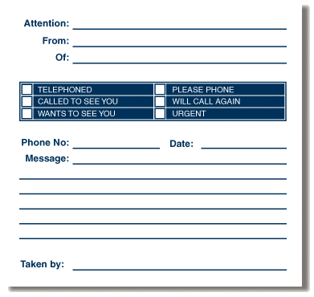

Activity 22
Using the phone at work
- What are some situations where you might have to answer or use a phone in a hospitality business?

- Does your workplace have a set of guidelines for using the telephone?
If so, what are some of the important points in it?

Activity 23
Answering the telephone and taking messages
In this activity you will practise answering the telephone and taking a telephone message.

Section summary
Now you have completed this section you should have developed the following skills and knowledge.
Tick each box if you are satisfied that you have those skills and knowledge.

Know how to communicate at work in a professional manner.
Know how to communicate with people from other cultures.
Check instructions.
Communicate in writing at work.
Answer the telephone and take messages at work.
Notes

3 Providing customer service skills
What is good customer service?
Hospitality is a service industry. Part of your job is to give customers a happy experience so they will return and recommend your establishment to others.
Here are the four steps to providing good customer service:
- Connect with the customer.
- Find out what the customer wants.
- Meet the customer’s needs and requests.
- Add a little bit extra when you can.
Good customer service is based on good communication.
You need to use your toolbox of communication skills with customers to provide good customer service.
1. Connect with the customer
This helps customers feel confident that you will take good care of them.
- Use an open question in your greeting e.g. ‘Good morning, how can I help you?’
- Use active listening to show the customer that you are genuinely interested in what they are saying.
- Use open body language.
2. Find out what the customer wants
Use a mix of open and closed questions.
Use open questions:
- to show interest in customers and get them chatting
- to seek information so you can start to work out what their needs are.
Good afternoon, ma’am. What would you like today?

Do you like spicy food?

Use closed questions:
- to get facts
- to control the discussion and
keep the customer focused.
Watch your customer's body language.
Are they happy with your service? Do you need to find out more?
3. Meet customer requests
Do your best to meet customer requests promptly.
If there is a delay, keep the customer informed.
If you can’t meet a customer’s request in a reasonable timeframe you should:
- apologise
- recommend an alternative
- refer them to your supervisor or manager.

Your scope of authority
This means that you shouldn’t do things or make decisions which are not part of your normal job role.
If a customer makes a request that is outside the scope of your job, you should:
- seek help from another staff member
- refer the customer to your supervisor.
The guest in 305 threw his car keys at me and asked me to get his laptop from his car. Can you deal with him please?

Customer requests must be reasonable. You are not expected to:
- break the law
- humiliate or demean yourself (make yourself feel bad)
- do anything that is unsafe or dangerous.
If you are ever asked to do something you feel is not right, excuse yourself and immediately contact management.
4. Add a little bit extra when you can
This will depend on the department you work in.
You can do this through things you say and things you do.
Things you say | - Is there anything else I can help you with?  - Nice to see you again.  - I look forward to seeing you again soon.  - Use the customer’s name if you know it.  - Put a ‘smile in your voice’ on the telephone.
Things you do | - Smile.  - Use open body language.  - Listen actively if a customer wants to chat.  - Open the door for a customer or let the customer walk through first.  - Give information – suggest things to do, places to go, talk about venue facilities.  - Offer to help if you can see that a customer needs it.

Activity 24
Practise customer service skills
Your trainer will organise an activity so you can practise using customer service skills.

Help customers with special needs
You may regularly deal with customers who have special needs.
You should take special care with them, without making them feel they are a nuisance.

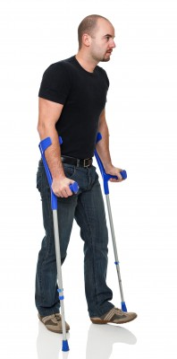
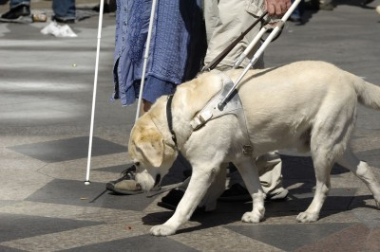

Activity 25
Helping a customer with special needs
Discuss together:
- What kinds of people may have special needs?
- How might you be able to help these customers?
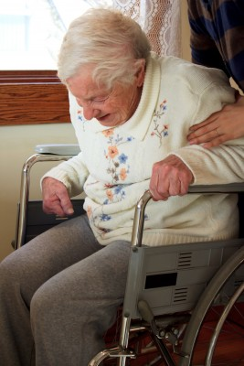

Provide information to customers
Good customer service means being able to answer customers’ questions.
Information about your business
You need to know about the hospitality business you work in – things like:
- restaurant or café opening hours
- room types
- leisure facilities (gym, pool, sporting facilities)
- laundry facilities
- medical facilities
- emergency assembly points.
Information about your local area
You also need to know about your local area – the things a visitor might want to see and do. You may also need to know about local transport and where to get transport timetables.

Activity 26
Know information about your business
- If a guest asked you for some of the previous information, could you tell them?
If not, what would you do?
- Find out 5 things about the hospitality business you work in. Share these with others in the group.

Activity 27
Know information about your area
Find out information about a tourist attraction or facility in your area which might be of interest or use to visitors.
Share the information you find with the rest of the group.

Section summary
Now you have completed this section you should have developed the following skills and knowledge.
Tick each box if you are satisfied that you have those skills and knowledge.

Provide customer service skills.
Understand what is good customer service.
Help customers with special needs.
Find out some information about the business and local areas.
Notes

4 Responding to conflicts and complaints
Guests generally expect friendly service, clean and well maintained facilities and a level of quality in line with what they paid. They are dissatisfied if they feel their needs or expectations have not been met.
Conflict with a customer
There may be many reasons for conflict with a customer or guest.
Some common examples are:
- they believe a staff member was rude or unhelpful
- facilities closed e.g. pool, restaurant
- expectations not being met – room size, windows, ventilation
- dissatisfied with food or service in food outlets
- dissatisfied with accommodation or services – the room too noisy, too cold, no view
- cleanliness
- booking mismanaged
- a mistake with an account – the guest may have been charged for items they didn’t use
- something broke down e.g. hot water, air conditioning
- noise from other customers.

Some complaints are reasonable, some are unreasonable. Either way, they need to be resolved calmly and promptly.

If a customer is complaining, how might they be feeling?

Customer warning signs
A customer may show warning signs of becoming angry or distressed.
The customer might:
- speak more loudly and quickly
- argue with staff or another guest
- swear or speak rudely
- cry
- make twisted facial expressions
- physically touch someone
- slam doors or make other noise
- throw or kick something.

If you see these warning signs, ask for help from your supervisor or a workmate.

Conflict between workmates
In the hospitality industry you work with a lot of different people. They all have different personalities, ways of doing things, ideas, ways of communicating – and many more differences. Because of the differences, there could sometimes be conflict or arguments between workmates.
Reasons for conflict
Some reasons for conflict between workmates include:
- work pressure
- bad communication which causes a misunderstanding
- prejudice – about all sorts of things from which football team the other person barracks for, what kind of car they drive, through to issues of ethnicity, gender, body shape and age
- intolerance about difference in opinions
- difference in beliefs
- people gossiping about others
- a team member not pulling their weight.

Steps to resolve a problem
Step | Example
1. Calm the person  - Use active listening  - Use open body language  - Don’t interrupt | My room hasn’t been cleaned today. I came back after a hot day to have a nice shower and the dirty towels are still all over the bathroom floor.
2. Check you understand  - Summarise to make sure you understand the problem  - Ask questions to gather all the information you need | So let me just check – your room hasn’t been cleaned at all?  What is your room number, sir?
3. Respond  - Apologise  - Express understanding of their feelings  - State what action you will take:  - correct the situation  - refer on to supervisor  - other possible solutions  - give a time line | I’m very sorry.  That’s very annoying for you.  I will contact my supervisor at once.  Can someone clean your room later today?
4. Act  - Do what you said you would do. | I’ve contacted my supervisor and she has arranged for a cleaner to do your room at 7 pm tonight while you are at dinner. It will take about 20 minutes. Is that okay, sir?  Is there anything else I can do for you, sir?  Once again, I apologise for the inconvenience.
5. Follow up
- Your supervisor will do this.

Remember:
You don't have to accept verbal or physical abuse.
If you feel worried or uncomfortable, call your supervisor.
How to apologise
- Use the customer’s name if you know it.
- Show concern. State that you understand they feel upset, inconvenienced or distressed.
- Say you are sorry. Even if the business is not to blame for the problem, you are still sorry about the situation and for their upset.
- Do not make excuses. Don’t tell the customer it was the fault of a particular individual or department. They do not want to know whose fault it was – they just want it fixed.

I’m so sorry, ma’am. One of the cleaners didn’t turn up for work today so we’ve been short-staffed.

I’m so sorry, ma’am. I’ll contact my supervisor and get it done as soon as possible.

- Thank the customer for complaining. They have brought a problem to your attention, so it can be fixed. It will help your business do better next time.

Refer to your supervisor
You may have the power, within your job role, to deal with some complaints or problems. However, you may need to refer other complaints problems to your supervisor, who will make a decision about what to do.

Activity 28
Dealing with a complaint
A customer has complained about their meal and left it half-eaten. What should you do?
A – Offer them a free meal
B – Offer them a refund
C – Check with your supervisor
D – Offer them a free drink.

Activity 29
Your workplace complaints procedure
- Do you have a procedure in your workplace for handling complaints?
- What are some main points in it?

- Have you ever had to deal with a complaint at work? If so, what did you do?

Activity 30
Handling complaints
Below are some problems which can happen in a hospitality business.
What could you do to resolve each situation?
Discuss ideas in your group and then share your ideas with the rest of the group.
Handling complaints
What could you do to resolve each situation?
Story 1  A customer in the café complains that his cup of coffee has spilt into the saucer. He refuses to drink it.  What should you do? | Story 2  A guest at the hotel comes to reception after her first night and complains that her room is noisy because it overlooks the main road. She is tired and grumpy as she didn’t sleep last night. She is staying for 5 nights.  What should you do?
Story 3  When a guest is checking out she complains that extra charges have been put on the bill. She says she didn’t use the mini bar or make any telephone calls but these are on her bill. She is very angry.  What should you do? | Story 4  A family sitting by the door of the café complains that it is too cold. The door doesn’t shut properly and you would have to run over and shut it yourself every time someone entered and left..  What should you do?
Story 5  The breakfast service in the restaurant is over at 10.30 am and the staff are packing up and cleaning the area.  Three customers arrive at 11.00 am wanting breakfast. They said they weren’t told what time breakfast finished.  What should you do? | Story 6  A guest arrives at the hotel after a long flight. He has to make an important presentation in the afternoon and he made a special request when he booked that his room would be ready so he could have a nap. The room is not ready and he is very upset.  What should you do?

Section summary
Now you have completed this section you should have developed the following skills and knowledge.
Tick each box if you are satisfied that you have those skills and knowledge.

Know how to recognise signs of conflict.
Know how to resolve a conflict with a customer or workmate.
Notes

5 Personal presentation
First impressions are very important. A customer will see your personal presentation as a sign of the standards and quality of the business. If they see staff with dirty or crumpled uniforms and messy hair, they may feel that the hygiene of their rooms and food will be similar.
So you need to put care and attention into your personal presentation.

Activity 31
Personal presentation checklist
Read the list below. Tick the box if you meet this standard every day.
Area | Standard in hospitality work | I meet this standard
Personal hygiene | Shower daily, use deodorant  Clean teeth daily  No body odour, bad breath or smelly feet
Clothing | Uniform as required  Clean, tidy, ironed  No stains, rips or tears  No tight or revealing clothing
Hair | Clean, brushed and tidy  Long hair tied back
Face | Women – not too much makeup and perfume  Men – clean-shaven or neatly-trimmed facial hair
Hands | Clean hands  Nails clean and trimmed
Shoes | Clean, not worn out, fit correctly  Non-slip sole, covered toes, no high heels
Decorations | Jewellery, nail polish, false nails, facial piercings, tattoos – check your workplace policy

Uniforms
Many hospitality businesses have policies and procedures about personal dress and presentation, including uniforms.
Uniforms must be kept in good repair, with no frays, rips or tears. If your uniform gets worn or damaged, you should promptly exchange it for a new item or get it repaired.
The type of uniform you wear will depend on your job. For example, if you work in the kitchen you will wear a different uniform from the porter.
NOTE:
If you work in a kitchen or restaurant, you must not wear your uniform outside of the work area. You might bring germs from outside into the work area.
It is against the law and you or your employer might be fined.

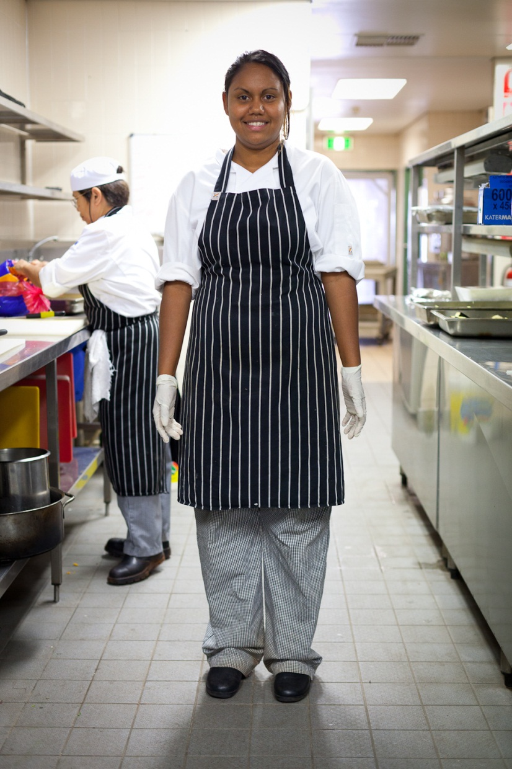

Posture
Posture is how you stand and move. Your posture is a kind of non-verbal communication. It can tell people about your attitude to your job.
Customers can see you when you wait on them, serve them at the bar or walk around the property doing your job. They form opinions based on what they see.

Activity 32
Posture
Discuss together:
What would customers think if they saw these things around the venue?
- The bar attendant slouching against the bar
- Two room attendants having a noisy chat and a laugh in the corridor
- A maintenance person snoozing at lunch time on the lawn
- The receptionist with his shoes off and his feet up on another chair
- A kitchen attendant in her uniform smoking outside the restaurant or café
- A porter playing computer games on the computer at his desk.

Section summary
Now you have completed this section you should have developed the following skills and knowledge.
Tick each box if you are satisfied that you have those skills and knowledge.

Know the importance of a clean, tidy appearance and uniform.
Know the importance of posture.
Notes

6 Working in a team
What is a team?
A team is a group of people who work together to achieve the same goals or have a common interest or need. They can be found in the workplace; but they can also be found in the home, clubs, community, school or sport.
A team can be a formal team such as a work group or footy team; or an informal team such as a group of people who go for a walk at lunchtime.
Team goals
The team’s goals are what need to be achieved by the team. Here are some examples of team goals.
- Providing hotel reception services so that guests are checked in and checked out quickly, accurately and with a good customer service attitude.
- Cleaning rooms within the timeframe set by the head housekeeper, and following workplace procedures, so that they are clean and comfortable for guests.
- Playing the football game fairly and following the rules of the game, so that all team members are able to participate, but with the aim of winning the premiership.

Activity 33
Being in a team
- Are you part of a team, or have you been in the past? If so, what was the team?

- What was good about being in a team?

- What was bad about being in a team?

- What words do teams make you think of?

Teams in the workplace
Your workplace will probably have many teams or groups. Some example of teams at your hospitality workplace could be the:
- reception team
- housekeeping team
- maintenance team
- cleaning team
- portering team.

Activity 34
What teams are in your workplace?
Discuss these questions together.
- What teams are there in your workplace?
- Which one do you belong to?
- What is the purpose of the team you belong to?

What makes a good team?
Look at some of the things than can help people be a good team together.
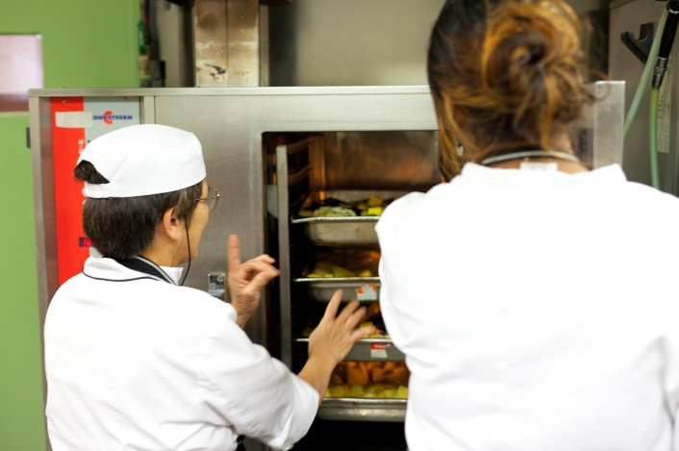
Sharing
Listening
Trust
Helping
Discussing

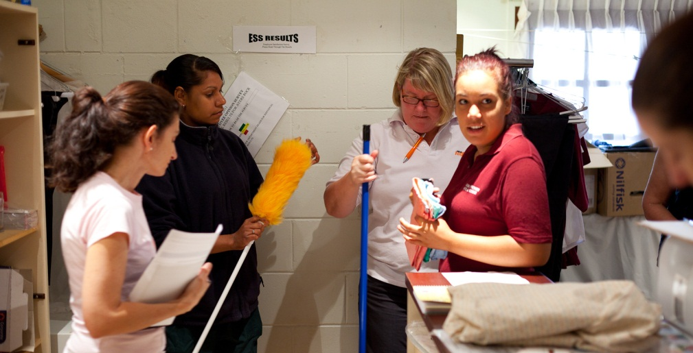
Questioning
Joining in

Activity 35
Are you a good team member?
Here is a list of things that a good team member does at work.
Have a look at them, and tick if you think you do these things all the time, some of the time or never.
Do you do these things? | All the time | Some of the time | Never
- Listen to instructions and follow them accurately
- Complete my own workload on time
- Help out other team members when needed
- Come to work on time and do my job reliably
- Share information about the job with my workmates
- Talk about problems and be prepared to listen to other’s ideas
- Ask for help when I need it
- Accept that we are all different and that some people will have different opinions
- Trust my team members and not gossip about them
Are there any ways you could improve as a member of a team?

Activity 36
Being a good team member
What could you do in these situations to be a good team member?
Talk together about different things you could do or say.
Situation 1
Your supervisor keeps getting annoyed that your work area is really messy. You and your workmates agree, but there’s no system or rules to follow.
Situation 2
You think that the store room would work better if it was organised differently. Your team mate says it’s fine the way it is and why change it.
Situation 3
One of your workmates is Muslim and is fasting before Ramadan. Your workmates keep asking him to join them for lunch and talking about food in front of him.
Situation 4
You have had a very busy morning. A lot of guests arrived at once and now you are having a little rest before lunch. A team mate looks busy, but he didn’t come and help you when you were busy, so you ignore him.

Activity 37
A team activity

In this activity, you will experience being part of a team.

Activity 38
Who would you rather work with?
Our attitudes (things we think) and behaviour (things we do) affect how we get on with our workmates and how well our team works.
Read the attitudes and behaviour of Paddy and Trish below.
Who would you rather work in a team with? Why?
I’ll just clean this up and then the next person will have a clean bench to start.
I’ll see if I can find someone who can answer your question.
Here – let me help you.
That looks dangerous – I’ll tell maintenance.
It’s the end of my shift – someone else can clean it up.
It’s not my job!
Don’t ask me,
I don’t know.
I don’t like that maintenance bloke – let him find out himself.
Why do they send emails?
I can’t be bothered with that!
I’ll have to learn how to do some new things in this job.
Paddy
Trish

Meetings
Meetings are an important team activity. Many workplaces have meetings regularly, for example each morning at the beginning of the shift, or once a week. They can be held to:
- make plans
- keep up to date with what’s happening
- improve cooperation.
This is a time to:
- learn things that affect your job
- have a say about things that affect your job.
Everyone should be free to have their say, and everyone should be listened to.
Some meetings are informal and some are formal with an agenda and notes of the meeting kept. However, whatever type of meeting, as a team you can come up with more ideas than you would on your own.

Activity 39
Your workplace meetings
- What meetings do you have at your workplace?
- How do people show that they want to speak at your meetings?
- Do you get a chance to give your opinions at meetings?
How do you behave at meetings?
People behave differently at meetings.
Some people make comments, ask questions and give ideas during meetings.
Other people mainly watch and listen. These people may have good ideas but find it difficult to speak in front of others. They may not completely understand but maybe they are afraid of showing that in front of their team.

Activity 40
How do you behave at meetings?
Read each item below.
Then tick the box that best describes how you behave at meetings.
What do you do in meetings? | Often | Sometimes | Never
Ask questions if you don't understand something
Wear your iPod and turn the volume up
Join in the discussion
Make smart comments
Think about something else more interesting
Listen when others are talking
Only listen when it’s something you’re interested in
Feel upset if you say something and others don't listen to you
Don’t say anything at all
Based on an activity in the Horticulture Toolbox for Indigenous Learners,
Australian National Training Authority (ANTA) 2002
Not AGAIN!
I already know that won’t work.

Make decisions and set priorities
In your work, you will sometimes have to make decisions and set priorities (decide what is more important to do and what is less important).
Activity 41Make decisions and set priorities
Jarnika has just come back from her lunch break. It’s 1.30 pm and she has a lot of things to do before she finishes at 5 pm. Help Jarnika to decide on her priorities for these tasks.
Number Jarnika’s tasks in their order of priority – the order you think she should do them in. Start with Number 1 for the most important task.
Order of priority | Jarnika’s tasks | Time it will take
 | Tidy up the shelves in the store-room. She said she would do this at the last week’s team meeting | 40 minutes
 | Clean her cleaning equipment and put it away | 30 minutes
 | Have a tea-break | 20 minutes
 | Finish mopping the corridors that she started before lunch | 50 minutes
 | Call her sister to check what’s happening tonight | 10 minutes
 | Check next week’s roster on the noticeboard | 10 minutes
 | Give the carpet in the lobby a quick vacuum – her supervisor asked her to do this as an ‘extra’ | 30 minutes
 | Go to the weekly team meeting at 3 pm | 30 minutes
 | Fill in the sick leave form for the day she was sick last week | 10 minutes

Ask for assistance
There may be times when you can’t do something on your own. Don’t be afraid to ask for help. Often there are service peaks that require some help for 5 or10 minutes and then it's over. You might need to let your supervisor know that you need help, or ask a workmate.
Ask politely and thank the person who helped you.
Always be prepared to help others in return.
How to ask for assistance
When you are asking for assistance, you can say things like this:

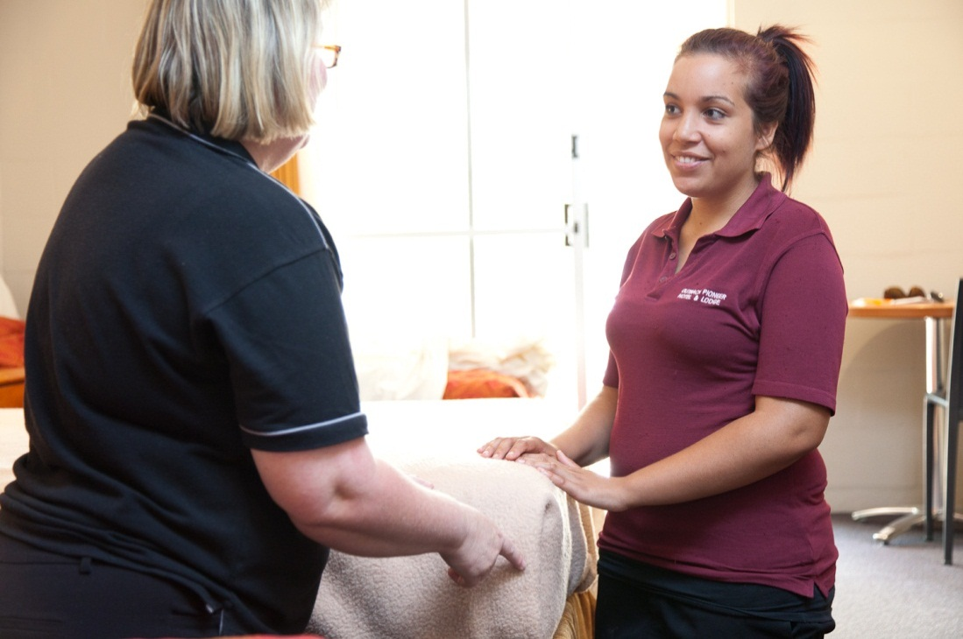
Excuse, do you think you could help me? I’m having trouble …..
Could you please ….?
Please can you help me, I’m not sure what to do here.
If you have some time, can you help me with ….?
Would you mind helping me. I don’t think I’ll be able to finish …….

Activity 42
Practise asking for assistance
Here are some situations when you might need assistance.
With a partner, take it in turns to ask politely for help.

- A room has been left very dirty so will take longer to clean. This will put you behind in your schedule and you know there are a lot of arrivals in the afternoon.
- A coach of tourists arrives. They need a quick check-in and their luggage taken to their rooms. You know you won’t be able to do it by yourself as quickly as the guests would like.
- There is a sudden rush in the bottle shop, with many customers waiting to be served.
- Every room service breakfast tray has been requested at 8.30 am.
- The chef has asked you to peel the potatoes and cut up the carrots for dinner. You have started but you don’t think you will be able to finish them in time.

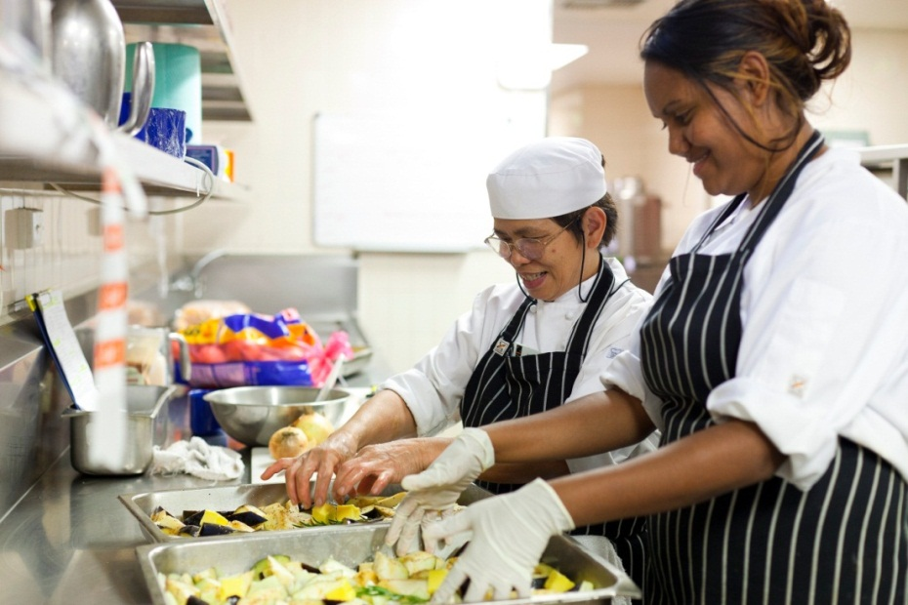

Giving and responding to feedback
Giving and responding to feedback is an important part of communicating.
Positive feedback
Feedback can be positive. You might praise someone for doing a good job or for helping you. Or someone might praise your work.
Negative feedback
However, you might need to give negative feedback to a workmate if there is a problem. You should:
- state what you believe the problem is
- discuss a way to resolve it.
Or your supervisor or a workmate may give you some negative feedback.

Giving negative feedback
Here are some suggestions for giving negative feedback.
Suggestions for giving negative feedback | Don’t say this … | Say this …
- Be specific, not general  - State the facts. Don’t talk about your feelings or what others have said.  - Don’t generalise – You always…, You never… | You never clean up the storeroom. | You didn’t clean up the storeroom when you finished your shift last night.
- Focus on the problem or the behaviour, not the person | Why are you so lazy? | This made it difficult for me today -it was hard to find things.
- Use your communication skills  - Ask questions – there may be a reason or explanation you don’t know about.  - Listen actively, so the person feels valued.  - Use summarising to check your understanding.  - Talk about how to improve the situation.  - Use positive non-verbal communication to calm any strong feelings. | Clean it up now, you can’t get away with slackness! It just makes more work for the rest of us. I don’t care what you were planning to do after work | Is there a reason why you didn’t clean up the storeroom? (e.g. person may have been ill)  So you were ill last night and didn’t have the energy to do it. I hope you are feeling better.  If this happens again, you should tell your supervisor or ask another person to help you.

Responding to negative feedback
Sometimes you might receive some negative feedback from your supervisor or a workmate. Maybe you have done something incorrectly. Treat negative feedback as an opportunity to learn how to do something better next time.
It can be difficult to stay calm when this happens.
- Listen actively to what the person is saying.
- Use open body language.
- Ask questions to try to understand what the problem really is.
Here are some ways you can respond to negative feedback.
Ways to respond to negative feedback | Don’t say this … | Say this …
Acknowledge anything you are responsible for.  Don’t make excuses. | It’s not my fault.  I couldn’t help it.  No-one offered to help. | Yes, I’m sorry I didn’t clean up the storeroom last night at the end of my shift.
Explain your own view of the situation.  Point out anything you did well.  Acknowledge things you could do better. | I was sick. Nobody takes any notice of me. It just gets turned against you as if being sick is doing something wrong. | I’m sorry I made a problem for other people. I was sick last night. I did manage to get all my other work done.  I guess I should have asked for help but I didn’t want to be a nuisance.
Talk about what you could do to prevent the problem from happening again. | Well, what did you expect me to do? | Next time I feel sick and can’t finish my job, I’ll let you know/ I’ll ask for help.
Ask what else you might do to improve your performance. | What else have I done wrong? | Is there anything else you can suggest I could do to make my work better?

Activity 43
Giving and responding to negative feedback
Your trainer will give you some situations where you have to give and receive feedback.
Use the previous suggestions, and practise giving feedback to a workmate and responding to feedback.

Negotiate changes in your work
Sometimes you may want to make a change in your work routine or make something new happen. You might have to negotiate with your supervisor or workmates about it. This means talking it over, seeing what the problems might be and trying to find a solution.
You might want to negotiate things like:
- the time you start and finish work
- when to take your holidays
- extra training to help you do your job better
- flexible hours
- some time off work to study or care for someone who is sick.
When you want to negotiate with a workmate or supervisor, for example to take time off work, keep these things in mind.

What does negotiating mean? | Example
Both sides can have their say about a change. | You can ask your supervisor for the time off work as you have an appointment.  Your supervisor may ask the reason and how urgent it is and talk about whether or not this is possible and why.
What you are asking for must be reasonable (fair and realistic). | You must have a good reason, and not ask for time off work at a particularly busy period.
When people can’t agree on a solution, they might come to a compromise – they both give way a little and ‘meet in the middle’. | Your supervisor may let you have time off work, but not on the day you asked for. You are happy with this as you will be able to change the appointment you made.
Some things are ‘not negotiable’. This means they can’t happen. | If it is a particularly busy time, the time off is ‘not negotiable’ – your supervisor will not allow it.
Other things are ‘negotiable’. This means they might be able to happen. | If the time you want off work is not at a busy time, your supervisor may let you take it.

Activity 44
Negotiating changes at work
In this activity, you will practise negotiating some changes at work. Your trainer will organise this activity for you.

Section summary
Now you have completed this section you should have developed the following skills and knowledge.
Tick each box if you are satisfied that you have those skills and knowledge.

Understand the importance of teams.
Identify what makes a good team.
Set work priorities.
Know how to ask for assistance.
Give and receive feedback.
Negotiate changes in your work.
Notes

Key words
Word | Meaning
attitudes | The way you think about things, especially if this shows in the way you behave
barrier | A block, or a problem that prevents people communicating with each other
behaviour | Things we do
clarify | Check what the person means
workmate | Workmate, team mate
communication | Sending a message that your listener understands, and understanding other people’s messages
compromise | Situation in which people accept something slightly different from what they really want
courteous, courteously | Polite, politely
customer | A guest in a hotel, someone who buys something from a shop or has a drink or meal in a restaurant, café or bar
demean | Do something that makes you feel bad
effective | Works properly
feedback | A response
formal | Polite, professional
gender | The different behaviour of men and women
gesture | Movements with your hands and arms e.g. pointing, scratching your head
humiliate | Embarrass, shame
idiom | Words or phrases that have a widely understood cultural meaning that is different to their literal meaning e.g. ‘it’s raining cats and dogs’, ‘the buck stops here’, ‘getting off the track’
informal | Casual, relaxed
jargon | Specialist words that are used by ’insiders’
literal | Exact
negotiate | Talk about a problem so you can solve it
non-verbal | Not using words – using actions or the way you hold your body
pleasantries | Polite words such as please and thank you
posture | Position of your body
prejudice | Pre-judging someone without getting to know them
priorities | Things you have to do first
procedures | A written list of actions that tells you how something should be done
prompt, promptly | Quick, quickly
pronunciation, pronounce | The way words are said
protocol | Guidelines on how to do something properly
rapport | A feeling of understanding and trust between two people
reasonable | Fair and realistic
respond | Answer
scope of authority | Tasks that are in your job description, that you have the right to carry out The types of tasks and decisions which are a normal part of your job
slang | Words, expressions and meanings which are informal and used by people who know each other well or have the same interests
tone | How someone says something, that shows how they are feeling
verbal | Using spoken words
volume | Whether something is loud or soft

