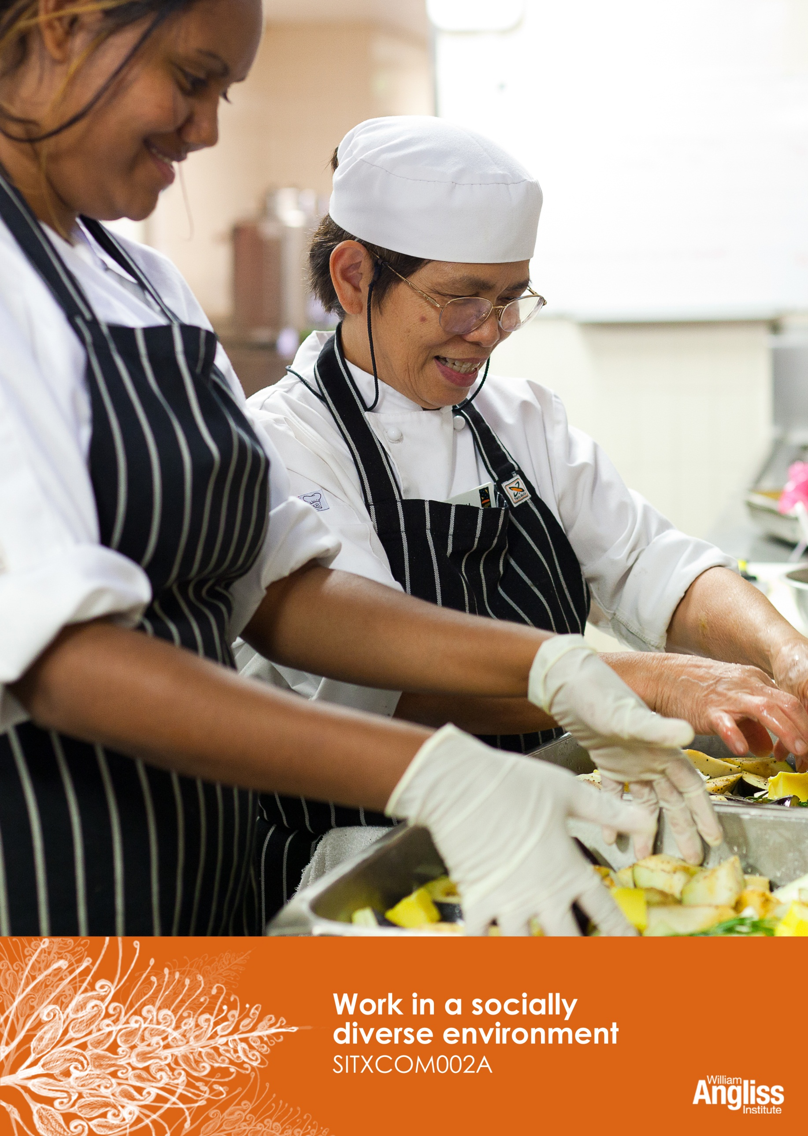

© Commonwealth of Australia. 2012
CC BY-NC-SA
This work is copyright. Except where otherwise indicated, and save for the Commonwealth Coat of Arms, the Department has applied the Creative Commons Attribution-Noncommercial-Share Alike 3.0 Australia Licence to this work.
The Department of Education, Employment and Workplace Relations must be attributed as the author of the Department’s copyright material.
As far as practicable, material for which the copyright is owned by a third party has been clearly labelled. The Department has made all reasonable efforts to ensure that this material has been reproduced in this resource with the full consent of the copyright owners.
Requests and enquiries concerning the Department’s copyright material should be addressed to:
The Copyright Officer
Department of Education, Employment and Workplace Relations
Location code C148CW2
GPO Box 9880 Canberra ACT 2601
Or emailed to copyright@deewr.gov.au
Funded under the Workplace English Language and Literacy (WELL) Program by the Australian Government Department of Education, Employment and Workplace Relations.
The views expressed in this publication do not necessarily represent the view of the Minister for Education or the Australian Government. The Australian Government does not give any warranty nor accept any liability in relation to the contents of this work.
ISBN 978-1-922108-07-4

Development Team
Content | William Angliss Institute  Macsmith and Associates
Photography & graphics | Benjamin B Photography

Acknowledgments
We would like to acknowledge the generous support of the following organisations and the Indigenous learners and employees in those venues for giving their permission for photography:
Ayers Rock Resort, Yulara, NT
Charcoal Lane Restaurant, Fitzroy, Vic
Lux Foundry Café, Brunswick, Vic
Peninsula Palms (Compass Group Australia), Dampier, WA
Permissions
We would like to acknowledge Ecolab who have kindly granted permission for their photographs of their products to be incorporated in this resource.
Multicultural Services of Central Australia
Department of Immigration and Citizenship
NAATI: The National Accreditation Authority for Translators and Interpreters Ltd
Logan City Council, QLD
Australian Network on Disability
Australian Human Rights Commission
Tourism Research Australia
Cultural Warning
People of Aboriginal or Torres Strait Islander descent should be aware that this publication contains images of people who may be deceased
Disclaimer
Every effort has been made sure that this booklet is free from error or omissions. However, you should conduct your own enquiries and seek professional advice before relying on any fact, statement or matter contained in this book. William Angliss Institute of TAFE is not responsible for any injury, loss or damage as a result of material included or omitted from this course.

Contents
Welcome vi
Icons vi
What you will learn vii
1 Diversity in Australia 1
Who are Australians? 2
What is culture? 8
International visitors to Australia 10
Anti-discrimination laws in Australia 13
Workplace policies 14
Section summary 16
2 Differences in ability 17
What is a disability? 17
Assisting people with a disability 20
Communicating with people with disabilities 21
Section summary 23
3 Working with diverse people 24
Know about different cultures 24
Showing respect for others 30
Don’t think in stereotypes 32
Ways for the workplace to support diversity 33
Section summary 34
4 Communicating with people from other cultures 35
Overcoming language barriers 41
Getting help from outside organisations 44
Section summary 48

5 Cross-cultural misunderstandings 49
Resolving misunderstandings 49
Referring problems to your supervisor 52
Section summary 54
Key words 55

Welcome
Icons
These signs tell you what type an activity is:
 | Do this activity in a big group.
 | Do this activity in a small group.
c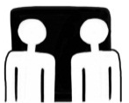 | Do this activity in pairs.
 | Do this activity by yourself.
Do this activity using the internet.
If you are not connected to the internet, your trainer will provide you with another activity.
Do this activity in your workplace.
If you are not in a workplace, your trainer will provide you with another activity.

What you will learn
This unit will help you to be aware of the needs of customers and colleagues from diverse backgrounds. It will help you to:
- communicate with people from different social and cultural backgrounds with respect and sensitivity
- address cross-cultural misunderstandings.

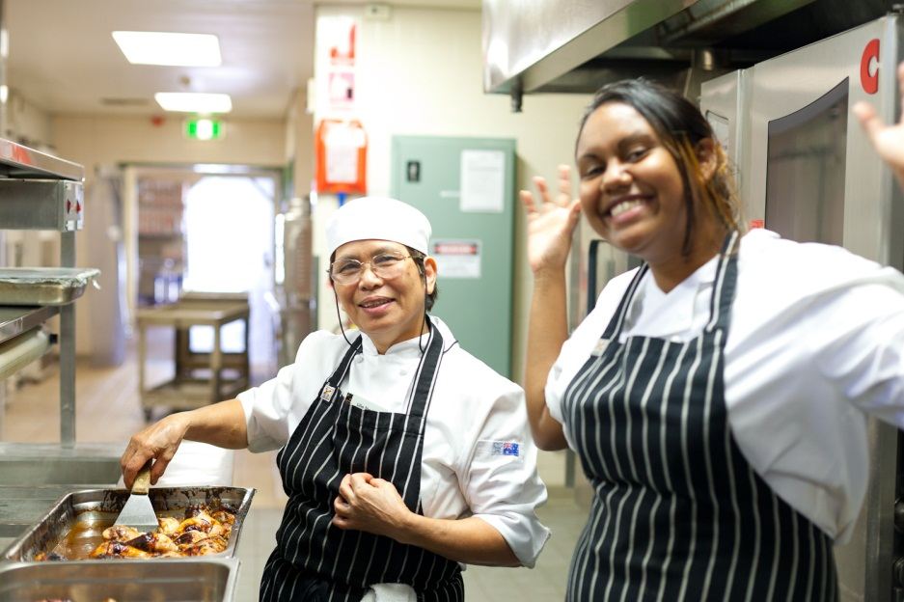

1 Diversity in Australia
In the Australian hospitality industry you will work with colleagues and customers from many different backgrounds.
These people may be different to you because of their:
- race
- cultural background
- language
- special needs e.g. diet
- abilities
- family structure
- gender
- sexual preference
- age.
This diversity means that your colleagues and customers may look different, have different beliefs and different ways of doing things.
Communicating with people from different backgrounds can sometimes be difficult. There can be misunderstandings.
This is why you need to learn how to communicate with people from a range of backgrounds.

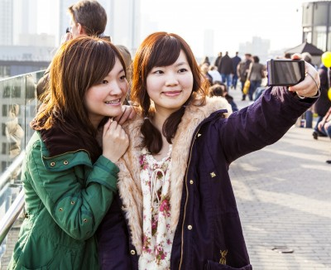

Who are Australians?
Australia has one of the most diverse populations in the world in terms of culture and languages.
More than 22 million people live in Australia. They come from a wide range of backgrounds.

The British set up colonies from 1788.
British, Europeans and others migrated to Australia. The colonies grew and the new nation of Australia evolved.
Migrants from over 200 countries have come in different ‘waves of migration’. Recent migrants are from Asia, Africa and the Middle East.
Indigenous peoples have inhabited Australia for up to 60,000 years.

Australians come from diverse countries
In 2011, Australia’s population was over 22 million.
- 2.5% of people are Indigenous
- 30.2% of Australians were born overseas
- About 46.3% have at least one parent born overseas.
From Australian Bureau of Statistics, 2011

From Australian Bureau of Statistics, 2011

Activity 1
Australians come from diverse countries
Look at the previous graph and answer these questions.
1. What are the four main countries of Australians born overseas?

2. Do any of the top 10 countries come as a surprise to you?

3. Do you know the nationalities of other people who have migrated to Australia?

Australians have diverse beliefs
People in Australia have many different faiths - over 120 different religions and denominations. Some do not belong to a religious group.

Australians speak diverse languages
Languages in Australia
- Australians speak more than 200 different languages.
- 56,000 people speak over 50 Indigenous languages.
- 19% of Australians speak languages other than English at home.
- The most common other languages are Italian, Chinese, Greek, Arabic and Vietnamese
From the Australian Human Rights Commission Face the Facts Report, 2008
and the Australian Bureau of Statistics, 2011

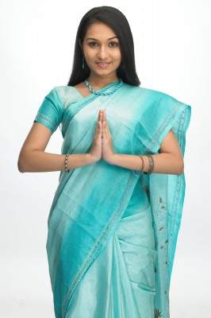

Australians have come to Australia for diverse reasons
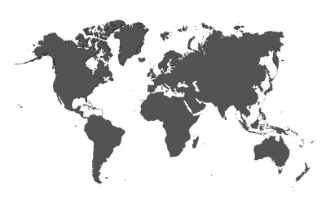
Sent as a convict from England in 1823 for stealing to feed his family.
From China in 1863 to look for gold.
From Ireland in 1851 to escape a famine.
Kidnapped from Vanuatu in 1877 to work on Queensland sugar plantations.
From Italy after World War 2 to give their children a better life.
From Vietnam in 1974 to escape the war.
From Somalia in 2009 to get away from the fighting and starvation.

These people are all Australians
I am Fernandez. I am 51 and live in Darwin. I came to Australia from Timor l’Este. I speak Tetum, Portuguese and English.
I am married with 3 children. I am a waiter in a hotel restaurant. I like Portuguese ‘fado’ music and soccer. I am a Catholic.
My name is Dave. I am 34 and came from New Zealand for a job. I speak English and some Maori.
I work in a government department in Canberra. I live with my girlfriend. We like going out to restaurants and movies.
Hi, my name’s Jimmy. I’m 23 and live in a country town in Western Australia.
My family came to Australia from Scotland 100 years ago. I have a hearing disability and use Auslan sign language.
I’m a car mechanic and I like motorcycling and action movies. I like camping with my mates on holidays.
My name is Marina. I’m a 17 year old Indigenous girl from a family living near Alice Springs. I speak English and some Warlpiri.
I love rap music and playing netball. I am studying hospitality.
I am Toula. I work as a chef in a hotel in Sydney.
My parents were factory workers. They come from Greece. I only speak English though.
I live with my partner in an apartment in Sydney. I love surfing and going to the gym.

What is culture?
Your culture is part of your identity – who you are. Culture is the groups you belong to that influence parts of who you are. Some groups you are born into and some groups you become a part of at different times during your life.
Your culture shapes the way you see the world and how you live. If you are aware of your own culture it helps you to understand other cultures.

I am a wife and mother.
I speak English, Tamil and Sinhala.

I am Muslim.
For me, family is the most important thing in life.
I never wear outdoor shoes inside the house.
I am from Sri Lanka.

Some aspects of culture are obvious, such as language, ways of dressing and behaving. But other aspects of culture are harder to see such as values, customs and beliefs.

Remember that each individual is more than their culture.

Activity 2
Australians come from diverse countries
How do you identify yourself?
1. How do you describe who you are?
Look at the examples, and then finish the sentence about yourself.
2. Then discuss in small groups: Are any of these aspects more important to you? Why?
Attribute | Example | Me
Gender | I am a woman. | I am ...
Ethnicity | I am Vietnamese. | I am ...
Name | I am Gina. | I am ...
Family background | I am part Samoan. | I am ...
Career or job title | I am a room attendant… | I am ...
Relationship to others | I am a friend / mother / son… | I am ...
Interests | I like sewing / surfing… | I like ...
How you think about yourself | I am funny / serious / clever… | I am ...
Adapted from Young people in the workplace, Australian Human Rights Commission
International visitors to Australia
This table shows information about visitors coming to Australia in 2010 and 2011. It shows how many people visited, and the reason they came to Australia.

From Tourism Industry Facts and figures at a glance: May 2011
Tourism Research Australia

Activity 3
International visitors to Australia (1)
Look at the previous chart and answer the questions.
1. What is the main purpose of international visitors coming to Australia?

2. How many international visitors in this group came to Australia in 2011?

3. What is the second main purpose of people visiting Australia?

4. How many international visitors in this group came to Australia in 2011?

How much money did they spend?
This chart shows where visitors to Australia came from in 2010 and how much money each group spent.

From Tourism Industry Facts and figures at a glance: May 2011
Tourism Research Australia

Activity 4
International visitors to Australia (2)
Look at the previous chart and find the answers to the following questions.
- What are the top four countries that most visitors come from?
Country
1
2
3
4
- What are the top four countries that spend most per person?
Country
1
2
3
4
- What are the top four countries that spend most in total?
Country
1
2
3
4

Anti-discrimination laws in Australia
Australia has laws to make sure that all Australians:
- are free to express their own culture and beliefs
- respect the right of others to express their own culture and beliefs
- have equal opportunity in social, political and economic life
- are treated fairly, free from discrimination on the grounds of race, culture, religion, disability, language, gender or other basis.
These laws (or Acts) have been passed by both federal and state governments.
A quick guide to anti-discrimination laws
The law | What it means
Age Discrimination Act | Whether you are young or old, you have the right to be treated fairly and to have the same opportunity as other Australians.
Disability Discrimination Act | People who have disabilities have the same rights as other Australians.
Sex Discrimination Act | All Australians have the right to be treated equally and not discriminated against on the grounds of sex, pregnancy or their marital status.  They also have the right to not be sexually harassed.
Racial Discrimination Act | Discrimination against people on the basis of their race, colour, descent or national or ethnic origin is unlawful.
Australian Human Rights Commission Act | Defines discrimination and connects Australia to international human rights laws.
Racial Hatred Act | Public racially offensive or abusive behaviour is unlawful.
Equal Opportunity for Women in the Workplace Act | Employers should give women equal employment opportunities. They should remove any barriers to women entering and advancing in their organisation.
Fair Work Act and National Employment Standards (NES) | The NES sets out 10 minimum standards of employment, including up to 12 months unpaid parental leave. It also allows parents or carers of a child under school age, or of a child under 18 with a disability, to request a change in working arrangements to assist with the child’s care.
State-based anti-discrimination laws | All Australian states and territories have their own Acts which make discriminatory behaviour unlawful.
Workplace policies
Most workplaces have their own rules about treating people fairly. These are called policies. They are usually based on the laws to prevent discrimination.
They tell employees how they are expected to behave.
Here is an example:

 | Wattle Park Hotel Anti-discrimination Policy
We are required by law to provide a workplace which is free from discrimination and harassment.
No employee should discriminate against, harass, victimise or vilify any workplace colleagues, contractors or members of the public for any reason, including:
- gender |  | - relationship status
- age |  | - breastfeeding
- race |  | - religious belief or activity
- disability |  | - political belief or activity
- family responsibilities |  | - trade union activity
- pregnancy |  | - sexuality.
Any such behaviour is prohibited under both state and federal legislation

Activity 5
Your workplace policies
Find your workplace policies that are about treating people fairly.
- What are the names of the policies?

- What are 3 things they tell you about how to behave fairly towards other people?

Section summary
Now you have completed this section you should have developed the following skills and knowledge.
Tick each box if you are satisfied that you have those skills and knowledge.

Understand diversity in Australia.
Understand how your culture is part of your identity.
Know about different international visitors to Australia.
Understand Australian anti-discrimination law.
Identify and know your own workplace policies about treating people fairly.
Notes

2 Differences in ability
Another way people can be different is in ability. We call this disability. One in five Australians has a disability.
What is a disability?
Some people have disabilities from when they are born. For others it may be the result of an accident, illness or ageing.
Some disabilities are short term and some are long term. Some come and go. Some people may have more than one disability.
Many medical conditions such as cancer, arthritis or chronic fatigue syndrome may result in disabilities.
People with disabilities can face barriers when accessing facilities or services.

Activity 6
Learn about disability
Read about different types of disability in the following table.
Discuss together. Then write brief notes into the table.
1. What problems might a person with that disability face in a hospitality environment?
2. How could you assist that person with a disability?

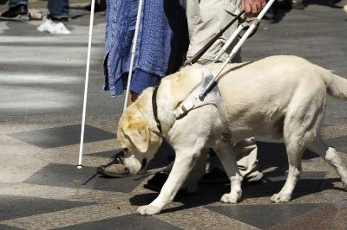

There are many different types of disability. Some common ones are listed here.
Type of disability | What you may see | What problems might they face in a hospitality environment? | How could you assist?
Loss of sight | Person may:  - wear thick glasses  - use a stick  - have a guide dog
Loss of hearing | Person may:  - use a hearing aid  - ask you to repeat things  - turn one side of their head towards you as you speak  - speak in a slurred way  - use Auslan (Australian sign language)
Mobility disability | Person may:  - use a stick, crutches or walking frame  - use a wheelchair
Speech disability | Person may:  - point and gesture to communicate  - use a speech board or other communication device
Intellectual disability | Person may:  - have an aide with them  - communicate unclearly  - behave in a more child-like way than their age
Mental health problems e.g. anxiety disorders, phobias or depression | Person may:  - display unpredictable responses  - display unusual behaviour  - display signs of anger or frustration  - withdraw from communication

Assisting people with a disability
Signs
Signs are an important way to show customers and the public that your business is accessible to people with a disability.

Activity 7
Signs and symbols
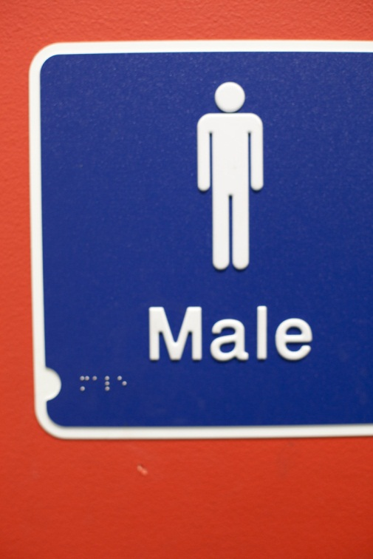
1. Do you recognise these signs?

What do they mean?

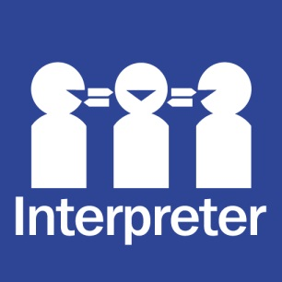

2. Walk around your workplace.
a) What signs can you find that could help people with a disability?

b) What other things can you see that would help people with a disability?
Use this list to help you.
Tick the things you find.
Wheelchair ramps
Large print menus
Menus or signs in Braille
Safety bars in public area toilets
Disabled toilets
Rooms fitted out for people with disabilities e.g. furniture low to the ground, seat in the shower, grip bars
Walkways wide enough for wheelchairs
Anything else?
Communicating with people with disabilities
- What should you do if you are not sure about the best way to communicate with a person with a disability?
Ask them.
- How should you talk to and look at the person?
Look and speak directly to the person with the disability, not to their carer or interpreter.
- What should you do if you can’t understand something the person said?
Ask the person again.
Be patient – people with some kinds of disability may take a little longer to understand and respond.
- How should you treat the person?
With respect and consideration – the same as you would with everyone else.
Don't assume what the person can or can't do.

Language is powerful
Use language that puts the person first and the disability second.
Negative language | Positive language
He’s disabled | He has a disability
A handicapped person | A person with a disability
Deaf | A person with a hearing disability
Blind | A person with a vision disability
Handicapped, a spastic, a cripple | A person with a physical disability
Wheelchair-bound, confined to a wheelchair | Uses a wheelchair, a wheelchair user
Mentally retarded | A person with an intellectual disability

Section summary
Now you have completed this section you should have developed the following skills and knowledge.
Tick each box if you are satisfied that you have those skills and knowledge.

Know about different kinds of disability.
Identify signs in the workplace that assist people with a disability.
Communicate respectfully with people with disabilities.
Notes

3 Working with diverse people
It’s easy living and working with people who are just like you – you feel like you understand them.
But in a diverse country like Australia, and in the hospitality industry, you may have to work with people who aren’t like you at all. These people may be colleagues (workmates) or guests and customers in your hospitality workplace.
The main strategies for working smoothly with people from different backgrounds to yourself are:
- know about different cultures
- show respect for others
- don’t think in stereotypes.
Know about different cultures
You can’t know everything about every culture, but it can help to know a little about the cultures of your workmates and your main visitor groups.

Activity 8
Find out about another culture
Choose one of these countries:
- China | - Germany | - France
- India | - Japan | - Saudi Arabia
- America | - Malaysia | - Singapore
- South Korea

- Find information about the language and culture of people from this country.
Your trainer will organise this activity.
Try to find information that is important for hospitality workers to know about.
- Write brief notes in the following table.
3. Share your information with the group.

COUNTRY:
Greetings & forms of address
Physical contact
Religion/s
Non-verbal communication
Food customs, preferences, taboos
Attitude to alcohol
Dress
Modesty for women
Level of formality
Language/s spoken
Anything else hospitality workers may need to know about?

Activity 9
Using your cultural knowledge
Here are some stories where knowing a little about different cultures would have helped communication.
Read each story. Then discuss the questions together.
Story 1 – Greetings and forms of address
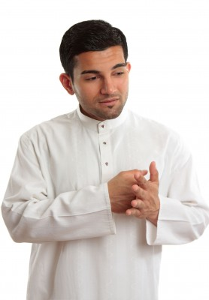
Matt had met all the Middle Eastern convention guests at reception. The next day he greeted one man this way: ‘G’day Aziz, how are you going, mate?’ The man nodded briefly but did not smile or reply.

- How might the guest have felt?
- What cultural knowledge would have helped Matt?

Story 2 – Family and social obligation
Winston needed to go to a cousin’s funeral. His workmate Candice got angry that he was having time off and said, ‘You Aboriginals are always going to funerals’.

- What might Candice be thinking and feeling?
- What cultural knowledge would have helped Candice?

Story 3 – Religions
Barney wished all the customers ‘Merry Christmas’ as they left the cafe. Some of them were wearing Middle Eastern dress.

- How might the Middle Eastern guests feel?
- What cultural knowledge would have helped Barney?

Story 4 – Modesty for women
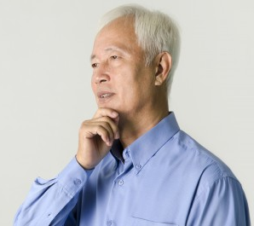
Marcia was at reception. She is 19 and had the two top buttons of her shirt undone. Some of the guests from Malaysia looked away when they saw her.

- Why do you think the guests looked away?
- What cultural knowledge would have helped Marcia?

Story 5 – Food preferences
An Indian customer asked Ken what was on the menu for vegetarians. Ken said he could just order from the menu and remove the meat.

- How might the Indian guest feel?
- What cultural knowledge would have helped Ken?

Showing respect for others
We should treat our colleagues and customers with respect and sensitivity.

Activity 10
What do we mean by ‘respect’?
Discuss in your group:
1. Think of a time you were treated with respect by someone.
What was the situation?
What did the person do that made you feel respected or worthwhile?
2. Think of a time you were not treated with respect by someone.
What was the situation?
What did the person do that made you feel not respected or worthwhile?

Activity 11
Some ways to show respect
What are some ways to show respect for colleagues and customers from different backgrounds? Talk together and make a list.

Activity 12
The benefits of respecting others
How does it help to be respectful of colleagues and customers from different backgrounds?
In a small group, discuss these statements.
Then circle YES or NO.

If I am respectful of others: | What do you think?
Customers will feel like they matter. | YES / NO
People will boss me around. | YES / NO
The workplace will be fairer. | YES / NO
I will be obeying the law. | YES / NO
I will be following workplace policy. | YES / NO
I will get more tips. | YES / NO
People will respect me in return. | YES / NO
Going to work will be more enjoyable. | YES / NO
I’ll get better shifts. | YES / NO

Don’t think in stereotypes
Stereotyping is making assumptions about a person because of their appearance, their background or their culture. When we think in stereotypes, we are often prejudiced.
Prejudice is when you pre-judge a person or situation rather than asking and finding out the facts. You assume (believe without proof) that you know or understand.

Activity 13
Fact or stereotype?
Read the statements below.
Decide if each statement is a stereotype (write S) or a fact (write F).
S/F
1. All Australians love sport.
2. Most people over 70 years of age are retired from work.
3. All politicians are dishonest. You can’t trust them.
4. Americans are rich.
5. People are poor because they are lazy and don’t want to work.
6. The Australian Government is run mainly by men.
7. Indians only eat curry.
8. People in wheelchairs can’t play sport.
9. Australia is a wealthy country with a lot of natural resources.
10. Vietnamese people most commonly work in bread shops.
11. Fat people are happier than thin people.
12. Men are braver than women.
13. People who wear glasses are intelligent.
14. All Aboriginal people are good at art.
Adapted from Prejudice no way!
NSW Department of Education and Training 2006

Ways for the workplace to support diversity
A hospitality business might use many ways to make sure the workplace respects diversity. The business could:
- have policies and procedures in place to support diversity
- train staff in how to be aware of people’s diversity and show respect for it
- offer family-friendly shifts to staff
- employ staff from a diverse range of backgrounds, including people with a disability
- build staff knowledge of cultural and religious festivals celebrated by guests and staff
- employ staff who speak another language
- offer basic foreign language training for staff
- offer English-as-a second-language programs for staff who need it
- translate emergency procedures and other signs into the languages of key employee and visitor groups
- make sure facilities are suitable for people with a disability.

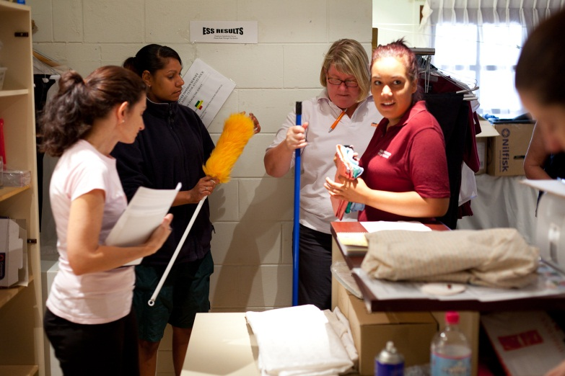

Section summary
Now you have completed this section you should have developed the following skills and knowledge.
Tick each box if you are satisfied that you have those skills and knowledge.

Know about different cultures and use this knowledge in the hospitality industry.
Show respect for others.
Know the difference between stereotypes and facts.
Know what a hospitality business could do to support diversity.
Notes

4 Communicating with people from other cultures
In the hospitality industry you will need to communicate with colleagues and customers for many different reasons. For example:
- meeting, greeting and farewelling customers
- giving directions
- giving instructions
- answering enquiries
- serving customers
- working in a team.
Cultural differences can affect verbal and non-verbal communication.
Here are some guidelines for communicating and respecting cultural differences.

Guidelines for communicating with people from other cultures
- Don’t stereotype. Do not assume all people from a particular culture behave in the same way. Treat people as individuals first.
- Ask people respectfully about their culture so you can understand and treat them as they wish to be treated.
- Speak clearly and concisely (not too many words).
- Speak at close to normal speed but sound words out properly. Don’t speak really slowly – this can seem like you think people are inferior (worth less than you) or childish. English speakers may not understand your accent. Non-English speaking people may need time to translate.
- Use simple words and short sentences.
- Don’t use slang (such as togs, mozzie, barbie).
- Don’t raise your voice. It won’t help people to understand better!
- Don’t give too much information at once. Talk for a short time, then check for understanding.
- Use visual communication such as maps, photos, drawings and diagrams.

- Your non-verbal communication is important too.
- Use gestures or sign language to communicate.
- Show a friendly attitude.
- Be careful. Eye contact, facial expressions, gestures and posture can mean things to the guests that you don’t expect.
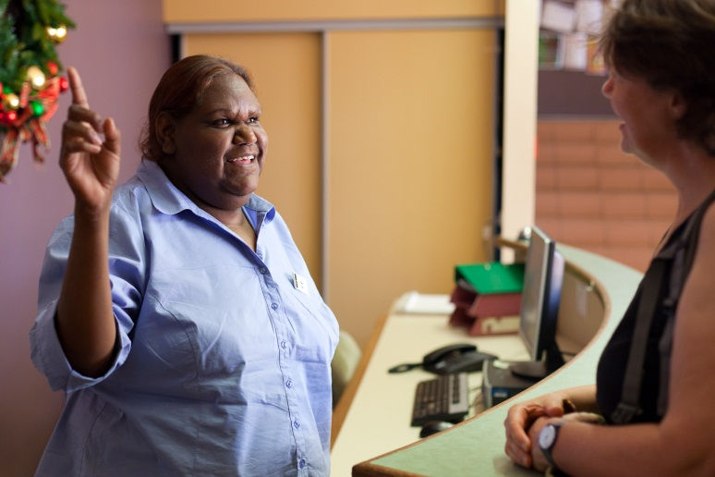

- Check for understanding.
- If you’re having difficulty understanding a message, ask the person to repeat or clarify it. “I’m sorry, I didn’t understand. Could say that again please, ma’am?”
- Or repeat their message back to them. “So you want to check out tomorrow, sir?”
- If you don’t understand a person’s name, ask them to spell it.
- If you think your message has not been understood, check with the person. “Would you like me to say that again, sir?”
- Be friendly but not over-familiar.
- Don’t stand too close to people, or touch them.
- Don’t make jokes. There are cultural differences about what is funny.
- Don’t discuss religion or politics. People may be sensitive about these.

Activity 14
Communciating with people from other cultures
Read the following stories. Discuss the question.
You might like to look again at the previous guidelines for communicating with people from other cultures.
Story 1
Gerry works in a team with Tranh but she rarely makes eye contact with him. Gerry thinks that Tranh is being rude and not interested in what he is saying.
In Tranh’s culture it is not polite to make eye contact. She is not being rude. She is interested in what Gerry is saying.
- Which guidelines would help Tranh and Gerry communicate better?

Story 2
Teena was organising a party but she was not sure about inviting Leila. Leila is a Muslim and Teena thought Muslim girls couldn’t go out on their own or be in places where there was alcohol.
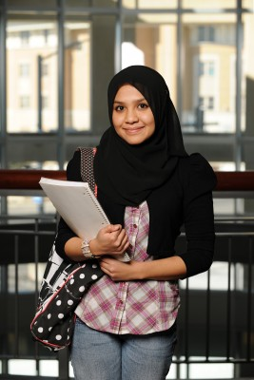
Actually, Leila loves barbeques, drives her own car and goes out a lot. She does not drink alcohol but she doesn’t have a problem with others drinking alcohol.

- Which guidelines would help Teena and Leila communicate better?

Story 3
An African guest in the hotel spoke English but did not understand Australian accents. He did not understand Michael listing the specials on the menu, so Michael spoke really slowly. The guest felt insulted and said he was ‘not stupid’.

- Which guidelines would help Michael communicate better with his guest?

Story 4
James was taking an order in the restaurant but he wasn’t quite sure what the customer was saying because she had a very strong accent.
He politely asked her if she could repeat the order. He then checked with her that he had got it right.
- Which guidelines did James follow to communicate well with his customer?

Story 5
Pete wanted to know which of the Indonesian customers wanted the chocolate dessert. He pointed his finger at each of them and asked, ‘You chocolate?’, ‘You chocolate?’
His customers seemed upset. He did not realise that pointing a finger is considered very rude in Indonesian culture. Indonesians use their thumb to point.

- Which guidelines would help Pete communicate better with his customers?

Overcoming language barriers
Sometimes it is difficult to communicate with people who do not speak the same language as you. But you can use methods to help, such as:
- using gestures and sign language
- speaking in simple English
- writing the message
- using visual communication methods such as drawings, maps or pictures
- learning basic words in a foreign language
- using a translator or colleague who speaks the other language.
One way of making people from other cultures feel welcome is to learn a little of their language.

Activity 15
Learn a foreign language
Your trainer will organise an activity where you can practise some words in a foreign language.
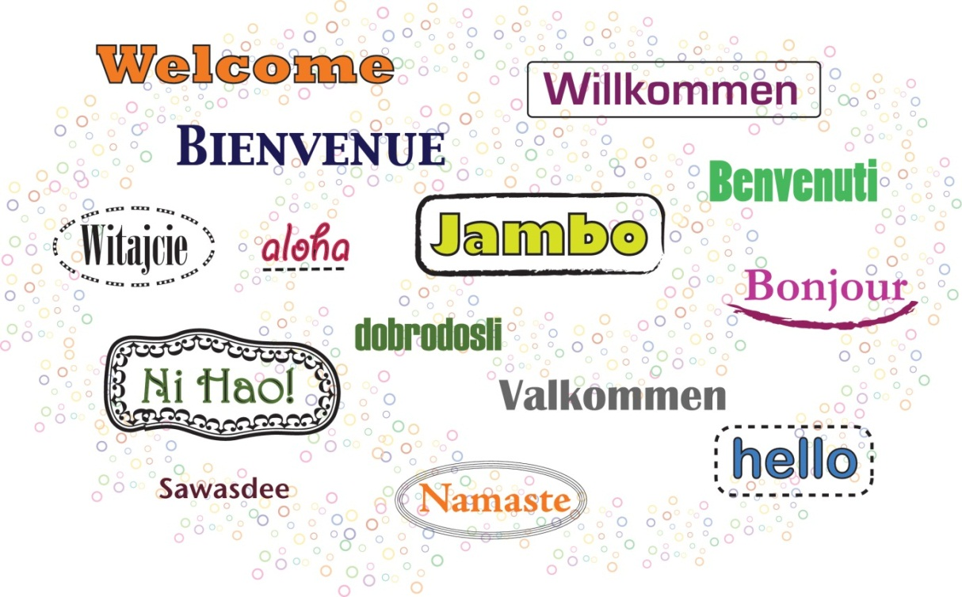

Activity 16
Overcoming language barriers
Read each story. Then tick the actions which would help communication. You can tick more than one action.
Story 1
Jenny works in front-of-house. Some Chinese guests arrive who do not speak any English. Jenny does not speak Chinese.
What things should Jenny do to help communication?
- Listen carefully
- Speak slowly and clearly
- Speak loudly
- Show the registration form and hold out a pen
- Find a Chinese-speaking colleague to translate

Story 2
Fred is working with a Filipina workmate in the kitchen who does not speak English very well. He is trying to explain that she must wear gloves to use cleaning chemicals but she does not understand.
What things should Fred do to help communication?
- Give her some gloves and use gestures to indicate the chemical is dangerous
- Ask the supervisor to explain she needs to wear gloves
- Speak loudly
- Speak slowly and clearly
- Draw a picture of her wearing gloves

Story 3
Some guests from Germany ask Shaun for directions on how to get to the nearest supermarket. They only speak a little English.
What things should Shaun do to help communication?
- Draw a small map
- Show them the map on Google maps or his phone
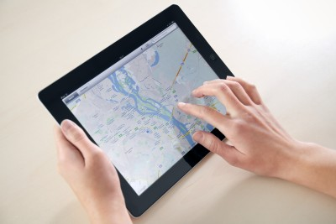
- Speak slowly and clearly
- Learn basic German.
- Use sign language to indicate right, left and so on

Activity 17
Practise communicating
Your trainer will organise this activity to give you practice in communicating with people from different cultures.

Getting help from outside organisations
Sometimes you may need to get help from outside your workplace to communicate effectively with colleagues or guests from different backgrounds.
Here are some examples of the kinds of places you could contact:
Activity 18
Help from outside organisations
Look up these websites. Find one piece of information from each website which could help you communicate with diverse people.

Your local council may have multicultural services.

To find an interpreter or translator in your area try: <http://www.naati.com.au/

Disability advocacy groups may have advice.
Look at:
<http://www.and.org.au/>

TIS National is an interpreting service run by the Department of Immigration and Citizenship on a fee-for-service basis. It is available 24 hours a day, seven days a week.
<http://www.immi.gov.au/>

Local cultural organisations may
have information and advice about multicultural workplace policies and cross-cultural communication. Here
is one example:
<http://www.mcsca.org.au/>

Outside source | What help could they give your organisation to communicate better?
Translation services | Translate brochures, signage and website into languages of your main international tourist groups.
Interpreting services | Interpret what a visitor is saying, especially in an emergency.
The internet  Local library | Information about different cultures and customs.  Advice on the correct ways of behaving when dealing with people from other cultures.  Information in a visitor’s first language.
Embassies or consulates  Local cultural organisations | May provide:  - cultural information about other languages and cultures  - interpreting services in an emergency.
Educational institutions | May have basic foreign language courses for staff.
Government agencies  Disability advocacy groups | Advice on how to assist and communicate better with people with a range of disabilities.

Activity 19
Getting outside help
Read each situation in the following table.
Look back at the previous information on outside groups. Where do you think Wattle Park Hotel could get advice or help?
The situation | Where could they get advice or help?
- Wattle Park Hotel is hosting a conference. They know many of the people attending would have vision disabilities.
- A mining camp catering service wants to employ more Indigenous people.
- Wattle Park Hotel noticed that they were getting more visitors from Indonesia.
- Wattle Park Hotel is renovating some of the guest rooms and wants to make them more accessible to people who use wheelchairs.
- A Malaysian guest at Wattle Park Hotel calls reception in the middle of the night – she is upset but does not speak enough English to explain what her problem is.

Section summary
Now you have completed this section you should have developed the following skills and knowledge.
Tick each box if you are satisfied that you have those skills and knowledge.

Communicate well with people from other cultures and who speak a different language from your own.
Know where to get help when communicating with diverse people.
Notes

5 Cross-cultural misunderstandings
Misunderstandings can still happen, even when we are doing our best.
If a misunderstanding arises with a customer or colleague, work out what the problem is, then act to correct the difficulty as quickly as possible.
Resolving misunderstandings
Here are some guidelines for dealing with cultural misunderstandings.
- Apologise sincerely.
- To help smooth upset feelings, use a friendly and courteous tone and language, open body language and appropriate gestures.
- Don’t make long excuses.
- Don’t make the person feel inferior (worth less than you). Show respect for the person’s viewpoint or behaviour even if you don’t agree with it or understand it.
- Learn by your mistakes. Work out what went wrong and learn from it. Ask colleagues for advice about what to do differently.
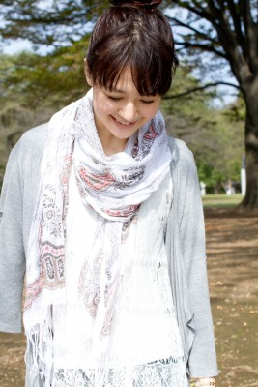

Activity 20
Possible cultural misunderstandings between colleagues
Look at the following causes of misunderstanding and examples. Talk to other in your group about how you could prevent this in the future.
Make some notes in the table.
Discuss with the whole group. Some have been done for you.
Cause of misunderstanding | Example | How could I prevent this in future?
Different first language | Didn’t understand instructions  Got something wrong | Don’t use slang  Speak clearly, check they have understood
Different body language | Won’t meet your eyes when you talk to them  Has different meaning of nodding and shaking the head
Different attitudes to being part of a team | Doesn’t offer help to colleagues  Believes it is not appropriate to speak up at team meetings
Different attitudes to authority figures such as supervisors | May not ask the supervisor to repeat instructions  Doesn’t seek assistance from the supervisor when they should
Different work practices | May prefer to work alone rather than in pairs or teams  May need to pray during working hours
Different social behaviours e.g. level of formality, food sharing, socialising with opposite sex | Doesn’t respond well to friendly approaches | Don’t jump to conclusions  Don’t judge  Accept differences  Ask respectful questions.

Referring problems to your supervisor
Cultural and language misunderstandings can cause problems.
Sometimes you can deal with the problem yourself. But sometimes you may need to refer the problem to your supervisor.

Activity 21
What should I do?
Read each story. Then discuss it in your group.
Story 1: Early for the bus
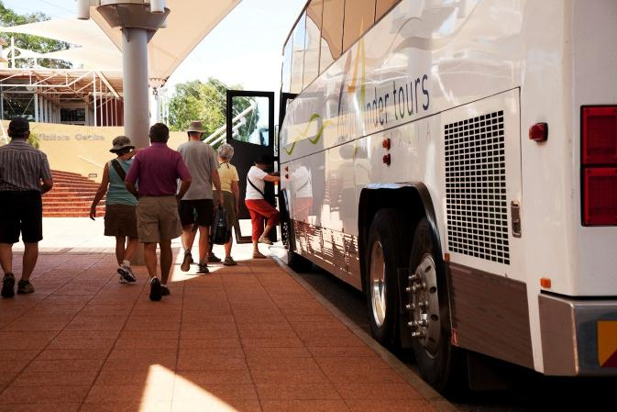
An American visitor has returned to the front door of the cultural centre an hour early. You told everyone to be ‘back by half one’. The visitor thought you meant she had to be back by ‘half off one’. This is how Americans describe 12.30 (half an hour from one o’clock). She is not happy as she had to rush around the museum.

What would you do?
- Refer the customer to your
supervisor? YES / NO
- Something else?

Story 2: Food customs
Your Muslim guests have just realised that there is bacon in the quiche you have served them. Two of them have taken a mouthful. Eating pork is not allowed in their religion and they are very upset. You told them there was no pork in the dish, but you forgot that bacon was pork.

What would you do?
- Refer the customers to your
supervisor? YES / NO
- Something else?

Story 3: Aussie Chinese
Some visitors who look Chinese arrived at the hotel. Mike thought they were from mainland China. When they arrived at their room, he explained how the air conditioning worked in very slow English and using hand signals. Then one of them said ‘Thanks, mate!’ in an Aussie accent. He was from Sydney and spoke fluent English.
What would you do?
- Refer the customer to your supervisor? YES / NO
- Something else?

Story 4: Japanese bath
Some guests from Japan have flooded the bathroom. In Japan you shower outside the bath and the floor has a drain.

What would you do?
- Refer the customers to your supervisor? YES / NO
- Something else?

Section summary
Now you have completed this section you should have developed the following skills and knowledge.
Tick each box if you are satisfied that you have those skills and knowledge.

Identify issues which may cause cross-cultural misunderstandings with colleagues or customers.
Resolve cross-cultural misunderstandings.
Know when to refer issues about cross-cultural communication to your supervisor.
Notes

Key words
Word | Meaning
advocacy group | A group that tries to influence the decisions of a government to help improve conditions for people
anti-discrimination laws | Laws about treating all individuals fairly and equally regardless of gender, culture, language etc
assume, assumption | Believe something is true without proof
Auslan | Australian Sign Language
Braille | A system of printing for blind people, where the letters are printed as groups of raised dots that can be felt with the fingers
Colleague | A person you work with
cultural diversity | The variety of traditions, beliefs and cultures within society
culture | A group who share patterns of customs, beliefs and ways of life
discrimination | When a particular group of people are treated differently and unfairly
diverse, diversity | A range of different people
ethnic group | A social group who have common origins and history. They generally also have a common culture and a sense of group belonging
gestures | Movements of parts of the body, e.g. head or hands to express an idea or feeling
harass | Repeatedly annoying or attaching someone
inferior | Worth less than
legislation | Laws
marital status | Whether a person is married or not
mobility, mobile | Able to move around
prejudice | An unreasonable dislike of a group of people or things
prohibited | Banned, against the law
stereotype | Making assumptions about a person because of their appearance, their background or their culture
victimise | To treat unfairly
vilify | To speak badly about someone

