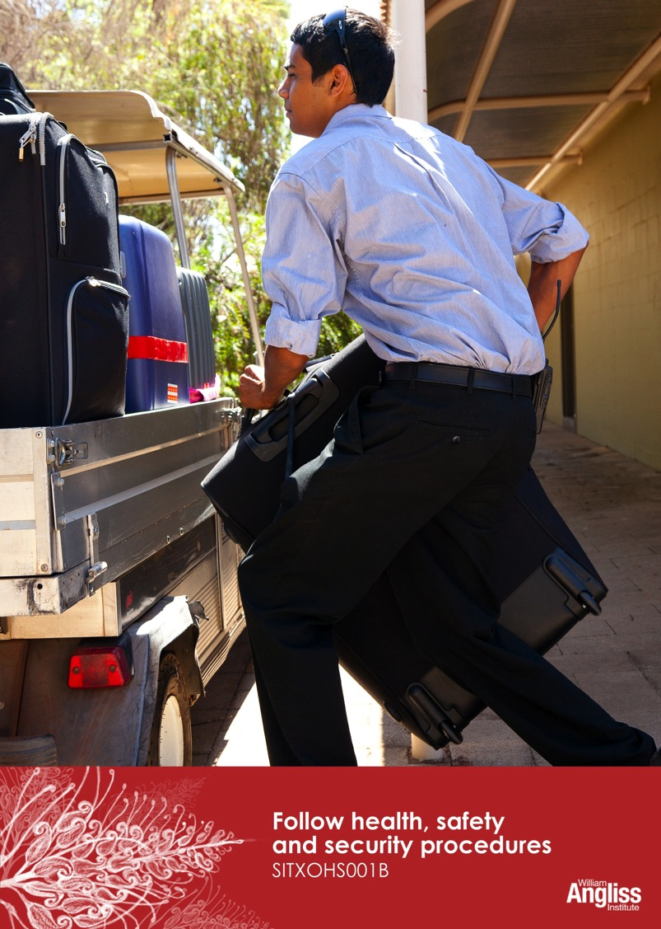
act

© Commonwealth of Australia. 2012
CC BY-NC-SA
This work is copyright. Except where otherwise indicated, and save for the Commonwealth Coat of Arms, the Department has applied the Creative Commons Attribution-Noncommercial-Share Alike 3.0 Australia Licence to this work.
The Department of Education, Employment and Workplace Relations must be attributed as the author of the Department’s copyright material.
As far as practicable, material for which the copyright is owned by a third party has been clearly labelled. The Department has made all reasonable efforts to ensure that this material has been reproduced in this resource with the full consent of the copyright owners.
Requests and enquiries concerning the Department’s copyright material should be addressed to:
The Copyright Officer
Department of Education, Employment and Workplace Relations
Location code C148CW2
GPO Box 9880 Canberra ACT 2601
Or emailed to copyright@deewr.gov.au
Funded under the Workplace English Language and Literacy (WELL) Program by the Australian Government Department of Education, Employment and Workplace Relations.
The views expressed in this publication do not necessarily represent the view of the Minister for Education or the Australian Government. The Australian Government does not give any warranty nor accept any liability in relation to the contents of this work.
ISBN 978-1-922108-02-9

Development Team
Content | William Angliss Institute  Macsmith and Associates
Photography & graphics | Benjamin B Photography
Acknowledgments
We would like to acknowledge the generous support of the following organisations and the Indigenous learners and employees in those venues for giving their permission for photography:
Ayers Rock Resort, Yulara, NT
Charcoal Lane Restaurant, Fitzroy, Vic
Lux Foundry Café, Brunswick, Vic
Peninsula Palms (Compass Group Australia), Dampier, WA
Permissions
We would like to acknowledge the following organisations who have granted permission for their copyright materials to be incorporated in this resource:
Safe Work South Australia
WorkSafe Victoria
Ecolab
Cultural Warning
People of Aboriginal or Torres Strait Islander descent should be aware that this publication contains images of people who may be deceased
Disclaimer
Every effort has been made sure that this booklet is free from error or omissions. However, you should conduct your own enquiries and seek professional advice before relying on any fact, statement or matter contained in this book. William Angliss Institute of TAFE is not responsible for any injury, loss or damage as a result of material included or omitted from this course.

Contents
Welcome v
Icons v
What you will learn vi
1 Introducing health, safety and security 1
Common injuries in the hospitality industry 1
What is a hazard? 3
Young workers at risk 4
Effects of injury and illness 7
Health and safety laws 9
Legal rights and responsibilities 11
Section summary 16
2 Health and safety practices and procedures 17
Safe work practices 17
Health, safety and security procedures 36
Reporting health, safety and security concerns 39
Section summary 42
3 Emergency situations 43
What is an emergency situation? 43
Emergency procedures 44
Complete an incident report form 47
Section summary 51
4 Getting involved in health and safety 52
Why is it important for you to participate in workplace health and safety? 52
Risk management 54
The Hierarchy of Control 56
Section summary 61
Key words 62

Welcome
Icons
These signs tell you what type an activity is:
Do this activity in a big group.
Do this activity in a small group.
Do this activity in pairs.
Do this activity by yourself.
Do this activity using the internet.
If you are not connected to the internet, your trainer will provide you with another activity.
Do this activity in your workplace.
If you are not in a workplace, your trainer will provide you with another activity.

What you will learn
In the hospitality workplace there are many hazards (dangers) which can cause injury, disease or even death to you and others.
So being safe in the workplace is very important. Workplace health and safety is usually called ‘OHS’ (occupational health and safety) or ‘WHS’ (work health and safety).
In this unit you will learn how to:
- follow your organisation’s health, safety and security procedures
- use safe work practices in everything you do in at work
- take part in your organisation’s health and safety management practices.

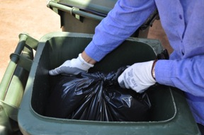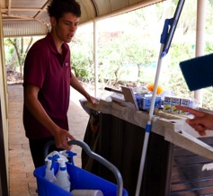
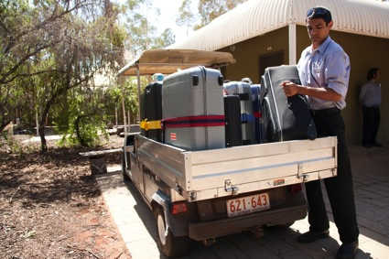
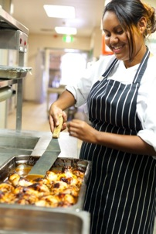

1 Introducing health, safety and security
Common injuries in the hospitality industry
In the hospitality industry, these are the most common injuries:

Shoulder
Muscle and tendon sprains and strains
Hand and finger
Cuts
Lacerations
Ankle
Muscle and tendon sprains and strains
Knee
Muscle and tendon sprains and strains
Back
Muscle and tendon sprains and strains
Forearm
Burns
Wrist
Fractures
Foot and toe
Sprains and strains
Fractures
Lacerations
Crushing
Bruises

Activity 1
Common incidents in hospitality
Here is a list of common activities in the hospitality industry.
What could go wrong while you are doing the task? What injuries could result?
Look at the picture on the previous page to help you.
Activity | Possible incident | Possible injury
Moving kegs of beer | Drop the keg on your foot | Break or bruise toes
Cooking with hot oil
Mixing up cleaning chemicals
Walking on a greasy floor in the kitchen
Shifting heavy tables
Carrying things up and down stairs
Hurrying while chopping vegetables
Pulling a queen bed out from the wall
Clearing up broken glass
Getting plates out of the warmer

What is a hazard?
A hazard is something that can possibly cause injury or harm to people or property.
Hazards in hospitality workplaces can include:
Physical hazards | - Liquid spills on floors  - Lifting heavy loads  - Working near hot objects and liquids  - Working with knives or other sharp tools  - Poor lighting  - Exposure to hazardous substances  - Faulty machinery  - Faulty wiring in electrical appliances  - Unsafe storage of stock or equipment  - Electrical leads lying across high traffic areas  - Blocked stairways and emergency exits.

Psychological hazards  (mental or  emotional) | - Fatigue  - Work-related stress  - Bullying  - Violence.  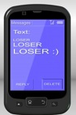

If you notice a hazard in the workplace, you should report it to your supervisor or to the Health and Safety Representative in your workplace. Do this as soon as possible so the hazard can’t cause an injury.

Young workers at risk
More than half of hospitality workers are aged 25 or less. Young workers are more likely to be injured at work and hospitalised than any other age group.
Young people who are injured at work often think it is their own fault. As a result, they may not report the incident (thing that went wrong). So the same thing could happen again because nobody has fixed the problem that caused the injury.
Activity 2
Preventing incidents
Read each story. Discuss with your group how the incident could have been prevented.
Story 1: No training
Hailey was new on the job in the kitchen. She was told to use the meat-slicing machine. She hadn’t been trained how to use if but she felt she couldn’t say no.
It started to go too fast for her, but she didn’t know where the emergency cut-off switch was. The machine cut the tip off her finger as the machine guard was not attached.
How do you think the incident could have been prevented?
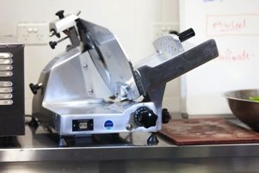

Story 2: No experience
Shane was recently trained to clean rooms. Then he was sent to clean on his own.
He did not recognise a faulty electrical fitting and got an electric shock.

How do you think the incident could have been prevented?

Story 3: No knowledge of rights or responsibilities
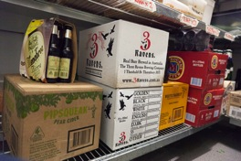
Toni was asked to carry heavy boxes from a store room. She did not want to do it as they looked too big for her alone. But she was scared to say no as she was a casual staff member and thought they wouldn’t give her any more work if she complained.
When carrying one of the boxes, she strained her back and ended up not able to work for a month.

How do you think the incident could have been prevented?

Story 4: No supervision
Marcella was asked to run the bottle shop alone just for one evening. Some drunken men came in and started behaving aggressively. They refused to pay for a slab of beer and threatened to be violent if she called for help.
She was very stressed by the incident and had to see a counsellor and take time off work.
How do you think the incident could have been prevented?
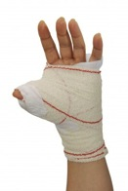
Story 5: No fear
Marty thought he didn’t need to wear the chain glove when he was cutting up meat. He thought he was good at his work so couldn’t get hurt.
But the sharp knife slipped and he needed 10 stitches in his hand. He was off work for a week.
How do you think the incident could have been prevented?
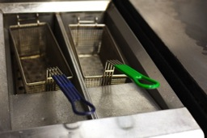
Story 6: No sleep
Pete was studying full-time and then worked in a fast food store at night.
One evening when he was really tired he burnt his arm with hot fat.

How do you think the incident could have been prevented?

Effects of injury and illness
Every year in each Australian state and territory, many people are injured in the workplace. For example, every year in Queensland approximately 100 people die and 30,000 are seriously injured at work.
Workplace Health and Safety Queensland, 2009 figures
Workplace injury and illness has costs for both the injured person and their workplace.
Possible costs to the injured person and their family
- Pain, illness and discomfort
- Lost income
- Medical costs, including medicines, rehabilitation, physiotherapy
- Reduced quality of life (enjoyment of daily life)
- Upset family life, social and recreational activities
- Possible ongoing health problems, including inability to work
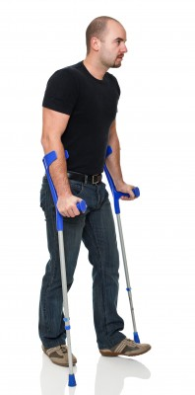
- Psychological and emotional stress, loss of morale (confidence).

Possible costs to the business
- Payment of fines
- Prosecution in court
- Lost production
- Cost of replacing injured staff
- Cost of staff time on Return to Work programs
- Increased Work Cover premiums
- Company reputation
- Lower staff morale
- Breakdown of teams and workplace relationships.

Activity 3
Effect of workplace injuries

Young woman injured in workplace accident
A young woman, Marly Watts aged 22, was working in a café kitchen when she slipped on wet newspapers on the floor. The papers had been put down to soak up water leaking from a fridge hose. Marly knocked a frying pan with hot fat in it and her arm and hand got burnt.  The workplace procedure was to mop up spills straight away. But staff often just covered a spill with newspaper until the end of the shift. | The leaking fridge hose had been a problem for two days but hadn’t been fixed.  Marly was in hospital for two weeks. She has some bad scars and may need plastic surgery later.  The employer was prosecuted and had to pay a large fine. They also had to improve their workplace safety and give staff better training.

What are the effects of the workplace injury in this story?
1. Effects for the young woman
2. Effects for the employer
3. Effects for the workplace
Health and safety laws
A national health and safety Act became law in January 2012. It is called the Work Health and Safety Act 2011.
Before this, each state and territory has had its own health and safety laws. Some states have not changed over to the new national law. Each state and territory still has its own organisation to administer the laws.
State/Territory | Health and safety law | Organisation responsible
Australian Capital Territory | Work Health and Safety Act 2011 | WorkSafe ACT  <www.worksafe.act.gov.au>
New South Wales | Work Health and Safety Act 2011 | WorkCover NSW  <www.workcover.nsw.gov.au>
Northern Territory | Work Health and Safety Act 2011 | NT WorkSafe  <www.worksafe.nt.gov.au>
Queensland | Work Health and Safety Act 2011 | Workplace Health and Safety Queensland  <www.worksafe.qld.gov.au>
South Australia | Occupational Health, Safety and Welfare Act 1986 | SafeWork SA  <www.safework.sa.gov.au>
Tasmania | Workplace Health and Safety Act 1995  The new law will commence in Tasmania on 1 January 2013 | Workplace Standards Tasmania  <www.wst.tas.gov.au>
Victoria | Occupational Health and Safety Act 2004 | WorkSafe Victoria  <www.worksafe.vic.gov.au>
Western Australia | Occupational Safety and Health Act 1984 | WorkSafe WA  <www.worksafe.wa.gov.au>
NOTE: This information was correct on 1 June 2012.
Always check the website for the latest information.
URLs may change.

Activity 4
Health and safety laws
Look at the previous table and answer these questions.
1. In your state or territory, what is the name of the health and safety law?
2. In your state or territory, what is the name of the organisation responsible for administering the health and safety laws?

Activity 5
OHS laws in your state or territory
Go to the website of the responsible organisation in your state or territory.
Look up the hospitality industry.
Find an interesting piece of information and show it to another learner.

Legal rights and responsibilities
What happens when people do not follow the law?
Companies and individuals can be given large fines if they do not carry out their responsibilities in relation to health and safety laws.
All employees (workers) and employers (bosses) have legal rights and responsibilities in relation to workplace health and safety.
Rights are things that should be provided for you.
Responsibilities are things you should do.
Employer responsibilities
The health and safety laws generally say that an employer must do these things:
Responsibility | Examples
Provide a safe and healthy workplace for employees | - Provide and maintain safe plant (machinery and equipment) and safe systems of work.  - Remove any risks to health and safety of employees, or reduce them as far as is reasonably possible. This includes both physical hazards and psychological (mental or emotional) hazards  - Provide adequate facilities for workers.  - Monitor (check on) the health of workers.  - Record workplace incidents and notify the relevant authority.
Provide training and supervision | - Show employees how to carry out their tasks safely, how to use equipment, how to use personal protective equipment (PPE) and how to recognise and report hazards on the job. This is often called induction.  - Provide a supervisor who knows about the job and the health and safety requirements.  - Explain health and safety policies and procedures.
Talk about health and safety | - Ask employees and health and safety representatives to help identify workplace hazards and suggest ideas to control them.  - Raise issues at staff or team meetings.

Activity 6
Did the employers act responsibly?
Look back at the stories in Activity 2.
Did any of those employers NOT act responsibly?
Employee responsibilities
The law say that you, the employee, must do these things:
Responsibility | Examples
Take reasonable care for your own health and safety | - Don’t come to work under the influence of drugs or alcohol.  - Take regular breaks to avoid injury.  - Don’t keep working if you are injured.
Take reasonable care for the health and safety of others in the workplace, including your colleagues, customers, and visitors | - Don’t block emergency exit doors with boxes.  - Always put up the wet floor signs when mopping.  - Take care that a long electrical lead in a public walkway doesn’t become a trip hazard.
Cooperate with your employer to make the workplace safe | - Follow workplace policies and procedures.  - Wear required PPE.  - Attend health and safety training.  - Help to identify and control hazards and risks.
Act professionally and responsibly at all times | - Notify your supervisor immediately if you find a hazard.  - Advise other workers if you see them doing something risky.  - Don’t bully or play tricks on others.

Activity 7
Did the employees act responsibly?
Look back at the stories in Activity 2.
Did any of those employees NOT act responsibly?
Health and safety representatives (HSR)
Employees have the right to have someone represent them on workplace health and safety matters. This person is called the health and safety representative (HSR).
If the workplace does not have an HSR, employees have the legal right to ask their employer to set up a health and safety group. This is called a Designated Work Group (DWG).
Then they can elect one of its members to be the Health and Safety Representative.

Activity 8
Who is your Health and safetyrepresentative?
In your workplace, find out if there is a health and safety representative (HSR).
If there is, what is their name?

If an injury happens
Employers must have a plan for what to do if a worker is injured. They must:
- investigate what happened
- change things so it won’t happen again
- help the injured worker get back to work as soon as possible
- organise insurance claims, compensation and medical expenses where needed.
If you suffer a work-related injury or illness, report it to your employer as soon as possible.

Activity 8
Health and safety – who’s responsible?
Who has responsibility for these things in the workplace? Tick the boxes.
Health and safety in the workplace | Employer is responsible | Employee is responsible
- Organise OHS training
- Attend OHS training
- Provide necessary safety equipment
- Make sure all equipment is in safe condition
- Provide personal protective equipment (PPE)
- Use correct PPE as required
- Provide safety and operational manuals and signage
- Follow workplace procedures
- Provide proper toilets and lunch rooms
- Consider the safety of others; don’t behave in a way that puts others at risk
- Don’t come to work if you are affected by drugs or alcohol
- Provide training on identifying and dealing with workplace hazards
- Attend OHS meetings and contribute ideas about how to make the workplace safer
- Report any hazards or injuries
- Make sure chemicals are stored safely
- Use chemicals according to workplace procedures

Activity 9
Injury report form
Tina Wilson is a room attendant at Banksia Gardens Hotel. She slipped and sprained her ankle when she was coming down the motel steps carrying a vacuum cleaner.
Help Tina fill in the Injury Report Form. Use today’s date.
Banksia Gardens Hotel
INJURY REPORT FORM
Name of employee
Address
Phone
Department
Role
Date of injury |  |  |  | Time of injury
Date injury reported |  |  |  | Time injury reported
Where did the injury happen?
What is the injury?
Body parts injured?
How were you injured?
What task were you doing?
Witnesses
Treatment given by
Action taken (tick) |  |  | - Returned to work  - Sent home  - Sent to doctor  - Sent to hospital
Name of person filling in this form
Employee’s signature

Section summary
Now you have completed this section you should have developed the following skills and knowledge.
Tick each box if you are satisfied that you have those skills and knowledge.
Identify common injuries in the hospitality industry and common causes of those injuries.
Be aware of the current health and safety laws in your own state or territory in Australia.
Know the legal health and safety responsibilities of employers.
Know the legal health and safety responsibilities of workers.
Know what to do if you have a workplace injury or illness.
Notes

2 Health and safety practices and procedures
Safe work practices
Safe work practices (SWPs) are ways of doing your work safely.
The main safe work practices you should know about and follow are:
- Use correct manual handling techniques.
- Use safe posture and movements. Use ergonomically sound furniture and workstations (designed to keep your body comfortable).
- Avoid getting tired by taking breaks and rotating (swapping around) tasks.
- Use hazardous (dangerous) equipment safely e.g. sharp knives, hot surfaces, electrical appliances.
- Handle hazardous substances safely.
- Pay attention to safety signs.
- Use personal protective equipment as required.
- Identify and remove or control hazards from your own work area.
Each workplace has its own set of procedures which describe how everyone must do their work tasks. These procedures include the relevant safe work practices. When people start in a new job they should get ongoing training about these safe work practices and procedures.
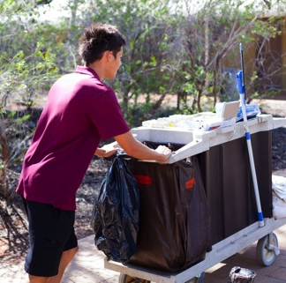
1. Correct manual handling
Manual handling is when you use force to physically move something or someone. It includes pushing, lifting, pulling, lowering, holding and carrying. Almost half of the injuries in the hospitality industry involve manual handling.
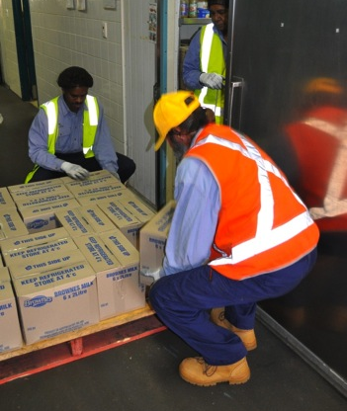

I always bend my knees and bend my back as little as possible when I’m picking up a box in the store room.

Activity 10
Manual handling
Think about your work activities. When do you do manual handling?

Guidelines for lifting
1. Plan the lift
- Assess the load – how heavy or awkward is it? How low is it?
- Do you need help – a team lift? Could you use equipment?
- Plan the path – where is the load going to? Can you make the distance shorter? Are there things in the way?
2. Get in position
- Place your feet slightly apart so your posture is stable, no wider than your shoulders.
- Bend your knees not your back.
- Get a firm hold on the load.
- Keep the load close to your body,
- Straighten your legs to lift and use your leg muscles, not your back.
- Move smoothly, avoid jerky movements.
- Hold the load around waist level.
3. Carry the load
- Turn by moving your feet, not by twisting your body.
- Keep your shoulders level and facing the same direction as your hips.
- Look ahead, not down, so you can see where you are going.
- To put the load down, bend your knees and keep your back straight.

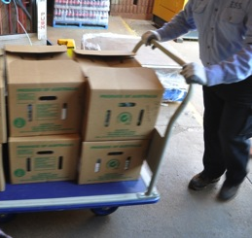

Reduce the risks of manual handling
- Push rather than pull.
- Ask for help – do a team lift.
- Use a trolley or forklift.
- Break a big load down into smaller lots.
- Change the package size of heavy items.
- Store loads close to where they will be used.
- Store heavy items around waist height, not high or low.
- Don’t lift heavy items while you're sitting down.

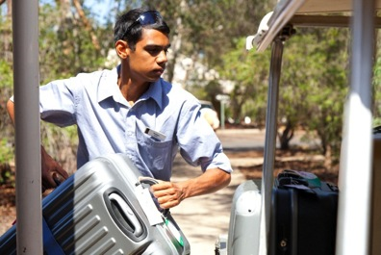
2. Safe posture
Posture means the way you hold your body. Good posture protects your back and neck. Movements like sitting, stretching, pushing, pulling and bending can strain your muscles and joints if you are slouching, slumping, twisting, hunched or standing off-balance while you do them.
There are many different tasks in hospitality work where it protects you if you use safe posture.
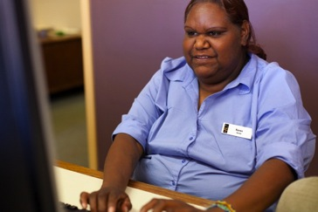
When I’m sitting at the desk in reception I always make sure I’m sitting up straight with my back supported.

Ergonomically sound furniture and equipment
Well-designed furniture and equipment helps you use good posture and movements. For example:
- a laundry trolley with a rising base so you don’t have to reach down into it
- a computer table set at a height so your hands aren’t strained
- shelves at a height so that you don’t have to reach up or bend down to get things.

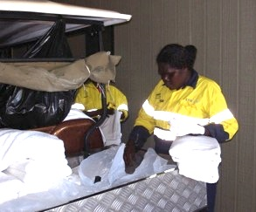
We keep the clean bed linen in the back of the golf cart. It’s just the right height so we don’t get a back ache from bending over.

Activity 11
Safe posture
- Which hospitality tasks involve movements like sitting, stretching, pushing, pulling and bending?

- Look at these room attendants making beds. How are they using safe postures to protect their body from strain?
She is using her thigh muscle and knee to push the
bed, not bending and using her back.

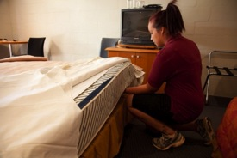

3. Avoid getting tired
In hospitality work, people can get tired because of shift work, long hours or being physically active. It is easier to make mistakes and get injured when you are tired.
There are two ways of avoiding this.
- Rotate jobs (change from one to another)
Do a heavy task, then change to a lighter task for a while. Or change from a boring or repetitive task (doing the same thing over and over).This means you use different muscles or use them in different ways so they have a chance to recover.
- Take breaks
This also helps your muscles recover. More frequent, shorter rest breaks are better for recovery than fewer, longer breaks.

Activity 12
Avoid getting tired
What are some hospitality work tasks where it would help to take breaks and rotate tasks?
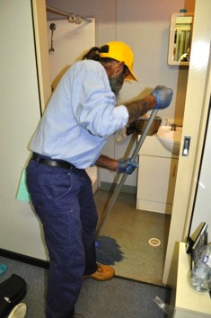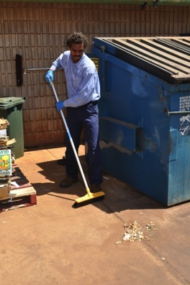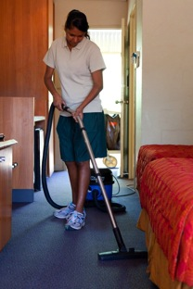

4. Safe use of equipment
In hospitality workplaces you often have to work with hazardous equipment such as electrical equipment and sharp blades. These things can cause serious injury or even death if not used correctly. Don’t use equipment unless you have been instruction in how to use it correctly.
To prevent injury from electrical appliances:
- always unplug electrical equipment before cleaning it
- do not use a piece of equipment if the electrical cord is frayed
- electrical leads should not be wrapped around equipment when you are using it
- do not use electrical equipment near water.
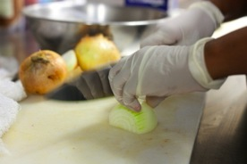
I always make sure that the kettle is unplugged before I clean it.

Activity 13
Hazardous equipment
1. What electrical equipment might you use or handle in your hospitality work?

2. What other dangerous equipment might you use or handle in your hospitality work?

Work safely with electrical equipment
If you see a warning tag on machinery, an appliance or equipment, it means it is damaged, faulty or unsafe. It may need to be repaired, maintained or inspected.
You must not operate anything with a ‘Do Not Operate’ or ‘Out Of Service’ tag on it. Once it is repaired, the tag will be removed.
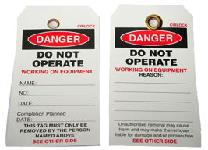

Read and obey all tags that you find placed on tools, equipment, appliances or machinery.

5. Safe handling of hazardous substances
Some hazardous (dangerous) substances are used in the hospitality industry e.g. cleaning chemicals. They can damage your health and cause injury so you need to learn how to handle them safely.
Chemicals can affect you if you:
- breathe in fumes
- get them on your skin
- get them in your eyes
- don’t wash your hands after handling them and they get into food that you eat.

Your employer will train you in how to handle chemicals safely.
You must also know some basic first aid in case of an incident. First aid advice is on the Material Safety Data Sheet for every chemical in your workplace.

What is a Material Safety Data Sheet (MSDS)?
Chemical manufacturers write an MSDS for each product they make. It tells you:
- what is in the product
- any health hazards of the product
- how to store the product safely
- first aid information if there is an incident
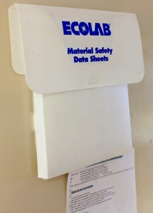
- advice on how to use and handle it safely.

You need to know where the MSDSs in your workplace are kept.

Activity 14
Hazardous substances
What hospitality tasks might require you to handle cleaning chemicals, poisons or other hazardous substances?

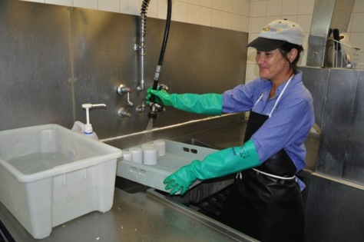
I always wear the heavy duty gloves and apron when I’m using dishwasher chemicals.
I know where the eyewash bottle is too, just in case.

6. Safety instructions
Safety instructions can be in different forms.
Verbal  (speaking) | Watch out Jan – always check you’ve turned off the gas before you reach over the stove!
Written procedures  or instructions | TO ALL KITCHEN HANDS  Do not leave spills on kitchen floor as people can slip and fall.  Mop them up immediately.  Leave WET FLOOR signs in place until floor is dry.
Graphic
(pictures)
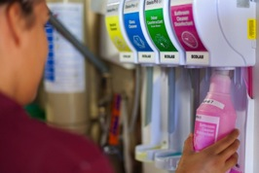

In Australia, safety signs are colour-coded.
Colour | Meaning | Examples
Red | Warning, danger
Yellow | Caution, be careful
Green | Safety
Blue | Mandatory  (you MUST...!)

Activity 15
Safety signs in your workplace
1. Circle the warning signs you have seen in your work area.

2. With a digital camera or phone, take photos of other safety signs in your workplace.
Talk together about what they mean.

7. Use personal protective equipment (PPE)
Personal protective equipment (PPE) is clothing or equipment that protects you when you are working.
Types of PPE
Personal protective equipment includes:
- eye protection e.g. goggles, safety glasses
- body protection e.g. aprons, gloves
- hearing protection e.g. ear plugs, ear muffs
- respiratory protection e.g. face masks, respirators
- foot protection e.g. safety boots
- head protection e.g. hard hats.

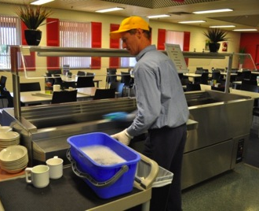
Using PPE
Employers must provide PPE and show you how to use it. They must also maintain it in good condition.

You must use the correct PPE. If you do not wear correct PPE:
- you may be injured
- you may be fined
- your boss may be fined.

You must follow the lawful direction of your employer. So if they provide the PPE you must wear or use it.

Activity 16
Personal protective equipment (PPE)
What kinds of PPE are you required to use for the following work tasks?
Type of work | PPE
Kitchen work
Dishwashing work
Housekeeping work
Maintenance work
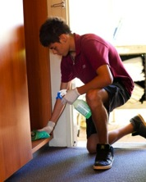
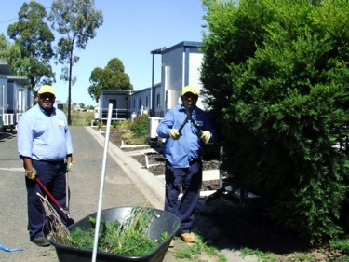
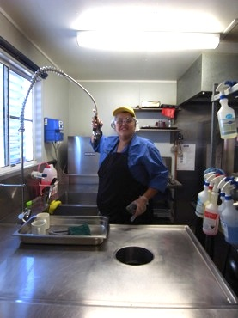
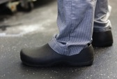

8. Identify and control hazards
All workers must help identify (point out) things in their workplace that could cause injury or illness. These are called hazards.
Then their team will discuss how to eliminate (get rid of) the hazard, or do something to minimise the harm it might cause.

Activity 17
Identify hazards
Can you think of two hazards in each of the work areas listed?
Work area | Examples of hazards
Housekeeping and cleaning
Kitchen and food service
Retail
Receiving and storing goods

Activity 18
Workplace bullying
Bullying is also a workplace hazard. It can cause stress and sometimes lead to mental health problems or violence.
Complete this questionnaire about bullying.
Does someone do any of these things
to YOU or other workers
in YOUR workplace?
- Often threaten you
- Constantly look over your shoulder while you do your work
- Call you names, tease, insult or generally make fun of you
- Always tell you that you are not doing a good job
- Make you feel kept apart and keep you away from the group
- Make you feel afraid and worried
- Deliberately not include you in workplace activities
- Spread gossip about you
- Give you an unreasonable amount of work to do
- Hide your tools or belongings
- Send you threatening or unpleasant messages through email, chat rooms, Facebook, SMS or other ways

If you ticked yes to any of these things then workplace bullying might be a problem in your workplace.

Adapted from Workplace health and safety training resources kit
WorkCover SA, now Safe Work South Australia

What can you do?
If you feel you are being bullied, you need to report it. You could do one, some or all of the things below.
You could:
- talk to someone you trust, inside or outside the workplace
- report the problem to your supervisor
- call Lifeline 13 11 14 (cost of a local call) to speak to a trained counsellor 24-hours a day.
These people will advise you on what action to take.

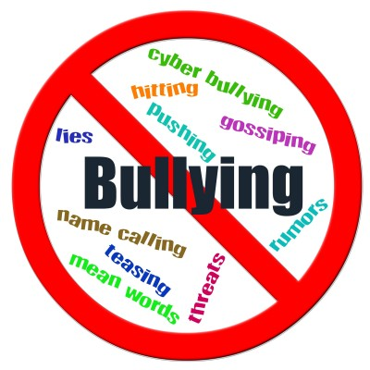

Health, safety and security procedures
Each workplace has its own procedures. Procedures describe how you must do work tasks. They list all the steps you have to take so that everyone uses the same method. This means you do the job well and you also do the job safely.
Workplaces must have procedures for health, safety and security so that everyone follows the same rules. When people start in a new job they should get training about these procedures.
Here are some of the Banksia Gardens Hotel’s health, safety and security procedures.
Banksia Gardens Hotel
HEALTH, SAFETY AND SECURITY PROCEDURES
Identify and report hazards promptly and follow safe work practices.
- Slips, trips and falls
- Keep your work area well maintained and tidy
- Watch where you’re going
- Clean up spills immediately
- Wear shoes with covered toes and non-slip soles
- Use marked pathways
- Use handrails when climbing stairs
- Kitchen safety
- Wear long sleeves, rolled down
- Wear other protective clothing as specified
- Use dry thick cloths when touching hot utensils
- Turn off steam before opening steamers
- Be careful near deep fryers
- Keep gas cylinders away from heat
- Keep floors dry and clean, and clear up spills immediately
- Keep knife blades sharp and handles clean
- Unplug machines and equipment before cleaning
- Make sure all equipment is unplugged and stoves are turned off at end of day

- Electrical safety
- Inspect equipment and the power cord before you use it. Do not use if it is not faulty or damaged
- Only use electrical equipment that has a current inspection tag
- Report any damage to your supervisor or manager promptly
- Be especially careful when working in wet areas
- Unplug equipment before cleaning it
- Personal safety
- If you feel uncomfortable or unsafe in a situation, leave or call for help
- Call police if there is any violence
- Don’t work on your own at night
- Leave the hotel with a colleague at night
- Stay away from quiet areas behind buildings or other isolated places
- Know the contact methods and details for security and your supervisor
- Cash handling
Don’t do this task without the hotel training in how to handle cash safely
Don’t get distracted by customers
Never leave a cash register unattended
Never leave too much money in the register. Tell your supervisor if you have a large amount of cash
- Harassment and bullying
- Tell the person who is harassing or bullying you to stop
- If you are uncomfortable with doing this or nothing changes after you ask them to stop, tell your supervisor or manager
- All complaints of bullying or harassment will be treated seriously and action will be taken to make sure it stops

Activity 19
Follow workplace safety procedures
At the Banksia Gardens Hotel:
1. What are 3 things you should do to prevent slips, trips and falls?
2. What are 3 things you should do in the kitchen to prevent injury?
3. What are 3 things you should do so that you are safe when you are using electrical appliances?
4. What are 3 things you should do about personal safety?
5. What are 3 things you should do so that you are safe when you are handling cash?
6. What are 2 things you should do if you are being bullied or harassed?

Reporting health, safety and security concerns
If you are concerned about your own or a workmate’s health, safety or security, talk to your employer, supervisor or Health and Safety Representative (HSR) straight away. Your employer is legally required to respond to your complaint.
Your concern might be faulty equipment, unsafe work practices, slippery floors, lack of PPE, lack of training, bullying or suspicious behaviour.
Here are some examples of the type of things you must report.
Type of problem | Example Report | Action taken
1. Unsafe work practices | Debra worked in the housekeeping department and had to pull the cleaning trolley up three steep steps to get to one block of rooms. She reported this to her supervisor. | A ramp was put in so she did not have to pull the trolley up the steps.
2. Breaches (breaking) of OHS procedures | In the kitchen, the OHS procedures clearly said that all spills must be cleaned up immediately to prevent people slipping on them. Luke’s workmates did not always do this so he confidentially (privately) reported it to his supervisor. | The supervisor gave all the kitchen hands some extra training in clearing spillages.
3. Suspicious behaviour or unusual events | Marti noticed that there was a stranger hanging around the employee car park so she reported this to her supervisor. | The supervisor notified security. They approached the person to identify themselves.

Ask if you are not sure
If you don’t know how to do something safely, or you aren’t sure, ask for help or training before you begin the task.
Work is important, but your health and safety is more important.
Here are some ways you could raise an issue with your immediate supervisor:
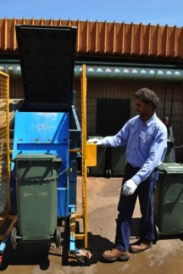
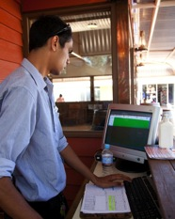
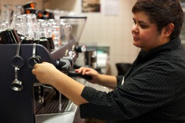
I’m not sure how this works. Could you spare a few minutes to show me again?

I think I’ve got the hang of this, but can you watch please, just to make sure I’m doing everything right?
I’m still a bit uncomfortable with this. Would you mind showing me again?

From WorkSafe Victoria
Safety tips for young workers
http://www.worksafe.vic.gov.au

Activity 20
Report your health, safety and security concerns
Your trainer will organise an activity for you to practise reporting concerns about health, safety and security hazards to a supervisor.

Activity 21
Hazard report form
Your trainer will give your group a hazard to report.
Work together to complete this hazard report form.
Banksia Gardens Hotel
HAZARD REPORT FORM
Complete all sections and hand to your supervisor or Health and Safety Officer
Reported by: | Name:  Role:  Department:  Date:
Briefly describe the hazard or health, safety or security issue.
Location of hazard or health, safety or security issue.
Received by | Name:  Role:  Department:  Date:
Section summary
Now you have completed this section you should have developed the following skills and knowledge.
Tick each box if you are satisfied that you have those skills and knowledge.
Know safe work practices.
Know how to follow health, safety and security procedures.
Know how to identify and report unsafe work practices and hazards.
Notes

3 Emergency situations
What is an emergency situation?
An emergency is an event that:
- you usually don’t know is going to happen
- is a dangerous situation; threatens the health and safety of people or property
- needs urgent attention to bring it under control.
In most hospitality workplaces it is not only the workers who are affected. There are usually guests or visitors involved too.
Activity 22
What can cause an emergency?
Can you think of 4 other things that could cause an emergency?
Workplace emergencies can be caused by:
- Fire | - Customer making a threat
- Explosion | - Bomb threat
- Power failure

Emergency procedures
Your workplace should have an emergency procedure which tells everyone what to do.
This is often called an emergency plan. It should tell you about:
- immediate action to take in particular types of emergency
- who to call to raise the alarm
- how to notify emergency services (police, fire service, ambulance, SES)
- how, when and where to evacuate
- names of people responsible for making decisions during the emergency (sometimes called an emergency warden).
Here is the Banksia Gardens Hotel Emergency Procedure. It is posted on the wall of each work area with the details filled in.

Banksia Gardens Hotel
EMERGENCY PROCEDURE
This is: Area 3
Your emergency warden is: Sally Jackson
Security contact details: Dial 123 on any internal phone or your 2-way radio
The Assembly Point for your area is: the front car park.
- If there is an emergency, fire or accident
- Stay calm.
- Raise the alarm.
- If police, fire or ambulance services are required, call 000.
- Only trained staff should try to extinguish small fires.
- Know the drill to evacuate the building.
- Evacuation procedure
- Move calmly.
- Do not panic guests or colleagues.
- Go directly to the Assembly Point for your department.
- Do not stop to gather personal items or finish tasks.
- Give help to guests if it is safe to do so.
- Report to your emergency warden once you are at the Assembly Point.
In an emergency,
your safety is the most important thing.
Do not put yourself at risk.

Activity 23
The emergency procedure
Find the emergency procedure for your workplace.
Find out the answers to these questions.
Your supervisor or the health and safety representative (HSR) might help you.
1. What types of emergencies are listed in the procedure?
2. If you are with a colleague who slips, hits their head on the ground and is unconscious, what should you do first?
- If you see smoke coming from under the door of a guest room, what should you do first?
- If you see smoke coming from the chemical store room, what should you do first?
- If there is an evacuation from your work area, where should you go?
- Would you need to help evacuate guests?

- Who is the emergency warden in your work area?

Complete an incident report form
Most workplaces have an emergency incident report form to report the details of an emergency.
Activity 25
Complete an incident report form
Use the following form to report one of these incidents. Use today’s date.
1. A kitchen fire
At 10.35 am there was fire in some hot fat. You sounded the alarm and then called your manager on the mobile phone. The hotel fire officer put out the fire. You had a burnt arm and had to go to the medical centre. The stove needs repairs.
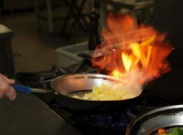

2. Stuck in the lift
At 4.15 pm you could not open the door of the service lift to get out. You sounded the alarm and then waited for 45 minutes for the service team to get you out. You were slightly stressed but there were no injuries. The lift is out of order until it can be checked properly.
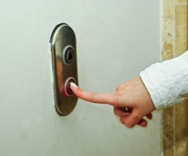

Banksia Gardens Hotel
INCIDENT REPORT FORM
1. Time of incident |  | Date: / / Time: am/pm
2. Location of incident
3. Briefly describe the incident
4. Describe any injury and action taken
5. Describe any damage to property and action taken
4. Reported by: |  | Name:  Role:  Department:  Date:
5. Reported to: |  | Name:  Role: (supervisor/OHS officer)  Department:  Date

Activity 24
Workplace emergency quiz
1. Where is the nearest fire extinguisher?
2. Are you allowed to use the fire extinguishers?
3. Where is the fire blanket?
4. Are you allowed to use the fire blanket?
5. Where is the nearest emergency exit from your work area?
6. Where is the first aid room?
7. Where is the first aid kit?
8. Where is the eye wash kit?
9. Where is the chemical shower (if there is one)?
10. Where is your emergency evacuation plan posted?
11. Who is the trained first aider in your department?

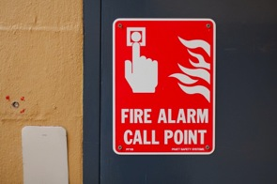
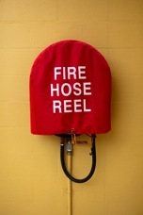
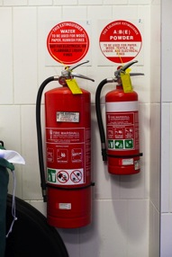
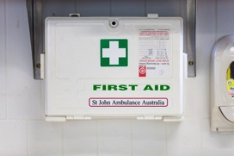
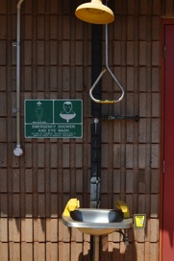

Section summary
Now you have completed this section you should have developed the following skills and knowledge.
Tick each box if you are satisfied that you have those skills and knowledge.
Identify different kinds of emergencies.
Understand the emergency procedures in your workplace.
Know what you should do in an emergency.
Complete an emergency report form.
Notes

4 Getting involved in health and safety
The law says that workers must participate in decisions about health and safety. Workers should be involved in:
- health and safety training
- identifying hazards and risks in the workplace
- suggesting ways of eliminating (getting rid of) or controlling hazards and risks.
All workplaces can choose to have a Health and Safety Representative, a Health and Safety Committee or a Designated Work Group to deal with health and safety issues.
Why is it important for you to participate in workplace health and safety?
The people who do the work are more likely to know what the problems are. Often managers and supervisors don’t see the everyday problems. That is why it is important for all workers to be involved in their own safety.
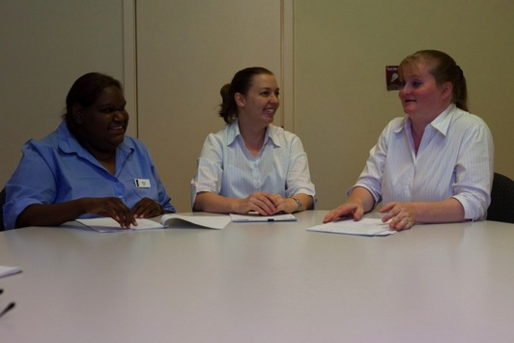

Activity 26
How can you participate?
There are many different ways for you to participate in health and safety improvements in your workplace.
Look at the list below.
Circle YES for the ones you have done so far.
Ways to participate | Have you done this?
- Have informal discussions with your own work group or team about health and safety problems and ways to improve things. | YES / NO
- Make a suggestion to improve health and safety e.g. fill in a suggestion form, add an item to a whiteboard list. | YES / NO
- Participate in a risk and hazard assessment in your work area. | YES / NO
- Attend OHS induction training. | YES / NO
- Attend normal staff meetings where health and safety is sometimes discussed. | YES / NO
- Contribute to a discussion at a staff meeting about an OHS issue. | YES / NO
- Go to a special staff or work group meeting to talk about a particular problem. | YES / NO
- Fill in a staff survey or questionnaire about health and safety. | YES / NO
- Attend chemical handling training. | YES / NO
- Go to a formal OHS committee meeting. | YES / NO
- Talk with your OHS representative about a concern. | YES / NO
- Listen to the OHS representative’s report at a regular staff meeting. | YES / NO
- Other ways?

Risk management
All businesses follow a process to identify hazards and reduce risks. This is called risk management.

A hazard is … | Anything that could harm you or others | - A frayed cord on the vacuum cleaner.
 |  | - Out-of-date chemicals in the back of the store room.
A risk is … | How likely it is that the hazard will cause harm  How serious that harm would be | - The frayed cord is a daily risk and could cause serious harm.  This hazard should be eliminated quickly.
- The old chemicals are in a locked store. They could cause serious harm, but it is unlikely.
This hazard could be left until the next big clean-out.

The steps in risk management are called different things in different workplaces. But they usually follow the SAFE process.
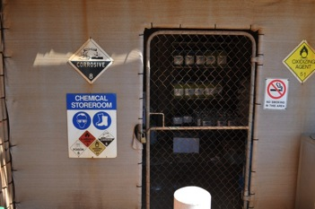
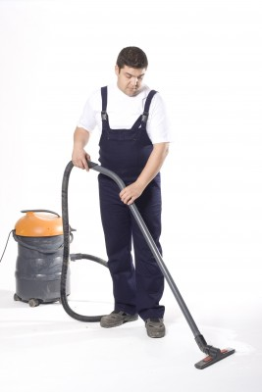

The SAFE process
 | What does it mean? | Example
1 See it | Identify workplace hazard | Lawn mower throwing up stones into the eyes of people passing by.
2 Assess it | Work out the risk of a hazard:  - How likely is it to cause harm?  - How serious would the harm be? | Lawns are mowed in the mornings when guests are moving around between rooms and dining area. Only a low to medium chance of an incident, but the harm could be serious.
3 Fix it | Find a workable solution to control the hazard – either get rid of it, or reduce the risk.  Use the Hierarchy of Control to help think about solutions. | You could:  - put up barriers to keep people at a distance  - stop mowing when guests pass by change mowing time to early afternoon.
4 Evaluate | Pick a time to go back and check that the solution actually works.  Be prepared to think again. | After one month, talk to the maintenance people:  - Has the risk of an incident been lowered?  - Are there any problems we didn’t foresee?  - Do they have any other ideas now?

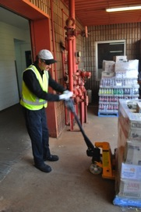
The Hierarchy of Control
A hierarchy is a list of things in order of importance. The best way to fix the problem is to get rid of a hazard. This is called elimination.
When elimination is not possible, the hazard must be made less dangerous. This is called controlling the hazard.
The best ways to control the hazard are listed below in order of importance.
Hazard control method | Example
1. Eliminate (get rid of) the hazard | The washing machines in the laundry were old top loaders and getting the wet sheets and towels out was heavy work. The hotel decided to send the work out to a contractor.
2. Substitute the hazard (replace it with something else) | The housekeeping department replaced a toxic bleach-based cleaning chemical with a safe non-toxic one.
3. Isolate (separate) the hazard | The maintenance department set up witches’ hats around the lawn mowing operations so people would not be hit by stones.
4. Change equipment | Instead of lifting a heavy floor polisher up four steps to the conference room, maintenance built a portable ramp.  Instead of lifting heavy trays of glasses from high shelves and carrying them to the bar, they are now stored on waist-high shelves and they are moved to the bar on trolleys.
5. Change work practices | Workers were trained in how to use new ironing equipment in a safe way, according to procedures.
6. Use personal protective equipment | Cleaners use heavy-duty chemical gloves, aprons and full face masks when they are cleaning the stove and oven with stove cleaner.

Hazard control tool
Your workplace will have a form to record hazard identification and control. Here is an example:
Banksia Gardens Hotel
HAZARD CONTROL TOOL
Person completing form: Tanya Lee  Work team: Kitchen |  |  | Phone: X305  Date: 11/02/2012
SEE IT  Describe hazard and location |  | Forklift delivering supplies to kitchen travels across pathway used by kitchen workers to get to storeroom.
ASSESS IT |  | How likely is it that someone will get hurt?  Unlikely 0 1 2 3 4 5 Highly likely
How serious would the harm be if there was an incident?
Not serious 0 1 2 3 4 5 Very serious
FIX IT |  | Immediate/temporary control:  Place warning signs along path and at exit from kitchen.  Conduct brief training at daily meeting.
Permanent control:
Change pathway or put safety barriers along forklift path to prevent pedestrian access.
EVALUATE IT |  | Hazard controlled? Yes No  Evaluated by: Phil Lemanah  Date: 02/03/12  Reviewed by: Jenn Daley  Date: 02/04/12

Activity 27
Hazard control
Choose one of these hazards and complete the following hazard control tool:
- Wet floor – The kitchen attendant likes to leave early on Thursdays so he mops the kitchen floor while the cooking staff are still working.
- Manual handling – Staff have to lift heavy trays of glasses in the store room and carry them down a long hallway to the bar.
- Armed robbery – A lot of cash is kept at reception overnight sometimes and there is no security after hours.
- Handling hazardous substances – Disinfectant is bought in bulk and has to be put into smaller spray containers by cleaning staff. They do it in a very small work room. The ventilation is poor and the rubber gloves are old and have tears in them.

SEE IT – Write your hazard in the box.

ASSESS IT – Discuss the two questions and choose a rating.

FIX IT – Discuss some ideas for an immediate/temporary control and a permanent control. Write at least one idea in each box.

EVALUATE IT – Report back to the whole group. Explain your group’s ideas about how to control the hazard. Ask the group – to help you work out whether your solution will work.

HAZARD CONTROL TOOL
Form completed by:

SEE IT |  | Describe hazard and location.
ASSESS IT |  | How likely is it that someone will get hurt?  Unlikely 0 1 2 3 4 5 Highly likely
How serious would the harm be if there was an incident?
Not serious 0 1 2 3 4 5 Very serious
FIX IT |  | Immediate/temporary control:
 |  | Permanent control:
Immediate | Straight away, right now
Temporary | For a little while, but not a solution forever
Permanent | Forever

Activity 28
Virtual kitchen
Go to the Virtual Kitchen, which is a web based activity. Your trainer will give you the web address.
Your task is to identify and safely remove hazards.
Use the mouse to click on the hazards.
Then choose the best way to control each hazard.

Activity 29
Virtual hotel
Go to the Virtual Hotel, which is a web based activity. Your trainer will give you the web address.
Your task is to identify and safely remove hazards.
Use the mouse to click on the hazards.
Then choose the best way to control each hazard.

Section summary
Now you have completed this section you should have developed the following skills and knowledge.
Tick each box if you are satisfied that you have those skills and knowledge.
Know the SAFE process for risk management.
Understand what the Hierarchy of Control is used for.
Take part in activities to make your workplace safer.
Discuss how to deal with hazards and risks.
Notes

Key words
Word | Meaning
bullying | Repeated unreasonable behaviour towards a worker that causes damage to their health and safety. Bullying can be verbal, physical, social, in writing or electronic.
concern | Worry
confidential, confidentially | Private, privately
control | Find a solution for a problem
eliminate | Get rid of
emergency | A dangerous situation. It needs urgent action to bring it under control and keep people safe
evaluate | Assess
fatigue | Serious tiredness
harass, harassing, harassment | Regularly bothering and upsetting you. It may be emotional, physical, verbal or sexual.
hazard | Anything that could harm you or others
hierarchy | A list of things in order of importance
Hierarchy of Control | The order of doing things to control a hazard, from the most effective to the least effective
identify | Point out
incident | Thing that went wrong
induction | Help employees get to know the workplace, their tasks, and safety procedures
isolate | Separate
mandatory | You must do this thing
manual handling | Using force to move something at work e.g. lifting trays of glasses, pushing a bed away from the wall, pulling a vacuum cleaner
notify | Tell someone
occupational health and safety (OHS) | Health and safety in the workplace
personal protective equipment (PPE) | Clothing or equipment that protects you when you are working
repetitive | Doing the same thing over and over
risk | How likely it is that a hazard will cause harm, and how serious that harm would be
risk control | Getting rid of a hazard or, if you cannot do this, making it less dangerous
risk management | The process of trying to reduce risks to workers
rotate | Change from one thing to another
substitute | Replace with something else

