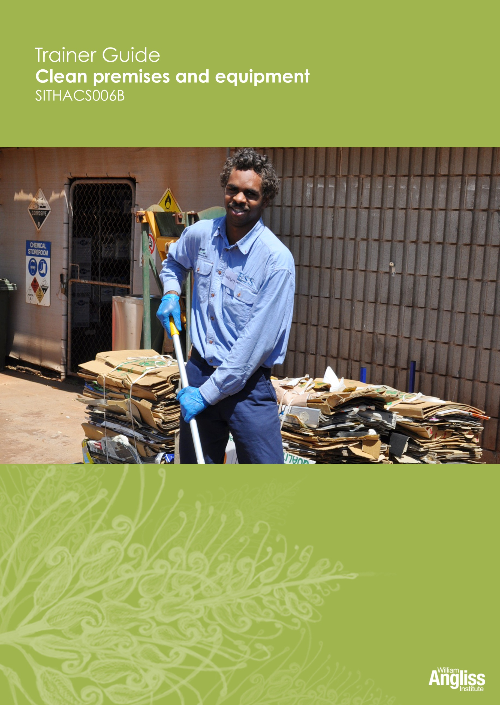

© Commonwealth of Australia. 2012
CC BY-NC-SA
This work is copyright. Except where otherwise indicated, and save for the Commonwealth Coat of Arms, the Department has applied the Creative Commons Attribution-Noncommercial-Share Alike 3.0 Australia Licence to this work.
The Department of Education, Employment and Workplace Relations must be attributed as the author of the Department’s copyright material.
As far as practicable, material for which the copyright is owned by a third party has been clearly labelled. The Department has made all reasonable efforts to ensure that this material has been reproduced in this resource with the full consent of the copyright owners.
Requests and enquiries concerning the Department’s copyright material should be addressed to:
The Copyright Officer
Department of Education, Employment and Workplace Relations
Location code C148CW2
GPO Box 9880 Canberra ACT 2601
Or emailed to copyright@deewr.gov.au
Funded under the Workplace English Language and Literacy (WELL) Program by the Australian Government Department of Education, Employment and Workplace Relations.
The views expressed in this publication do not necessarily represent the view of the Minister for Education or the Australian Government. The Australian Government does not give any warranty nor accept any liability in relation to the contents of this work.
ISBN 978-1-922108-05-0
Development Team
Content | William Angliss Institute  Macsmith and Associates
Disclaimer
Every effort has been made sure that this booklet is free from error or omissions. However, you should conduct your own enquiries and seek professional advice before relying on any fact, statement or matter contained in this book. William Angliss Institute of TAFE is not responsible for any injury, loss or damage as a result of material included or omitted from this course.

Contents
What is in this guide? 1

LLN requirements of the unit 2

Guide to the activities 3
Activity 1 Would you stay in this hotel? 3
Activity 2 The cleaning trolley 3
Activity 3 Your workplace cleaning trolley 3
Activity 4 Use the correct equipment for the job 3
Activity 5 Using equipment safely 4
Activity 6 Care of cleaning equipment 4
Activity 7 Your workplace cleaning equipment 4
Activity 8 Clean a piece of hospitality equipment 4
Activity 9 Reporting damaged equipment 5
Activity 10 Fill in a Maintenance Request tag 5
Activity 11 Different surfaces 5
Activity 12 Use the right equipment and products 6
Activity 13 Reading a MSDS 6
Activity 14 Diluting chemicals 7
Activity 15 Cleaning products in your workplace 7
Activity 16 Emergency procedures in your workplace 8
Activity 17 What needs to be cleaned at the Wattle Café? 8
Activity 18 What to clean in your workplace 8
Activity 19 Eagle’s Nest Hotel cleaning schedule 8
Activity 20 Your workplace cleaning schedule 8
Activity 21 Workplace hazards for cleaners 9
Activity 22 Match the procedure to the surface 12
Activity 23 Wet mopping 12
Activity 24 Cleaning a public toilet 12
Activity 25 Is your workplace environmentally friendly? 12
Further resources 13

What is in this guide?
This Trainer Guide to Activities is part of a set of resources to support delivery of 9 units from qualifications in the SIT07 Hospitality Training Package.
The resources have 3 components:
1. Learner Workbook.
2. General Trainer’s Guide
This single guide contains information to assist trainers to understand:
- the purpose and design of the resources
- strategies for working with learners with lower LLN levels
- strategies for working with Indigenous learners
- strategies for designing and conducting assessment appropriate to these learner groups and AQF levels.
3. Trainer’s Guide to Activities
There is one of these for each unit. It contains:
- a summary of the LLN requirements of that unit
- advice on using the Learner Workbook activities for that unit.
This Trainer Guide to Activities supports the highlighted unit.
- SITHIND001B Develop and update hospitality industry knowledge
- SITXCOM001A Work with colleagues and customers
- SITXCOM002A Work in a socially diverse environment
- SITXOHS001B Follow health, safety and security procedures
- SITXOHS002A Follow workplace hygiene procedures
- SITHACS005B Prepare rooms for guests
- SITHACS006B Clean premises and equipment
- SITHCCC003B Receive and store kitchen supplies
- SITHCCC004B Clean and maintain kitchen premises

LLN requirements of the unit
SITHACS006B Clean premises and equipment.
Skill | Applications
Reading | Read and understand product labels and safety instructions
Speaking and listening | Report equipment faults
Writing | Report equipment faults
Numeracy | Calculate the dilution of cleaning products  Interpret a schedule
Computer literacy | None
Research | None

Guide to the activities

This guide to the activities provides:
- advice on carrying out an activity where it may not be obvious from the design of the activity itself. When the design of an activity speaks for itself, comments are on possible variations, enhancements or extensions of the activity that would ensure it is useful for learners with lower LLN skills.
- possible answers where this may assist the trainer to understand the intent of the activity.
Activity 1 Would you stay in this hotel?
The extracts are extreme examples, but help make the point that cleaning is critical to a successful hospitality business.
If learners have difficulty reading, you could read the extracts aloud or ask more confident readers to read an extract to the rest of the group.
Use the activity to stimulate ideas. For example, for Q.3 get ideas from learners and write brief notes on the whiteboard. Learners can copy down notes from the board.
Activity 2 The cleaning trolley
Learners may use different words to describe the equipment and products. Use this as an opportunity to teach them correct industry terminology.
Activity 3 Your workplace cleaning trolley
This activity is workplace based.
As well as learning about the trolley, this is a communication activity. Encourage learners to use industry terms and practise talking to others about the equipment.
Activity 4 Use the correct equipment for the job
Elicit learner suggestions and give positive reinforcement to individuals who volunteer ideas. Encourage learners to articulate reasons why they have given an answer, whether or not it is the correct answer.

Activity 5 Using equipment safely
Discuss each guideline and elicit suggestions.
Provide support and encouragement to all learners. Ask quiet people early so all the obvious ideas are not gone, but not first so it is not too challenging for them. Find the value in all responses, even if they are tangential.
Activity 6 Care of cleaning equipment
Small groups will discuss what might happen if equipment is left dirty or poorly maintained. Ask them to feedback answers to the whole group. Here are some suggestions, but they may come up with others.
- A vacuum cleaner with a clogged filter and full dust bag.
Will not suck effectively and may cause the cleaner's motor to eventually overheat and break down.
- A mop which was used to clean up broken glass is not properly cleaned before being used again.
May cause damage to the next area to be cleaned, e.g. scratch a wooden floor.
- Fran scenario
This scenario can lead to an interesting discussion based on real conflicts of duty. Fran needs to make a judgment about her (and her supervisor’s) priorities. Is it more important to stick to her schedule even if the public sees a messy and dirty trolley? Or is it more important for the public to see a clean, orderly trolley even if some cleaning is missed out or completed quickly?
Activity 7 Your workplace cleaning equipment
Use this activity to familiarise the learners with the types of equipment available in their actual workplace, what it is called and what it is used for.
Show learners that there are usually instructions on how the equipment is used, either written or in pictures or both.
If learners are not yet in a workplace, you could take pictures of cleaning equipment and ask learners what they think it is used form.
Activity 8 Clean a piece of hospitality equipment
This activity gives learners supervised practice in what may be a challenging activity for some. It also gives them practice in talking about what they are doing and why, which is a skill they need to practise to confidently answer oral assessment questions

Activity 9 Reporting damaged equipment
This discussion should help learners feel comfortable in prioritising their personal safety over task completion.
Activity 10 Fill in a Maintenance Request tag
Discuss with the group first what action they would take. Stress safety and letting the supervisor know.
If there is an Equipment Defect Report or similar reporting process at the learner’s place of work, use that form if possible.
You may need to assist some learners to complete the form.
If some learners need greater support with writing, you could make a completed copy of the Maintenance Request tag so these learners could copy the words.
You may wish to provide extra practice for these learners. You could make copies of the tag for these learners to practise further.
Activity 11 Different surfaces
Elicit learner suggestions and suggest some yourself if necessary. Possible answers:
Area | Could be made of:
Floors | Wood  Carpet  Marble  Rubber  Tiles  Concrete  Vinyl
Walls, skirting boards and ceilings | Painted  Tiled  Wooden  Wallpaper
Furniture, fixtures and fittings | Metal  Plastic  Ceramic  Glass  Leather  Fabric
Bathroom basins and toilets | Ceramic  Chrome taps  Plastic seats and lids  PVC piping
Activity 12 Use the right equipment and products
Elicit learner suggestions and suggest some yourself if necessary.
Activity 13 Reading a MSDS
The language in MSDSs is complex, so this activity gives some supported practice in locating and understanding relevant information within a large wordy document.
To avoid putting pressure on individuals to read the whole document, ask small groups to look at one question, then they tell the rest of the group where the information is and, in plain English, what the MSDS is telling them to do.
- What are three parts of your body that could be affected if you get the product on you?
Eyes, skin, lungs
- What Personal Protective Equipment should you wear when you use it?
Respirator, goggles or glasses, heavy rubber gloves, apron, covered shoes
- What first aid should you give if someone gets it in their eye?
Wash with large amounts of water for approx. 15 minutes holding eyelid open. Seek medical attention.
- What advice does the MSDS give about handling this chemical safely?
Good ventilation, always wash your hands after use, wear correct PPE.

- Should you smoke in an area where you have recently used this chemical?
No – it is highly flammable.
- Can you use a garden hose or a bucket of water to put out a fire with this chemical in it?
No – it needs a fog, foam or dry agent type fire extinguisher.
- If the chemical is spilled or leaks, how should you dispose of it? Can you wash it away with a hose into the drains?
No you shouldn’t wash it into the stormwater. You should cover it with sand, collect it and put it into a lidded container, then contact your chemical disposal agent to dispose of it correctly.
Activity 14 Diluting chemicals
a. How much detergent will you put in?
WATER | CHEMICAL
1 litre | 20 ml
x 10 | x 10
= 10 litres | = 200 ml

b. The detergent cap is also measuring cup. It holds 20 mls. How many caps of detergent will you put in the bucket? 10 caps.
If learners need extra practice with this numeracy, make up some more activities based on real workplace products and ratios.
If some learners do not understand the concept of proportions, try using the analogy of cooking a cake or damper – the proportions of the ingredients need to be correct for the mixture to work right. Getting the quantities right when mixing chemicals to do a cleaning task is the same.
Activity 15 Cleaning products in your workplace
Use this activity to familiarise learners with what is used in their particular workplace, the different tasks each product is used for, and the procedures of a particular workplace for handling chemicals.
Stress the importance of safety and the need to take notice of warning signs and use PPE.
For Q.7, you might need to model this yourself with a product first. This activity gives learners practice in talking about what they are doing and why, which is a skill they need to practise for oral assessments.
Listening to the learners explain to others will give you some feedback on what they have understood.
Some learners may need help to read labels. This is an opportunity to identify if any individuals have problems with this.
Activity 16 Emergency procedures in your workplace
This asks learners to find out the procedures for their particular workplace. If learners are in different workplaces, it may be an opportunity to discuss different procedures and possible reasons for them.
If learners are not yet in a workplace, use a sample emergency procedure and ask them to find the information.
Activity 17 What needs to be cleaned at the Wattle Café?
Learners may have different words to describe the parts of the café and the equipment in it. Acknowledge this, and teach them the industry accepted terminology.
Learners can discuss as a group how often things need to be cleaned. Lead them to the correct reasons for the cleaning frequency of different items. Remind them that this may be different to what they would do at home.
Instead of using this picture, you could take photographs in the learners’ workplace to use, showing it electronically.
Activity 18 What to clean in your workplace
If the workplace is large, divide up the areas and distribute them amongst pairs of learners.
If they work in different workplaces, they may end up with slightly different lists.
If learners are not yet in a workplace, you could take some pictures of workplaces, including a range of departments, to show electronically.
Activity 19 Eagle’s Nest Hotel cleaning schedule
This is an oral communication activity which requires learners to practise reading a workplace cleaning schedule, and ordering tasks.
Activity 20 Your workplace cleaning schedule
Q.2 focuses learners on the issue of timing cleaning tasks to cause least inconvenience to guests. You could change the areas in Q.2 to suit a different type of workplace.
If there is no cleaning schedule or program, you may need to supply a sample.

Activity 21 Workplace hazards for cleaners
You could divide the hazards up, and have small groups look at two or three. Learners could then share what they have found with the whole group, and contribute their answers to complete the table. This gives learners practice in oral communication.
An electronic version for the whole group to look at makes it easier to share ideas, and for slower readers and writers to copy from the board or screen.
Learners could make posters based on parts of the table to put around walls.
Some suggested general answers are in the following table, but specific procedures will vary between workplaces.

Workplace hazards for cleaners
Possible hazard | Injury or damage it could cause | What you should do
Liquids spilt on the floor, such as water, oil or cleaning products | Slips  Chemical contamination e.g. a rash if it gets onto someone’s skin | Clean up and mop area as soon as possible  Put up wet floor signs  Put up barriers to keep people out until it is safe
Heavy equipment such as floor scrubbers | Back, neck and shoulder injuries | Use ramps and lifts to carry heavy equipment up stairs  Use a team lift
Broken glass and china | Cuts from broken glass or sharp edges  Glass splinters can get into the food | Clean up breakages carefully and dispose of them safely e.g. don’t pick up broken pieces with your bare hands, wrap pieces in newspaper to dispose of them
Broken or damaged furniture | Might break when a visitor is sitting on it, causing a fall  People can be cut by sharp edges | Report any broken or damaged furniture to the supervisor  Remove the furniture from use, or put a sign on it to warn people not to use it
Washing electrical equipment without turning it off and unplugging it | Injury or death from electrocution | Turn off electrical equipment and unplug it before cleaning it  Call ambulance if someone is injured
Needles and syringes in bins | Needlestick injury which can pass on infection and diseases | Use correct workplace procedures for disposing of used syringes  Always use a sharps container  (this is covered in more detail in the learner workbook)
Human waste, vomit, blood, used condoms and used bandages or bandaids in bins | Diseases can be passed on | Use protective gloves and aprons, and equipment such as dustpans to remove waste hygienically to a suitable disposal area  If you accidentally touch this waste with your bare skin, wash and disinfect the area affected  Blood spill kits, if they are available at work, will contain all the protective covering you need  Sheets and towels affected by human waste are put in a special bag for washing. (Red biohazard waste hazard bag)  Wash hands afterwards
Sharp things e.g. knives and scissors, food scraps such as chop bones and shells from shellfish | Cuts  Cross-contamination of any germs on the object to you | Use gloves  Be careful when cleaning areas you can’t see  Wrap all sharp objects before putting them into the bin
Hot surfaces e.g. in kitchens and dining rooms | Burns  Scalds from boiling water | Check a room for possible heat hazards first before cleaning  Always assume such a surface is hot

Activity 22 Match the procedure to the surface
This activity provides the procedure and asks the learner to deduce the surface. This can lead to a discussion about the reasons for selecting different products and equipment.
Activity 23 Wet mopping
It would enhance the activity to make an electronic version of the Standard Operating Procedure for wet mopping so that you can highlight and underline as learners suggest and everyone can see and adjust their answers.
This activity should lead to discussion about safe manual handling and safe chemicals handling in the context of an actual cleaning task.
Q.4 aims to get learners to estimate and discuss what is a reasonable timeframe for a task.
Activity 24 Cleaning a public toilet
It would be helpful to make an electronic version of the Standard Operating Procedure so that you can highlight and underline as learners suggest and everyone can see and adjust their answers.
Activity 25 Is your workplace environmentally friendly?
The language in the questionnaire should be familiar to learners at this point, but the activity should not be threatening to learners. You may choose to read each question aloud to the group and discuss the answers before everyone marks an answer.
The objective of the activity is to:
- pull together the strategies for minimising harm to the environment scattered through the workbook, and discuss them together
- recycle and reinforce the knowledge
- practise the language.
Extension activities:
- Use the completed questionnaire to identify which actions workers can take as an individual and which ones are dependent on management policies.
- Organise someone from the workplace to talk to learners about strategies to reduce the environmental impacts of cleaning products and processes.
- Learners could make posters promoting ways for cleaners to help the environment, such as turning off equipment when not being used and not wasting water.

Further resources
If you as a trainer wish to learn more about environmentally sustainable practices in the hospitality industry, you could download this resource from the NSW Business Chamber of Commerce:
Sustainability Toolkit – Hospitality
An introductory guide to basic sustainability principles, practices and actions that hospitality businesses can use to help manage their costs and climate change impacts.
<http://www.nswbusinesschamber.com.au/NSWBC/media/Misc/Policy%20Documents/Sustainability-Toolkit-Hospitality.pdf>

