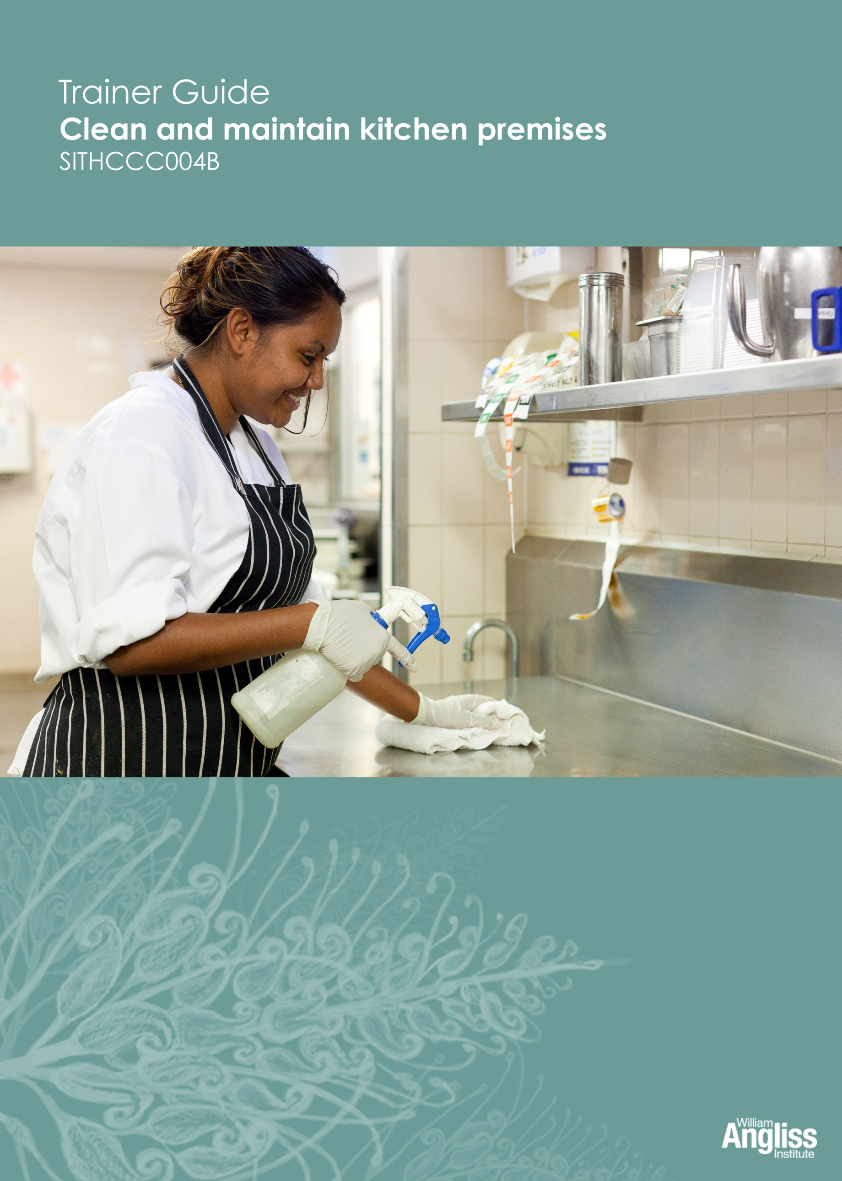

© Commonwealth of Australia. 2012
CC BY-NC-SA
This work is copyright. Except where otherwise indicated, and save for the Commonwealth Coat of Arms, the Department has applied the Creative Commons Attribution-Noncommercial-Share Alike 3.0 Australia Licence to this work.
The Department of Education, Employment and Workplace Relations must be attributed as the author of the Department’s copyright material.
As far as practicable, material for which the copyright is owned by a third party has been clearly labelled. The Department has made all reasonable efforts to ensure that this material has been reproduced on this website with the full consent of the copyright owners.
Requests and enquiries concerning the Department’s copyright material should be addressed to:
The Copyright Officer
Department of Education, Employment and Workplace Relations
Location code C148CW2
GPO Box 9880 Canberra ACT 2601
Or emailed to copyright@deewr.gov.au
Funded under the Workplace English Language and Literacy (WELL) Program by the Australian Government Department of Education, Employment and Workplace Relations.
The views expressed in this publication do not necessarily represent the view of the Minister for Education or the Australian Government. The Australian Government does not give any warranty nor accept any liability in relation to the contents of this work.
ISBN 978-1-922108-03-6
Development Team
Content | William Angliss Institute  Macsmith and Associates
Disclaimer
Every effort has been made sure that this booklet is free from error or omissions. However, you should conduct your own enquiries and seek professional advice before relying on any fact, statement or matter contained in this book. William Angliss Institute of TAFE is not responsible for any injury, loss or damage as a result of material included or omitted from this course.

Contents
What is in this guide? 1

LLN requirements of the unit 2

Guide to the activities 3
Activity 1 Would you eat here? 3
Activity 2 Storing cleaning items 3
Activity 3 Use the correct equipment for the job 4
Activity 4 Use equipment safely 4
Activity 5 Ask for help or advice 5
Activity 6 Care of cleaning equipment 6
Activity 7 Kitchen cleaning equipment 6
Activity 8 Report damaged equipment 7
Activity 9 Fill in a Maintenance Request tag 7
Activity 10 Different surfaces 7
Activity 11 Use the right equipment and product 8
Activity 12 Use chemicals safely 8
Activity 13 Use the correct PPE 8
Activity 14 Reading an MSDS 8
Activity 15 Diluting chemicals 8
Activity 16 Cleaning products in your workplace 9
Activity 17 Workplace hazards for cleaners 9
Activity 18 Emergency procedures 10
Activity 19 The kitchen at the Wattle Café 10
Activity 20 Equipment in your workplace kitchen 10
Activity 21 Wattle Café’s cleaning schedule 10
Activity 22 Your workplace cleaning schedule 11
Activity 23 Prepare a daily cleaning worksheet 11
Activity 24 Cleaning the meat slicer 11
Activity 25 Cleaning kitchen equipment 11
Activity 26 Cleaning a piece of equipment 11
Activity 27 Cleaning surfaces 12
Activity 28 Cleaning storage areas 12
Activity 29 Your workplace cleaning procedure 12
Activity 30 Cleaning waste bins 12
Activity 31 Waste at your workplace 12
Activity 32 Handling linen at your workplace 12
Activity 33 Is your workplace environmentally friendly? 13
Environmental sustainability – further information 14

Appendix: Cards for Activity 5 15

What is in this guide?
This Trainer Guide to Activities is part of a set of resources to support delivery of 9 units from qualifications in the SIT07 Hospitality Training Package.
The resources have 3 components:
1. Learner Workbook.
2. General Trainer’s Guide
This single guide contains information to assist trainers to understand:
- the purpose and design of the resources
- strategies for working with learners with lower LLN levels
- strategies for working with Indigenous learners
- strategies for designing and conducting assessment appropriate to these learner groups and AQF levels.
3. Trainer’s Guide to Activities
There is one of these for each unit. It contains:
- a summary of the LLN requirements of that unit
- advice on using the Learner Workbook activities for that unit.
This Trainer Guide to Activities supports the highlighted unit.
- SITHIND001B Develop and update hospitality industry knowledge
- SITXCOM001A Work with colleagues and customers
- SITXCOM002A Work in a socially diverse environment
- SITXOHS001B Follow health, safety and security procedures
- SITXOHS002A Follow workplace hygiene procedures
- SITHACS005B Prepare rooms for guests
- SITHACS006B Clean premises and equipment
- SITHCCC003B Receive and store kitchen supplies
- SITHCCC004B Clean and maintain kitchen premises

LLN requirements of the unit
SITHCCC004B Clean and maintain kitchen premises.
Skill | Applications
Reading | Follow cleaning schedules  Read instructions and labels on equipment and cleaning chemicals
Speaking and listening | Listen to instructions
Writing | None
Numeracy | Calculate the dilution of cleaning products  Interpret a schedule
Computer literacy | None
Research | None

Guide to the activities

This guide to the activities provides:
- advice on carrying out an activity where it may not be obvious from the design of the activity itself. When the design of an activity speaks for itself, comments are on possible variations, enhancements or extensions of the activity that would ensure it is useful for learners with lower LLN skills.
- possible answers where this may assist the trainer to understand the intent of the activity.
Activity 1 Would you eat here?
Use this extreme example in the article to get the learners talking about the problems a dirty kitchen can cause.
You could read the article out loud to the group as they follow in their workbook and elicit responses from the learners.
If there is a more recent article in a local newspaper, use that one instead.
Activity 2 Storing cleaning items
Discuss each guideline as a group.
Ask learners: ‘Why is it important to do this?’ ‘What problems does it prevent?’ At this stage they may not be able to think of many ideas.
After you have discussed each guideline together, write some brief notes on the whiteboard based on learners’ responses which they can copy down.
Here are some suggested responses.
Guideline | Why is this important?
1. Make sure items are completely dry before you store them. | To prevent germs multiplying quickly on damp surfaces
2. Don’t store things on the ground or near doorways. | To prevent pests, contamination, trip hazards
3. Store cutting boards vertically in a rack. | So they drain and air dry all over
4. Store bowl-shaped items upside down on a clean shelf. | So they don’t get dust, pests or dirt in them
5. Store knives in a knife block or on a magnetic strip rather than loose in a drawer. | So no-one cuts themselves
6. Wrap the cord around electrical  equipment before you store it. | So there are no loose cords catching in other items, no tangles
7. Keep storage areas clean, dry and  orderly. | So no moisture or dirt contaminates clean equipment  To make it easy to find things and get them out
Activity 3 Use the correct equipment for the job
Encourage learners to think of the answers and some reasons themselves, even if it is not the ‘right’ answer.
Discussing this in small groups may encourage learners with low confidence to suggest ideas. Then lead a whole group discussion where the small groups share ideas together.
Activity 4 Use equipment safely
Elicit responses from the learners and make notes on the board as they respond.
Give reinforcement for volunteering. Ask quiet people early so all obvious ideas are not gone, but not first so it is not too challenging for them.
Here are some suggested responses.
Guidelines for using cleaning equipment safely | Important because?
Never use equipment if you are not sure how to use it. | Could get injured  Could cause damage to the equipment
Always follow the manufacturers’ instructions. | Could get injured  Could cause damage to the equipment
Check equipment before you use it – make sure it is clean and safe to use. | Could get injured  Equipment may not work efficiently
Don’t lift heavy equipment. Ask for help or use ramps or lifts. | Could injure your back  Could drop and damage the equipment  Could drop on your foot
Don’t leave equipment lying around. | Someone could trip over it and injure themself
If equipment is not working properly or is damaged, don’t use it. Tell your supervisor. | Could get injured  Could damage the equipment
Don’t let electric cords trail behind you. | Someone could trip over them
Unplug electrical equipment when it is not being used. | Save electricity  Someone could accidently turn it on
Don’t use electrical equipment near water. | Could get electrocuted
Put equipment away in its correct place after you have finished. | Easy to find next time  Easy for other people to find
Activity 5 Ask for help or advice
This is a short communication activity to give learners practice in asking for help if they are not sure how to use a piece of equipment. Often people are unwilling to ask for further explanations, especially young people. This activity gives them some language to use and practice in using it.
The cards for this activity are in the Appendix of this guide. Copy and cut them up so that you have about twice as many cards as learners, so they have a choice.
There is also a card for the ‘supervisor’, with possible responses. Copy one supervisor card for each pair of learners.
Model the activity with a confident learner first, so learners understand what to do.
- Put learners into pairs. One person is the ‘employee’ and the other is the ‘supervisor’.
- The ‘employee’ draws a card from the equipment cards. They are not sure how to use this piece of equipment and must ask their ’supervisor’ for help. They can use the suggested questions in their workbook, or their own questions.

- The ‘supervisor’ gives a possible response, using the suggestions on their card or their own response. Encourage them to use a different response for each request for help.
- Then swap roles so both people in the pair get practice asking for help.
Note: The ‘supervisor’ does not actually give instructions on how to use the equipment.
Alternative activity: Take pictures of the equipment in the workplace and use them instead of these cards.
Activity 6 Care of cleaning equipment
Encourage the group to think of all the possible consequences. A few have been given.
a) A dishwasher slowly gets a clogged drain.
It will eventually block up and flood.
b) A mop that was used to clean up a grease spill is not thoroughly washed before it is put away.
Next time it is used, it will smear grease over the surface. Also the grease will get solid and it will be more difficult to clean the mop next time.
c) Cloths that are used for wiping down food preparation benches are not cleaned and sanitised after each use.
This could cause cross-contamination, as the germs on the cloth could transfer to the next surface they are used on and then onto food.
d) The handles of the bucket are loose.
The handles might fall off and you could drop the bucket on your foot when filled with water.
Activity 7 Kitchen cleaning equipment
This activity is to familiarise the learners with the type of equipment available, what it is called and what it is used for.
You could approach this activity in different ways depending on the learners’ access to the workplace.
Alternatives:
- Ask the learners find out about the kitchen cleaning equipment next time they go into the workplace, and come back to the group with the answers.
- Ask for ideas about what they remember from the last time they were in the workplace.
- Take photos of a storage area and show to the learners electronically.
- Learners could take photos of equipment with cameras or mobile phones, label them and put them in a folder or display on the wall.
- If there are no energy efficiency signs on equipment, such as a Star Rating on the dishwasher, you could show a picture of this and explain what it means in terms of electricity and water use.
Activity 8 Report damaged equipment
This discussion can be used to check learners’ understanding of the safety issues involved, and to reinforce the message that they must never operate any faulty equipment and must report it immediately.
Activity 9 Fill in a Maintenance Request tag
Go through the sections on the tag first, reading the name and clarifying for learners what needs to be written in each section.
Elicit from the learners what action they would take so they have some ideas about what they can write. Write the relevant key words on the board, so no-one is discouraged by fear of spelling wrongly.
Alternative activities:
- If you think learners will have difficulty completing the form, you could:
- hand out copies of a completed form so they can copy it
- display a blank form electronically and complete the form together as learners suggest the information orally.
- Use the maintenance request form or similar form from the learners’ workplace instead of the sample in the workbook.
Activity 10 Different surfaces
Here are some suggested responses.
Area | Could be made of:
Kitchen floors | Lino, wood, tiles, slate, cork
Walls | Painted plaster, stainless steel, tile
Skirting boards | Painted wood, stainless steel
Kitchen benches | Granite, wood, stainless steel
Kitchen sinks | Stainless steel, ceramics
Stove tops and ovens | Stainless steel, enamel, ceramic glass
Body of cooking appliances e.g. juicer or blender | Stainless steel, plastic, glass
Activity 11 Use the right equipment and product
Encourage learners to look at the notes about cleaning products and equipment before they complete this activity, and also the previous activity about what surfaces are made from.
You could write a grid on the whiteboard and complete it as learners come up with suggestions.
Activity 12 Use chemicals safely
You could have a general discussion, or go over each point one at a time. Stress the importance of using chemicals safely, and how dangerous they can be if they are not used correctly.
Activity 13 Use the correct PPE
Alternative activities:
- Take pictures of people in the learners’ workplace to use
- Ask them to observe what PPE people are wearing in their workplace.
Activity 14 Reading an MSDS
This is not a reading skill required in the unit, but is included as OHS laws require MSDSs to be in workplaces and this is an opportunity for learners to look at one in a highly supported situation.
If you feel it may have a negative effect on your learners’ confidence, omit it.
The language in a MSDS is complex, so explain key words as necessary, and work as a group.
Alternative activities:
- Use a MSDS example from the learners’ workplace
- Use a simplified version of a MSDS.
Activity 15 Diluting chemicals
a) 20 mls x 10 = 200 mls
b) 10 caps of detergent
Use the model to design extra practice activities for learners who need it.

Activity 16 Cleaning products in your workplace
This activity is to familiarise learners with what is used in the workplace, and that different products are used for different cleaning jobs.
Stress the importance of safety, to them, their colleagues and the food; and the need to read labels, taking notice of warning signs and using the products correctly.
This is also an opportunity to talk with learners about what products are less harmful for the environment and why; and how to use them so they cause the least amount of damage e.g. not using more than is needed.
Activity 17 Workplace hazards for cleaners
Encourage learners in small groups to come up with as many ideas as they can.
Draw the grid on the board or display it electronically and ask learners to suggest information for the gaps. You write it in clearly and simply.
Suggest changes to their ideas as necessary (with explanations), and then add any others so there is a complete list which learners can copy into their workbook.
Here are some suggestions.
Possible hazard | Injury or damage it could cause | What you should do to prevent injury or damage
1. Cleaning up liquids spilt on the floor e.g. water, oil or cleaning products | Slips, trips or falls – you or others.  Chemicals on skin or food. | Clean up and mop area as soon as possible  Handle chemicals safely, use PPE  Put up ‘Wet Floor’ signs
2. Using heavy equipment e.g. floor scrubbers | Strains | Don’t lift by yourself  Follow manufacturer’s instructions for operation
3. Not rinsing and sanitising cleaning cloths after use | Cross-contamination | Rinse and sanitise cleaning cloths following workplace procedures
4. Taking apart kitchen appliances to wash them | Cuts and other injuries  Damage to equipment | Follow manufacturer’s instructions  Do not take apart unless you have been trained how to do it safely
5. Contact with sharp things e.g. knives, broken glass or food scraps such as bones | Cuts | Wash knives one at a time – do not put in soapy water  Wrap broken glass and bones before disposing of them  Wear thick gloves when handling broken glass
6. Working near hot surfaces | Burns | Be careful of steam  Wear gloves
Activity 18 Emergency procedures
Learners may have been given this information during induction, or they can find the answers as a workplace activity.
You could ask the OHS representative to come and talk to the learners about safety and what to do if there is an accident or emergency.
Activity 19 The kitchen at the Wattle Café
Learners may use different words to describe the equipment and other parts of the kitchen. Acknowledge this, and teach them the correct industry terminology, as they will have to use this in the workplace.
Alternative activity: Use a picture of the learners’ workplace, showing it electronically.
Activity 20 Equipment in your workplace kitchen
This is an extension of the previous activity. Use the learners’ workplace procedures to help decide how often things should be cleaned.
Activity 21 Wattle Café’s cleaning schedule
This is an activity in reading a schedule as well as a communication activity.
Model the activity with a confident learner first, so learners understand what to do.
Move around the groups as they tell the others the order they have to do the tasks. Then ask for volunteers to tell the rest of the group.

Activity 22 Your workplace cleaning schedule
This task is workplace specific.
Alternative activity: Provide a sample cleaning schedule.
Activity 23 Prepare a daily cleaning worksheet
Normally a schedule would be developed by someone else in the kitchen. The objective of this activity is for learners to think about the reasons for the order of cleaning tasks so schedules feel logical rather than random. The activity should also build an awareness of the impact of cleaning activities on guests or customers.
Learners may suggest some differences in order of tasks. Check these fit with the given information, but answers do not need to be perfect and there is some room for flexibility.
Draw up the worksheet on the board or have an electronic copy, then build it with suggestions from the learners. For example, ask ‘What will be cleaned at 9 am?’, ‘Who will clean it?’
Alternative activities:
- Use an interactive whiteboard so learners can complete the schedule on the board.
- Use sticky labels so they could build the schedule on a blank wall.
Activity 24 Cleaning the meat slicer
Once learners have completed this activity in pairs, display it electronically and mark it up as learners suggest.
The photos can also be uses as a stimulus for discussion.
Activity 25 Cleaning kitchen equipment
Display the procedure electronically and mark it up as learners suggest answers. Don’t go too fast - learners need to see where the answers are in the written procedure.
Alternative activity: Use a standard operating procedure from the learners’ workplace.
Activity 26 Cleaning a piece of equipment
The objective of this activity is to give learners practice in explaining to an observer what they are doing and why. This is an assessment skill. The activity should be carried out supportively rather than as a test.
Use a piece of equipment which learners will have to clean in the workplace.
- Demonstrate slowly to the whole group first, saying what you are doing and why.
- Ask a confident learner to demonstrate to learners while you talk about what they are doing and why. Ask the learner some questions and encourage them to give full answers.
- Place learners into pairs to practice. They should watch each other carefully, giving advice and asking questions as they work.
- Then each learner can demonstrate to you individually (if time allows). Ask the learner to explain what they are doing and why, or ask questions at various points in the process, as you would during an observation assessment activity.
Activity 27 Cleaning surfaces
Display the procedure electronically and mark it up as learners suggest answers. Don’t go too fast - learners need to see where the answers are in the written procedure.
Alternative activity: Use a standard operating procedure from the learners’ workplace.
Activity 28 Cleaning storage areas
If learners are already in a workplace, they could also use their experience from the workplace to answer these questions.
Use the questions as triggers for discussion, explanation and checking learners’ understanding rather than as a test activity.
Activity 29 Your workplace cleaning procedure
This activity is workplace specific.
Alternative activity: Give the instructions for cleaning a piece of equipment, or demonstrate it, so learners can take notes.
Activity 30 Cleaning waste bins
As you discuss each guideline, ask for suggestions from the group and write on board. Learners can copy the answers into their workbook. Write clearly, using few words and plain language.
Activity 31 Waste at your workplace
This activity is workplace specific. Use the answers as a source of discussion, especially if learners are in different workplaces with variations in practice.
Activity 32 Handling linen at your workplace
This activity is workplace specific. Use the answers as a source of discussion, especially if learners are in different workplaces with variations in practice.

Activity 33 Is your workplace environmentally friendly?
The language in the questionnaire should be familiar to learners at this point, but the activity should not be threatening to learners. You may choose to read each question aloud to the group and discuss the answers before everyone marks an answer.
The objective of the activity is to:
- pull together the strategies for minimising harm to the environment scattered through the workbook, and discuss them together
- recycle and reinforce the knowledge
- practise the language.
Extension activities:
- Use the completed questionnaire to identify which actions workers can take as an individual and which ones are dependent on management policies.
- Organise someone from the workplace to talk to learners about strategies to reduce the environmental impacts of cleaning products and processes.
- Learners could make posters promoting ways for cleaners to help the environment, such as turning off equipment when not being used and not wasting water.

Environmental sustainability – further information
Here are some websites where you can find more information.
Australian Government, Department of Sustainability, Environment, Water, Population and Communities
The department is responsible for implementing the Australian Government's policies to protect our environment and heritage, and to promote a sustainable way of life.
<http://www.environment.gov.au/education/>
Sustainability Victoria
<www.sustainability.vic.gov.au>
Sustainability Toolkit – Hospitality
An introductory guide to basic sustainability principles, practices and actions that hospitality businesses can use to help manage their costs and climate change impacts.
<http://www.nswbusinesschamber.com.au/NSWBC/media/Misc/Policy%20Documents/Sustainability-Toolkit-Hospitality.pdf>

Appendix: Cards for Activity 5
Employee cards
Make 1 set for each pair of learners.
Computer for reservations |  | 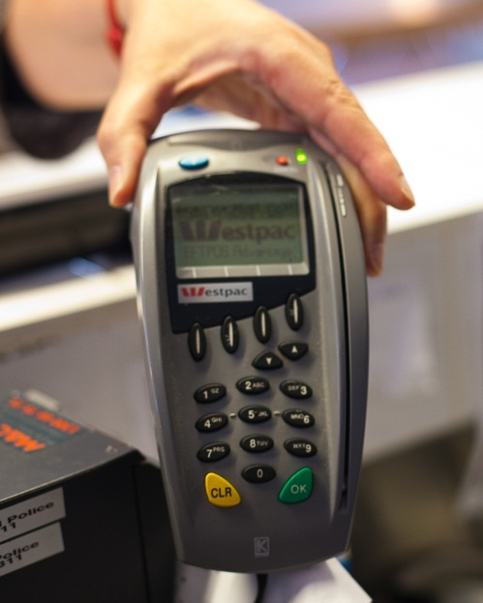  EFTPOS machine
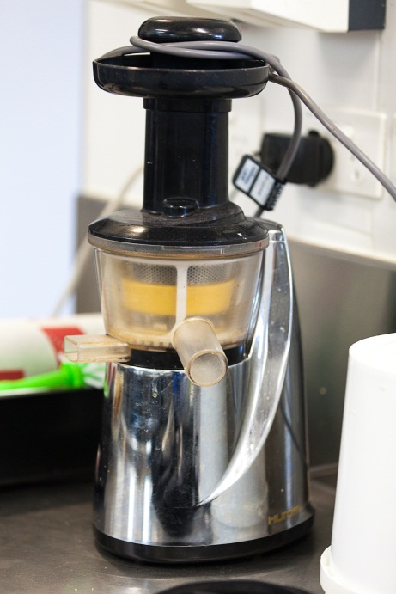  Blender |  | 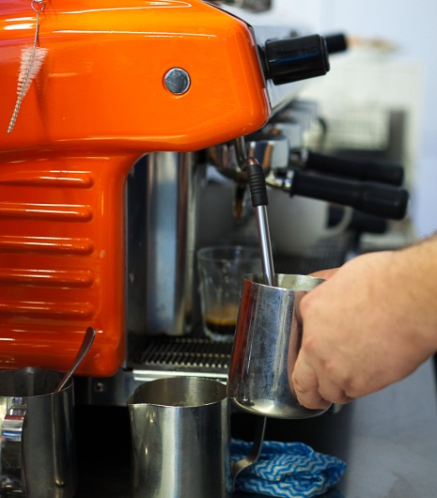  Coffee machine
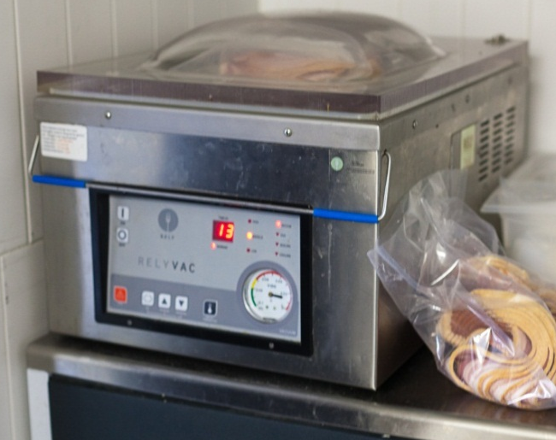  Vacuum packing machine |  | 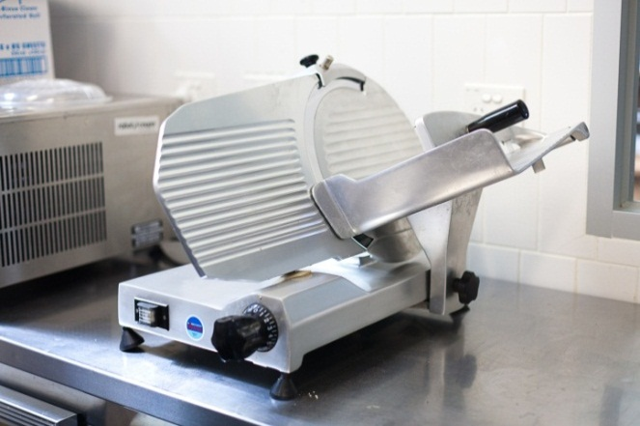  Meat slicing machine
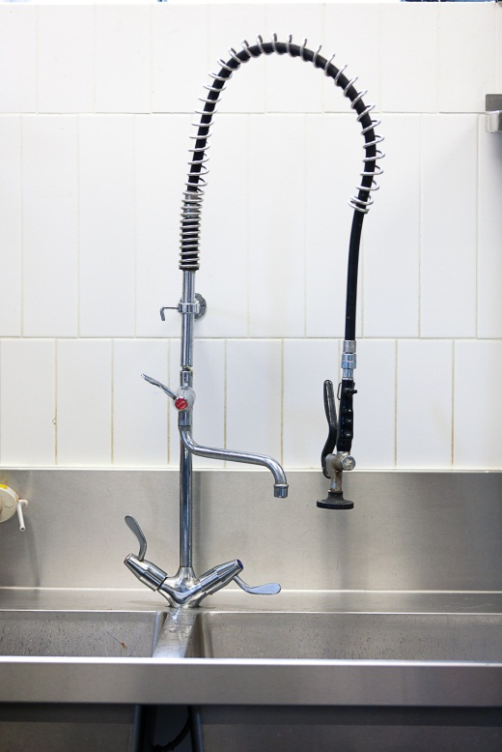  Dish rinsing spray nozzle |  | 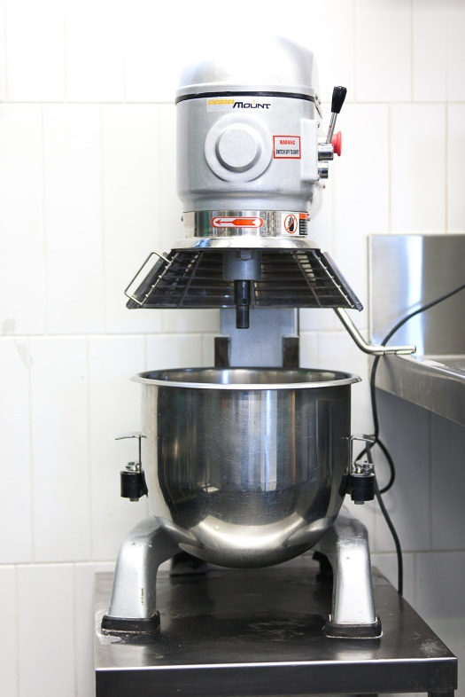  Dough mixing machine
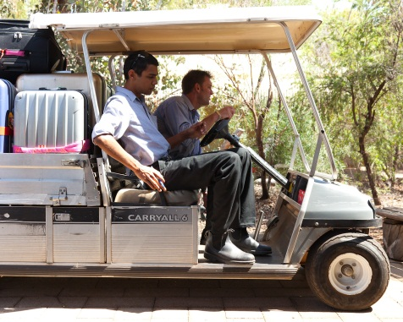  Golf cart | Guest alert  (rings when your order is ready)
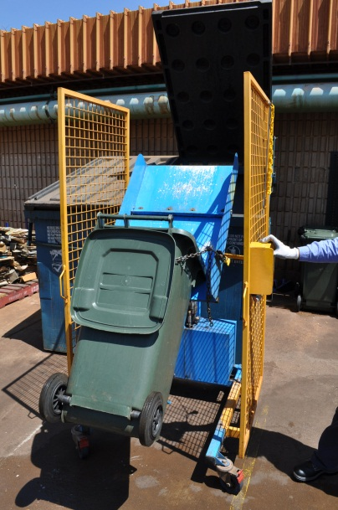  Waste bin emptying machine | Leaf blower

Supervisor card
Make 1 for each pair of learners.
THE SUPERVISOR
FIRST
- Now you’ll be right with this won’t you?
- Jason showed you how to use this yesterday, didn’t he?
- Off you go, you’ll work it out.
- I haven’t got time to show you now, but Allan will show you later.
- You’ve watched Samantha use this, haven’t you?
*******************************************
SECOND
- Okay, now watch carefully.
- Take your time, I’ll show you again.
- Let’s get together tomorrow and I’ll go over it again.
- I can show you now – is that OK? Then you can practise when I’m here to help.
- I’ll get Jack to show you when he’s free.
- I know, it’s a bit tricky - let me go over it again.
- OK, it’s important to make sure you get it right.

