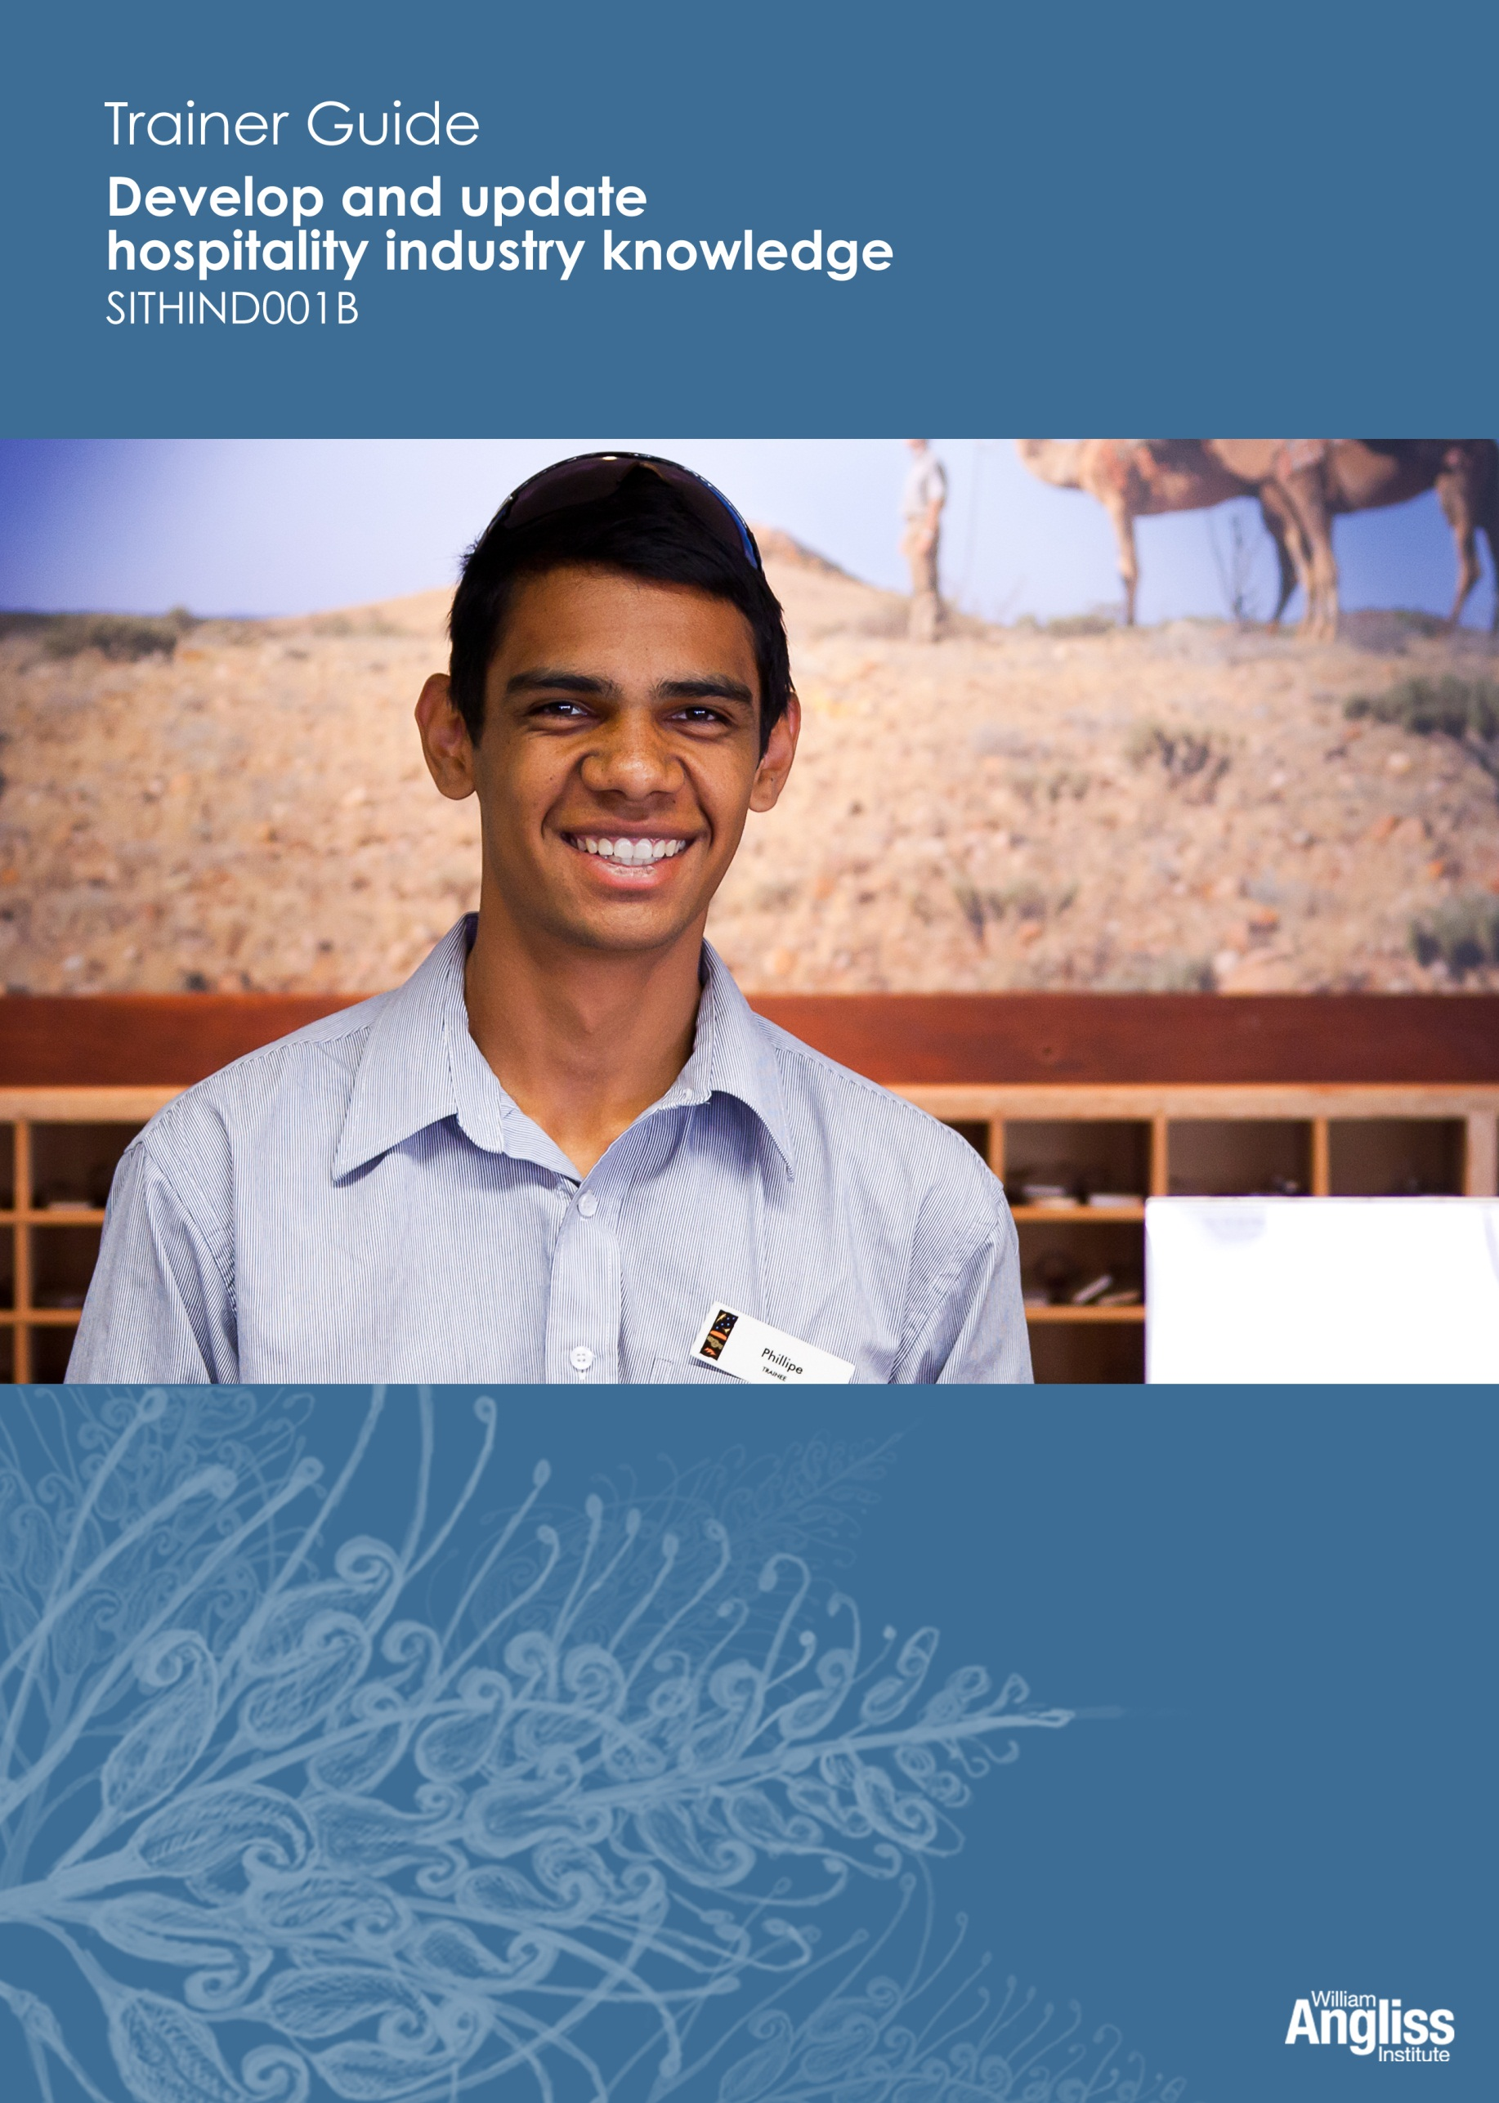

© Commonwealth of Australia. 2012
CC BY-NC-SA
This work is copyright. Except where otherwise indicated, and save for the Commonwealth Coat of Arms, the Department has applied the Creative Commons Attribution-Noncommercial-Share Alike 3.0 Australia Licence to this work.
The Department of Education, Employment and Workplace Relations must be attributed as the author of the Department’s copyright material.
As far as practicable, material for which the copyright is owned by a third party has been clearly labelled. The Department has made all reasonable efforts to ensure that this material has been reproduced in this resource with the full consent of the copyright owners.
Requests and enquiries concerning the Department’s copyright material should be addressed to:
The Copyright Officer
Department of Education, Employment and Workplace Relations
Location code C148CW2
GPO Box 9880 Canberra ACT 2601
Or emailed to copyright@deewr.gov.au
Funded under the Workplace English Language and Literacy (WELL) Program by the Australian Government Department of Education, Employment and Workplace Relations.
The views expressed in this publication do not necessarily represent the view of the Minister for Education or the Australian Government. The Australian Government does not give any warranty nor accept any liability in relation to the contents of this work.
ISBN 978-1-922108-00-5
Development Team
Content | William Angliss Institute  Macsmith and Associates
Disclaimer
Every effort has been made sure that this booklet is free from error or omissions. However, you should conduct your own enquiries and seek professional advice before relying on any fact, statement or matter contained in this book. William Angliss Institute of TAFE is not responsible for any injury, loss or damage as a result of material included or omitted from this course.

Contents
What is in this guide? 1

LLN requirements of the unit 2

Guide to the activities 3
Activity 1 Hospitality jobs 3
Activity 2 Hospitality businesses 3
Activity 3 Types of businesses 3
Activity 4 Hospitality departments 4
Activity 5 FOH or BOH? 5
Activity 6 Describe a hospitality workplace 5
Activity 7 Find out about these jobs 5
Activity 8 Describe a job 5
Activity 9 Share your information 6
Activity 10 RSA training 6
Activity 11 Looking ahead – my plan 6
Activity 12 Find a mentor 6
Activity 13 Hospitality, tourism and retail 6
Activity 14 Tourism sectors 6
Activity 15 Research the tourism industry 7
Activity 16 Support services 7
Activity 17 External supplies 8
Activity 18 The AHA 8
Activity 19 The union 8
Activity 20 Share your knowledge 8
Activity 21 My technology skills 8
Activity 22 Working conditions 8
Activity 23 Pass on a work memo 9
Activity 24 Change in the industry 9
Activity 25 Quality standards 9
Activity 26 QA in your workplace 10
Activity 27 Quality standards in other businesses 10
Activity 28 What is the employer looking for? 10
Activity 29 Who would you employ? 11
Activity 30 Who would you rather work with? 11
Activity 31 The effect of employability skills on others 11
Activity 32 My employability skills 11
Activity 33 How could you improve? 11
Activity 34 What could happen if you break the laws? 12
Activity 35 Chat’n’Chew café 12
Activity 36 The Capricorn Hotel 12
Activity 37 Duty of care 12
Activity 38 Social responsibility 13
Activity 39 House policies 13
Appendix 14
Cards for Activity 23 14

What is in this guide?
This Trainer Guide to Activities is part of a set of resources to support delivery of 9 units from qualifications in the SIT07 Hospitality Training Package.
The resources have 3 components:
1. Learner Workbook.
2. General Trainer’s Guide
This single guide contains information to assist trainers to understand:
- the purpose and design of the resources
- strategies for working with learners with lower LLN levels
- strategies for working with Indigenous learners
- strategies for designing and conducting assessment appropriate to these learner groups and AQF levels.
3. Trainer’s Guide to Activities
There is one of these for each unit. It contains:
- a summary of the LLN requirements of that unit
- advice on using the Learner Workbook activities for that unit.
This Trainer Guide to Activities supports the highlighted unit.
- SITHIND001B Develop and update hospitality industry knowledge
- SITXCOM001A Work with colleagues and customers
- SITXCOM002A Work in a socially diverse environment
- SITXOHS001B Follow health, safety and security procedures
- SITXOHS002A Follow workplace hygiene procedures
- SITHACS005B Prepare rooms for guests
- SITHACS006B Clean premises and equipment
- SITHCCC003B Receive and store kitchen supplies
- SITHCCC004B Clean and maintain kitchen premises

LLN requirements of the unit
SITHIND001B Develop and update hospitality industry knowledge
Skill | Applications
Reading | Read and understand general information aspects of the hospitality industry  Read and understand plain English information on key hospitality and general workplace legislation
Speaking and listening | Ask questions of supervisors or colleagues  Provide a verbal summary of information  Share information researched with colleagues  Answer questions testing underpinning knowledge
Writing | Take notes, summarise and record information in basic documents such as information sheets, portfolios and files
Numeracy | None
Computer literacy | Source industry information
Research | Identify information sources  Search information sources and collect sufficient relevant information  Sort information  Identify key points
Note: The Unit of Competency specifically refers to plain English versions of legal documents and information of similar complexity. The unit does not require learners to read the original documents. Learners only need to know the key content of these documents, not details.
Guide to the activities

This guide to the activities provides:
- advice on carrying out an activity where it may not be obvious from the design of the activity itself. When the design of an activity speaks for itself, comments are on possible variations, enhancements or extensions of the activity that would ensure it is useful for learners with lower LLN skills.
- possible answers where this may assist the trainer to understand the intent of the activity.
Activity 1 Hospitality jobs
To get a group going ask ‘What can you see in the photos?’
This activity has no right answer; it aims to stimulate ideas and see what learners know.
Give positive reinforcement to individuals who volunteer ideas. Ask quiet people early so all the obvious ideas are not gone, but not first so it is not too challenging for them.
Activity 2 Hospitality businesses
Elicit learner suggestions, and suggest possibilities yourself as required to fill any significant gaps.
Activity 3 Types of businesses

Commercial | Industrial | Institutional
Wedding and party caterers  Backpacker hostels  Caravan parks  Take-away restaurants  Licensed clubs | Mining camps  Defence forces  Film crew catering | Nursing homes  Prisons  Hospitals  School canteens
Others they might think of, or you might suggest, are:
Guest house, B&B, winery, cruise liner, airports, coach camping tour companies …

Activity 4 Hospitality departments
Elicit learner suggestions, and suggest possibilities yourself as required to fill any significant gaps. Keep to a broad overview rather than being too detailed.
Department | Tasks
Food and Beverage | - Serve food and drinks in bars, restaurant, room service, functions  - Take payments  - Perform cellar tasks
Kitchen | - Prepare food for guests and staff  - Plan menus  - Order and store food  - Wash dishes  - Clean kitchen
Front Office | - Take reservations  - Check guests in and out  - Provide information to guests  - Prepare accounts  - Organise luggage
Housekeeping | - Clean rooms and replace linen  - Clean public areas  - Organise laundry requirements  - Check rooms for damage and report
Sales and Marketing | - Advertise the business  - Make package deals with travel agents
Accounts and Finance | - Pay invoices from suppliers  - Prepare wages  - Prepare tax  - Undertake business budgeting – revenue and expenditure
Human Resources | - Advertise for, interview and select new staff  - Organise training  - Keep staff records
Leisure | - Provide leisure activities for guests e.g. gym, fitness training, spa  - Provide children’s activities
Maintenance | - Carry out repairs  - Paint and decorate  - Maintain garden and grounds
Security | - Keep buildings and grounds secure for guests  - Handle troublesome guests  - Guard and transport money
Activity 5 FOH or BOH?
Elicit responses from learners by asking ‘Do staff in this job normally deal directly with customers?’
Activity 6 Describe a hospitality workplace
If learners are unable to manage the reading and writing to do this alone, pair them with another learner who can assist them.
Activity 7 Find out about these jobs
Learners who have little or no computer literacy will need assistance either during or outside of class time. Working in pairs or small groups may be an option.
Accessing this website is required for the next activity.
Activity 8 Describe a job
This activity requires the skills of reading, summarising and writing key point. It is more difficult than it appears and learners who struggle with it may need structured help for example, by picking out key points on a printed item using a highlighter.
Deter learners from copying whole sentences or paragraphs from text. Point out that there are only two lines to write on, so information should be brief and use key words.
Activity 9 Share your information
This should be conducted in a low key way. It is the first of several similar activities, and learners should become more accustomed to it as they repeat it.
Activity 10 RSA training
Some websites you could direct students to are:
<http://responsiblealcohol.vic.gov.au/wps/portal/rav/training/employee>
<http://www.olgr.nsw.gov.au/courses_rsa_courses.asp>
<http://www.ahawa.asn.au/training/responsible_service_of_alcohol__rsa_.phtml>
<http://www.olgc.sa.gov.au/general/Applications/PDFLodgementGuides/IS_RegisteredTrainingOrganisations_LG.pdf>
Check URLs regularly as they can change without warning.
Activity 11 Looking ahead – my plan
This activity may be difficult for some learners for personal or cultural reasons, so be sensitive to this.
It should be preceded by discussion amongst learners and with the trainer about their goals and possible pathways, so they have some ideas to write down.
Ask learners to write the actual years on the path, and makes some notes underneath at each point.
Activity 12 Find a mentor
This may not be possible at this early point in training or because the learner is away from home. You might want to adapt or vary this activity depending on the learners’ context.
Activity 13 Hospitality, tourism and retail
This activity could be done or checked in a large group, as a way of clarifying learners’ understanding of the different sectors.
Activity 14 Tourism sectors
Help learners think of other examples – local, intestate or international.

Activity 15 Research the tourism industry
Before you start this activity, check URLs as they can change without warning.
Put learners into 6 groups, one for each website. If there is no access or limited access to computers, the trainer should print out some adapted information and give copies to groups.
To mix up the groups for an exchange of information:
Give each learner in a group a number, from 1 upwards. Then ask all the 1s to form a new group, all the 2s, and so on.
Activity 16 Support services
Learners may need some support completing this activity. Here are some suggestions.
Support service | What do they supply?
Food | Meat, poultry, fruit, vegetables, dairy, bakery goods, dry goods, snack foods
Beverages | Beer, wine, spirits, soft drinks
Non-food goods | Cigarettes, newspapers, toilet paper
Linen | Bedding, towels, tablecloths, napkins
Laundry | Wash bedding, towels, tablecloths and napkins
Cleaning | Cleaning chemicals and tools  Soaps and shampoos for guest rooms  May subcontract out cleaning
Stationery | Pens, paper, envelopes for administration  Note pads for rooms  Cash register rolls
Security | May subcontract out
Trades services | Electrical, plumbing, maintenance, refrigeration
Entertainment agents | Book acts and bands
Equipment | Tables and chairs, refrigeration equipment, air conditioning, telecommunications, cash registers
Florists | Flowers for public areas e.g. reception
Advertising and promotion | Pamphlets or brochures  Menu production
Travel agents | Accommodation packages

Activity 17 External supplies
Use answers as a source of discussion, especially if learners are in different workplaces.
Activity 18 The AHA
The questions are really just a driver for exploring the AHA website. Give learners time to look around the website before you discuss the answers.
Activity 19 The union
The questions are really just a driver for exploring the United Voice website. Give learners time to look around the website before you discuss the answers.
Activity 20 Share your knowledge
Before you start this activity, check URLs as they can change without warning.
If learners have no internet access, you will need to supply printed magazine extracts, printed webpages or other sources of information. Assist learners to pick out the key points from the information.
Encourage learners not to copy down sentences or paragraphs from the information, but to identify a key point and tell or explain it in their own words. Listeners are more likely to understand if they do this.
You could demonstrate this activity by using an electronic copy of an article and highlighting the key points.
Encourage listeners to ask questions for clarification if they don’t understand.
Activity 21 My technology skills
This activity should be conducted carefully to avoid embarrassing individuals with little technology experience.
You may need to begin by explaining or demonstrating the technologies or applications, or encouraging learners who are have more technology experience to explain or demonstrate.
Activity 22 Working conditions
This activity has a dual purpose – for the learner to gather the information, and for them to practise clear oral communication with a workplace colleague.

Activity 23 Pass on a work memo
This is a pair work activity. Learners may need assistance (from other learners or from you) to identify the key parts of the message. Do not ‘over-support’ learners.
Memos for the activity can be found at the Appendix. Copy and cut the page so that you have a different memo for each person in the pair.
Activity 24 Change in the industry
This is a challenging activity, and you may choose to omit it, or to do it as a whole group which allows a higher level of trainer input and direction.
You might choose to replace the factors listed with some more current and relevant to your location and learner group.
If the activity is carried out in small groups, they should be no larger than three people. Otherwise quiet members can become less visible and tend not to contribute.
Here are some possible answers.
Factor | Effect on hospitality
Flu epidemic in Asia | - Fewer tourists go overseas  - More domestic tourists
Advertising campaign to promote Indigenous cultural tourism in Western Australia | - Increase in WA Indigenous cultural tourism  - Possible drop in tourists to other areas
Brisbane flood | - No visitors to Brisbane  - Possible increase in tourism to other areas  - Government needs to encourage tourists to return
Australian dollar rises in value against the US dollar | - Cheaper to go overseas  - Fewer domestic tourists
Activity 25 Quality standards
This activity could be used to encourage discussion about what standards we expect and why we expect them.

Activity 26 QA in your workplace
This activity asks learners to recycle the information in the preceding section. Responses can be shared with the whole group, which also provides an opportunity to bring up anything different if they have observed other practices in their workplace.
Possible answers:
- Use checklists for tasks
- Use standard operating procedures for tasks
- Use rosters and schedules to set targets for amounts of work completed
- Check the finished quality of the product or service by supervisor or self-check
- Discuss performance and problems at team meetings
- Fill in report forms about difficulties or problems encountered
- Use customer complaint or feedback forms to identify problems
- Follow other site-specific and job-specific procedures.
Activity 27 Quality standards in other businesses
This activity asks learners to relate the concept of quality and standards back to their own personal experiences. The aim is to help them understand why their customers will care about quality and standards.
Activity 28 What is the employer looking for?
The trainer should lead the group to underline or highlight the words that describe the kind of person the manager is looking for:
- professional
- friendly
- energetic
- reliable
- team player
- presentable.
Discuss together what these words mean in practical terms.
Note: Questions parts b and c should be responded to privately and individually by each learner. This is not suitable for group discussion, but should be used to help the each individual begin to self-evaluate against a credible job ad.

Activity 29 Who would you employ?
Use learners’ ideas to guide a discussion about the 3 applicants’ strengths and disadvantages as potential employees.
Again, the aim is to help learners ‘get inside the head’ of an employer, to understand what they value in an employee and why.
Activity 30 Who would you rather work with?
Use learners’ ideas to guide a discussion which teases out the differences between the pairs of responses.
You could ask:
- ‘What kind of person would say this?’
- ‘What else might they be like?’
The aim is to help learners understand the value to themselves of employability skills in their work group colleagues.
Activity 31 The effect of employability skills on others
There are no right answers for this activity. Its aim is to consolidate the understanding developed in the preceding activities, that employability skills have a genuine impact on all aspects of our work and workplace.
Activity 32 My employability skills
This activity should be personal. Assist individually learners who have difficulty with the reading.
Activity 33 How could you improve?
Learners should work on this in pairs or individually if they prefer.
Use learners’ answers to guide a group discussion about practical ways for improving their employability skills.
Then individuals can use these ideas to complete “This week I will…”

Activity 34 What could happen if you break the laws?
Ask learners to suggest ideas of possible penalties. Write suggestions on the whiteboard, so learners can copy them down.
Suggestions may include:
- fines for the business or individuals
- court case
- temporary or permanent closure
- jail for individuals
- injury to workers or customers
- death of workers or customers
- negative customer reactions
- loss of business reputation
- loss of business
- loss of income for workers.
Activity 35 Chat’n’Chew café
YES, Steve is breaking the law.
Steve is breaking the Trade Practices Act. He has misrepresented his business. The picture is not of his café. His café does not have trees and flowers outside and he does not serve gourmet food.
Activity 36 The Capricorn Hotel
YES, Brian is breaking the law.
Brian is breaking the Equal Opportunity Act. He is discriminating against Renee because she is female. She may be the best employee at the job.
Activity 37 Duty of care
Read the article aloud to the group. Explain any language that learners are not clear on, and encourage questions. Then discuss the question as a group.
Possible answers:
- Refuse service to the patron earlier
- Arrange transport home for him
- Escort him to the bus stop and make sure he got on the bus safely.
Discuss the pros and cons of these ideas. Learners may disagree with the court decision, but part of the activity’s purpose is to show that we must comply with the law whether we agree with it or not.
Activity 38 Social responsibility
Read the article aloud to the group. Explain any language that learners are not clear on, and encourage questions. Then discuss the question as a group.
Possible answers:
- Refuse service to drunken patrons
- Liaise with local authorities to arrange transport to be available at closing times to transport patrons quickly away from venues.
Activity 39 House policies
This activity is workplace specific. If learners are from different workplaces, they can share what they find.

Appendix
Cards for Activity 23

Student 1

MEMO TO STAFF 18 September
Changed Roster Times
From 1st October, cleaning rosters will start ONE HOUR EARLIER in the morning due to the heat. That is, housekeeping staff will start at 5 am, not 6 am.
Please make sure you are on time for your shifts after 1st October.
Housekeeping Supervisor
S. Kilmartin
Head Housekeeper

Questions for your partner:
- Are the new rules for QuikCleen?
- Are the short gloves okay?

Student 2

MEMO TO STAFF 5th June
CHANGE TO PPE for TUFFKLEEN
The State OHS Authority has released new guidelines for the use of certain chemicals.
From now on, when you use Tuffkleen on the bins, you must wear:
- full protective faceguard
- long sleeve heavy duty gloves
- full-length heavy duty apron
- work boots.

The Management

Questions for your partner:
- You mean we start at 5.30 am?
- What date does the new time start?

