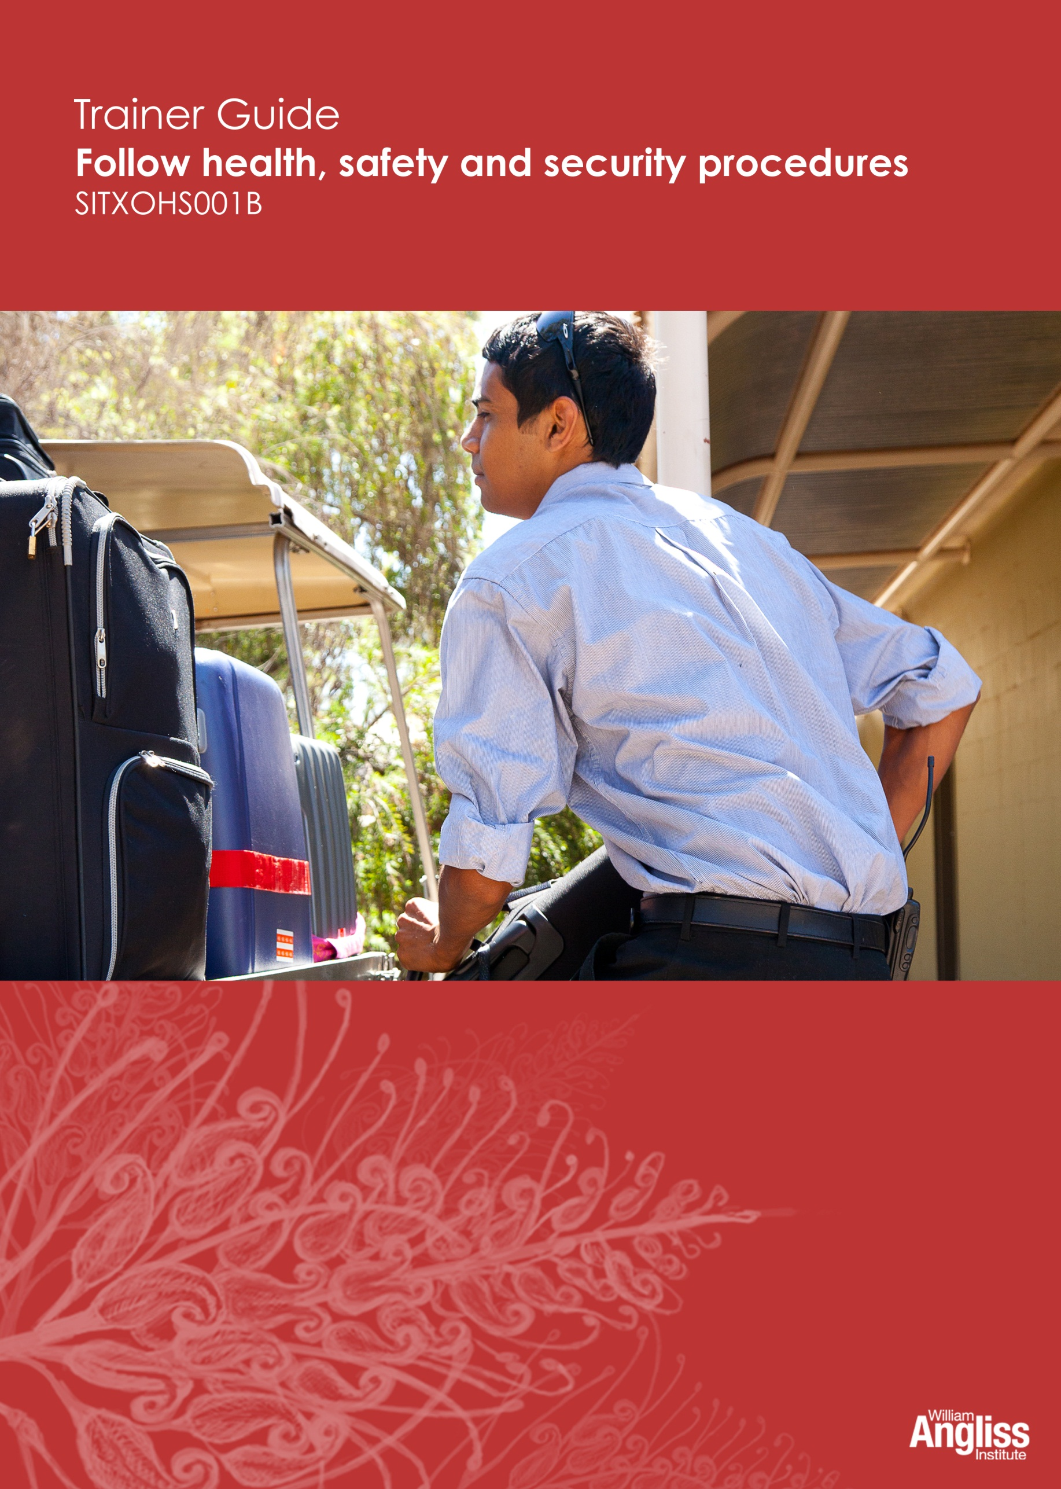

© Commonwealth of Australia. 2012
CC BY-NC-SA
This work is copyright. Except where otherwise indicated, and save for the Commonwealth Coat of Arms, the Department has applied the Creative Commons Attribution-Noncommercial-Share Alike 3.0 Australia Licence to this work.
The Department of Education, Employment and Workplace Relations must be attributed as the author of the Department’s copyright material.
As far as practicable, material for which the copyright is owned by a third party has been clearly labelled. The Department has made all reasonable efforts to ensure that this material has been reproduced in this resource with the full consent of the copyright owners.
Requests and enquiries concerning the Department’s copyright material should be addressed to:
The Copyright Officer
Department of Education, Employment and Workplace Relations
Location code C148CW2
GPO Box 9880 Canberra ACT 2601
Or emailed to copyright@deewr.gov.au
Funded under the Workplace English Language and Literacy (WELL) Program by the Australian Government Department of Education, Employment and Workplace Relations.
The views expressed in this publication do not necessarily represent the view of the Minister for Education or the Australian Government. The Australian Government does not give any warranty nor accept any liability in relation to the contents of this work.
ISBN 978-1-922108-02-9
Development Team
Content | William Angliss Institute  Macsmith and Associates
Disclaimer
Every effort has been made sure that this booklet is free from error or omissions. However, you should conduct your own enquiries and seek professional advice before relying on any fact, statement or matter contained in this book. William Angliss Institute of TAFE is not responsible for any injury, loss or damage as a result of material included or omitted from this course.

Contents
What is in this guide? 1

LLN requirements of the unit 2

Guide to the activities 3
Activity 1 Common incidents in hospitality 3
Activity 2 Preventing incidents 3
Activity 3 Effect of workplace injuries 4
Activity 4 Health and safety laws 4
Activity 5 OHS laws in your state or territory 4
Activity 6 Did the employers act responsibly? 4
Activity 7 Did the employees act responsibly? 4
Activity 8 Who is your health and safety representative? 4
Activity 9 Health and safety – who’s responsible 5
Activity 10 Injury report form 6
Activity 11 Manual handling 6
Activity 12 Safe posture 6
Activity 13 Avoid getting tired 6
Activity 14 Hazardous equipment 6
Activity 15 Hazardous substances 7
Activity 16 Safety signs in your workplace 7
Activity 17 Personal protective equipment (PPE) 7
Activity 18 Identify hazards 8
Activity 19 Workplace bullying 9
Activity 20 Follow workplace safety procedures 9
Activity 21 Report your health, safety and security concerns 9
Activity 22 Hazard report form 10
Activity 23 What can cause an emergency? 10
Activity 24 The emergency procedure 10
Activity 25 Complete an incident report form 10
Activity 26 Workplace emergency quiz 11

Activity 27 How can you participate? 11
Activity 28 Hazard control 11
Activity 29 Virtual Kitchen 11
Activity 30 Virtual Hotel 12
Appendix 13
Cards for Activity 20 13
Cards for Activity 21 21

What is in this guide?
This Trainer Guide to Activities is part of a set of resources to support delivery of 9 units from qualifications in the SIT07 Hospitality Training Package.
The resources have 3 components:
1. Learner Workbook.
2. General Trainer’s Guide
This single guide contains information to assist trainers to understand:
- the purpose and design of the resources
- strategies for working with learners with lower LLN levels
- strategies for working with Indigenous learners
- strategies for designing and conducting assessment appropriate to these learner groups and AQF levels.
3. Trainer’s Guide to Activities
There is one of these for each unit. It contains:
- a summary of the LLN requirements of that unit
- advice on using the Learner Workbook activities for that unit.
This Trainer Guide to Activities supports the highlighted unit.
- SITHIND001B Develop and update hospitality industry knowledge
- SITXCOM001A Work with colleagues and customers
- SITXCOM002A Work in a socially diverse environment
- SITXOHS001B Follow health, safety and security procedures
- SITXOHS002A Follow workplace hygiene procedures
- SITHACS005B Prepare rooms for guests
- SITHACS006B Clean premises and equipment
- SITHCCC003B Receive and store kitchen supplies
- SITHCCC004B Clean and maintain kitchen premises

LLN requirements of the unit
SITXOHS001B Follow health, safety and security procedures
Skill | Applications
Reading | Read and understand:  - workplace safety signs  - workplace procedures  - emergency evacuation plans  - hazard identification and risk assessment tools and template documents
Speaking and listening | Follow the safety directions of supervisors or managers  Report unsafe work practices or other issues including suspicious behaviour  Clearly report and explain hazards  Participate in the OHS consultation process  Participate in risk assessments  Assertively suggest control methods
Writing | Possibly to fill in an incident report
Numeracy | None
Computer literacy | None
Research | None

Guide to the activities

This guide to the activities provides:
- advice on carrying out an activity where it may not be obvious from the design of the activity itself. When the design of an activity speaks for itself, comments are on possible variations, enhancements or extensions of the activity that would ensure it is useful for learners with lower LLN skills
- possible answers where this may assist the trainer to understand the intent of the activity.
Activity 1 Common incidents in hospitality
This activity aims to raise awareness of the importance of safety at work by focussing on the effect on the individual. Don’t expect learners to have all the answers.
When learners have completed the activity, ask them to share responses with the whole group. You may want to add any glaring omissions to this discussion.
Remind learners to look at the photo on the previous page which shows injuries common to hospitality workers.
Activity 2 Preventing incidents
Read one story aloud to the whole group, and lead a group discussion on what should have happened. Elicit learner suggestions and give positive reinforcement to learners who volunteer ideas.
Then break learners into small groups. Give each group one story to read and discuss, and give their ideas to the whole group.
Alternative activities:
- Learners read a story in pairs and discuss, then give ideas to the whole group.
- Place learners in small groups with a more confident reader in each group. Ask that learner to read a story to the rest of the group. Then they discuss.
- You read each story aloud to the learners (appropriate for lower levels of literacy), and lead a group discussion.

Activity 3 Effect of workplace injuries
In this activity you are stressing the consequences of workplace accidents.
You could read the stories aloud to the learners first, especially if they have lower levels of literacy.
Activity 4 Health and safety laws
Learners should look at the table above the activity to help them answer the questions. The table may need explanation, especially if learners are not used to reading tables.
Activity 5 OHS laws in your state or territory
This is a communication activity as well as a computer literacy activity, as learners talk about their interesting piece of information with another learner.
Be alert to variations in the computer literacy of individual learners, and provide support or group people appropriately.
Extension activity: Ask for volunteers to share their interesting piece of information.
Activity 6 Did the employers act responsibly?
Elicit suggestions from the group.
Show learners how to look back to the relevant information in the section above to work out the answers.
Activity 7 Did the employees act responsibly?
Elicit suggestions from the group.
Show learners how to look back to the relevant information in the section above to work out the answers.
Activity 8 Who is your health and safety representative?

Activity 9 Health and safety – who’s responsible
The correct responses are ticked below.
Health and safety in the workplace | Employer is responsible | Employee is responsible
Organise OHS training
Attend OHS training
Provide necessary safety equipment
Make sure all equipment is in safe condition
Provide Personal Protective Equipment (PPE)
Using correct PPE as required
Provide safety and operational manuals and signage
Follow workplace procedures
Provide proper toilets and lunch rooms
Consider the safety of others – don’t behave in a way that puts others at risk
Don’t come to work if you are affected by drugs or alcohol
Provide training on identifying and dealing with workplace hazards
Attend OHS meetings and contribute ideas about how to make the workplace safer
Report any hazards or injuries
Make sure there is safe storage for chemicals
Use chemicals according to workplace procedures

Activity 10 Injury report form
Alternative activities:
- Use the equivalent form from the learners’ workplace if available.
- Learners complete this form in pairs, so they can provide support to each other.
- You complete one form and then let learners (or those who need to) copy it.
- Show the form electronically on a screen and ask for suggestions, filling it in together.
Activity 11 Manual handling
Elicit from the learners what work activities involve manual handling. Ask quiet people early so all the obvious ideas are not gone, but not first so it is not too challenging for them.
Activity 12 Safe posture
In small groups, learners should identify which hospitality work tasks involve movements like sitting, stretching, pushing, pulling and bending.
To help learners with the second part of this activity, refer them back to the section on safe posture. You could physically demonstrate the movements. As you demonstrate the movements, elicit responses from the learners.
Activity 13 Avoid getting tired
Elicit responses from the learners. You may have to prompt or suggest, especially if they haven’t yet started work in a hospitality business.
Activity 14 Hazardous equipment
Discuss why particular equipment might be dangerous and what kind of injuries might result from incidents using these items. Examples may include knives and electrical equipment such as:
- slicers
- mincers
- mixers
- food processors
- dough machines
- floor polishers
- pressure washers

- steam cleaners or hoses
- vacuum cleaners
- washing machines and dryers
Activity 15 Hazardous substances
Answers may include:
- Cleaning: chemical cleaning agents such as detergents, cleaning fluids, polishes and air fresheners, insect sprays.
- Washing linen: laundry detergents.
- Maintenance: cleaning and garden chemicals.
- Kitchen: oven cleaning products.
- Bar/beverage work: gases to put bubbles in beverages.
Activity 16 Safety signs in your workplace
You could upload learner photos to a computer and project them for a group recognition activity.
You may need to get permission from workplace management for this activity.
Activity 17 Personal protective equipment (PPE)
Possible answers are given.
Type of work | PPE
Kitchen work | Non-slip footwear  Apron and cap  Heat resistant gloves for ovens and stoves  Cut-resistant gloves for some knife tasks  Goggles, chemical resistant gloves and respirator when using cleaning chemicals
Dishwashing work | Heat-resistant gloves  Apron and cap  Chemical resistant gloves  Goggles and mask when decanting and using hazardous chemicals  Non-slip footwear
Housekeeping work | Work gloves when handling garbage  Disposable waterproof gloves when handling linen and cleaning rooms  Chemical-resistant gloves when handling undiluted chemicals  Goggles and mask when decanting and using hazardous chemicals
Maintenance work | Work gloves for manual handling e.g. boxes, furniture, garbage  Steel-toed boots when working with heavy tools and equipment  Safety glasses when general eye protection is required  Hard hat when working at heights  Ear muffs when working with noisy machinery  Chemical-resistant gloves when cleaning with chemicals  Footwear with ankle support for outdoor work
Activity 18 Identify hazards
Some possible answers are given below.
Work area | Examples of hazards
Housekeeping and cleaning | Handling cleaning products and other chemicals  Exposure to biological waste  Straining to reach difficult places  Pulling the trolley not pushing it  Exposure to sharps, syringes and broken glass
Kitchen and food service | Wet or slippery floors  Hot cooking equipment  Draining or disposing of used oil  Sharp objects used in food preparation
Retail | Violent crimes resulting from cash handling  Heavy lifting
Receiving and storing goods | Storeroom not well lit or ventilated  Handling frozen food  Pest control – chemical and mechanical  Lifting, carrying, pushing & pulling
Activity 19 Workplace bullying
Learners should individually complete this activity, if their reading level is appropriate.
Encourage a full discussion afterwards but avoid learners feeling pressured to disclose a specific incident. Help learners distinguish between single acts of unpleasant behavior and repeated acts.
Stress that bullying is a workplace hazard and employers must deal with it, just like they have to deal with any other workplace hazard.
Also focus on the active response of the person who is bullied. They must find someone they feel comfortable with to talk about it.
Activity 20 Follow workplace safety procedures
Alternative activity: Use a procedure from the learners’ workplace instead of the Banksia Park Hotel procedures.
Activity 21 Report your health, safety and security concerns
This activity aims to help learners practise verbally reporting health, safety and security concerns to a supervisor. It uses a triad format, where two learners act out the scenario and a third learner observes and gives them feedback later.
The cards for this activity are in the Appendix of this guide.
Put the roles on a PowerPoint or whiteboard and explain how the activity will work. This means learners can hear your explanation and also read it.
Divide learners into groups of three. They can decide who will tke which role.
Give each trio a matching pair of employee and supervisor cards.
Encourage learners to explore the roles outside of the provided lines, if they feel confident to do so. Have fun with the activity.
Brief the observers to give their feedback neutrally and with the aim of helping the employee develop confidence in their speaking and their rights. Remind them that they will also be observed and given feedback.
Within each triad, learners rotate roles of employee, supervisor and observer.
Alternative activity: Do the activity in pairs if you think the triad format is not suitable for your learner group.

Activity 22 Hazard report form
The cards for this activity are in the Appendix of this guide.
Give each small group a card describing a hazard they need to report. They can work on the wording together. Help learners complete the form as needed.
Alternative activities:
- Use a form from their workplace.
- Project the form onto a screen and complete it as a group.
Activity 23 What can cause an emergency?
Help learners with this activity as needed. Some extra suggestions are:
- robbery or armed hold-up
- natural disaster e.g. bushfire, flood, earthquake, cyclone
- someone requiring urgent medical attention
- escape of hazardous materials e.g. gas leak, chemical spill.
Activity 24 The emergency procedure
If learners are not yet in the workplace, give them another set of workplace emergency procedures.
Activity 25 Complete an incident report form
Before asking learners to complete the form:
Look at the form together and help learners get an overview of it. Consider doing this electronically.
- Identify the different sections.
- What information does each section ask for?
- Can you find key words to give you a hint about what is needed?
- Can we write in brief, not in full sentences?
Alternative activities:
- Use a form from the learners’ workplace.
- Assist individual learners who need more help to complete the form, or pair them with a more competent writer.
- Make a completed copy of the form so learners who need greater support with writing can copy the words.

Activity 26 Workplace emergency quiz
This quiz is based on workplace-specific information. You may need to help learners find out some answers.
Stress that people need training before they are allowed to use fire extinguishers.
Extension activity: Make copies of the workplace evacuation plan and ask learners to mark where they should go, or show you where they should go. Reading a floor plan can be difficult for learners with lower literacy, so they may need assistance to understand what the evacuation plan actually means “on the ground”.
Activity 27 How can you participate?
Read each question aloud before learners mark their answer.
Develop and check understanding e.g. ask learners to give some examples or explain what each point means.
Activity 28 Hazard control
This activity gives the learners practice in participating in health, safety and security in the workplace, and practice in giving their ideas.
Complete one hazard control tool first, using one of the hazards listed. Elicit suggestions from the group.
Give each small group one hazard, so that all the hazards in the activity are covered.
Extension activity: Ask each small group to explain their suggestions to the rest of the group, with reasons.
Activity 29 Virtual Kitchen
This is an online activity about hazard control, based in a commercial kitchen.
Depending on availability of computers, this activity could be done as a whole-class activity with the media projected onto a screen, as a small group activity, or individually.
Go to the Virtual Kitchen: <http://www.safework.sa.gov.au/contentPages/EducationAndTraining/ActivitiesAndTests/VirtualKitchen/vkitchenframe.htm>
The task is to identify and safely remove hazards.
Learners use the mouse to click on the hazards and then choose the best way to eliminate or reduce each hazard.

Activity 30 Virtual Hotel
This is an online activity about hazard control, based in a hotel.
Depending on availability of computers, this activity could be done as a whole-class activity with the media projected onto a screen, as a small group activity, or individually.
Go to the Virtual Hotel:
<http://www.safework.sa.gov.au/contentPages/EducationAndTraining/ActivitiesAndTests/VirtualHotel/parts/vhotelframe.htm>
The task is to identify and safely remove hazards.
Learners use the mouse to click on the hazards and then choose the best way to eliminate or reduce each hazard.
The Virtual Kitchen and Virtual Hotel require the Macromedia Flash 7 player.
If Flash Player is already installed, learners can enter the game by clicking the link.
Otherwise the player will need to be downloaded by visiting Macromedia's Flash Download Centre and following their installation instructions.

Appendix
Cards for Activity 20
Your role | What you do
Employee | Take a card and read what is on it.  Tell your supervisor about your concern.  If they don’t understand you, try to explain it again clearly and calmly.
Supervisor | Listen to employee’s concern.  Ask the question/s on your card.
Observer | Listen to the employee and supervisor.  Did the employee explain his/her concern clearly?  Was the supervisor sympathetic?  Did they communicate well with each other?  Can you suggest any ways they could communicate better?

Employee 1  Lack of training  I have to use the hedge trimmer tomorrow but nobody has shown me how to use it properly.  Jack isn’t in tomorrow. | Supervisor 1  Lack of training  I’ll ask Jack to show you before you start the job.  Is there anyone else who can show you?  If not, put off the job until you have been trained.  Are you happy with that solution?

Employee 2  A strange or suspicious person  Every night when I leave the bar to go home, there’s a strange man hanging around in the car park. He tries to talk to me and it scares me.  I finish work at 11 p.m. The other staff are busy cleaning up. I have to park in the employees’ carpark at the back and it’s not very well lit. | Supervisor 2  A strange or suspicious person  What time do you finish work?  Can someone walk you to your car?  Fill in the report form and I will recommend that night staff be allowed to park at the front.  Are you happy with that solution?  Also, would you like to report it to the police?

Employee 3  Broken or malfunctioning equipment  When I use the food mixer it gets very hot.  I think it might be faulty. | Supervisor 3  Broken or malfunctioning equipment  Don’t use the mixer any more.  I will arrange to get it tagged as unsafe, then get it checked by an electrician.  Fill in this form now to report the defect.  You can borrow a spare mixer from the patisserie department for now.  Are you happy with that solution?

Employee 4  Lost keys  I can’t find the keys to the storage room. I’m sure I left them on the housekeeping trolley. | Supervisor 4  Lost keys  It’s good that you reported this.  I will tell security immediately. They will give you a spare set of keys.  Can you please fill in the report form?  It’s important to carry all keys on your person and not leave them lying around.  We will do a bit more training on this so that everyone remembers what to do.  Are you happy with that solution?

Employee 5  Loss of property, goods or materials  When I leave the mini bar trolley in the corridor, I think bottles are going missing. | Supervisor 5  Loss of property, goods or materials  You should have a list of what is on the trolley, so can you please check what is missing and complete the report form?  You should never take a housekeeping trolley into the guest rooms, but it is OK to take the mini-bar trolley in.  We will do a bit more training on this so that everyone remembers what to do.  Are you happy with that solution?

Employee 6  No warning sign  There is no sign on the boiling water tap in the staff lunch room.  Yesterday I used it instead of the normal hot tap and got burnt when I was washing my cup. | Supervisor 6  No warning sign  Have you had the burn looked at by a first-aid officer?  You will need to fill in an incident/injury form to report this.  Short-term, I will get a ‘DANGER! BOILING WATER!’ sign for the tap.  Long-term, we will discuss in the meeting this week how to manage this hazard better.  Are you happy with that solution?

Employee 7  Fittings not working properly  The lock on the cleaning store room isn’t working properly. I have to hold the door tight with one hand to get the key to turn. | Supervisor 7  Fittings not working properly  Thanks for reporting that.  Can you fill in a maintenance form and I will have it fixed today.  Meanwhile, I will leave the door open but cordon it off to the public.  Are you happy with that solution?

Cards for Activity 21
Light bulb blown  The light bulb in the cellar hallway is blown – I can’t see as I go down the stairs. | No warning sign  There is no sign on the boiling water tap in the staff lunch room.  Someone might use it instead of the normal hot tap and get burnt.
Trip hazard  The carpet between the servery area and the dining room has curled up on the edge. It’s dangerous when we’re walking out with trays. | Equipment missing  The full face mask we use when we’re handling very hazardous chemicals is missing. We don’t use it often, but it’s very important.

Broken or malfunctioning equipment  When I use the food mixer it gets very hot. I think it might be faulty. | Fittings not working properly  The lock on the cleaning store room isn’t working properly. I have to hold the door tight with one hand to get the key to turn.

