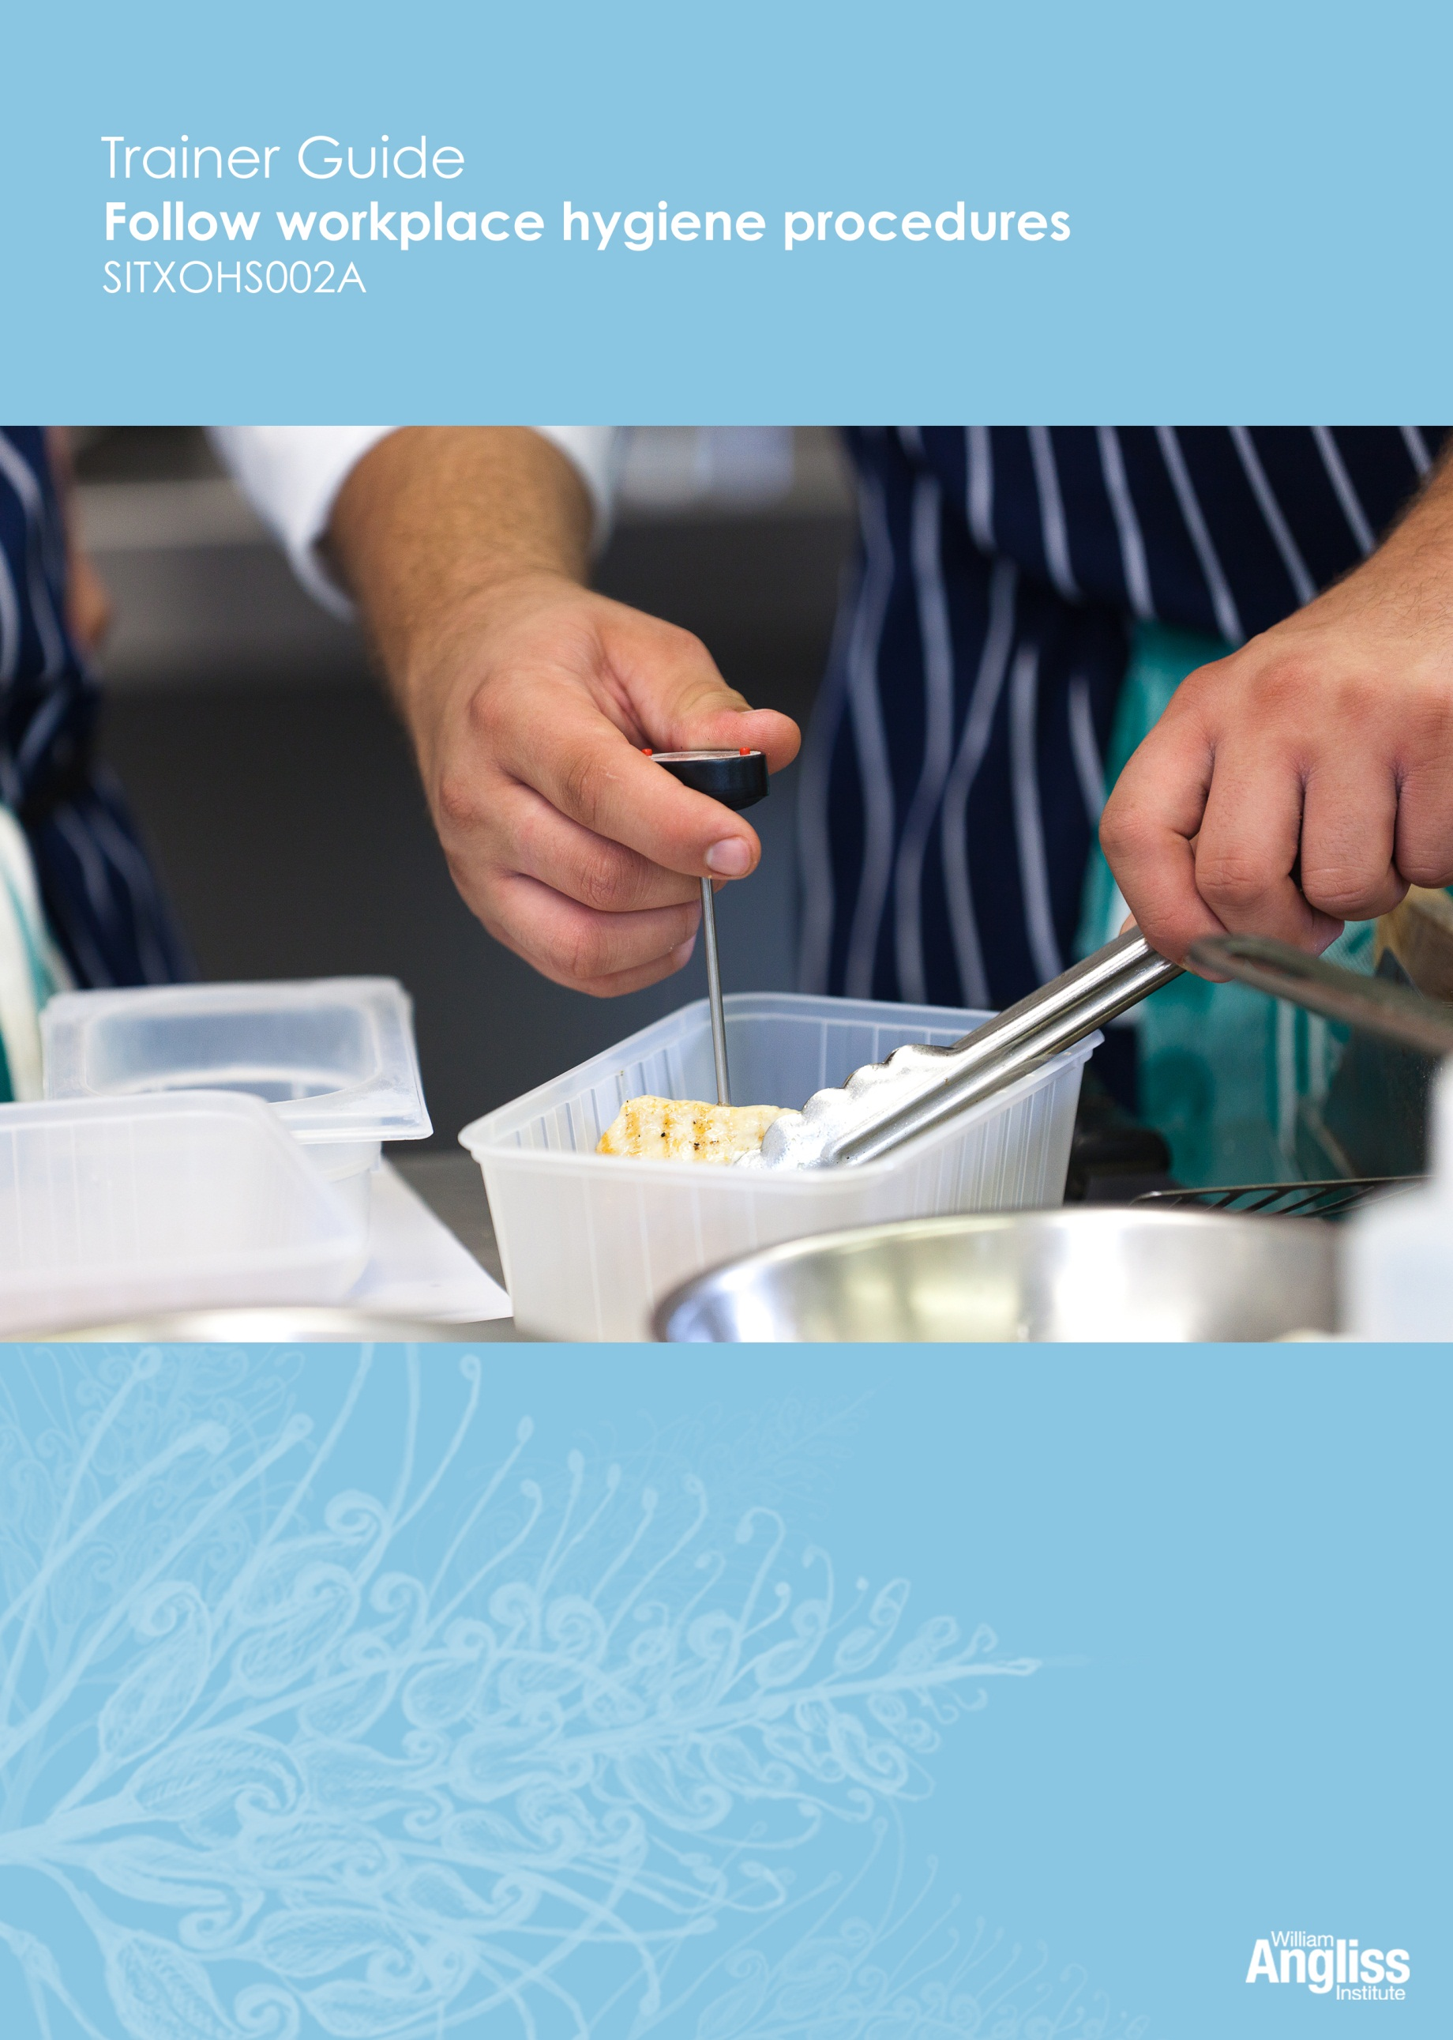

© Commonwealth of Australia. 2012
CC BY-NC-SA
This work is copyright. Except where otherwise indicated, and save for the Commonwealth Coat of Arms, the Department has applied the Creative Commons Attribution-Noncommercial-Share Alike 3.0 Australia Licence to this work.
The Department of Education, Employment and Workplace Relations must be attributed as the author of the Department’s copyright material.
As far as practicable, material for which the copyright is owned by a third party has been clearly labelled. The Department has made all reasonable efforts to ensure that this material has been reproduced in this resource with the full consent of the copyright owners.
Requests and enquiries concerning the Department’s copyright material should be addressed to:
The Copyright Officer
Department of Education, Employment and Workplace Relations
Location code C148CW2
GPO Box 9880 Canberra ACT 2601
Or emailed to copyright@deewr.gov.au
Funded under the Workplace English Language and Literacy (WELL) Program by the Australian Government Department of Education, Employment and Workplace Relations.
The views expressed in this publication do not necessarily represent the view of the Minister for Education or the Australian Government. The Australian Government does not give any warranty nor accept any liability in relation to the contents of this work.
ISBN 978-1-922108-01-2
Development Team
Content | William Angliss Institute  Macsmith and Associates
Disclaimer
Every effort has been made sure that this booklet is free from error or omissions. However, you should conduct your own enquiries and seek professional advice before relying on any fact, statement or matter contained in this book. William Angliss Institute of TAFE is not responsible for any injury, loss or damage as a result of material included or omitted from this course.

Contents
What is in this guide? 1

LLN requirements of the unit 2

Guide to the activities 3
Activity 1 Have you had food poisoning? 3
Activity 2 Food poisoning at the local pub 3
Activity 3 Cross-contamination of food 3
Activity 4 The food safety laws 3
Activity 5 What can you see in this kitchen? 4
Activity 6 Your workplace kitchen 4
Activity 7 Food poisoning in the news 4
Activity 8 Your personal hygiene 4
Activity 9 Hands can pass on germs 4
Activity 10 Practise hand washing 5
Activity 11 Give Marcia some advice 5
Activity 12 Telling your supervisor 5
Activity 13 Following workplace procedures 5
Activity 14 Read the signs 5
Activity 15 Signs in your workplace 6
Activity 16 Fridge and freezer temperatures 6
Activity 17 Correct food temperatures 6
Activity 18 Your workplace fridge 6
Activity 19 Prevent cross-contamination of food 6
Activity 20 Washing fruit and vegetables 6
Activity 21 Your workplace cleaning schedule 6
Activity 22 Cleaning at your workplace 6
Activity 23 Handling linen at your workplace 6
Activity 24 Handling rubbish at your workplace 7
Activity 25 Controlling pests at your workplace 7

Activity 26 Dealing with pests 7
Activity 27 Dealing with hygiene hazards 8
Activity 28 What should I do? 8
Further information on food safety 10
Appendix 11
Cards for Activity 12 11
Cards for Activity 28 12

What is in this guide?
This Trainer Guide to Activities is part of a set of resources to support delivery of 9 units from qualifications in the SIT07 Hospitality Training Package.
The resources have 3 components:
1. Learner Workbook.
2. General Trainer’s Guide
This single guide contains information to assist trainers to understand:
- the purpose and design of the resources
- strategies for working with learners with lower LLN levels
- strategies for working with Indigenous learners
- strategies for designing and conducting assessment appropriate to these learner groups and AQF levels.
3. Trainer’s Guide to Activities
There is one of these for each unit. It contains:
- a summary of the LLN requirements of that unit
- advice on using the Learner Workbook activities for that unit.
This Trainer Guide to Activities supports the highlighted unit.
- SITHIND001B Develop and update hospitality industry knowledge
- SITXCOM001A Work with colleagues and customers
- SITXCOM002A Work in a socially diverse environment
- SITXOHS001B Follow health, safety and security procedures
- SITXOHS002A Follow workplace hygiene procedures
- SITHACS005B Prepare rooms for guests
- SITHACS006B Clean premises and equipment
- SITHCCC003B Receive and store kitchen supplies
- SITHCCC004B Clean and maintain kitchen premises

LLN requirements of the unit
SITXOHS002A Follow workplace hygiene procedures
Skill | Applications
Reading | Know how to access and follow hygiene procedures and policies  Read and interpret diagrams that identify good hygiene practices  Very basic understanding of government legislation and regulations
Speaking and listening | Report hazards, poor organisation practices and other issues
Writing | None
Numeracy | Read a thermometer  Calculate times for cooling and reheating food  Interpret schedules
Computer literacy | None
Research | None

Guide to the activities

This guide to the activities provides:
- advice on carrying out an activity where it may not be obvious from the design of the activity itself. When the design of an activity speaks for itself, comments are on possible variations, enhancements or extensions of the activity that would ensure it is useful for learners with lower LLN skills.
- possible answers where this may assist the trainer to understand the intent of the activity.
Activity 1 Have you had food poisoning?
This is just a general discussion to encourage learners to think about, from personal experience, the importance of keeping food safe to eat.
Try to elicit some responses. You may need to prompt the learners a bit to talk, for example about times when they were sick after eating something, or terrible cafés they have been to.
Activity 2 Food poisoning at the local pub
Don’t expect all the answers to this – it is intended just to continue the discussion about the importance of safe handling of food.
Activity 3 Cross-contamination of food
Elicit from learners that germs from coughing can pass from hand to hand, then to food, then to the person eating the food.
Activity 4 The food safety laws
This is quite a difficult document to read, and most learners would not need to read the document at work. Rather, they would follow instructions given to them including instructions on posters on the wall. However, it is a useful activity to explore language of the Food Standards Code.
Alternative activity: Pick out one or two parts and explain them.
Extension activity: After learners have completed the unit, review this page to see if it is more meaningful to them. Ask them to give examples of what parts mean in practice.

Activity 5 What can you see in this kitchen?
Use this activity to stimulate discussion about what makes a kitchen hygienic.
When learners have finished circling things in the picture, ask them what they have circled and why.
Alternative activity: Put the pictures up electronically and do the activity as a group.
Activity 6 Your workplace kitchen
If your learners are not yet in a workplace, or do not have access to a workplace, you could take photos of a commercial kitchen and show them electronically.
Activity 7 Food poisoning in the news
The aim of this activity is to reinforce that food poisoning can be a big problem for people and businesses.
If learners have access to the internet, help them find articles by googling ‘food poisoning + their state or territory’ or putting the search terms into the search engine of a newspaper website.
Learners can work in small groups, with each group reading the same article.
Assist learners to pick out and highlight the key points from the information they find.
Learners can then practise speaking by telling another group about it. Encourage each person in the group to say something and encourage the other group to ask questions.
If learners do not have access to the internet, or the literacy demands of the activity are too high for the group, you could read aloud a summary of a news article about food poisoning and the group could talk about this.
Activity 8 Your personal hygiene
This is a personal activity. Encourage the learners to think about their own hygiene. Give positive reinforcement throughout the training.
If there is an obvious problem, you will need to speak to the learner separately and confidentially and encourage change.
Activity 9 Hands can pass on germs
This can start a discussion about cross-contamination. Prompt the learners to think about what people in the photos have been doing with their hands before they perform the activity, and what they might do afterwards.

Activity 10 Practise hand washing
As learners carry out this task, they should explain what they are doing and why. This gives learners practice in the assessment skill of explaining orally to an observer why they are doing something.
Activity 11 Give Marcia some advice
Elicit learner suggestions and make suggestions yourself as required. There are no actual right or wrong answers.
Extension activities:
- Set up a role play, with one person being Marcia and the other person giving advice.
- Encourage learners to use this language later, politely giving advice to others they see doing something which could cause contamination or cross-contamination of food.
Activity 12 Telling your supervisor
The aim of this activity is to reinforce the importance of ringing their supervisor if they are sick and for learners to practise doing it and using appropriate language.
Cards for this activity are in the Appendix of this guide. Copy cards so that there are employee cards for half the class and supervisor cards for the other half.
Ask the learners to work in pairs - one is the employee, one is the supervisor. Give an employee and supervisor card to each pair.
The pairs practise the conversation, then swap roles and cards.
Extension activities:
- Listen to another pair as they have the conversation.
- A confident pair could demonstrate their conversation to the whole group.
- Use mobile phones as props
- ‘Ad lib’ a conversation with a different illness.
Activity 13 Following workplace procedures
This activity is workplace specific. Encourage learners to talk about what they do at work and how they find out what to do and how to do it.
Activity 14 Read the signs
After pairs have talked about these signs, elicit answers from whole group.

Activity 15 Signs in your workplace
If your learners are not yet in a workplace, or do not have access to a workplace, you could take photos of signs and show them electronically.
Activity 16 Fridge and freezer temperatures
Refer learners back to the Temperature Danger Zone picture to help them answer this question.
Activity 17 Correct food temperatures
Refer learners back to the notes in their workplace about keeping food at the correct temperature to help with this activity.
Activity 18 Your workplace fridge
When the learners have the information, they could share it, such as writing it on posters, butchers’ paper or the whiteboard to compare what they found.
Activity 19 Prevent cross-contamination of food
If learners are not yet in a workplace, you could use the activity to reinforce things that prevent cross-contamination of food, by eliciting from learners why the action is important.
Activity 20 Washing fruit and vegetables
As learners are carrying this task, encourage them to explain what they are doing and why they are doing it. It is important to give learners practice in explaining orally to an observer as this is an assessment skill.
Activity 21 Your workplace cleaning schedule
If there is no written cleaning schedule at the workplace, you could supply a cleaning schedule from a typical local workplace.
Activity 22 Cleaning at your workplace
If learners are not yet in a workplace or do not have access to a workplace, you could take photos of a cleaning products and equipment from a suitable workplace and show them electronically.
Activity 23 Handling linen at your workplace
This activity will be workplace specific.
Stress the importance of handling linen correctly to prevent cross-contamination, particularly wearing gloves when handling dirty linen.
Activity 24 Handling rubbish at your workplace
This activity will be workplace specific.
Stress the importance of handling rubbish correctly to prevent cross-contamination, particularly washing hands after they have handled rubbish even if they have been wearing gloves.
Activity 25 Controlling pests at your workplace
This activity will be workplace specific.
Use this as a general discussion about the types of strategies that can be used to control pests.
Activity 26 Dealing with pests
You may need to elicit this information, and make suggestions yourself.
Some suggestions:
Pest problem | What should be done?
There are mouse droppings in the food area. | Have the storeroom cleaned thoroughly  Set traps  Make sure food is in sealed containers  Have any holes where mice could get in blocked up  If this does not work, a specialist pest controller may have to be called
A bag of flour has been nibbled by something at the corner. No flour seems to have been touched. | This could be mice, rats or insects  Throw out the flour  Make sure flour is in tins rather than being left in bags  Use an approved bait  Clean the storeroom  Set traps
You see a fly walking across the raw food that is ready to be cooked. | Throw out the food  Check the fly screens are shut and that there are no holes on them  Do not use fly spray around food
Flyscreen door on kitchen propped open while staff move new stock into fridges | Close the flyscreen door  Have someone at the door to open and close it when required until the stock has been moved  Check that there are no flies inside
There are spiders’ webs in the corner of a crockery cupboard | Clean out the cupboard  Check regularly for spiders  Check there are no cracks in the wall for spiders to breed  If there is a problem a specialist pest controller may have to be called
Someone has bought their little pet dog to work at lunchtime to show people | Ask the person to take the dog home as no animals are allowed in the kitchen  Clean and sanitise any place where the dog has been and make sure everyone one who has touched the dog washes their hands
Activity 27 Dealing with hygiene hazards
Elicit responses from the whole group. Or you could have pairs or small groups think about 1 question then share with the whole group.
Encourage learners to give reasons why they would take that action.
This activity will depend on the workplace procedures and the individual learner’s level of responsibility in the workplace. In some cases the learner will be able to deal with the situation. At other times they would tell the supervisor, such as the food being at the wrong temperature.
Activity 28 What should I do?
Cards are provided in the Appendix of this guide. Copy enough for 2 cards per person.
Divide learners into groups of four.
Put a stack of the cards on the table for each group.
Ask each person in the group to take a card. They should read what is on it and think about what they would do.

In turn, each person reads out their card and tells their group what they would do in the situation. The rest of the group can add suggestions or comment.
Later, discuss answers with the whole group.
Alternative activity: Instead of 4 learners taking 4 different cards, they could work in [pairs i.e. a pair has the same card and discusses together what they would do, then tell the other pair.

Further information on food safety
Do Food Safely
An online food safety program developed by the Victorian Government. The language level is accessible, there are voiceovers and some interactive activities. An engaging activity if learners have access to the internet.
<http://dofoodsafely.health.vic.gov.au/>
Food Standards Australia and New Zealand (FSANZ)
- <www.foodstandards.gov.au>
Department of Health in the states and territories
- Northern Territory
<www.health.nt.gov.au>
- Victoria
<www.health.vic.gov.au>
- Australian Capital Territory
<www.health.act.gov.au>
- New South Wales
<www.health.nsw.gov.au>
- Queensland
<www.health.qld.gov.au>
- South Australia
<www.sahealth.sa.gov.au>
- Tasmania
<www.dhhs.tas.gov.au>
- Western Australia
<www.health.wa.gov.au>
Note: These URLs were correct at 31 May 2012. Always check with the organisation or department for the most current information.
Contact details may change.

Appendix
Cards for Activity 12
THE EMPLOYEE
You woke up this morning with a blocked nose and a sore throat. You ring your supervisor to say you can’t come to work.
In the conversation, you need to say these things:
- I can’t come to work today.
- I’m sick. I’ve got a blocked nose and a sore throat.
- Maybe I’ll be better tomorrow. Can I ring you this afternoon to let you know?
- I’m sorry, I know it’s a nuisance for you.

THE SUPERVISOR
One of the kitchen hands rings you to say he/she is sick. You want to know some things and give advice.
- What’s wrong?
- Will you be okay tomorrow?
- You need to fill in a sick leave form when you return.
- Thanks for letting me know.
- Yes, ring me this afternoon and let me know if you can come in tomorrow.

Cards for Activity 28
The fridge is at the wrong temperature. | A workmate has a dirty uniform.
There is a cockroach in the  dry goods storage area. | A workmate is coughing and blowing his nose in the kitchen.
A new workmate isn’t following cleaning procedures properly. | You notice someone cutting raw chicken,  then using the same cutting board  and knife to cut tomatoes.
Dirty tea towels are being thrown on a corner of the food preparation bench. | Milk in the fridge has gone bad  and smells funny.

