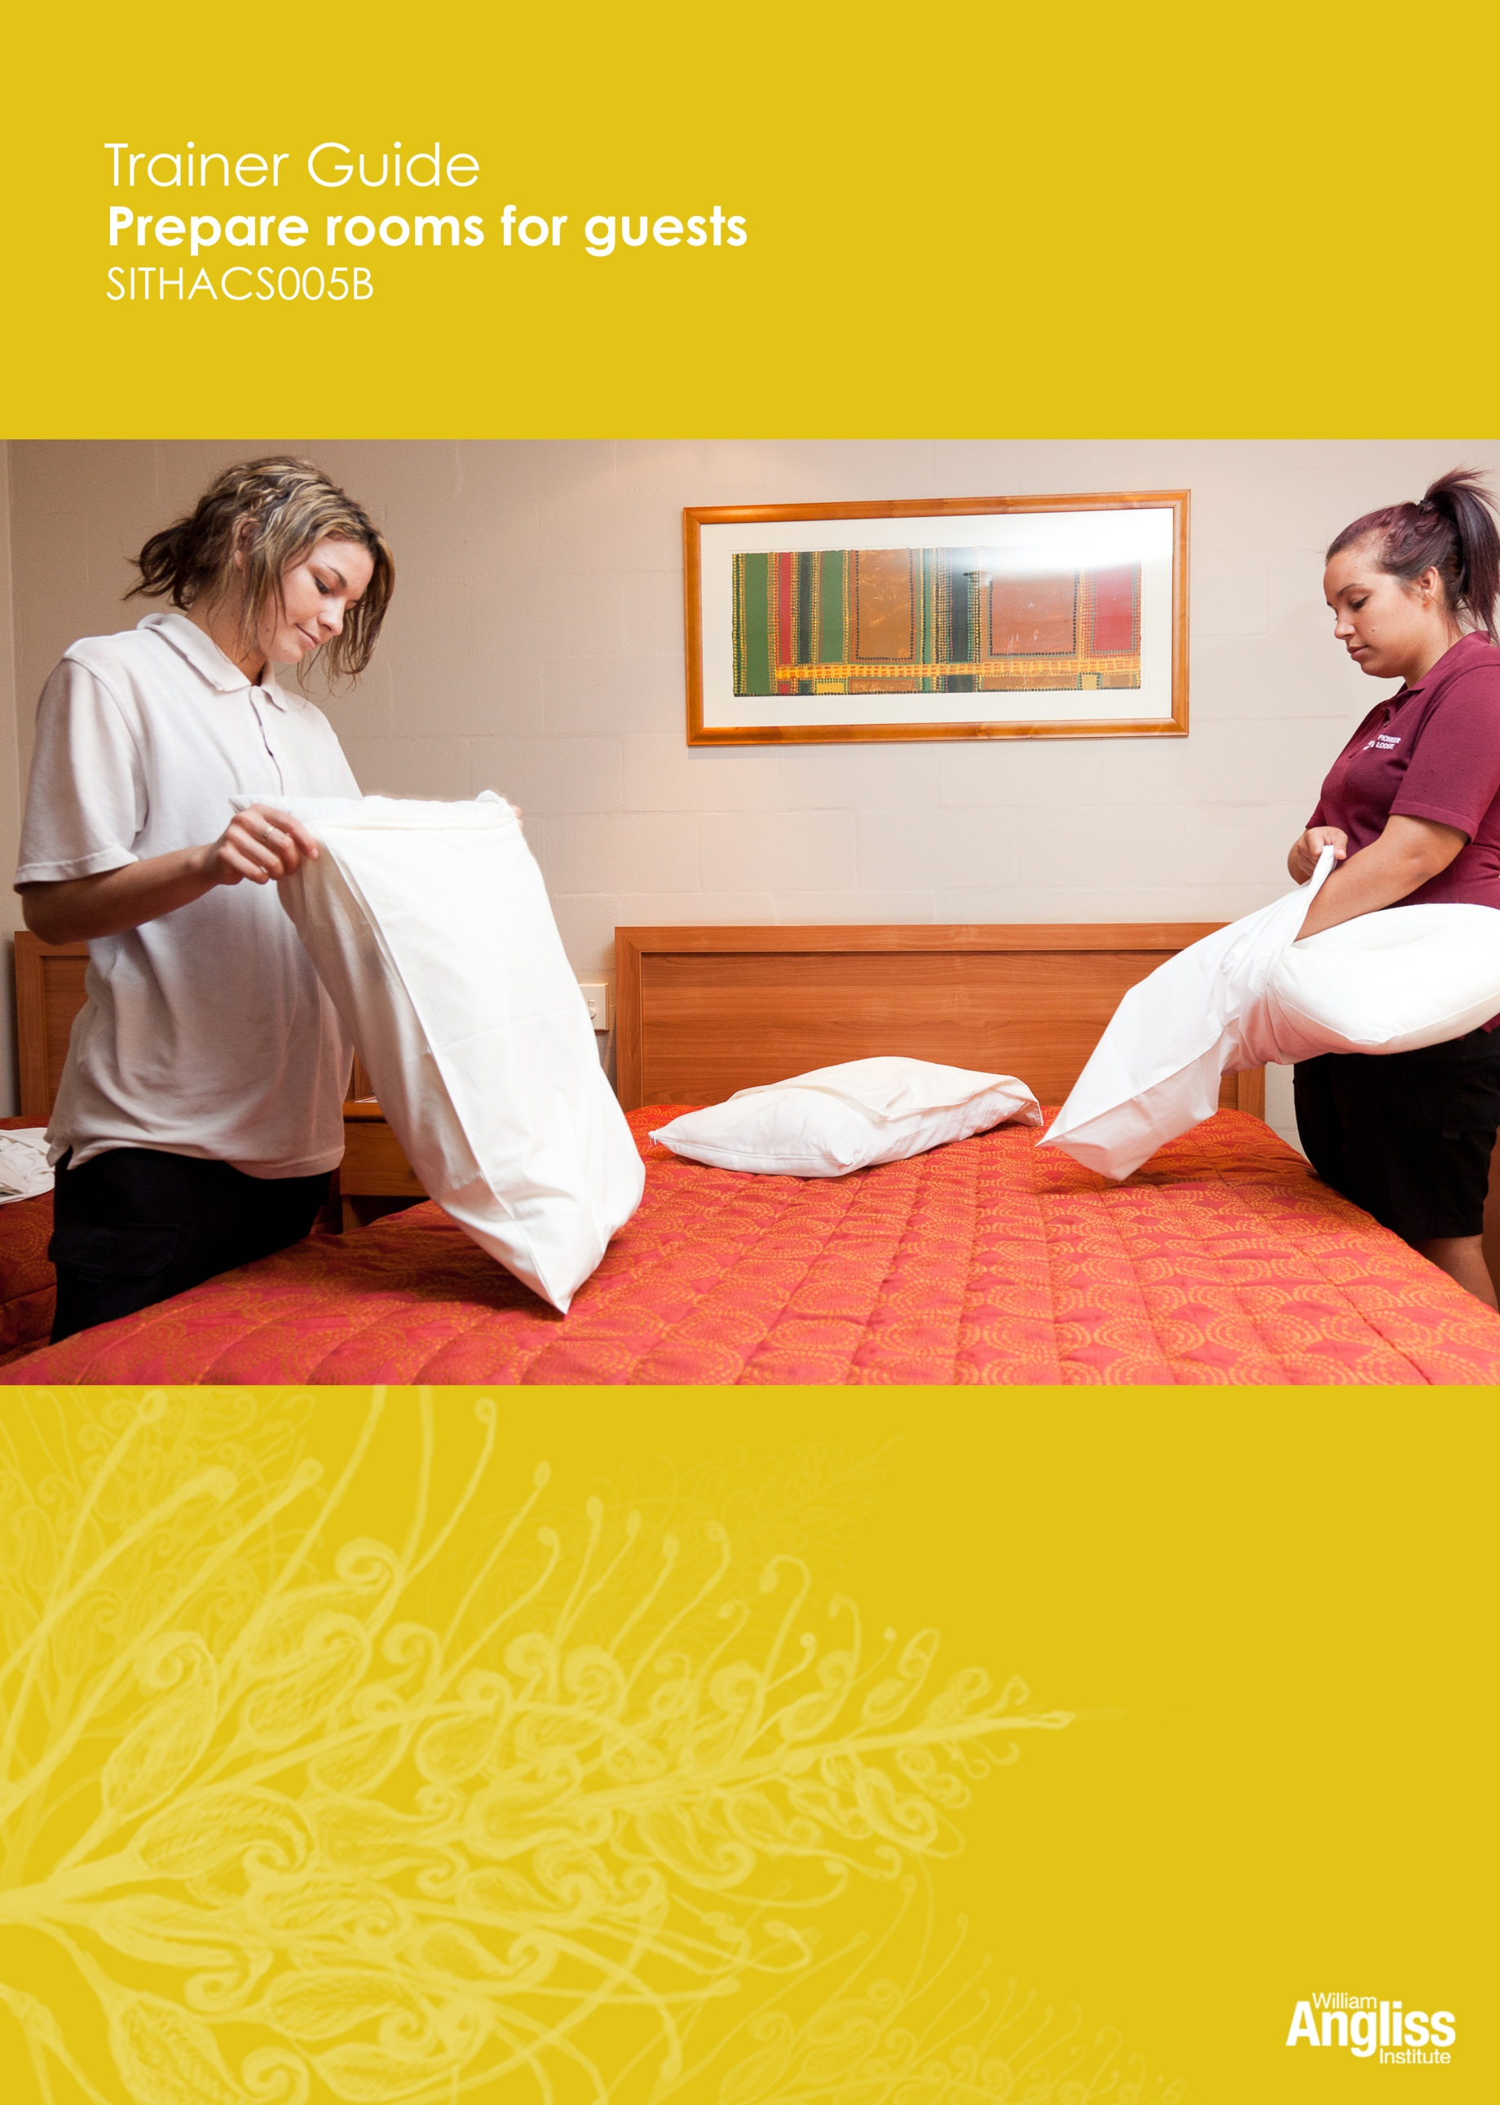

© Commonwealth of Australia. 2012
CC BY-NC-SA
This work is copyright. Except where otherwise indicated, and save for the Commonwealth Coat of Arms, the Department has applied the Creative Commons Attribution-Noncommercial-Share Alike 3.0 Australia Licence to this work.
The Department of Education, Employment and Workplace Relations must be attributed as the author of the Department’s copyright material.
As far as practicable, material for which the copyright is owned by a third party has been clearly labelled. The Department has made all reasonable efforts to ensure that this material has been reproduced in this resource with the full consent of the copyright owners.
Requests and enquiries concerning the Department’s copyright material should be addressed to:
The Copyright Officer
Department of Education, Employment and Workplace Relations
Location code C148CW2
GPO Box 9880 Canberra ACT 2601
Or emailed to copyright@deewr.gov.au
Funded under the Workplace English Language and Literacy (WELL) Program by the Australian Government Department of Education, Employment and Workplace Relations.
The views expressed in this publication do not necessarily represent the view of the Minister for Education or the Australian Government. The Australian Government does not give any warranty nor accept any liability in relation to the contents of this work.
ISBN 978-1-922108-04-3
Development Team
Content | William Angliss Institute  Macsmith and Associates
Disclaimer
Every effort has been made sure that this booklet is free from error or omissions. However, you should conduct your own enquiries and seek professional advice before relying on any fact, statement or matter contained in this book. William Angliss Institute of TAFE is not responsible for any injury, loss or damage as a result of material included or omitted from this course.

Contents
What is in this guide? 1

LLN requirements of the unit 2

Guide to the activities 3
Activity 1 Housekeeping tasks 3
Activity 2 Employability skills 3
Activity 3 Working safely 3
Activity 4 Melissa’s housekeeping worksheet 5
Activity 5 Workplace housekeeping worksheet 6
Activity 6 What’s on the trolley 6
Activity 7 The cleaning bucket 6
Activity 8 How much linen? 6
Activity 9 Cleaning supplies and room supplies 7
Activity 10 Trolley safety rules 7
Activity 11 More trolley safety 7
Activity 12 Clean and restock your trolley 8
Activity 13 Ordering supplies 8
Activity 14 Mark’s housekeeping worksheet 8
Activity 15 Accessing rooms 8
Activity 16 Your workplace procedure 8
Activity 17 Key control 8
Activity 18 Making beds 8
Activity 19 Bed making procedure 9
Activity 20 Guidelines for cleaning rooms 9
Activity 21 Cleaning a vacant dirty room 9
Activity 22 Cleaning bathrooms 9
Activity 23 Cleaning products and equipment 9
Activity 24 Diluting cleaning products 9
Activity 25 Signs of pests 10

Activity 26 Pest control procedures 10
Activity 27 Unusual or suspicious items or activity 10
Activity 28 Security in your workplace 10
Activity 29 Lost property 10
Activity 30 An environmentally friendly workplace 11
Activity 31 Hazardous substances in your workplace 11
Further resources 12

What is in this guide?
This Trainer Guide to Activities is part of a set of resources to support delivery of 9 units from qualifications in the SIT07 Hospitality Training Package.
The resources have 3 components:
1. Learner Workbook.
2. General Trainer’s Guide
This single guide contains information to assist trainers to understand:
- the purpose and design of the resources
- strategies for working with learners with lower LLN levels
- strategies for working with Indigenous learners
- strategies for designing and conducting assessment appropriate to these learner groups and AQF levels.
3. Trainer’s Guide to Activities
There is one of these for each unit. It contains:
- a summary of the LLN requirements of that unit
- advice on using the Learner Workbook activities for that unit.
This Trainer Guide to Activities supports the highlighted unit.
- SITHIND001B Develop and update hospitality industry knowledge
- SITXCOM001A Work with colleagues and customers
- SITXCOM002A Work in a socially diverse environment
- SITXOHS001B Follow health, safety and security procedures
- SITXOHS002A Follow workplace hygiene procedures
- SITHACS005B Prepare rooms for guests
- SITHACS006B Clean premises and equipment
- SITHCCC003B Receive and store kitchen supplies
- SITHCCC004B Clean and maintain kitchen premises

LLN requirements of the unit
SITHACS005B Prepare rooms for guests.
Skill | Applications
Reading | Read schedules and timetables for room servicing  Read product labels and product safety instructions
Speaking and listening | Read schedules and timetables for room servicing  Read product labels and product safety instructions
Writing | Order trolley supplies  Record damaged items
Numeracy | Calculate the dilution of cleaning products  Calculating amount of linen needed for a shift
Computer literacy | None
Research | None

Guide to the activities

This guide to the activities provides:
- advice on carrying out an activity where it may not be obvious from the design of the activity itself. When the design of an activity speaks for itself, comments are on possible variations, enhancements or extensions of the activity that would ensure it is useful for learners with lower LLN skills.
- possible answers where this may assist the trainer to understand the intent of the activity.
Activity 1 Housekeeping tasks
Make the activity more kinetic by writing the tasks on paper and sticking them around walls.
Put the ‘You have to…’ items on separate sheets of paper. Divide these among the groups and ask learners to stick them under the matching task.
This might require some negotiation until learners agree.
Activity 2 Employability skills
You could put the advertisement up electronically and ask for suggestions from the learners, then highlight the employability skills.
Learners could then copy this into their workbook.
Use the activity as a starter for discussing what employability skills are and why they are important at work.
Activity 3 Working safely
Use this activity to get learners to think about the movements they make in each task.
Here are some suggested responses. You could draw the table on a whiteboard and fill in the gaps as learners volunteer ideas, or invite learners to write up their own ideas.
Learners can then copy the responses into their workbooks.

1. Task | 2. What movements does the task involve? | 3. How can I do these movements safely?
Make beds  - Move bed  - Strip bed  - Put on clean linen  - Replace bedding  - Lift dirty linen and place into bag  - Put pillows into pillowcases | Push, bend, stretch, lift, twist  Heavy work  Work low | - Push bed away from wall, do not pull it  - Move around the bed, do not stretch across it  - Push bed with my knees  - Bend my knees or kneel on floor when working low  - Place linen and bedding on chair or spare bed, not on floor  - Don’t shake anything above shoulder level  - When lifting linen make sure the load is manageable, hold items close to your body, never twist
Clean bathroom  - Clean basin, bath, shower, toilet  - Place towels on high shelves  - Use chemicals  - Polish mirror | Repetitive motions  Stretch, forceful arm movements  Slips, trips and falls  Work high, work low  Awkward reaching, twisting | - Place chemical bucket under the vanity against the wall to avoid a trip hazard  - Kneel or squat to clean toilet and lower half of shower  - Hold on to tap handle for balance when coming up  - Do not reach above shoulder height.
Vacuum floors  - Move furniture  - Push and pull vacuum cleaner  - Stretch into awkward corners | Repetitive motions  Stretch, forceful arm movements  Slips, trips and falls  Heavy work | - Check for slips and trips hazards  - Keep cord behind machine where I will not trip over it  - Keep my back straight  - When picking up items at floor level bend at the knees and maintain posture
Dust room  - Repetitive motions | Repetitive motions  Squat, stretch, kneel, twist  Work high, work low | - Squat or kneel to work low  - Move frequently rather than over-reaching  - Use extension tools for high work
Mop floors  - Move heavy bucket  - Mopping | Repetitive motions  Stretch, forceful arm movements  Lift heavy object  Slips, trips and falls | - Check for slips and trips hazards  - Half fill mop bucket  - Keep my back straight
Clean kitchen area  - Clean mini bar fridge  - Clean benches | Bend, stretch, twist  Repetitive motions  Work low | - Take care around light and electrical switches  - Squat or kneel to clean fridge, do not bend
Move trolley  Push and pull trolley | Push, pull, bend, stretch, twist  Heavy work, forceful arm movements  Trips or falls | - Always push the trolley, never pull  - If the trolley is stuck, never lift it – get help  - Squat or kneel to reach low items – never bend my back  - I must be able to see over the top of your trolley
Restock trolley  - Squat, kneel to reach low shelves in storeroom  - Reach for bundles of linen from store  - Lift clean linen on trolley | Push, pull, bend, stretch  Heavy work  Work low | See safe work procedure later in the section.
Activity 4 Melissa’s housekeeping worksheet
This is an activity in reading schedules or timetables.
Explain the Status key first.
To help learners complete this activity, you could put the worksheet up electronically and highlight the areas where they will find the information.
When checking answers, go around the pairs asking learners to contribute. Treat all responses with respect, modelling good classroom behaviour for learners.

Activity 5 Workplace housekeeping worksheet
This activity will be workplace specific.
If learners are not yet in a workplace, you could bring a worksheet from another hotel so learners can compare them.
Activity 6 What’s on the trolley
Learners may not know the names of the items, or call them by different names. This is an opportunity to familiarise them with industry terminology.
Alternative activity: Take a picture of a workplace cleaning trolleys and use this for the activity.
Activity 7 The cleaning bucket
As for Activity 6.
Activity 8 How much linen?
This is an activity in basic maths needed in housekeeping.
If pairs are having difficulty, take the opportunity to assist them individually while the rest of the group is occupied.
When checking answers, explain the working slowly and write it up on the whiteboard.
Answers are supplied below:
Type of linen | Which cabins? How many people? | Melissa needs …
Single fitted bottom sheets | Cabin 4 only =1 bed | 2
Single flat top sheets | Cabin 4 only = 1 bed | 2
Queen fitted bottom sheets | Cabins 4, 5 & 6 = 3 beds | 3
Queen flat top sheets | Cabins 4, 5 & 6 = 3 beds | 3
Pillow cases (2 per person) | Cabin 5 & 6 = 8 people  plus extra pillow Cabin 4 | 16 plus 1 = 17
Towels (1 per person) | Cabins 4, 5 & 6  = 3 cabins x 4 people | 12
Bath mats (2 per cabin) | Cabins 4, 5 & 6  = 3 cabins x 2 mats | 6
Hand towels (1 per person) | Cabins 4, 5 & 6  = 3 cabins x 4 people | 12
Tea towels (2 per cabin) | Cabins, 4, 5 & 6  = 3 cabins x 2 tea towels | 6
Face washers (1 per person) | Cabins 4, 5 & 6  = 3 cabins x 4 people | 12
Activity 9 Cleaning supplies and room supplies
Learners need to access a storeroom for this activity. They can work individually or in pairs.
Activity 10 Trolley safety rules
To make the activity more engaging, have a trolley present and demonstrate some of the safety rules. Discuss learners’ ideas and suggest others as required to fill gaps or stimulate discussion.
Draw up a grid on the whiteboard and fill the gaps as learners make suggestions. Learners can then copy this into their workbooks.
Alternative activities:
- Discuss one rule at a time as a whole group
- Divide into smaller groups and give each small group one or two rules to think about. Then return to the group to share ideas.
Activity 11 More trolley safety
Encourage learners to think about any other trolley safety points.
Possible answers include:
- Don’t load wet items over clean linen where they can drip onto clean items
- Keep dirty linen & clean linen separate
- Don’t put your drink bottles or food containers on the trolley.

Activity 12 Clean and restock your trolley
This information will be workplace specific.
If learners are not in the workplace, you could show them a checklist for restocking a trolley.
Activity 13 Ordering supplies
If some learners need extra practice, you could copy the form and substitute different items.
Activity 14 Mark’s housekeeping worksheet
If learners need support with this activity, you could put the worksheet up electronically and highlight the areas where they will find the information.
You may have to review the Status key with learners.
Activity 15 Accessing rooms
These questions require problem-solving skills.
Read out the problem to the group and ask for ideas about what should be done. Discuss the pros and cons of various suggestions, aiming for the group to come to a consensus in the end.
Ideally, you would display the procedure electronically so you could highlight the sections where the answers can be found.
Activity 16 Your workplace procedure
This activity is workplace specific.
Activity 17 Key control
See Activity 15.
Extension activity: The learners role play this activity in pairs. It can be difficult to refuse a guest request so some practice in this can be useful.
Activity 18 Making beds
See Activity 15.

Activity 19 Bed making procedure
See Activity 15. Suggested answers are below.
- Stripping sheets from bed
- Inspecting bedding and mattress for staining
- Moving bed correctly by pushing with knee
- Turning top of sheet over quilt, doona or blanket at bed head end
- Putting plumped-up pillow in pillowcases
- Positioning top sheet, correct side up (check hem), top edge at bed head
- Putting bedspread in position.
Activity 20 Guidelines for cleaning rooms
This is a problem solving activity. The answers are not in the procedures. Encourage learners to think about the reasons why they do these tasks in this way.
Activity 21 Cleaning a vacant dirty room
See Activity 15. This is a problem solving activity, applying procedures to a situation. The activity will also familiarise learners with the tasks involved in cleaning rooms.
Remind learners to look at both procedures for cleaning rooms to answer these questions.
Activity 22 Cleaning bathrooms
See Activity 15. This is a problem solving activity, applying procedures to a situation. The activity will also familiarise learners with the tasks involved in cleaning bathrooms.
Activity 23 Cleaning products and equipment
You can ask learners to fill this in while in their workplace or simply to remember what they have seen. They can do the activity in pairs, small groups or (if they are all in the same workplace) as a whole group.
Activity 24 Diluting cleaning products
- 20 mls x 10 = 200 mls
- 10 caps of detergent
This is a simple calculation learners may have to do. If they need extra practice, you can develop other questions based on this model.

Activity 25 Signs of pests
Elicit responses from learners and writ them briefly and clearly on the whiteboard, so learners can copy down the answers.
Some possible answers follow.
- What are some possible signs that pests may be in a room?
Droppings, spots on walls and surfaces, eggs and cocoons
Customer reports seeing or hearing them
Dead animal/insects in room
Nibble marks on food left out
Animal/insect noises
Customer reports skin irritation or bites
Blood spots.
- What should Mark do if he sees ants on the bench in a cabin kitchenette at The Gums?
Use only a small amount of eco-friendly insect spray.
Wear gloves and a mask.
Report to supervisor for further pest control action.
Activity 26 Pest control procedures
Answers will be workplace specific.
Activity 27 Unusual or suspicious items or activity
See Activity 15. This is a problem solving activity.
Activity 28 Security in your workplace
Answers will be workplace specific.
Activity 29 Lost property
See Activity 15. This is a problem solving activity, applying procedures to a situation.
Q. 4 is an activity in form filling. Go through the sections of the form first, reading the headings and asking learners what needs to go in each section.

Alternative activities:
- Help learners individually if needed
- Display a blank form electronically and complete the form as learners give you the information. They can then copy the writing into their workbooks.
Activity 30 An environmentally friendly workplace
The language in the questionnaire should be familiar to learners at this point, but the activity should not be threatening to learners. You may choose to read each question aloud to the group and discuss the answers before everyone marks an answer.
The objective of the activity is to:
- pull together the strategies for minimising harm to the environment scattered through the workbook, and discuss them together
- recycle and reinforce the knowledge
- practise the language.
Extension activities:
- Use the completed questionnaire to identify which actions workers can take as an individual and which ones are dependent on management policies.
- Organise someone from the workplace to talk to learners about strategies to reduce the environmental impacts of cleaning products and processes.
- Learners could make posters promoting ways for cleaners to help the environment, such as turning off equipment when not being used and not wasting water.
Activity 31 Hazardous substances in your workplace
Answers will be workplace specific.

Further resources
Bed making process
<http://www.youtube.com/watch?v=cgInC05IlrY&feature=related>
‘Ultra clean’ housekeeping
<http://www.youtube.com/watch?v=orhCpT7H-lo&feature=related>
How to find bed bugs in hotels
<http://www.youtube.com/watch?v=UHcc5xbSo9g>
Sustainability Toolkit – Hospitality
An introductory guide to basic sustainability principles, practices and actions that hospitality businesses can use to help manage their costs and climate change impacts.
<http://www.nswbusinesschamber.com.au/NSWBC/media/Misc/Policy%20Documents/Sustainability-Toolkit-Hospitality.pdf>

