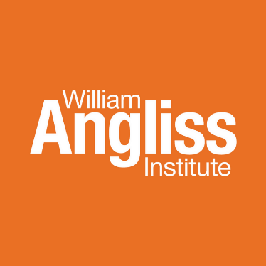

Careers and Employment Expo 2025

Wednesday 1st of October 2025 | 11:30am – 2:30pm

**Student Prize draw TERMS AND CONDITIONS**

**How to enter**

Participants enter by registering and attending the Careers and Employment Expo 2025 held at the Angliss Conference Centre Level 5 Building A, William Angliss Institute Melbourne campus. At the check-in table, students will receive a raffle ticket.

**Conditions of entry**

1. The competition is free to enter and is only open to William Angliss Institute current students and Alumni.
2. Only one entry per person is allowed.
3. **Prize(s)**

**Raffle prizes will be available on the day**

* 1. **Ferguson Plarre:** 2 x $100.00 Fergusson Plarre’s Bakehouse Gift Card, both valid until 11/9/2028, redeemable at any Fergusson Plarre’s Bakehouse retail store.
  2. **Australian Venue Co**: Dining voucher at one of AVC's 250+ venues valued at $250.00 with a 3-year expiry.
  3. **Daniel’s Donuts**: 1 x $50 Gift Voucher, with a 3-year expiry, to use at any Daniel’s Donuts store.
  4. **Ovolo Hotels:** 1 x One night accommodation, inclusive of breakfast, with a 12-months expiry.
  5. **TFE Hotels:** 1 x Gift Voucher for one nights’ accommodation in a Lead room type at Adina Apartment Hotel Pentridge Melbourne, valid until 18 August 2026.
  6. **Uplift Events:** Team (2 persons) entry into our 2025 public Great Pursuit Amazing Race on Sunday, 2nd of November 2025 valued at $90.00, expiry 29/11/2025.
  7. **Pan Pacific:** “High Tea for 2” voucher at Pan Pacific Melbourne valued at $158 with a 6-months validity (until March 2026).
  8. **Veriu Group:** Overnight stay at any Veriu Group hotel (25 across Veriu and Punthill brands), which will be valid for 12 months from issue. Value will depend on which hotel they stay at.
  9. **Artisanal Group:** 1x coffee voucher, valid for 6 months.
  10. **SushiSushi:** Store Gift Voucher valued at $100; expiry date TBC.
  11. **Tour Guides Australia**: 1st prize = FREE Tour Guiding Fundamentals micro credential training course valued at $750.00; 2nd prize = A year's Affiliate Membership of Tour Guides Australia, valued at $50. Both prizes have a 12-months expiry *(ONLY available to current Tourism students)*.
  12. **Young Tourism Network:** 1 Year YTN Membership, valued at $50 with a 12-month expiry *(ONLY available to current Tourism students)*.

All voucher amounts are in Australian dollars (AUD). Checked it attendees will be randomly selected for these prizes. The prizes are not transferrable, exchangeable or redeemable for cash.

**Competition Period**

The competition commences at 11:30 AM AEST on October 1st, 2025, and closes at 2:30 PM AEST on October 1st, 2025.

**Selection and Notification of the Winner**

**Participants:** Checked in until 2:00pm

**Prize Draws:** 2:00 pm

All winners will be drawn according to above list.

***The winners will be announced at the selected time. If a student winner is absent, we will contact them via SMS after the event.*** For more information about William Angliss Institute's privacy policy, visit: <https://www.angliss.edu.au/siteassets/pdf-files/policy/privacy-policy.pdf>